**v. 2.0**

**Veterans Benefits Administration**

**Technical Training & Evaluation (20M51)**

**June 14, 2013**

VBA Learning Catalog User Guide



**Record of Changes**

|  |  |  |
| --- | --- | --- |
| **Version** | **Date** | **Changes to the User Guide** |
| v. 2.0 | June 14, 2013 | Complete revision to correspond with release of v. 2.0 |
| v. 1.0 | September 24, 2013 | New document created upon initial launch of catalog |

Table of Contents

Overview 3

Site Navigation 3

Search Box 3

Top Navigation Bar 4

• Audience 4

• Curriculum 4

• Category 4

• Design/Delivery 4

• Competency 4

Side Navigation Bar 5

• Audience 5

• Curriculum 5

• Category 5

• Design/Delivery 5

• Service 5

Viewing Course Records 6

Managing Catalog Items 8

List Options and Settings 8

Additional Catalog Tips 9

Tips for Successful Searching 9

Tips for Successful Filtering 9

Breadcrumbs 9

# Overview

This guide is intended to help you navigate the VBA LC (Learning Catalog) and utilize its features, such as the robust search engine and list (shopping cart). The catalog homepage resides at <http://hvnc.gdit.com/lc/>. The catalog can also be accessed from the following locations:

* Technical Training & Evaluation section of the ED&T Website:

<https://vbaw.vba.va.gov/bl/edt>

* *RVSR & VSR Training* section of the Compensation Service Training Website:

<https://cptraining.vba.va.gov>

# Site Navigation

The VBA LC site provides three navigation methods for locating training courses and materials:

1. Search Box
2. Top Navigation Bar
3. Side Navigation Bar

## Search Box



The Search Box, located within the top banner of the VBA Learning Catalog, provides a quick way to search for training courses and materials. You can use this feature to search by:

* TMS Item Number
* Lesson Title
* Keyword (the system searches the title and the description of each course for results)

The Search Box is programmed with an auto-complete feature where text can be entered and matching words that contain that text will appear.

Catalog help is available by selecting the question mark icon next to the Search Box. For further assistance, select the “Contact Us” link.

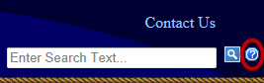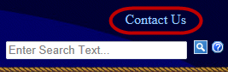

Top Navigation Bar

The VBA LC navigation tool is a horizontal bar located across the top of the site. Users can search for courses by hovering over one of the five primary selections, including:

* Audience – Search for a specific target audience. For example, within the Compensation Service audience box, you can search for courses targeted toward Intermediate-level VSRs.
* Curriculum – Search within a Service’s specified curriculum, such as VR&E’s National Training Curriculum.
* Category – Locate specially categorized courses, such as one-time mandated items or those belonging to the Transformation Initiative.
* Design/Delivery – Search by the method in which the training is intended to be delivered (e.g., instructor-led, online, or webinar).
* Competency – The Competency selection has not been activated. It currently serves as a placeholder for the upcoming VBA Competency effort.

Follow these steps to navigate the top navigation bar:

1. Hover the mouse pointer over the desired primary selection. Each primary selection is further divided by the VBA Services.
2. Each VBA Service box contains a secondary selection hyperlink.
3. Click on the desired secondary selection to view courses that are grouped under that selection. **Note:** clicking on the Service name will show all courses within that Service.

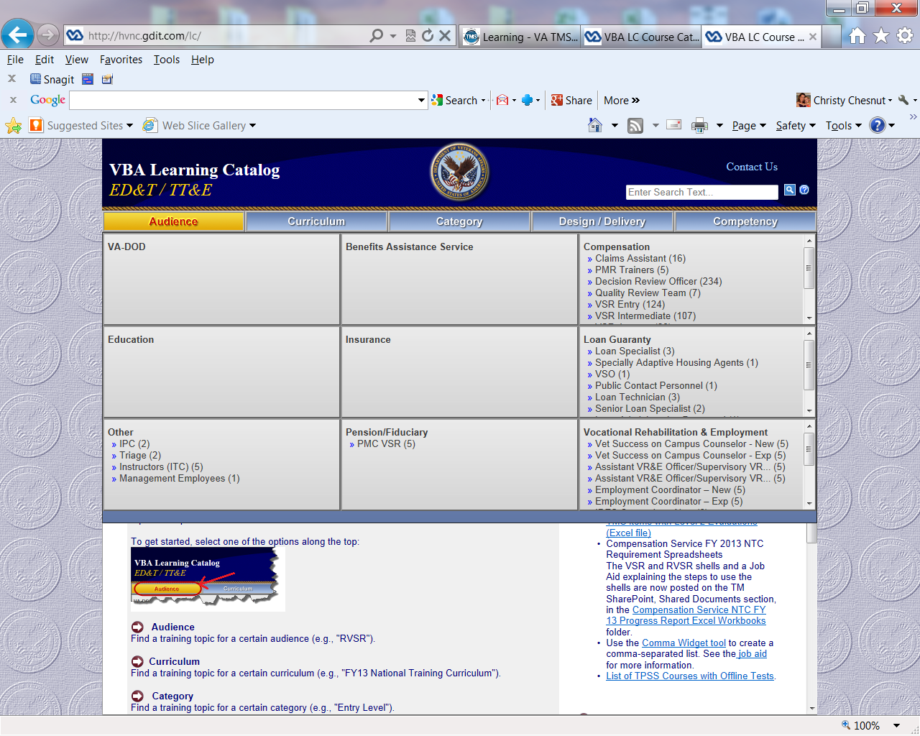

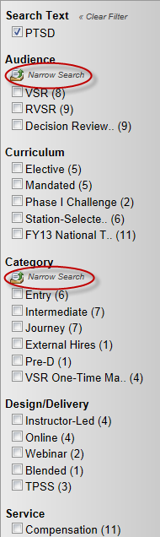Side Navigation Bar  
  
The side navigation bar provides a convenient way to further narrow secondary selections to locate courses. To utilize the side navigation bar, first initiate a search using the "Top Navigation Bar" or “Search Box” (see directions above). Once the results page populates, the side navigation bar will appear on the left.

The Side Navigation Bar is divided into five sections, each with unique functionality:

* Audience – By selecting the checkbox(es) next to the desired audience(s), you *narrow* your search to courses targeting only that audience(s). This can be helpful when developing a training plan that spans several job positions (audiences).

NOTE: If you wish to expand your search to include courses listed within *either* audience, select the “Narrow Search” link, and the system will allow you to switch to “Expand Search” mode.

* Curriculum – You can further *narrow* your initial search by selecting a single checkbox within the “Curriculum” section. For example, you may want to locate training on PTSD that appears in the Compensation Service National Training Curriculum (NTC). By selecting the NTC checkbox, only those courses that are part of this curriculum will appear.

NOTE: If you select more than one checkbox, your search will expand to include items within *either* curriculum you have selected.

* Category – By selecting the checkbox(es) next the desired category(s), you *narrow* your search to courses falling only within that category or categories. For example, if you need to find an item that is a once-in-a-career mandated item for both VSRs and RVSRs, you would select both category checkboxes.

NOTE: If you wish to expand your search to include courses listed within *either* category, select the “Narrow Search” link, and the system switch to “Expand Search” mode.

* Design/Delivery – You can locate courses that use a specific delivery method (e.g., instructor-led, online, or webinar) by selecting a Design/Delivery checkbox. Selecting more than one checkbox will provide courses with *either* delivery method chosen.
* Service – You can *narrow* your search to only courses developed for a specific VBA Service by selecting the corresponding Service checkbox.

By selecting the “Clear Filter” link at the top of the Side Navigation Bar, you can remove all search criteria and restart your search.

# **Viewing Course Records**

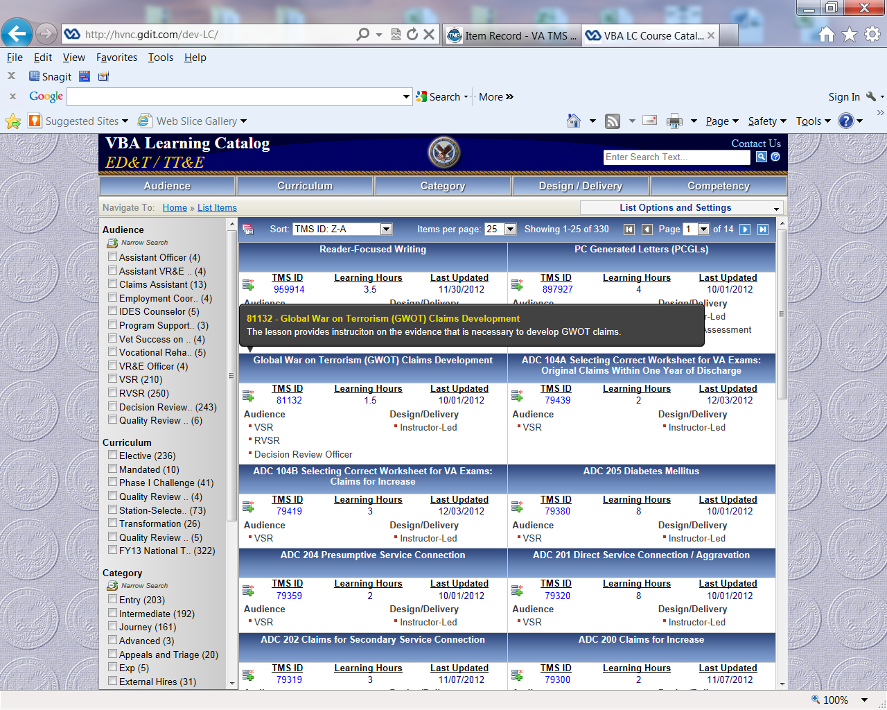Once you have completed your search, the results page will display a list of courses in “Card View” by default. Card View provides “at-a-glance” course details, such as the title, audience, TMS ID, learning hours, the date the course was last updated, and the design/delivery method. Hover your mouse over the title of the course to reveal the course’s description.

Alternately, you can choose to view results in “List View.” To switch to List View, select the document icon to the left of the “Sort” box.

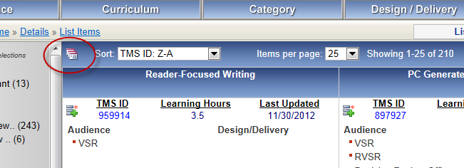

List View displays the courses in a condensed list, allowing you to view more courses at once. In List View, only the TMS Item ID, title, learning hours, and date the course was last updated appear. You can still hover over the title of the course to display the course description.

Both Card View and List View allow for sorting by TMS ID, Item Title, Learning Hours, and Date Last Updated using the Sort dropdown box. In List View, you can also sort by clicking on the column headings. You can toggle between Card View and List View by clicking the document icon at any time.

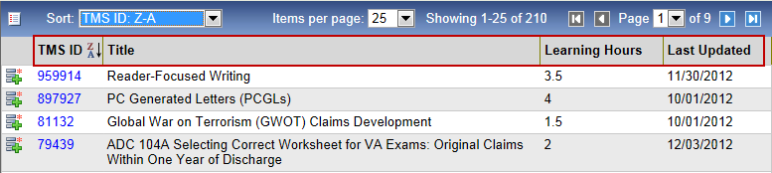

You can increase the number of courses displayed on one screen by changing the number within the “Items per page” dropdown.

Whether in Card View of List View, you can select the blue TMS Item ID hyperlink to reveal the full course record.

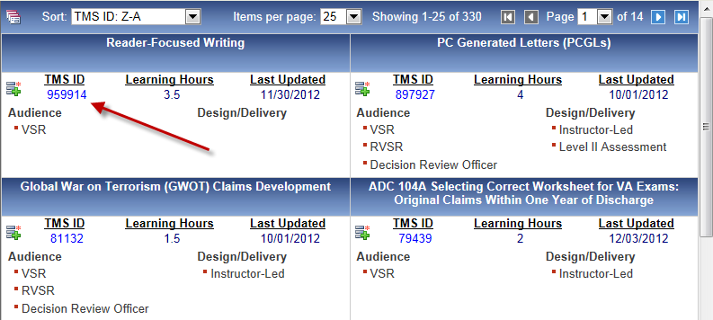

The full course record provides the same data listed within Card View, plus additional resources, including:

* A full course description, prerequisites to the course, and course objectives
* Other information relevant to the course, including instructions for completing the course
* A table listing the audience, curricula, and categories in which the course belongs
* A Related Links section with links to the course’s training materials, including handouts, lesson plans, visuals, fast letters, and a direct link to the course in TMS

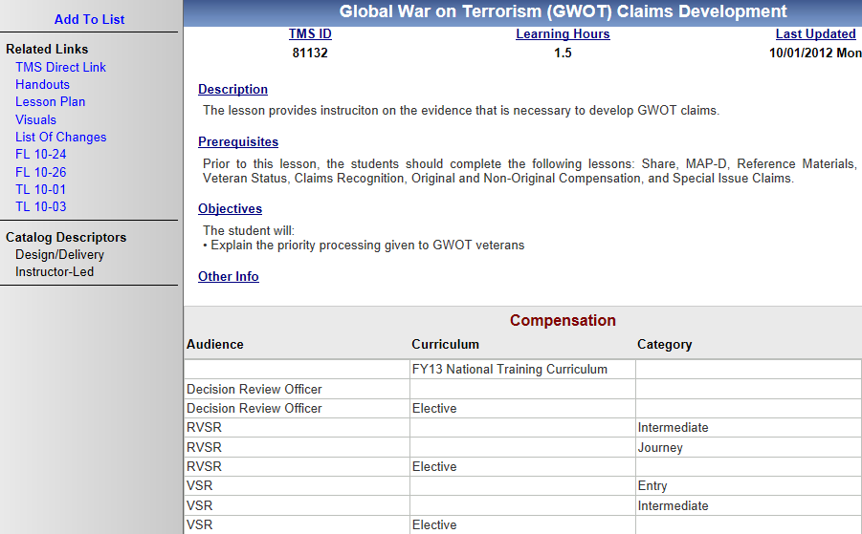

# Managing Catalog Items

**Quick Tip**

The “List Options and Settings” dropdown menu allows you to add more items to your list, remove items, and switch between Card View and List View. You can also turn off the feature that displays course descriptions when you hover over course titles.

The List feature of the VBA LC application enables you to create a "shopping cart" of courses as you browse. It is a useful device for saving a potential course for later review or for building a training plan.

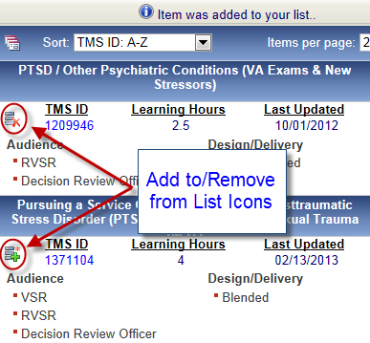To add courses to your list from either Card View or List View, select the “Add to List” icon within the desired course record.

Observe that the icon and hyperlink text change from "Add to List" to "Remove from List." This indicates that the item was successfully added to your list. There is also a message below the top navigation bar that says "Item was added to your list," confirming your addition.

Simply select the “Remove from List” icon to clear a course from your list. You will also have the option of removing selections later while viewing your list.

## 

## List Options and Settings

To view the list you created, select the “List Options and Settings” dropdown menu, and choose “View list items.”

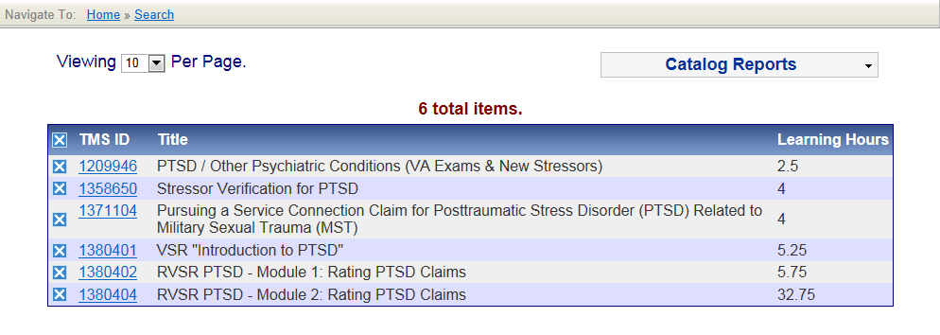The list of items you selected is displayed, with the TMS Item ID (which links to the full course record), Title, and Learning Hours.

Remove individual courses from your list by clicking the X icon next the the item you wish to remove. To clear all items from your list, select the X icon in the top (header) row.

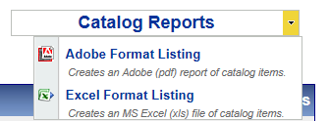The Catalog Reports dropdown provides you with the option of converting your list into a PDF or Excel file. The PDF and Excel files contain full course details and can be emailed, saved, or printed.

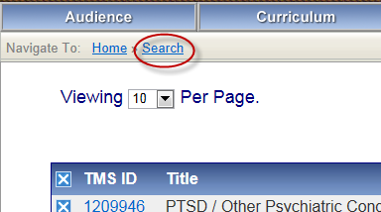If, at any time, you wish to return to your initial search results screen, select the “Search” breadcrumb hyperlink in the upper left-hand corner of the screen. You can also select “Home” to return to the catalog homepage and start a new search.

# Additional Catalog Tips

## Tips for Successful Searching

* While entering a keyword, TMS Item ID, or course title, the Search Box will display potential matches as you type. If the word is an exact match, select it and click the magnifying glass icon. If the word is not an exact match, continue typing.
* Spaces are permitted. Don't forget to use them where appropriate.
* The search can be initiated by clicking the magnifying glass icon OR by pressing the Enter key.

## Tips for Successful Filtering

The Search Box can be used in combination with the Side Navigation Bar to filter result sets. By first entering text into the Search Box or using the Top Navigation Bar, you can build an initial result set. Now you have the freedom to narrow your results by selecting an item in the Side Navigation Bar, or typing a term in the Search Box.

## Breadcrumbs

Breadcrumbs are a common navigational tool used on websites. They are a series of hyperlinks that enable a user to see a trail of page visits as a site is navigated. This trail allows a user to conveniently return to previously visited pages. In VBA LC site, the breadcrumbs are present in the top left side when at least one category selection has been made. As an example, by clicking on a primary selection using the top navigation bar, the Home breadcrumb will appear.

In addition to using Breadcrumbs, you can always return home by clicking on the main VBA Learning Catalog text in the top left-hand corner of each page.