VBA Learning Catalog
User Guide



Version 1.0

Veterans Benefits Administration
Technical Training and Evaluation (20M51)

September 24, 2012
Record of Changes

Version | Changes to the User Guide
Version 1.0 | Entirely new version.

Table of Contents
Table of Contents 3
Overview 4
1.0 Audience 5
2.0 Curriculum 8
3.0 Category 11
4.0 Design/Delivery 14
5.0 Competency 17

Overview
The purpose of this document is to provide Training Managers (TMs) and Quality Review Team (QRT) training members’ procedures for using the VBA Learning Catalog. This tool can be accessed from the:
- Technical Training & Evaluation section of the ED&T Website
- VBA Learning Catalog section of the Compensation Service Training Website.

The Learning Catalog allows users to select the following options:
1.0 Audience
2.0 Curriculum
3.0 Category
4.0 Design/Delivery
5.0 Competency
These options are explained in the following sections of this guide.

You can also search for content using the “Search” feature:
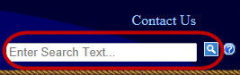

Any further questions may be answered by using the “Help” option:
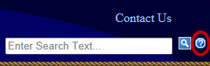

If you still have questions, click on the hyperlinked “Contact Us” text:
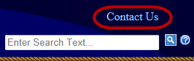

1.0 Audience
This section of the VBA Learning Catalog allows users to find a training topic for a certain audience.
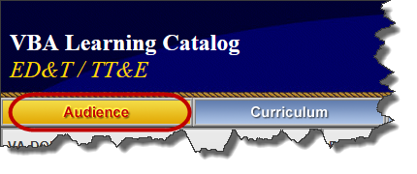
To view the applicable training topics:
- Hover over the “Audience” button from the top of the home screen.
- Determine for which Service you want to view the available training (e.g., Compensation).
NOTE: clicking on the Service name will show you all training options.
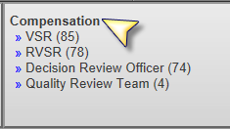
- Click on the applicable audience (e.g., RVSR).
- Within the filtered screen, you can further filter your options using the left-hand menu.
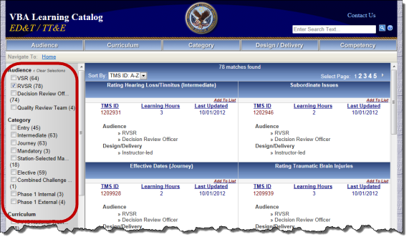

Clicking on the TMS ID allows you to view all the instructional materials for that topic:
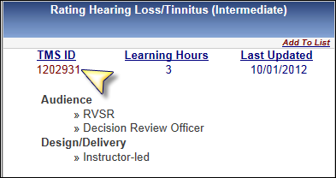

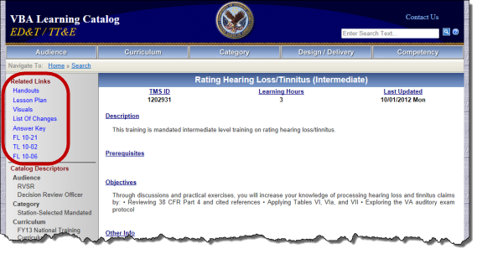

Clicking on “Add to List” allows you to view all the instructional materials for that topic:
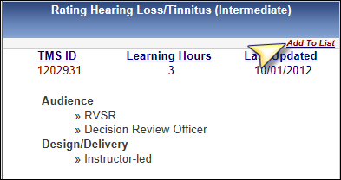

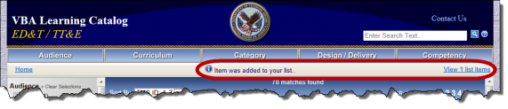

When you view your list items, you can see your current catalog of list items. From this page, you can remove items and view or print them in either Adobe PDF or Microsoft Excel form.
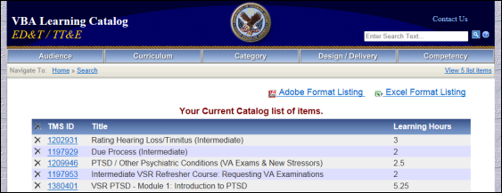

2.0 Curriculum
This section of the VBA Learning Catalog allows users to find a training topic for a certain curriculum.
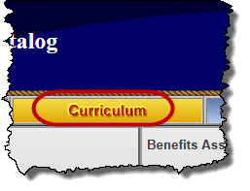
To view the applicable training topics:
- Hover over the “Curriculum” button from the top of the home screen.
- Determine for which Service you want to view the available training (e.g., Compensation).
NOTE: clicking on the Service name will show you all training options.
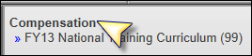
- Click on the applicable curriculum (e.g., FY13 National Training Curriculum).
- Within the filtered screen, you can further filter your options using the left-hand menu.
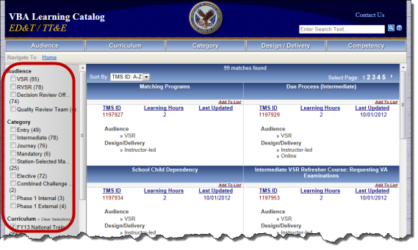

Clicking on the TMS ID allows you to view all the instructional materials for that topic:

Clicking on “Add to List” allows you to view all the instructional materials for that topic:

When you view your list items, you can see your current catalog of list items. From this page, you can remove items and view or print them in either Adobe PDF or Microsoft Excel form.

3.0 Category
This section of the VBA Learning Catalog allows users to find a training topic for a certain category.
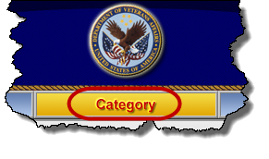
To view the applicable training topics:
- Hover over the “Category” button from the top of the home screen.
- Determine for which Service you want to view the available training (e.g., Compensation).
NOTE: clicking on the Service name will show you all training options; a scroll option will appear to the right when you can view more categories.
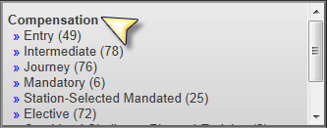
- Click on the applicable category (e.g., Entry).
- Within the filtered screen, you can further filter your options using the left-hand menu.
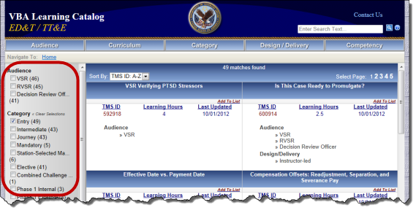

Clicking on the TMS ID allows you to view all the instructional materials for that topic:

Clicking on “Add to List” allows you to view all the instructional materials for that topic:

When you view your list items, you can see your current catalog of list items. From this page, you can remove items and view or print them in either Adobe PDF or Microsoft Excel form.

4.0 Design/Delivery
This section of the VBA Learning Catalog allows users to find a training topic for a certain design/delivery option.
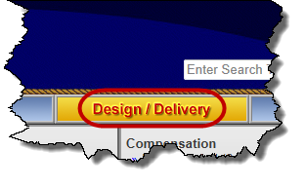
To view the applicable training topics:
- Hover over the “Design/Delivery” button from the top of the home screen.
- Determine for which Service you want to view the available training (e.g., Compensation).
NOTE: clicking on the Service name will show you all training options.
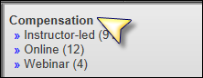
- Click on the applicable category (e.g., Webinar).
- Within the filtered screen, you can further filter your options using the left-hand menu.
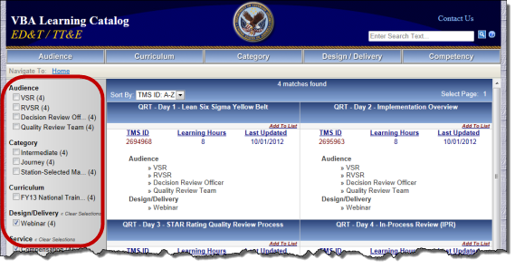

Clicking on the TMS ID allows you to view all the instructional materials for that topic:

Clicking on “Add to List” allows you to view all the instructional materials for that topic:

When you view your list items, you can see your current catalog of list items. From this page, you can remove items and view or print them in either Adobe PDF or Microsoft Excel form.

5.0 Competency
This section is not yet populated with content, but it’s coming soon!

This section of the VBA Learning Catalog will allow users to find a training topic for a certain competency.
