

**Table of Contents**

**Page**

Table of Contents 1

Preface 2

When to take Action 3

Types of Action 4

Types of Emergencies and Responses 7

Overview of the Evacuation Team Mission 14

Position Descriptions 16

Building Information Sheet 20

Occupant Information Sheet 21

Evacuation Information 22

Notification List for Fire Drill 23

Emergency Telephone Numbers24

Command Center Team 25

Emergency Evacuation Routes/Building Assembly Area 26

Floor Plans 27

Floor Monitors 31

Bomb Threat Checklist 35

Evacuation/Bomb Threat Search Chart 36

Attachment 2, FPMR, Part 101.20.003-101-20.103-5 37

**Preface**

The best way to protect against the potentially harmful effects of both manmade incidents and natural disasters is to ensure that all building occupants know how to respond in an emergency. This level of protection involves pre-planning, training, and rehearsal.

Pre-planning includes establishing the Occupant Emergency Plan (OEP) and developing a team comprised of employees designated to undertake certain responsibilities to ensure that personnel are moved quickly to safety, that damage to property is minimized, and that proper authorities are notified in the event of a localized emergency, as outlined in this OEP. Training is conducted to ensure that all tenants understand the contents of the OEP and their individual responsibilities. Rehearsals, or drills, provide an opportunity to practice emergency procedures to ensure efficient response in the event of a real emergency.

Participation in OEP activities includes all tenants regardless of employment status (e.g., managers, supervisors, OEP team members, volunteers, contractors, and hosts of visitors). Each individual must assume the responsibility for his or her own planning and safety in an emergency, as well as for working effectively with emergency planning officials.

The purpose of this OEP is to give all personnel at ***1800 G Street NW*** the best information to survive a disaster. In addition to providing insight into standard safety procedures, this document is intended to impress upon each employee the seriousness of the potential problems and to emphasize the responsibilities they have in an emergency situation.

**Scope**

This handbook describes the OEP for the building; and the intent is to provide the occupants of the building with information to identify potential threats and locate the authorities on site to provide threat management. This OEP applies to all employees, support contractors, and visitors occupying 1800 G Street NW and assumes a localized emergency in which the facility is impacted in part or in whole.

**Effective Date**

The effective date of this OEP is 03 August 2022. This OEP will be reviewed and updated on an annual basis.

**When to Take action**

Each employee should maintain situational awareness so he or she can respond to an emergency in a practical manner and in accordance with the OEP.

The decision to activate the Emergency Evacuation Team shall be made by the Designated Official or the designated official alternate, this decision shall be based upon the best available information, including an understanding of local tensions, the sensitivity of the target agencies, and previous experience with similar situations. Advice shall be solicited, when possible, from the GSA/building manager, the appropriate Federal Protective Service, Federal, and local fire and law enforcement agencies.

When there is advance warning of a situation, such as notification of disruption to utility services, the Designated Official shall initiate appropriate action in accordance with the OEP. After normal duty hours, the Federal Official closest to the problem shall represent the Designated Official or his or her alternates and shall act in accordance with the OEP.

When there is immediate danger, occupants may be evacuated or relocated in accordance with the OEP. This may be accomplished by sounding the fire alarm system or by other appropriate means. Some situations are best managed by evacuating part(s) of the building. In those cases, the fire alarm will sound on the floors in imminent danger to evacuate in a phased manner. The floor immediately affected the floor immediately above and immediately below will be evacuated first followed by any other floors in danger.

During an emergency, personnel are responsible for themselves first. No one can help another if they become a victim themselves. Floor Monitors are responsible for all of the on-duty personnel in their area when an emergency occurs. Their responsibility extends to making sure all personnel in their area are aware of an emergency situation occurring, and what the appropriate response is. Supervisors are responsible for knowing the capabilities and limitations of their employees and provide self-identified disabled personnel with appropriate assistance in accordance with the OEP.

Sometimes evacuation is not an appropriate or prudent response to a particular situation. In the event of an emergency of this sort, such as the outside release of a hazardous material or protests that escalate to a dangerous level, leaving the building might expose employees to more danger than staying in the building. In such cases, shelter in place programs will be put into effect

**Types of Action: Building Evacuation**

**MAIN ENTRANCE**. During evacuation, all occupants exiting through the building’s main lobby shall proceed to either 18th or 19th Street, then go south on either 18th or 19th Street to Rawlins Park at E Street, NW. Occupants will remain at least 300 feet away from the building until an ALL CLEAR signal is given by the Sidewalk Monitors.

**Emergency Evacuation Routes**

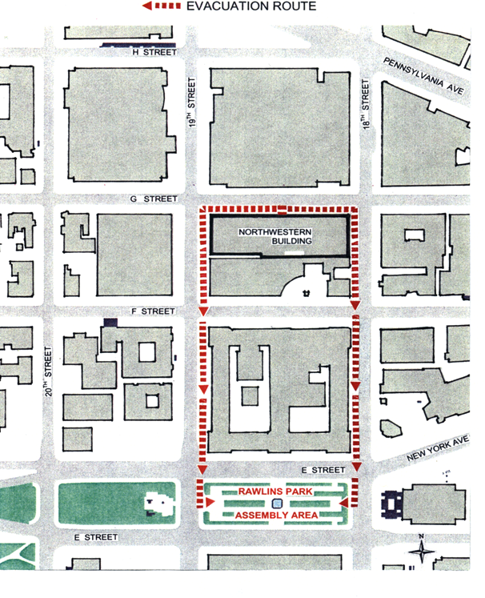

|  |  |  |
| --- | --- | --- |
| **Designated Assembly Area Locations** | | |
| **1800 G Street Exits** | **Assembly Area** | **Distance** |
| Main Exit | Rawlings Park | *NOTE: Remain at least 300 ft. away from the building.* |

**Shelter-in-Place (SIP)**: Some emergency situations may make going outdoors dangerous. In some emergencies, evacuating immediately may not be the best course of action. Many emergences such as severe weather, earthquakes, threats of violence, active shooter, bomb threat and suspicious package, may require the opposite of an evacuation; to remain inside and attempt to avoid possible exposure to dangerous conditions outside. Leaving the area might take too long or put occupants in harm’s way. In such a case, it may be safer for occupants to stay indoors than to go outside and evacuate. Shelter-in-Place (SIP) is a protective action taken inside the building, with doors and windows closed, to minimize occupants’ chance of injury and staying at your workspace (as in the case of an active shooter) or going to a designated safe area (as in the case of a tornado or severe weather). SIP is a voluntary action for civilians, unless mandated by law enforcement or public health officials.

The Designated Official may decide to implement SIP if it is determined that it is safer to remain inside the facility because of:

* Severe weather (tornados, thunderstorms, hail, etc.)
* Earthquake
* Threats of Violence
* Active Shooter (Gunman or Sniper)
* Bomb threat
* Suspicious package/object

Releasing a large number of employees onto the roads and public transportation will only add to the confusion and panic. Exposure to some hazard or harm is likely, and releasing occupants will spread the hazard to others, including family members. Depending on the type of emergency, close all fresh air intakes to the building. Wait for an ALL-CLEAR announcement before returning to work areas.

**Types of emergencies and responses**

**General**

Most emergencies can be handled routinely. The Designated Official, or his or her designated alternate will identify and emergency and the proper course of action to be taken. Employees must be familiar with procedures and are responsible for following them. Familiarity comes from practice.

Organizations responsible for each type of emergency must be identified and notified by the Designated Official. Telephone numbers for the proper officials are listed on page **24** of this OEP. Members of the Evacuation Team must be familiar with the capabilities, limitations, and response times of each emergency service.

Some typical emergencies that could occur are described in this plan along with their responses. All possibilities that could justify an emergency response cannot be covered. While general categories are addressed, each situation must be dealt with at the time of the occurrence, taking into consideration the specific circumstances surrounding the event, in addition to the degree of threat and the number of employees in jeopardy. Pages **7** to **12** will cover:

* Severe weather (tornados, thunderstorms, hail, etc.)
* Earthquake
* Threats and Violence
* Active Shooter (Gunman or Sniper)
* Bomb threat
* Suspicious Package/Object

This is by no means an all-inclusive list of potential emergencies but should provide an informative baseline for the Designated Official and their team to decide on an appropriate course of action.

**Severe weather**

During severe weather, occupants should be alert to possible hazardous conditions. Suggested actions to take during severe weather include:

**severe weather**

* Stay inside and away from windows
* Go to your designated safe area (SIP Area)
* Do not use your computer
* Do not go outside until you get an All-Clear signal
* Follow the directions of the occupant emergency coordinator and Emergency team

**Earthquake**

**If you are inside, stay inside.** DO NOT run outside or to other rooms during shaking.

In MOST situations, you will reduce your chance of injury from falling objects and even building collapse if you immediately:

* DROP to the ground; take COVER by getting under a sturdy table or other piece of furniture; and HOLD ON until the shaking stops. If there isn’t a table or desk near you, cover your face and head with your arms and crouch in an inside corner of the building.
* Stay away from glass, windows, outside doors and walls, and anything that could fall, such as lighting fixtures or furniture.
* Stay inside until the shaking stops and it is safe to go outside. Listen for further instructions over the Public Address System.
* DO NOT use the elevators.
* Be aware that the electricity may go out or the sprinkler systems or fire alarms may turn on.

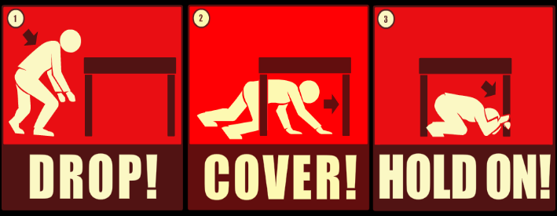

DO NOT stand in a doorway. You are safer under a table. In modern houses, doorways are no stronger than any other part of the house. The doorway does not protect you from the most likely source of injury−falling or flying objects. Most earthquake-related injuries and deaths are caused by falling or flying objects (e.g., TVs, lamps, glass, bookcases), or by being knocked to the ground.

**Threats and Violence**

Not threatening, but angry or hostile customer/co-worker:

* Stay calm. Listen attentively.
* Maintain eye contact.
* Be courteous. Be patient.
* Attempt to avoid escalating the situation.

Threatening person shouting or swearing:

* Signal a coworker or supervisor that you need help.
* Do not make any calls yourself.
* Have someone call 911 if danger is imminent, local security or the VAIOC at (202) 461-5510

Threatening with a gun, knife or other weapon:

* Stay calm. Quietly signal for help.
* Maintain eye contact. Stall for time.
* Keep talking but follow instructions from the person who has the weapon.
* Never try to grab a weapon.
* Watch for a chance to escape to a safe area.

**Active Shooter (Gunman or Sniper)**

**HOW TO RESPOND WHEN AN ACTIVE SHOOTER IS IN YOUR VICINITY**

**Evacuate**

* If there is an accessible escape path, attempt to evacuate the premises. Be sure to;
* Have an escape route and plan in mind
* Evacuate regardless of whether others agree to follow
* Leave your belongings behind
* Help others escape, if possible (Special Needs Occupants)
* Prevent individuals from entering an area where the active shooter may be
* Keep your hands visible
* Follow the instructions of any police officers
* Do not attempt to move wounded people
* Call 911 when you are safe

**Hide Out (Seek Shelter)**

* If evacuation is not possible, find a place to hide where the active shooter is less likely to find you:
* By hiding in an area out of the shooter’s view
* By staying at staying at your current location and taking cover (i.e. by crawling under a cubicle and placing the chair in front of you)
* By entering an adjacent office
* By hiding in a closet
* Lock the doors and blockade the door with heavy furniture to prevent entry to your hiding place
* Silence your cell phone and/or pager

Turn off any source of noise (i.e., radios, televisions)

**Take Action against the active shooter**

* As a last resort and only when your life is in imminent danger, attempt to disrupt and/or incapacitate the active shooter by;
* Acting as aggressively as possible against him/her
* Throwing items and improvising weapons
* Yelling
* Committing to your actions



**Bomb Threat**

The following are suggested actions to take when a bomb threat is received:

**If you receive a threat by telephone:**

* Stay calm and courteous
* Keep the caller on the phone – DO NOT HANG UP when he/she does.
* Ask where the bomb is, when it will explode, what it looks like.
* Listen for background noises.
* Listen for speech patterns, accents, etc.
* If the danger is imminent, call 911
* Call local security
* Call VAIOC: (202) 461-5510

**If a threat is received by handwritten note or through the mail:**

* Call 911.
* Handle note as minimally as possible.

**If a threat is received by email:**

* Call 911.
* Do not delete the message.

The DO will evaluate the threat and determine if evacuation of the facility is prudent. Occupants may be asked to search their work areas to identify any suspicious packages. In either case, occupants must follow direction provided by emergency response personnel.

**Suspicious Package and Hazardous Materials**

Suspicious Package

* Suspicious Packages and Envelopes May Have
* Unusual labeling or excessive postage
* Postmark that does not match the return address
* Marked with threatening language
* Appears strange
* DO NOT TOUCH or OPEN THE PACKAGE OR MATERIAL!
* Call 911
* Call local security
* Call VAIOC at: (202) 461-5510.
* Keep people away from the immediate area.
* If evacuation is required, follow steps for Fire/Evacuation.



**Chemical, Biological, or Radiological Contaminants (hazmat)**

Chemical, Biological, or Radiological Contaminants

* Stay Inside
* Follow instructions given over the Public Address System or from emergency personnel on where to Shelter-in-Place.
* If possible, move to an interior room above ground floor with fewest windows and vents.
* Close and lock all windows exterior doors, and any opening to the outside.
* Use duct tape and plastic sheeting to seal all cracks around the door(s) and any vents into the room.
* Write down the names of everyone in the room and call your designated official/occupant emergency coordinator to report who is in the room with you, and their affiliation with your organization.
* Stay Calm and await further instructions from emergency personnel.

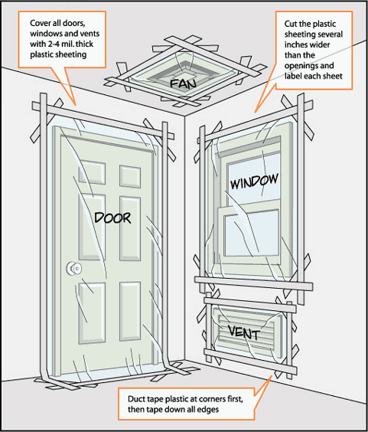

**Overview of the Evacuation Team Mission**

The mission of the evacuation or floor team is to encourage and assist persons to quickly and safely leave the building during an emergency. You are to see that any individual who cannot quickly evacuate by the stairs is taken to an area on that floor that is considered a safe designated area. For example, this could be an individual with heart trouble, pregnant, arthritis, broken leg, or does not have the stamina to negotiate the stairs.

A designated area for persons requiring assistance” (as labeled by a red colored sign) will be a room or area near a room that has as many of the following qualities as possible; solid door; an outside window to admit air if necessary; is located on the side of the building where a ladder may be able to reach the window and is near both the elevators and stairs. Those requiring assistance should be escorted to the room by a Monitor for the Special needs. The Monitor for the Special needs will remain with these persons until the rescue personnel arrive.

The entire physical area on your floor must be checked to verify that everyone has been alerted by the alarm. Persons located in some inner offices may not always hear the alarm and monitors must be aware that some employees are hearing impaired.

The Floor Monitor who is in charge of the floor's evacuation should be the last person to leave and he or she must report the following information to the Occupant Emergency Coordinator with the Command Center Team located in the building’s main lobby:

* The floor level number that you are responsible for:
* Your name:
* The floor is all clear when appropriate or (may describe the situation):
* The number of persons requiring assistance and their locations:

**PROCEDURE TO FOLLOW WHEN BOTH THE FLOOR MONITOR AND ALTERNATE ARE ABSENT DURING AN EMERGENCY**

**Be aware,** the Floor Monitor or Alternate Floor Monitor **may not** be present on their floor when the building alarm sounds, or strobe lights begin flashing. In such case the designated Floor Monitor or Alternate will not be available to perform the important task of reporting the final status of their floor to the Command Center. It will then be necessary for another monitor to perform this duty.

***Example:*** *During an evacuation, the Area Monitor travels to notify the Floor Monitor that their assigned floor area is completely clear. However, the Area Monitor discovers the Floor Monitor is absent or not at their designated post. The Area Monitor should then act in place of the Floor Monitor to ensure that someone will be available to report the floor status to the Command Center.*

***WHEN YOU HEAR THE BUILDING FIRE ALARM OR SEE THE STROBE LIGHT ALARMS FLASHING, YOU SHOULD:***

* **Always assume it is the real thing and not a false alarm!**
* Gather your wallet/purse, identification badge for re-entry, and coat if the weather is inclement. If you are visiting a lower floor than your work area when the alarm to evacuate is given, do not go back up to get your personal things.
* Close all office doors but lock only those leading to a secure area (emergency personnel may have to re-enter offices that open onto common hallways).
* Walk quickly and calmly to the nearest marked exit and ask others to do the same. Exit in an orderly manner. Know at least two ways out because some emergencies may prevent use of the stairwells normally used. (If smoke is present wet a cloth with water and breathe through it.)
* Leave by the **nearest stairwell** (**DO NOT** use elevators unless instructed to do so by emergency personnel).
* Special needs occupants or those who could slow the evacuation should identify themselves to the evacuation team. They should be placed in the nearest “Designated Room for Persons Requiring Assistance in Emergency Evacuation.” Designated rooms are located on each floor and are identified by a posted **Red Colored Sign**. Designated monitors will assist and remain with occupants requiring assistance. The floor monitor will notify the command center and help will be dispatched to the designated room to assist in removing any special needs occupant from the designated area of refuge to the elevator, down, and out of the building.
* Exit the building and move directly to your assembly area. Use caution when walking into the street because oncoming traffic may be unaware that the building is being evacuated.
* Once at the assembly area, report to your supervisor or site leader, remain quiet, and stay with your group.
* If you become trapped, call the fire department and police emergency number 911 or local security.

**Position Descriptions**

## DESIGNATED OFFICIAL:

* The Designated Official is the highest-ranking government official in a facility or may be another person agreed on by all tenant agencies. In the absence of a Designated Official, an alternate may be selected to carry out responsibilities.
* Authority to evacuate the building and grounds or any part thereof.
* Authority to order reentry of the building.
* Ensures that the emergency plan is developed, and occupants are prepared in the event of emergencies.
* Ensures all personnel are properly trained to perform their assigned tasks during an emergency.
* Ensure that public is informed as needed, and that proper authorization and review is conducted of all press releases concerning the emergency.
* Identifies potential hazardous or unsafe situations related to the incident.
* Exercises emergency authority to stop and prevent unsafe acts.
* Ensures appropriate Federal, State and Local agencies (IOC) are notified.
* Serves as the liaison with the outside responding agencies (i.e., Fire Department, Police, Federal Protective Services, etc.)

**OCCUPANT EMERGENCY COORDINATOR**:

* Assists Designated Official.
* Acts for Designated Official during absences.
* Performs delegated duties of the designated official.
* Serves as liaison between Designated Official and other members of the Command Center Team.

**FLOOR TEAMS**: Occupant Emergency Plans are, for the most part, carried out by Floor Teams assigned to each floor of a facility. Floor Team consist of a Floor Monitor, Area Monitors (one for each major area of the floor), Stairwell Monitors, and Monitors for the special needs occupants. There are Exit Monitors (for street- and ground level floors). Duties of the Floor Team members are outlined in the following paragraphs.

**FLOOR MONITOR**:

* Maintain communication with the Command Center (Occupant Emergency Coordinator) during an emergency; provide progress reports on floor evacuation. After occupants have cleared the floor, except for special needs occupants, the Floor Monitor must notify the command center located in the first-floor lobby. Notify the Occupant Emergency Coordinator, at the command center, that the floor has been cleared, the number of special needs persons that could not be evacuated, and the room area where they are located. The Floor Monitor will then exit the building.

***Note:*** *The Floor Monitor must physically report to the Command Center when radio communication is not possible.*

* **Schedule a meeting with your entire floor evacuation team.**
* Review the "Mission of the Evacuation Team."
* Designate exact boundaries of floor areas and assign responsibilities for these areas.
* Make necessary changes in floor organization with the approval of the Floor Team and Occupant Emergency Coordinators.
* Ensure that evacuation routes are clearly identified, posted and are known to occupants.
* Direct orderly flow of persons during fire drills and emergencies along prescribed routes, including orderly exit from the building at the first or ground floor.
* Ensure that all persons have vacated the floor.
* Assist with crowd control on the outside as requested.
* Floor Monitors and/or Elevator Monitors are instructed that in the event of a power outage or other situation which may interrupt elevator service they should check the elevators on their floor for trapped passengers. The monitor should advise trapped passengers to remain in the car away from the doors and to wait for assistance. The appropriate elevator mechanics or rescue personnel should then be notified through the Command Center.

**AREA MONITORS**:

* Work with Floor Monitor; notify Floor Monitor when area has been completely cleared.
* Direct orderly flow of persons during drills and emergencies, along the prescribed evacuation routes.
* Ensure that area is completely vacated, when required.
* Maintain list of special needs occupants, provide revisions to the Floor Monitor. List should include name, telephone extension, room number, and type of disability.
* During fire evacuation, direct persons attempting to use elevator to appropriate stairway; relinquish control of elevator to firefighting personnel when they arrive.
* Floor monitors should be instructed that in the event of a power outage or other situation which may interrupt elevator service they should check the elevators on their floor for trapped passengers. The monitor should advise trapped passengers to remain in the car away from the doors and to wait for assistance. The appropriate elevator mechanics or rescue personnel should then be notified through the command center.

**STAIRWELL MONITORS**:

* Control movement of persons on stairways, keeping them in single file and moving steadily at a walking pace; instruct persons to grasp handrails and proceed with caution.
* Keep door open to stairway until the area is clear.
* Restrict and monitor use of stairwells and escalators as necessary.
* Special needs persons who cannot evacuate by the stairs should be directed to the designated area for special needs occupants.

**SPECIAL NEEDS OCCUPANT MONITORS**:

* Know the locations and telephone numbers of the special needs persons to be assisted, types of disability, and the locations of crutches, wheelchairs, and other support devices.
* Be familiar with the designated safe areas of refuge on the floor.
* Assist special needs occupants to the designated area for special needs occupants. Remain with the special needs persons and await help arrive

**ASSEMBLY POINT MONITORS (Senior Official/Supervisor/Appointee for Office or Business Line)**:

* Immediately take head count of each occupant to ensure that everyone is present and accounted for.
* Reports the final head count to the Designated Official or Occupant Emergency Coordinator.

**MEDICAL COORDINATOR**:

* Assists the Occupant Emergency Coordinator.
* Identifies available medical emergency services.
* Maintains first aid equipment.

**TECHNICAL ADVISORS**:

* Building Engineers (Building Management). Works with the Occupant Emergency Coordinator or Command Center Team and provides information about the building and the operation of its mechanical systems.
* Physical Security Specialist. Works with the Occupant Emergency Coordinator or Command Center Team and provides advice on security and law enforcement matters and serves as liaison with Federal and local law enforcement agencies.

**Building Information Sheet**

|  |  |
| --- | --- |
| **Name** | **Description** |
| Building Name | Northwestern Building |
| Building Address | 1800 G ST, NW Washington DC, 20006 |
| Automatic Sprinkler System | Sprinklers completely installed in building |
| Elevator Capture and Recall System | Elevators will recall to the first-floor lobby by the smoke detection system, with the second-floor lobby as alternate stop.  **NOTE:** All elevators will be powered by the emergency generator when electrical power is interrupted to the building. |
| Smoke Detection System | Smoke detectors are located in elevator lobbies and at each return transfer to mechanical rooms. |

**Occupant Information Sheet**

|  |  |
| --- | --- |
| **Name** | **Description** |
| Primary Occupant Agency | Veterans Benefits Administration Central Office |

|  |  |  |  |  |
| --- | --- | --- | --- | --- |
| **Floor** | **Occupant** | **POC** | **Phone Number** | **Type of Occupancy** |
| Lower  Level | Colonial Parking | Allen Ellison | |  | | --- | | (202) 763-8895  aellison@ecolonial.com | | Parking Garage |
| 1 | Guard Desk |  | (202) 408-9774 |  |
| 4 | Veterans Benefits Administration | Charles Williams | (202) 461-7681 | Office |
| 5 | Veterans Benefits Administration | Charles Williams | (202) 461-7681 | Office |
| 6 | Veterans Benefits Administration | Charles Williams | (202) 461-7681 | Office |
| 8 | Veterans Benefits Administration | Charles Williams | (202) 461-7681 | Office |

**Evacuation Information**

|  |  |  |
| --- | --- | --- |
| **Issue** | **Point of Contact** |  |
| **Persons Authorized to Order Evacuation** | **Designated Official:**    **Occupant Emergency Coordinator:** Charles Williams  **FPS Official:**  **FPS Main Number:** Call to notify for fire drills    **Property Manager:** Donna Platt  **Mega Center**  (US Homeland Security Response Center) | O:  BB:  O: (202) 461-7681  BB: (202) 848-2954  O: (202) 359-8482  O: 1-877-437-7411  O: 202-842-0836  1-877-437-7411 |
| **Evacuation Signals** | **Fire:** Pull fire alarm box lever to activate fire alarm.  The sound of the fire alarm and flashing strobe lights are the signal for building occupants to evacuate. The public address (PA) system will relay an evacuation message verbally or be used to provide specific instructions/information according to the nature of the event.  **Explosion, Gas Leak or Suspicious Object:** Occupant Emergency Coordinator dispatches personnel to the area to assist in informing occupants of danger and instructing them to evacuate.  ***Note:*** *The public address system may be used to instruct building occupants.* | |
| **Alternate Site** | As directed | |
| **Building**  **Re-entry** | A member of the fire department will inform the Command Center Team when it is safe for evacuees to re-enter the building. In turn the Occupant Emergency Coordinator will radio Floor Monitors, at the assembly area, to announce an ALL CLEAR then the evacuees will return. | |

**Notification List for Fire Drills**

**The following Department officials should be notified when the date and time for a fire drill has been established:**

* Service Property Manager:
* Federal Protective Service:
* DC Police:
* Security Guard Office:
* Fire Department Official:
* Health Unit:
* VAIOC:

**Emergency Telephone Numbers**

|  |  |  |  |
| --- | --- | --- | --- |
| **Service** | **Provider** | **Contact Number** | **Contact Number**  **(After Hours)** |
| Building Manger/Emergency Coordinator | Donna Platt | (202) 842-0836 Office  dplatt@blakereal.com | 202438-0517 Cell |
| Asst Building Manager/Emergency Coordinator | Melanie Shanks | (202) 842-3732 Office  mshanks@blakereal.com | (202) 438-0434  Cell |
| Integrated Operations Center |  | (202) 461-5510 | (202) 461-5510 |
| Physical Security (OSLE) |  | (202) 461-0262 |  |
| Facilities Management | Gabriel Berhane | (202) 461-9585 |  |
| Security Guard Service | Site Supervisor | (202) 408-9774 Lobby Desk  (240) 477-2210 Cell  swhitfield@goldsvcs.com | 24/7 |
| Fire Department Emergency |  | **911** |  |
| Fire Department  Non - Emergency |  | |  | | --- | | (202) 673-3201 | |  |
| Federal Police/Homeland Security | Inspector  Gorge Montilla | (202) 245-2636 Office  (202) 430-1295 Cell |  |
| DC Police Department  Emergency | |  | | --- | |  | | **911** |  |
| DC Police Department  Non - Emergency |  | (202) 727-9099 |  |
| |  | | --- | | 2nd District Headquarters | | Station Desk  Watch Commander | (202) 715-7300  (202) 438-4421 |  |

**Command Center Team**

|  |  |  |
| --- | --- | --- |
| **Titles** | **Team Members** | **Phone Number** |
| **Primary** Command Center | At building exterior in front of the Fire Control Room, 1800 G Street, NW | (202) 223-2574 |
| **Alternate** Command Center | At building exterior, rear of World Bank Building near the corner of 18th and G Streets, NW | (202) 223-2574 |
| Designated Official | Ervin Pearson | O: (202) 461-9900  C: (267) 207-1973 |
| Alternate Designated Official | Allen Pinckney | O: (202) 461-9969  C: (202) 441-6394 |
| Occupant Emergency Coordinator | Charles Williams | O: (202) 461-7681  C: (202) 848-2954 |
| Alternate Occupant Emergency Coordinator | Shatara McNeil | O: (202) 461-8301  C: (202) 802-8605 |
| Medical Coordinator | Sonia Daramola | (202) 461-9110 |
| Damage Control Team | Donna Platt, Building Manager  Sean Sample, Chief Engineer | O: (202) 842-0836  O: (202) 842-0327 |

**Emergency Evacuation Routes**

**MAIN ENTRANCE**.



|  |  |  |
| --- | --- | --- |
| **Designated Assembly Area Locations** | | |
| **Rawlins Park** | **Assembly Area** | **Distance** |
| Main Exit | ***Location*** | *NOTE: Remain at least 300 ft. away from the building.* |

**4th Floor Plan**

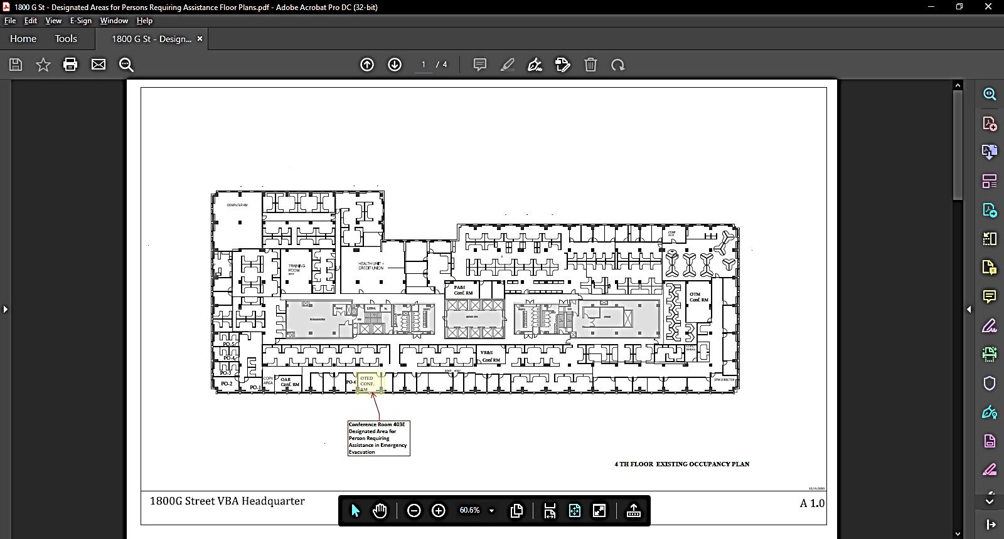

**5th Floor Plan**

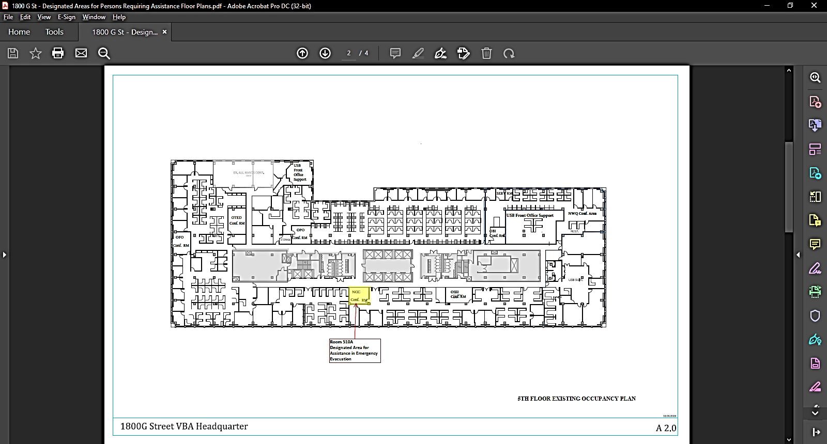

**6th Floor Plan**

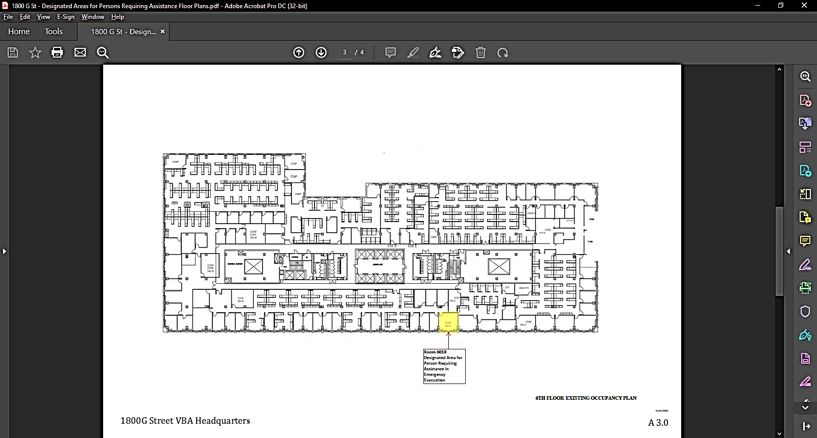

**8th Floor Plan**

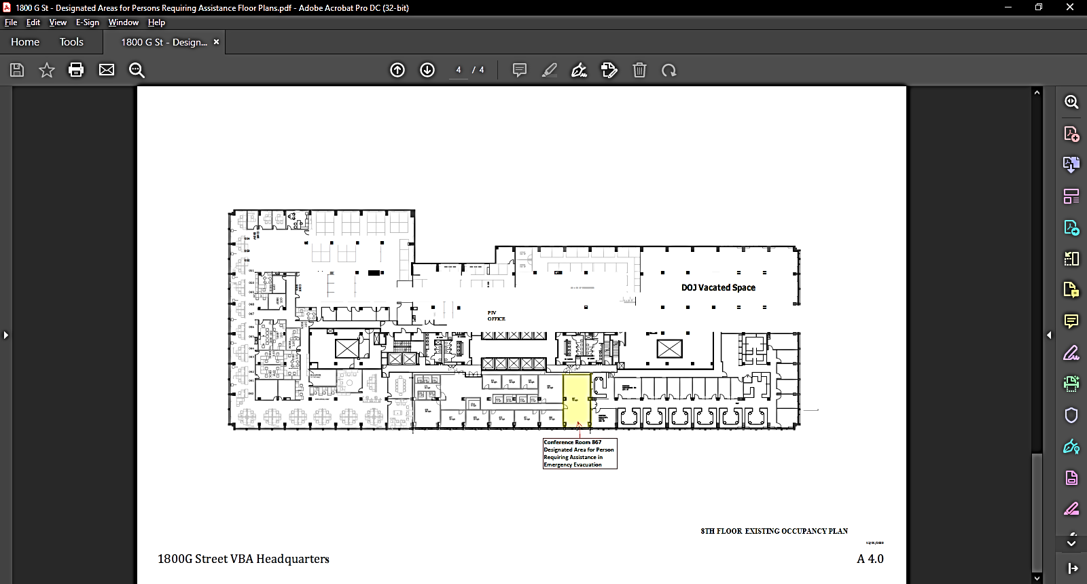

**4th Floor Monitors**

|  |  |  |  |  |
| --- | --- | --- | --- | --- |
| **Title** | **Name** | **Office Symbol** | **Phone**  **Number** | **Room Number** |
| Floor Monitor  **(Monday)** | PRI: Rachel Jones  ALT: John Shiver | OAR |  |  |
| Floor Monitor  **(Tuesday)** | PRI: Paul Leners  ALT: Jose Vidrio | OAR |  |  |
| Floor Monitor  **(Wednesday)** | PRI: Ryan Attaway  ALT: Raymond Bryan | OAR |  |  |
| Floor Monitor  **(Thursday)** | PRI: Garrison Pietrowiak  ALT: Eugene Scott | OAR |  |  |
| Floor Monitor  **(Friday)** | PRI: Shirish Pathak  ALT: Robertha Owens-Allen | PA&I |  |  |
| Area Monitor NW/SW  **(Monday)** | PRI: Allison Blaisdell  ALT: Nimfa Wilkerson | PA&I  VR&E |  |  |
| Area Monitor NE/SE  **(Monday)** | PRI: Rachel Dickinson  ALT | PA&I |  |  |
| Area Monitor NW/SW  **(Tuesday)** | PRI: David Zweifel - Keegan  ALT: | PA&I |  |  |
| Area Monitor NE/SE  **(Tuesday)** | PRI: Peter Granato  ALT: | VR&E |  |  |
| Area Monitor NW/SW  **(Wednesday)** | PRI: Sindhu Vallikat  ALT: Jonathan King | PA&I  VR&E |  |  |
| Area Monitor NE/SE  **(Wednesday)** | PRI: Larysa Rybak  ALT: | PA&I |  |  |
| Area Monitor NW/SW  **(Thursday)** | PRI: Praveen Kamath  ALT: Lee Seawright | PA&I  VR&E |  |  |
| Area Monitor NE/SE  **(Thursday)** | PRI: Yvette Debebe  ALT: | PA&I |  |  |
| Stairwell Monitors 1 | PRI: Frank Bryceland  ALT: Naiya Marshall | OTED  OTED |  |  |
| Stairwell Monitors 2 | PRI: Ferdinand Torres-Leon Jr  ALT: | OTED |  |  |
| Special Needs Monitor | PRI: Patrick Musaro  ALT: | OIT |  |  |
| **Designated Area for Persons Requiring**  **Assistance** |  |  |  | **CONF RM**  **403E** |

**5th Floor Monitors**

|  |  |  |  |  |
| --- | --- | --- | --- | --- |
| **Title** | **Name** | **Office Symbol** | **Phone**  **Number** | **Room Number** |
| Floor Monitor  **(Monday)** | PRI: Stephen Branham  ALT: | OPO |  |  |
| Floor Monitor  **(Tuesday)** | PRI: Stephen Branham  ALT: | OPO |  |  |
| Floor Monitor  **(Wednesday)** | PRI: Stephen Branham  ALT: | OPO |  |  |
| Floor Monitor  **(Thursday)** | PRI: Stephen Branham  ALT: | OPO |  |  |
| Floor Monitor  **(Friday)** | PRI:  ALT: |  |  |  |
| Area Monitor NW/SW  **(Monday)** | PRI:  ALT: |  |  |  |
| Area Monitor NE/SE  **(Monday)** | PRI:  ALT |  |  |  |
| Area Monitor NW/SW  **(Tuesday)** | PRI: Dan Nyugen  ALT: | OFO |  |  |
| Area Monitor NE/SE  **(Tuesday)** | PRI:  ALT: |  |  |  |
| Area Monitor NW/SW  **(Wednesday)** | PRI: Milton Sarriagarcia  ALT: | OFO |  |  |
| Area Monitor NE/SE  **(Wednesday)** | PRI:  ALT: |  |  |  |
| Area Monitor NW/SW  **(Thursday)** | PRI: Dauda Sannoh  ALT: | OFO |  |  |
| Area Monitor NE/SE  **(Thursday)** | PRI:  ALT: |  |  |  |
| Stairwell Monitors 1 | PRI:  ALT: |  |  |  |
| Stairwell Monitors 2 | PRI:  ALT: |  |  |  |
| Special Needs Monitor | PRI:  ALT: |  |  |  |
| **Designated Area for Persons Requiring**  **Assistance** |  |  |  | **CONF RM**  **510A** |

**6th Floor Monitors**

|  |  |  |  |  |
| --- | --- | --- | --- | --- |
| **Title** | **Name** | **Office Symbol** | **Phone**  **Number** | **Room Number** |
| Floor Monitor  **(Monday)** | PRI: Kristina Messenger  ALT: | CS |  |  |
| Floor Monitor  **(Tuesday)** | PRI: Laurine Carson  ALT: | CS |  |  |
| Floor Monitor  **(Wednesday)** | PRI: Erika Jasen  ALT: | CS |  |  |
| Floor Monitor  **(Thursday)** | PRI: Erika Jasen  ALT: | CS |  |  |
| Floor Monitor  **(Friday)** | PRI: Jocelyn Moses  ALT: | CS |  |  |
| Area Monitor  **(Monday)** | PRI: Kimberley Chisley  ALT: | CS |  |  |
| Area Monitor  **(Monday)** | PRI:  ALT | CS |  |  |
| Area Monitor **(Tuesday)** | PRI: Carla Riddick  ALT: | CS |  |  |
| Area Monitor  **(Tuesday)** | PRI:  ALT: | CS |  |  |
| Area Monitor  **(Wednesday)** | PRI: Carolyn McCollum  ALT: | CS |  |  |
| Area Monitor  **(Wednesday)** | PRI:  ALT: | CS |  |  |
| Area Monitor  **(Thursday)** | PRI: Carolyn McCollum  ALT: | CS |  |  |
| Area Monitor  **(Thursday)** | PRI:  ALT: | CS |  |  |
| Area Monitor  **(Friday)** | PRI: Jocelyn Moses  ALT: | CS |  |  |
| Area Monitor NE/SE  **(Friday)** | PRI:  ALT: |  |  |  |
| Stairwell Monitors 1 | PRI: Tommy Berry (Wed)  ALT: | EDU |  |  |
| Stairwell Monitors 2 | PRI: Ricardo Da Silva (Wed)  ALT: | EDU |  |  |
| Special Needs Monitor | PRI:  ALT: |  |  |  |
| **Designated Area for Persons Requiring**  **Assistance** |  |  |  | **Room**  **601R** |

**8th Floor Monitors**

|  |  |  |  |  |
| --- | --- | --- | --- | --- |
| **Title** | **Name** | **Office Symbol** | **Phone**  **Number** | **Room Number** |
| Floor Monitor  **(Monday)** | PRI: Derrick Cooley  ALT: | MDEO |  |  |
| Floor Monitor  **(Tuesday)** | PRI: Devin Andrews  ALT: Jose Vidrio | MDEO |  |  |
| Floor Monitor  **(Wednesday)** | PRI: Arashdeep Singh  ALT: Tim Hum | MDEO |  |  |
| Floor Monitor  **(Thursday)** | PRI: Brandon Williams  ALT: Jennifer Treger | MDEO |  |  |
| Floor Monitor  **(Friday)** | PRI: Allison Strickland  ALT: | MDEO |  |  |
| Area Monitor NW/SW  **(Monday)** | PRI: Charnae Richardson  ALT: Lawrence Leonard | LGY |  |  |
| Area Monitor NE/SE  **(Monday)** | PRI:  ALT |  |  |  |
| Area Monitor NW/SW  **(Tuesday)** | PRI: Wilma Spinney  ALT: Mark Connors | LGY |  |  |
| Area Monitor NE/SE  **(Tuesday)** | PRI:  ALT: |  |  |  |
| Area Monitor NW/SW  **(Wednesday)** | PRI: Alvin Young  ALT: Mark Connors | LGY |  |  |
| Area Monitor NE/SE  **(Wednesday)** | PRI:  ALT: |  |  |  |
| Area Monitor NW/SW  **(Thursday)** | PRI: Jason Latona  ALT: Alex Dickinson | LGY |  |  |
| Area Monitor NE/SE  **(Thursday)** | PRI:  ALT: |  |  |  |
| Stairwell Monitors 1 | PRI: Ken Becker (Wed/Thurs) | LGY |  |  |
| Stairwell Monitors 2 | PRI:  ALT: |  |  |  |
| Special Needs Monitor | PRI:  ALT: |  |  |  |
| **Designated Area for Persons Requiring**  **Assistance** |  |  |  | **CONF RM**  **867** |

|  |  |
| --- | --- |
| VASEAL  **BOMB THREAT CHECKLIST**  Quickly obtain as much information from the caller as you can as to where the device is located and at what time it will detonate. | |
| **EXACT WORDING OF THE THREAT**:  ___________________________________  ___________________________________  ___________________________________  ___________________________________  ___________________________________  Date:_______________ Time:________  Gender of Caller:______ Age:_________  Length of Call:_______________________  Phone Number Where Call is Received:  ___________________________________  **CALLER'S VOICE**:  ___ Calm ___ Nasal  ___ Angry ___ Stutter  ___ Excited ___ Lisp  ___ Slow ___ Raspy  ___ Rapid ___ Deep  ___ Soft ___ Ragged  ___ Loud ___ Clearing Throat  ___ Laughter ___ Deep Breathing  ___ Crying ___ Cracking Voice  ___ Normal ___ Disguised  ___ Distinct ___ Accent  ___ Slurred ___ Familiar  ___ Whispered  If voice is familiar, whom did it sound like:  _____________________________________ | **BACKGROUND SOUNDS**:  ___ Street Noises ___ Office Machinery  ___ Animal Noises ___ Factory Machinery  ___ Voices ___ Clear  ___ PA System ___ Static  ___ Music ___ Local  ___ House Noises ___ Long Distance  ___ Motor ___ Booth  ___ Other __________________________  **THREAT LANGUAGE**:  ___ Well Spoken (Educated)  ___ Foul  ___ Irrational  ___ Incoherent  ___ Taped  ___ Message read by Threat Maker  **REMARKS**: ________________________  ___________________________________  ___________________________________  ___________________________________.  DATE: _____/_____/_____  YOUR NAME: _______________________  POSITION: _________________________  PHONE NUMBER: ___________________  **NOTE: Upon completion of this form, please submit a copy to VA's Office of**  **Security and Law Enforcement (07).** |

**Evacuation/Bomb Threat Search Chart**

Building: 1800 G ST NW _

Date: ________________

|  |  |  |  |
| --- | --- | --- | --- |
| **Floor/Area** | **Time Evacuated** | **Searched** | **Remarks** |
|  |  |  |  |
|  |  |  |  |
|  |  |  |  |
|  |  |  |  |
|  |  |  |  |
|  |  |  |  |
|  |  |  |  |
|  |  |  |  |
|  |  |  |  |
|  |  |  |  |
|  |  |  |  |
|  |  |  |  |
|  |  |  |  |
|  |  |  |  |
|  |  |  |  |
|  |  |  |  |
|  |  |  |  |

**Management Regulations**

**Part 101-20: Management of Buildings and Grounds**

**(Only relevant parts are included)**

101.20.003 Definitions

(g) The “Designated Official” is the highest-ranking official of the primary occupant agency of a Federal facility; or, alternatively, a designee selected by mutual agreement of occupant agency officials.

(i) The term “emergency” includes bombings and bomb threats, civil disturbances, fires, explosions, electrical failures, loss of water pressure, chemical and gas leaks, medical emergencies, hurricanes, tornadoes, floods, and earthquakes. The term does not apply to civil defense matters such as potential or actual enemy attacks. Note: Civil defense emergencies are addressed by the Federal Emergency Management Agency.

(v) “Occupant Emergency Organization” means the emergency response organization comprised of employees of Federal agencies designated to perform the requirements established by the Occupant Emergency Plan.

(w) “Occupant Emergency Plan” means procedures developed to protect life and property in a specific federally occupied space under stipulated emergency conditions.

(x) “Occupant Emergency Program” means a short-term emergency response program. It establishes procedures for safeguarding lives and property during emergencies in particular facilities.

101.20.103. Physical protection and building security

101.20.103-1 Standard protection

For properties under its custody and control, GSA will provide standard protection services by:

(a) Responding to criminal occurrences, incidents, and life-threatening events through the use of Federal Protective Officers and local law enforcement officers where a response agreement is in effect.

(b) Installing and maintaining perimeter security devices and systems if they are monitored to provide timely response by authorized personnel;

(c) Implementing crime prevention activities, including tenant awareness programs;

(d) Investigating crimes and violations of Federal statutes, recording and evaluating reports of criminal incidents, and referring findings and evidence to appropriate enforcement agencies;

(e) Entering into cooperative agreements with local law enforcement agencies;

(f) Performing physical security surveys and providing security advisory services; or

(g) Coordinating a comprehensive Occupant Emergency Program.

(h) Periodically evaluating the effectiveness of protection services by indepth inspections of procedures and records.

101.20.103-4. Occupant Emergency Program

(a) The Designated Official (as defined in 101.20.003(g)) is responsible for developing, implementing, and maintaining an Occupant Emergency Plan (as defined in 101-20.003(w)). The Designated Official’s responsibilities include establishing, staffing, and training an Occupant Emergency Organization with agency employees. GSA shall assist in the establishment and maintenance of such plans and organizations.

(b) All occupant agencies of a facility shall fully cooperate with the Designated Official in the implementation of the emergency plans and the staffing of the emergency organization.

(c) GSA shall provide emergency program policy guidance, shall review plans and organizations annually, shall assist in training of personnel, and shall otherwise ensure proper administration of Occupant Emergency Programs (as defined in 101-20.003(x)). In leased space, GSA will solicit the assistance of lessor in the establishment and implementation of plans.

(d) In accordance with established criteria, GSA shall assist the Occupant Emergency Organization (as defined in 101-20.003(v)) by providing technical personnel qualified in the operation of utility systems and protective equipment.

101-20.103-5. Initiating action under Occupant Emergency Programs

(a) The decision to activate the Occupant Emergency Organization shall be made by the Designated Official, or by the designated alternate official. Decisions to activate shall be based upon the best available information, including an understanding of local tensions, in sensitivity of target agency (ies), and previous experience with similar situations. Advice shall be solicited, when possible, from the GSA buildings manager, from the appropriate Federal Protection Service official, and from Federal, State, and local law enforcement agencies.

(b) When there is immediate danger to persons or property, such as fire, explosion, or the discovery of and explosive device (not including a bomb threat), occupants shall be evacuated or relocated in accordance with the plan without consultation. This shall be accomplished by sounding the fire alarm system or by other appropriate means.

(c) When there is advance notice of an emergency, the Designated Official shall initiate appropriate action according to the plan.

(d) After normal duty hours, the senior Federal Official present shall represent the Designated Official or his/her alternate and shall initiate action to cope with emergencies in accordance with the plans.