### Vocational Rehabilitation & Employment

Transition to the Invoice Payment Processing System (IPPS)  
Playbook



September 2019

Contents

Overview 3

Authorization and certification Process 5

Completing the authorization form 5

Certifying invoices 7

Roles and Responsibilities 9

VR&E Officers, Assistant Officers, and Designees 9

VR&E Employees 9

Change Management Agents and Designees 9

Quality Assurance 9

Key Messages 10

Submitting Questions, Feedback, and Other Inquiries 10

Union Notification 10

Resources 10

Email Guidance 10

Invoice Payment Processing Training 11

IPPS User guide 11

Frequently Asked Questions 11

Acronyms 15

# Overview

The Vocational Rehabilitation and Employment (VR&E) program is transitioning to a fully digital, paperless environment. VR&E is the last business line within the Veterans Benefits Administration (VBA) dependent on paper records and processes. The transition to a digital and paperless environment will include the adoption of enterprise-wide technologies, as well as newly acquired, VR&E-specific tools. Becoming fully digital and paperless will help VR&E field staff, stakeholders, Servicemembers, Veterans and their families by:

* Enabling VR&E staff to access relevant documentation with ease.
* Facilitating seamless case transfers.
* Supporting case review processes by eliminating the need to send paper records.
* Establishing paperless work flow processes.

The result of the VR&E Modernization effort is for VR&E to operate within a more modern environment while leveraging a suite of tools to achieve its mission, goals, and customer outcomes. The Modernization effort directly supports VR&E in achieving the VBA Secretary’s three priorities:

1. Provide participants with the benefits they have earned in a manner that honors their service.
2. Ensure we are strong fiscal stewards of the money entrusted to us.
3. Foster a culture of collaboration.

Starting on November xx2019, the VR&E program will take another step in the Modernization transition Figure 1. As of this date, for Chapter 31 participants who are enrolled in college or university programs and for other services, VR&E will now issue electronic authorizations for services and receive electronic invoicing from the schools to be certified for payment. This will apply to both new and current participants who will be attending programs that begin on or after January 2020.

During this initiative, Case Managers will complete electronic authorizations for each program participant individually. The service provider will deliver a single invoice per participant for electronic review and certification for payment. By leveraging the enterprise platform, VR&E will ensure compliance with OMB Memorandum M-15-19, Improving Government Efficiency and Saving Taxpayer Dollars Through Electronic Invoicing dated July 17, 2015, that requires all federal agencies to transition to electronic invoicing for appropriate Federal procurements by the end of FY 2018.

This step will assist VR&E in its transition by:

* Reducing the number of steps required for Case Managers or their Supervisors to complete and send authorizations to service providers.
* Configuring controls for Supervisors and Directors to certify invoices line-items above set dollar amounts.
* Permitting stations to manage the users locally rather than sending requests to CO.
* Creating dashboards and reporting to manage the workload, review metrics, and ensure compliance with the payment regulations.

### Figure 1: VR&E Modernization Initiatives

###### 

Figure 1: The transition to a fully electronic, modern environment. VR&E is currently at Step 4—e-Invoicing (Invoice Payment Processing System & Tungsten).

# Authorization and certification Process

The process for submitting authorizations and certifying invoices is outlined in Figure 2. Authorizations should be issued for each service provider and for a single participant. This means if you are authorizing tuition, fees, books, and supplies at a college that uses an outside bookstore for books and supplies, you will need to send one authorization to the college and a separate authorization to the bookstore. Authorizations can be issued for colleges, universities, and other service providers. Authorizations can be configured for one or more Budget Object Codes (BOC) for the participant. Authorizations will continue to be required for bookstores, including non-campus bookstores.

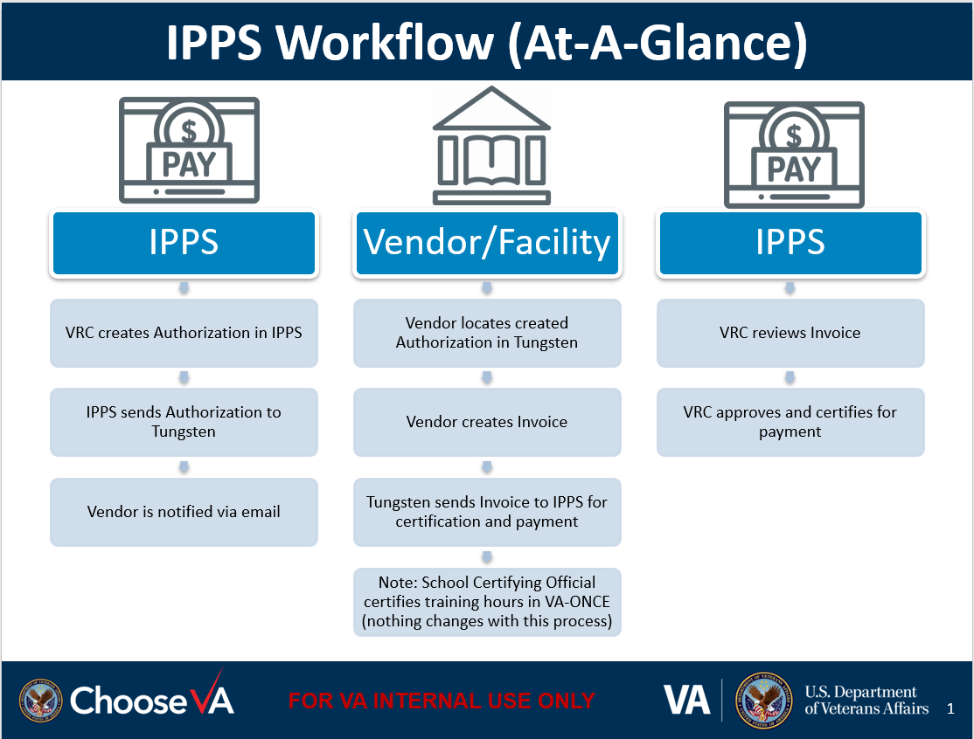

###### Figure 2: Authorization and Certification Workflow.

Once an authorization has been generated, an alert email will be sent to the School Certifying Official (SCO) or identified service provider point of contact (POC). An example of the authorization is available in Figure 4. The email will include a link into Tungsten, the system that service providers will use to see the details of the authorization. Case Managers have the My Authorizations screen to review all authorizations sent for their participants. The screen permits a Case Manager to view the details of the authorization as a PDF and to cancel authorizations.

Case Managers will receive an email notification once per day whenever invoices are received in IPPS with a link to the system. The thresholds for approval are listed in Figure 5. For invoices with a line item above the threshold, Case Managers can recommend invoices for approval or refuse the invoice. Invoices will progress through each role until they reach the role with final approval for the threshold. Approved invoices will be sent for payment processing and refused invoices will be returned to the provider. Invoices can be refused in part or entirely.

## Completing the authorization form

Case Managers and Supervisors can submit authorizations for program participants. The layout of the Authorization Form is shown in Figure 3. To complete an authorization form, enter the following information:

* Search and select a vendor using the vendor fields.
* Search and select the veteran using the participant fields.
* Enter the name of the services approved for the participant.
* Enter the authorization Start and End Date.
* Select the BOC line items that will be funded.
* Enter the SCO’s email address.
* Enter the facility code.

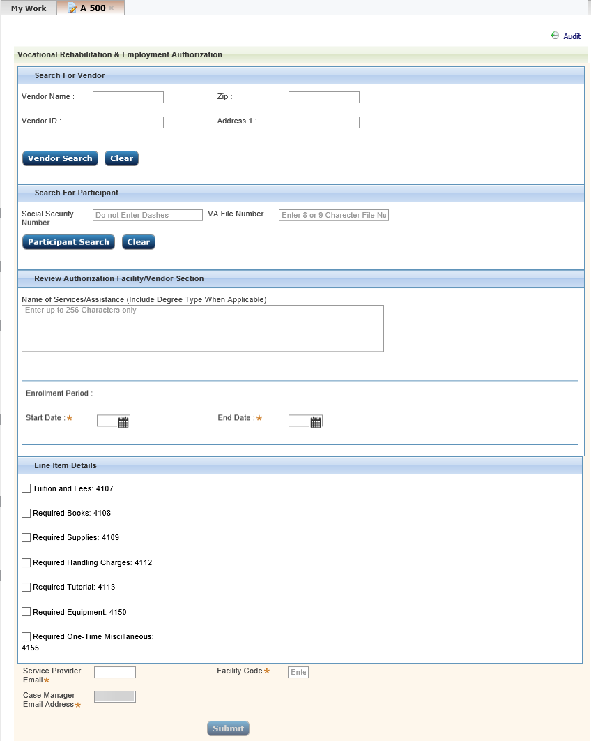

###### Figure 3: Authorization form available to the Case Manager and Supervisor roles in IPPS.

By default, the user completing the authorization form is listed as the Case Manager. Case Managers can enter another Case Manager or Supervisor as the Case Manager for this authorization. This is the user who will certify the invoices from the vendor when it arrives.

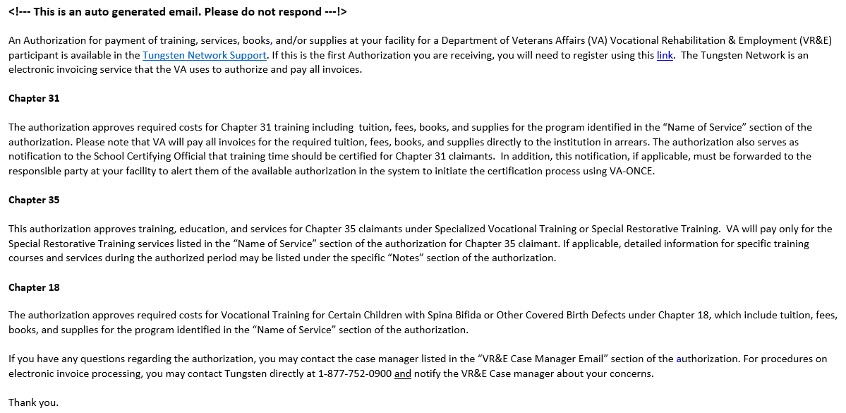

###### Figure 4: Authorization email with access to access Tungsten.

## Certifying invoices

Each role in IPPS has a different threshold of approval permissions for invoices. As each invoice is per participant in IPPS, this is the maximum per invoice for an individual participant’s services from the provider. An example of the certification screen for a high dollar invoice is shown in Figure 6.

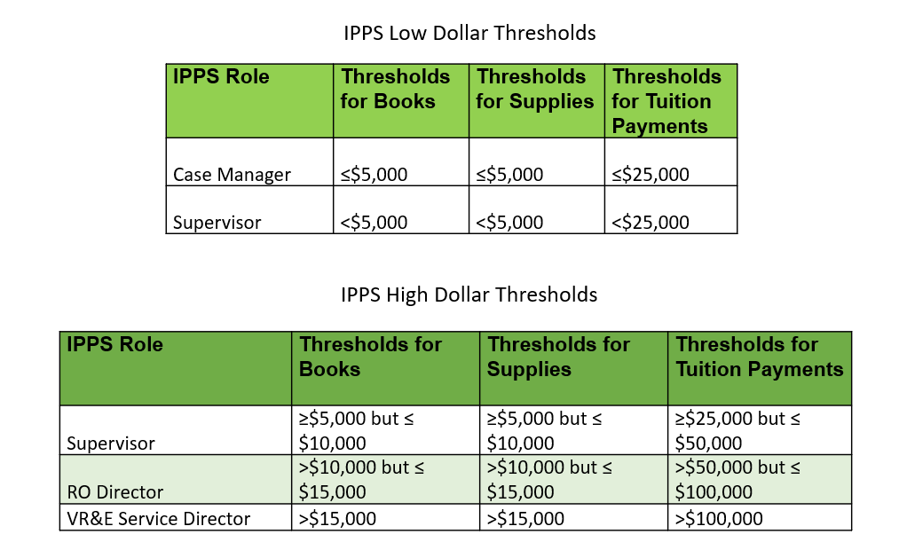

###### Figure 5: Thresholds for the IPPS roles to approve invoices.

To certify an invoice, go to the Worklist with the list of invoices available. Double click on the invoice to view the invoice details. The Case Manager must select the BOC for each line. A BOC may be used more than once. Select the radio button next to accept. Enter the date of acceptance and select submit. If the invoice exceeds the user’s role, the staff member will see Recommend Accept instead.

VR&E staff can modify individual lines in the certification. If for any reason the amount to apply should be changed, such as an existing credit or disputing the amount for part of a line item, the amount can be changed. The entire amount for an individual line can be deleted by selecting the X at the end of the row. If there are modifications to the invoice or if the invoice is late, additional data fields must be populated prior to submitting the certification.

VR&E staff can also refuse the entire invoice using the Refuse button. Any role in the system can refuse an invoice. The user must select an option from the dropdown list to explain the reason for refusing the invoice, which will be shared with the vendor.

###### 

###### Figure 6: Certification screen in IPPS

Once the appropriate role has certified the invoice, it will move into the payment process. Any role in the system can see the status of invoices for their station using the Invoice Inquiry System. This system allows the user to search for the payment status of an invoice by entering a variety of search parameters, including the invoice number, vendor name, participant information or invoices paid after 30 days.

# Roles and Responsibilities

The following section describes key staff responsibilities when using the IPPS to create authorizations and certify invoices.

## VR&E Officers, Assistant Officers, and Designees

* Review this Playbook.
* Complete the Invoice Payment Processing Training.
* Participate in and ensure staff participates in training on the initiative.
* Use CMA resources to answer questions and obtain additional assistance.
* Provide feedback to VR&E Service on quality of training and status of implementation at the RO.
* Ensure all staff have the appropriate level of access to IPPS.
* Direct all inquiries, questions, and feedback to the primary field liaison in your district.

## VR&E Employees

The employee category consists of Vocational Rehabilitation Counselors (VRCs), including VetSuccess on Campus (VSOC) Counselors and Integrated Disability Evaluation System (IDES) Counselors, Employment Coordinators (ECs), Management Analysts and Program Support Specialists.

* Review this Playbook.
* Complete the VR&E Transition to IPPS Training.
* Make the proper assessment of whether a program participant is participating in a program that qualifies for IPPS authorizations and certifications.
* Utilize IPPS to create all authorizations and to certify all invoices.
* Direct all inquiries, questions, and feedback to your VREO, Assistant VREO or designee.

## Change Management Agents and Designees

In July 2018, the VR&E Director engaged the Deputy Undersecretary for Field Operations regarding use of Change Management Agents (CMAs) to assist VR&E with the communication, training, implementation, and evaluation of VR&E modernization initiatives. The CMA role in the transition to eFolder effort is to:

* Participate in VR&E Transition to IPPS Training.
* Provide feedback to VR&E Service on quality of training and status of implementation at the RO.

# Quality Assurance

Quality Assurance (QA) reviews will continue to occur at both a national and a local level. The only change to procedures is the reviewers will have the ability to access reporting electronically on IPPS.

# Key Messages

The VR&E program is making incremental improvements towards its long-term modernization goal, in alignment with the VBA Secretary’s three priorities:

1. Provide Veterans with the benefits they have earned in a manner that honors their service.
2. Ensure we are strong fiscal stewards of the money entrusted to us.
3. Foster a culture of collaboration.

The ultimate modernization goal is to move VR&E into a digital and paperless environment and sunset any legacy information technology tools that are still being utilized. The IPPS is a key system to reach this goal. The IPPS will digitize both authorizations and certifications of invoices. This will both reduce the paper workload, standardize practices, and improve the efficiency and speed at which invoices are paid.

# Submitting Questions, Feedback, and Other Inquiries

VR&E Officers and Assistant VR&E Officers should direct inquiries to the primary field liaison in their district. The alternate liaison will address the inquiry if the primary liaison is unavailable. All inquiries, regardless of the nature or scope, should be sent to the associated district mailbox listed below:

|  |  |  |  |
| --- | --- | --- | --- |
| Area | Primary | Alternate | Email |
| Northeast | Latrese Arnold | Veronica Brown | [**VAVBAWAS/CO/VRE/NA**](mailto:VAVBAWAS/CO/VRE/NA) |
| Southeast | Veronica Brown | Latrese Arnold | [**VAVBAWAS/CO/VRE/SE**](mailto:VAVBAWAS/CO/VRE/SE) |
| Continental | LeGuster Seawright | Lynn Horwatt | [**VAVBAWAS/CO/VRE/MW**](mailto:VAVBAWAS/CO/VRE/MW) |
| Pacific | Lynn Horwatt | LeGuster Seawright | [**VAVBAWAS/CO/VRE/CONT**](mailto:VAVBAWAS/CO/VRE/CONT) |

###### 

# Union Notification

VR&E Service briefed its Labor Partners at the national level on this initiative. The American Federation of Government Employees (AFGE) and the National Federation of Federal Employees (NFFE) were briefed in May 2019.

# Resources

The following section provides a set of resources, including job aids, that provide informational overviews and step-by-step instructions to support VR&E employees in the transition to eFolder.

## Email Guidance

On August 28, 2019, email guidance on the initiation of the Pilot for IPPS provided instructions and resources to support limited use of IPPS for specific service providers in order to automate the authorization and invoices payment processes.

## Invoice Payment Processing Training

Training to support the IPPS and Tungsten rollout is available below, including videos, user guides and training slides to complement the playbook.

TBD

## IPPS User guide

Step-by-step instructions on how to use IPPS.

TBD

# Frequently Asked Questions

**General IPPS Questions:**

***Q1. When IPPS goes live, will Case Managers continue to be required to complete form 28-1905? Also, will the Case Manager need to upload the forms VBMS or add to the Financial/Facility Tab in CWINRS?***

Case Managers will not need to complete form 28-1905 for participants, except when not services or items need to be invoiced to VR&E, such as authorizations for OJT, Apprenticeships, Community Based Work Experiences and/or Chapter 35 SRT/SVT.

***Q2. Why will CWINRS Interface with FMS be disabled?***

Effective January 1, 2020, the CWINRS interface will be inactivated to prevent duplicate processing of any invoices.

***Q3. Will the 10% handling fee the schools charge be eliminated since we are transferring to this system?***

No, schools will still be permitted to charge the 10% handling fee with IPPS.

***Q4. If we have schools that have previously registered with Tungsten, do they have to reregister under VR&E?***

Schools/Service providers who have previously registered with Tungsten will be guided through the process of adding VA VR&E onto their accounts. They will not need new accounts—but they still need to connect with us.

***Q5. For schools that have terms that begin after the cutoff date of 10/8/2019, how should the invoices for those terms be processed?***

We are only piloting Drexel, Strayer, and University of California San Diego and their associated bookstores starting on 9/3/2019. Case Managers will continue to provide authorizations for other schools and service providers for services that will be completed by 12/31/2019 using the current process. Schools will not be able to invoice in Tungsten until they receive electronic authorizations from VR&E, and the nationwide rollout for creating authorizations is for terms starting on or after 1/1/2020. The 10/8/2019 date is to ensure we have all the schools prepared to receive authorizations in Tungsten when we begin the nationwide deployment.  
 ***Q6. Have schools been notified to submit all invoices prior to the deadline?***

Yes, the schools have been informed in the communication about the transition to Tungsten and IPPS.

***Q7. What happens if the school is not registered for Tungsten?***

When the Case Manager creates the authorization in IPPS, the Case Manager can enter the email address for the contact at the school. The contact will receive an email notification with a link to register for an account on Tungsten.

***Q8. For Acting Directors, will they have full capability for the IPPS system?***

The site administrator at your site will assign and manage the roles. This means a local contact will be able to assign and manage the roles for the staff at the station.

***Q9. If CWINRS will be turned off 01/02/2019, how will we pay late invoices?***

If any invoice is outstanding after the inactivation, the Case Manager will need to create a post-dated authorization in IPPS. The school will then need to submit the invoice through Tungsten and follow the new process.   
 ***Q10. Is it the expectation that the VREO would be the site administrator?***

No, this is not the expectation. Any user at the site can be the site administrator.

***Q11. Can you have more than one user role?***

No, at present a user can have only one role in the system. An enhancement request has been submitted to FSC to request hybrid roles to support the needs of the smaller stations.

***Q12. What is SSD’s role after the implementation of IPPS?***

With the implementation of IPPS, SSD is no longer in the VR&E invoice processing workflow. However, SSD will have access to run reports on the status of invoices in IPPS.

***Q13. Will there be audits of the entries in IPPS? If so, who will be performing the audits?***

Yes, FSC is developing policies and procedures to conduct period audits of a statistical sampling of these payments to ensure they comply with all applicable finance laws, regulation, and policy.

***Q14. If there is an overpayment or a participant drops out of the program, will there be an opportunity to have the EFT reversed where the service provider pays the refund to VA via direct deposit?***

No, unfortunately, there is no way for the school to return funds electronically currently.

***Q15. What is the impact of IPPS on the Case Manager’s workload?***

The expectation is that IPPS will significantly reduce the administrative burden on Case Managers by automating both the authorization and payment process. It will also allow easier visibility into the payment status, if a service provider should ask, as the Case Manager can run a report on all invoices paid using the Invoice Inquiry System.

***Q15. The user guide says that IPPS cannot be used in IE 11 in compatibility mode, and the recommendation is to use VBMS in compatibility mode after a patch. What should I do?***

If you need to have IE 11 in compatibility mode for VBMS, hold all IPPS work until the end of your tour of duty. At the end of the day, turn off the compatibility mode and log into IPPS to enter authorizations and/or review the invoices. Once you are finished, you can re-enable the compatibility mode for the next business day.

**Authorizations Questions:**

***Q1.*** ***Will IPPS automatically populate the facility code?***

No, this is currently not a capability. This has been submitted as an enhancement of the system.

***Q2. What are blocked and unblocked vendors?***

Blocked vendors are vendors whose address or banking information is incorrect in the system (so they are unable to be invoiced). You can only create authorizations on unblocked vendors. If there is an issue, have the vendor log into SAM.gov and update their information.

**My Work Questions:**

***Q1. In the box where you put the note, do you have to put the dollar amount?***

The notes in the line items is to be used for anything normally noted for the schools or to help ensure that the invoices only include approved line items.

***Q2. Does the invoice go to SSD once approved?***

No, the invoices are routed directly to FMS for payment. Because this is the case, it is essential that Case Managers and other approvers review the data for thoroughness and correctness before accepting an invoice.

***Q3. When we pay an invoice, what will we have to put into VBMS?***

With the implementation of IPPS, no entry is required for VBMS.

***Q4. What happens if the Case Manager is not available?***

The site administrator can reassign the invoice to another Case Manager or Supervisor role for approval.

***Q5. Will the Case Manager receive a notification if the Case Manager entered the email or the FC information incorrectly?***

If the information entered appears to be a valid email address, IPPS will issue the authorization to that email address. It will deliver to the incorrect email address, if it exists, or attempt to deliver to the incorrect email address. IPPS does not notify you if the email was undeliverable or if the FC is not accurate.

***Q6. Is the high dollar invoice the same as the high-cost memo?***

No, the high dollar invoice is a single invoice for the applicable participant that exceeds the amounts permitted for a Case Manager to approve.

**Invoice Inquiry System Questions:**

***Q1. Why is the VA File Number I entered not displaying the status of the participant’s invoices?***

When searching in the Invoice Inquiry System, you must enter the hyphens when searching for a VA file number to see the results for that participant. The search is an exact match, and the file number is saved with the hyphens in the system.

# Acronyms

|  |  |
| --- | --- |
| **ACRONYM** | **DEFINITION** |
| AFGE | American Federation of Government Employees |
| BOC | Budget Object Code |
| CWINRS | Legacy Corporate Case Management System |
| FC | Facility Code |
| FMS | Financial Management System |
| FSC | Financial Service Center |
| IE | Internet Explorer |
| IPPS | Invoice Payment Processing System |
| IT | Information Technology |
| M28R | VR&E Policy and Procedures Manual |
| NFFE | National Federation of Federal Employees |
| OBPI | Office of Business Process Integration |
| OFM | Office of Financial Management |
| OFO | Office of Field Operations |
| OJT | On-the-job Training |
| PDF | Portable Document Format File Type |
| PIV | Personal Identity Verification |
| QA | Quality Assurance |
| RO | Regional Office |
| SCO | School Certifying Official |
| SRT | Special Restorative Training |
| SSD | Service Support Division |
| STAR | Systematic Technical Accuracy Reviews Team |
| SVT | Specialized Vocational Training |
| VBA | Veteran Benefits Administration |
| VBMS | Veterans Benefit Management System |
| VR&E | Vocational Rehabilitation & Employment |
| VRC | Vocational Rehabilitation Counselor |
| VREO | Vocational Rehabilitation & Employment Officer |