Invoice Payment Processing System (IPPS)  
for Veterans Benefits Administration (VBA)  
Vocational Rehabilitation and Employment (VR&E)

User Guide



August 2019  
Department of Veterans Affairs  
Financial Services Center

Revision History

|  |  |  |  |
| --- | --- | --- | --- |
| Date | Revision | Description | Author |
| 8/26/2019 | 1.0 | Initial Creation | Joy Owen |

**Table of Contents**

1. Introduction 1

1.1. Purpose 1

1.2. Assumptions 1

1.3. Service and Support Contact 1

2. System Summary 1

3. Getting Started 1

3.1. Logging In 1

3.2. Screen Components 2

3.3. Exporting/Printing the Work List 3

3.4. Exiting the System 4

4. Roles in the IPPS Application 4

4.1. VRE Read Only 5

4.2. Case Manager 5

4.3. Supervisor 5

4.4. VRE Regional Office (RO) Director 6

4.5. Director 6

4.6. Site Administrator 6

4.7. Authorization Form 6

4.7.1. Search for Vendor 9

4.7.2. Search for Participant 11

4.7.3. Review Authorization Facility/Vendor 12

4.7.4. Line Item Details 14

4.7.5. Authorization Fields 14

4.8. My Authorizations 17

4.8.1. Filtering Authorizations 17

4.8.2. Searching the Authorization Report 19

4.8.3. Clearing an Authorization Report Filter 20

4.8.4. Cancelling an Authorized Invoice 21

4.8.5. Viewing a PDF of an Authorization 22

4.8.6. Refreshing the Screen 23

4.9. Certifying Invoices 23

4.9.1. Low Dollar Invoices 25

4.9.2. High Dollar Invoices 31

4.9.3. Notes and Attachments 40

4.10. Viewing Audit Information 43

4.11. Viewing Case Narrative 45

4.12. Site Administration 45

4.12.1. My Work 46

4.12.2. User Administration 46

4.12.3. Adding a User 47

4.12.4. Removing a User 50

4.12.5. Reactivating a User 51

4.12.6. Deleting User-Assigned Authorizations 51

4.12.7. Re-assigning an Authorization Number 53

4.13. Invoice Inquiry System (IIS) 55

4.14. Dashboard 58

4.14.1. Chart Actions 60

4.15. Monitor Activity 61

4.15.1. Viewing a Report 62

4.16. Actions Button 63

5. Exporting to Excel 64

6. Troubleshooting 64

6.1. User or Access Issues 64

6.1.1. Error When Logging In 64

6.1.2. Log-in Error Persists 64

6.2. Turning Compatibility Settings Off 65

7. Acronyms 66

Appendix A. List of Status Conditions 67

# Introduction

## Purpose

This User Guide aids in the use of the Invoice Payment Processing System (IPPS) for the Vocational Rehabilitation and Employment (VR&E) program in the Veterans Benefits Administration (VBA).

## Assumptions

This guide was written with the following prerequisites in mind:

* validated access to the system using Internet Explorer (IE) 11
* completion of any prerequisite training

## Service and Support Contact

For assistance, contact [VAFSCEnterpriseSupport@va.gov](mailto:VAFSCEnterpriseSupport@va.gov).

Phone: 866-372-1141

# System Summary

In IPPS, an authorization is created and sent to the Tungsten-Network (Tungsten). The Service Provider logs into Tungsten to review the authorization and converts it into an invoice. The invoice is sent back to IPPS for certification and payment.

IPPS is a web-based system that recognizes your credentials if you’re logged into your government computer with your Personal Identity Verification (PIV) card. A separate user name or password is not required.

# Getting Started

## Logging In

To log into IPPS:

1. Log into your government computer using your PIV card.
2. Go to <https://vaww.ipps.fsc.va.gov/prweb/PRWebLDAP1/>.

An Authorized Use warning displays (see Figure 1).

1. If you receive a message saying you are using an unsupported browser, see procedures in **Turning Compatibility Settings Off**.

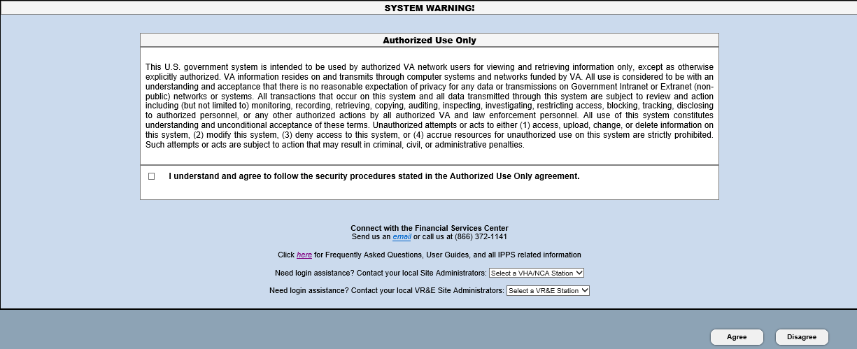

Figure 1. Authorization Notice

1. Click the checkbox at the bottom of the window and select **Agree**.
2. Access is granted with a provisional 90-day activity window. If you do not log into IPPS within a 90-day period, your access to the application is removed and you won’t be able to log in. To regain access, see **6.1 User or Access Issues.**

After a few seconds, the IPPS application displays. The interface appears differently based on your role.

1. If you get an error when logging in, see **6.1 User or Access Issues**.

## Screen Components

When you log into the system, your screen displays several components (see Figure 2).

The contents of each screen component depend on the role you are assigned. The screenshot in Figure 2 is for a Case Manager. See Table 1 for more details.

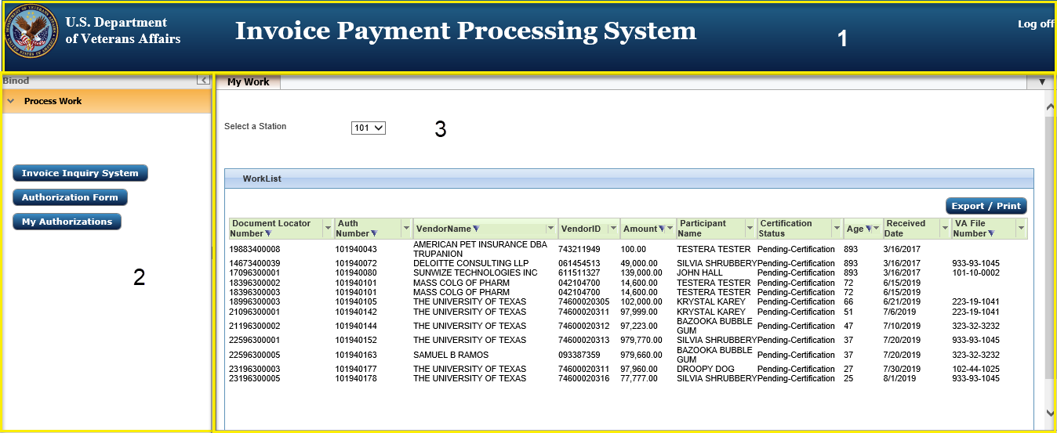

Figure 2. Home screen layout

Table 1. Screen Components

|  |  |
| --- | --- |
| Component Number | Component Name |
| 1 | Title bar |
| 2 | Navigation bar (this displays different options depending on the role of the user) |
| 3 | Workspace |

## Exporting/Printing the Work List

To export or print the worklist, complete the following steps:

1. From the My Work tab, select **Export/Print**.

The Work List redisplays in a different format (see Figure 3).

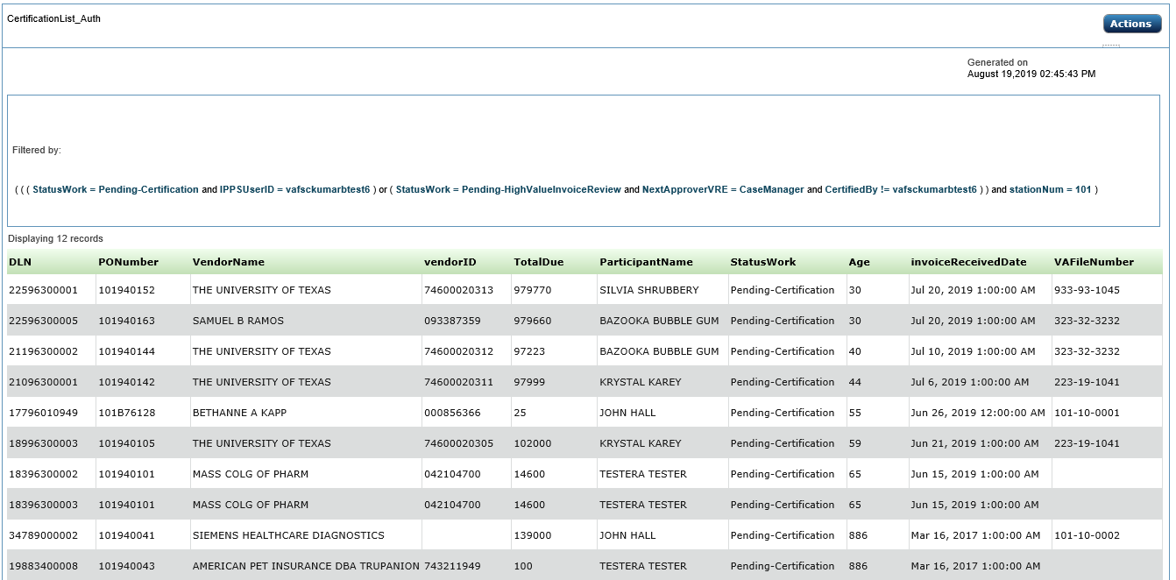

Figure 3. Work List (redisplayed)

1. To print or export the Work List, click the **Actions** button and select the desired option.

For more information on the Actions button, see ***4.16 Actions Button***.

## Exiting the System

If you don’t log off the application, the old session may be stored in cache so that it produces an error when you try to log in again. To fix this error, see ***6.1 User or Access Issues***.

To log off the system and prevent the error, click **Log Off** at the top right-hand side of the screen. When you log off, IPPS closes the application tab. If the application tab is the only one open, your browser window closes.

# Roles in the IPPS Application

There are several user roles in the IPPS application. The user can only be assigned one role at a time.

User roles include:

* VRE Read Only
* Case Manager
* Supervisor
* Site Admin
* RO Director
* Director

1. Each role has a corresponding 508 role for accessibility users.

Figure 4 displays the functionality available for each role.

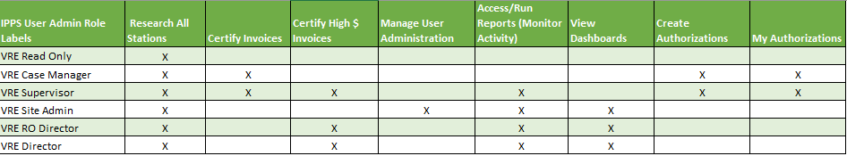

Figure 4. Role matrix

## VRE Read Only

VRE Read Only access includes:

* Research - see ***4.13 Invoice Inquiry System (IIS)***

## Case Manager

The Case Manager is responsible for creating an authorization for a Service Provider on behalf of a Participant.

The Case Manager can approve low dollar invoices.

Though a Case Manager can recommend approval for high dollar invoices, these invoices are automatically routed to the Supervisor for recommendation or final approval.

The Case Manager functions include:

* Research - see ***4.13 Invoice Inquiry System (IIS)***
* Create an authorization - see ***4.7 Authorization Form***
* View or cancel their own authorizations - see ***4.8 My Authorizations***
* Certify low dollar invoices - see ***4.9.1 Low Dollar Invoices***

## Supervisor

The Supervisor can create an authorization for a Service Provider on behalf of a Participant.

The Supervisor can approve low dollar invoices.

Though a Supervisor can recommend approval for high dollar invoices within their threshold, these invoices must be routed to another Supervisor or RO Director for recommendation or final approval if they served as the initial case manager.

The Supervisor functions include:

* Research - see ***4.13 Invoice Inquiry System (IIS)***
* Create an authorization – see ***4.7 Authorization Form***
* View or cancel authorizations - see ***4.8 My Authorizations***
* Certify low dollar invoices - see ***4.9.1 Low Dollar Invoices***
* Certify high dollar invoices - see ***4.9.2 High Dollar Invoices***
* Monitor Activity – see ***4.15 Monitor Activity***

## VRE Regional Office (RO) Director

In IPPS, the main task for an RO Director is to certify high dollar invoices. The RO Director functions include:

* Research - see ***4.13 Invoice Inquiry System (IIS)***
* Certify high dollar invoices - see ***4.9.2 High Dollar Invoices***
* Dashboard - see ***4.14 Dashboard***
* Monitor Activity – see ***4.15 Monitor Activity***

## Director

In IPPS, the main task for the Director is to certify high dollar invoices. The Director can see all authorizations from all stations that require certification.

The Director functions include:

* Research - see ***4.13 Invoice Inquiry System (IIS)***
* Certify high dollar invoices - see ***4.9.2 High Dollar Invoices***
* Dashboard - see ***4.14 Dashboard***
* Monitor Activity – see ***4.15 Monitor Activity***

## Site Administrator

In IPPS, the Site Administrator’s primary tasks are managing users and reassigning invoices for review to other Case Managers, if necessary. The Site Administrator functions include:

* Change roles, assign stations, reactivate or delete users - see ***4.12.2 User Administration***
* Dashboard - see ***4.14 Dashboard***
* Monitor Activity – see ***4.15 Monitor Activity***

## Authorization Form

The Authorization form is created in IPPS so that Service Providers can invoice for services rendered and School Certifying Officials (SCOs) can be notified that training hours should be certified in VA-ONCE.

To create an authorization, select the Authorization Form button (see Figure 5).

1. Your level of access determines the selections available in the navigation bar.

Shows left navigation bar with Authorization Form selected.


Figure 5. Select Authorization Form

The Authorization form displays (see Figure 6).

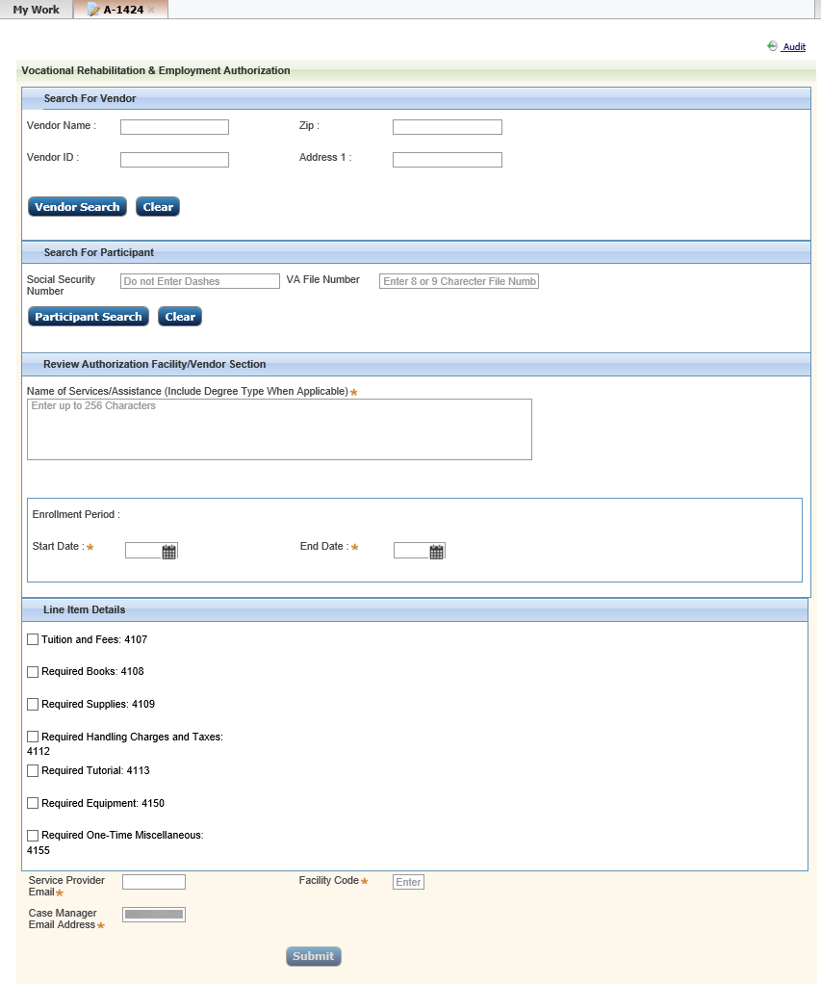

Figure 6. Authorization Form

### Search for Vendor

This search area is used to locate the service provider that will receive an authorization to provide services to a Participant. You can search for a vendor based on:

* Vendor Name: Can do a search on partial (like Toml for Tomlinson).
* Vendor ID (same as the Vendor’s Tax ID): Must include full Vendor ID number. This number can be found in CWINRS.
* Zip: Must include the exact vendor zip code.
* Address 1: Vendor address. Can do a search on partial elements (like Plant for Plantation Drive).

To complete a vendor search:

1. Enter one or more fields and click **Vendor Search**.

The search returns blocked and unblocked vendors (see Figure 7). Expand or minimize each section by clicking the double chevrons (chevron icon) to the left of the column. Information in the comments section of blocked vendors may point you to the correct unblocked vendor. You can only create authorizations on unblocked vendors.

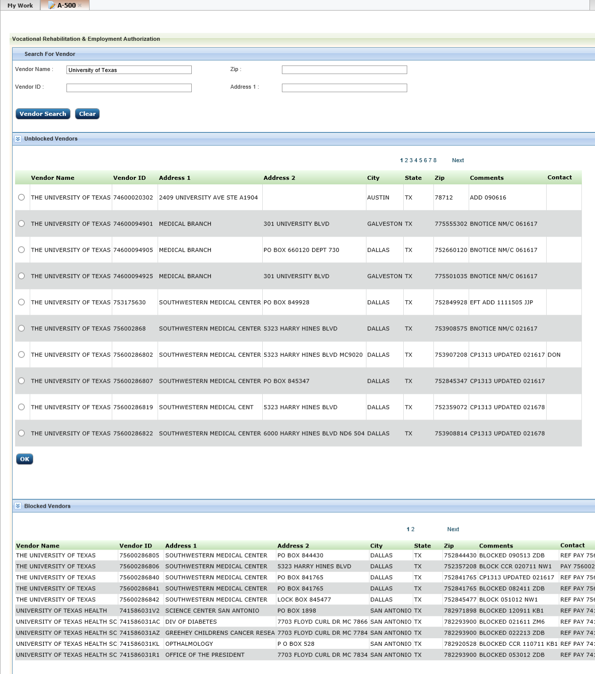

Figure 7. Vendor search results

1. From the Unblocked Vendors list, click the radio button next to vendor receiving services (see Figure 8).

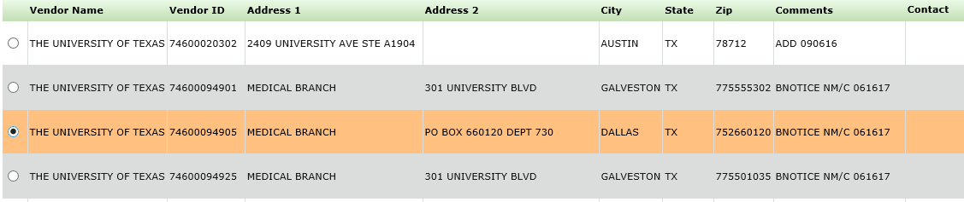

Figure 8. Vendor Selection

1. Blocked vendors are vendors whose address or banking information is incorrect in the system (so they are unable to be invoiced). If there is an issue, have the vendor log into SAM.gov and update their information.
2. Click **OK**.

Vendor details are populated in the Selected Vendor Details area (see Figure 9).

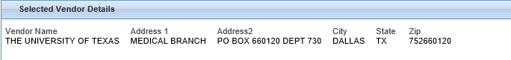

Figure 9. Vendor Details

1. A vendor must be selected to submit the authorization; otherwise, an error message displays on the screen. If you can’t find the vendor you are searching for, contact [VAFSCEnterpriseSupport@va.gov](mailto:VAFSCEnterpriseSupport@va.gov).

### Search for Participant

This search area is used to locate the Participant who is entitled to receive services from the Service Provider. You can search for a Participant based on:

* Social Security Number – no dashes or spaces
* VA File Number – 8 or 9 character number only with no special characters

Enter one or more fields and click **Participant Search**.

Search results display (see Figure 10).

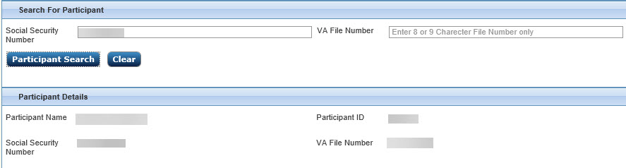

Figure 10. Participant Details

1. A participant must be selected to submit the authorization; otherwise, an error message displays on the screen.

### Review Authorization Facility/Vendor

This section provides further information on the vendor or facility. The following fields are provided in this area:

* Name of Services/Assistance (mandatory field)
* Facility/Vendor Enrollment Period

1. Enter information into the Name of Services/Assistance field as required. This includes degree type when applicable (see Figure 11).

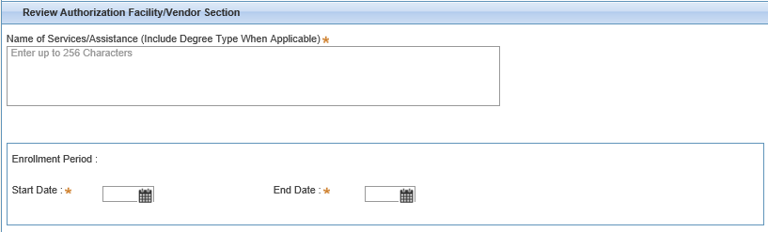

Figure 11. Name of Services/Assistance

1. In the Enrollment Period fields, you can either enter the date in mm/dd/yyyy format or use the Calendar to select dates (see ***4.7.3.1 Using the Calendar Tool***).
2. The End Date cannot be more than one year from the Start Date. If you select a date range of more than a year, an error message displays when you submit the form.   
     
   If you select an End Date before the Start Date or a Start Date after the End date, you will also get an error message when you submit the form.

#### Using the Calendar Tool

1. Click the calendar to the right of the Start Date/ End Date.

A calendar displays (see Figure 12).

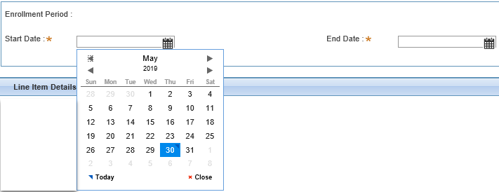

Figure 12. Start/End Date

1. Select a date on the calendar.

The field is filled with the selected date (see Figure 13).

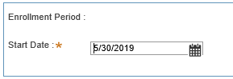

Figure 13. Date field (filled)

1. The End Date cannot be more than one year from the Start Date. If you select a date range of more than a year, an error message displays when you submit the form (see Figure 14).   
     
   If you select an End Date before the Start Date or a Start Date after the End date, you will also get an error message when you submit the form (see Figure 15).

Date more than one year error

Figure 14. Date more than one year error

End Date not before Start Date error

Figure 15. End Date not before Start Date error

### Line Item Details

The Line Item Details are the approved goods/services that VBA is funding.

Click the checkbox next to the Line Item(s) that are being funded.

1. At least one line item must be selected to submit the authorization; otherwise an error message displays on the screen.

A Notes field displays to the right of all checked line items for optional additional information (see Figure 16).

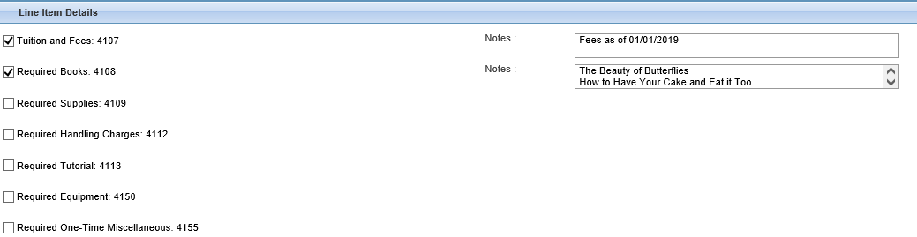

Figure 16. Line Item Details

### Authorization Fields

The fields at the bottom of the authorization form include:

* Service Provider Email – the email address for the Service Provider point of contact (POC), typically the School Certifying Official (SCO).
* Case Manager Email Address – the authorizing case manager. The Case Manager Email Address field is auto-populated. The field is still editable to allow for an alternative VA POC who has an IPPS account configured as a Case Manager or Supervisor.
* Facility Code – 8-digit code assigned to the facility. This code can be found in CWINRS.

1. Enter information into all required fields marked with an asterisk (see Figure 17).

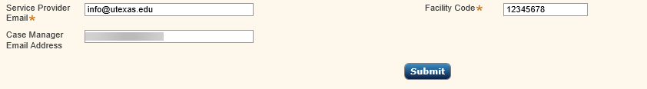

Figure 17. Authorization fields

1. Click **Submit**.

This creates the authorization and sends an email to the Service Provider (see Figure 18). You can view the authorization in My Authorizations (see ***4.8 My Authorizations***).

1. Upon selecting Submit, the email address entered for the Service Provider receives the New Authorization Notification email from IPPS.
2. Only a Case Manager or Supervisor can submit an authorization.

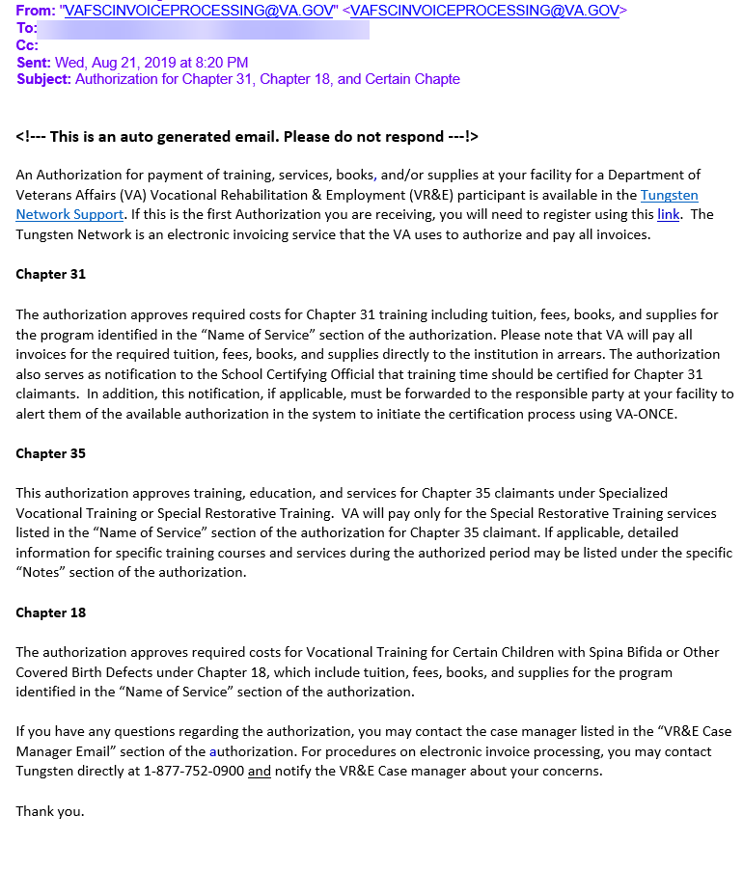

Figure 18. Auto-generated email

1. If any required fields have not been correctly filled, an error message displays. Click **OK**, make appropriate corrections, and click **Submit** again.

## My Authorizations

This selection in the left navigation bar provides the Case Manager or Supervisor a list of authorizations that have been created by you after they have been submitted. To view your authorizations:

1. Click **My Authorizations** from the Process Work area of the left navigation bar (see Figure 19).

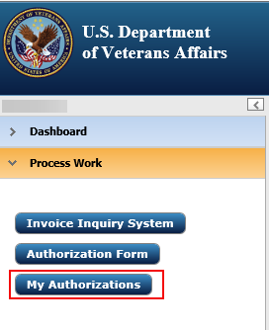

Figure 19. Selecting My Authorizations

A list of your authorizations displays (see Figure 20).

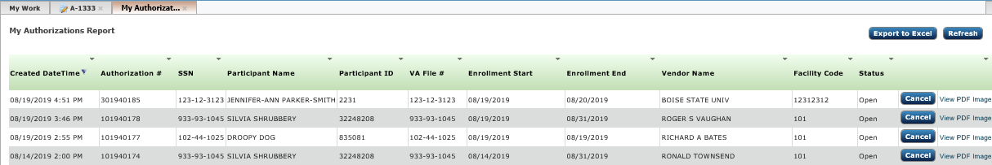

Figure 20. My Authorizations Report

### Filtering Authorizations

At the top of each column in the My Authorizations Report is a downward arrow (see Figure 21).

This graphic shows the dropdown arrows at the top of column headings in the My Authorizations report.

Figure 21. Dropdown arrows

To filter authorizations:

1. From My Authorizations Report, select the dropdown arrow for the column you want to filter by.

A list of information displays specific to that column (see Figure 22) for an example.

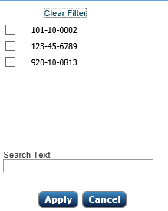

Figure 22. Example filter

1. Select the option you want to filter by (see Figure 23).

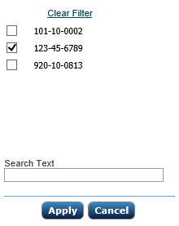

Figure 23. Filter option

1. Click **Apply**.

Only authorizations containing that option display (see Figure 24).

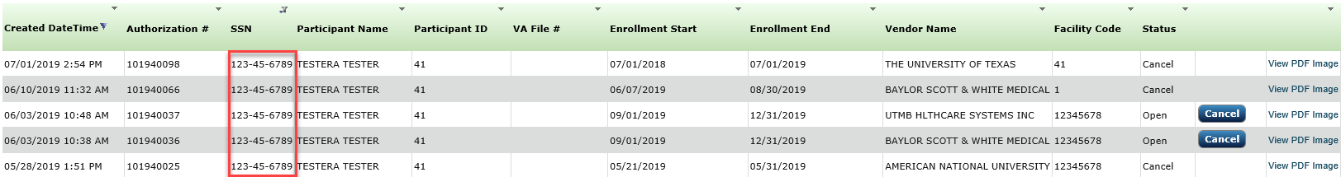

Figure 24. Filtered list

### Searching the Authorization Report

To search your list of authorizations, complete the following steps:

1. From the My Authorizations Report, select the dropdown arrow for the column you want to search. In this example, Participant Name is selected.

A dropdown list displays (see Figure 25).

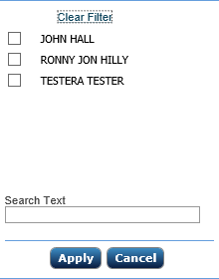

Figure 25. Option list

1. In the Search Text field, enter the text you want to search for (see Figure 26).

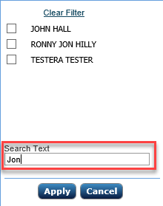

Figure 26. Search Text field

1. Click **Apply**.

The report is filtered by your search text (see Figure 27).



Figure 27. Filtered list

### Clearing an Authorization Report Filter

If you are in a filter and want to cancel it, you can clear the filter and return to the complete list of authorizations in your Authorization Report.

From the filter list click **Clear Filter** (see Figure 28).

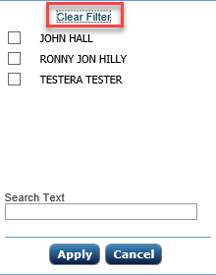

Figure 28. Clear Filter

The complete list of authorizations re-displays.

### Cancelling an Authorized Invoice

You can only cancel your own authorizations. To cancel your authorization:

1. Click **Cancel** next to an open authorization you want to cancel (see Figure 29).

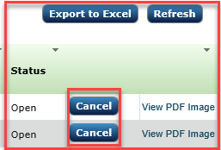

Figure 29. Cancelling an Authorization

A dialog box displays asking for you to confirm that you want to cancel the authorization (see Figure 30).

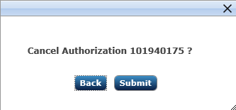

Figure 30. Cancel Authorization prompt

1. Click **OK**.

The authorization is canceled, the Status changes from Open to Cancel, and the Cancel button no longer displays (see Figure 31).

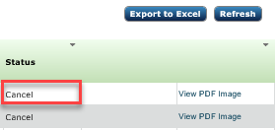

Figure 31. Cancelled Authorization

In addition, an auto-generated email is sent to the Service Provider (see Figure 32).

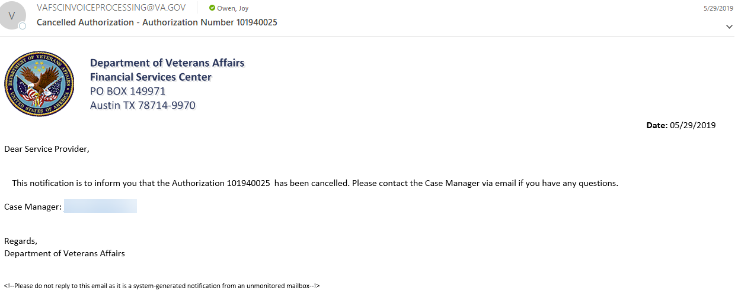

Figure 32. Auto-generated email

### Viewing a PDF of an Authorization

To view a PDF of an authorization:

1. Complete steps in ***4.8 My Authorizations***to open the My Authorizations Report*.*
2. Click **View PDF Image** for the PDF you want to view (see Figure 33).



Figure 33. View PDF Image link

The PDF displays (see Figure 34).

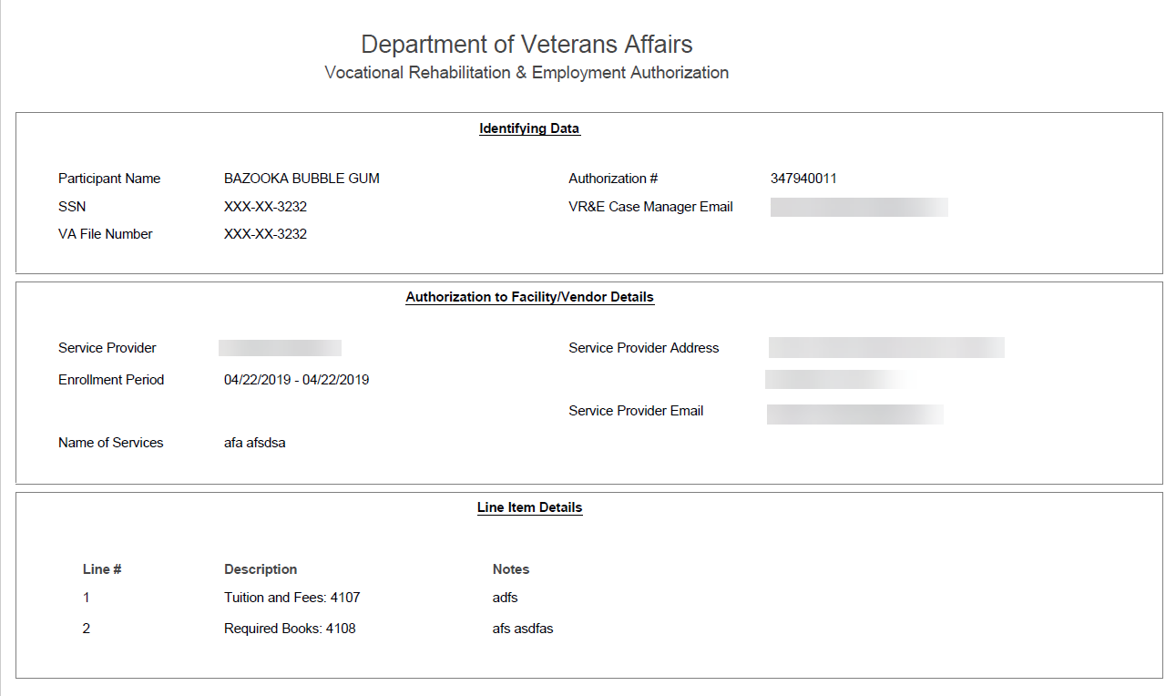

Figure 34. PDF link results

### Refreshing the Screen

If the Refresh button displays, you can click it to update the screen contents to display the most current information (see Figure 35). For instance, if you had the My Authorizations open in one tab and created an authorization in another tab, the refresh button would update the list to include the newly created authorization.

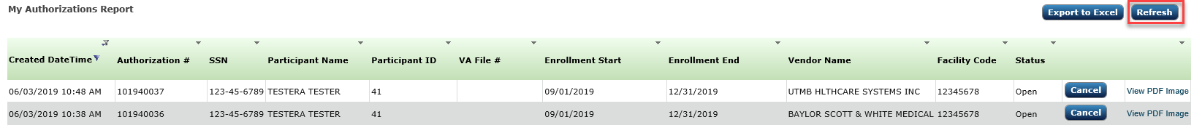

Figure 35. Refresh button

## Certifying Invoices

The certification Work List is a list of all invoices that need to be certified.

The roles that can certify invoices include:

* Case Manager – low dollar invoices
* Supervisor – low dollar invoices, high dollar invoices

Roles that can approve invoices include:

* Supervisor – low dollar invoices, high dollar invoices
* RO Director and Director – high dollar invoices

The invoice is routed one of several ways:

* If approval is recommended, it goes to the next higher role in the process for approval.
* If approval is given, the invoice is paid.
* If refusal is given, the invoice is archived, and a notification is sent to the vendor/service provider.

The amount of the subtotal per Budget Object Code (BOC) determines the approval path for tuition, books, and supplies. It also determines which selections are seen by the approver (either approve/refuse or recommend approve/refuse).

Each invoice works its way through the layers of approval in the system. When a user submits an invoice for approval, the system considers two factors:

* Has the threshold for the BOC subtotal been met or exceeded?
* Which role is next in the line for approval?

Low Dollar invoices only require a single approval from the Case Manager or Supervisor.

The following are thresholds for the two types of invoices to give you an idea of the approvals required:

* Table 2. IPPS Low Dollar Thresholds
* Table 3. IPPS High Dollar Thresholds

Table 2. IPPS Low Dollar Thresholds

|  |  |  |  |
| --- | --- | --- | --- |
| **IPPS Role** | **Thresholds for Books** | **Thresholds for Supplies** | **Thresholds for Tuition Payments** |
| Case Manager | <=$5,000 | <=$5,000 | <=$25,000 |
| Supervisor | <=$5,000 | <=$5,000 | <=$25,000 |

Table 3. IPPS High Dollar Thresholds

|  |  |  |  |
| --- | --- | --- | --- |
| **IPPS Role** | **Thresholds for Books** | **Thresholds for Supplies** | **Thresholds for Tuition Payments** |
| Supervisor | **>$5,000 but <= $10,000** | **>$5,000 but <= $10,000** | **>$25,000 but <=$50,000** |
| RO Director | **>$10,000 but <= $15,000** | **>$10,000 but <= $15,000** | **>$50,000 but <= $100,000** |
| Director | **>$15,000** | **>$15,000** | **>$100,000** |

For example, if an invoice comes in for books that exceeds $15,000, the Supervisor can recommend approval, then the RO Director can recommend approval, but the Director has the final approval.

If an invoice comes in for books for $6,000, the Supervisor provides the final approval, and it does not go to the next level.

### Low Dollar Invoices

Only the Case Manager or Supervisor approves low dollar invoices. To process a low-dollar invoice, complete steps in the next sections.

#### Opening an Invoice

To process low dollar invoices:

1. Log into IPPS (see ***3.1 Logging In*).**

The Case Manager or Supervisor My Work tab displays (see Figure 36).

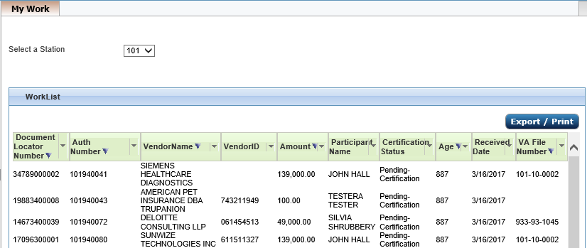

Figure 36. Case Manager/Supervisor My Work tab

1. If you have access to multiple stations, select the station for which you are processing invoices (see Figure 37).

Stations dropdown list

Figure 37. Stations dropdown

1. Click the invoice you want to process.

The certification details screen displays (see Figure 38). The invoice image opens in a separate window (see Figure 39).

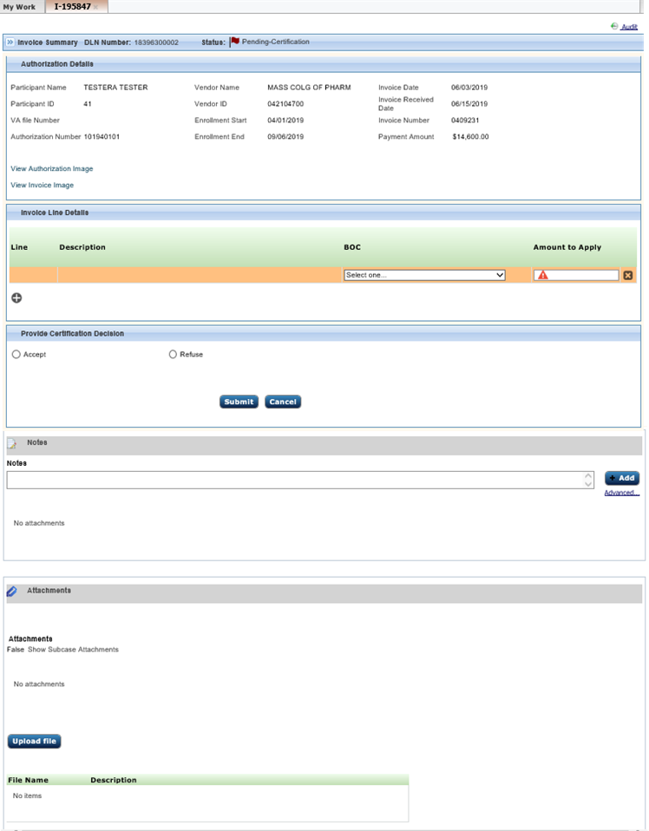

Figure 38. Certification screen

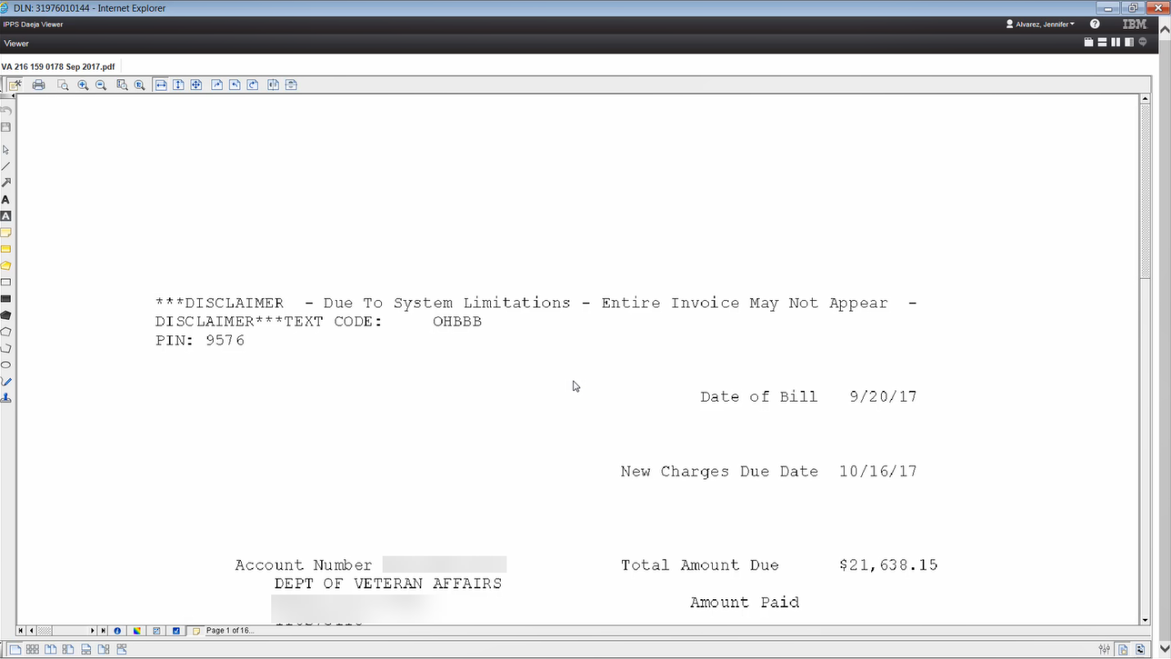

Figure 39. Sample Invoice Image

#### Certification Screen

Parts of the Certification screen include:

* Audit Link – provides a history of the invoice (see ***4.10 Viewing Audit Information***). This is hidden by default, but can be seen by selecting the link.
* Invoice Summary – contains metadata submitted from IPPS and is collapsed by default. You can view this information by clicking on the chevrons. This includes:
* Document Locator Number (DLN) Number - the unique ID of every invoice in IPPS
* Status of the invoice (see ***Appendix A List of Status Conditions*** for a list of possible statuses)
* Authorization Details – this area is pre-populated from the invoice and authorization. There are also links to open the Authorization and Invoice images.
* Invoice Line Details – this area displays the items that were entered by the service provider in Tungsten, a dropdown list for their Budget Object Code (BOC), and the amount for each line item.

1. If there’s a difference between the payment amount and the total of the line amounts, open the invoice image to see if there’s a handling charge and/or tax amount included. If you see one, click the plus sign (see Figure 40) and add the amount using the appropriate BOC (see Figure 41).

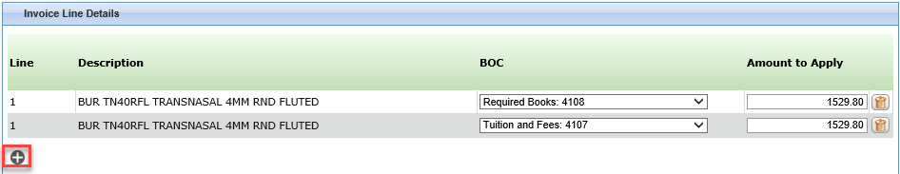

Figure 40. Line Details - plus sign

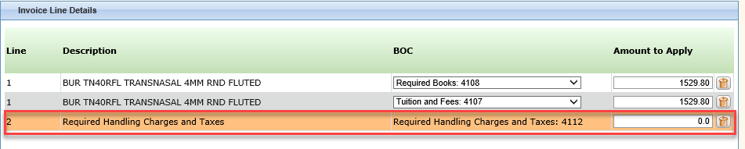

Figure 41. Line Details – Handling and Tax line added

* Provide Certification Decision – this area allows you to Accept or Refuse the invoice (or return it to the reviewer for high-dollar invoices).
* Notes and Attachments – these areas allow for additional notes or attachments to be filed with the invoice. See also ***4.9.3 Notes and Attachments***.

#### Accepting an Invoice

If the invoice is within the threshold for approval, the certifying official sees the Accept/Refuse radio buttons on the certification screen.

If the books or supplies subtotal amounts are <=$5000 (or tuition <= $25,000), no approvals are needed after certification.

To accept a low dollar invoice, complete the following steps:

1. From the open invoice screen, ensure that the amounts are correct for each item (see Figure 42). Select a BOC from a list of possible entries and update amounts to apply, as needed, directly into the Amount to Apply field. You can also delete a line item by selecting the trashcan to the right of the Amount to Apply field.

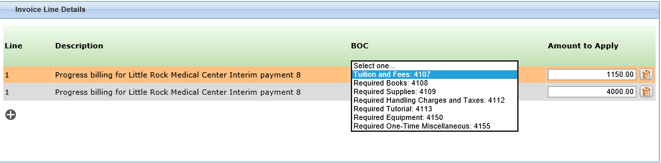

Figure 42. Budget Object Code and Amount entry

1. Select **Accept** in Provide Certification Decision.

Depending on the condition of the invoice, additional fields may display (see Figure 43). If it’s late or if amounts mismatch and so on, you are asked to provide further information. At a minimum, you are asked for the Date of Acceptance and a checkbox is provided if this is the final invoice to be approved for this authorization.

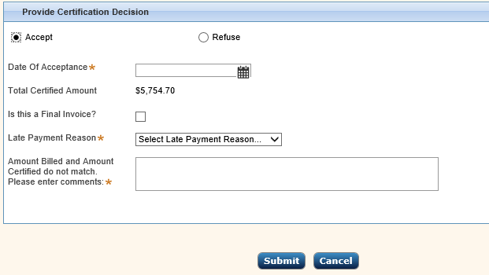

Figure 43. Accepting an Invoice

1. Enter all mandatory fields.

* Date of Acceptance: this field auto populates with the current date, but you can also enter the date in mm/dd/yyyy format or use the Calendar to select dates (see ***4.7.3.1 Using the Calendar Tool***).
* Verify the total certified amount.
* If this is a final invoice and no further invoices should be received from the service provider for the authorized time period, select the checkbox next to “Is this a final invoice” (see Figure 43). This prevents the vendor from sending any further invoices under the same authorization.

1. Authorizations can be based on various criteria (for every semester, for every fiscal year, and so on. If you select final, you are saying that this is the final invoice for the semester or fiscal year or other criteria upon which the authorization was based.

After submission, a status of Final shows when My Authorizations is selected (see Figure 44 ).

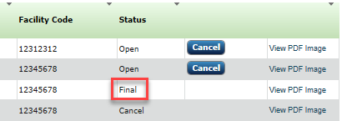

Figure 44. Final Status

* If displayed, enter a Late Payment Reason from the dropdown list (see Figure 45). This will display for any invoice over 56 days.

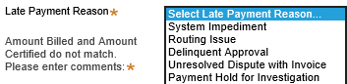

Figure 45. Late Payment Reason

* If displayed, enter required notes in Amount Billed and Amount Certified do not match field (see Figure 46). This field only displays if you edit the Amount to Apply for any line item.

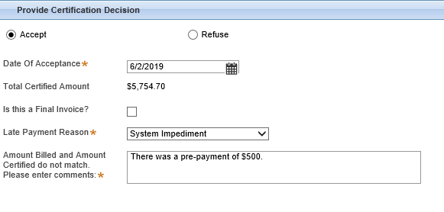

Figure 46. All fields entered

1. Select **Submit**.

You are asked to verify that you are authorized to certify this invoice (see Figure 47).

1. If you are overriding an error or if you’ve selected Final Invoice, a warning displays in this authorization window.

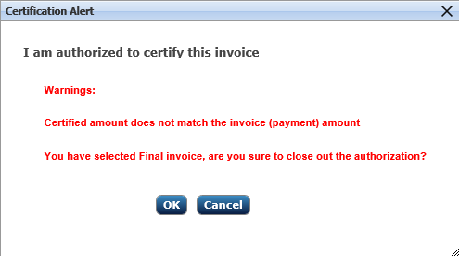

Figure 47. Authorized to certify

1. Click **OK**.

The system processes the certification and the invoice no longer displays in your Work List.

#### Refusing an Invoice

1. From the open invoice screen, select **Refuse** in Provide Certification Decision.

The refusal reason field displays (see Figure 48).

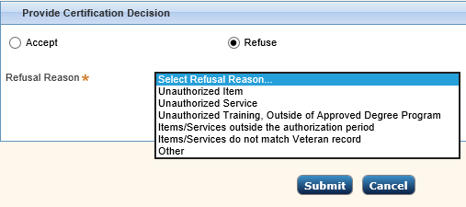

Figure 48. Refuse invoice

1. Select a reason from the dropdown list for refusing the invoice. If you select **Other**, you are asked for further information (see Figure 49). Enter the other reason in the Reasons text field.

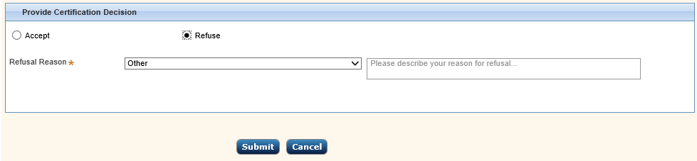

Figure 49. Other reason comments

1. Click **Submit**.

The invoice is archived, and a notification is sent to the vendor. It no longer displays in your Work List.

### High Dollar Invoices

Only the Supervisor, the RO Director, and the Director roles can certify high-dollar invoices.

#### Opening an Invoice

To process high dollar invoices:

1. Log into IPPS (see ***3.1 Logging In***).

The Supervisor or RO Director/Director My Work tab displays (see Figure 50).



Figure 50. Supervisor My Work tab

1. The RO Director and Director won’t see a Pending-Certification status as they don’t handle certifications.
2. If you have access to multiple stations, select the station for which you are processing invoices (see Figure 51).

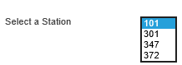

Figure 51. Stations dropdown

Certification Status for high dollar invoices shows Pending-HighValueInvoiceReview.

1. Click on the invoice you want to process.

The certification details screen displays (see Figure 52).

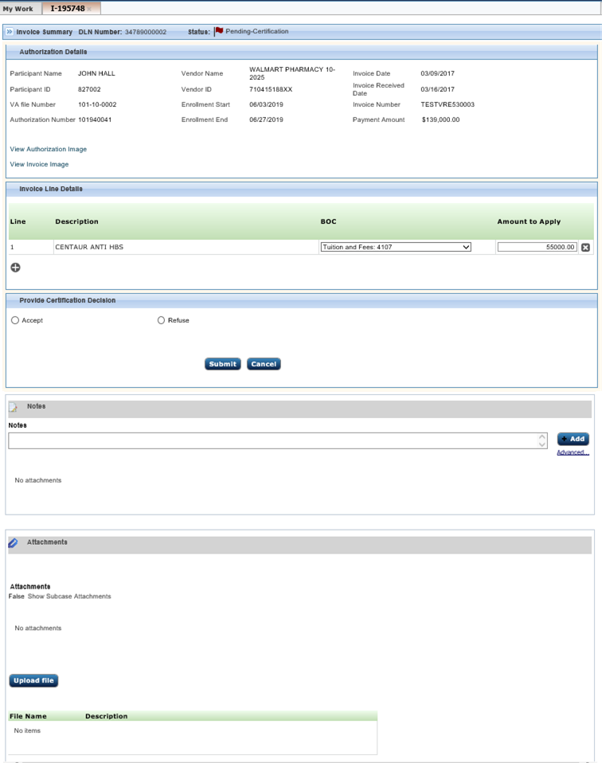

Figure 52. Certification screen

#### Certification Screen

Parts of the Certification screen include:

* Audit Link – provides a history of the invoice (see ***4.10 Viewing Audit Information***). This is hidden by default, but can be seen by selecting the link.
* Invoice Summary – contains metadata submitted from IPPS and is collapsed by default. You can view this information by clicking on the chevrons. This includes:
* Document Locator Number (DLN) Number - the unique ID of every invoice in IPPS
* Status of the invoice (see ***Appendix A List of Status Conditions*** for a list of possible statuses)
* Authorization Details – this area is pre-populated from the invoice and authorization. There are also links to open the Authorization and Invoice images.
* Authorization Details – this area displays pre-populated information from an invoice or authorization.
* Reviewer History – this area displays actions taken by previous reviewers.
* Invoice Line Details – this area displays the items that were entered by the service provider in Tungsten, a dropdown list for their Budget Object Code (BOC), and the amount for each line item.
* Provide Certification Decision – this area allows you to Accept or Refuse the invoice (or return it to the reviewer for high-dollar invoices). Based on your role, and the dollar value of the invoice you will see actions described in Table 4.
* Notes and Attachments – these areas allow for additional notes or attachments to be filed with the invoice. See also ***4.9.3 Notes and Attachments***.

Table 4. Certification actions

| **IPPS Role** | **High Dollar Invoice Certification Action** |
| --- | --- |
| VR&E Supervisor | * Accept * You only see Accept if you are the final approver or if this is the original review when the invoice status is Pending-Certification. * Refuse - archives the invoice and sends a notification to the vendor with the reason for refusal.   or   * Recommend Accept * Return to Reviewer – the invoice is returned to the original invoice reviewer. |
| VR&E RO Director | * Accept   You only see Accept if you are the final approver or if this is the original review when the invoice status is Pending-Certification.   * Refuse   or   * Recommend Accept   Recommendation for approval must always be routed directly to the Director role.   * Return to Reviewer   Return to Reviewer must always be returned to the original invoice reviewer. Invoice status is Pending-HighValueInvoiceReview. |
| VR&E Director | * Accept * Refuse * Return to Reviewer   Return to Reviewer must always be returned to the original invoice reviewer. Invoice status is Pending-HighValueInvoiceReview. |

#### Processing a High Dollar Invoice

To process an invoice with a value over the threshold for a certifying official, the invoice must first be recommended for acceptance which sends the invoice upward in the approval chain. If the next certifying official does not have authority to approve the dollar amount, they recommend acceptance as well until the invoice finally ends up on the desk of the certifying official that does have authority over this amount. For the amounts each role can certify up to, see ***Table 3. IPPS High Dollar Thresholds***.

##### Recommending Accept

If this is out of the certifying official’s threshold for acceptance, the “Recommend Accept” radio button displays. To recommend a high dollar invoice for approval, the Supervisor and, potentially. the RO Director complete the following steps:

1. Review the invoice and ensure the Invoice Line details are correct (see Figure 53).

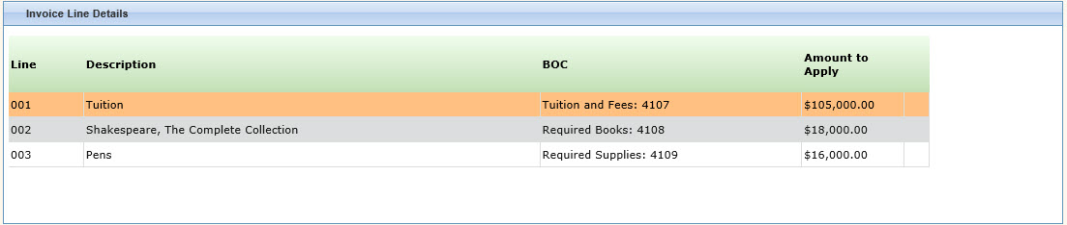

Figure 53. Invoice Line Details

1. Select **Recommend Accept** in Provide Certification Decision.

Some additional information displays (see Figure 54).

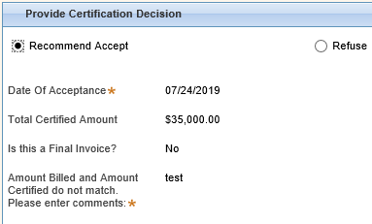

Figure 54. Additional Approval Information

1. Review the information displayed, and if there are no changes click **Submit**.
2. If changes are required, see **4.9.2.5 Return to Reviewer**.

The system processes the invoice and routes it to next higher role in the system. The invoice no longer displays in your Work List. It is listed as Pending-HighValueInvoiceReview in the Work List of the approver.

##### Accepting the Invoice

To accept a high dollar invoice, complete the following steps:

1. Every invoice is in Pending-Certification or Pending-HighValueInvoiceReview status. If the invoice is in Pending- Certification status, it is editable. If the invoice is Pending-HighValueInvoiceReview it’s read only. If the fields are editable, select from a list of possible entries for the BOC and update amounts to apply into the Amount to Apply field. You can also delete a line item by selecting the trashcan to the right of the Amount to Apply field (see Figure 55).

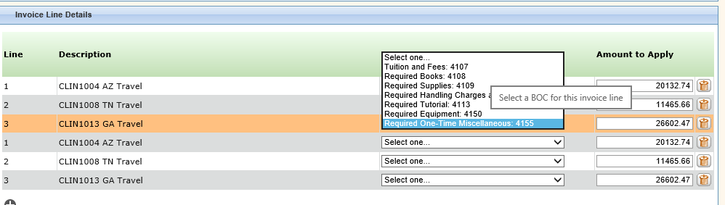

Figure 55. Budget Object Code and Amount entry

1. Select **Accept** in Provide Certification Decision.

Depending on the condition of the invoice, additional fields may display (see Figure 56). If it’s late or if amounts mismatch and so on, you are asked to provide further information. At a minimum, you are asked for the Date of Acceptance and a checkbox is provided if this is the final invoice to be approved for this vendor.

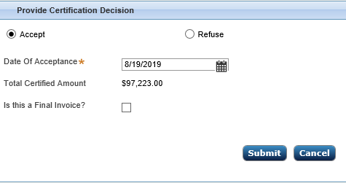

Figure 56. Accepting an Invoice

1. Enter all mandatory fields.

* Date of Acceptance: this field auto populates with the current date, but you can also enter the date in mm/dd/yyyy format or use the Calendar to select dates (see ***4.7.3.1 Using the Calendar Tool***).
* Verify the total certified amount.
* If this is a final invoice and no further processing will be done, select the checkbox next to “Is this a final invoice” (see Figure 60). This prevents the vendor from sending another invoice under the same authorization.

1. Authorizations can be based on various criteria (for every semester, for every fiscal year, and so on. If you select final, you are saying that this is the final invoice for the semester or fiscal year or other criteria upon which the authorization was based.

After submission, a status of Final shows when My Authorizations is selected (see Figure 57).



Figure 57. Final Status

* If displayed, enter a Late Payment Reason from the dropdown list (see Figure 58).



Figure 58. Late Payment Reason

* If displayed, enter required notes in Amount Billed and Amount Certified do not match field (see Figure 59).



Figure 59. All fields entered

1. Select **Submit**.

You are asked to verify that you are authorized to certify this invoice (see Figure 60).

1. If you are overriding an error or if you’ve selected Final Invoice, a warning displays in this authorization window.



Figure 60. Authorized to certify

1. Click **OK**.

The system processes the certification and the invoice no longer displays in your Work List.

#### Refusing the Invoice

To refuse a high dollar invoice, complete the following steps:

1. From the open invoice screen, select **Refuse** in Provide Certification Decision.

An additional field displays (see Figure 61).

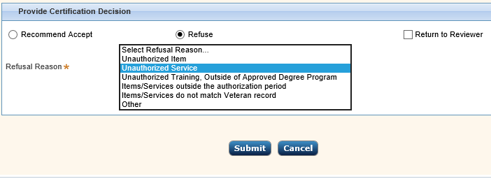

Figure 61. Refuse invoice

1. Select a reason from the dropdown list for refusing the invoice. If you select **Other**, you are asked for further information (see Figure 62). Enter the other reason in the Reasons text field.

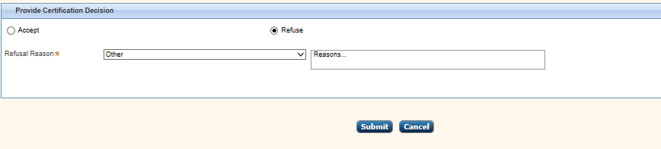

Figure 62. Other reason comments

1. The Refusal Reason and any notes are displayed in the email sent to the service provider.
2. Click **Submit**.

The invoice is archived, and a notification is sent to the service provider. It no longer displays in your Work List.

#### Return to Reviewer

If the next level approver feels the invoice needs to be adjusted, complete the following steps.

1. From the certification screen, select **Return to Reviewer** in Provide Certification Decision.

A Return to Reviewer text field displays for comments (see Figure 63).

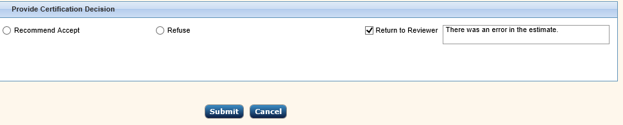

Figure 63. Return to Reviewer

1. List the reason the invoice is being returned in the text field.
2. Click **Submit**.

The system processes the invoice and routes it to the original reviewer. It no longer displays in your Work List.

### Notes and Attachments

At the bottom of the Certification screen is an area for Notes and Attachments (see Figure 64).

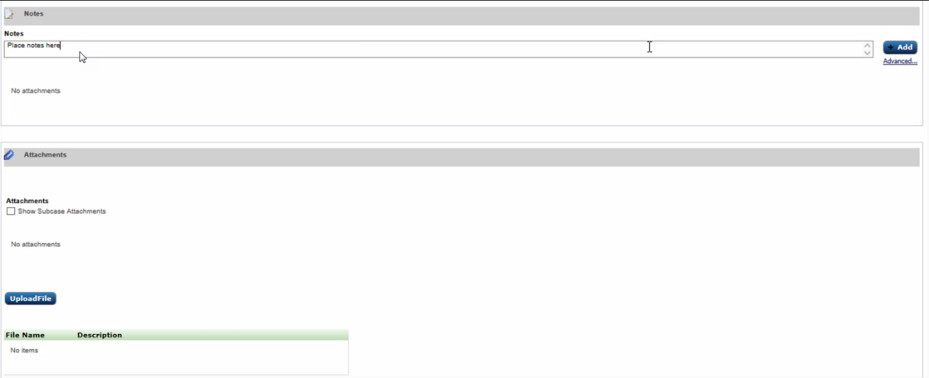

Figure 64. Notes and Attachments

#### Adding Notes to an Invoice

This area allows you to provide comments. To add notes:

1. Enter comments in the Notes field.
2. Click **Add**.

Notes are added to the invoice (see Figure 65).

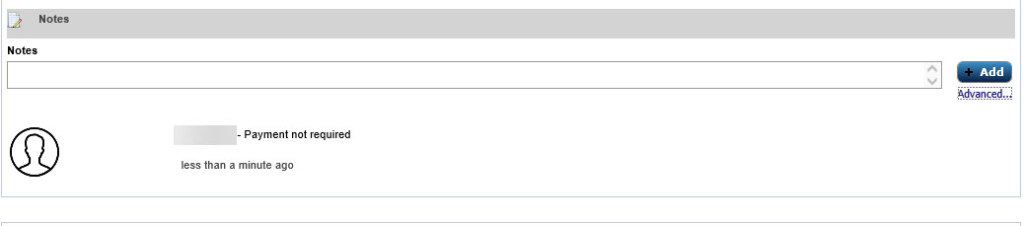

Figure 65. Notes added

#### Advanced Notes

To add a subject to your notes, complete the following steps:

1. Click the **Advanced…** link just under the Add button (see Figure 66).

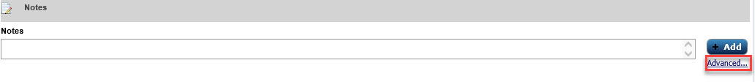

Figure 66. Advanced Link

You are prompted for further information (see Figure 67).

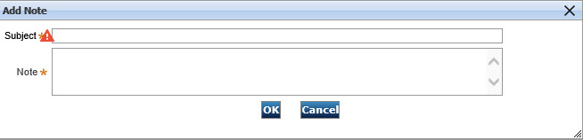

Figure 67. Add Note Information

1. Enter a subject for the note in the Subject field and contents of the note in the Note field.
2. Click **OK**.

The note is added to the invoice (see Figure 68).



Figure 68. Notes added

#### Adding Attachments to an Invoice

This area allows you to upload documents. To upload a document:

1. From the Attachments section, click **Upload file**.
2. Browse to the file you want to upload (read only .pdf or TIFF files with no password restrictions).
3. Enter a description for the file (see Figure 69).

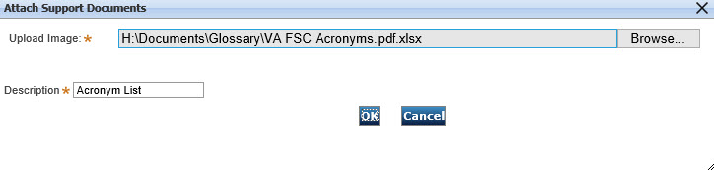

Figure 69. Attach Support Documents

1. Click **OK**.

The file is uploaded and saved to the Invoice (see Figure 70).

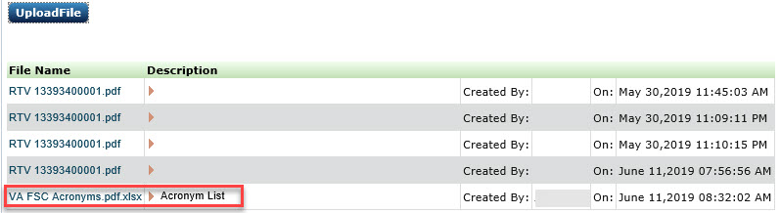

Figure 70. File Uploaded

## Viewing Audit Information

1. From the Certification screen, click **Audit** (see Figure 71).

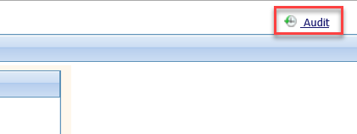

Figure 71. Audit Link

The audit details basic view displays (see Figure 72). This screen shows a detailed outline of when the action was taken, what action was taken, and who took the action.

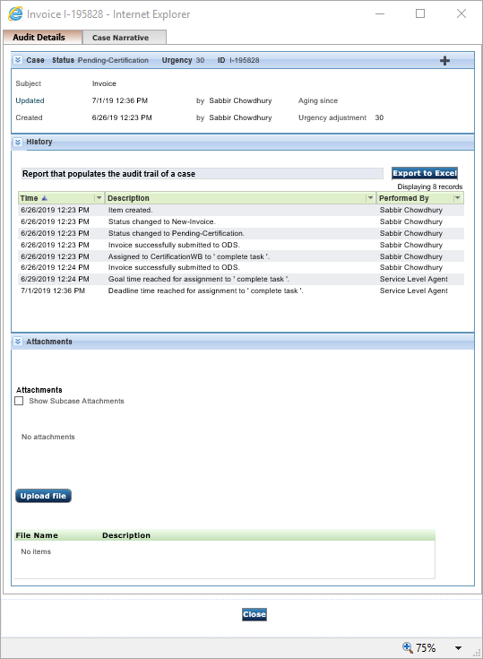

Figure 72. Audit Details

1. To view attachments or upload files, click the double chevron (chevron icon) next to Attachments to expand the listing (see Figure 73).

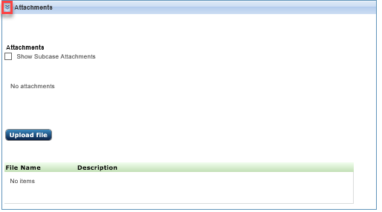

Figure 73. Attachments

From this listing you can add, view, or delete attachments.

1. When finished viewing the Audit tab, click **Close**.

## Viewing Case Narrative

To see comments left by the Certifying Official, select the Case Narrative tab (see Figure 74).

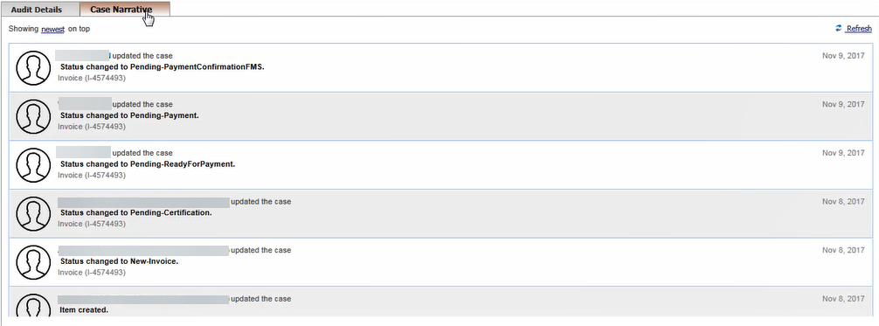

Figure 74. Case Narrative tab

When finished viewing the Case Narrative tab, click **Close**.

## Site Administration

This section discusses features available to the Site Administrator.

### My Work

The Site Administration My Work tab provides information on invoices that require administrative action. The Site Administrator does not have security permissions to open the invoices, but they can reassign unassigned invoices on the My Work tab.

1. If you are a site administrator, log into IPPS (see ***3.1 Logging In***).

The Site Administrator screen displays with the unassigned invoices listed in the My Work tab (see Figure 73).

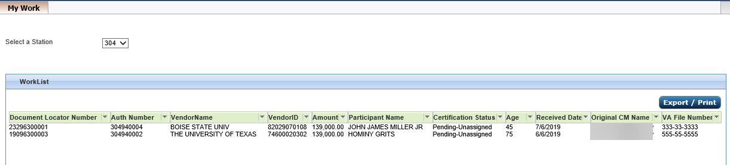

Figure 75. Site Admin My Work tab

1. To export or print the information in the My Work tab, see ***3.3 Exporting/Printing the Work List***.

### User Administration

User Administration is only available for the Site Administrator role. In this role, you can:

* add a new user
* reassign authorizations
* change roles
* assign stations
* reactivate disabled users
* delete users

To get to the User Management screen, click **User Administration** from the left navigation pane.

The User Management screen displays (see Figure 76).

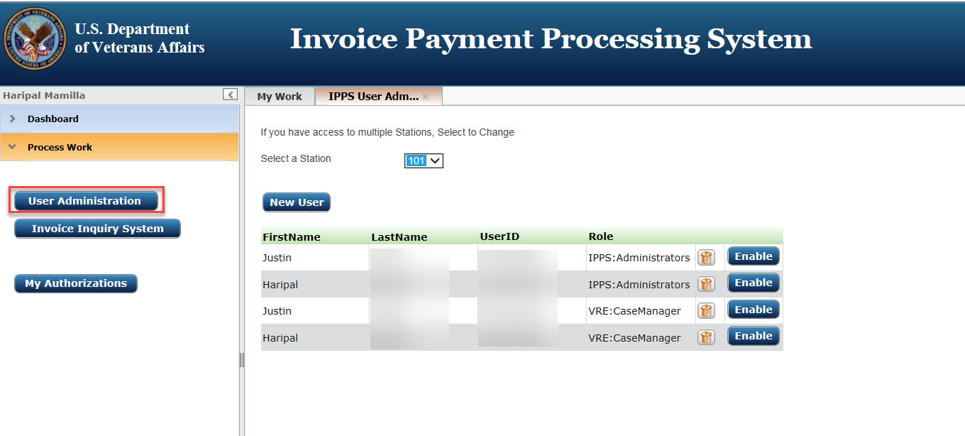

Figure 76. User Management screen

### Adding a User

To add a new user:

1. From the User Management screen (Figure 76), click **New User**.

The User Details window displays (see Figure 77).

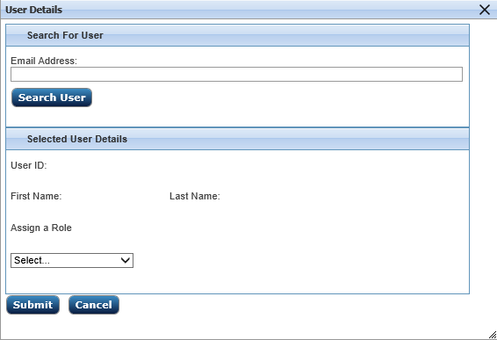

Figure 77. User Details window

1. Enter the user’s VA email address in the Email Address field
2. Click **Search User**.

Data is retrieved from the VA’s global address listing (GAL). This populates the user’s name and user ID fields. In addition, any authorizations assigned to the user display (see Figure 78).

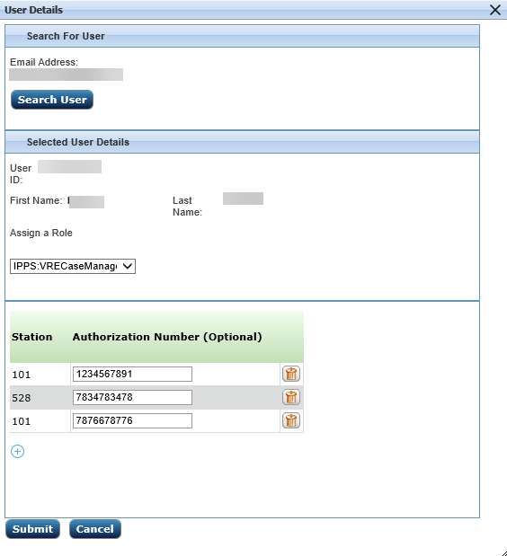

Figure 78. User Details window

1. Confirm the user’s details are correct.
2. Complete steps in ***4.12.3.1*** ***Assigning a Role***, ***4.12.3.2 Adding Authorizations***, and ***4.12.7 Re-assigning an Authorization Number*** as needed.
3. Click **Submit**.

The user is added to the IPPS User Administration screen.

1. If a user already exists in the system, a notification displays (see Figure 79).

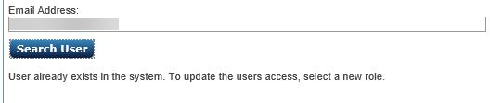

Figure 79. User Already Exists notification

#### Assigning a Role

Users can only have one role even if assigned to two different stations. If you are changing the role of the user, the station number carries over to the new role.

To assign a role to a user:

1. Select the role the user is to perform from the dropdown menu in the Assign a Role field of the User Details window (see Figure 80).

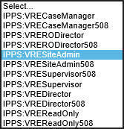

Figure 80. Role field dropdown list

1. If a user has transferred from a different VA station, they must be deleted from their previous station and added by their new site admin to their correct User ID.
2. Select **Submit** to complete the entry.

#### Adding Authorizations

To add an authorization assignment, complete the following steps:

1. Authorization Number is an optional field unless you are reassigning an authorization to a user.
2. From the bottom of the User Details screen, select the plus sign (see Figure 81).

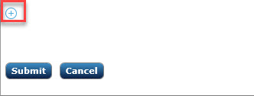

Figure 81. Plus sign

A new line displays at the bottom of the screen (see Figure 82).

Authorization details

Figure 82. Authorization details

1. Authorization number is read only for the roles of VRE Director, VRE RO Director, and for corresponding 508 roles.
2. If this is a new user, select the station and leave the Authorization Number to the defaulted value. The only exceptions to this are: a) if you are a VRE Director, VRE RO Director, and for corresponding 508 roles, you must enter an Authorization Number and b) if the user doesn’t have any authorizations assigned yet, one must be assigned.
3. Select a Station number from the Station dropdown list.
4. Enter the Authorization Number in the blank field to the right of the Station Number.
5. Select **Submit** to complete the entry.

### Removing a User

If a user has transferred from a different VA station, they must be deleted from their previous station and added by their new site admin to their correct User ID.

To remove a user from the IPPS user list:

1. From the User Management screen, click the trashcan icon next to the user you want to remove (see Figure 83).

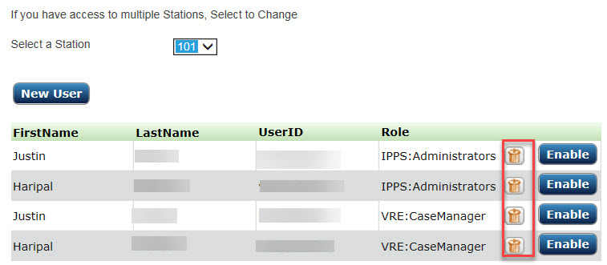

Figure 83. Remove User

You are asked to confirm the deletion (see Figure 84).

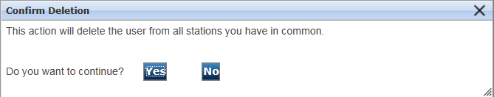

Figure 84. Confirm Deletion

1. Select **Yes**.

The user is deleted from the list.

### Reactivating a User

If a user has not logged into IPPS in the last 90 days, that user no longer has access to the system. If this is the case, when you view the user in User Management, the Enable button is active rather than grayed out. For the user to regain system access:

1. From the User Management screen, click the Enable User button next to the user you want to enable (see Figure 85).

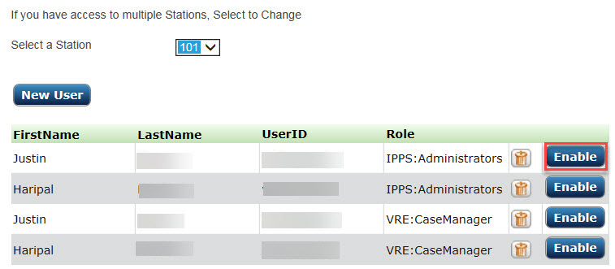

Figure 85. Enable User

1. Click **OK**.

The user is now able to access IPPS.

### Deleting User-Assigned Authorizations

To delete authorizations for a user:

1. Double click the user’s name from the IPPS User Administration screen (see Figure 86).



Figure 86. IPPS User Administration screen

A User Details window displays.



Figure 87. Authorization list

1. Click the trashcan to the right of the authorization you want to remove from the user.

The Authorization is deleted from the window.

1. Select **Submit**.

Your changes are saved.

### Re-assigning an Authorization Number

To re-assign an authorization number to another user, complete the following steps:

1. Double click the user’s name from the IPPS User Administration screen (see Figure 88).



Figure 88. IPPS User Administration screen

A User Details window displays (see Figure 89).

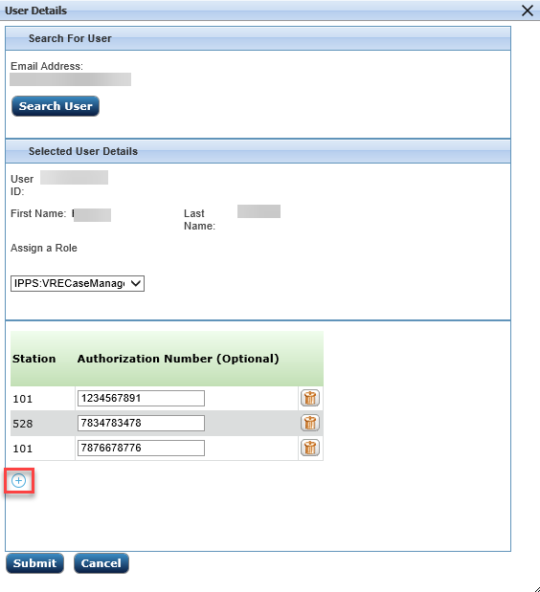

Figure 89. Authorization list

1. Click the “+” icon at the bottom of the window.

A blank line appears for the authorization you want to add (see Figure 90).

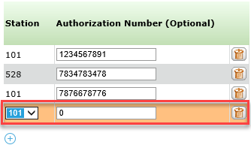

Figure 90. New Authorization Number entry field

1. Choose the Station number associated with the Authorization Number from the dropdown list.
2. Enter the Authorization Number in the Authorization Number Field.
3. Click **Submit**.

The new Authorization Number is added to the list of Authorizations for this user (see Figure 91).

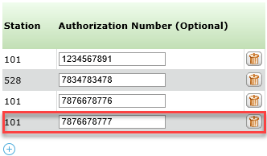

Figure 91. New Authorization included

## Invoice Inquiry System (IIS)

The IIS component is used to run searches for payment history, work in process, or invoices that are resolved or archived. To get to IIS, click **Invoice Inquiry System** from the Process Work section ofthe left navigation bar. The IIS tab displays (see Figure 92).

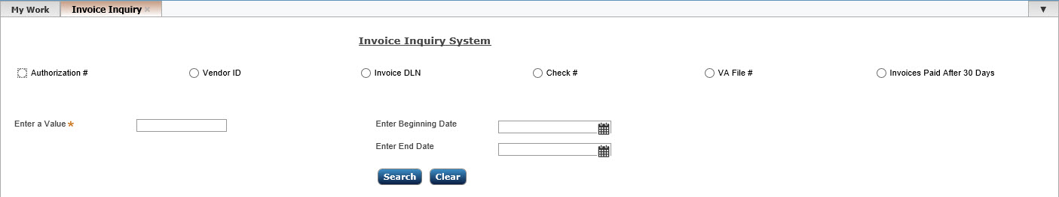

Figure 92. IIS tab

The following search options are available from IIS:

* Authorization #
* Vendor ID
* Invoice DLN (unique number in IPPS)
* Check #
* VA File #
* Invoices Paid After 30 Days

1. Once the Invoice Status search type is selected, enter the following additional query parameters:

* a value for the selected type (required)

1. Additional fields may display depending on the option type you select.

* a Beginning Date for the check number (optional)
* an End Date for the check number (optional)

1. To clear the search entry fields, click **Clear**.
2. Click **Search**.

Search results display (see Figure 93).

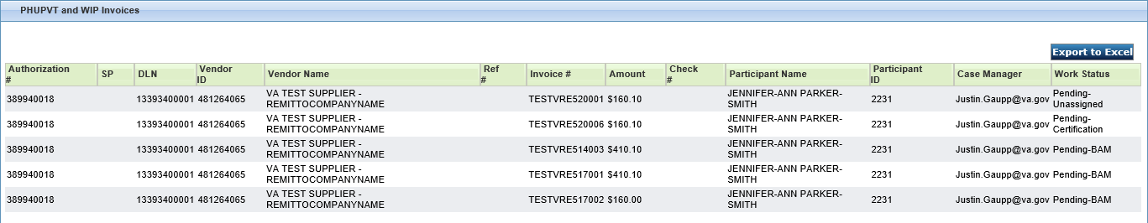

Figure 93. Invoice Status Search Results

See Table 5 for a description of the information on the screen.

Table 5. Invoice Results

| Column Title | Entry/Description |
| --- | --- |
| Authorization # | Authorization ID number |
| SP | This is a two-digit alphanumeric number that is unique for each payment. It translates to the reference number. For example, if the reference number is IT 595C9000010, then SP = 10. |
| DLN | Document Locator Number, the unique identifier for the invoice in IPPS |
| Vendor ID | Assigned number for the vendor |
| Vendor Name | Name of the vendor assigned to the authorization. |
| Ref # | This is an alphanumeric accounting reference number that tells which invoice the payment came from and which section it came from. |
| Invoice Number | Invoice Number associated with the Authorization |
| Amount | Amount of the invoice |
| Check # | If an invoice has been paid, a seven-digit Check Number is displayed. A check date should also display in the Check Date field. A check number beginning with a “Z” means the payment was fully offset by an FSC Bill of Collection. The invoice should be considered paid in full. |
| Participant Name | Name of the participant associated with the Purchase Order (PO) |
| Participant ID | Unique ID assigned to the participant |
| Case Manager | The Case Manager associated with the PO |
| Work Status | This column displays the status of processing |
| Age in Days | This is the number of days since IPPS received the Invoice.  This only displays in results for Invoices Paid After 30 Days. |

1. Double-click the invoice you want to view.

The invoice certification details display (see Figure 94) as well as an image of the invoice.

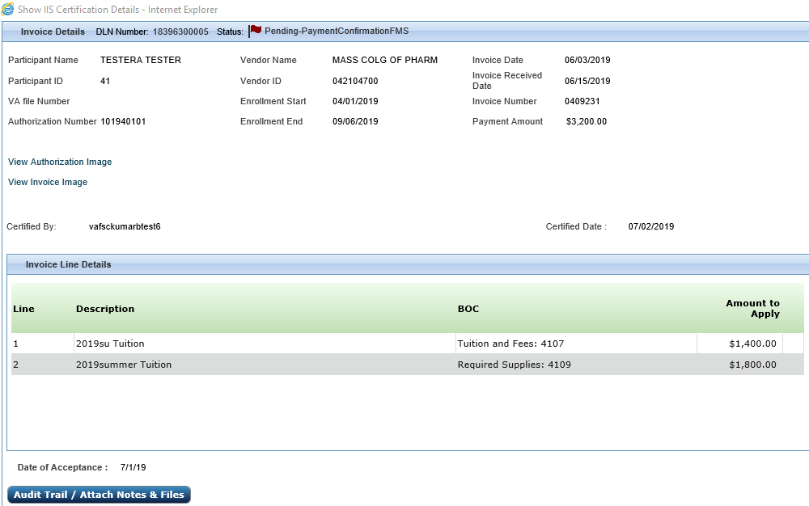

Figure 94. Invoice Certification Details

From this screen, you can:

* View Invoice Details
* Click **Audit Trail/Attach Notes & Files.** From here, you can:
* View Audit Details
* View Case Status by clicking the double chevrons to expand the area
* View History by clicking the double chevrons to expand the area
* View Attachments by clicking the double chevrons to open the area

Upload attachments by clicking **Upload file** (see ***4.9.3.3 Adding Attachments to an Invoice*** for more information)

* View Case Narrative (see ***4.11 Viewing Case Narrative*** for more information)
* Click **Close** to return to the previous screen

## Dashboard

The dashboard provides users with the status of payment processing in the system. There are three categories displayed:

* Invoices Pending Certification Over 14 Days
* Invoices Pending Certification Greater Than or Equal to 30 Days
* All Pending Invoices

1. To view the Dashboard, select **Dashboard** from the left navigation panel.

The charts display (see Figure 95).

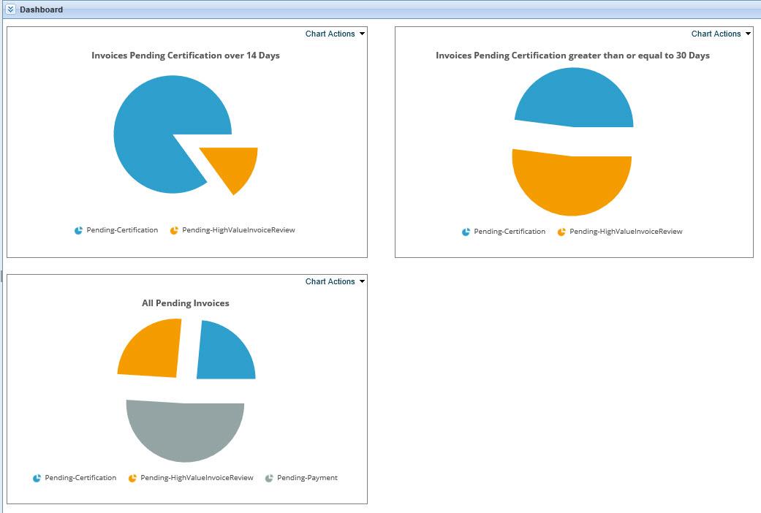

Figure 95. Dashboard

You can hover over the images to show the percentage of invoices in that category (see Figure 96).

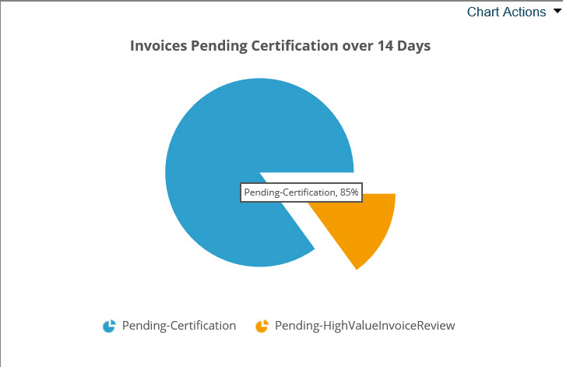

Figure 96. Percentage of Invoices

The charts have a dropdown menu selection. See the following section for more information.

### Chart Actions

To show chart data, complete the following steps:

1. Select **Show Data** from the Chart Actions dropdown (see Figure 97).

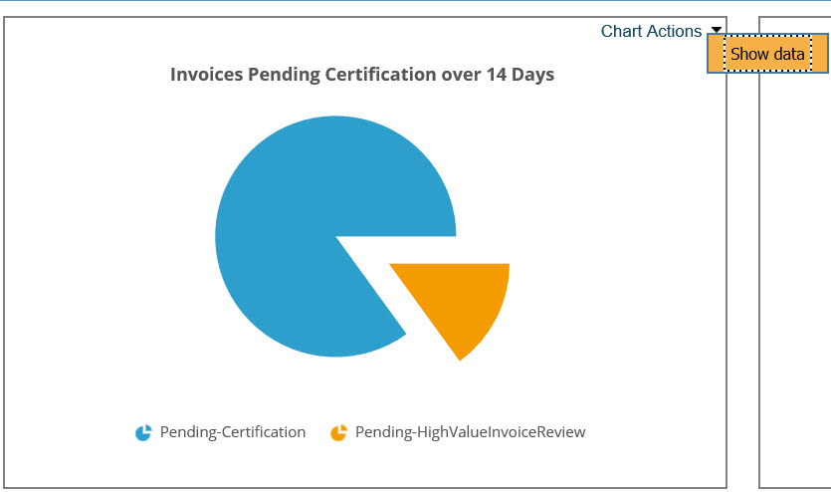

Figure 97. Show data

Fields associated with the chart display (see Figure 98). This is the number of days since IPPS received the Invoice.

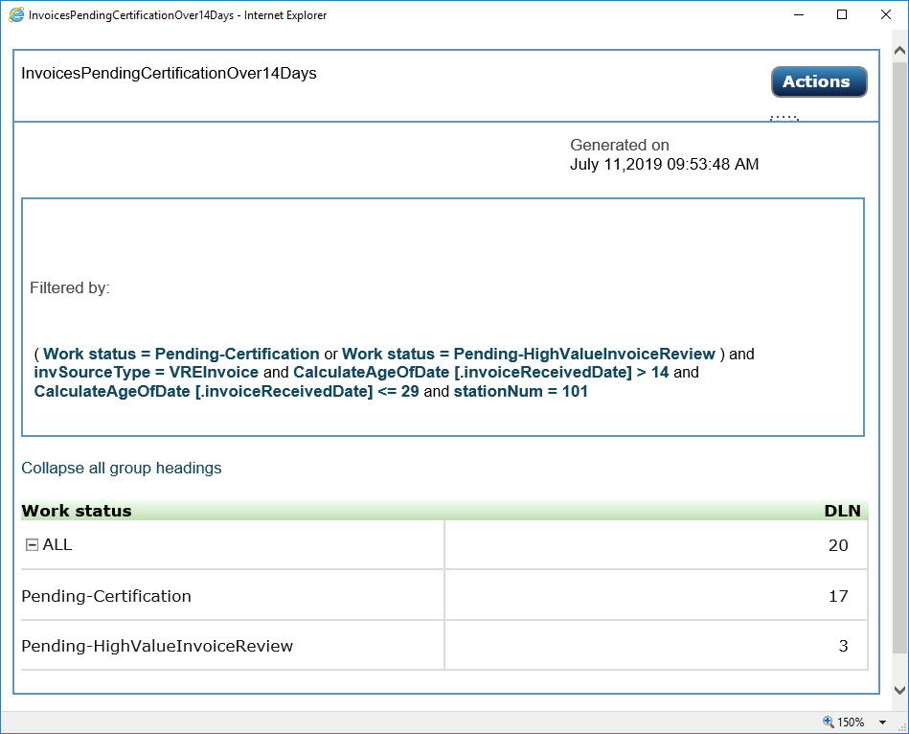

Figure 98. Show data fields

1. Click an entry in the first column to drill down further into details (see Figure 99).

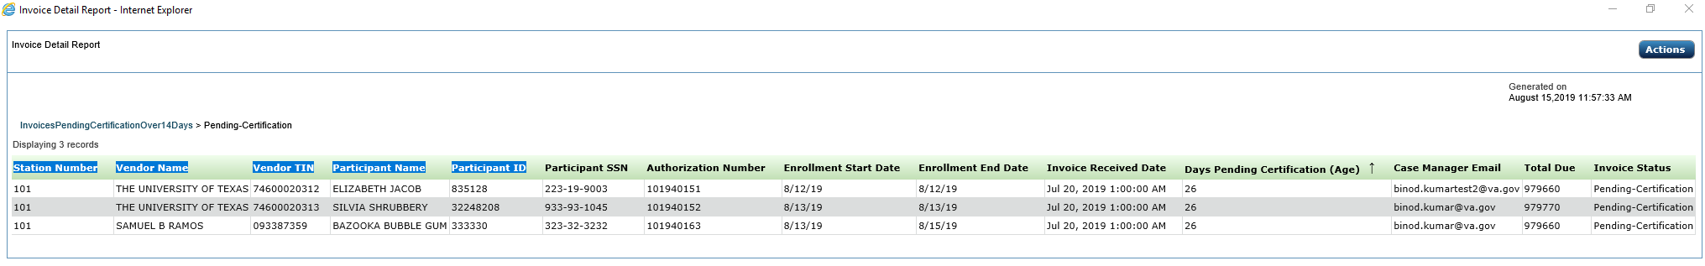

Figure 99. Drill down report

1. Click the **Action** button to print or export the report (see***4.16 Actions Button***).

## Monitor Activity

The Monitor Activity section of IPPS, like the Dashboard, allows users to retrieve data to monitor the health of a station’s invoice processing.

1. Results are filtered to the station(s) the user has access to.
2. To use this option, click **Monitor Activity** from the left navigation pane.

A report list displays (see Figure 100).

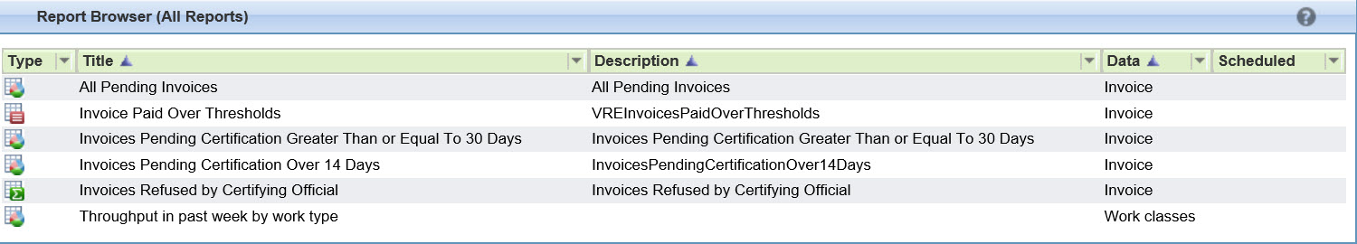

Figure 100. Monitor Activity listing

Reports available include:

* All Pending Invoices
* Invoice Paid Over Thresholds
* Invoices Pending Certification Over 30 Days
* Invoices Pending Certification Over 14 Days
* Invoices Refused by Certifying Official
* Throughput in the Past Week by Work Type

### Viewing a Report

To view a report, complete the following steps:

1. Double-click the report you want to view.

After a minute or so, the report displays in a new window on your screen (see Figure 101 for an example).

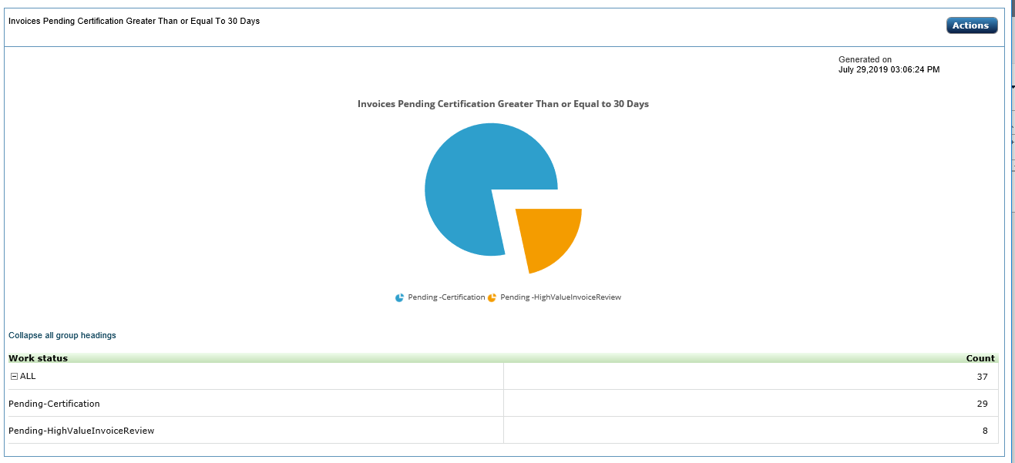

Figure 101. Sample report

1. You can drill down into the report by double-clicking the heading in the Work Status area for the desired detailed report.

The detailed report displays (see Figure 102).

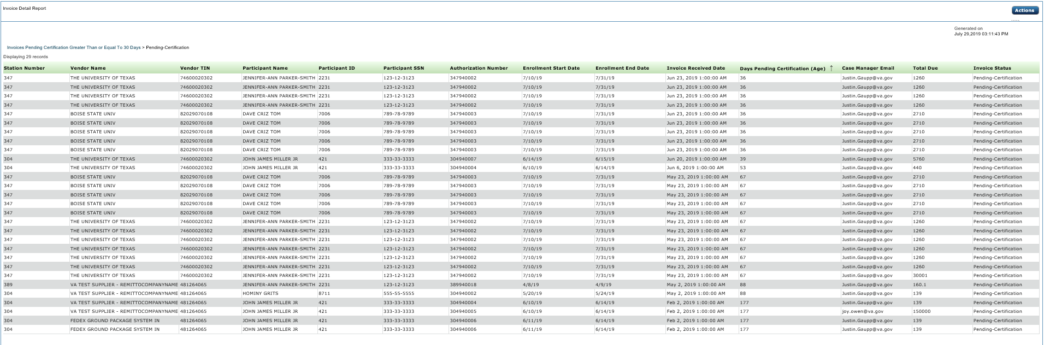

Figure 102. Example of a detailed report

1. To export or print the report (or perform other functions related to reporting), see ***4.16 Actions Button***.

## Actions Button

When the Action button displays (see Figure 103), it allows for further report manipulation.

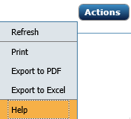

Figure 103. Actions button

Features available are described in Table 6.

Table 6. Action Button Options

| Selection | Action |
| --- | --- |
| Refresh | Refreshes data on the screen |
| Print | Allows you to print the report |
| Export to PDF | Allows you to export to PDF |
| Export to Excel | Allows you to export to Excel |
| Help | Provides context-sensitive help |

# Exporting to Excel

You can export data to Excel whenever the Export to Excel button displays on a page.

1. If you see the Export to Excel button, click it (see Figure 104).

This graphic displays the Export to Excel button

Figure 104. Export to Excel

You are asked if you want to open or save ExportData.xls (see Figure 105).

This shows a prompt to open or save the Excel document.

Figure 105. Open or Save prompt

1. Click **Open** to view the document or **Save** to save the document to your computer.
2. Another way to export to Excel is by selecting **Export to Excel** from the dropdown list for an Action button (see **4.16 Actions Button**).

# Troubleshooting

In this section, you’ll find troubleshooting procedures for system errors.

## User or Access Issues

### Error When Logging In

If you fail to log off, you may encounter a screen error when you try to re-enter IPPS.

To clear the error, select **File > New Session** from your IE11 browser and try again.

### Log-in Error Persists

Access is granted with a provisional 90-day activity window. If you do not log into IPPS within a 90-day period, your account is deactivated. Contact your Site Administrator.

To locate your local IPPS administrator:

1. Go to <https://vaww.ipps.fsc.va.gov/prweb/PRWebLDAP1/>.

An Authorized Use warning displays (see Figure 106).

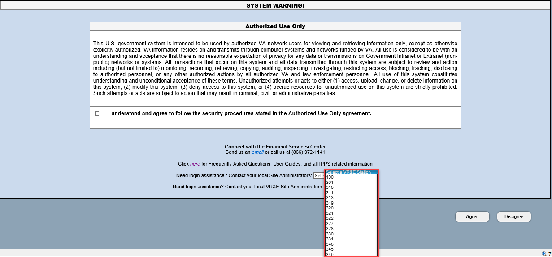

Figure 106. Authorization Notice

1. From the “Select a VR&E Station” dropdown box, select your station.

A list of site administrators displays for your station (see Figure 107).



Figure 107. Example list of administrators

## Turning Compatibility Settings Off

IPPS must be used with IE 11, and your compatibility settings should be blank. If your compatibility settings are turned on, an error message displays saying you are using an unsupported browser.

To turn compatibility settings off:

1. Close IPPS.
2. From Internet Explorer, go to the tools widget and select **Compatibility View** **Settings**.

The Compatibility View Settings window displays.

1. If any websites are listed in the Compatibility View area, select them and click **Remove**.
2. If any checkboxes are checked, clear them.
3. Select **Close.**
4. Open IPPS.

The screen should display correctly without error.

# Acronyms

| Acronym | Description |
| --- | --- |
| BOC | Budget Object Code |
| DLN | Document Locator Number |
| EFT | Electronic Funds Transfer |
| FAQ | Frequently Asked Questions |
| FSC | Financial Services Center |
| GAL | Global Address Listing |
| IE11 | Internet Explorer 11 |
| IIS | Invoice Inquiry System |
| IPPS | Invoice Payment Processing System |
| PDF | Portable Document File format developed by Adobe |
| PIV | Personal Identity Verification |
| POC | Point of Contact |
| RO | Regional Office |
| SCO | School Certifying Official |
| TIFF | Tagged Image File Format – one of several formats for digital graphics |
| VA | Veterans Affairs |
| VA-ONCE | VA-ONCE is an application used by SCOs to submit VA Forms 22-1999, 22-1999b, and 22-6553c. |
| VBA | Veterans Benefits Administration |
| VR&E or VRE | Vocational Rehabilitation and Employment |

1. List of Status Conditions

* Pending-Certification
* Pending-HighValueInvoiceReview
* Pending-Unassigned
* Pending-PaymentConfirmationFMS
* Pending-ScheduledPayment
* Pending-VREFMSRejectionResolution
* Resolved-PaymentConfirmed
* Resolved-Archived