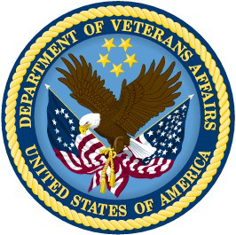 | DEPARTMENT OF VETERANS AFFAIRS  Veterans Benefits Administration  Office Information

Date

To

Subject: Veteran’s Name

Dear Sir,

Please be advised that Veteran’s Name is a participant in the Department of Veterans Affairs, Non-Paid Work Experience (NPWE) Program. He has been working in a NPWE as a Position Title with your Agency Name, since Date Started.

Veteran’s Name meets the criteria for the following Hiring Authorities:

VRA
VEOA
30% or More
Schedule A Appointing Authority
Disabled Veterans Enrolled in a VA Training Program

If you require any additional information I can be reached at VRC or EC contact information.

Sincerely,

EC Name
Employment Coordinator
Vocational Rehabilitation
and Employment Service

