VR&E SAHSHA Tip Guide
VR&E Housing Adaptation Grant & SAHSHA System Training (VA 4633274)

Contents
Overview 3
Registering 3
SAHSHA Tips 5

Overview
Below are steps to guide you as a first-time user in Loan Guaranty’s Special Adaptive Housing Special Housing Adaptation (SAHSHA) System. Also included are tips on navigating within SAHSHA once you have access.

Registering
What you do… | What the system displays…
- Navigate to the LGY Hub https://lgy.va.gov/lgyhub/ and bookmark website.  Click the [Sign In or Register for New Account] link to continue registering or logging into the LGY Hub. | 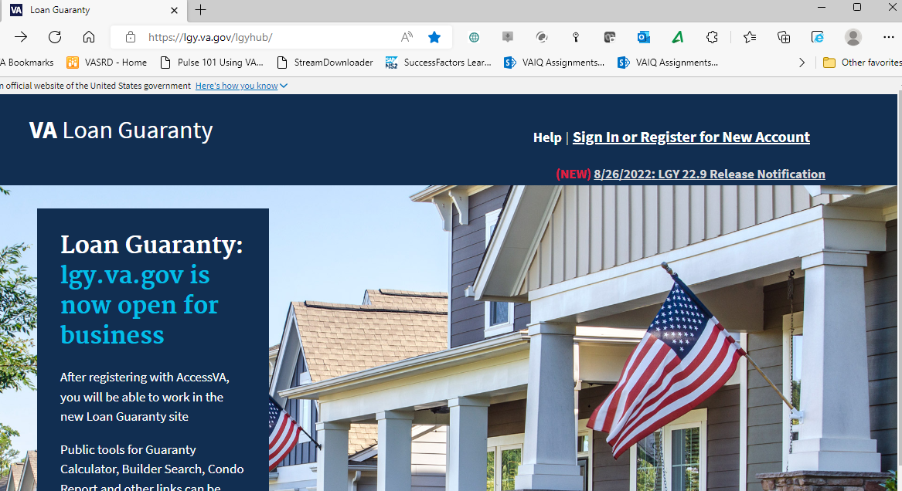
- Once registered or logged in, click on the [Help] option in the upper right corner under your name.  Scroll to the very bottom of the page to the blue [Submit a help ticket] button.  Then click on [Get help] | 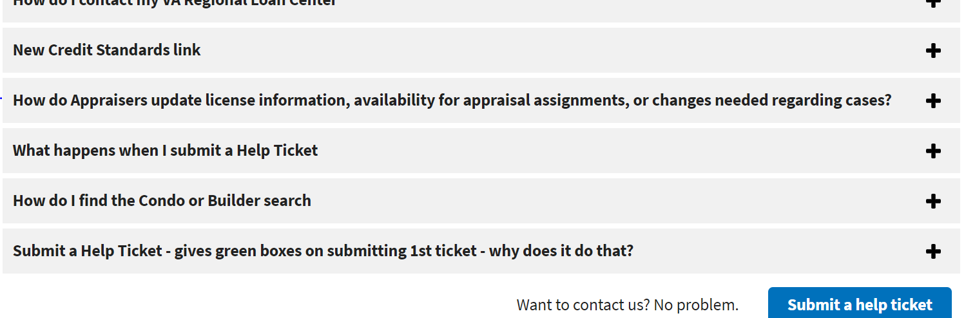  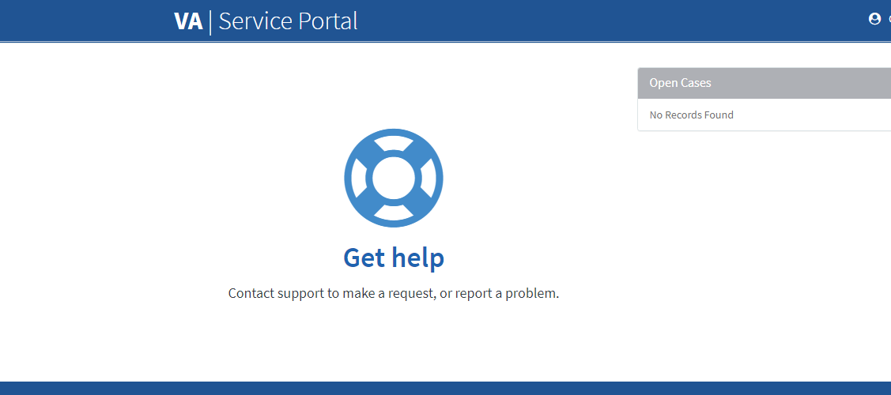
- The VA Service Portal will launch using your PIV card. The site will recognize you are a Registered User LGY asking for support and will import your personal information. Confirm your information is correct. Answer the required fields per the following:  *Are you having trouble logging in or registering for a VA LGY Product (VALERI, LGYHub, FFPS)? No, I’m logged in but have another issue.  *What product are you trying to access or have experienced a problem with? SAH (Specially Adaptive Housing)  *Category. Access Request (VA Employee) for various LGY applications and roles.  *Is there sensitive information? No.  *What is your role/affiliation with VA Loan Guaranty Systems? Other Role.  *Other Role(s). VR&E  *Description. Access to SAHSHA | 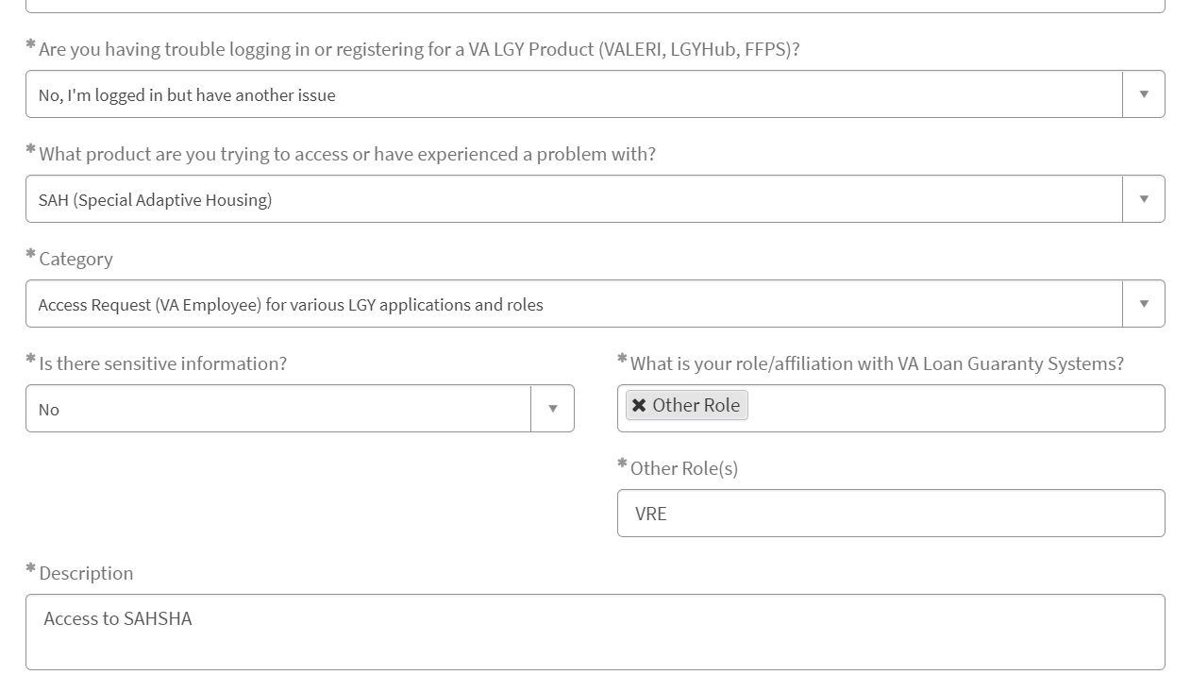
- Once you have been notified of access, log back in to the LGY Hub https://lgy.va.gov/lgyhub/.  Select the [SAH] tab on the left-hand side of the website to continue moving into the SAHSHA environment. | 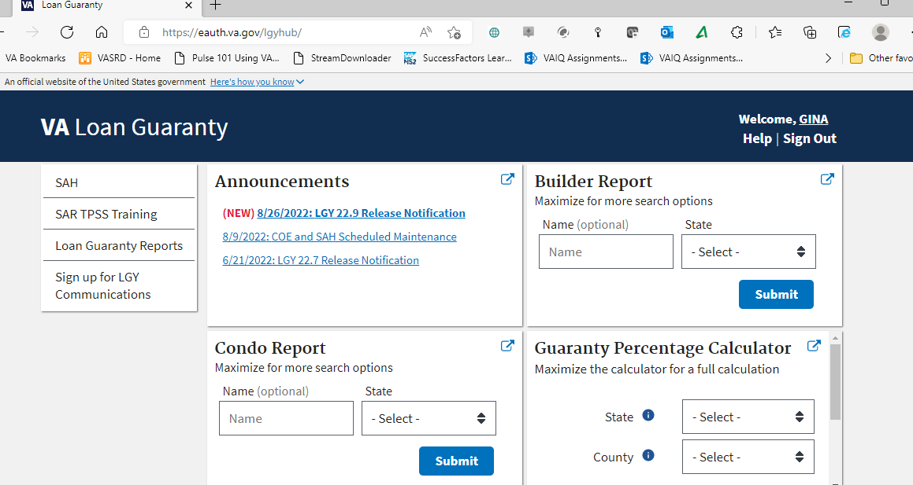

SAHSHA Tips
What you do… | What the system displays…
- This is initial screen for SAHSHA. You can see the recently accessed grants on the left-hand side column, or you can select the search button to locate your case. | 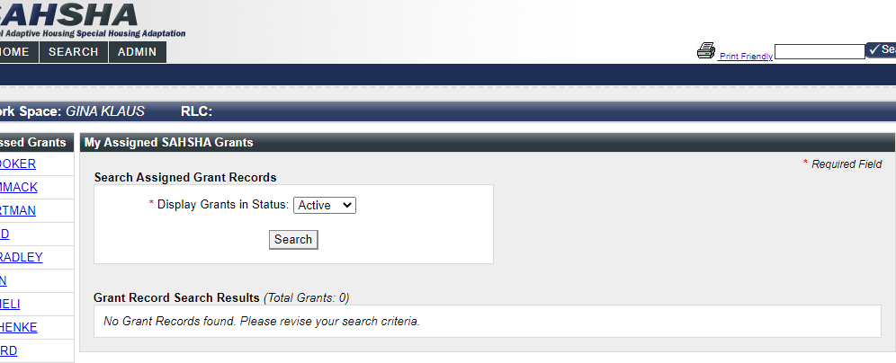
- This is the search field that will load. To locate your case, you can type by last name and search. You do not have fill out all the fields for the system to search cases. | 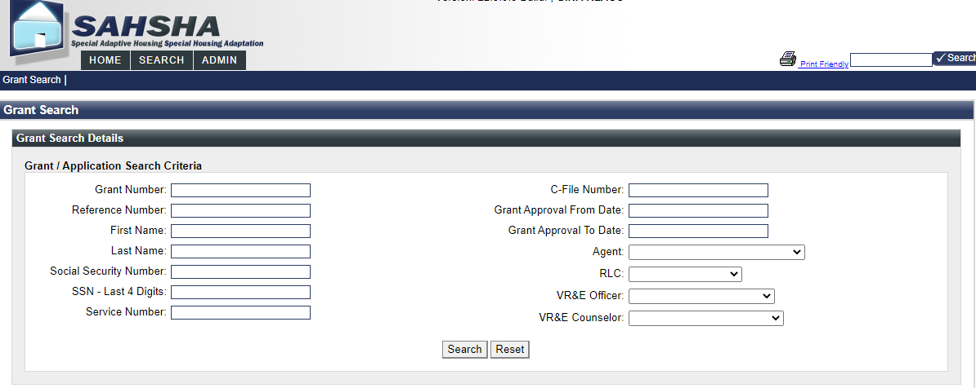
- The most frequent options you will use within a Grant Record are as follows:  - Use the [Notes] option to view current activities and enter a note to the SAH agent about the Veteran.  - Use the [Construction Bids / Contracts] option to view construction bids uploaded by the SAH agent to support the grant.  - Use the [Grant Approval] option to view the final costing and IL grant approval notes that the SAH agent enters.  - Use the [Inspections / Field Review] option to view the field review and inspections information.  - Within the [Docs/Correspondence] option, you can view all grant-related documents that both you and the SAH agent upload, such as the signed plan, closure letters or other necessary materials for the grant. The VRC must note in SAHSHA the document type such as the IILP, scope of work or closure letter. | 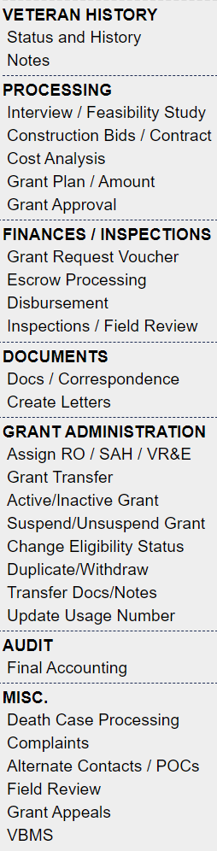  5  1  2  3  4
- This is the [Enter New Grant Note] page.  - Please do not check any of the check boxes.  - You can add a note within the text field and click [Submit].  - It will add your name as the person who submitted the note. | 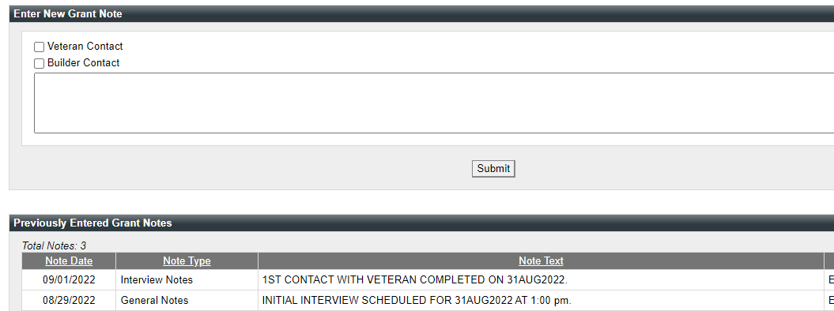
- This is the [Enter New Grant Document/Correspondence] page.  - The [Received Date] field and [Correspondence Type] field will be blank when you first add a document. | 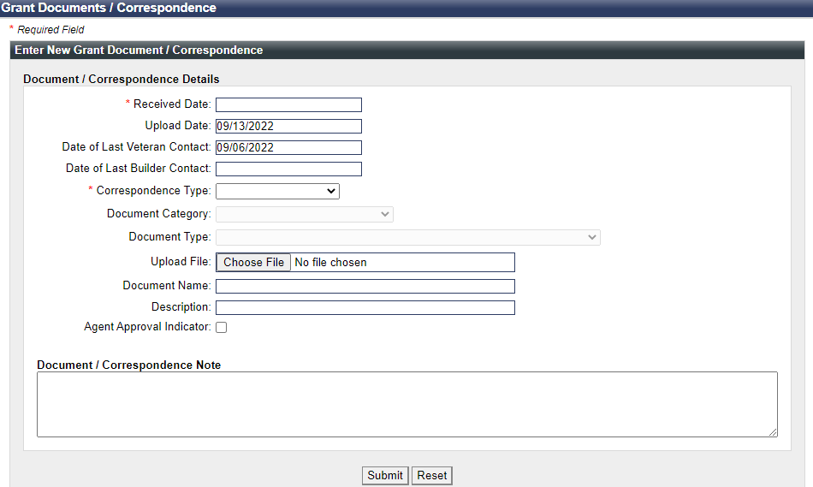
- First complete the required [Received Date] and [Correspondence Type] fields.  - Then the other required [Document Category] and [Document Type] fields become available for completion. | 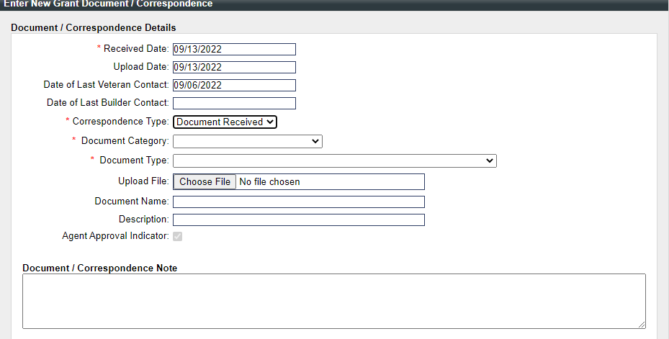
- Select the [Independent Living Documents] within the [Document Category] field.  - Four options become available to select within the required [Document Type] field.  - The uploaded file name should be similar to the [Document Type] field. | 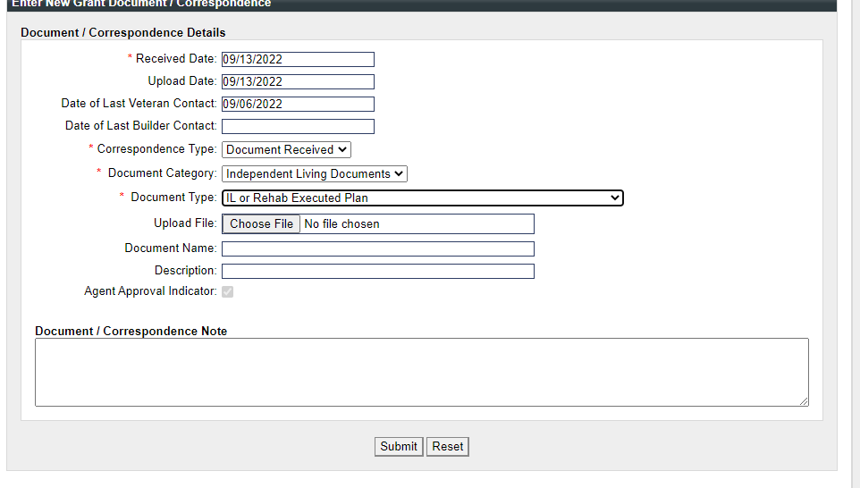
- One of the options that becomes available for selection within the required [Document Category] field is the [Other Documents] option.  - When the [Other Documents] option is selected, choose the [Document Type] identified as [Any Otherwise Unidentified Document].  - Fill in the [Document Name] and [Description] fields for easy identification. | 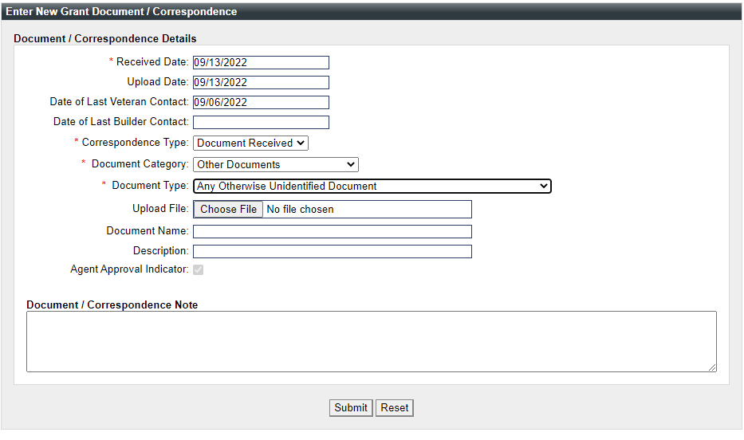
- This image shows examples of the documents that have been received on a case.  - You can click on the hyperlinked file name to view and download a document. | 