**Web-Enabled Approval Management System (WEAMS) Access Instructions for VR&E Staff**

WEAMS is a database for VA approved training facilities, facility codes, sub-facility codes (SFCs), approval status, and contact information. Information from WEAMS is used for ensuring that a program of training or course has been assigned a facility code and the facility code and for authorizing a Chapter 31 claimant’s subsistence allowance awards. Vocational Rehabilitation Counselors must check WEAMS to ensure that a program of training or course has been assigned a facility code and the facility code has not been suspended prior to developing a plan of services.

1. **Requesting Access To WEAMS**
2. All VR&E users must complete and submit VAF-8824e, Common Security Services (CSS) User Access Request.  The sample below displays the boxes that will need to be checked for access. The request must be View only permissions, except for the Modify Search Criteria Box under Function 3, which allows for advanced searches.

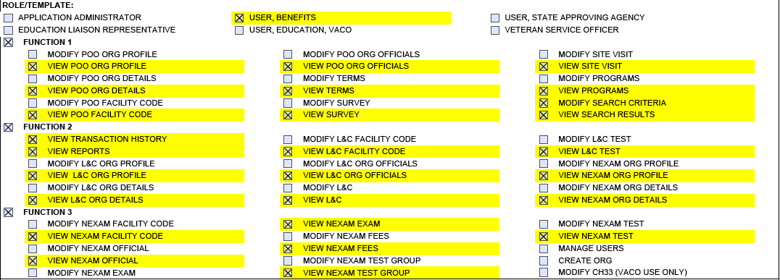

1. Once access is approved, the user must contact David Smith, VR&E Field Liaison, via email at david.smith231e18@va.gov, and inform him that the request to access WEAMS has been approved.  The subject line on the email must read “Assign States and Territories”. Subsequently, he will assign the appropriate states and territories that will allow the user to view all the facilities listed in WEAMS.
2. **Accessing WEAMS**
3. Once user permissions are set up, the user can access WEAMS from the Favorites Tab, in the VA Shortcuts Folder, under the VBA Folder.
4. After using the user’s PIV card to log in, the WEAMS Homepage will appear, as shown below.
5. If available, enter the code in the Facility Code data field, then click Search.
6. If the facility code is not available, click Search on the navigation menu. The name of the training facility may also be typed in the Organization Name data field.

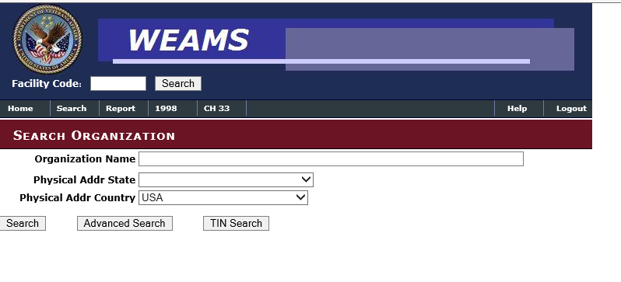

1. **Searching for Facility Information**
2. The next screen will display a list of associated main schools or campuses with corresponding facility or SFCs (see sample screenshot below).

Note:  SFCs are differentiated from the main campus facility code by an “X” on the third digit.

Once the correct facility is identified from the list, click on the facility to view if there are satellite campuses associated with the facility or main campus.

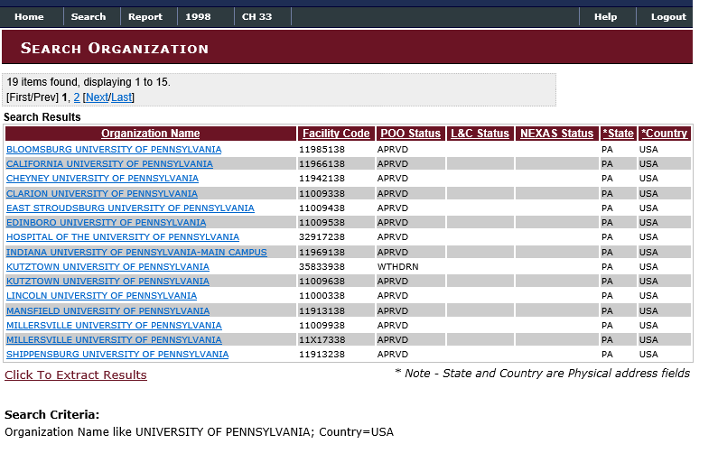

1. If the main campus has satellite campuses, the SFC associated with the satellite campus will be displayed, as shown below.

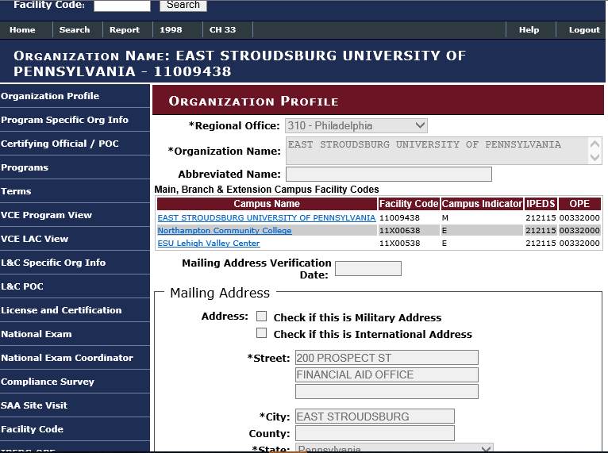

1. The mailing address and physical address of the campus will also be displayed, as shown below.

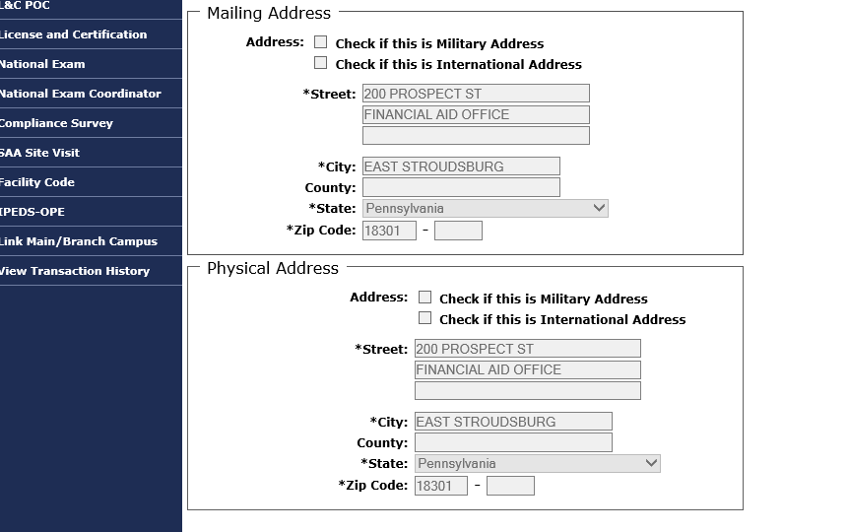

**Note:** The correct facility code or SFC must be used when sending authorizations to school facilities and to process the subsistence allowance awards in the Subsistence Allowance Module (SAM).