**Vocational Rehabilitation and Employment**

**Electronic Virtual Assistant (e-VA)**



**(powered by SARA)**

**Advanced Topics Training**

**03/31/2020 & 04/01/2020**

Contents

1. Introduction 3

1.1. How to use this document 3

1.2. Document Structure and Layout 3

1.3. Assumptions 3

2. Modify My Profile to Change How e-VA interacts with Me 4

2.1. Edit e-VA User Settings and Notifications 4

2.2. Modify Client List Display 6

2.3. Activating Auto-share 7

3. Requesting Shared Access 8

3.1. Flagging a Claimant Record as Confidential 10

4. Referring Claimants to Other Agencies 11

5. Adding an Assignment 13

5.1. Editing an Assignment 14

5.2. Custom Assignment Templates 19

6. Processing Documents and Images from e-VA Assignments 21

6.1. Processing Documents and Images from Text Conversations 25

7. Creating Appointment and Event Templates 26

7.1. Editing and/or Deleting an Appointment Template 29

7.2. Using an Appointment Template 29

7.3. Appointments – Global Calendar 30

8. Next Steps for Claimants who have NOT accepted e-VA 31

9. Staff Dashboard Report 32

# Introduction

The e-VA Training Exercises document is designed to support and reinforce live training sessions on the Vocational Rehabilitation and Employment (VR&E) Service’s new Electronic Virtual Assistant (e-VA) system.

VR&E is implementing the e-VA solution as part of its broader modernization effort. e-VA is powered by the Semi-Autonomous Research Assistant (SARA), an artificial intelligence (AI) based, mobile-centric application. The e-VA solution (powered by SARA) is designed to reduce administrative burdens for VR&E staff associated with routine tasks such as scheduling, communication, and case tracking.

In this guide we will introduce you advanced functionality and topics that can help you take full advantage of e-VA.

## How to use this document

VR&E staff participating in live training on e-VA will use the exercises in this document to practice new skills during the interactive training session. The exercises may also be used post-training event to refresh new skills and gain confidence in using advanced e-VA features and functionality.

During live training, the e-VA training instructor will demonstrate system functionality and lead users through the exercises in this document, providing an opportunity for hands-on practice of demonstrated capabilities in the training environment.

## Document Structure and Layout

The document is structured into topic-based objectives with exercises relevant to key e-VA features and functionality related to each topic.

## Assumptions

We assume you have gone through basic e-VA training and have read the e-VA user guide. If not, please refer to chapter 1 of the e-VA User Guide which covers topics like assumptions, key terms, icons used and more.

# Modify My Profile to Change How e-VA interacts with Me

You should by now have worked with e-VA for a while and you may notice it is not doing things exactly how you would like it to. The following allows you to change how e-VA interacts with you on a higher level.

Click on the [**My Profile**] icon at the header of the page

## Edit e-VA User Settings and Notifications

Click [**Edit User Settings**] to continue. Check and uncheck boxes as follows:

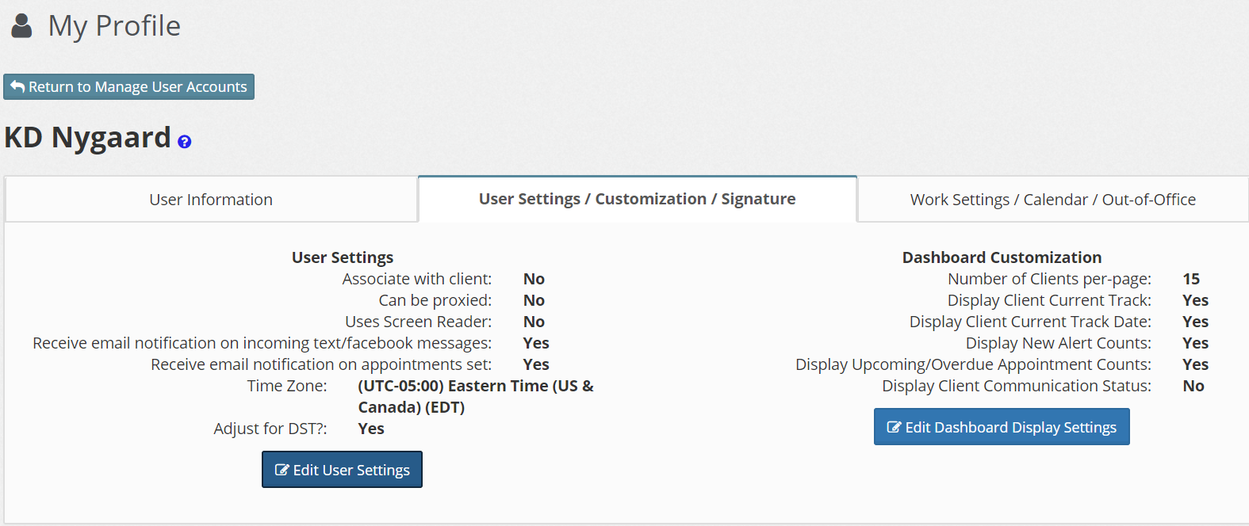

**Associate with client –** Leave this box checked if you typically will have a client caseload. If it is not checked, you CANNOT be assigned any clients to manage (office managers and administrators typically will not have a caseload/clients).

**Can be proxied –** Proxying determines whether or not other staff can act on your behalf (e.g., on vacation, out sick). Leave this box checked if you are a front-line staff member.

**Receive email notification** **on incoming text/Facebook messages** – If you want to be notified by e-VA that you have an incoming text message or Facebook Messenger message (Messenger is not available in e-VA), leave this box checked. Anytime you have an incoming message, e-VA will send you an email with the message you received. This setting is useful if you are not in e-VA all the time but want to know when a client messages you. If you are spending most of your time in e-VA, you may want to uncheck this box.

**Receive email notification** **on appointments set –** Leave this box checked if you want to receive an email confirmation of appointments you set. This setting is useful if you use another calendar system (e.g., Outlook) because e-VA attaches a link in the notification that will automatically open your calendar and schedule it.

**Time Zone settings and Daylight Savings Time.** This allows you to change your TMZ if necessary.

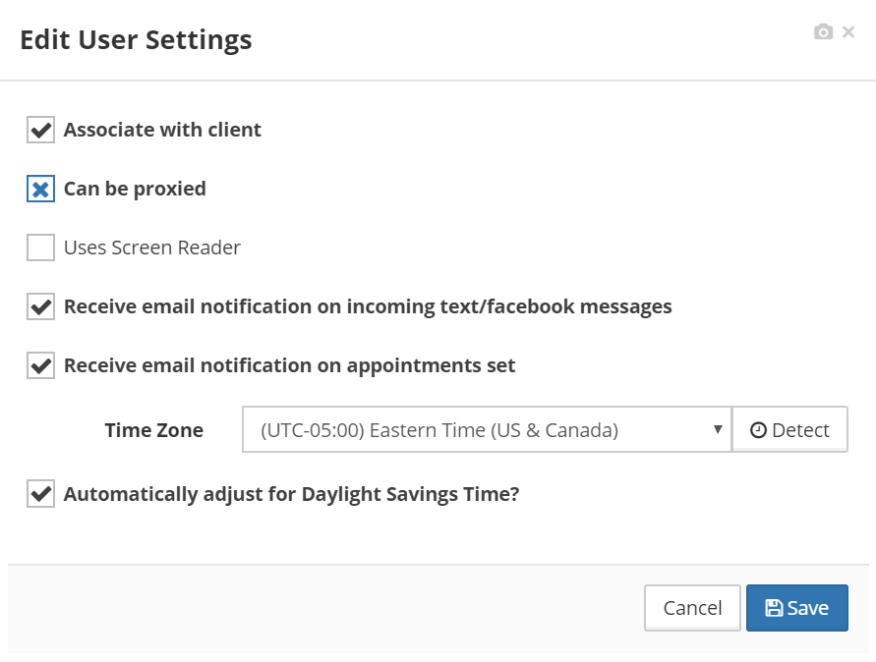

## Modify Client List Display

Click [**Edit Dashboard Display Settings**]



This tab allows you to control what client information you will be seeing on the Dashboard.

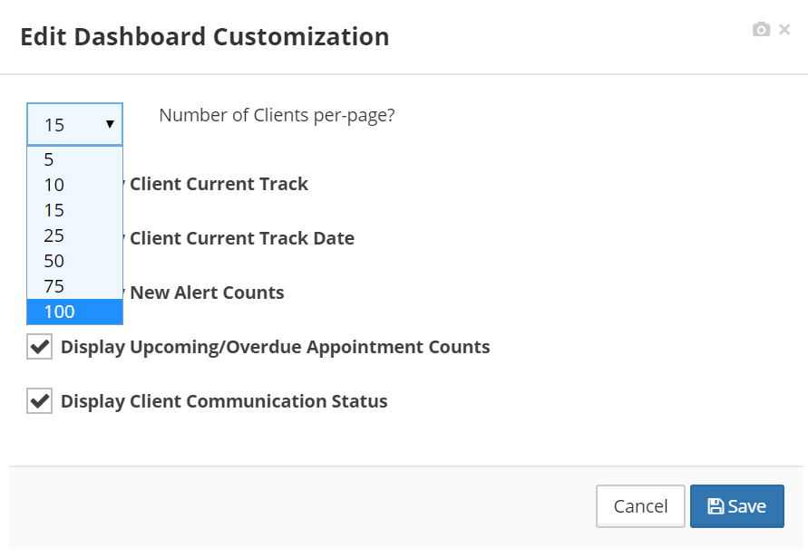**Number of Clients per-page? –** Use the drop-down menu to select the number of clients to be displayed per page on your Client List tab of the Dashboard.

You can uncheck some of the remaining checkboxes if you screen is “cramped” and difficult to read.

## 

## Activating Auto-share

We have already dealt with Client Sharing in the basic training. The Auto-Share functionality is useful if you always want to share your client load with a specific team member. When you engage Auto-Share, every time a new client is assigned to you, that client will automatically be shared with the person(s) you designate.

Click the [**Proxy and Sharing**] tab under [**My Profile**]

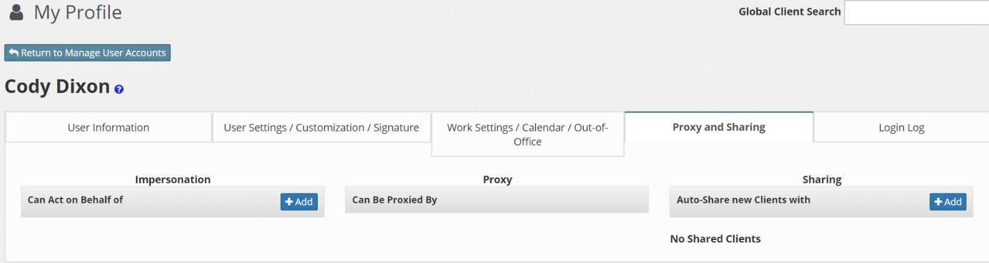

The Proxy and Sharing tab has three columns:

1. Can Act on Behalf of: A list of staff you can act on behalf of. (**For Managers**)
2. Can be Proxied By: A list of staff that can act on your behalf. (**For Managers**)
3. Auto-share new Clients with: Any new Claimant sent from CWINRS to e-VA will automatically be shared with anyone on this list. The Claimant will appear on their Client List as a Shared Client.

If you want to add a staff member to automatically share new Claimants with, click the [**+Add**] button in the **Sharing** column. In the pop-up, start typing the name of the staff member to proxy you. As you type, a list of staff will appear. Click on the desired name.

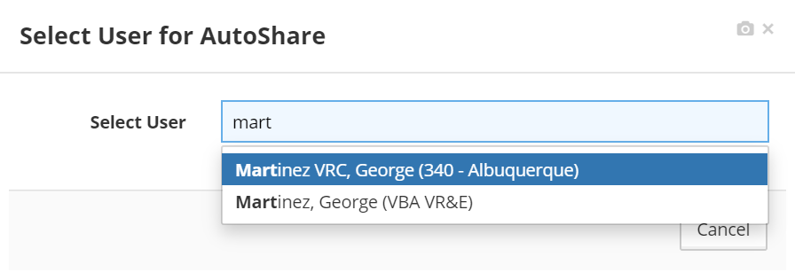

Once you clicked on a name, it will appear below the column header. You can add as many team members you like, just as you can delete a team member by clicking on the red trashcan icon.

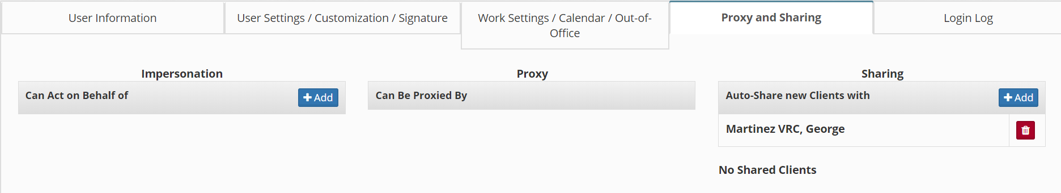

# Requesting Shared Access

Depending upon your access level you may come across client records listed as “View-Only Mode”. In this mode, you only have access to limited information about the client. If you need additional access, you will need permission from the lead counselor for the client.

To request access, Click the [**Request Shared Access**] button to request shared access from the Claimant’s Primary VRC.

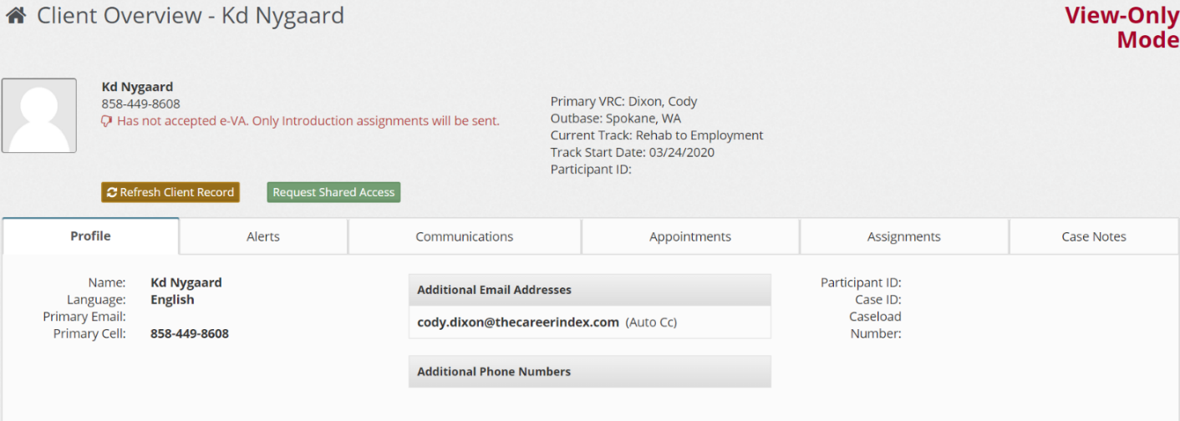

After you click the button, a message box pops up.

Compose a message and click the [**Send**] button to send the request to the Primary VRC.

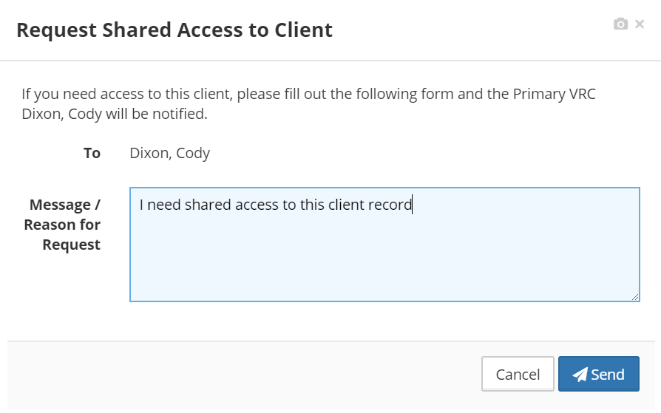

Once you click send, the message will go to the designated counselor. Once the counselor grants access, you will be able to see the client information.

## Flagging a Claimant Record as Confidential

The Primary VRC can flag a Claimant record as “Confidential” to hide the following details from other staff: Case Notes, Alerts, Assignments and Communication history. The details will not be hidden from direct supervisors.

To mark the record confidential, Click the [**Edit Profile Information**] button in the Client Overview screen.

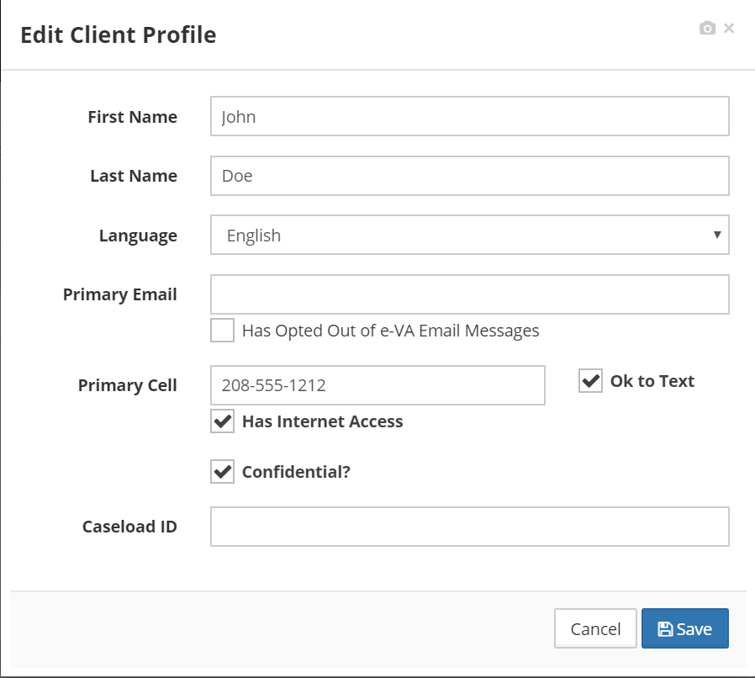

Checking the [**Confidential**] box will hide tabs from Users viewing the record in “View-Only Mode”. In this mode, only basic contact and appointment information will appear.

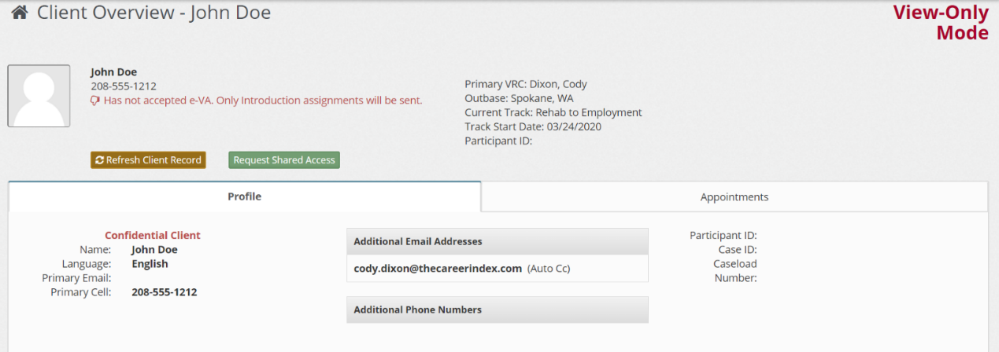

# Referring Claimants to Other Agencies

Use the referral feature in e-VA to connect a Claimant with another program/agency. The advantage of this functionality is that:

1. It allows you to use e-VA’s built in referral templates to both referee and referrer.
2. e-VA will automatically follow up with both parties after a week to get feedback which will be reported by to you AND uploaded into your case management system.

The [**Refer This Client**] button located in the **Reassign/Share/Refer** tab is another powerful function in e-VA. How it works depends on whether your agency is linked to other agencies using e-VA in your area.

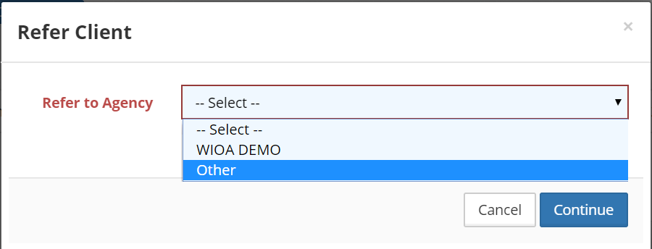

If there are other agencies in your area using e-VA, they will appear in the drop down. If not, select “Other”, click [Continue] and fill in the form.

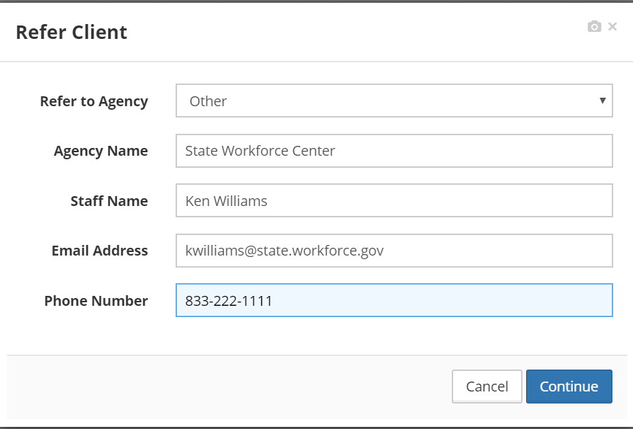

When you click [**Continue**], an email and SMS form will appear where you can edit the message going to the referrer and referee. You can add attachments if needed. When done, click [**Send**]. The messages will be sent to both parties and e-VA will follow up with both parties after a week to gather information the result of the referral. That information will also go into the client’s case notes.

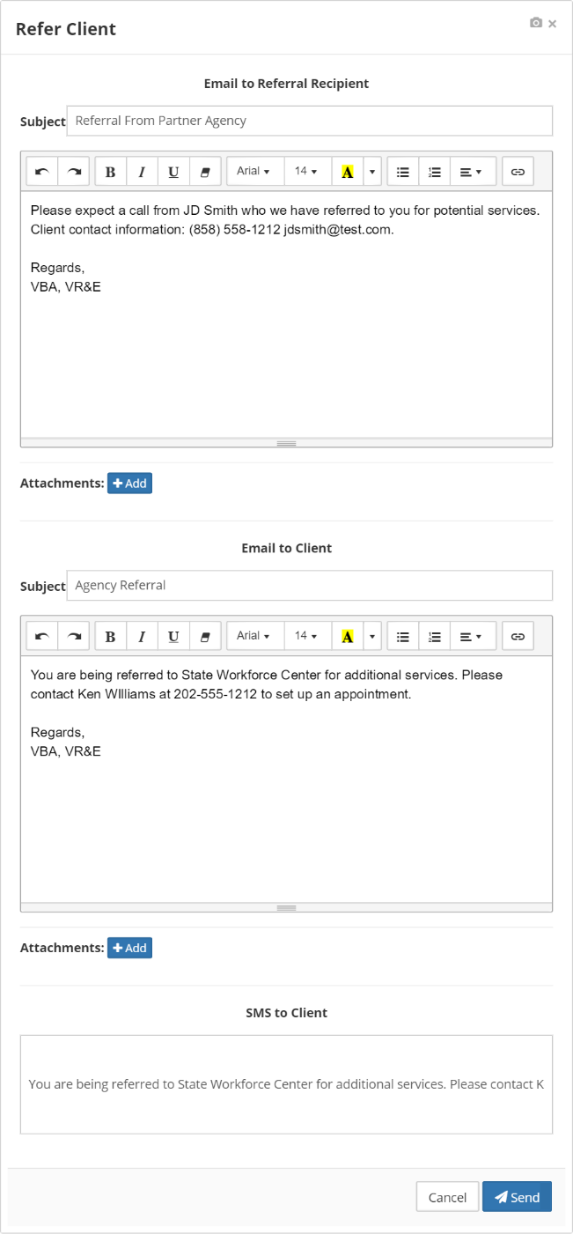

# Adding an Assignment

In addition to all the automated assignments in e-VA, you also have access to an extensive library of “manual” assignments. An assignment that is “manual” simply means that you the counselor, assigns it manually. Everything else is automatic as usual.

The following are examples when you may want to add a special assignment manually:

1. You may need proof of purchase or a W2 from a Claimant.
2. You have a Claimant in training that graduates soon; you would want to add a “Job Search” assignment in addition to the “Training Follow-up” assignment.

When this need occurs, from the Client Profile screen, click the [**Assignment Tab**] and then the blue **[+ Add Assignment**] button.

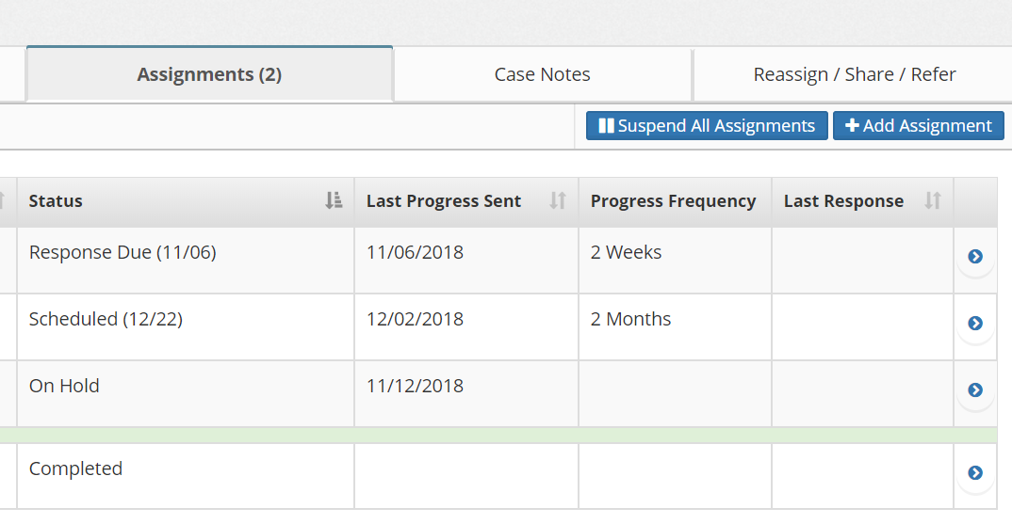

This will bring up a list of available assignments (note: certain assignments are not available in all tracks, i.e., assignments are track dependent).

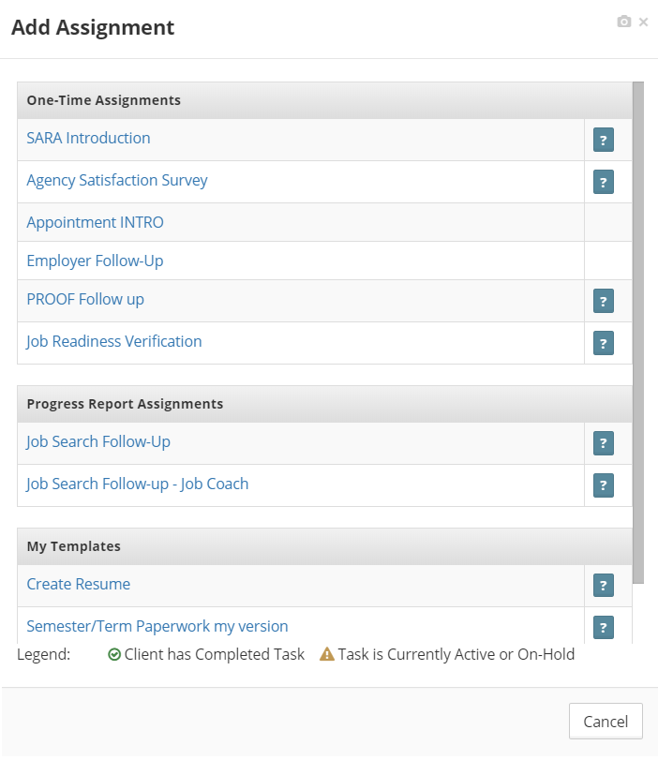

You can use the right scroll bar to see all assignments. Click on the assignment you want to use.

Clicking on the ? mark to the right of the name will give you more information about the specific assignment.

Icons next to the assignment will indicate whether the Claimant has previously completed this assignment or if the assignment is currently active for the Claimant. If it is, e-VA will ask for verification that you still want to add the assignment.

## Editing an Assignment

Occasionally, you may want to change an assignment. For example, you may want to adjust the assignment’s timing, frequency, or message.



You can change almost everything about an assignment, except the interview that might be associated with it.

Assignments that are manually added by staff, as well as e-VA generated assignments, can be customized per the Claimant’s needs.

To edit an assignment:

* Click the **[Assignments]** tab
* Click on the assignment’s name to expand details
* Click **[Edit]**

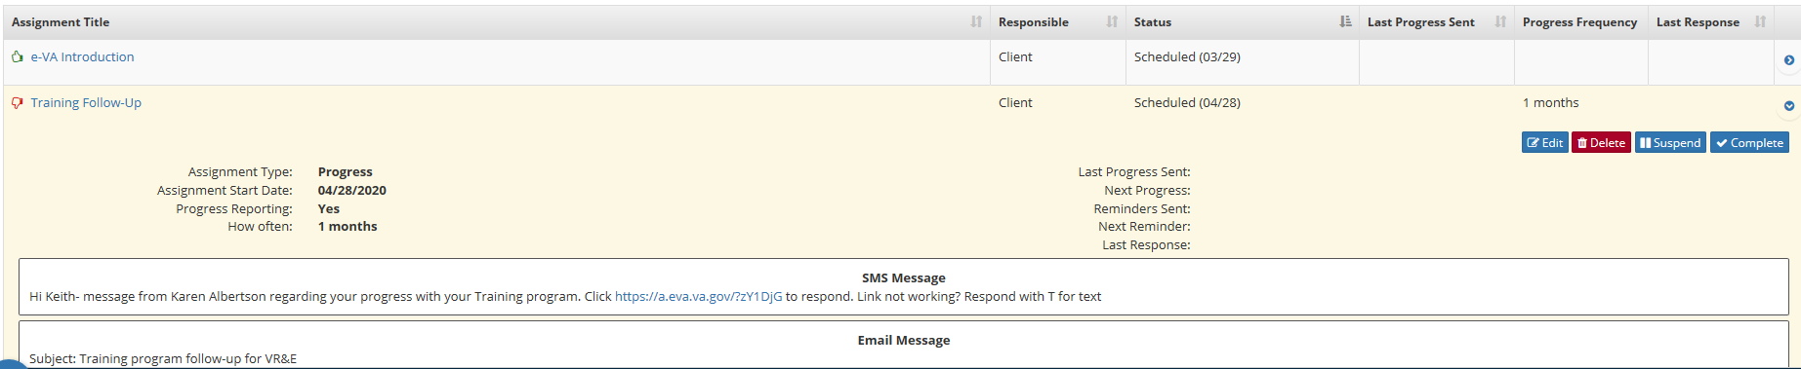

Editing and adding an assignment is done in the same way.

The Edit Screen is a split screen with assignment specifics to the left and the email text editor to the right.

* Claimant’s contact information (specific for the assignment) can be edited including **Name**, **Email**, and **Cell number.**

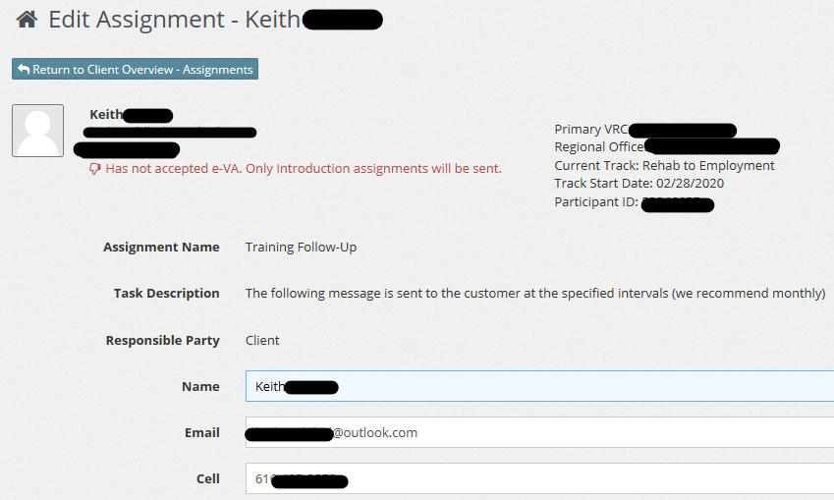

* The start date can be changed by clicking on the start date drop-down box or by clicking the calendar icon. Enter/select desired start date.

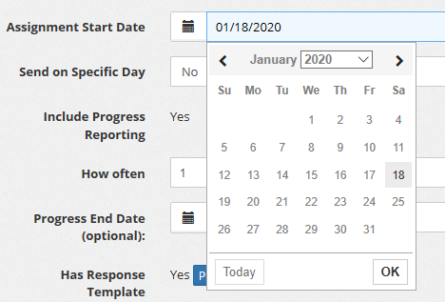

* **Send on Specific Day**:
  + Customize the **Assignment Start Date** further by configuring the assignment to send on a specific day of the week or day of the month. Use the drop down next to **Send on Specific Day** to select either option.
  + Select the **Weekday** or enter the **Day of Month** acordingly.
  + **Actual Start Date** will calculate based upon selections made.

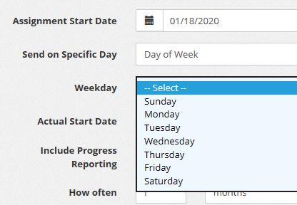

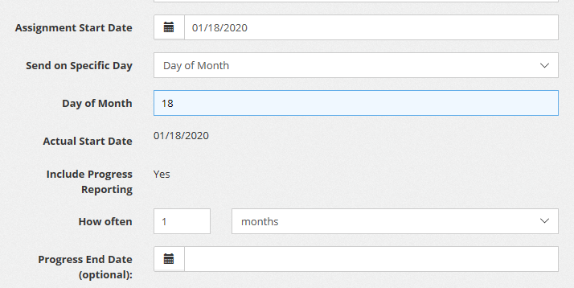

* **How often:**
  + If the assignment is a progress (repeating) assignment, the time between sending each message is editable using the fields next to **How often.**
  + The first field identifies the number between assignments.
  + The second field represents the time interval: days, weeks, or months (e.g., entering a “1” in the first field and selecting “months” in the second field will result in the assignment sending once a month).
  + Progress assignments do not automatically have an end date and will continue to send per the configured intervals until the assignment is cancelled (i.e., the client track changes).
* **Progress End Date (optional):** Select an end date for the assignment if needed. Example: Your agency has a requirement to follow up for one year regarding change in employment or employment status; the example below shows you how to do that.

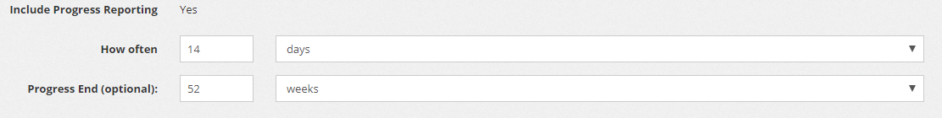

* **Preview:** Click **Preview** to launch the interview questions associated with the assignment (if applicable).

Screenshot of preview button

* **SMS (Text) Message Edit:**
  + Edit the text message for the assignment to personalize the verbiage. As you type, you can see the final message changing accordingly.
  + Click “load default SMS regarding” to revert to the original message.
  + This feature is only applicable if the assignment is not to a third party, which only uses email.

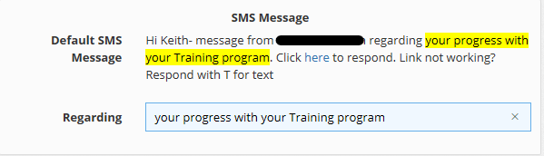

* **Email Message Edit:**
  + The **Subject, Salutation,** and **Body** for the assignment message can be edited.
  + Place your cursor in any of these fields to customize the email.

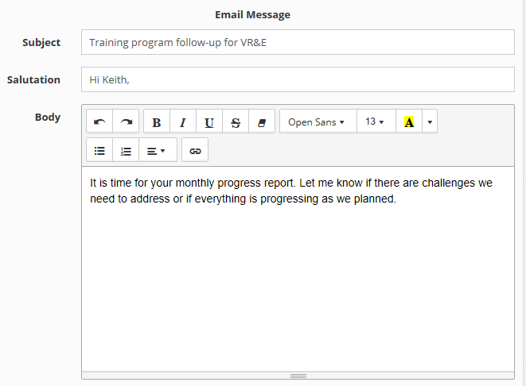

* + The **Closing** field is customizable, and adding **Attachments** is also an option.

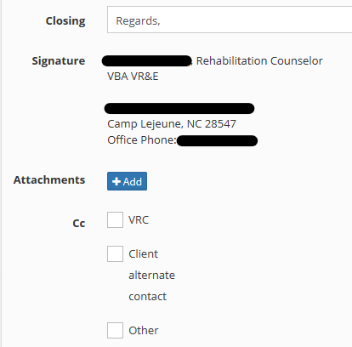

When you are done, click either [**Schedule Assignment**] or [**Send Assignment Now**]. If you click [**Send Assignment Now**], e-VA will send it immediately rather than using the send date you may have entered for it.

## Custom Assignment Templates

Periodically, you may want to create your own custom assignments. For example, you may want to have a customized PROOF assignment for collecting a Claimant’s Free Application for Federal Student Aid (FAFSA®) information that you can use with all your academic Claimants in a semester.

Using that example, go to the Assignment Tab in the Client Profile screen and click [**Add Assignment**] to display a list of available templates.

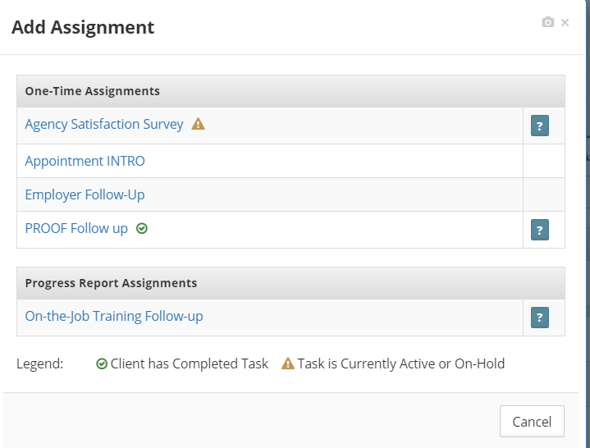

From the list, select a standard template that you wish to use as a basis for the new, custom template you want to create. In this case, select [**PROOF Follow-up]** by clicking on it.

Now enter the information as described above. **Note:** Don’t worry about the name and contact information which will default to the client you are currently on. When you save the template to your custom templates, it will automatically use the defaults from whatever client record you are currently on.

Once you are done entering the required information, click the [**Save this to My Templates**] at the bottom left of the screen.

Screenshot of save this to my templates button

When you click the [**Save**] button, a pop-up will appear that allows you to name it. The name you enter will appear under “My Templates” when you add an assignment.

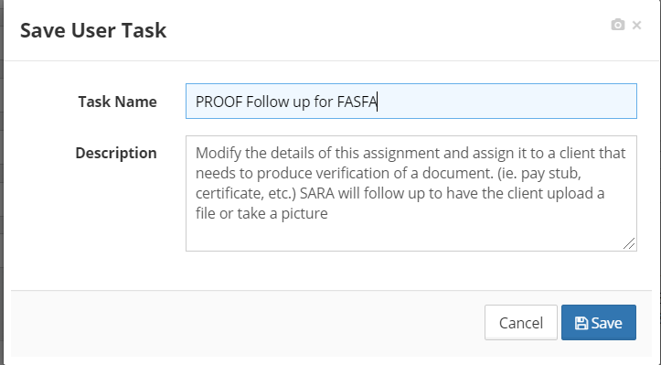

Make sure to name the task something relevant that you can remember.

If you wish to change the template later on, repeat the process above and then click [**Save Changes to Your Custom Template**] at the bottom left of the editing screen.

# Processing Documents and Images from e-VA Assignments

e-VA’s Photo/Upload feature (purple alerts) can capture items such as pay stubs, receipts, or training certificates. The Training Follow-up assignment offers the Claimant an opportunity to upload a document or image. As a VRC, you also can manually send out a document request to a Claimant at any time using the [**PROOF Follow-up**] assignment.

The following images depict a scenario where the Claimant is prompted within an assignment to submit a document:

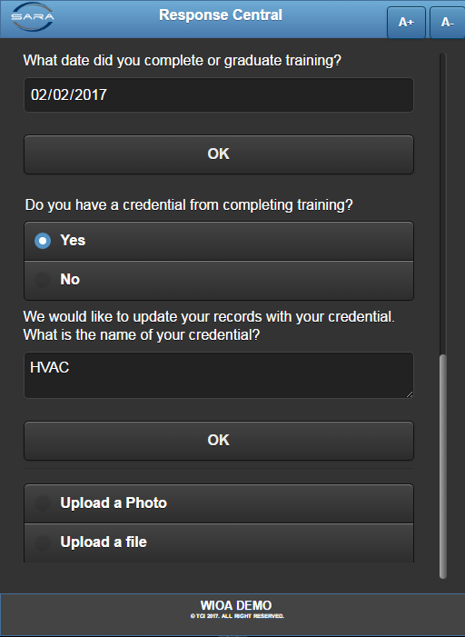 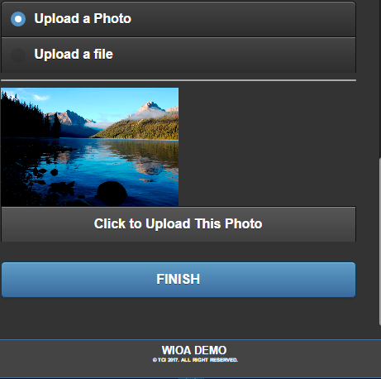

Images/documents captured by e-VA and attached to alerts, are to be processed by the VRC. The section below addresses the process from the Client Overview screen and [**Alerts**] tab.

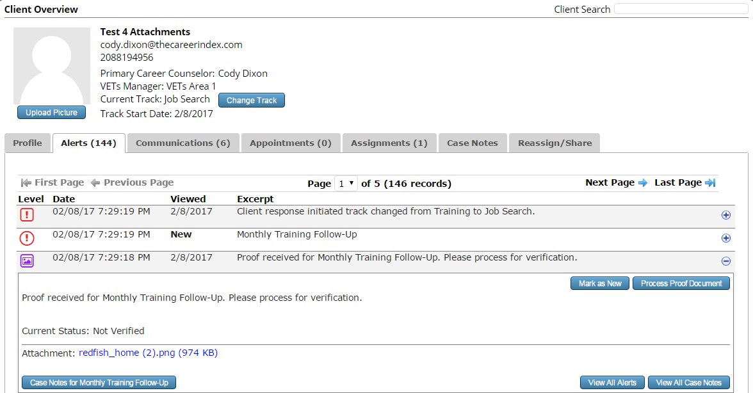

Process Button

Link to view uploaded document

*Note: The image above may vary from what you see in e-VA.*

When you process the uploaded document, you will have the option to:

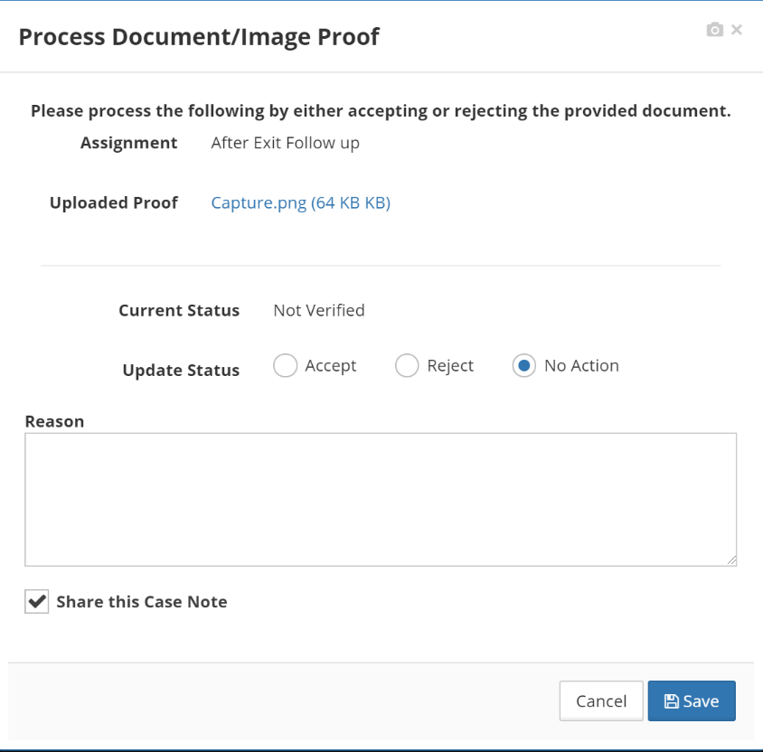

* Accept the Document: it will complete the assignment, enter a case note to include the document that was submitted and state that it was accepted.
* Reject the Document: it will complete the current assignment and will prompt the case manager to resend the request to the Claimant using the PROOF Follow-up Task with notes stating reason for rejection and corrective action.
* Take No Action: it will leave the assignment in an incomplete status.

Typically, the documentation submitted will suffice, but sometimes it will not. For example, the documentation may be blurry, or the picture is unrelated to the requested document. In these scenarios, it is appropriate to reject it.

If you reject the document, the following message will appear:

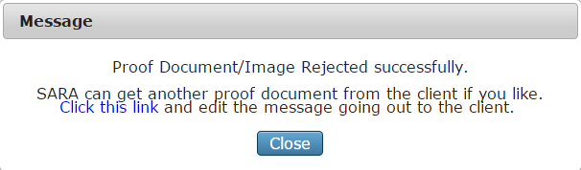

Select the “Click this Link” hyperlink to have e-VA follow up for the requested document. You will be taken to the [**Edit Assignment Screen****].**

After you click “Schedule Assignment” or “Send Assignment,” e-VA does the rest. You will be notified, once the Claimant resends the document.

## Processing Documents and Images from Text Conversations

Claimants can also send documents or images, when texting their VRC directly. All incoming documents and images within a VRC text message conversation are automatically attached to the Text Message case note thread in e-VA.

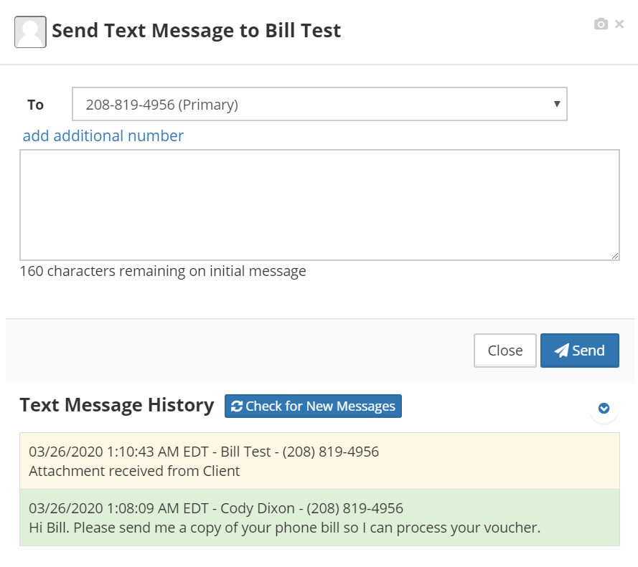

A **Black Alert** will be generated containing a link to the attachment. The alert is accessed in the [**Client Alerts]** tab.

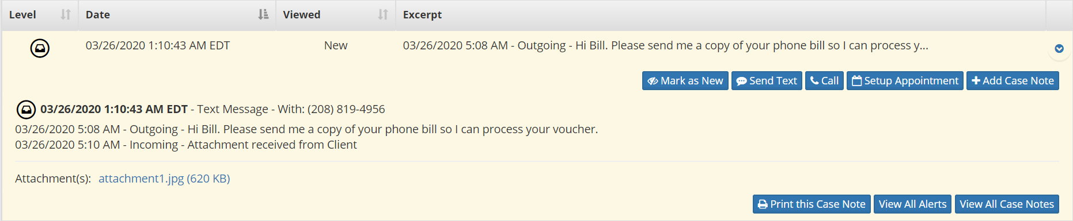

Click on the attachment link to view it (it will be downloaded to your desktop for viewing).

An image or document received as part of a text conversation does not have to be processed. It is automatically part of the case note in e-VA. If the image is insufficient, just text the Claimant and ask them to retry.

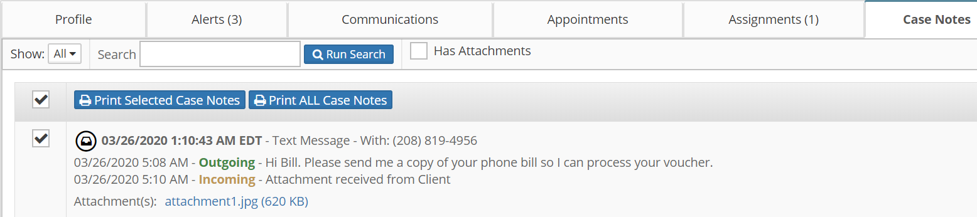

Note: The attachment is also viewable from Case Notes by clicking on the attachment link in the specific case note.

# Creating Appointment and Event Templates

You can create your own custom appointment and event templates that can be used again and again. For example, you may want to have a special appointment message for intial intake appointments or a specific event template for orientations.

On the dashboard, click on the [**Appointments**] option and then select [**Manage My Templates**] from your global navigation bar.

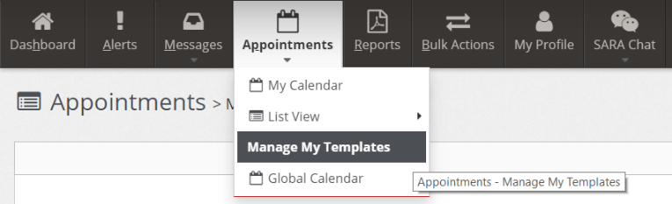

Then click on the [**+Add Template**] button.

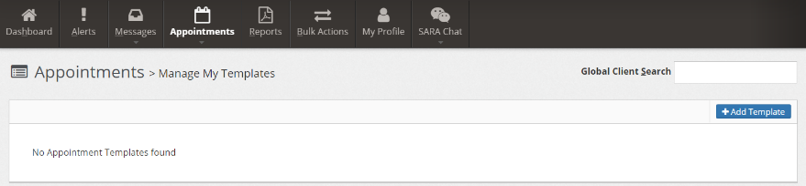

Now complete the appointment template as shown below and click on [**Save**].

[**Template Name**] is a unique name for the template that you create.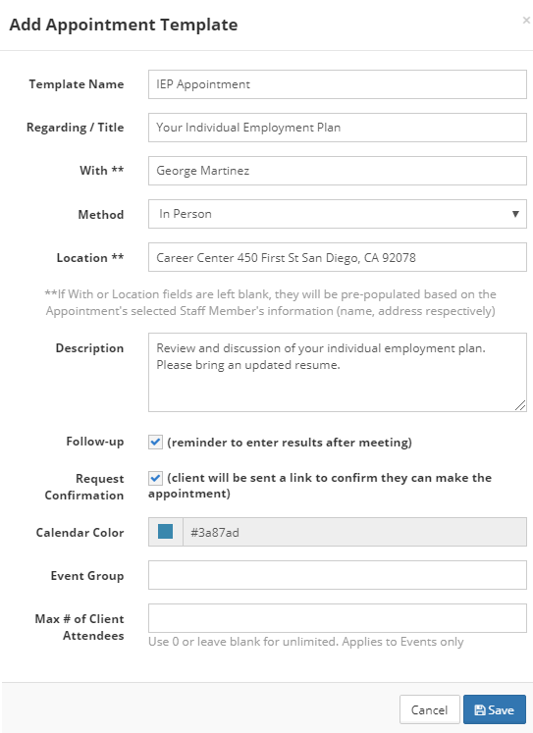 Only you have access to these appointment templates.

[**Method**] allows you to select how the appointment will be conducted by default (In Person, Phone, Tele-Counseling, or Home Visit). **Note:** you can always change it when you select the template for use.

If [**With\*\***] and [**Location\*\***] fields are left blank, they will be pre-populated based on the appointment’s selected staff member’s information (name, address respectively).

[**Request Confirmation**] allows you to include a link in your appointment template that prompts the recipient to confirm that they can make the appointment.

[**Calendar Color**] allows you to color code your templates.

[**Event Group**] and [**Max # of Client Attendees**] are used when creating event templates.

You can create as many templates as you’d like and manage them all from your **[Manage** **My Templates]** page. 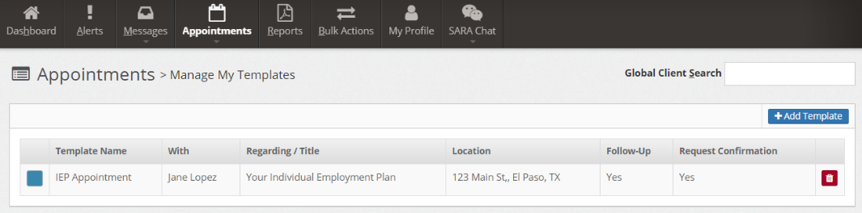

## Editing and/or Deleting an Appointment Template

To edit your saved templates, go to **[Manage My Templates]** page and click the template you want to edit and repeat the process above. To delete a template, click on the [**Delete**] icon.



## Using an Appointment Template

From the **Add Appointment** form, click on the [**Change Template**] drop-down menu and select your appointment template.

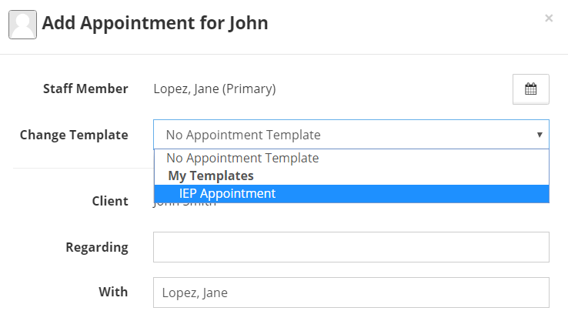

Edit the [**Start**] and [**End**] times for the appointment, prior to saving the appointment.

## Appointments – Global Calendar

You have the option of viewing your Global Calendar which shows your appointments as well as the appointments of your co-workers within your location.

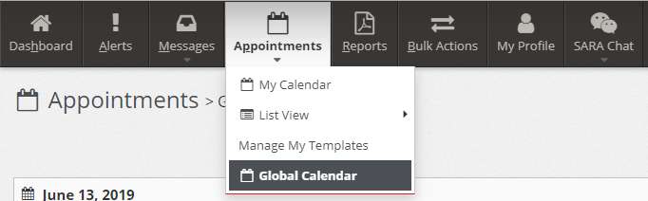

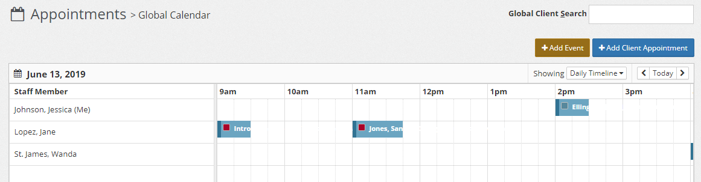

Use the “Showing” drop-down menu to change your calendar view.

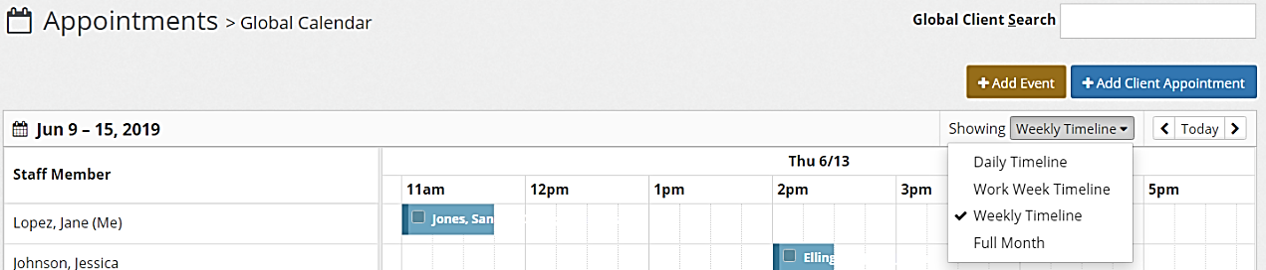

# Next Steps for Claimants who have NOT accepted e-VA

The e-VA Introduction is always the first assignment to go out to the Claimant. Until the Claimant accepts e-VA using the Intro assignment, no other assignments will go out to the Claimant. You will also notice a red thumbs down icon in the Claimant information area and a red alert bar under Assignments.

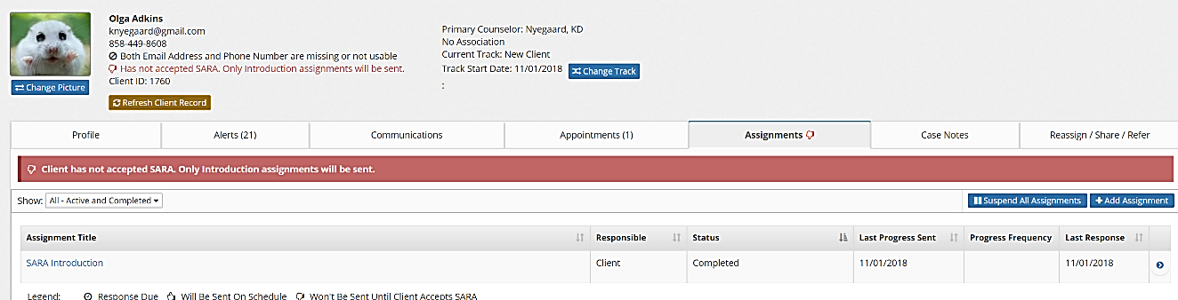

If the Claimant remains unresponsive to the Intro assignment, you may have to contact the Claimant directly and encourage them to accept e-VA.

A quick way to connect with every Claimant who has not accepted e-VA is to use the **[Bulk Actions]** tab in the Global Banner at the top of the screen. Select the **“Not Accepted e-VA yet”** option from the **Special** filter then select a communication method.

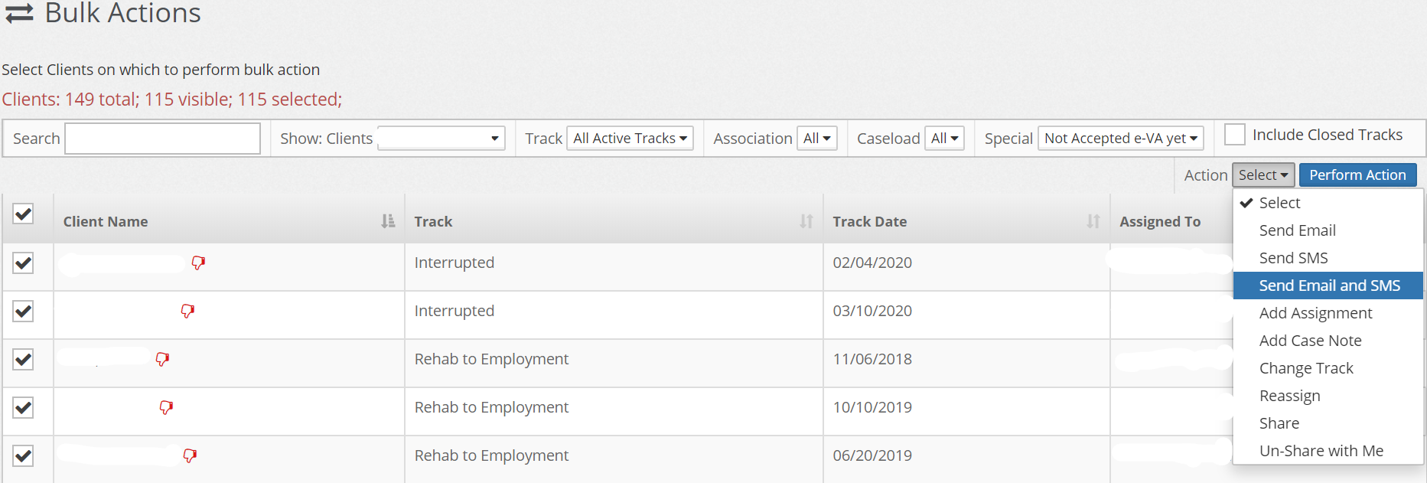

Send a mass text and/or email via [**Bulk Actions****]** to the list of Claimants. Suggested text/email:

*Hi, this is (staff name) from VR&E. You should have recently received messages from e-VA, our new Virtual Assistant communication system. e-VA is helping us stay in contact with you by sending you text messages and/or e-mails for upcoming appointments and important tasks. Have you received any messages from e-VA?*

This starts the conversation and if the Claimant approves, click the blue [**Reactivate**] button for the Introduction assignment in the **[Assignment]** tab. Let the Claimant know the message is on its way and assist the Claimant through the steps of accepting or declining if needed.

# Staff Dashboard Report

The default report for staff is the dashboard report.

The staff dashboard report has two sections: scheduled assignments for the next 5 days and your performance details.

* Click **[Reports]** to access the dashboard report.
  + This report can also be accessed by clicking **[Reports], [General], [Staff Dashboard].**
* **Scheduled Assignments – Next 5 days**
  + Claimants listed will be sent a message from e-VA in the next five days.
    - Click the Claimant’s name to jump to that Claimant’s record where you can edit the assignment if needed.
  + Other columns show how many attempts e-VA has made to send the message, how the message is being sent, and the type of message.
  + Review this report weekly so you know what e-VA is planning to do. Reviewing this report gives you an opportunity to intervene with a direct text or email if you see multiple attempts without an answer. You can also edit assignments if needed.

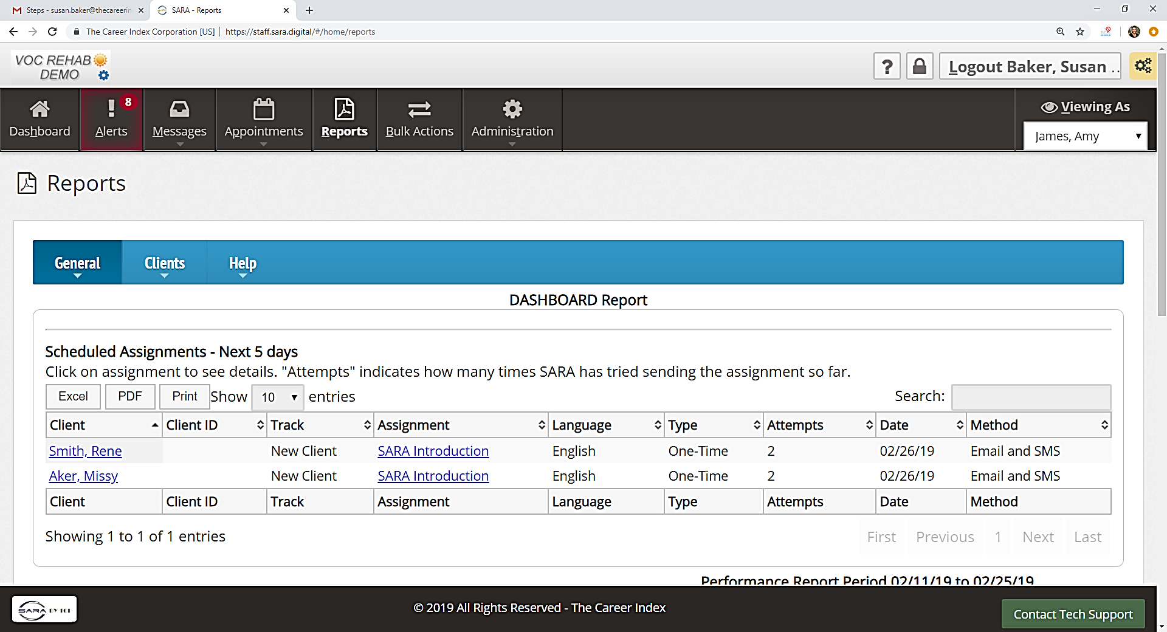

Access client record

Assignment details

Number of attempts e-VA has tried

How the message is sent

* **Performance Summary**
* VR&E Supervisors and Administrators will be using e-VA reports to monitor Key Performance Indicators (KPI). Your staff dashboard report provides summary details of your individual KPIs and an average for your location. The data displayed is for a two-week period and is refreshed nightly.



* **Clients**
  + **Caseload:** Clients in active tracks
  + **e-VA Idle:** Number of clients in caseload where e-VA has nothing to do
  + **Idle %**: Percent of caseload where e-VA has nothing to do (should be below 5%)
* **Unviewed Alerts**
  + **Red, Yellow, Black Alerts:** Number of red, yellow and black alerts not viewed as of last night (does not include system alerts)
  + **Alerts**
  + **Viewed:**Number of alerts viewed in past 14 days
  + **Actions Taken:**Number of actions taken on alerts viewed in past 14 days
* **Communications**
  + **Client-Staff:** Direct communications (email and text) from clients to staff in past 14 days
  + **Staff-Client:** Direct communications (email and text) from staff to clients in past 14 days
* **Entered Employment:**
  + **Recorded:** Clients who entered employment in past 3 months
  + **Placed %:** Placement percent of caseload who entered employment in past 3 months