VRE Training Website Script - NCT
 | 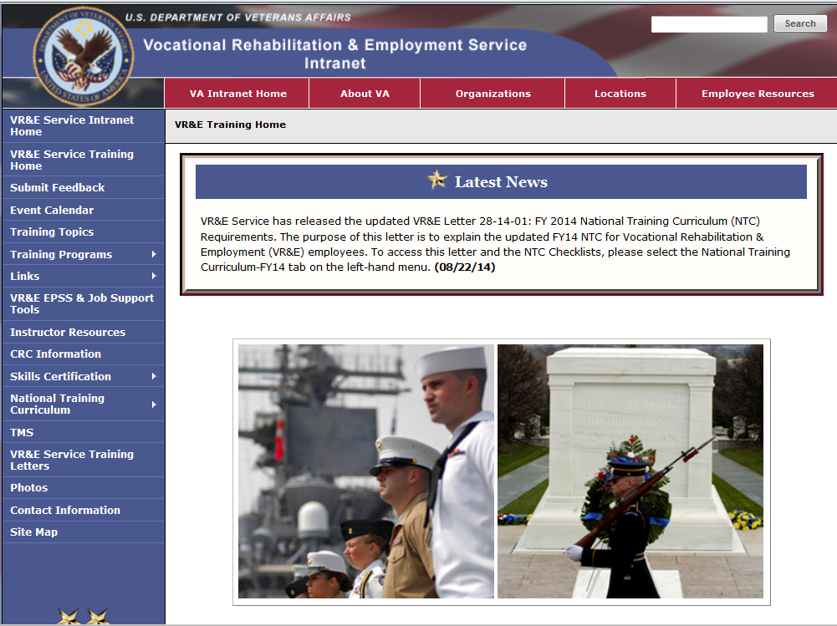 | Welcome! This tutorial is designed to show you the VR&E Training Website. This website is a centralized location that allows VR&E to maintain many important and useful employee resources. In this tutorial you will receive a brief introduction to the multitude of resources available to assist in performing your job. The web address for this site is http://vretraining.vba.va.gov
 | 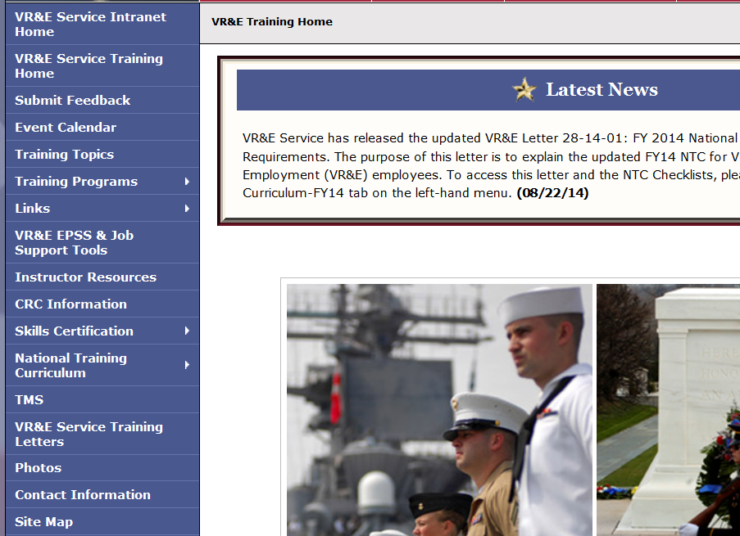 | On the left side of the site there are multiple options available ranging from training to professional development as well as links for other VA, VBA and VR&E resources. We can begin by selecting the first link, VR&E Service Intranet Home.
 | 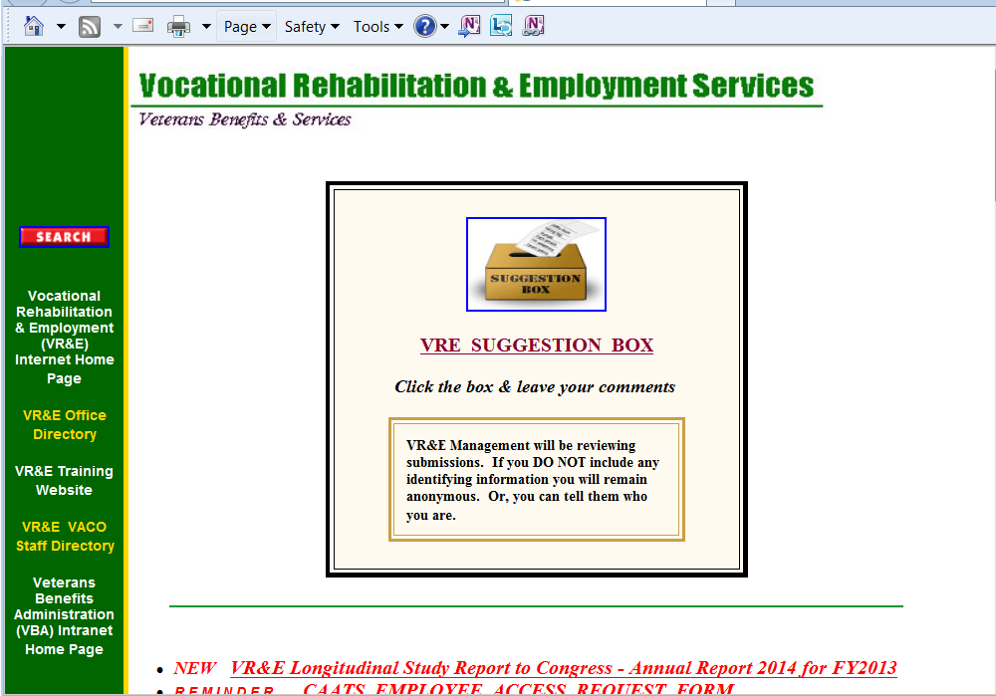 | This will open another page, the VR&E Intranet Website. Here is access to our National VR&E Office Directory, a link back to VR&E Training Website and VR&E Central Office Staff Directory. The VR&E Office Directory offers a list of all the VR&E Offices with contact information for Officers, Assistant Officers and Supervisors. You may need this when trying to transfer cases or staffing cases with other offices.
 | 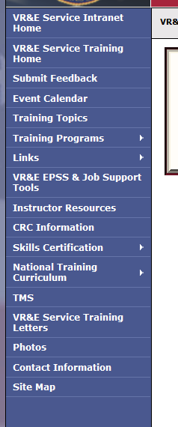 | The next area on the Training Website that we will look at is the event calendar.
Point to Training Topics | 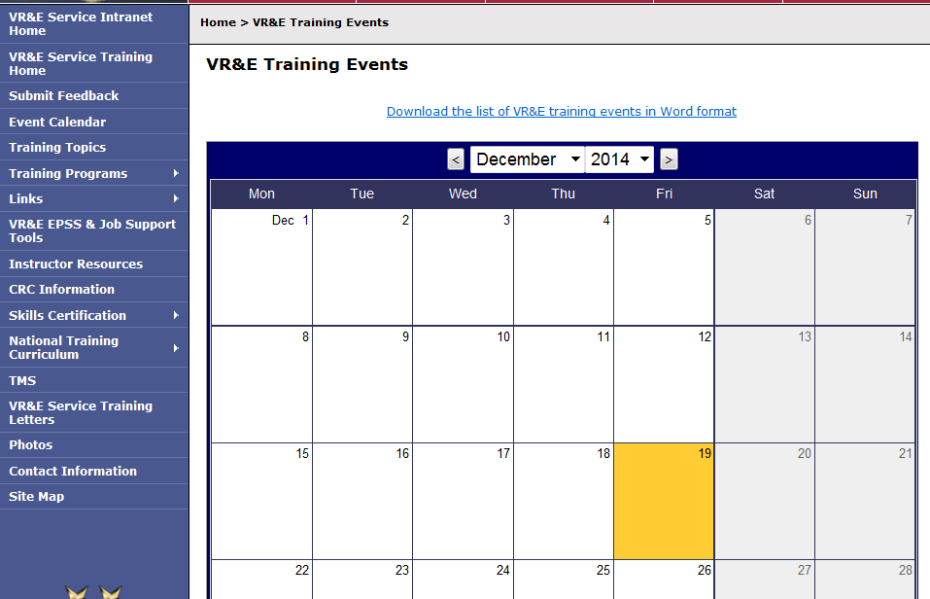 | Here you will find some of the events that take place around VR&E.  The next link on the left is Training Topics.
Point to the Training Program drop down window | 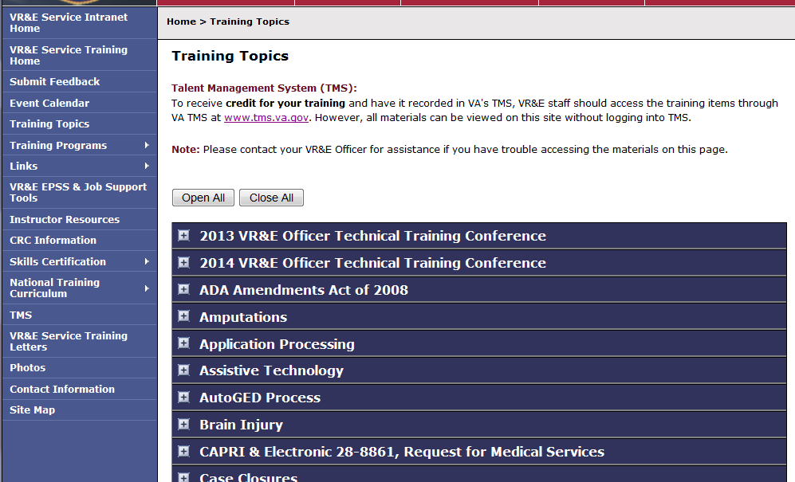 | Here you will find an archive of training material and information. It includes a central place to store information on past live and virtual training. This includes such things as the VR&E Officer Technical Training Conference, Employment Coordinators Training, VetSuccess on Campus Training Conference Material and much more.  Below Training Topics is a Training Program drop down window.
Point to Links. | 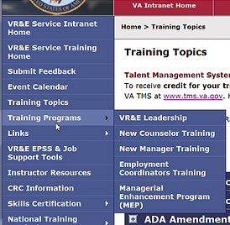 | As you scroll over this link, you will see the options for VR&E Leadership, New Counselor Training, New Manager Training, Employment Coordinators Training and the Managerial Enhancement Program.  Links is the next option.
Point to VR&E EPSS… | 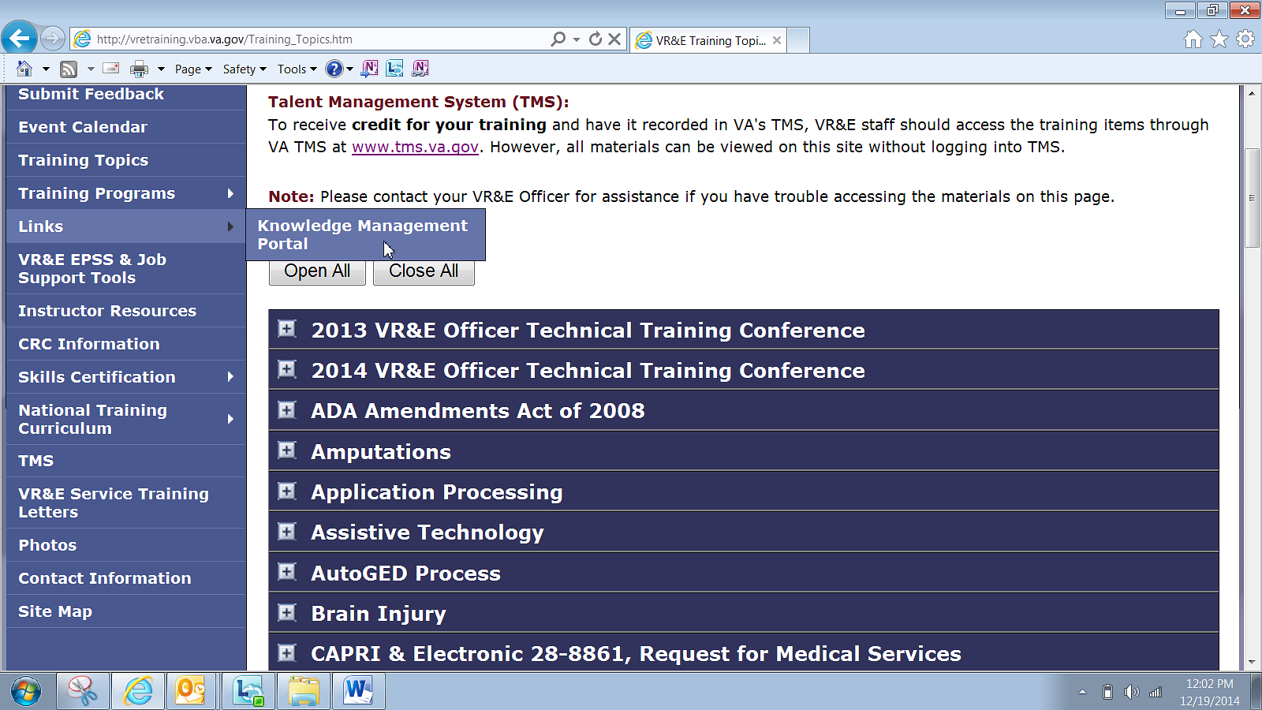 | Here you will find a direct link to the Knowledge Management Portal.  Next on the list is VR&E EPSS & Job Support Tools.
Point to Instructor Resources | 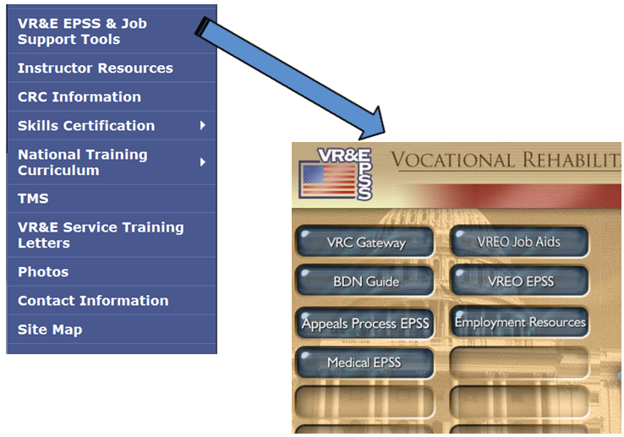 | This is a link that will take you directly to the Job Support Tools site which includes the VRC Gateway, BDN Guide, Appeals Process EPSS, Medical EPSS, VREO Job Aids, VREO EPSS and Employment Resources.  Following VR&E EPSS and Job Support Tools is Instructor Resources.
Point to CRC Information | 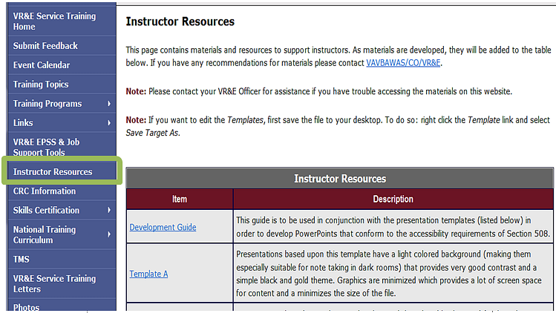 | Instructor Resources area is home to a Training Development Guide and multiple PowerPoint templates that can be used in the development of training and presentations.  The following option, CRC Information, is one area that many of you will need to use to maintain your certification.
Point to Skills Cert | 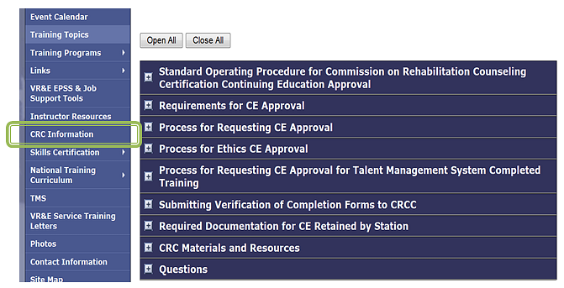 | VR&E counselor continuing education credit is managed by VA Central Office. This part of the webpage is designed to provide VR&E counselors with current information about Certified Rehabilitation Counseling, CRC, Continuing Education maintenance. Please be sure to check this area periodically. Here you will find details on contacting the manager and instructions on requesting continuing education approval.  Next on the list is Skills Certification.
Point to National Training Curriculum | 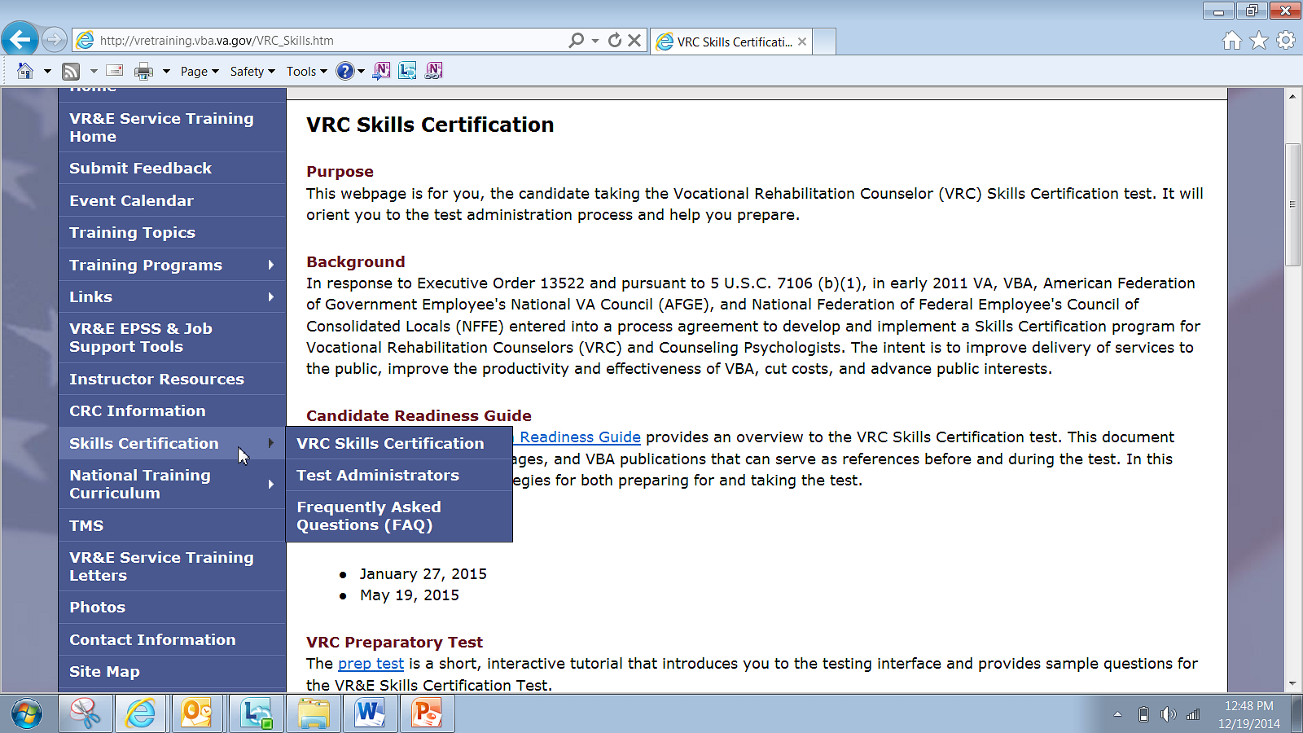 | This part of the webpage is for new counselors and candidates that will be taking the Vocational Rehabilitation Counselor Skills Certification test. It will orient individuals to the test administration process and help in preparation.  The National Training Curriculum is the next item on the list.
Point to VR&E Service Training Letters | 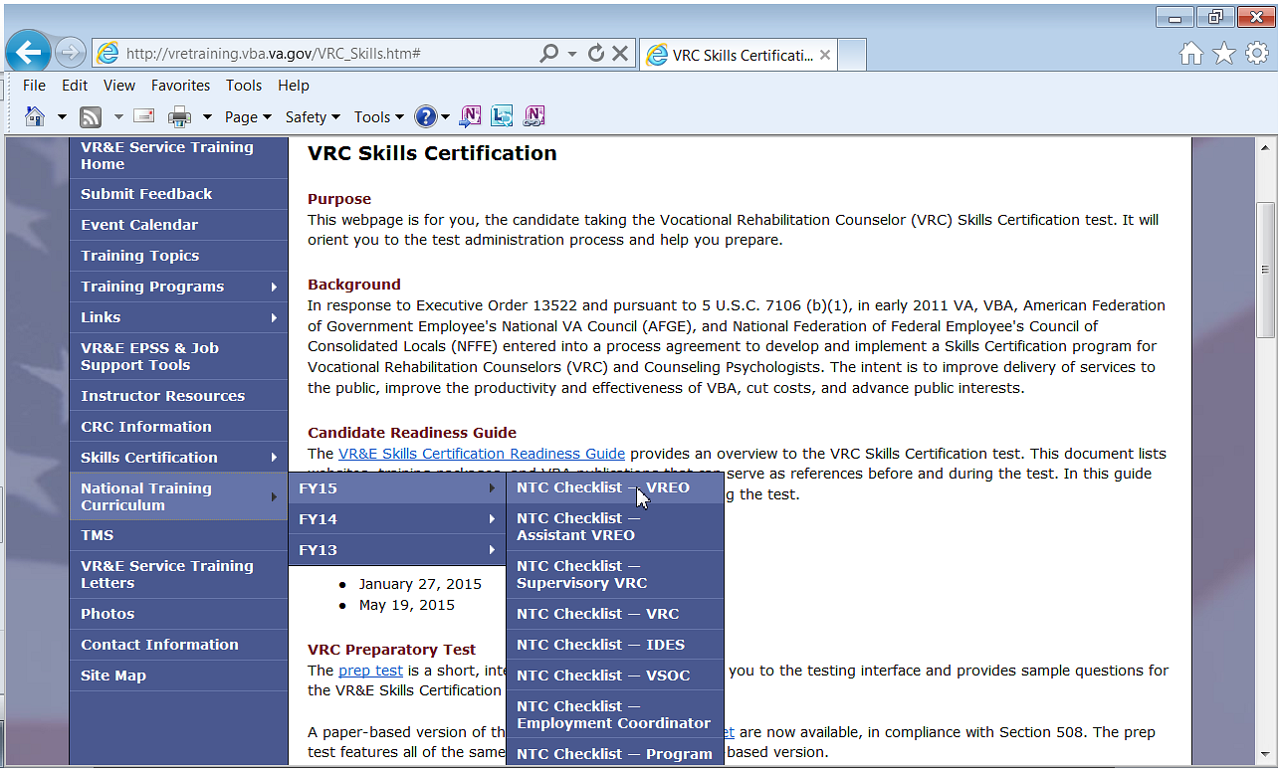 | Here you will find an archive, along with the current years, training plan for all VR&E positions. You should contact your training manager or manager if you have questions about the items on the list.  VR&E Service Training Letters will open an archive of the previous years' letters released from VR&E Service for training.
Point to Photos | 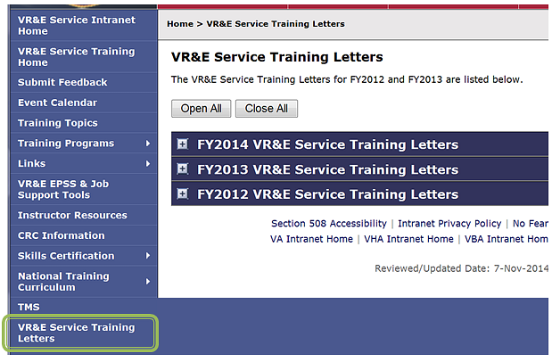 | This is where VR&E Service keeps past and present training letters.  The Photos section is one of the final options on the page.
Point to Contact Information | 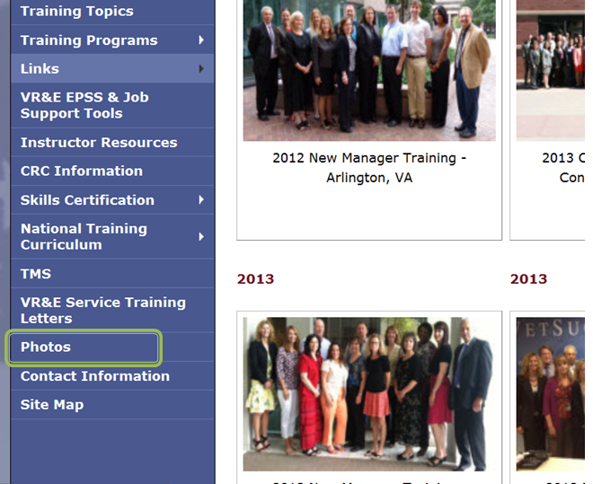 | This is an archive of photos that were taken in the past at training events.  The final option is Contact information.
 | 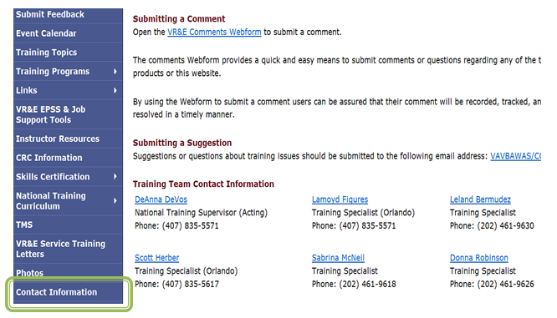 | The contact information listed is for individuals with the training team, VRC skills certification test and union representatives. However, it is always encouraged as a best practice to first consult with local management before reaching out to any individuals outside of your local office.  This concludes the tutorial on the VR&E Training Website. You may want to take some time to explore this website on your own and to familiarize yourself with the layout and information available.

