USAJOBS and Special Hiring Authorities
 | 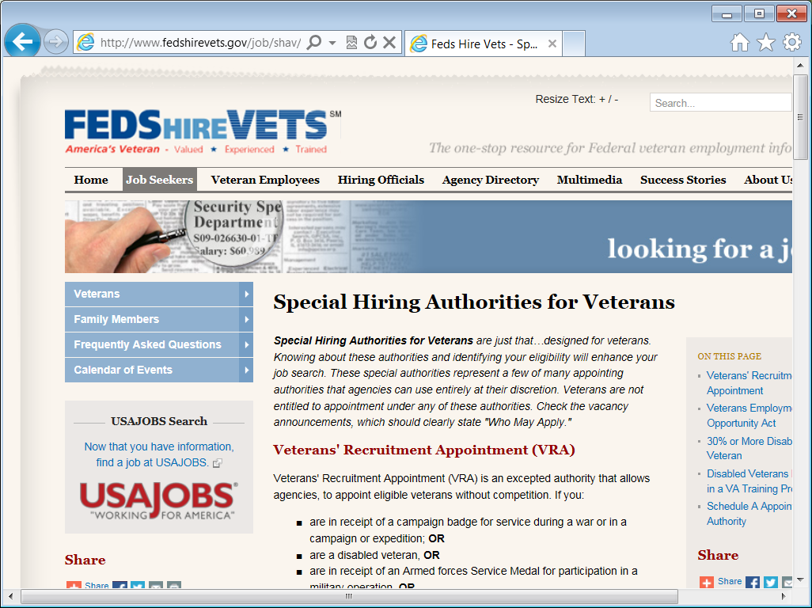 | Welcome. This tutorial is designed to introduce you to Special Hiring Authorities for Veterans. It is important that all counselors be familiar with the special hiring authorities available to Veterans to assist with seeking and securing employment.  Special Hiring Authorities for Veterans are just that…designed for Veterans. Knowing about these authorities and identifying eligibility will enhance the job search. These special authorities represent a few of many appointing authorities that agencies can use entirely at their discretion. Veterans are not entitled to appointment under any of these authorities.
 | 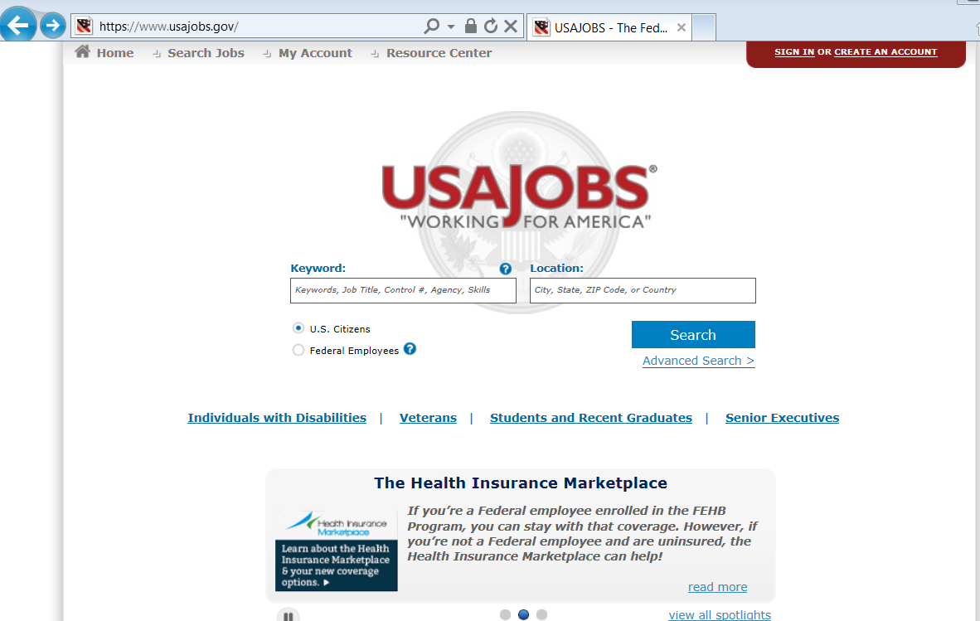 | The job search and use of Special Hiring Authorities can begin at USAJOBS.gov which is a free web-based job board enabling federal job seekers access to thousands of job opportunities across hundreds of federal agencies and organizations.
 | 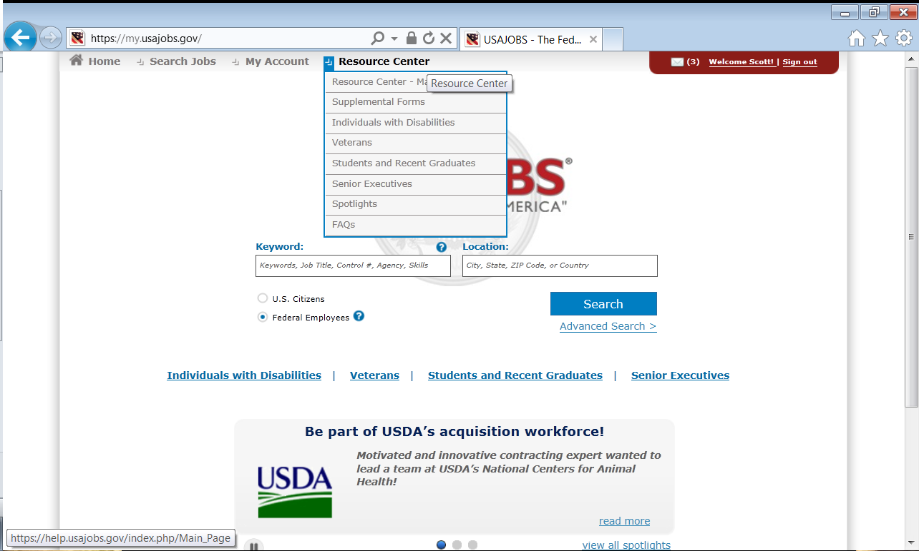 | The resource center in USAJOBS.gov provides users’ access to the Special Hiring Authorities and other useful resources. For the purpose of this tutorial, we will be selecting the option “Veterans” under the Resource Center drop down menu.  But before we do so, it is important to recognize that USAJOBS.gov is a central hub for many of the job seeking needs you can use as a case manager helping Veterans seek employment.
 | 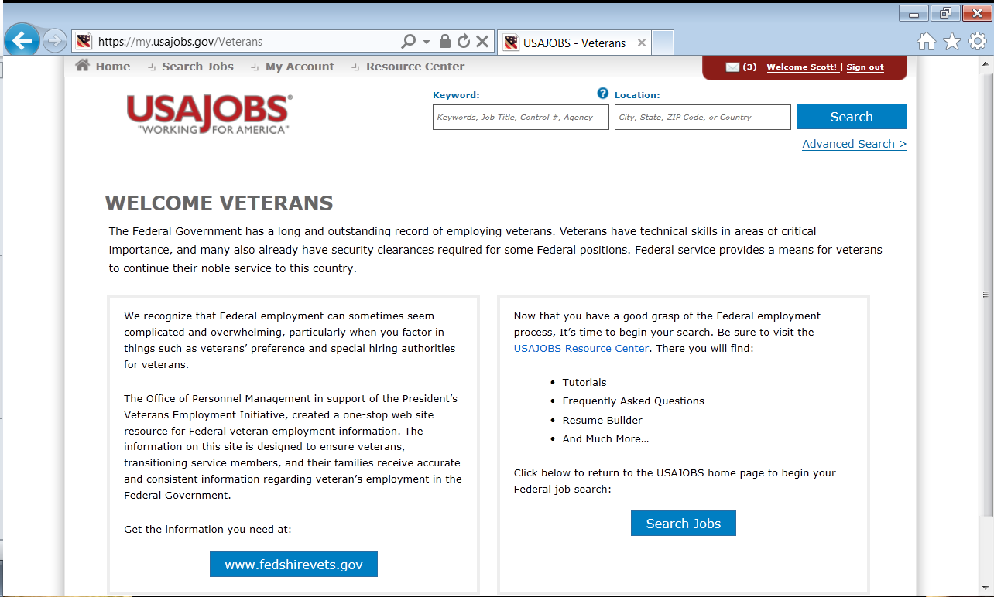 | USAJOBS.gov and fedshirevets.gov are both OPM websites that work together in providing you the best possible resources and ease to seeking employment. They recognize that Federal employment can sometimes seem complicated and overwhelming, particularly when you factor in things such as Veterans’ preference and special hiring authorities for Veterans.  The Office of Personnel Management in support of the President’s Veterans Employment Initiative, created a one-stop web site resource for Federal veteran employment information. The information on this site is designed to ensure veterans, transitioning service members, and their families receive accurate and consistent information regarding veteran’s employment in the Federal Government.  From here I will select the www.fedshirevets.gov option.
 | 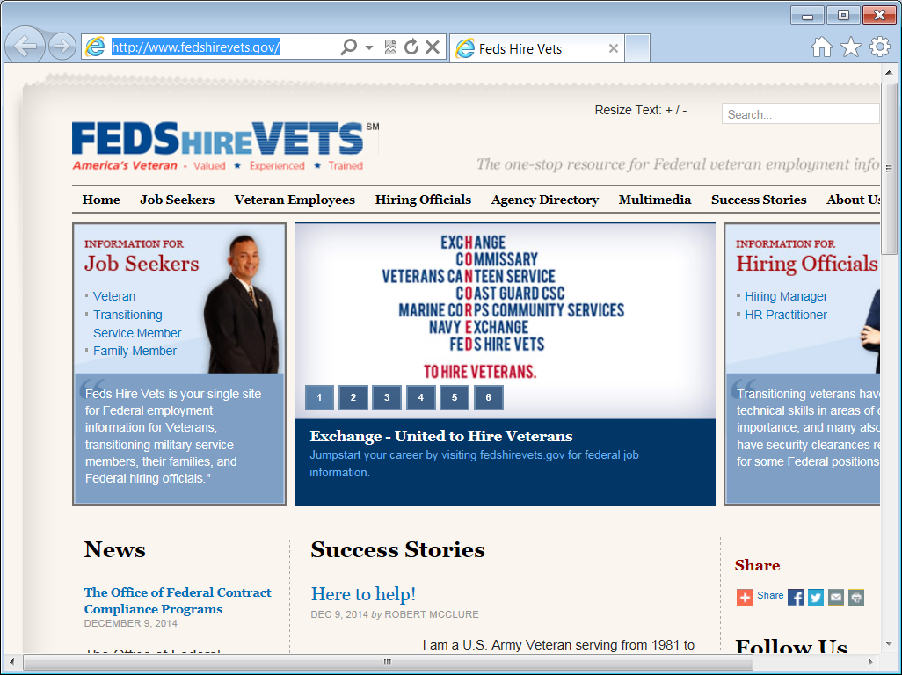 | This website is a direct result of the Presidents Executive Order. In partnership with the Departments of Defense, Labor, Veterans Affairs, Homeland Security, and other Federal agencies, the vision is that this Website will be the preeminent source for Federal employment information for Veterans, transitioning service members, their families, Federal Human Resource professionals and hiring managers. The goal is to provide consistent and accurate information and useful training and other resources in a way that will inform the applicant, the hiring agency, and case managers helping Veterans become employed.
 | 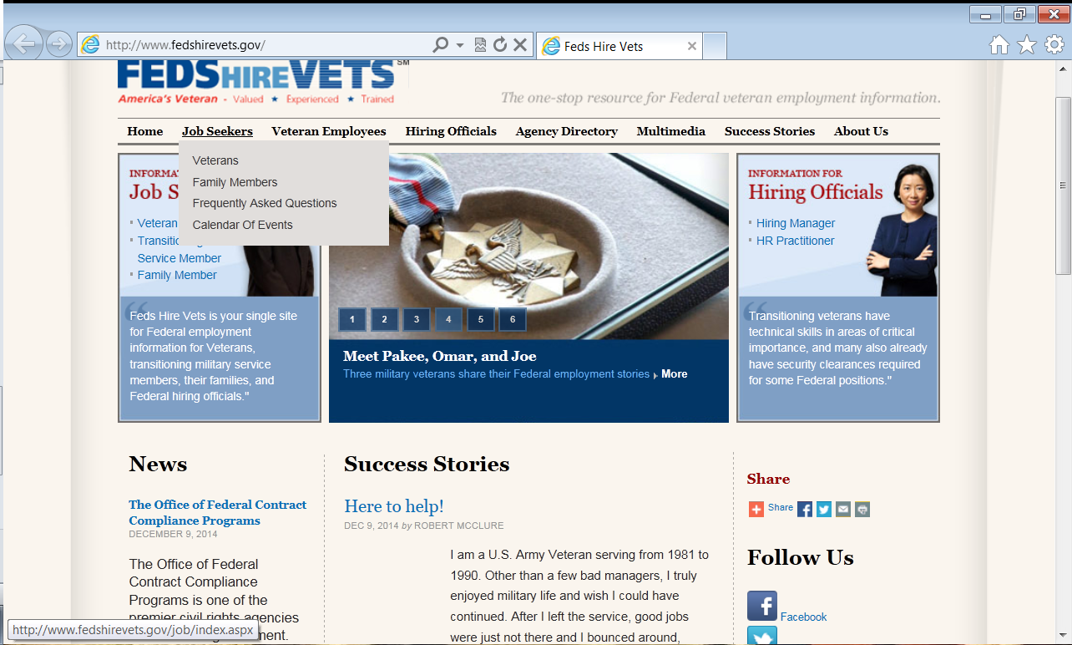 | For the purpose of this orientation, I will focus primarily on the Job Seekers menu link. Here you will find a more specific section applying to Veterans and Special Hiring Authorities.  Select the Veterans option from the drop-down menu.
 | 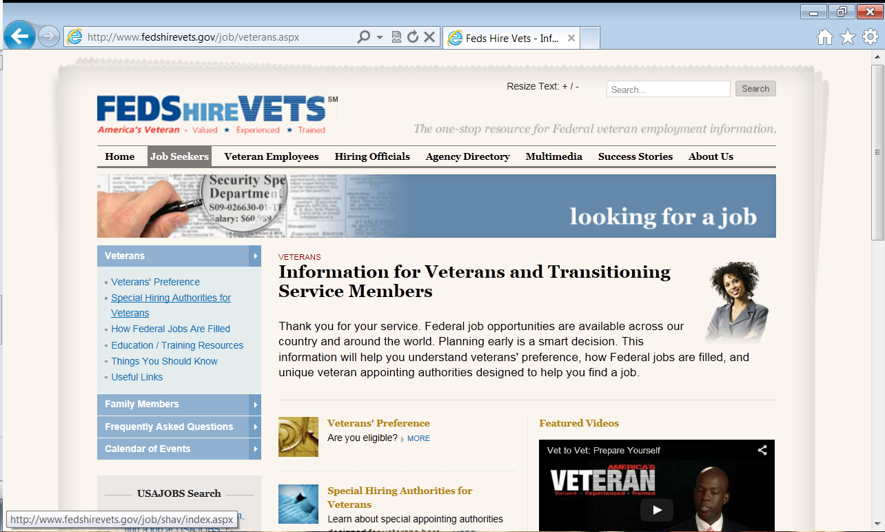 | Planning early is a smart decision. The information on here will help you understand veterans' preference, how Federal jobs are filled, and unique veteran appointing authorities designed to help Veterans secure employment.  The Special Hiring Authorities for Veterans link will open up additional information and examples used for the numerous authorities.
 | 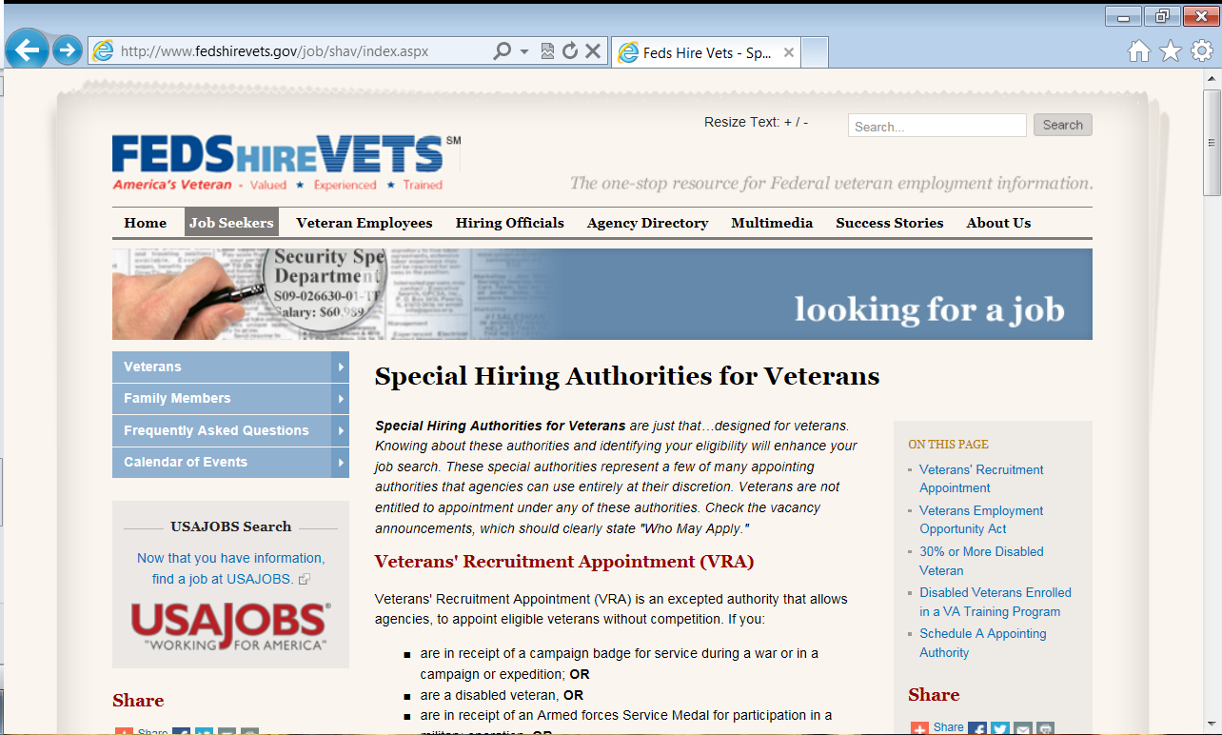 | Here you will see a list of many of the special hiring authorities for Veterans referred to in USAJOBS announcements. It is important to understand some of the terms used throughout the descriptions.
 | 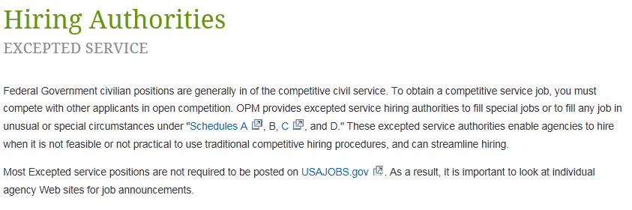  http://www.opm.gov/policy-data-oversight/hiring-authorities/excepted-service/ | An expected Service Appointment is one where the hiring agency doesn’t have to follow traditional competitive hiring techniques. Most Excepted service positions are not required to be posted on usajobs.gov. As a result, it is important to look at individual agency web sites for job announcements.
 | 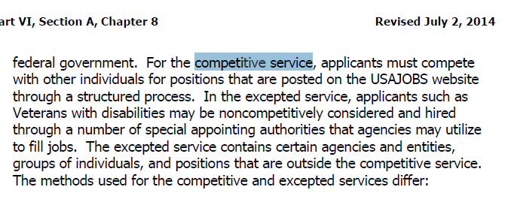  http://www.benefits.va.gov/WARMS/docs/admin28/M28R/Part_VI/pt06_ch08_secA.pdf pg 8-2 | In the competitive service, an individual must go through a competitive process which is open to all applicants. This process may consist of a written test, an evaluation of the individual's education and experience, and/or an evaluation of other attributes necessary for successful performance in the position to be filled.  Now we will explore the different authorities.
 | 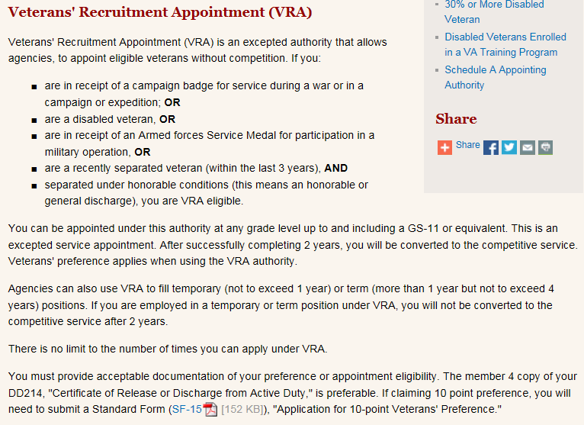 | The Veterans Recruitment Appointment or VRA gives agencies the discretion to appoint eligible Veterans to positions in the federal government without competition. Veterans may be appointed to any grade level in the General Schedule through GS-11 or equivalent. This authority also allows applicants with disabilities rated at 30 percent or more, or rated at 10 or 20 percent and determined to have a “serious employment handicap” to be employed by VA as Veterans benefits counselors, Veterans claims examiners, Veterans representatives at educational institutions and counselors at readjustment centers. Applicants must meet the basic qualifications for the position to be filled.
 | 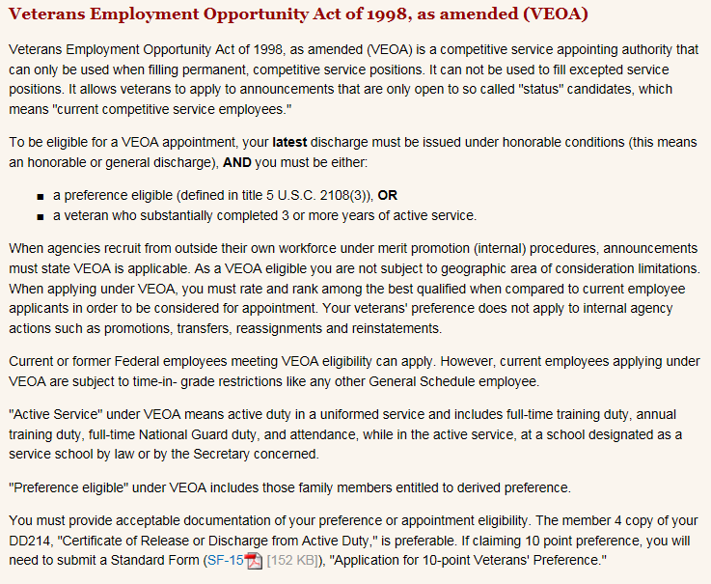 | The Veterans Employment Opportunity Act of 1998 authority, unique to the competitive service, allows Veterans to apply to positions under merit promotion procedures, inside the federal government, when the agency is recruiting outside of its own workforce. Veterans’ preference is not a consideration
 | 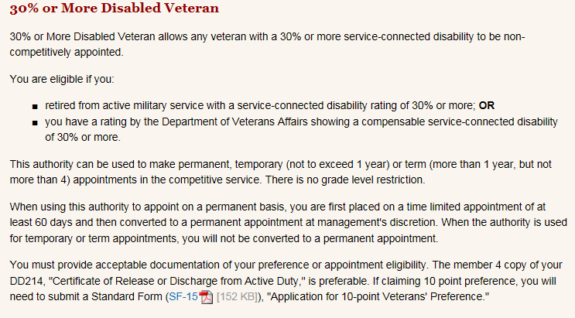 | For 30 percent or more disabled Veterans, they may be initially appointed noncompetitively to a temporary or term appointment. Then, as early as day 61 of employment under this authority, hiring managers may convert Veterans to a career or career-conditional appointment. There is no grade-level limitation for this authority. Applicants must meet all qualification requirements for the position to be filled.
 | 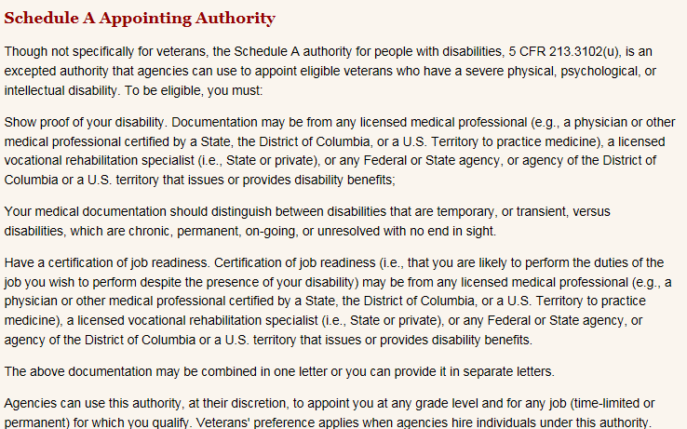 | The Schedule A Appointment Authority is an excepted service authority which is an alternative to authorities specifically designed for Veterans. Schedule A provides a way to hire individuals with physical, psychiatric or cognitive impairments without competition. Schedule A employees can be converted to permanent positions in the competitive service after completing two years on the job demonstrating satisfactory performance, with or without reasonable accommodation.
 | 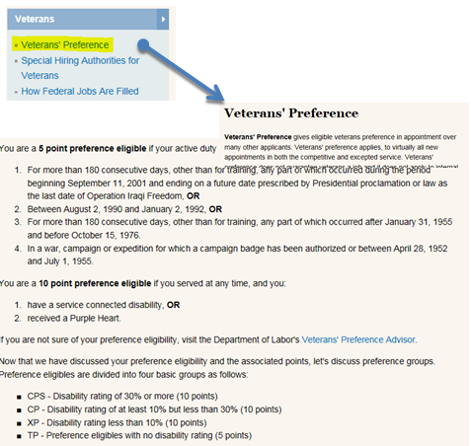 | Another resource very closely related to the hiring authorities is Veterans Preference. You can find information on this by selecting Veterans under job seekers. Veterans’ preference is a tool to assist in the placement of Veterans in federal government positions, providing a first consideration. Veterans’ preference applies to permanent and temporary positions in both the competitive and excepted services.
 | 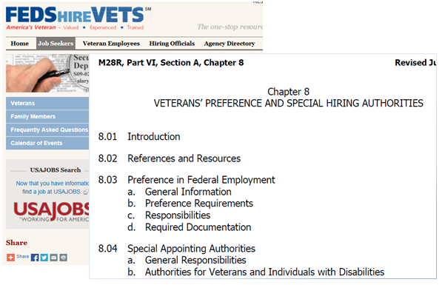  http://www.benefits.va.gov/WARMS/docs/admin28/M28R/Part_VI/pt06_ch08_secA.pdf pg 8-i | Feds Hire Vets was used to present these hiring authorities because the site is available to case managers and Veterans. Therefore, you can always refer Veterans to the website for additional information.  You can also find information and details about these hiring authorities in the VR&E Manual under Part VI, Section A, Chapter 8. This may further help in clarifying some of the authorities.
 | 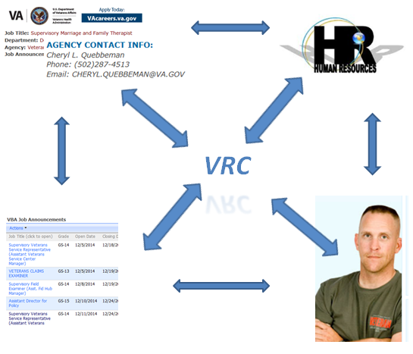 | You have now been introduced to many of the authorities and preferences available as tools to assist Veterans in obtaining employment. It is critical to communicate with local and national Human Resources and Hiring Officials to ensure Veterans are able to be placed using appropriate authorities. You are often the link between the Veterans and Agencies. Therefore, continue to build relationships with the community and try to advocate for the Veteran whenever applicable. You professional assistance may secure the employment that a Veteran Needs.  This concludes the overview of USAJOBS and Special Hiring Authorities. Please take some time to review the resources, tools and to familiarize yourself with the authorities and preferences.

