# |  | Action on Screen | Screenshot |  | Audio
4 | You are now on the Web Automated Reference Material System (WARMS) webpage http://www.benefits.va.gov/WARMS/  Select the Vocational Rehabilitation and Employment link.  On the numbered list, show page listing topics |  |  | 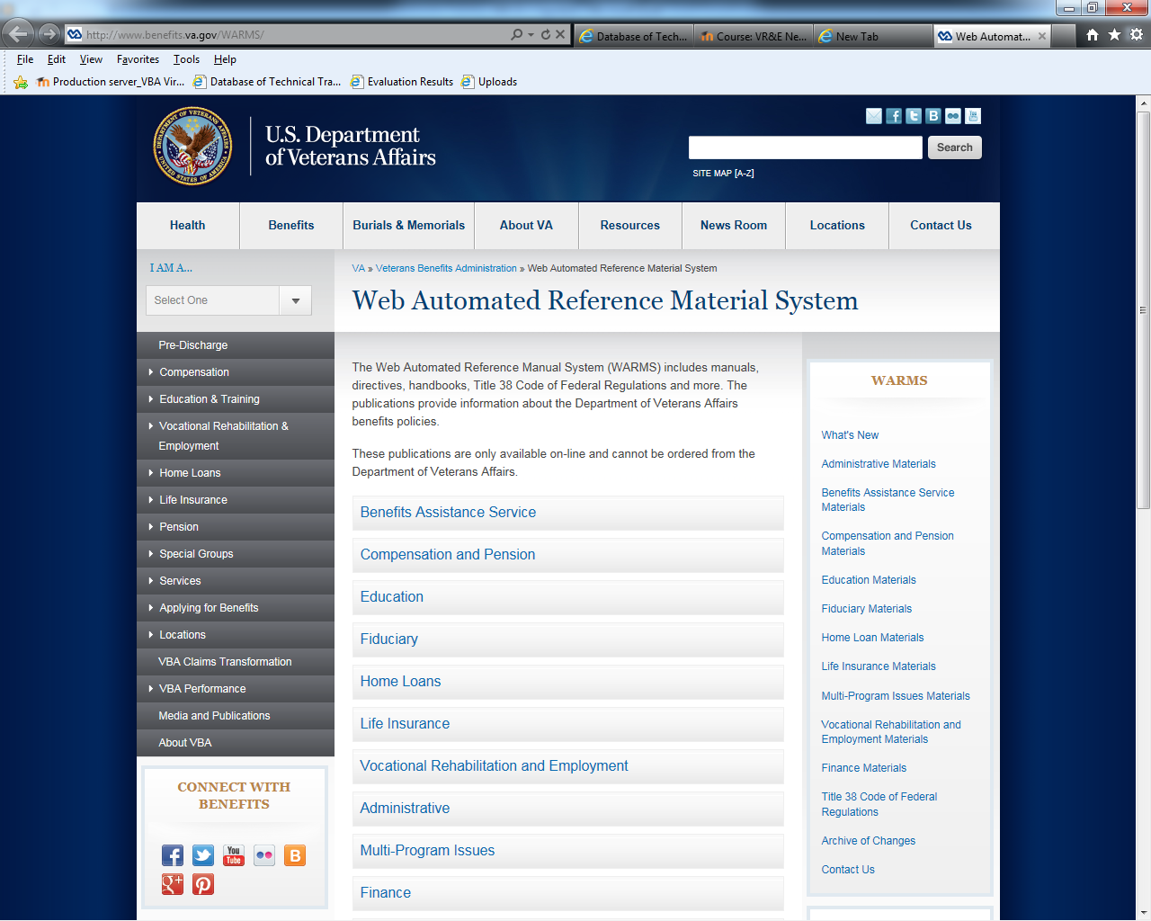 |  | Welcome! This tutorial is designed to show you the Web Automated Reference Material System or (WARMS) resource. The link to enter WARMS is http://www.benefits.va.gov/WARMS/  The Web Automated Reference Manual System (WARMS) includes manuals, directives, handbooks, Title 38 Code of Federal Regulations, and more for each of the business lines in VBA.  The VRC job is very difficult and complex and often not black and white. It is imperative that you are familiar with the laws and regulations when doing your job. It will save you a lot of time and frustration and will help you become more confident in doing your job right.  Let’s take a moment to discuss how these different laws and regulations are implemented within VR&E to have a better understanding of how to utilize WARMS.  Actions and procedures described in the M28R, also know as the VR&E manual, originate from the laws included in 38 U.S.C. VA circulates regulations to implement these laws, which are published in the CFR. VR&E Service and other business lines are then able to develop a manual from the U.S.C. and CFR. When policy clarification is needed regarding certain regulations or modifications to procedures contained in the M28R, VR&E Service and the VA issues circulars, or policy or procedural guidance letters,  it is critical that VR&E staff adhere to :  1. 38 U.S.C.  2. 38 CFR  3. M28R  4. Circulars  5. Policy or procedural guidance letters  6. Similar guidance issued by VR&E Service, the Under Secretary of Benefits, or the Secretary of VA  It is important to note that previously issued VA and VR&E Circulars and Policy Letters have been incorporated into the M28R. As a result, those circulars and policy letters that were issued prior to the publishing of the manual have been rescinded. The rescission information, to include the date of revision and where the information is currently found in the M28R, is available on the Knowledge Management Portal (KMP). Rescission information is available on the “Policies and Guidance” page on the KMP, in the “Rescinded” and “Rescinded By” columns.  This might seem like a lot of information. However, today’s overview will provide you information on where to locate these resources, references and manuals.  So let’s take a look at the Vocational Rehabilitation and Employment section of WARMS. Select the Vocational Rehabilitation and Employment link.
5 | Point to the three manual links under the top Mlink. |  |  | 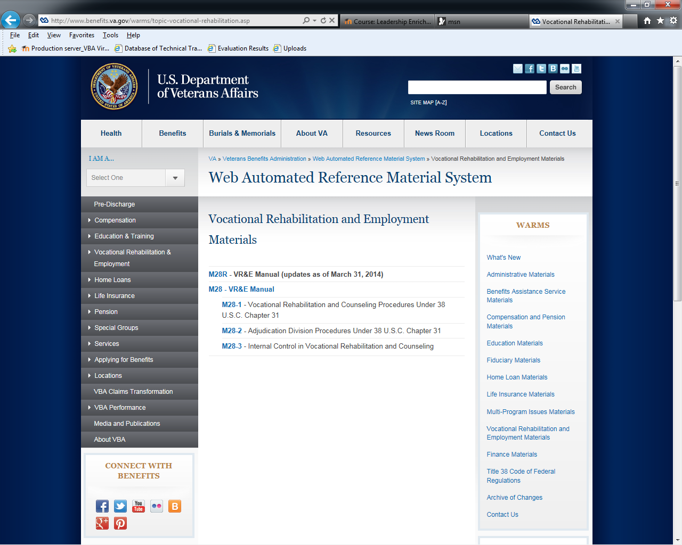 |  | Notice the older and outdated manuals listed below the current manual. These links are available for you to use as references.
6 | Select the M28R link. |  |  |  |  | The current V-R-&-E Manual rewrite is listed above the older manuals.  Select the M28R link to access the manual.
7 | Slowly scroll down the page |  |  | 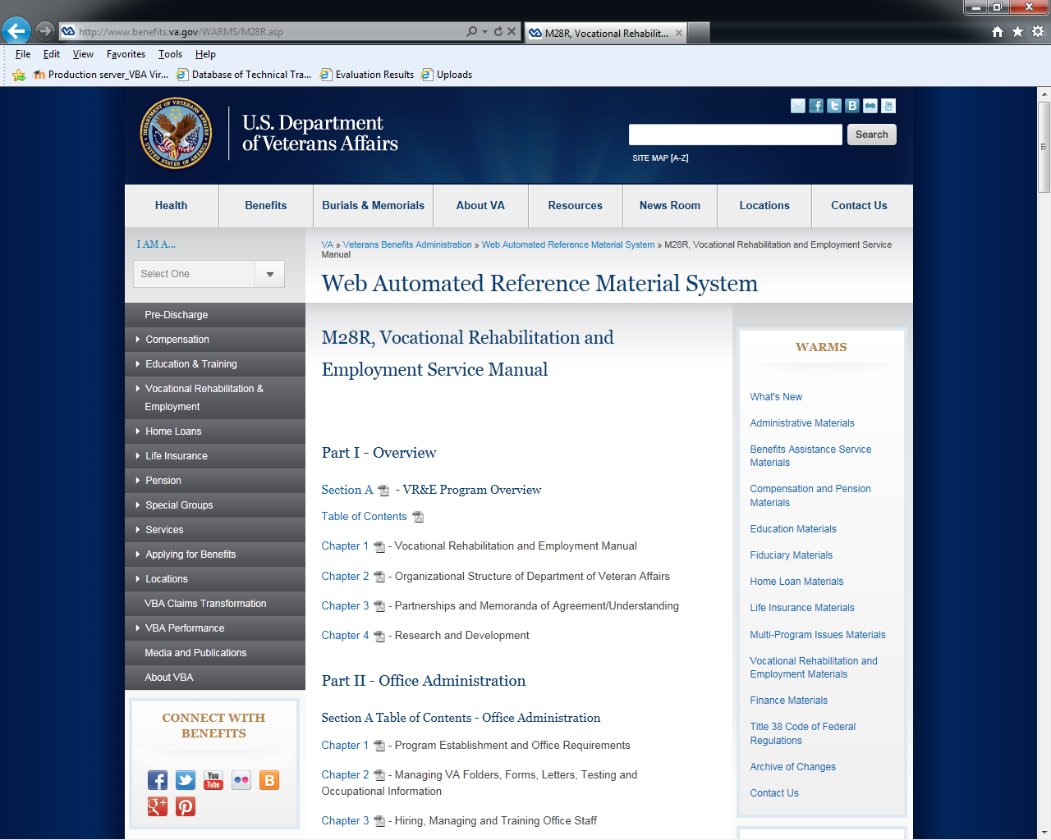 |  | The M-28-R, Vocational Rehabilitation and Employment Service manual has all the information you need to do your job as a vocational rehabilitation counselor, or V-R-C. Whether you need information about skill certification, entitlement determination, or retro induction, this manual breaks down the various processes and provides tools such as flowcharts.
 |  |  |  | 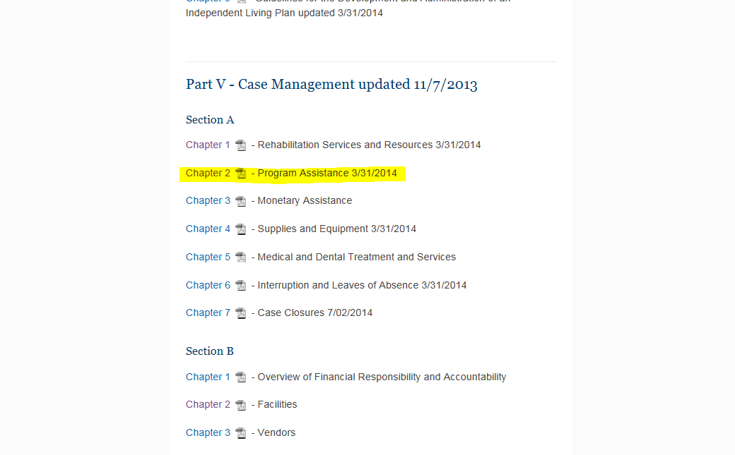 |  | Let me show you what you might see as you look up information in M28R under WARMS. For this exercise, I am going to select Program Assistance, which is Chapter two, Section A, in Part Five of the Manual.
 |  |  |  | 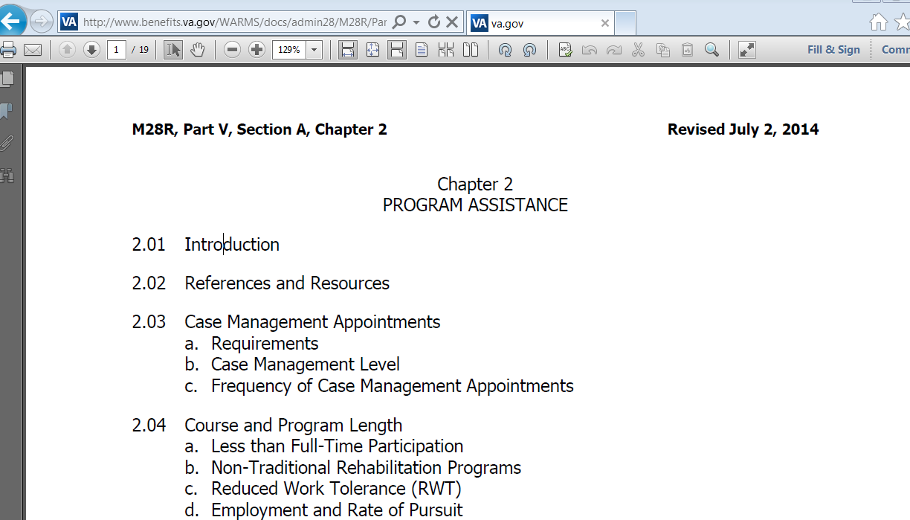 |  | Here you can see the Chapter on Program Assistance. The table of contents hyperlinks the specific section to the part of the manual. Therefore, you can select the section you want to go to by selecting the topic in the table of contents. First, select section 2.02, which is the References and Resources section of the chapter.
 |  |  |  | 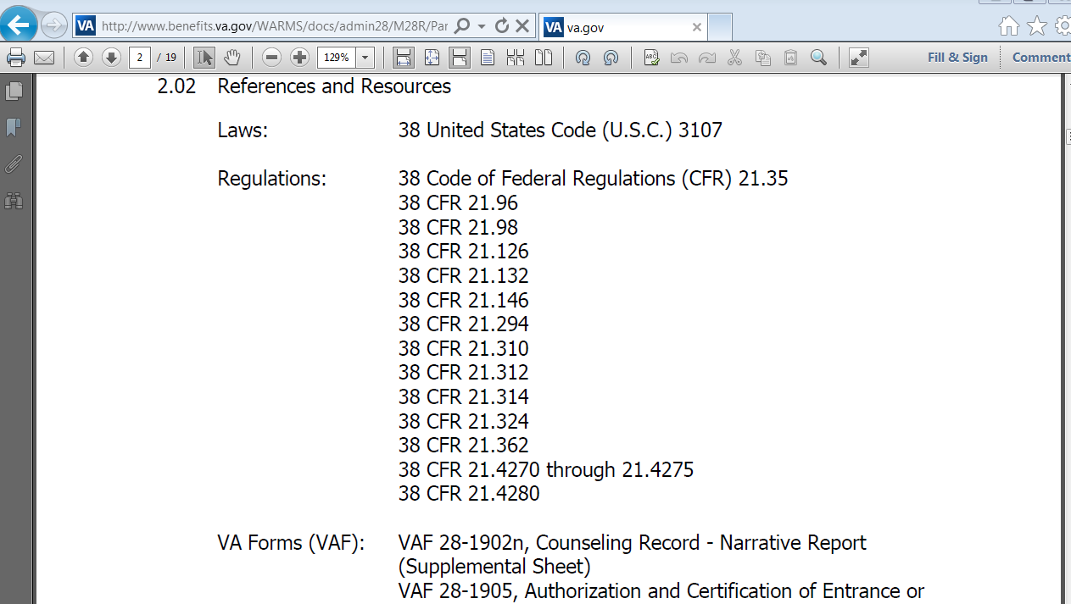 |  | Earlier, you were shown the resources used in the development of the manual. You can see here a list of the U.S.C. and Regulations used to develop this chapter. You can also see the VA Forms which specifically apply.
 |  |  |  |  |  | Back at the top, in the table of contents, select the Case management level, which is sub-paragraph b of Chapter 2, paragraph 3.
 |  |  |  | 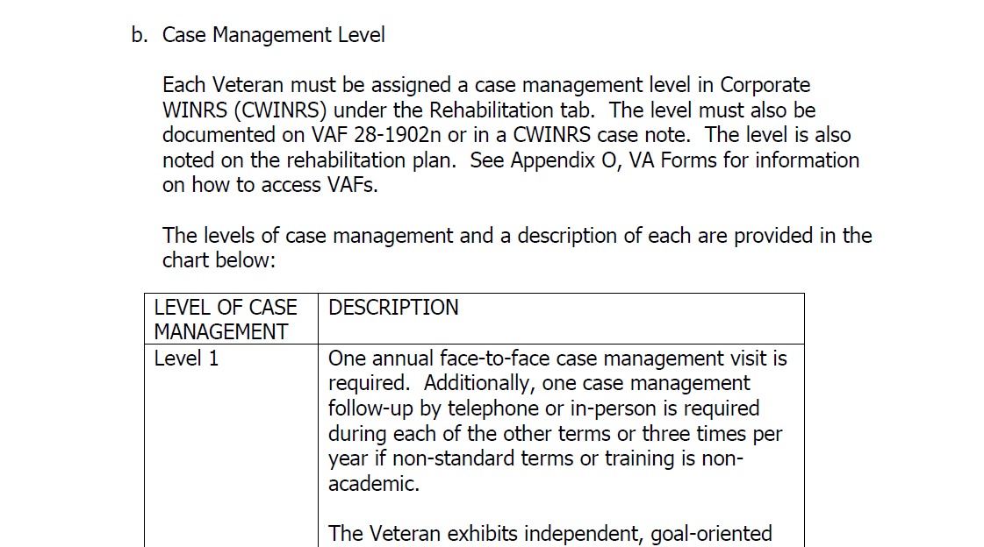 |  | The webpage will jump to the Case Management Level section of the manual. Here you can see a detailed description of the different case management level and determining factors. This is a key component of your job and this is where you would go to find out how to determine the level of case management.
 | Scroll to the top of the page - http://www.benefits.va.gov/WARMS/M22_4.asp#d  (Back page & use the WARMS links in the right-hand column.  Select the Title 38 Code of Federal Regulations link. |  |  | 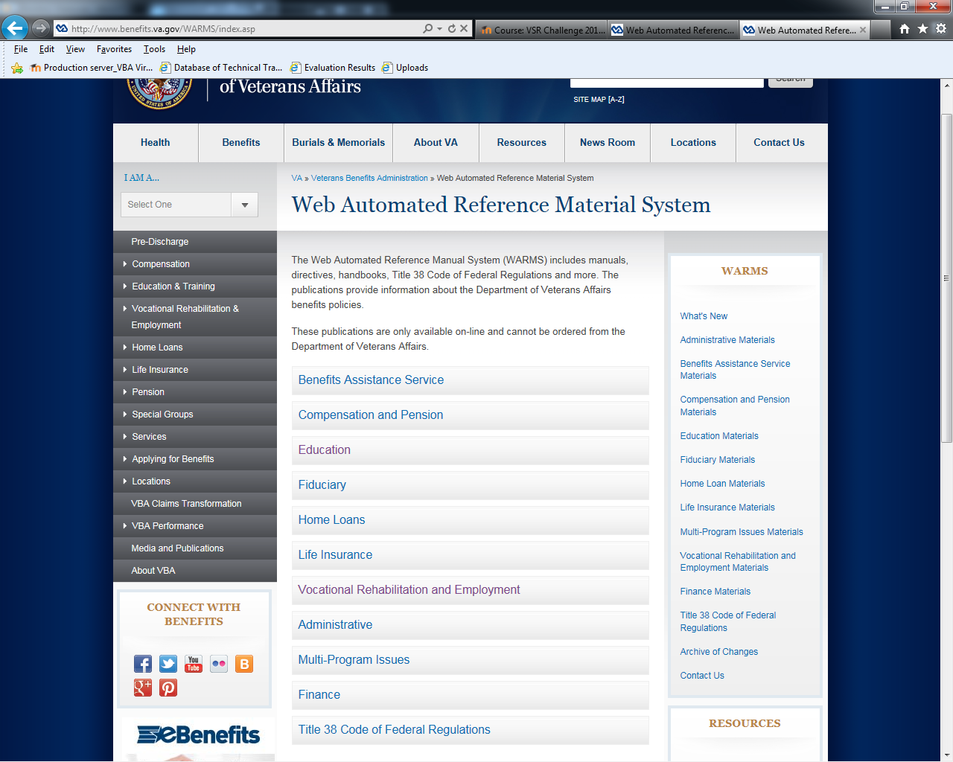 |  | Return back to WARMS so we can take a look at another resource available on WARMS, 38 Code of Federal Regulations, or C-F-R.
 | Select the Book G link. |  |  | 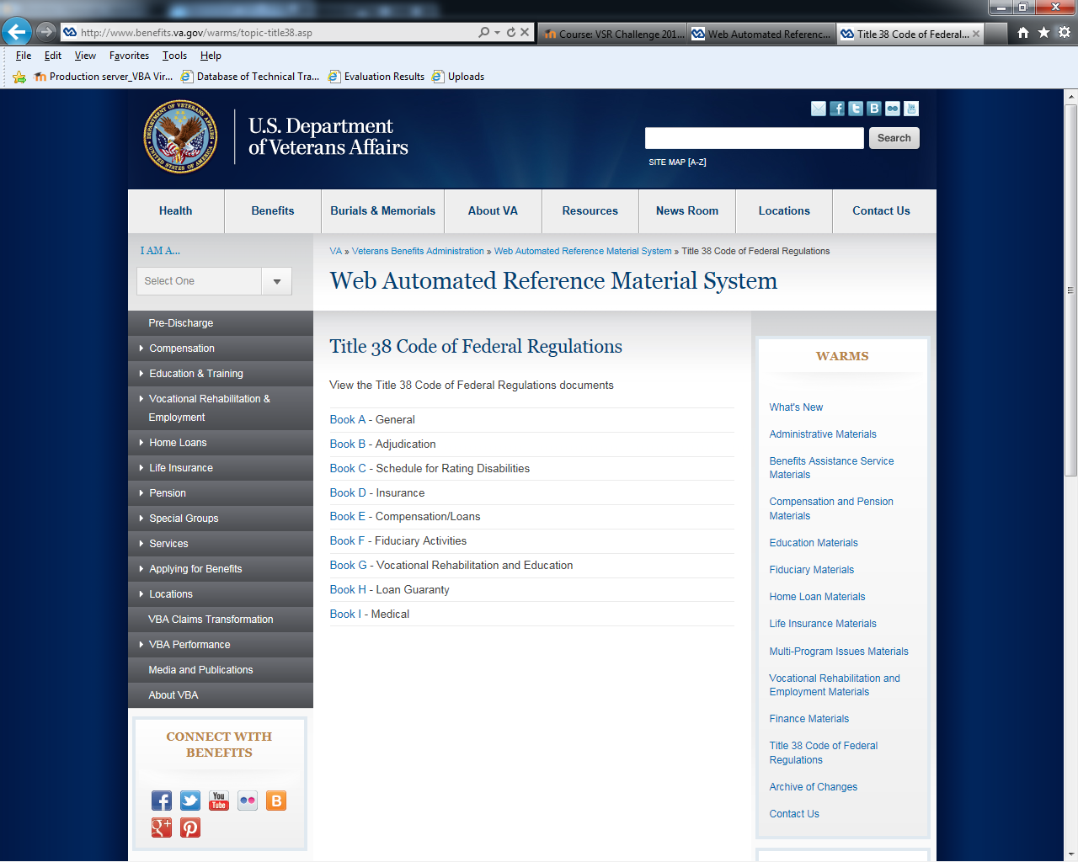 |  | Service manuals actually come from the information provided in the 38 C-F-R. V-R-&-E information is in Book G.
 | Scroll down to the Independent Living Services link.  Select the link. |  |  | 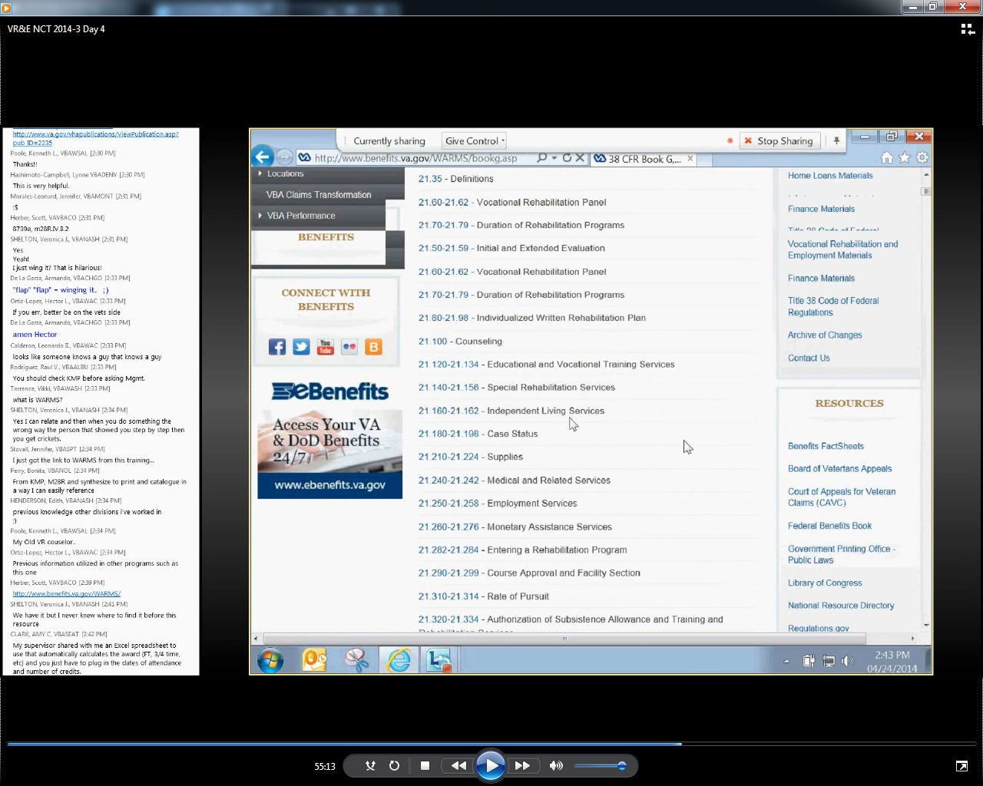 |  | You might have questions about an independent living, or I-L plan. Scroll down through Book G until you reach the Independent Living Services link.
 | Select the Independent living services link, 21.160. |  |  | 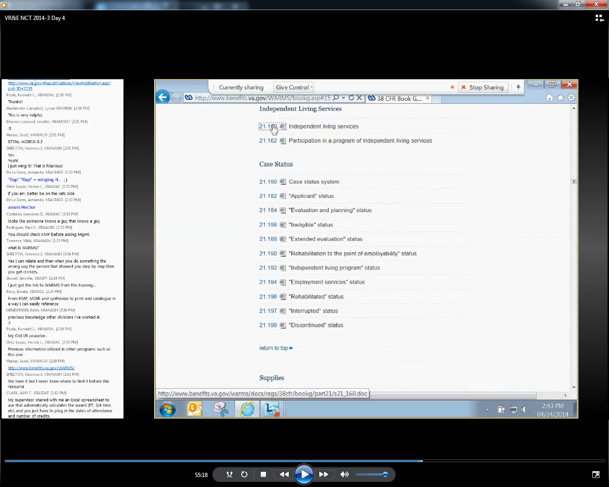 |  | Let’s open the document 21.160 – Independent Living Services.
 | Close the Word doc. |  |  | 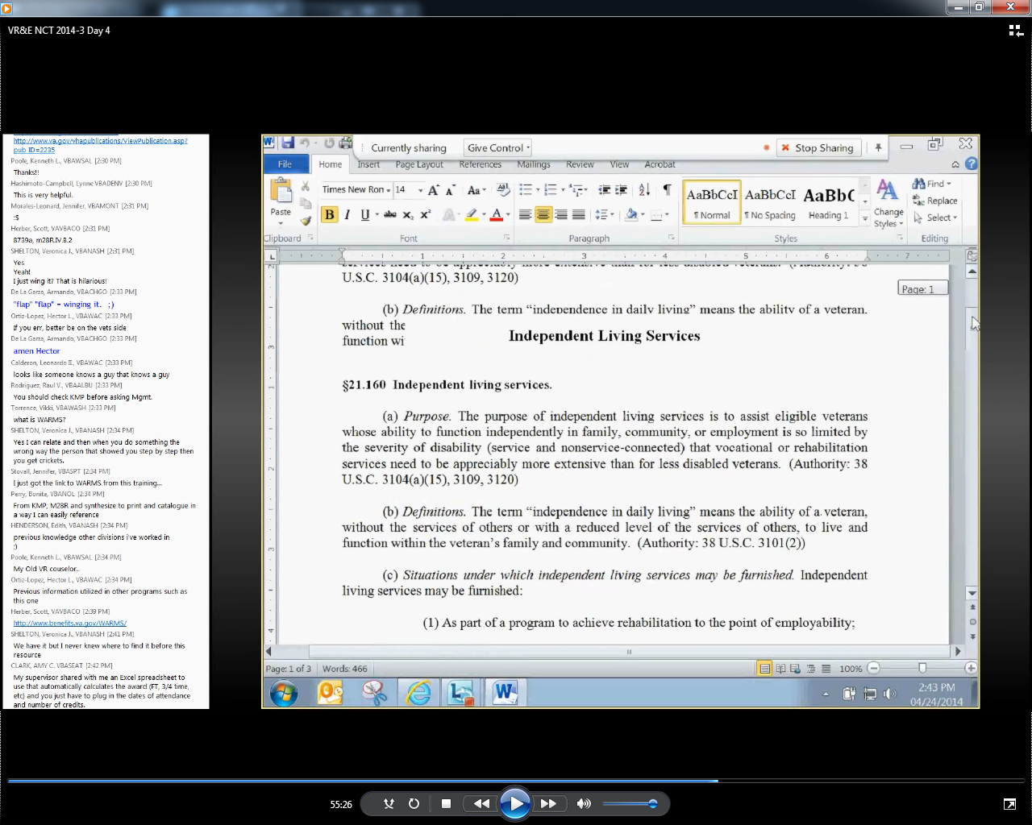 |  | This document can help you better understand what I-L is. As well as what the purpose of the program is.
8 | Select the Education link. |  |  |  |  | In addition to the M-28-R V-R-&-E Service manual, WARMS provides access to other V-B-A Service manuals.  A V-R-C who is processing awards might need to look at information available in the Education section of WARMS.
9 | Point to the M22-4 link.  Point to the Claims Processing – Awards Issues title.  Select the M22-4 link. |  |  | 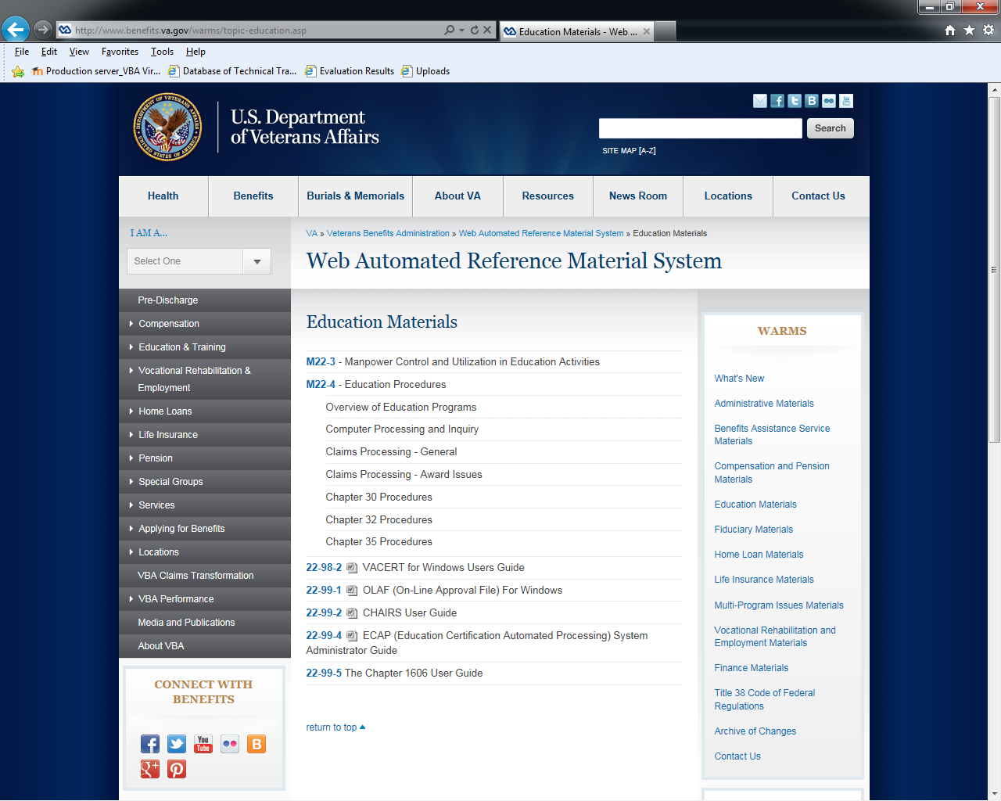 |  | The M-22-4 Education Procedures manual provides information about claims processing and award issues.
10 | Select the Part 4 – Claims Processing – Award Issues link. |  |  | 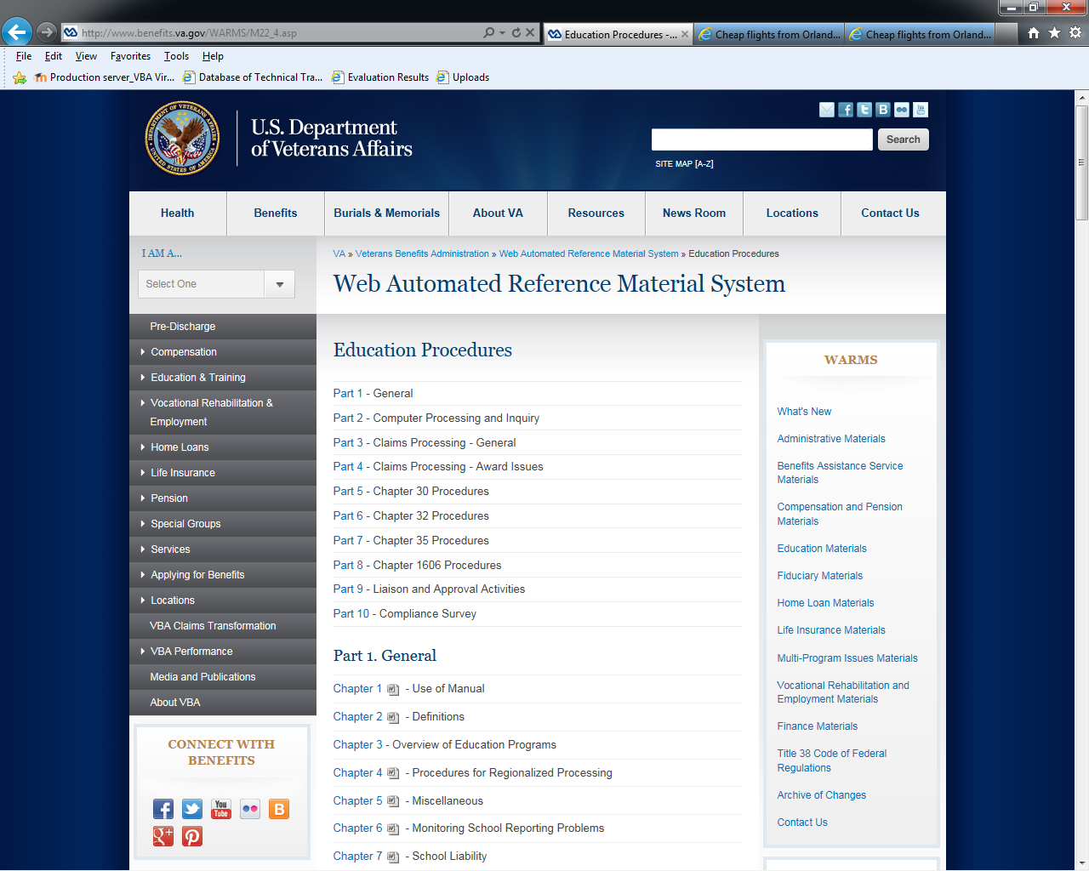 |  | Once on the main Education Procedures page, select the Part 4 – Claims Processing – Award Issues link.
11 | Point to the measurement of college level courses & dependency issues Chapter links.  Select the Chapter 14 link. |  |  | 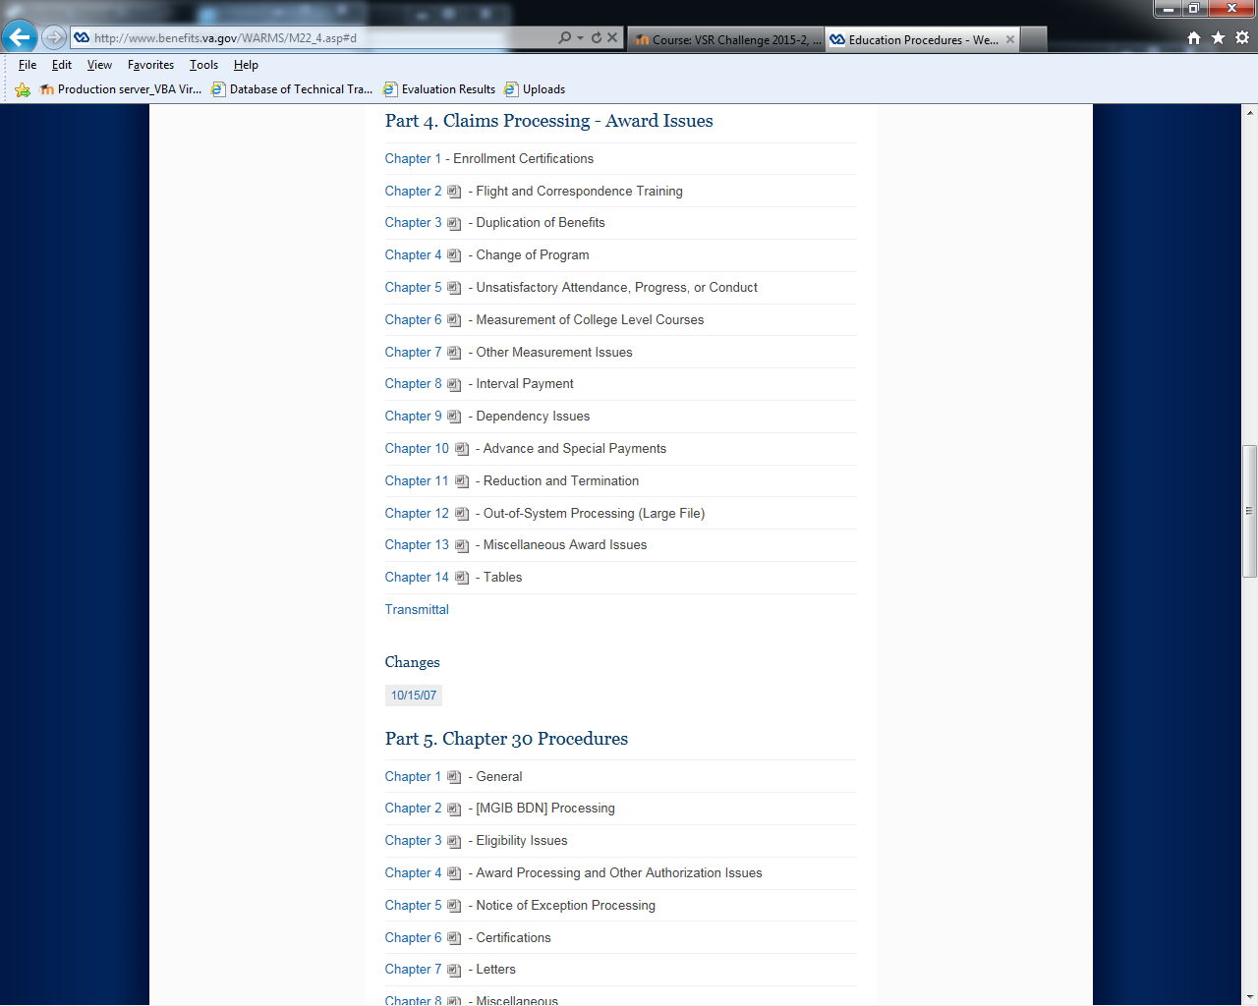 |  | In this section, you find topics like measurement and dependency issues. Tables are also available. Each of the Chapter links in the Award Issues section opens a Word document.
12 | Scroll to page 4.  Stop on table 14.02a  Close the Word doc. |  |  | 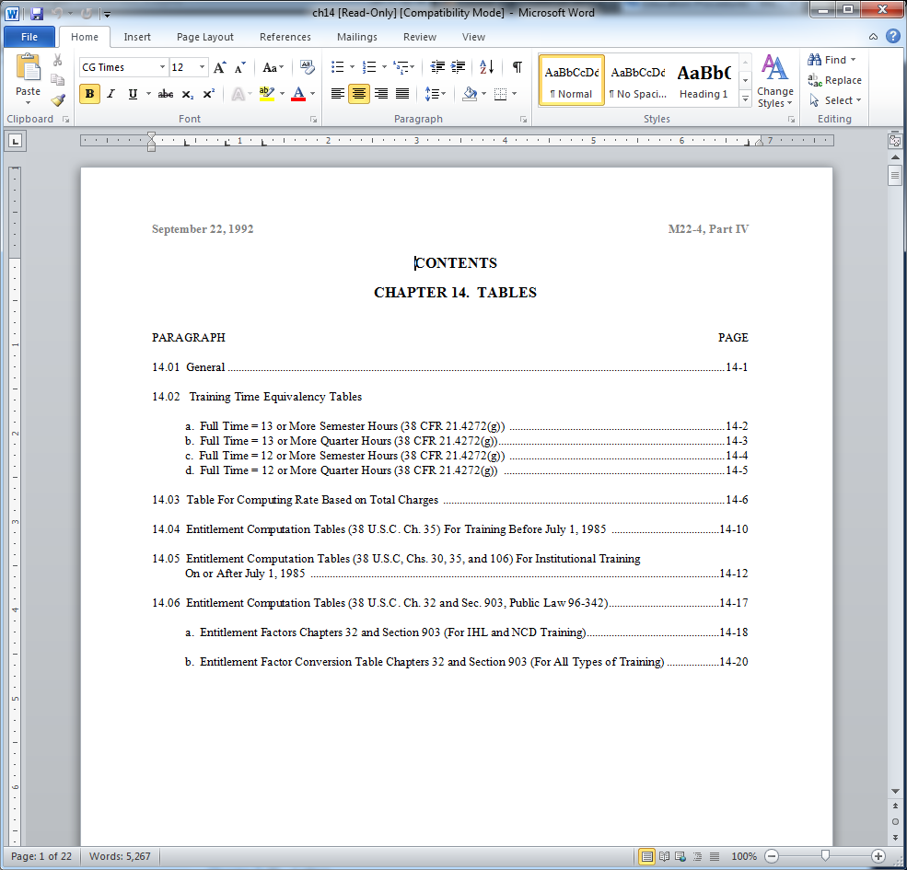  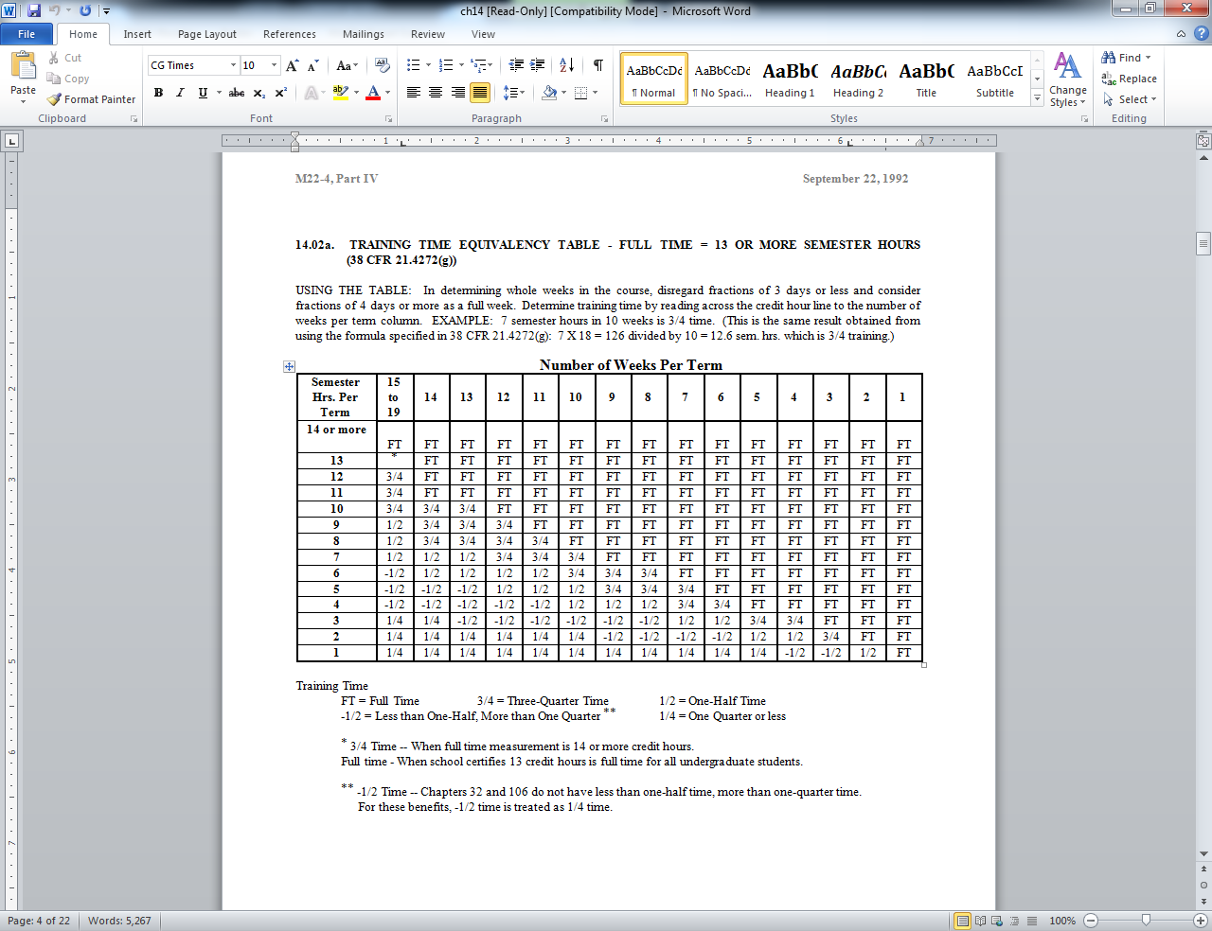 |  | Let’s open Chapter 14 – Tables. This Tables document can be useful when determining how to measure awards.
13 | Select the Web Automated Reference Material System breadcrumb.  Demo ends on the main WARMS page. |  |  |  |  | That concludes the demonstration of WARMS. Please take time to look over this resource. Knowing what is here can help you easily locate answers down the road.

