# | Action on Screen | Screenshot | Audio
- 3 | You are now on the Vocational Rehabilitation & Employment Job Support Tools portal  Hover over the button that links to Medical EPSS.  Select the button that links to Medical EPSS. | 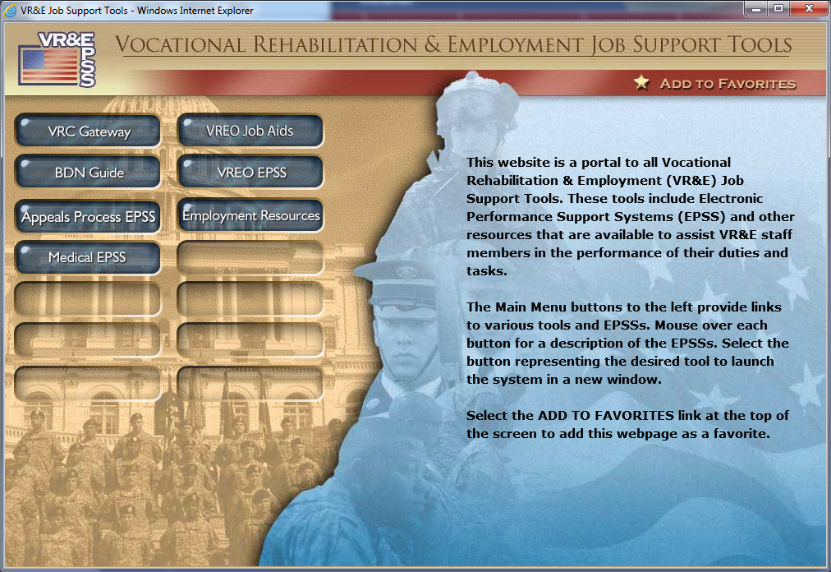 | Welcome! This tutorial is designed to show you the Medical Electronic Performance Support System, also known as the Medical E-P-S-S. To open the Medical EPSS, you will need to navigate to the VR&E Job Support Tools Website. The link to this site is: http://epss.vba.va.gov/vre_jst/default.html  or you can access it directly through the VR&E Training Intranet site. The Medical EPSS is only available through the Internal, or VA Intranet, site.  If you are accessing it through the internet, you will find the Medical EPSS option inactive.  Here you will see the Vocational Rehabilitation & Employment Job Support Tools portal. This portal provides access to electronic performance support systems –or E-P-S-S-s—and other resources designed to assist V-R-&-E staff members in performing a variety of tasks.  If you haven’t done so yet, you may want to bookmark this page by selecting “Add to Favorites” in the top right corner of the screen.  Select the Medical E-P-S-S button on the left side of the screen to open the Medical EPSS.
 | You are now on the Medical E-P-S-S site.  Point to the systems listed on the left side.  New screen to have bulleted questions scroll in. | 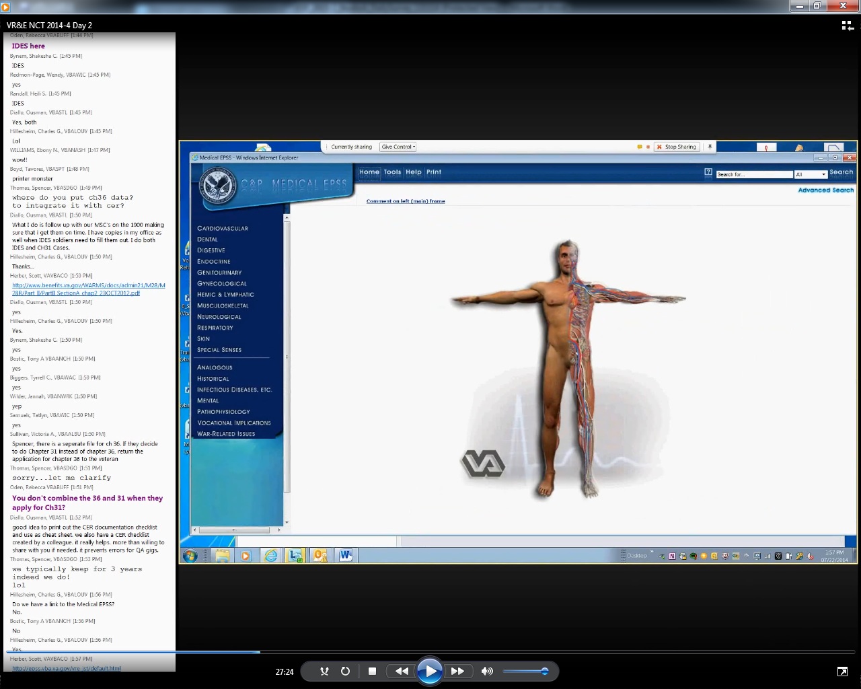 | This brings you to the Medical E-P-S-S.  The Medical E-P-S-S was initially developed for Compensation Service. For a V-R-C, this resource is useful for evaluation and planning. You may get cases where are not familiar with what is being described. Not understanding the information can be problematic in terms of:  - How do you define what the Veterans’ limitations are?  - How do you define what the Veterans’ capabilitites are?  - What are the vocational implications of the Veterans’ limitations and capabilities?  You need to make sure that the types of jobs you are looking at for Veterans do not agravate their disabilities and that their disabilities do not get worse over time. Your goal is to prepare Veterans for a career they CAN do long term. Information provided on the Medical E-P-S-S can help you in making these decisions and providing Veterans the necessary assistance.
- 5 | Select the Cardiovascular option. (after the left side…)  Point to the different options in the Cardiovascular submenu:  - Overview  - Rating Schedule  - And various diagnostic code groupings | 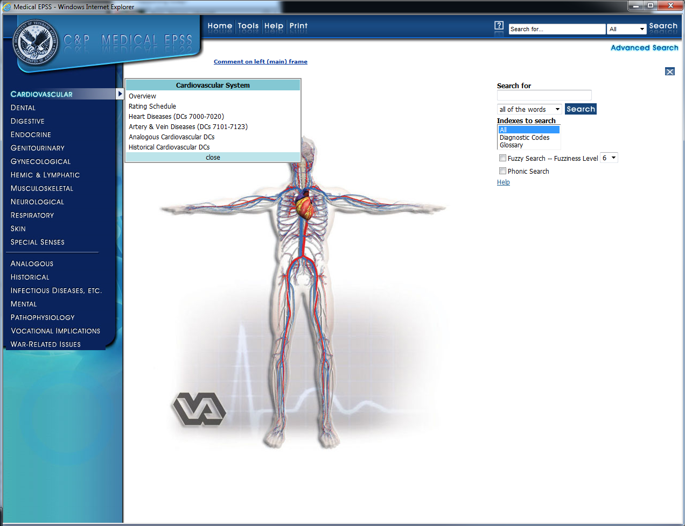 | The left side of the Medical E-P-S-S lists the body systems.  If you select a body system, a submenu appears. Within each submenu there are options for:  - Overview  - Rating Schedule  - And various diagnostic code groupings
 | Select the Overview option. | 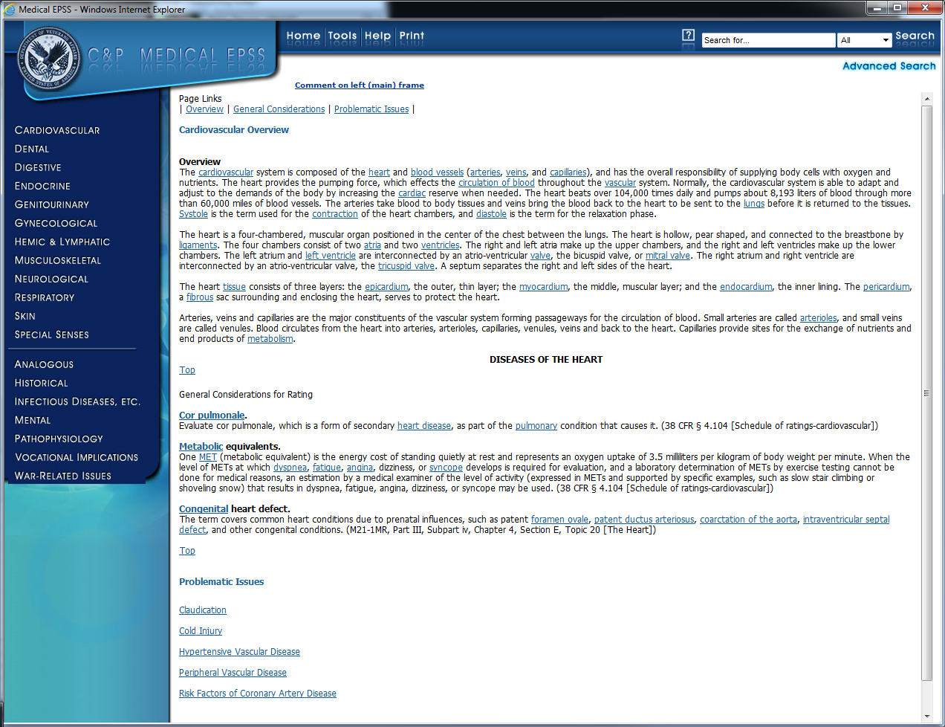 | After selecting the cardiovascular Overview option, the overview displays in the main part of the webpage. Here you can see that it does exactly as it states, provides a detailed overview of the disability along with some additional supportive information. You have numerous links to chose from throughout the page that may help in clairifying the information or in obtaining additional information about the disabilty.  Select Cardiovascular and Rating Schedule to view the Rating Schedule.
 | Select Cardiovascular and Rating Schedule to view the Rating Schedule. | 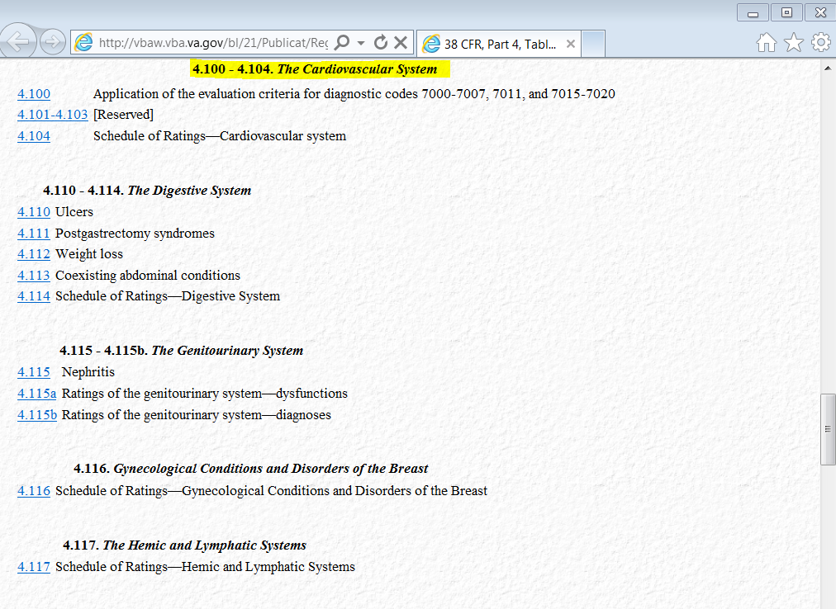 | There are additional options available to further explore the disability and the ratings. For this example, I am going to chose the 4.104 Schedule of Ratings – Cardiovasular system link to the left of the title.
 |  | 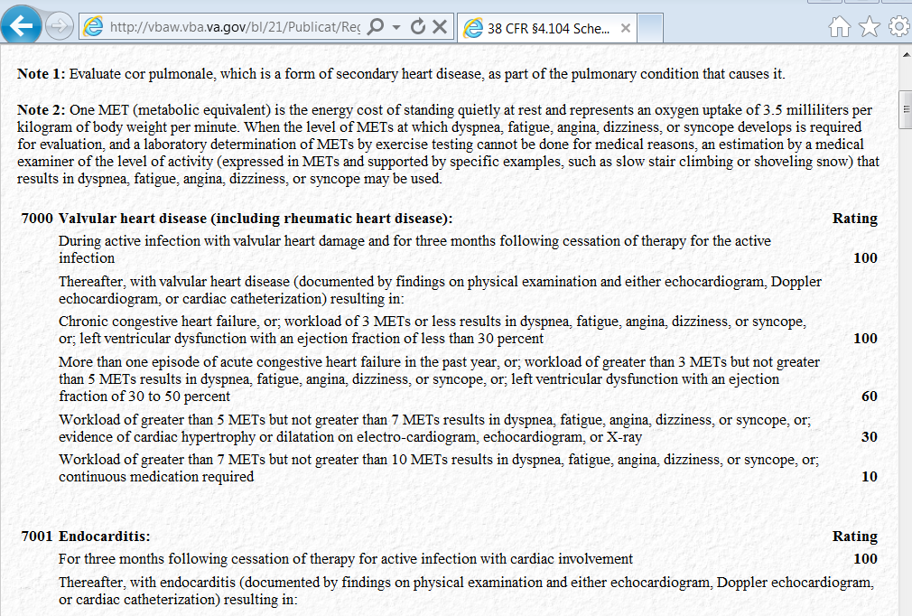 | This screen shows the different rating levels for the disability choosen. It provides the user an overview of the different ratings with specific information on the severity of it.
 |  | 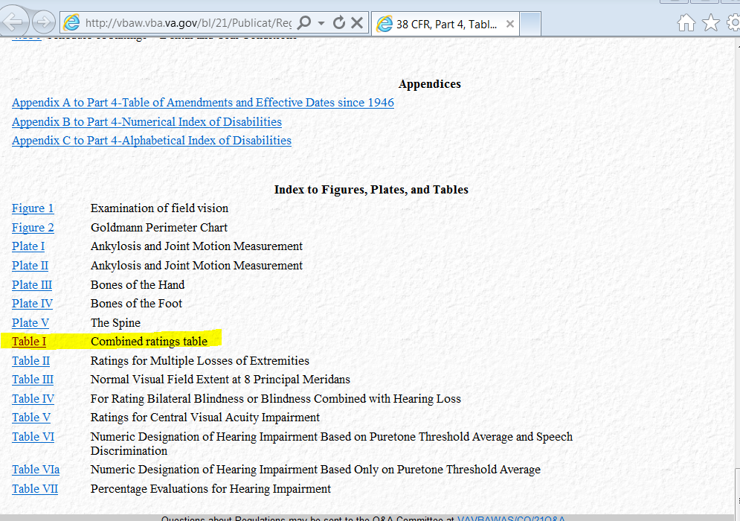 | If you return back to the Rating Schedule option, you can locate and select the “Combined Ratings Table” option. For this exercise, locate the “Index to Figures, Plates, and Tables section at the bottom of the page. Open Table I – the Combined Ratings table to open up an additional page on information describing how combined rating percentages are calculated.
 |  | 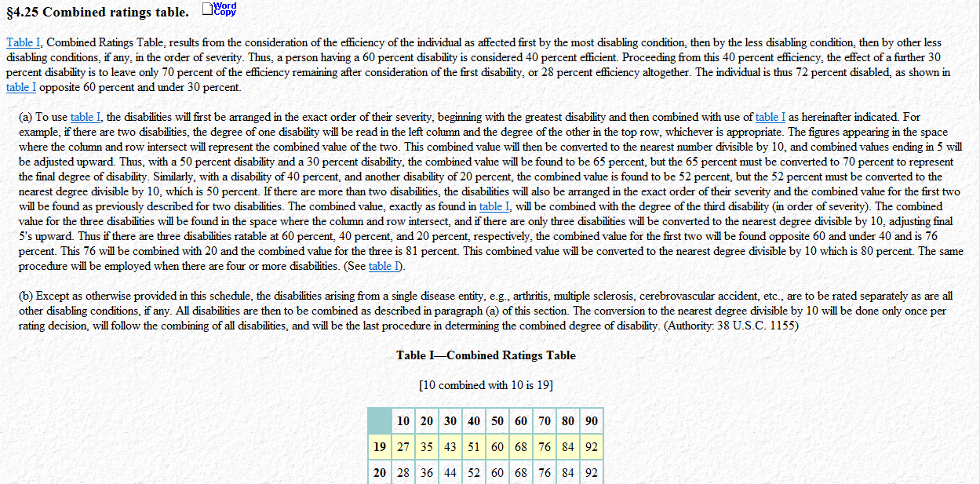 | You will see a description of how the ratings are combined for Veterans having more than one disability. There is also a Combined Ratings Table for quick reference. You will find this useful when Veterans ask you about how their combined rating was calculated.
 |  |  | This concludes Part 1 of the Medical EPSS tutorial. Watch Part 2 of MEPSS to continue learning more about this resource.
 | Left click each option as you read it:  - Analogous  - Historical  - Infectious diseases  - Mental  - Pathophysiology  - War-related issues and  - Vocational implications  NOTE: The Vocational implications option is listed out of order for a reason. Select that last so the demo can continue on into that section.  Select the Vocational Implications as the final option. |  | Welcome to Part two of the Medical Electronic Performance Support System. You will now be introduced to additional resources within this job aid, including resources specifically for VR & E.  From the Home page of the Medical EPSS, near the bottom of the page on the left side you will see other options including:  - Analogous  - Historical  - Infectious diseases  - Mental  - Pathophysiology  - Vocational implications  - War-related issues  Let’s look at Vocational Implications which is dedicated primarily to VR&E.
 | Scroll down to the Traumatic Brain Injury link.  Select the Traumatic Brain Injury link. | 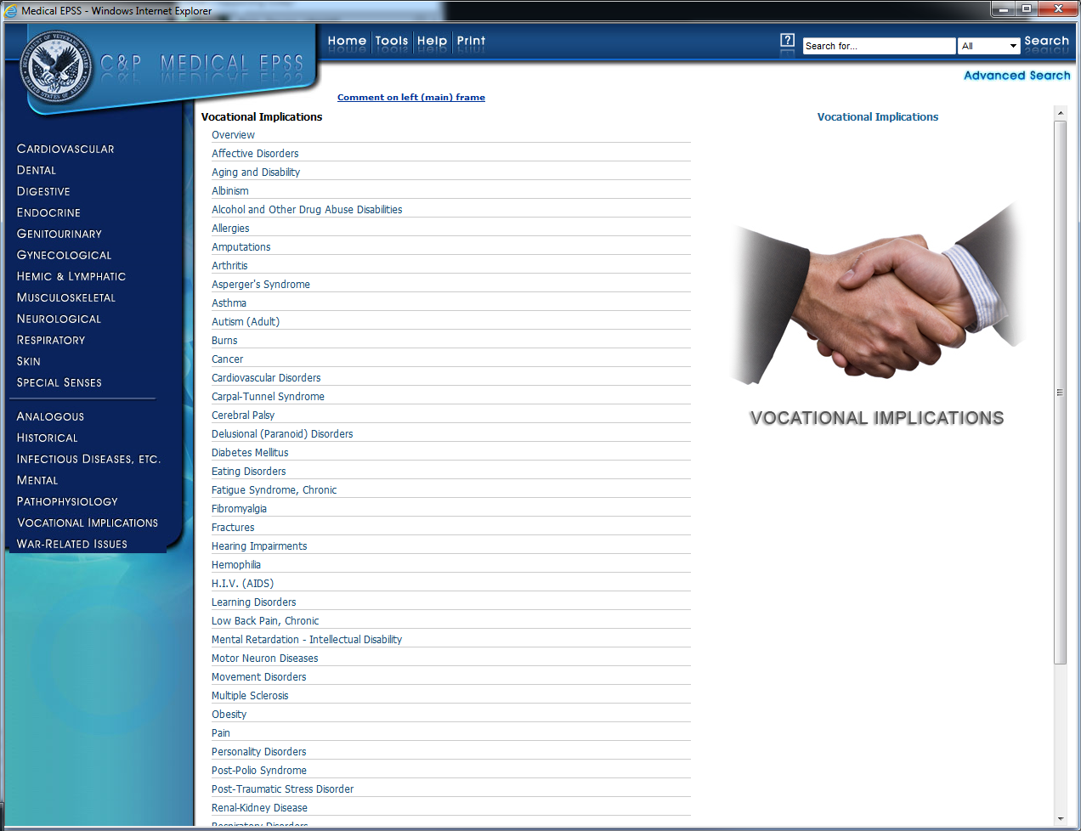 | This section of the Medical EPSS is intended to assist VR&E, VRCs and ECs with identifying Vocational Impediments and Common Functional Limitations of Veterans. The information is highly applicable to anyone working with persons who experience disabling conditions. It provides pertinent information about specific disabilities that will aid VR&E, VRCs and ECs with providing appropriate services. The information from this section of the Medical EPSS was taken from the Disability Handbook - 2012 Edition.  Let’s take a look at traumatic brain injury, also known as T-B-I by selecting the Traumatic Brain Injury link.
9 | Point to each section:  - Common Functional Limitations, and  - Vocational Impediments  Point to the section links at the top of the page  Point to the Vocation Implications link at the top of the page  Select the Vocation Implications link. | 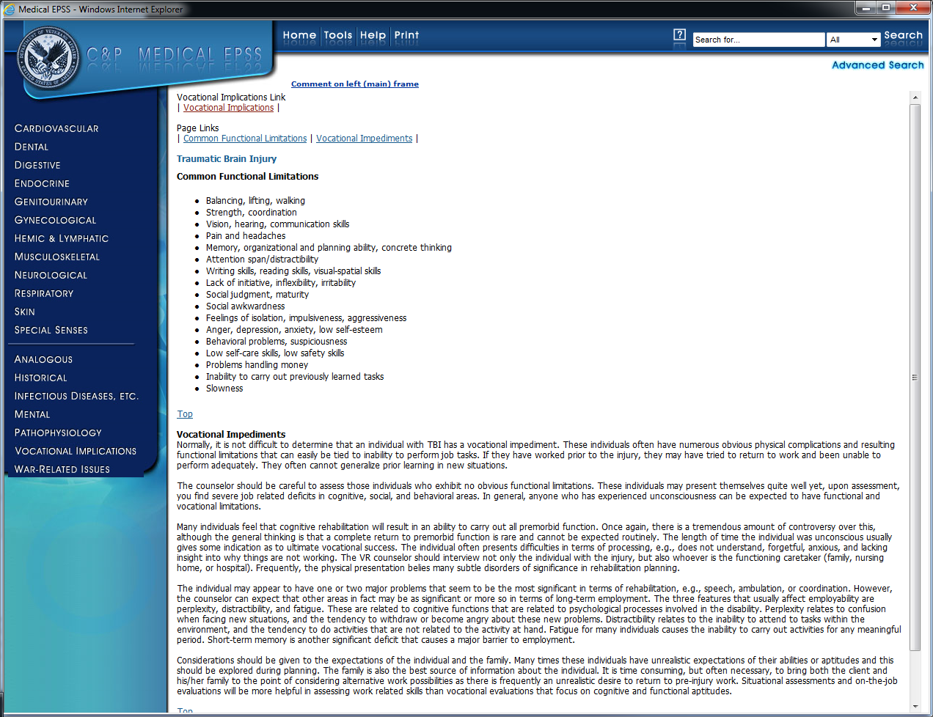 | Most disorders have two sections: common functional limitations and vocational impediments. These can be used in discussing disability limitations in the narrative during the entitlement process and monitoring a Veterans treatment and progress.  Common functional limitations are the things you need to ask the Veteran so that you can address all the issues when completing the VA Form 28-1902b and providing services.  You can then do vocational exploration based on a lot of the information developed here.  But you first have to ask the Veteran or find information that provides understanding on things like:  - How far can the Veteran walk?  - Can the Veteran run?  - Can he or she climb stairs?  The vocational impediments section gives you information about the kind of issues you might want to consider. Veterans will sometimes come in with expectations that they can do things that they really cannot do. They might have been able to do it before, but not with the current conditions they have. You as the V-R-C need to investigate the condition and use the Medical E-P-S-S to help you document.  You can return to the Vocational Implications page by selecting the Vocational Implications link at the top of the page.
10 | Select the Mental option on the left side of the page.  Select the Anxiety Disorders option. | 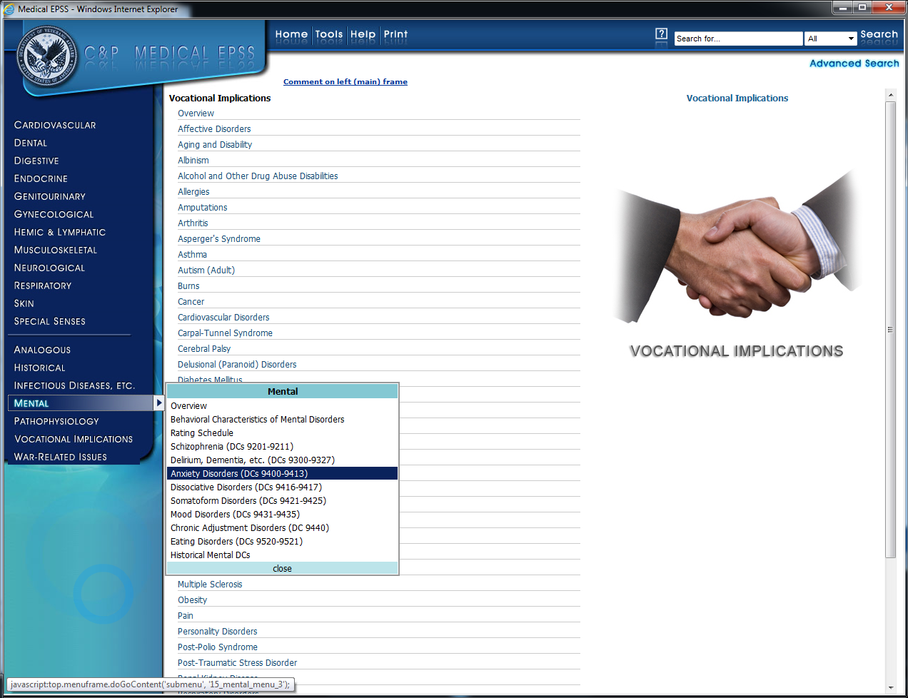 | Let’s take a look at a helpful topic within the Mental category, Anxiety Disorders.
11 | Select the 9411 – Post-traumatic stress disorder link. | 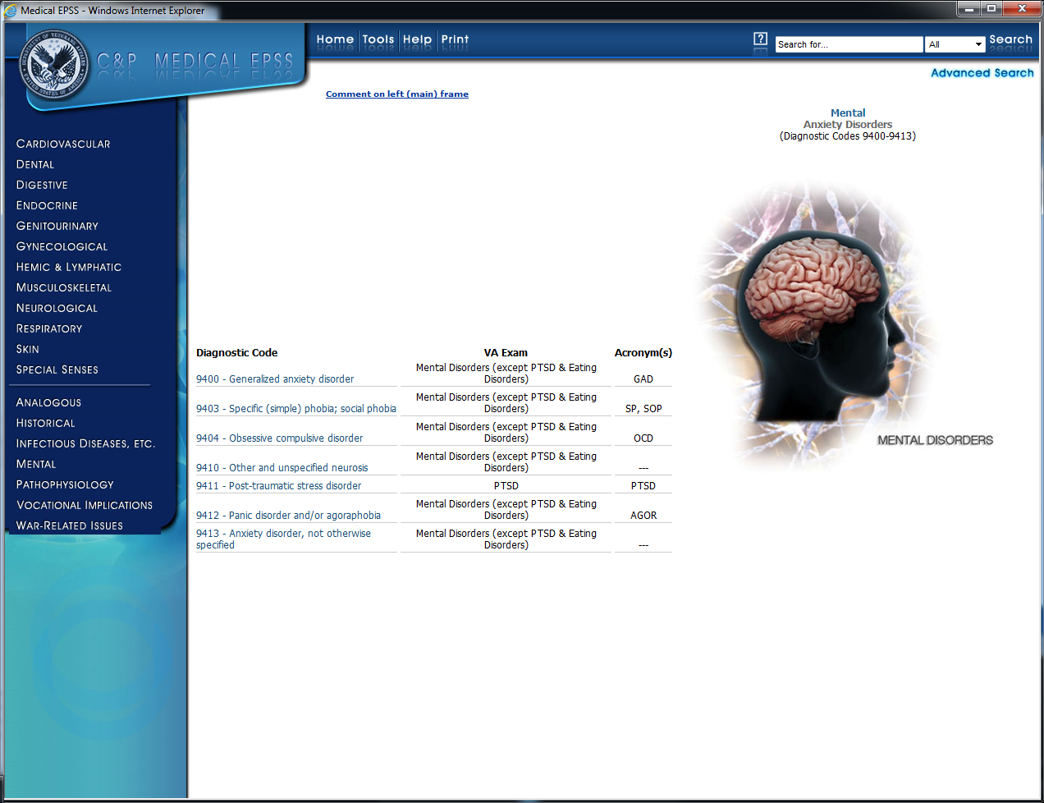 | On this page you will find a link to information about P-T-S-D, or post-traumatic stress disorder. Select 9411 – Post traumatic stress disorder to further explore.
12 | Scroll down the page, point to each:  - Definition  - Etiology  - Signs & symptoms | 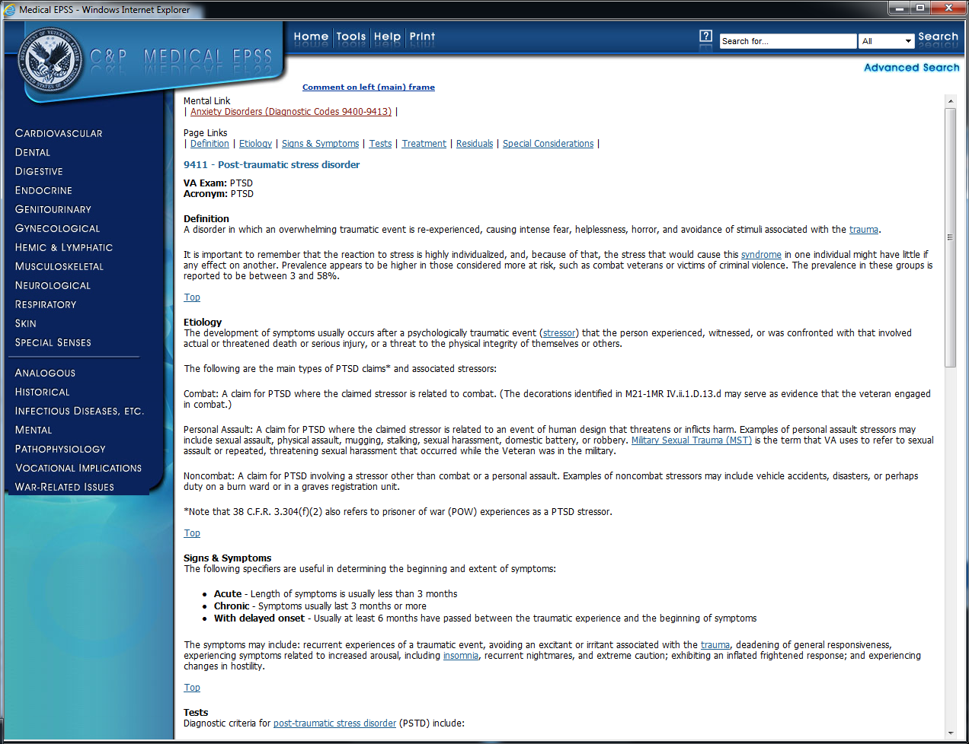 | This P-T-S-D page gives you the definition, etiology, signs, and symptoms of P-T-S-D. This can include trauma from the Veteran’s time in Service or other life situations.
13 | Select War-Related Issues in the left column.  Select the Agent Orange & Related Illnesses link. | 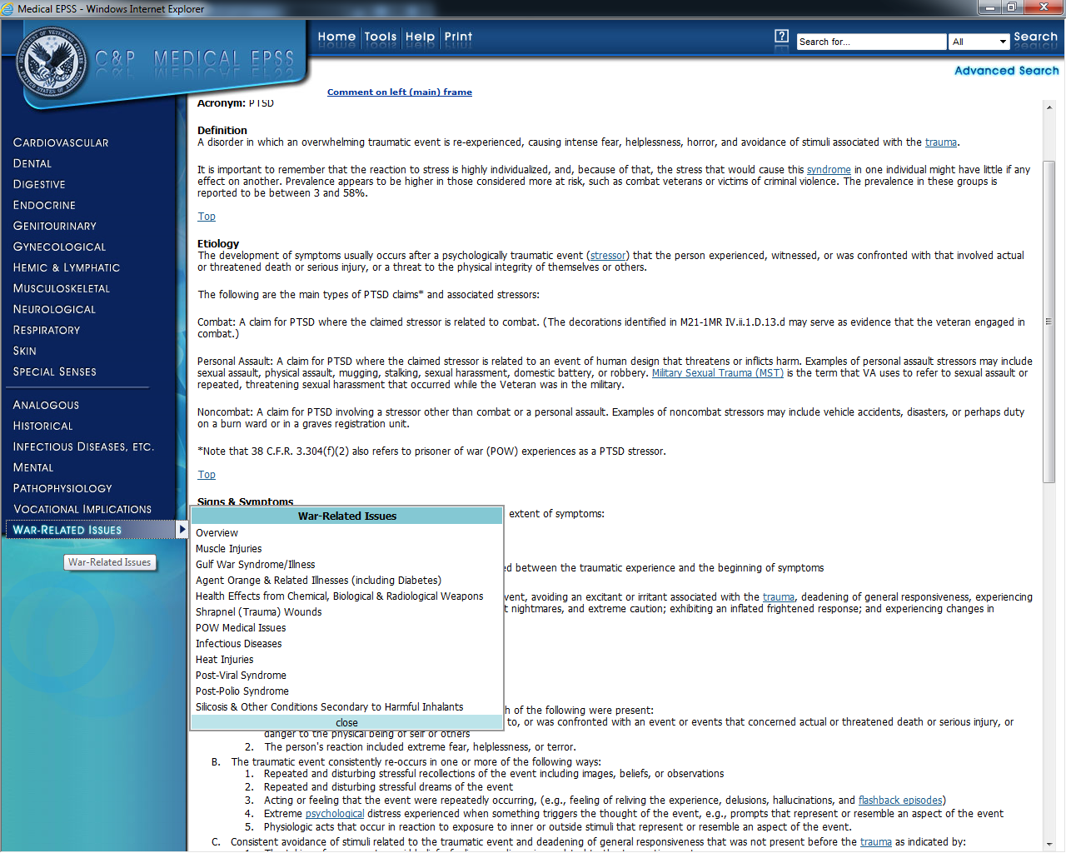 | On the far left column, let’s select war-related issues to further explore Agent Orange & Related Issues.
14 | Scroll down the page. | 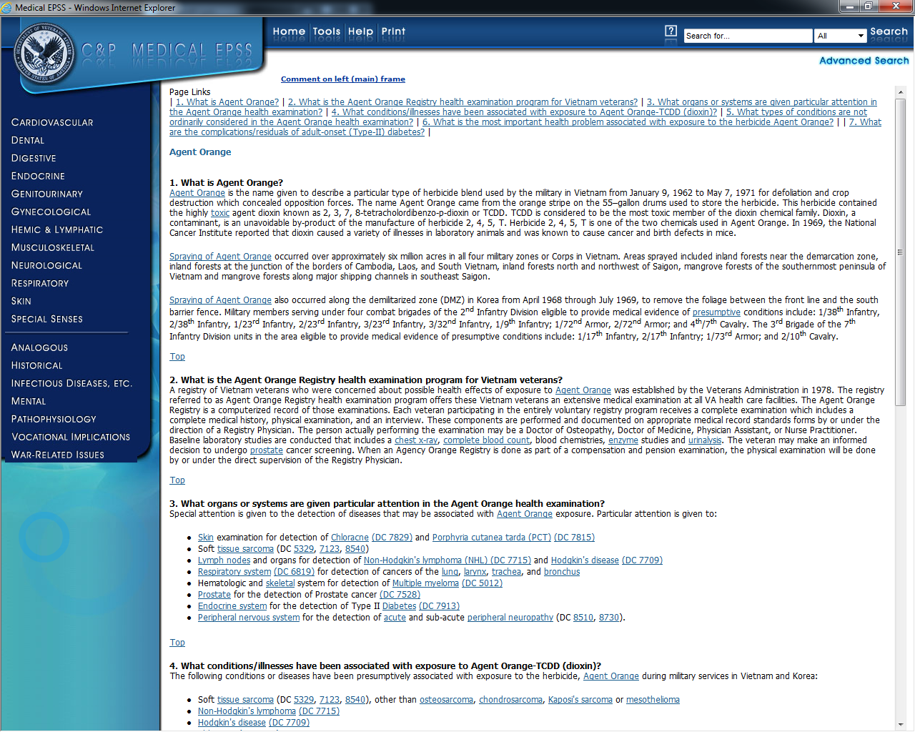 | This page provides an overview of Agent Orange, information about the Registry, conditions or illnesses associated with Agent Orange and much more.
15 | Select War-Related Issues in the left column.  Select the POW Medical Issues link. |  | Back on the left column, let’s again select War-Related Issues, so that we can take a look at POW medical issues.
16 | Scroll down the page. | 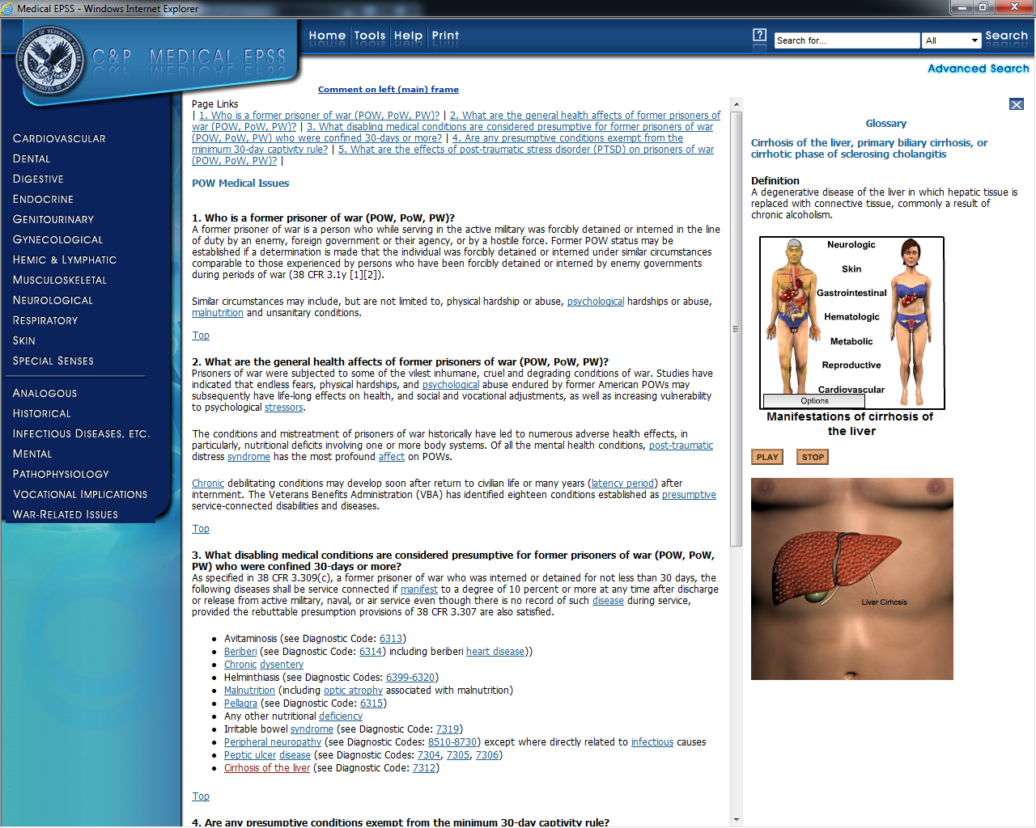 | Take some time to go through this POW medical issues section. You will find a lot of information you may not be aware of; this section has a lot of different things you need to understand and get a better feel of what is going on with Veterans affected by this.
17 | Point to the following options:  - Tools  - Help, and  - Print  Select the Tools option. |  | At the top of the page, let’s take a look at the tools available to you.  In addition to the Home link that we have already used, you can see:  - Tools  - Help, and  - Print
18 | Select each tab as you say it:  - Glossary  - Acronyms & Abbreviations  - Symbols  - Graphic Catalogs  - Tutorial Catalogs  - C&P Intranet Rating Job Aids  - Diagnostic Tests & Exams, and  - The STR Tool  Close the Tools window. | 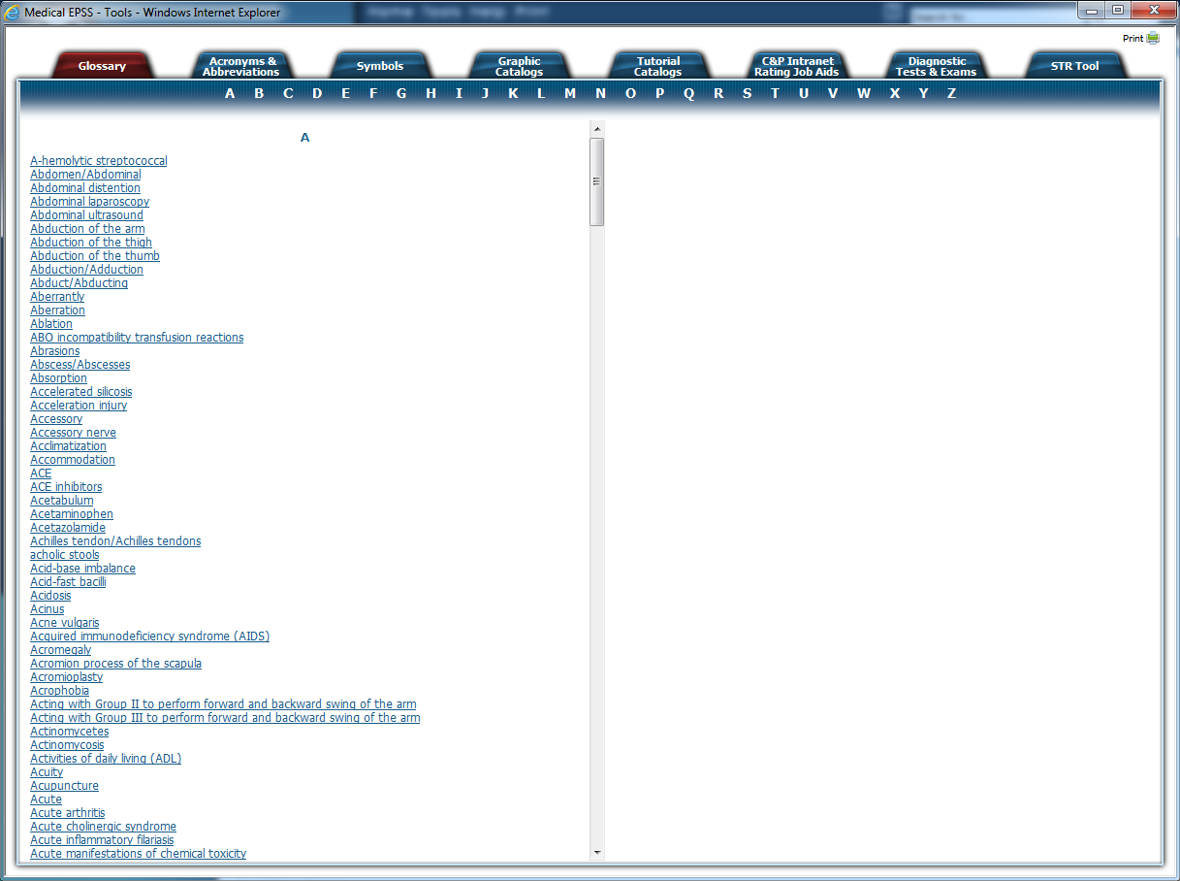 | The Tools page provides a number of resources you can use to help you understand the information provided in the Medical E-P-S-S.  The tools include:  - Glossary  - Acronyms & Abbreviations  - Symbols  - Graphic Catalogs  - Tutorial Catalogs  - C&P Intranet Rating Job Aids  - Diagnostic Tests & Exams, and the  - STR Tool
19 | Select the Help option. |  | Next to the Tools option is the Help option.
20 | Select each tab as you say it:  - Introduction  - Screen Layout  - Content Layout  - Navigation  - Search  - Technical  - Send Comments  - About MEPSS  Close the Help window. | 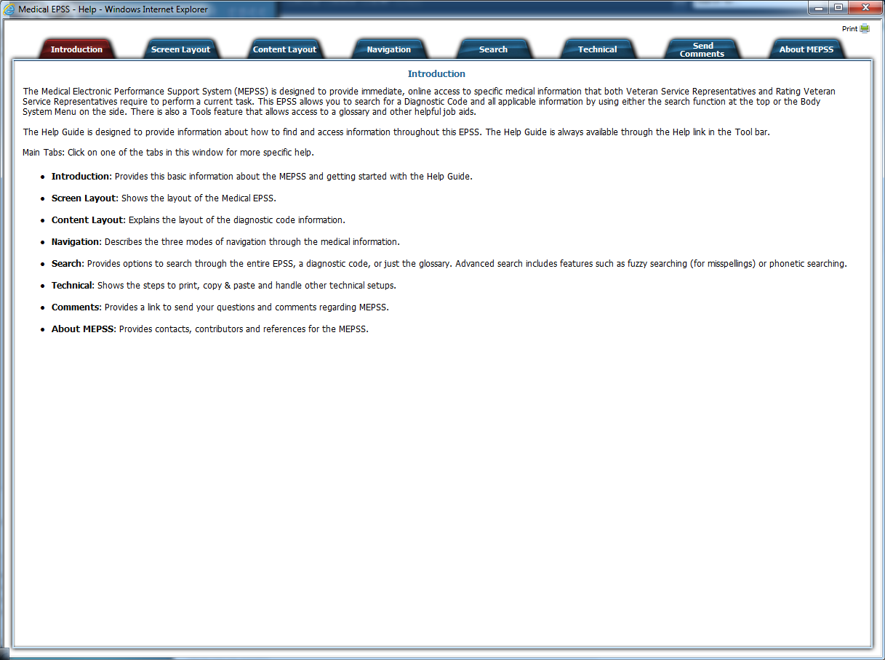 | The Help guide provides information about how to find and access information throughout this E-P-S-S.  The Help tabs are:  - Introduction  - Screen Layout  - Content Layout  - Navigation  - Search  - Technical  - Send Comments and  - About M-E-P-S-S
21
22 | Point to the search options  Select the Advanced Search option. |  | The Medical E-P-S-S also has search features at the top right corner of the page, which includes Advanced Search.
23 | Select the X to close the advanced search. | 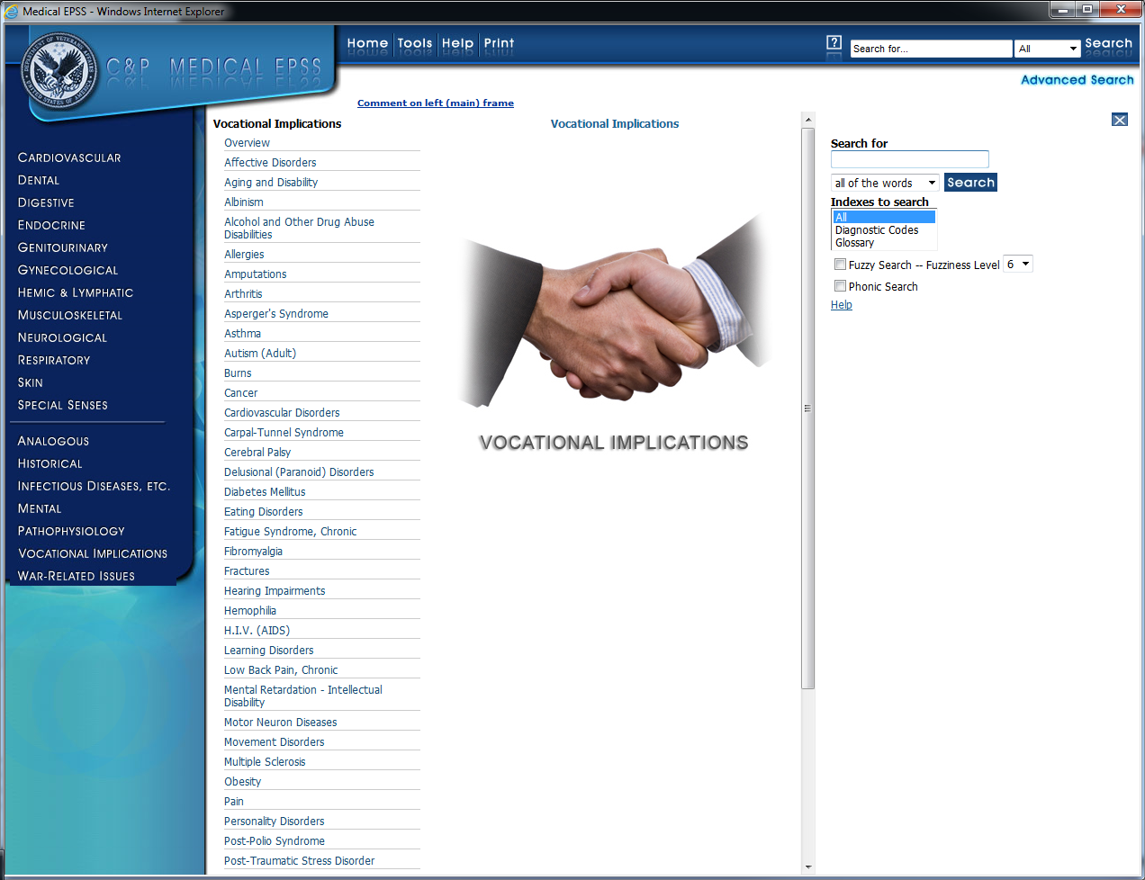 | You can type in a Term, select which Index to Search and can even opt to have the system search for topics that are possibly spelled wrong.
24 | Select the Home option.  The demonstration ends on the main Medical EPSS page. |  | That concludes the demonstration of Medical E-P-S-S.  Please take time to look over this resource. Knowing what is here can help you easily locate answers down the road.

