# | Action on Screen | Screenshot | Audio
1. | VR&E Service Training Intranet page  0  Show highlighting the tab called “VR&E EPSS & Job Support Tools” on the left menu. | 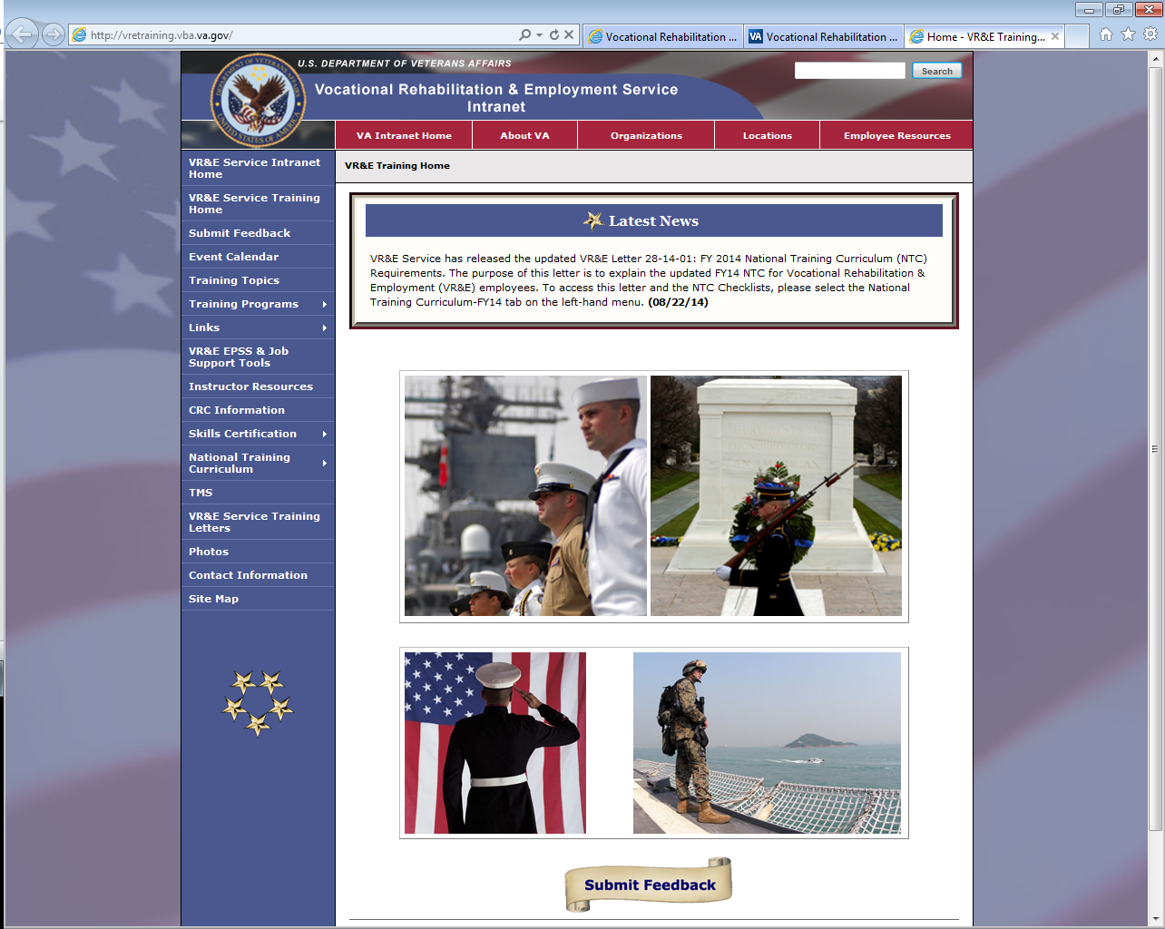 | Welcome! This tutorial is designed to show you the VRC Electronic Performance Support System- -or EPSS Gateway. This is a valuable tool for all VR&E Employees, whether you are new on the job, performing case management activities and familiarizing yourself with CERs and other VA sources or journeyman on the job looking to recall the steps for infrequent duties such as independent living services, non-paid work experiences or case closures. It offers step-by-step procedures for performing routine and not-so-routine tasks, while also providing you with examples and checklists that you can use on the job. This job aid is always available to you and it is important to become familiar with the different areas, duties and uses to assist in performing case management and other duties as a case manager, correctly.  The EPSS can be accessed through the Vocational Rehabilitation and Employment Service Training Intranet site. The training website is vretraining.vba.va.gov/  From here you select the tab on the left titled “VR&E EPSS & Job Support Tools.”
2. | Access VRC EPSS  via Intranet or Internet links:  Intranet: http://epss.vba.va.gov/vre_jst/default.html  Internet:  http://www.vba.va.gov/bln/vre/epss/VRE_JST/default.html | 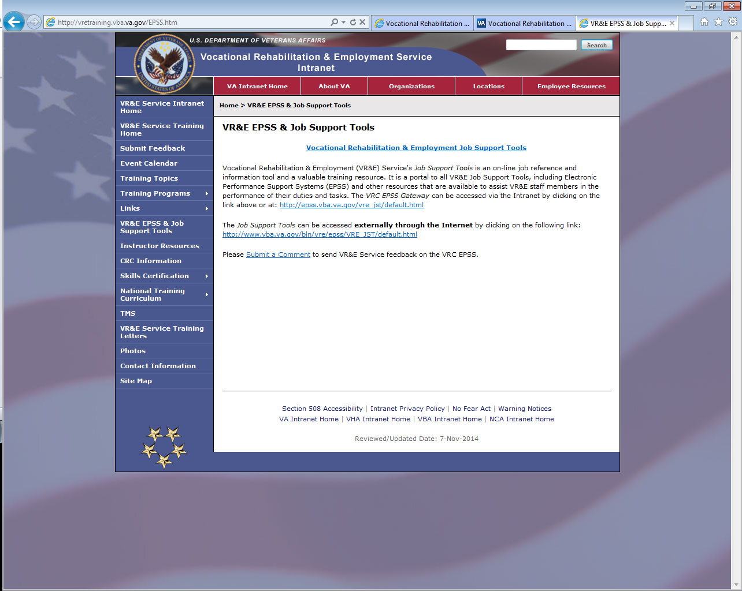 | Depending on your location you will either select the intranet link or the internet link. Intranet is for individuals that are on a VA network or VA computer. Those of you who are out based may find it easier to use the Internet link; however, you may have limited access to VRC Gateway.  For the purposes of this demo, we are selecting the intranet link.
3. | Vocational Rehabilitation & Employment Job Support Tools portal | 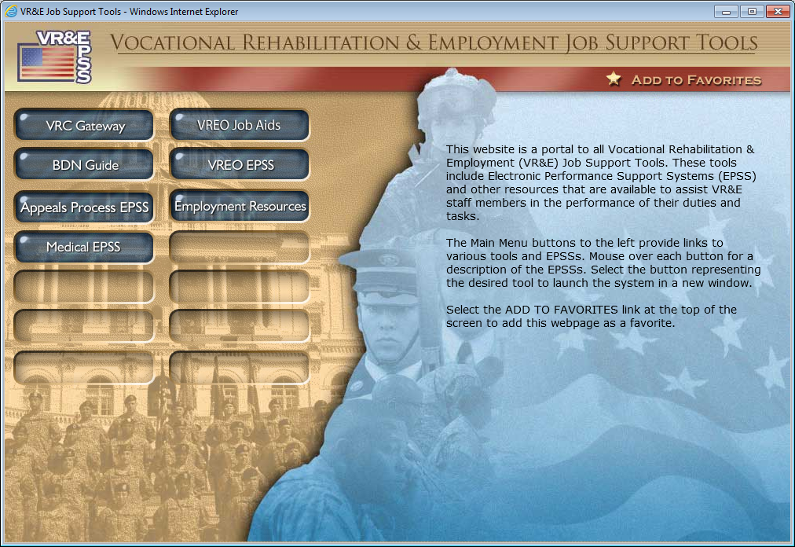 | Here you’ll see the Vocational Rehabilitation & Employment Job Support Tools portal. This portal provides access to electronic performance support systems –or EPSSs—and other resources that have been designed to assist VR&E staff members in performing a variety of tasks. Your options are VRC Gateway, BDN Guide, Appeals Process EPSS, Medical EPSS, VREO Job Aids, VREO EPSS and Employment Resources. You can scroll over each of the options to obtain a brief description of its contents.  At this point, for future quick access to these job support tools, you may want to select the Add to Favorites option located in the top right corner of the portal. This will allow you to add this to your favorites and have the ability to access this site directly.
4. | Access the VRC EPSS Gateway  Hover over and select button that links to VRC Gateway | 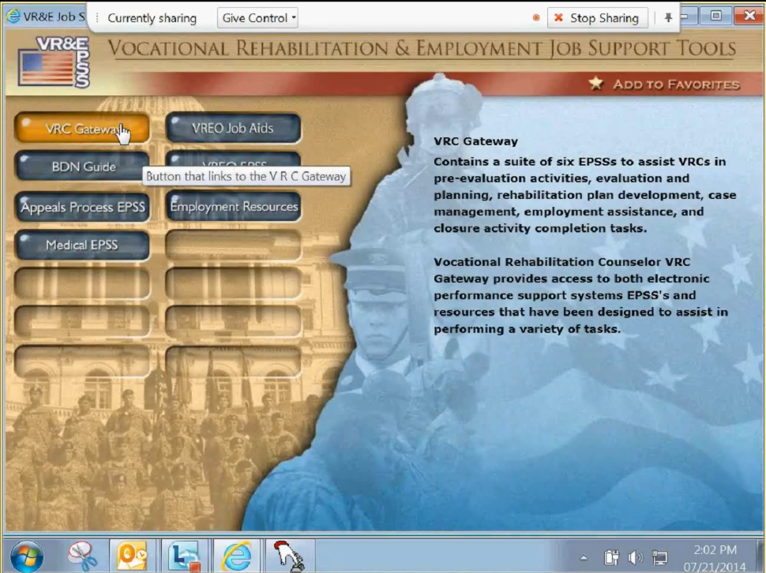 | For the purpose of this demonstration, click the VRC Gateway button on the left side of the screen to open the VRC EPSS Gateway.
5. | Scroll over each numbered “Duty” to show the summary that appears on the right side. | 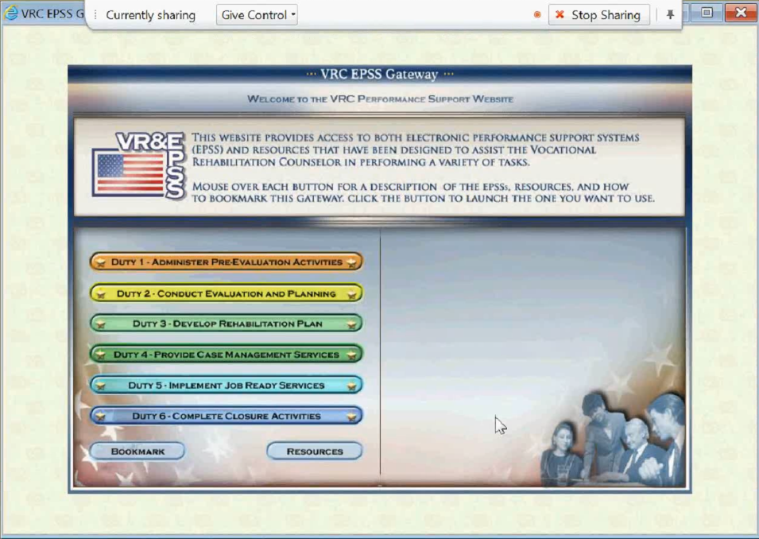 | The VRC Gateway contains a suite of six EPSSs, to assist VRCs in pre-evaluation activities, evaluation and planning, rehabilitation plan development, case management, Implement Job ready services, and closure completion activities.  You can hover your cursor over each Duty to see a summary on the right side of the screen. This feature is a helpful quick look tool for new counselors to obtain a description of what is inside the duty. You will notice another bookmark option, at the bottom left of the portal, which will allow you again direct access to this tool. The Resources tab below the EPSS duties opens another window of options for frequently used forms, checklists and other resources for each area. These resources are also located throughout the EPSS as you select the different options.
6. | Select (open) “Duty 2- Conduct Evaluation and Planning” | 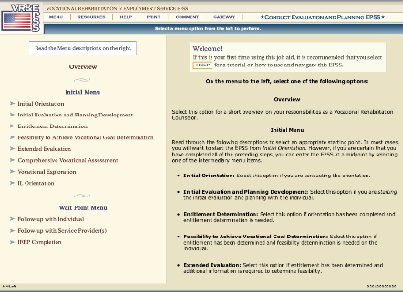 | For demonstration purposes, we’re going to select a Duty that you as a VRC may use frequently… Duty 2- Conduct Evaluation and Planning. Notice the interface of VRC Gateway to general EPSS. The tasks are listed to the left and guided steps are on the right. This is a general layout for this entire suite of Duty’s. At the top of the screen, you can always return to the main duty entry point by selecting Menu. You can return to all the duties or EPSSs by selecting Gateway on the far right. Here you see again the Resources option. In addition, you have help, print and comment available. We will look more at these in a moment.
7. | Mouse over links on left side of screen under the Initial Menu and Wait Point Menu’s. Select “Entitlement Determination”. | 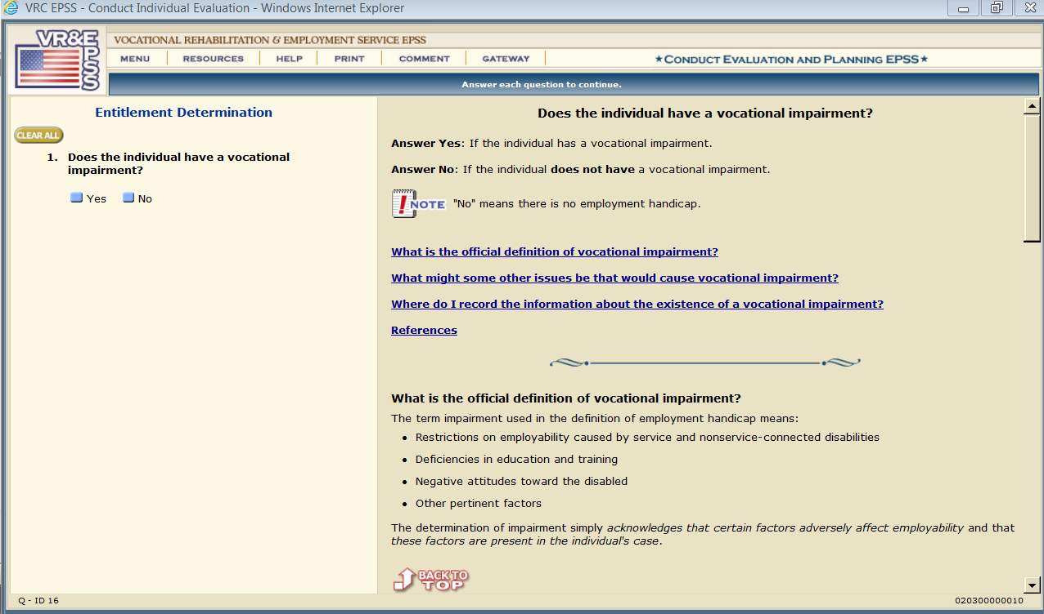 | After choosing an option such as Entitlement Determination, you can view several examples of frequently asked questions and step-by-step instructions for completing your task. Simply check the corresponding box to advance through the screens or select Clear All to clear all your choices and begin from step one of duty.
8. | Scroll to bottom of page. | 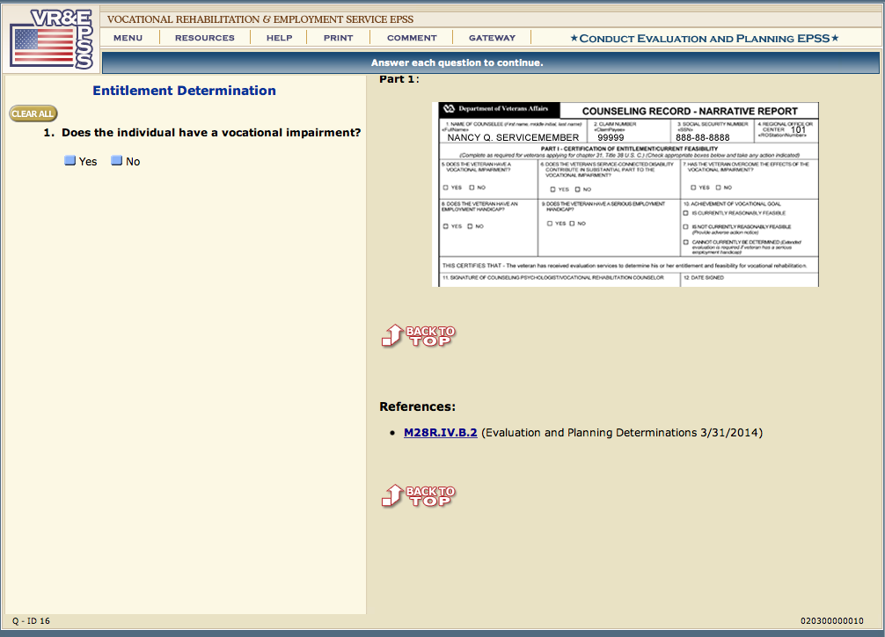 | After selecting any option from the initial menu, you may scroll down to the bottom of the screen to find the reference material. On many of the pages, the reference material is directly linked to the source of the reference. You will most often find reference to the M28R VR&E Manual and the CFR Code of Federal Regulations. This provides information about where additional clarification can be found.
9. | Select Resources tab | 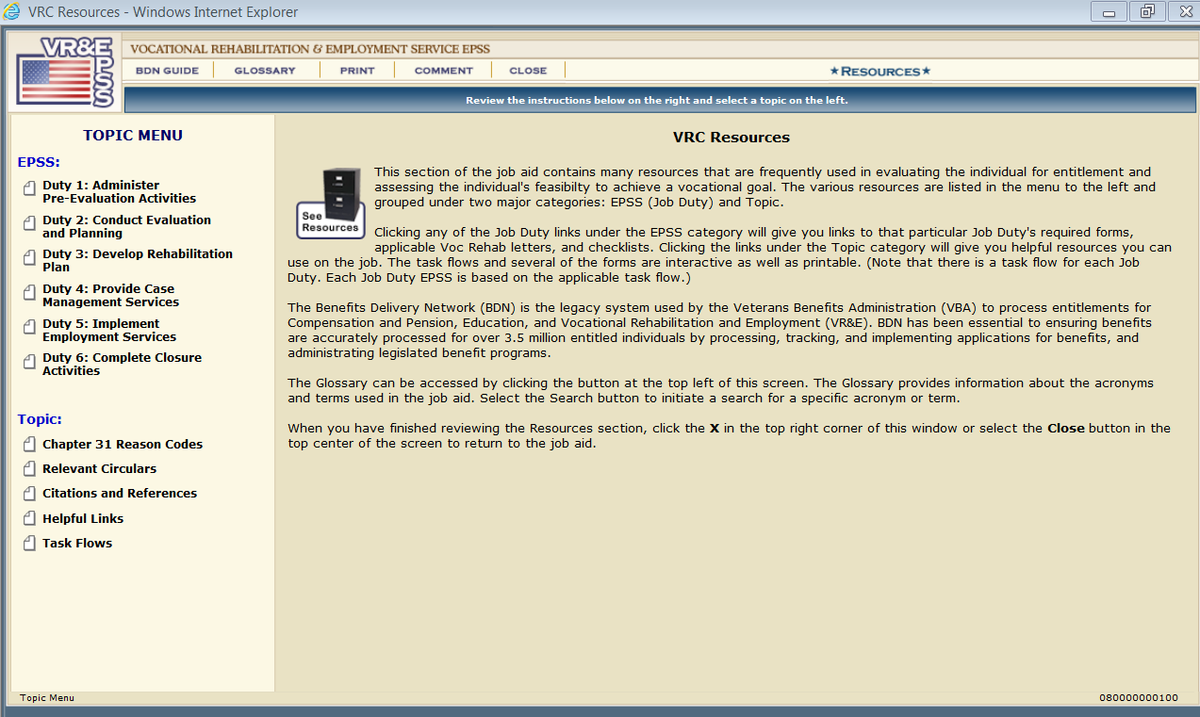 | When you select the Resources tab, a new display window opens. This window contains resources that are used frequently by counselors. You will notice a menu along the left side of the screen. You need to start by selecting a specific duty. As you recall, we were previously looking in Duty 2.
10. | Select Duty 2: Conduct Evaluation and Planning | 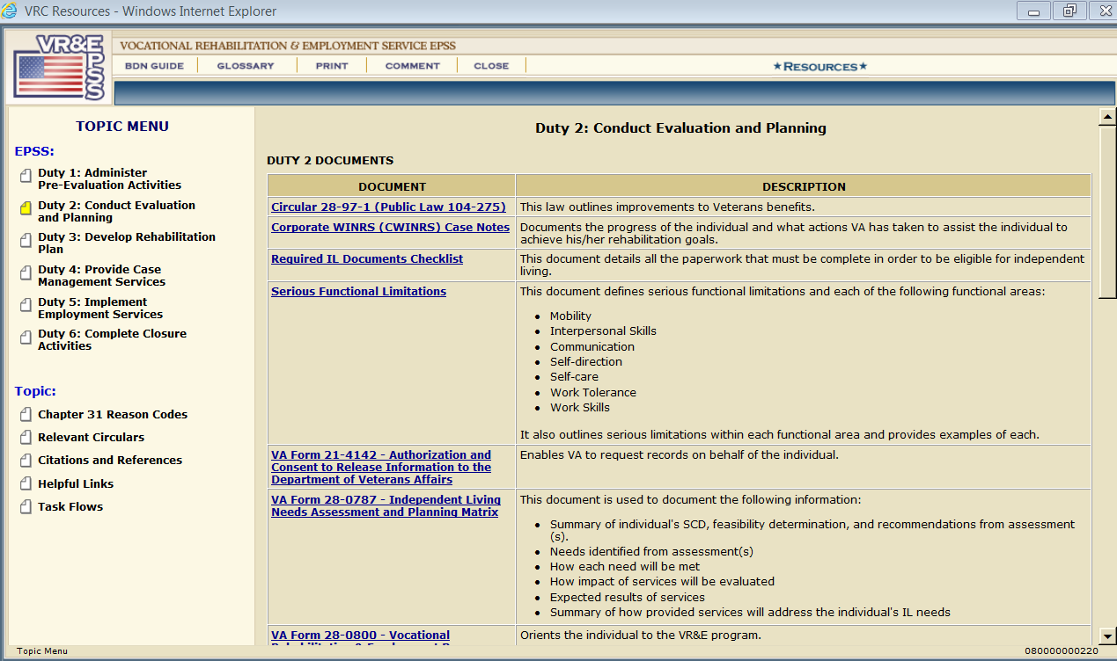 | By selecting Duty 2 from the main resource page, you open up a list of some of the items that can be found in the resource tab which includes checklists, letters, and forms that are used throughout the duty. Each duty has a different set of resources which apply directly to the specific area or task. You can also find some other helpful resources available under Topic on the left pane. You may want to explore these links to determine which items would be helpful with your assigned duties.
11. | Select Close, and return to the EPSS menu. | 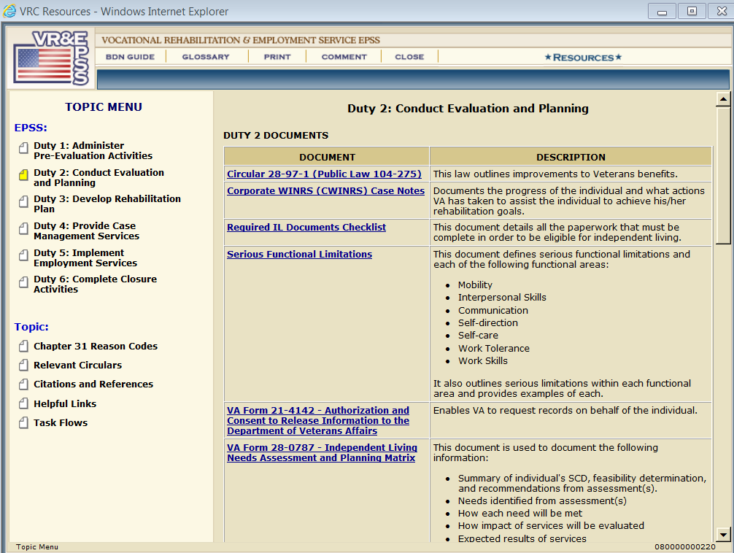 | To return to the EPSS main page, select close.
12. | Select the Help tab | 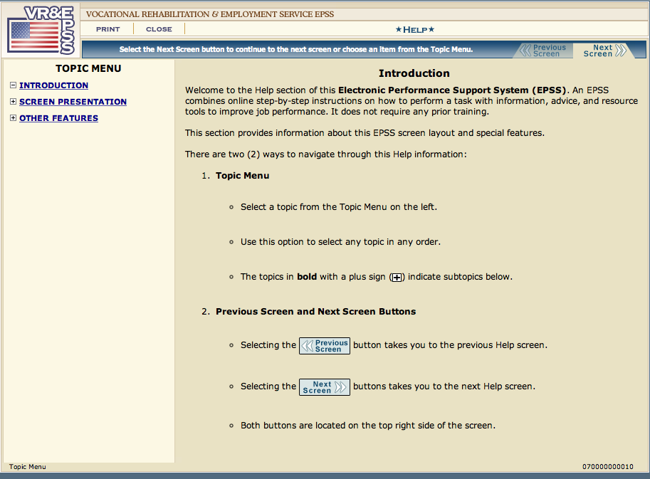 | Let’s now take a look at the additional options available across the top of the screen. First let’s select the help tab which will assist you in navigating the EPSS screen layout, explain special features, and explain functionality in more detail.
13. | Select the Print tab | 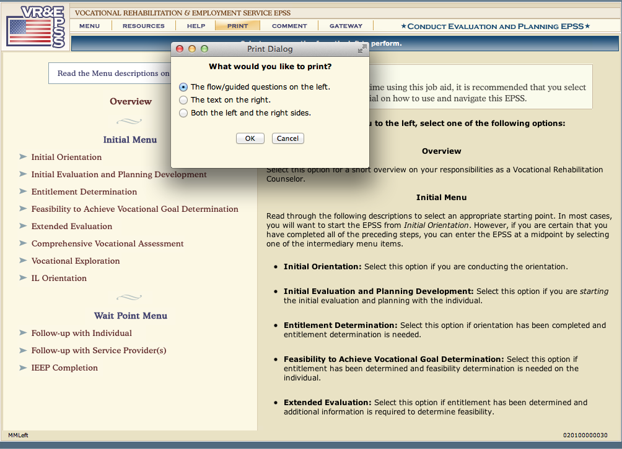 | When the Print tab is selected, a dialog box will appear. This will give you the option to print the flow/guide questions on the left, the text on the right, or both on the left and right. Simply select the radio button of your desired task and click Ok or cancel to complete. However, this set of job aids is always available to the counselor. Therefore, you may just want to refer back to here or save key components to your computer for quick or routine access.
14. | Select Comment tab | 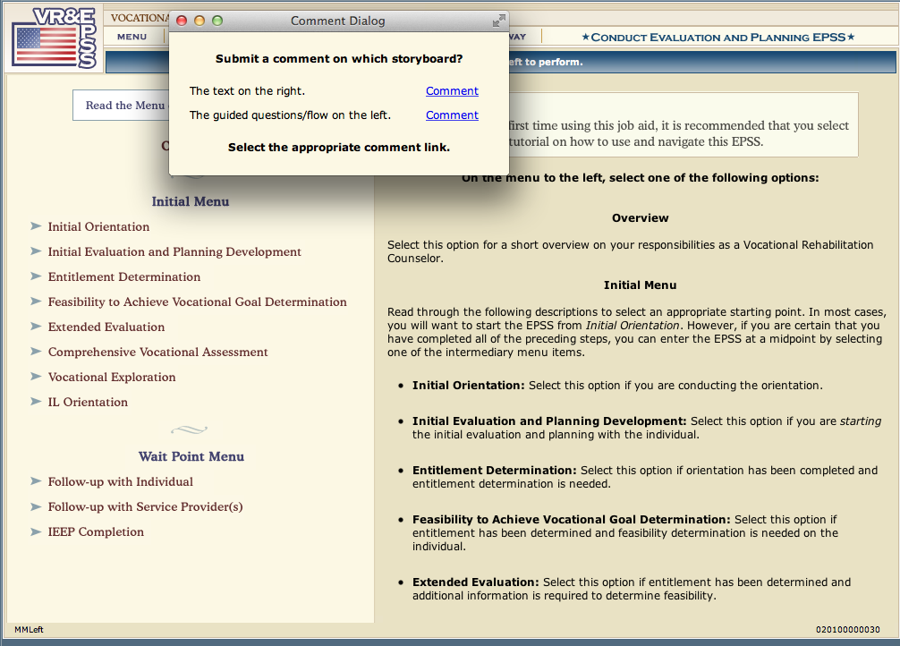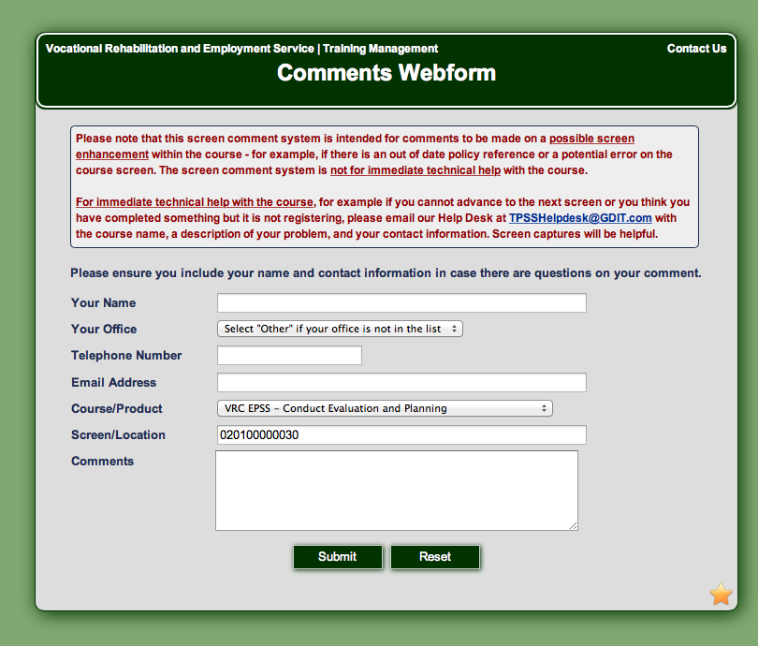 | When the Comment tab is selected, a comment dialog box will automatically open. This dialog box allows you to select what you want to leave for your comment. Simply click the corresponding comment link that fits your needs.  Once a link is selected, a new webpage will display. You can leave feedback on or about a specific issue. The comment can be a question related to policy and procedures, something to help clarify, or if there’s been an update not reflected in the text. Select Submit or Reset to complete your comment. It is always a good idea to consult with your local mentor or manager for technical questions.
15. | Select Close, and then select Gateway. |  | You can return to the main page, or Gateway, by selecting close from the resources page, and then selecting Gateway.
16. | Select Gateway tab | 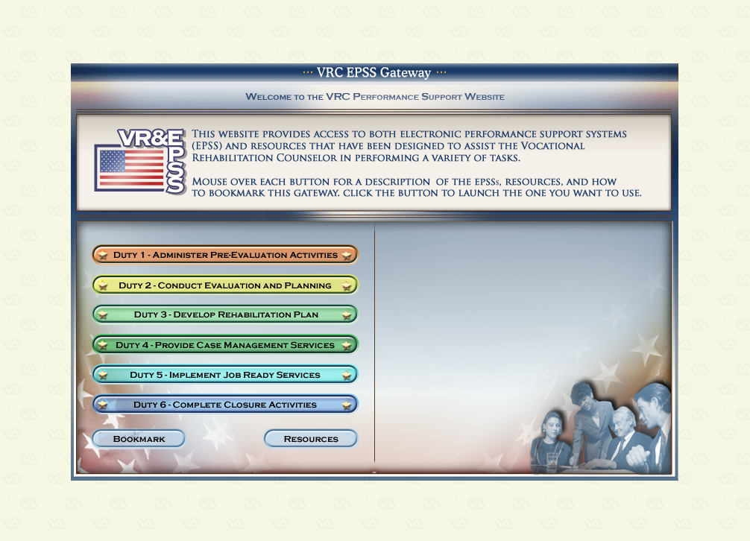 | When the Gateway tab is selected, you are taken back to the main EPSS menu. This allows you to navigate to another Duty or Resources more readily.
17. | Wrap-up |  | You may exit out of VRC Gateway EPSS or choose another Duty to explore. This concludes this lesson and overview of the VRC Electronic Performance Support System. Please take some time to further review and become acquainted with this valuable resource.
18.

