Identifying The Type of Claim Scenarios
SCENARIO #1: A service connected Veteran files a claim indicating he wishes to file for aid and attendance. He also provides income information in his claim. Is this a claim for Special Monthly Compensation (SMC) or Special Monthly Pension (SMP)? Why or why not?
The veteran did not specifically indicate that the claim was for aid and attendance due to his service connected conditions. Since income information is also provided, entitlement to both should be addressed. A VSR may use the phone to attempt to clarify the issue further, and document their conversation with the Veteran in the c-file. However, if the Veteran cannot be reached over the phone, we must consider it a claim for both SMC and SMP.
SCENARIO #2: A Veteran files a claim indicating she is filing for compensation on part I, question 1 of the application, and provides all the needed information regarding the compensation claim. She also provides income information, which exceeds the maximum annual pension rate, and states that she had no unreimbursed medical expenses. Is this a claim for pension? YES
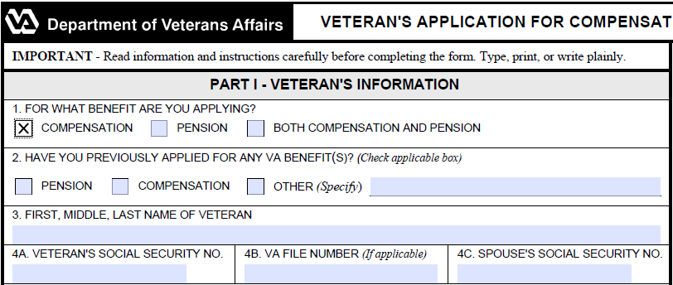
What development action, if any, should we take regarding pension?
None. We should not send Section 5103 Notice (formerly VCAA Notification), and should deny the pension claim administratively in our decision notification letter due to excessive income, since the applicant does not meet the basic eligibility requirements (Per M21-1 I.1.A.3.b).
SCENARIO #3: A Veteran indicates he is filing a claim for service connection for a lower back condition and pension, but failed to provide any income information. What would we do?
Send the veteran a Section 5103 Notice for the lower back condition, and consider the pension claim incomplete. Follow the instructions in M21-1 I.1.B.1.g for an incomplete application, such as contacting the Veteran by telephone and requesting clarification and additional information regarding the pension claim, or sending the Veteran a letter indicating which pieces of information are missing.

DTA Claims Review Questions
Break into small groups. You will be handed a sample claim, and as a group, answer the questions below about the claim.
(The below answers are based on the Sample Claim provided on the C&P Training website.)
1. What issues are being claimed?
Bilateral knee condition
Back condition, to include DDD secondary to the bilateral knee condition
Constant headaches secondary to the back condition
Wrist condition
Chronic sinusitis
Pension

2. What issues require a Section 5103 Notice?

Bilateral knee condition
Back condition, to include DDD secondary to the bilateral knee condition
Constant headaches
Wrist condition
Chronic sinusitis
3. Are there any issues that do not require a Section 5103 Notice? What are they? Why do they not require a Section 5103 Notice? What should we do with these issues?
Yes: Pension would not require a Section 5103 notice as the claimant does not meet the basic eligibility requirement of wartime service. An administrative denial of this issue is in order in the decision notification letter, once the compensation issues have been decided.

4. Are there any other development actions that are needed, such as requests to third parties for information? How will we request this information?

VAMC records will need to be requested from Lincoln and St. Cloud VAMCs.
VAF 21-4142s will need to be sent to the claimant for Dr. Jones of What Do The 5 Fingers Say medical group, and if returned, sent to the doctor to obtain the records.
Obtaining Non-Federal Records

SCENARIO #4: A Veteran claims service connection for a foot condition. We sent the Veteran a Section 5103 Notice on March 2, 2017.

On March 24, 2017, the Veteran submits a signed VA Form 21-4142 and 4142a indicating treatment by a private physician, but did not list conditions or dates of treatment. The date is now April 2, 2017. What development action should be taken on the claim?

We should contact the claimant by telephone, or if unable to reach by phone, generate a development letter to the claimant requesting the return of a completed VA Form 21-4142a. If the VSR has a signature, dates, and conditions, but not a complete address for the doctor, this can generally be found online, or by calling the physician’s office.
Obtaining Federal Records Q&A
If a veteran indicates treatment from 1987, but we only have records in the CAPRI system going back to 1992, what should we do?
Print the available relevant records and send an electronic 7131 request for the records regarding treatment from 1987 to the earliest date the records are available in CAPRI.

How many follow up requests would we need?
As many times as it takes to get a response.
What would we do if we received a negative response?

Document the RO’s attempts to obtain the records and leave it to the rating specialist to add the following free text in their rating decision:

“We have been unable to obtain records from [insert name of VAMC] for the period [insert date range of treatment/ counseling]. We have determined that these records do not exist. We will now make a decision based on the evidence of record.

SCENARIO #5: A Veteran files a claim for an increase in her service connected back condition. She also indicates she is receiving SSA disability for her back condition. Should we request the SSA records? Why or why not?
Yes, according to M21-1 III.iii.1.C.1.d, VA is required to the records because it pertains to her claim for increased disability compensation.
VA Examinations in Pension Cases

SCENARIO #6: A World War II Veteran claims pension due to coronary artery disease (CAD), chronic renal disease and diabetes mellitus (DM). The Veteran submits private medical records that show cardiac hypertrophy with an ejection fraction of 55 percent and METs of 7. Using CAPRI, we also discover VA medical records that show that he is on a restricted diet and taking insulin, but no regulation of activities. Service treatment records do not show treatment for any of these conditions. If you are developing this case today, what action should you take?

A VA general medical examination is warranted since there is medical evidence of record, but it is not adequate for pension purposes. The evidence shows that we can evaluate coronary artery disease (CAD) and diabetes mellitus (DM), but not chronic renal disease. In addition, the evaluations for CAD and DM are not enough to consider the Veteran permanently and totally disabled according to 38 CFR 4.16.

