Pension and fiduciary service
PMC VSR Intermediate Core Course
Phase 5: Proficiency Development Part 6: Award Adjustments Extension
Phase 5.6 Knowledge Enhancer Prep
Lesson Plan

July 2024

Phase 5.6 Knowledge Enhancer Prep

Lesson Overview
Topic | Description
Time Estimate: | 3 hours
Purpose of the Lesson: | This Knowledge Enhancer Preparation (KE Prep) is part of the Core Pension Training (CPT) curriculum for PMC VSRs. The purpose of the Phase 5.6 KE Prep serves as a supplemental resource that provides additional activities and content to reinforce material covered throughout training, as well as to prepare the VSR to resubmit the Level 2 assessment(s).
Prerequisite Training Requirements: | Prior to taking the Phase 5.6 KE Prep lesson, trainees must complete PMC VSR Core Course Phases 1–5.6.
Target Audience: | This Knowledge Enhancer preparation is for entry-level PMC VSRs.
Lesson References: | - Claim Types job aid  - Old Law and Section 306 Pension Programs job aid  - Processing a SMP Claim job aid  - Processing a Grant of Benefits job aid  - Processing a Denial of Benefits job aid  - Incarceration/Fugitive Felon job aid  - Processing Contested Claims job aid
Lesson Objectives: | By the end of this lesson, the trainee should be able to:  - Identify contested claims  - Determine steps required in processing Special Monthly Pension (SMP), Aid and Attendance (A&A) and Housebound (HB) claims  - Explain incarceration and fugitive felon adjustments  - Assess apportionment claims
What You Need: | - Lesson plan  - Slides  - Projector  - Appendix A Phase 5.6 KE Prep Worksheet  - Sample letter for Part 1 exercise of Appendix A to discuss proper notification (Contested Claims)  - Discussion points and examples for charts, images, and feedback  - Prepared answers and discussion points for all practice exercises and class activities  - Access to VBA Intranet  - Pen and paper or access to a whiteboard  - Access to the following systems:  - SHARE  - VBMS

Instructor Notes
This Knowledge Enhancer preparation will provide trainees with an additional support on topics covered in Phases 1-5.6. This will include a review objectives, participation in activities or games to reinforce their understanding, and a question-and-answer forum to address any confusion or misconceptions about the information presented.
PowerPoint Slides | Instructor Activities
Phase 5.6: Knowledge Enhancer Prep | DISPLAY slide  “Phase 5.6: Knowledge Enhancer Prep”  INTRODUCE yourself as the instructor.  INTRODUCE the lesson.
Lesson Objectives  - Identify contested claims  - Determine steps required in processing Special Monthly Pension (SMP), Aid and Attendance (A&A) and Housebound (HB) claims  - Explain incarceration and fugitive felon adjustments  - Assess apportionment claims | DISPLAY slide  “Lesson Objectives”  PRESENT the objectives.
Why This Matters!  - Phase 5.6 is comprised of intermediate level courses requirements in processing contested, SMP, A&A, and HB claims, as well as determining incarceration, fugitive felon, and apportionment adjustments.  - the KE Prep is used to reinforce various concepts via practice activities and exercises for continued development.​ | DISPLAY slide  “Why This Matters!”  DISCUSS the importance of the courses in Phase 5.6 and why the KE Prep matters.
Knowledge Enhancer Preparation Overview  - This Knowledge Enhancer preparation will consist of the following:  - Lesson objectives review  - Group activities/games  - Question/answer forum | DISPLAY slide  “Knowledge Enhancer Preparation Overview”  STATE the KE Prep will consist of an overview of objectives from each course, as well as activities, games, and Q&A sessions.
Phase 5.6 Lessons  - Introduction to Contested Claims  - Introduction to SMP, A&A and HB Claims  - Introduction to Incarceration Adjustments  - Introduction to Fugitive Felon Adjustments  - Introduction to Apportionment Claims | DISPLAY slide  “Phase 5.6 Lessons”  REMIND trainees of the topics covered during Phase 5.6.  STATE that the KE will cover material centered on each of the topics.
Introduction to Contested Claims Objectives  - Define types of contested claims  - Identify indicators of contested claims  - Determine if evidence is sufficient to process contested claims and apply the correct development actions for the information/evidence missing from claims  - Determine entitlement to contested claims  - Decide the award actions for contested claims  - Identify notification requirements | DISPLAY slide  “Introduction to Contested Claim Objectives”    REVIEW the objectives.
Introduction to Contested Claims  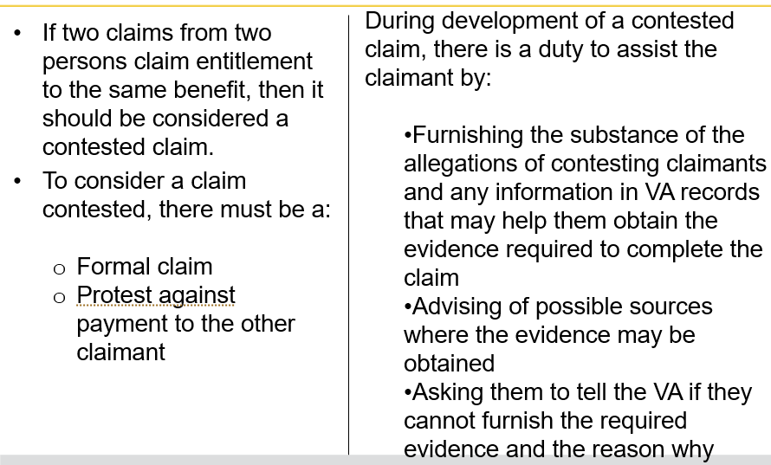 | DISPLAY slide  “Introduction to Contested Claims”    REVIEW the steps in the chart with trainees.  USE the discussion points you have prepared for this lesson to provide further insight, clarification, and examples.    ASK if there are any questions and provide additional information as needed.
Practice Exercise -Contested Claims  - Instructions:  - Work in groups of two.  - Review the chart in Part 1 of Appendix A: Phase 5.6 Worksheet to determine correct actions.  - Complete Part 1 – Contested Claims exercise  - Be prepared to share your responses and rationale with the class.  - Time allowed: 30 minutes | DISPLAY slide  “Practice Exercise- Contested Claims”    READ the instructions to trainees.    ALLOW 30 minutes to complete the exercise
Practice Exercise: Contested Claims Q&A   | DISPLAY slide  “Practice Exercise: Contested Claims Q&A”  SELECT a group to share their answers aloud.    ASK other groups if they agree or disagree with the answers given and provide their reasons for disagreeing.  PROVIDE additional clarification and feedback using the answers and discussion points you prepared for this class.
Introduction to SMP, A&A, and HB Claims Objectives  - Define Special Monthly Pension (SMP), Aid and Attendance (A&A), and Housebound Status (HB)  - Determine Who May Qualify for A&A and Housebound Status Under 38 CFR 3.351  - Identify the Correct VA Forms for SMP | DISPLAY slide  “Introduction to SMP, A&A, and HB Claims Objectives”    REVIEW objectives for the course with trainees.
Introduction to SMP, A&A, and HB Claims (1 of 2)  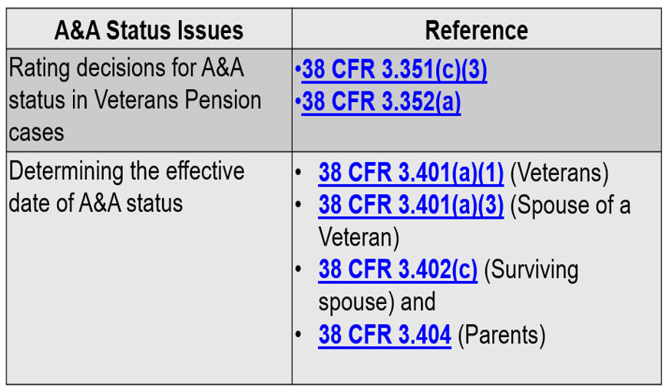 | DISPLAY slide  “Introduction to SMP, A&A, and HB Claims (1 of 2)”  USING the discussion points you prepared for this course, REVIEW and DISCUSS the chart and provide additional information based on your level of expertise.  ASK if there are any questions and provide additional information as needed.
Introduction to SMP, A&A, and HB Claims (2 of 2)  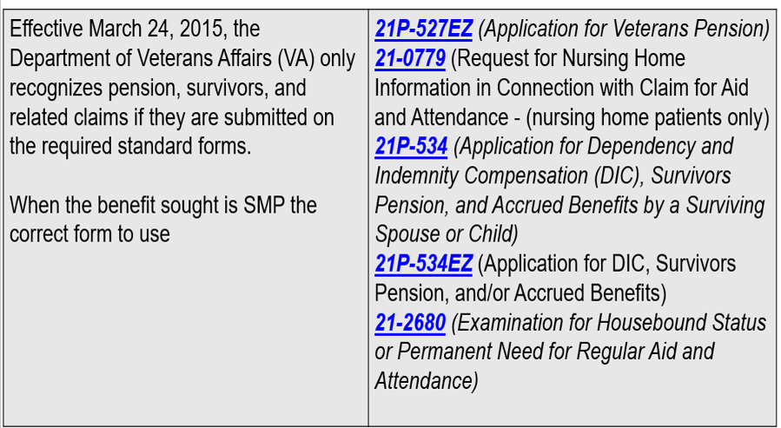 | DISPLAY slide  “Introduction to SMP, A&A, and HB Claims (2 of 2)”  USING the discussion points you prepared for this course, continue the REVIEW and DISCUSSION in the chart and provide additional information based on your level of expertise.  ASK if there are any questions and provide additional information as needed.
Class Activity: SMP, A&A, and HB Claims  - (Yes, or No?) Does an individual qualify for A&A if the person is a surviving spouse under 38 USC 1315(g)?  - Why or why not?  - Name the CFR reference that qualifies or disqualifies the person.  - (Fill in the blank.). Veterans eligible for pension qualify for HB status if they have a single permanent disability rated __ percent under a schedular evaluation and have other disabilities independently ratable at ___ percent or more or are permanently ________ by reason of their disabilities.  - (True or False?). Beneficiaries may not receive increased Old-Law Pension or Section 306 Pension because of needing A&A or being HB. | DISPLAY slide  “Class Activity: SMP, A&A, and HB Claims”  RANDOMLY select trainees to answer each of the questions.  ASK others if they agree with the answer.  PROVIDE feedback and additional information and clarification using the answers you prepared.
Practice Exercise: SMP, A&A, and HB Claims  - Instructions:  - Work in groups of 4.  - Review the sentences in Part 2 of Appendix A: Phase 5.6 Worksheet to determine the correct actions/response.  - Complete Part 2 – SMP, A&A, and HB Claims exercise  - Be prepared to share your responses and rationale with the class.  - Time allowed: 20 minutes | DISPLAY slide  “Practice Exercise: SMP, A&A, and HB Claims”    This Photo by Unknown Author is licensed under CC BY-NC  INFORM trainees that this exercise is based solely on memory.  PROVIDE instructions for this exercise.  ALLOW 20 minutes to complete.
Practice Exercise: SMP, A&A, and HB Claims Q&A   | DISPLAY slide  “Practice Exercise: SMP, A&A, and HB Claims Q&A”    RANDOMLY select trainees to share and compare answers aloud.    USE the answers you prepared before the class to provide clarification and feedback on answers given.  ASK if there are any questions and provide additional information as needed.
Incarceration and Fugitive Felon Adjustments Objectives  - Determine actions based on the source of the incarceration notification  - Determine actions based on the source of the fugitive felon notification  - Apply the correct development actions for the information/evidence missing from claim  - Decide the award action(s)  - Create decision notice | DISPLAY slide  “Incarceration and Fugitive Felon Adjustments Objectives”    REMIND trainees of the objectives.
Incarceration Adjustments  - 38 CFR 3.665 requires the reduction of a beneficiary’s Dependency and Indemnity Compensation (DIC) when the beneficiary is incarcerated more than 60 days following conviction of a felony.  - A person incarcerated for conviction of a felony may not receive full DIC after 60 full days of incarceration, under 38 CFR 3.665(a).  - Payment is reduced to one-half the rate that is payable to a Veteran for a service-connected (SC) disability VA has rated 10-percent disabling, according to 38 CFR 3.665(d)(3).  - 38 CFR 3.666 requires the discontinuance of a beneficiary’s pension when the beneficiary is incarcerated more than 60 days following conviction of a felony or misdemeanor.  - The proper effective date for reducing or discontinuing benefits is the 61st day of incarceration. | DISPLAY slide  “Incarceration Adjustments”  REVIEW and DISCUSS each bullet point on the slide.  INSTRUCT trainees to access each of the CFRs and briefly REVIEW and DISCUSS each CFR with the trainees.  PROVIDE additional feedback and information based on your level of expertise.  ASK if there are any questions and provide additional information as needed.
Fugitive Felons  - 38 USC 5313B prohibits the payment of VA benefits to a beneficiary or apportionee while the beneficiary is a fugitive felon, and the dependent(s), to include apportionees of a Veteran while the Veteran is a fugitive felon, and additional VA benefits to a beneficiary for a dependent who is a fugitive felon.  - Dependent children of a fugitive surviving spouse may continue to receive benefits in their own right. | DISPLAY slide  “Fugitive Felons”  SELECT two trainees to read each bullet point aloud.  USING the discussion points you have prepared for this lesson, provide additional information.  ASK if there are any questions and provide additional information as needed.
Class Activity: Remove the Dependent  - Name the required action you must take when it is determined that the name, date of birth, and Social Security number (SSN) that is printed on Form FFP-3 matches the beneficiary or dependent in receipt of pension.  - You (do or do not) reduce benefits if the beneficiary is incarcerated in a foreign penal institution.  - You (do or do not) reduce benefits if the beneficiary is residing in a civil commitment center.  - Name 4 official Federal, State and local government sources for information regarding an individual’s incarceration that VA acknowledges. | DISPLAY slide  “Class Activity: Remove the Dependent”  SELECT a trainee to answer the question.  ASK others if they agree with the answer.  PROVIDE feedback and additional information and clarification using the answers you prepared.
Introduction to Apportionment Claims Objectives  - Define Apportionment  - Identify the correct VA Form for apportionment  - Determine who may receive an apportionment of a beneficiary’s benefits  - Identify regulations under which VA may apportion benefits  - Identify situation where an apportionment is not appropriate | DISPLAY slide  “Introduction to Apportionment Claims Objectives”  REVIEW objectives for the course with trainees.
Introduction to Apportionment Claims (1 of 2)  - The Department of Veterans Affairs (VA) will consider a claim for an apportionment of a beneficiary’s VA benefits only upon receipt of VA Form 21-0788, Information Regarding Apportionment of Beneficiary’s Award.  - An apportionment may be paid to or for a Veteran’s  - estranged spouse  - child that is in an estranged or former spouse’s custody  - child that is not living with the Veteran or the Veteran’s surviving spouse, or  - dependent parent | DISPLAY slide  “Introduction to Apportionment Claims (1 of 2)”  SELECT a trainees to read each bullet point aloud.  PROVIDE additional details based on your level of expertise.  ASK if there are any questions and provide feedback and examples as needed.
Introduction to Apportionment Claims (2 of 2)  - When processing an apportionment claim, claims processors must first determine whether an apportionment is payable under the provisions of 38 CFR 3.450.  - The evidence of record must show the following to justify the apportionment of a Veteran’s benefits to an estranged spouse under the provisions 38 CFR 3.450:  - spouse does not reside with the Veteran, and  - Veteran is not providing a reasonable level of support to the spouse  - If benefits are not apportionable under 38 CFR 3.450, claims processors must determine whether a special apportionment under the provisions of 38 CFR 3.451 is in order. | DISPLAY slide  “Introduction to Apportionment Claims (2 of 2)”  REVIEW and DISCUSS each bullet point.  INSTRUCT trainees to access each of the CFRs.  BRIEFLY review and discuss each CFR with trainees.  ASK if there are any questions and provide feedback and examples as needed.
Class Activity: Apportionment Claims  - Which CFR prohibits the apportioning of a Veteran’s benefits for a child the Veteran has given up for adoption?  - If a claimant is a child under age 18, or child aged 18 or older who is permanently incapable of self-support, payment of VA education benefits (does or does not) preclude the child from concurrently receiving an apportionment of disability or survivors' benefits, if the individual case warrants this action?  - (True or False?). VA may apportion benefits to a dependent, even if the dependent is not on the beneficiary’s award, if the dependent’s relationship to the Veteran, on whose service the award is based, is properly established.  - If the beneficiary is a surviving spouse or child in receipt of DIC, and benefits are subject to reduction because the surviving spouse was incarcerated, you should consider the provisions under which CFR to determine entitlement to an apportionment? | DISPLAY slide  “Class Activity: Apportionment Claims”  SELECT a trainee to answer the question.  ASK others if they agree with the answer.  PROVIDE feedback and additional information and clarification using the answers you prepared.
Practice Exercise: Apportionment Claims  - Instructions:  - Work in groups of 4.  - Review the sentences in Part 3 of Appendix A: Phase 5.6 Worksheet to determine apportionment is payable or not payable.  - Complete Part 3 – Apportionment Claims exercise  - Be prepared to share your responses and rationale with the class.  - Time allowed: 20 minutes | DISPLAY slide  “Practice Exercise: Apportionment Claims”  This Photo by Unknown Author is licensed under CC BY-NC  INFORM trainees that this exercise is based solely on memory.  PROVIDE instructions for this exercise.  ALLOW 20 minutes to complete.
Practical Exercise: Apportionment Claims Q&A   | DISPLAY slide  “Practice Exercise: Apportionment Claims Q&A”  RANDOMLY select trainees to share and compare answers aloud.  USE the answers you prepared before the class to provide clarification and feedback on answers given.  ASK if there are any questions and provide additional information as needed.
Questions?   | DISPLAY slide  “Questions”  ASK trainees if there are any questions regarding the material covered during the KE Prep Session. If the KE is/was used to provide additional training/practice due to proficiency issues, TMs/Instructors will need to determine which course(s) the trainee(s) should retake based on the test results.  ASSIGN KEs to the trainee(s) based on their individual results.
What’s Next  - Assigned Knowledge Check in the Assessment Portal as determined by the Training Manager (TM) and/or Instructor.  - Complete the Phase 5.6 Knowledge Enhancer Prep Survey | DISPLAY slide  “What’s Next?”  INSTRUCT trainees to complete the Phase 5.6 Knowledge Enhancer Prep Survey.

