PENSION AND FIDUCIARY Service
PMC VSR Core Course
Phase 6: Processing Claims
Lesson 5: Process Special Monthly Pension (SMP) Claims (A&A/HB)
Lesson Plan
June 2022

Process SMP Claims

Lesson Overview
Topic | Description
Time Estimate: | 3 hours
Purpose of the Lesson: | This lesson is part of the entry-level curriculum, Core Course for PMC VSRs. The purpose of this lesson is to train PMC VSRs on how to process special monthly pension (SMP) claims through demonstration, practice, and feedback. This lesson also includes instruction on how to use the systems for processing SMP claims.
Prerequisite Training Requirements: | Prior to taking the Process Special Monthly Pension (SMP) Claims (A&A/HB) lesson, trainees must complete:  - PMC VSR Core Course Phases 1–5  - Phase 6 Lessons 1-4. (Refer to the PMC VSR Program of Instruction for a list of lessons.)
Target Audience: | This lesson is for entry-level PMC VSRs.
Lesson References: | - VA Form 21-0779 (Request for Nursing Home Information in Connection with Claim for Aid and Attendance)  - VA Form 21-2680 (Examination for Housebound Status or Permanent Need for Regular Aid and Attendance)  - 38 CFR 17.73 (Medical Foster Homes – General)  - 38 USC 1521 (Veterans of a Period of Ward)  - 38 CFR 3.103 (Procedural Due Process and Other Rights)  - 38 CFR 3.104 (Binding Nature of Decisions)  - 38 CFR 3.402 (Surviving Spouse)  - 38 CFR 3.404 (Parents)  - 38 CFR 3.502 (Surviving Spouse)  - 38 CFR 3.326 (Examinations)  - 38 CFR 3.159 (Department of Veterans Affairs Assistance in Developing Claims)  - 38 CFR 3.351 (Special Monthly Dependency and Indemnity Compensation, Death Compensation, Pension and Spouse’s Compensation Ratings  - 38 CFR 3.352 (Criteria for Determining Need for Aid and Attendance and “Permanently Bedridden”  - 38 CFR 3.504 (Parents; aid and attendance)  - 38 CFR 3.660 (Dependency, Income and Estate)  - 38 CFR 4.17 (Total Disability Ratings for Pension Based on Unemployability and Age of the Individual)  - M21-1 II.iii.1.A (Application for Benefits)  - M21-1 VI.i.1.B.1.b. (Decision Notice Requirements)  - M21-1 IX.ii.1.A (General Information on Requirements for Aid and Attendance (A&A) and Housebound Status Under 38 CFR 3.351)  - M21-1 IX.ii.1.A.2.a. (Who May Qualify for Housebound status Under 38 CFR 3.351)  - M21-1 IX.ii.1.B (Aid and Attendance (A&A) Status for Beneficiaries who are Patients in a Qualified Nursing Home)  - M21-1 IX.ii.1.B.3.e. (Sending a Notice of Proposed Adverse Action to Reconsider and/or Remove A&A)  - M21-1 IX.iii.2.B (Pension Adjustments in Unusual Situations)  - M21-1 IX.iii.2.C.6 (A&A and Housebound Claims in Protected Pension Programs)  - M21-1 X.iii.1.A (Reports of Hospitalization and Other Information Exchanges Between Department of Veterans Affairs (VA) Regional Offices (ROs) and Medical Facilities)  - M21-1 XII.i.2.B (Aid and Attendance (A&A) and Housebound Determinations for Survivors)  - M21-1-4, Appendix B (End Products (EP) Codes)  - Processng a SMP Claim job aid
Technical Competencies: | - Program Benefits and Eligibility (PMC VSR)  - Processing Claims (PMC VSR)  - Special Monthly Pension (SMP) Processes (PMC VSR)  - VBA Applications (PMC VSR)
Lesson Objectives: | - Process special monthly pension (SMP) claims (A&A/HB).  - Recognize indicators of an SMP claim.  - Determine if evidence is sufficient to process claim for A&A or HB benefits.  - Apply the correct development actions for the information/evidence missing from claim.  - Determine if claim should be submitted to rating activity.  - Decide the award action for an SMP claim.
What You Need: | - Lesson Plan  - Processing an SMP Claim job aid  - Sample Rating for trainess to process for practice.  - Slides  - Projector  - Whiteboard/flip chart with different colored markers  - Copy of a completed form for the following:  - VA Form 21-2680 Examination for Housebound Status or Permanent Need for Regular Aid and Attendanc  - VA Form 21-0779 Request for Nursing Home Information in Connection with Claim for Aid and Attendance for review  - VA Form 27-0820b, Report of Nursing Home or Assisted Living Information  - Demonstration claim: to demonstration on how to enter an institution into the system  - Demonstration claim: to demonstrate how to make an adjustment in the system.  - Demonstration claim: to demonstrate how a PMC VSR would develop for missing evidence or information needed to process an SMP claim.  - Sample Rating for trainess to process for practice.  - Answer key for the lesson summary review questions (located at the end of the lesson plan)

Instructor Notes
This lesson provides trainees with instruction, practice, and the needed references to process SMP claims. Trainees will also be required to demonstrate how to use the systems for processing the claims.
PowerPoint Slides | Instructor Activities
Lesson 5: Process Special Monthly Pension (SMP) Claims (A&A/HB) | DISPLAY slide  “Lesson 5: Process Special Monthly Pension (SMP) Claims (A&A/HB)”  INTRODUCE yourself as the instructor.  INTRODUCE the lesson.  STATE that the technical competencies and references used for this course are located at the beginning of the trainees guide.  STATE that although some of the discussion also applies to compensation benefits, this lesson specifically focuses on pension.
Lesson Objectives  - Process special monthly pension (SMP) claims aid and attendance (A&A) and housebound (HB)  - Recognize indicators of an SMP claim.  - Determine if evidence is sufficient to process claim for A&A or HB benefits.  - Apply the correct development actions for the information/evidence missing from claim.  - Determine if claim should be submitted to rating activity.  - Decide the award action for an SMP claim. | DISPLAY slide  “Lesson Objectives”  DISCUSS the lesson objectives
Why This Matters!  - Processing SMP Claims is important because under 38 CFR 3.351, A&A benefits may be paid to a Veteran who is receiving pension or is a patient in a nursing home (NH), a Veterans spouse if the Veteran is entitled to receive additional compensation for a spouse, surviving spouses or parents who are receiving or entitled to receive Dependency and Indemnity Compensation (DIC), or a surviving spouse who is receiving Survivors Pension, or death compensation.  - To qualify for HB status under 38 CFR 3.351 the individual must be a Veteran eligible for pension, or surviving spouse eligible for pension or DIC. | DISPLAY slide  “Why This Matters!”  READ the reason the course matters to trainees.  EXPLAIN that parents receiving death compensation may also qualify for A&A.  STATE for pension purposes, a medical foster home recognized and approved is equivalent to a nursing home.
Definitions (1 of 3)  - Permanently housebound refers to an individual is substantially confined to their home (ward or clinical areas, if institutionalized) or immediate premises because of disability or disabilities that are reasonably certain to be permanent.  - Aid and attendance (A&A) is a benefit to assist eligible individuals who:  - Require the aid of another person to perform the personal functions required in everyday living  - Are blind  - Are patients in a nursing home, State Veteran’s Home or VA-approved medical foster home | DISPLAY slide  “Definitions (1 of 3)”  READ over each definition with the trainees.  PROVIDE examples and additional explanations based on your knowledge and experience.
Definitions (2 of 3)  - A nursing home (NH) is defined as any extended care facility that is licensed by a State to provide skilled or intermediate-level nursing care, a NH care unit in a State Veterans’ home that is approved for payment, or a VA NH care unit.  - The term contract nursing home refers to a non-VA NH under contract with VA to provide NH care at VA expense for a specified period of time.  - A medical foster home (MFH) means a privately owned residence, recognized and approved by VA, that offers a non-institutional alternative to NH care for Veterans who are unable to live alone safely due to chronic or terminal illness | DISPLAY slide  “Definitions (2 of 3)”  SELECT two or three trainees to read each definition aloud.  PROVIDE examples and additional explanations based on your knowledge and experience.
Definitions (3 of 3)  - Care facility other than a nursing home means a facility in which a disabled individual receives health care or custodial care.  - A licensed health care provider refers to a person licensed to furnish health services by the State or country in which the services are provided.  - Bedridden refer to the condition requiring the claimant remain in bed. | DISPLAY slide  “Definitions (3 of 3)”  DISCUSS each definition listed on the slide.  STATE that a facility must be licensed if facilities of that type are required to be licensed in the State or country in which the facility is located. a facility that is residential must be staffed 24 hours per day with care providers.    ASK trainees if there are any questions on the definitions discussed so far.  PROVIDE feedback and clarification as needed.
Prescribed Forms  - Effective March 24, 2015, the Department of Veterans Affairs (VA) only recognizes pension, survivors, and related claims if they are submitted on the required standard forms.  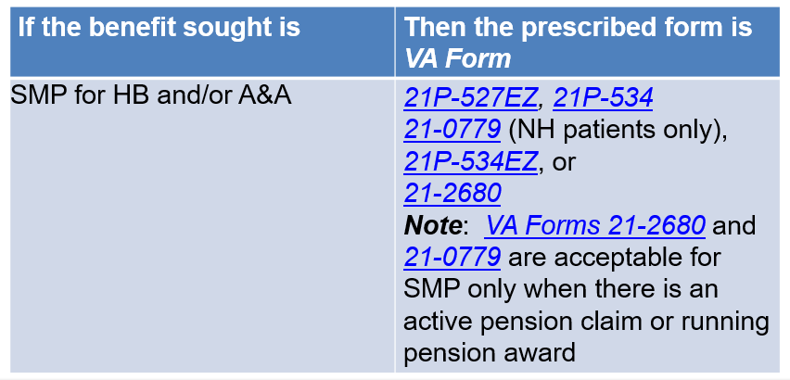 | DISPLAY slide  “Prescribed Forms”  EXPLAIN that effective March 24, 2015, the Department of Veterans Affairs (VA) only recognizes pension, survivors, and related claims if they are submitted on the required standard forms.  DISCUSS the chart with trainees.  STATE that VA Form 21-2680 is a claim for both A&A and housebound benefits.    EMPHASIZE that VA Form 21-2680, can be used as a standalone form if the claimant and/or the supporting documentation identifies whether the benefit sought is SMP (only when there is a running pension award).
Signature Requirements  - No claimant signature is required when  - VA Form 21-2680 is accepted as a prescribed form for a claim for SMP  - VA Form 21-0779 is accepted as a prescribed form for a claim for A&A (nursing home patients only), or  - VA Form 21P-0969, Income and Asset Statement in Support of Claim for Pension or Parents’ Dependency and Indemnity Compensation (DIC), is accepted as a statement in support of a pending claim for pension or Parents’ DIC | DISPLAY slide  “Signature Requirements”  DISCUSS the points on the slide.    REFER trainees to the Process a SMP Claim job aid.  ALLOW trainees five minutes to review and read the job aid.  TELL trainees that they will refer to the job aid throughout the course.
Determing Qualification for A&A (1 of 3)  - Individuals in the following categories may qualify for A&A status under 38 CFR 3.351:  - a Veteran who is receiving pension if the Veteran is a patient in a NH  - a Veteran’s spouse, if the Veteran is entitled to receive additional compensation for the spouse  - a surviving spouse or parent receiving DIC, and  - a surviving spouse receiving Survivors Pension, or death compensation | DISPLAY slide  “Determining Qualification for A&A (1 of 3)”  DISCUSS the content on the slide.    REFER trainees to the following references:  38 CFR 3.351 (Special monthly dependency and indemnity compensation, death compensation, pension and spouse's compensation ratings).  38 CFR 3.352 (Criteria for determining need for aid and attendance and “permanently bedridden).  ALLOW trainees ten minutes to read the CFRs.  STATE that these references are critical to understanding and successfully processing A&A/HB claims, and will be referred to throughout this lesson.  ASK trainees to raise their hands, and select the first person to raise his/her hand to answer the following questions (NOTE: the answers are provided under each question for you):  - What term is used to describe an individual who is a health-care professional who consults with the unlicensed person providing the health-care services at least once each month to monitor the prescribed regimen?  - “under the regular supervision of a licensed health-care professional”  - Are determinations that a Veteran is so helpless, as to need of regular A&A based solely upon the opinion that the claimant's condition would require him or her to be in bed?  - No; Determinations that the veteran is so helpless, as to be in need of regular A&A will not be based solely upon an opinion that the claimant's condition is such as would require him or her to be in bed.  - Is it true that the permanently housebound requirement is met when the surviving spouse is substantially confined to his or her home?  - yes
Determining Qualification for A&A (2 of 3)  - There is no statutory or regulatory requirement for a Veteran pensioner to have a rating of 100-percent disabled to be determined in need of regular A&A  - if a Veteran pensioner meets the criteria for A&A under 38 CFR 3.352(a), the rating activity may grant SMP at the A&A rate even though the Veteran is not rated 100-percent disabled under the rating schedule | DISPLAY slide  “Determining Qualification for A&A (2 of 3)”  EXPLAIN that there is no statutory or regulatory requirement for a Veteran pensioner to have a rating of 100-percent disabled to be determined in need of regular A&A  STATE that if a Veteran pensioner meets the criteria for A&A under 38 CFR 3.352(a), the rating activity may grant SMP at the A&A rate even though the Veteran is not rated 100-percent disabled under the rating schedule.
Determining Qualification for A&A (3 of 3)  - Only surviving spouses who are receiving or entitled to receive DIC, or Survivors Pension may qualify for the HB rate under 38 CFR 3.351  - HB benefits may not be authorized without a rating decision except when the surviving spouse was receiving housebound benefits on the Veteran's award prior to the Veteran's death  - Authorize the payment of A&A benefits without a rating decision if  - evidence establishes the claimant is a patient in a NH, or  - the surviving spouse was in receipt of A&A benefits on the Veteran's award prior to the Veteran's death | DISPLAY slide  “Determining Qualification for A&A (3 of 3)”  DISCUSS each point on the slide.  ASK trainees if there are any questions on the material covered so far, and provide feedback and clarification as needed.
Qualifying for HB Status  - Individuals who may qualify for HB status under 38 CFR 3.351:  - Veterans eligible for pension, and  - surviving spouses eligible for pension or DIC  - Veterans eligible for pension qualify for HB status if they have a single permanent disability rated 100 percent under a schedular evaluation, and  - have other disabilities independently ratable at 60 percent or more, or  - are permanently HB by reason of their disabilities | DISPLAY slide  “Qualifying for HB Status”  DISCUSS each point on the slide.  REFER trainees to 38 CFR 3.351 (Special monthly dependency and indemnity compensation, death compensation, pension and spouse's compensation ratings).  INFORM trainees that in pension claims, the single 100-percent disability and the disability that causes the Veteran to be housebound must be permanent.  STATE that a finding of housebound in this manner is sometimes referred to as “statutory housebound.
Indicators of a  SMP Claim (1 of 3)  - When accepting VA Form 21-2680, Examination for Housebound Status or Permanent Need for Regular Aid and Attendance as a claim for SMP, the form is a potential claim for both A&A and HB benefits.  - A grant of A&A renders the issue of HB moot for the same type of benefit for SMP since A&A is the greater benefit.  - The issue of entitlement to SMP based on HB status need not be addressed when A&A is granted for the same type of benefit or SMP | DISPLAY slide  “Indicators of a SMP Claim (1 of 3)”  SELECT two or three trainees to read each point on the slide.  TELL trainees that VA Form 21-2680 can be used as a standalone form to claim spousal or survivors’ A&A or housebound benefits when there is an active claim and/or running DIC or Survivors Pension award and the benefit sought is adequately identified.
Indicators of a SMP Claim (2 of 3)  Determination of a claimant’s need for A&A or HB benefits is based on medical evidence  - Statements by licensed health care professionals meeting the requirements of 38 CFR 3.326 and 38 CFR 3.159  - Statements from officials of nursing homes (NHs) are acceptable to establish resident status without the need for a physical examination and may be provided on VA Form 21-0779  - Missing information may obtained by telephone and documented on VA Form 27-0820b, Report of Nursing Home or Assisted Living Information | DISPLAY slide  “Indicators of a SMP Claim (2 of 3)”  DISCUSS the content on the slide.  REVIEW a copy of VA Form 27-0820b with trainees.  DISCUSS the information that must be documented on the form.  PROVIDE further examples and additional information based on experience and as needed.
Indicators of a SMP Claim (3 of 3)  Determination of a claimant’s need for A&A or HB benefits is based on medical evidence  - VA Form 21-2680, for survivors may be accepted, and issued to claimants, as needed, for completion by their medical provider  - A rating decision is required to determine a surviving spouse’s entitlement to either the A&A rate, when the surviving spouse is not a patient in a NH, or HB rate | DISPLAY slide  “Indicators of a SMP Claim (3 of 3)”  ASK for a volunteer to read the content on the slide.  EXPLAIN that although VA Form 21-2680 may be accepted as a prescribed claim form for SMP, it is not required to grant entitlement to either benefit.  STATE that if A&A is denied, the rating decision must address the issue of housebound status. If, however, HB has been previously granted, the issue of entitlement to HB need not be readdressed and/or continued in the rating decision.
End Products (EPs) – (1 of 2)  - Special monthly pension (SMP): EP 120 applies to claims for entitlement to SMP  - Claims for SMP based on aid and attendance or HB status, including claims based on NH status  - EP 135 applies to reductions based on hospitalizations in a Medicaid-approved nursing facility and adjustments to restore benefits based on discharge from hospitalization (includes claims adjudicated under the provisions of 38 CFR 3.551-3.558  - When restoration of benefits is required upon receipt of discharge from hospitalization, the EP 330 associated with hospitalization discharge established should changed to an EP 135 | DISPLAY slide  “End Products (EPs) - (1 of 2)”  DISCUSS the content on the slide.  INSTRUCT trainees to use the corresponding VSC or PMC EP 135 claim label depending on the benefit.  INFORM trainees that the EP 330 is also used for screening automated hospitalization reports and those limited contract nursing home reports that must be established manually.
End Products (EPs) - (2 of 2)  - For reductions based on hospitalization in a Medicaid-approved nursing facility, clear the EP 135 and EP 600 established for the notification of proposed reduction  - If the hospital adjustment includes an administrative grant of A&A, clear the EP 120 instead of EP 135  - The hospitalization adjustment EP 330 should be changed to:  - EP 135 upon receipt of discharge from hospitalization when restoring benefits, or  - EP 120 upon receipt of standardized form for SMP, if applicable, or cleared if no adjustment to the award or letter is required, or EP 600 is established | DISPLAY slide  “End Products (EPs) - (2 of 2)”  CONTINUE discussions on end products.  ASK trainees if they have any questions regarding EPs.  PROVIDE feedback and clarification as needed.
Demonstration: Reviewing VA Form 21-0779    VA Form 21-0779, Request for Nursing Home Information in Connection With Claim for Aid and Attendance | DISPLAY slide  “Demonstration: Reviewing VA Form 21-0779”  USING the completed VA Form 21-0779 you selected for this course, review and discuss the form.  RESTATE that statements given by officials of NHs are acceptable to establish resident status without the need for a physical examination.
Processing VA Form 21-2680  When a Veteran’s spouse, surviving spouse, or parent is identified as the claimant or the individual being examined on VA Form 21-2680, apply the following steps:  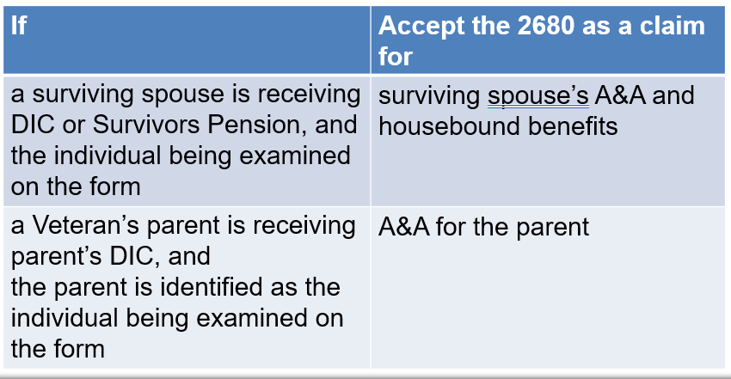 | DISPLAY slide  “Processing VA Form 21-2680”  TELL trainees that when a Veteran’s spouse, surviving spouse, or parent is identified as the claimant or the individual being examined on VA Form 21-2680, they are to follow the steps shown in the chart.  REVIEW the steps in the chart with the trainees.
Scenario—Special Monthly Pension (SMP) Claim  VA Form 21-2680, Examination for Housebound Status or Permanent Need for Regular Aid and Attendance | DISPLAY slide  “Demonstration: Reviewing VA Form 21-2680”  USING the completed VA Form 21-2680 you selected for this course, review and discuss the form.  RESTATE that VA Form 21-2680 may be accepted as a prescribed claim form for SMP, but it is not required to grant entitlement.
Referring Claims to the Rating Activity (1 of 2)  - A rating decision is required in a Veterans Pension case  - if the Veteran does not meet the requirement of patient status in a qualified NH, or  - to authorize A&A from the date of hospital admission when the immediately preceding period of hospitalization exceeded 90 days | DISPLAY slide  “Referring Claims to the Rating Activity (1 of 2)”  DISCUSS the content on the slide.
Referring Claims to the Rating Activity (2 of 2)  - Refer A&A and HB claims filed by Section 306 and Old-Law pensioners to the rating activity unless:  - the claim is for A&A based on NH status  - election of current-law pension is not in the claimant’s financial interest, even with A&A, or  - the claimant did not submit current medical evidence on or with an appropriate prescribed claim form | DISPLAY slide  “Referring Claims to the Rating Activity (1 of 2)”  DISCUSS the content on the slide.  STATE that a rating decision is required to determine a surviving spouse’s entitlement to either the A&A rate, when the surviving spouse is not a patient in a nursing home, or housebound rate.  ASK trainees if there are any questions.  PROVIDE feedback and examples as needed.
Reduce or Discontinue SMP: Not Permanent and Total (P&T)  - For cases that are “Not P&T” a notice of proposed adverse action must include the citation of 38 CFR 4.17  - Control cases involving a proposal to discontinue P&T, A&A, or HB status, so that rating activity action may be taken immediately at the end of the 65-day notice of proposed adverse action period:  - route the case to the rating activity after the 65-day due process period expires, or  - all development associated with a personal hearing is completed, if VA receives a hearing request from the beneficiary within 30 days of the notice of proposed adverse action, whichever is later | DISPLAY slide  “Reduce or Discontinue SMP: Not Permanent and Total (P&T)”  STATE that for cases that are “Not P&T” a notice of proposed adverse action must include the citation of 38 CFR 4.17  INSTRUCT trainees to control cases involving a proposal to discontinue P&T, A&A, or HB status, so that rating activity action may be taken immediately at the end of the 65-day notice of proposed adverse action period:  - route the case to the rating activity after the 65-day due process period expires, or  - all development associated with a personal hearing is completed, if VA receives a hearing request from the beneficiary within 30 days of the notice of proposed adverse action, whichever is later  REMIND trainees that the learned about due process in Phase 5.  REFER trainees to M21-1 VI.i.1.B.1.b. (Decision Notice Requirements) and review the decision notice requirements with trainees as a refresher, and state that the notification will need to follow the notice requirements listed, if the proposed “not P&T” notice is confirmed.
Rating Determinations Involving A&A (1 of 2)  Take actions when the rating activity determines there is or is not a need for A&A or HB  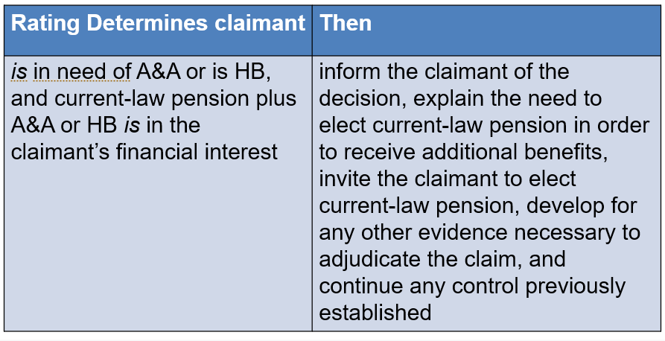 | DISPLAY slide  “Rating Determinations Involving A&A (1 of 2)”  REVIEW the chart with the trainees and state to take these actions when the rating activity determines there is or is not a need for A&A or HB.
Rating Determinations Involving A&A (2 of 2)  Take the following actions when the rating activity determines there is or is not a need for A&A or HB  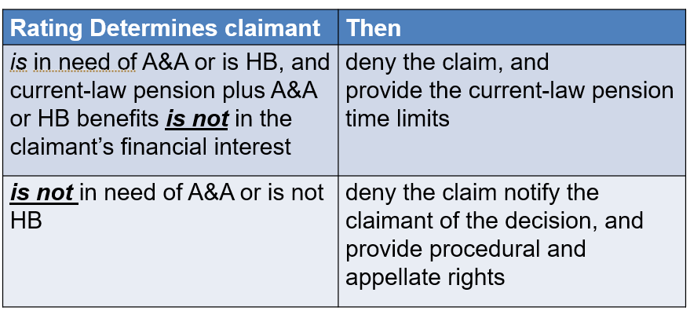 | DISPLAY slide  “Rating Determinations Involving A&A (2 of 2)”  CONTINUE discussions reminding trainees that these are actions to take when the rating activity determines there is or is not a need for A&A or HB.  ASK trainees if there are any questions.  PROVIDE feedback and examples as needed.
Awarding A&A Without a Rating (1 of 2)  - If evidence establishes that a beneficiary is a patient in a qualified NH, and there are no concurrent issues requiring a RD, then  - enter basic NH information in the INSTITUTIONALIZATION screen  - select STATUTORY A&A DECISION in the INSTITUTIONALIZATION ADJUSTMENTS screen, and  - enter A&A under 38 CFR 3.351(c)(2) in the OTHER PRINT REMARKS field  - If a period of VA or non-VA hospitalization results in a discharge of the beneficiary, within 90 days, as a patient to a qualified NH, authorize A&A without a rating decision from the first day of the month following such hospital admission | DISPLAY slide  “Awarding A&A Without a Rating (1 of 2)”  INSTRUCT trainees to authorize the payment of A&A benefits without a rating decision if evidence establishes the claimant is a patient in a nursing home, or the surviving spouse was in receipt of A&A benefits on the Veteran's award prior to the Veteran's death  STATE that if a period of hospitalization of 90 days or less results in a discharge to a nursing home, authorize payment of A&A benefits from the date of hospital admission, subject to the effective date provisions in 38 CFR 3.402(c) or 38 CFR 3.404.  STATE that if there are no concurrent issues requiring a rating decision, then  - enter basic NH information in the INSTITUTIONALIZATION screen  - select STATUTORY A&A DECISION in the INSTITUTIONALIZATION ADJUSTMENTS screen, and  - enter A&A under 38 CFR 3.351(c)(2) in the OTHER PRINT REMARKS field  INSTRUCT trainees to access 38 CFR 3.402 (Surviving Spouse) and 38 CFR 3.404 (Parents) and read over the CFRs.  ALLOW trainees three to five minute to read each CFR.  EMPHASIZE that housebound benefits may not be authorized without a rating decision except when the surviving spouse was receiving housebound benefits on the Veteran's award prior to the Veteran's death.
Awarding A&A Without a Rating (2 of 2)  - Award A&A based on patient status in a qualified NH if  - a responsible official of the facility states that the person is a patient in the facility because of a mental or physical disability, and the claimant submitted an appropriate standard form requesting A&A or  - the person is a patient in a VA Nursing Home Care Unit or in a contract nursing home and the claimant submitted an appropriate standard form requesting A&A | DISPLAY slide  “Awarding A&A Without a Rating (2 of 2)”  DISCUSS each point on the slide.  INSTRUCT trainees to treat reports of hospitalization received without a standard form as a request for application.    ASK if there are any questions and provide clarification and feedback as needed.
Demonstration: Adding Institutions in VBMS  - Use the “Institutionalizations Page” to process award adjustments (add events and adjustments)  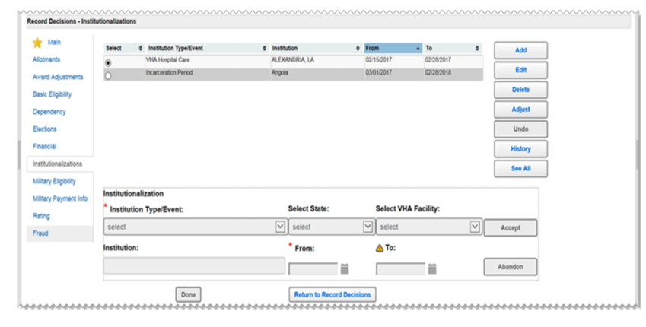  - For non-VA institutions, enter the name n the “Institution” box  - For a VHA institution, click “Select State” to select the state of where the institution is, then select the VHA by name  - Enter the date the institutionalization began in the “from” box  - Enter the date ended in the “to” box  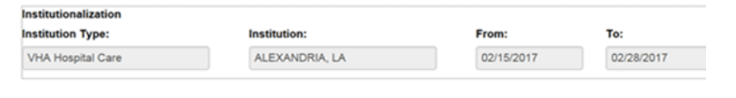  - Click “accept” then “done” | DISPLAY slide  & 29. “Demonstration: Adding Institutions in VBMS”  TELL trainees that this portion of the lesson will focus on how to enter an institution in VBMS.  INSTRUCT Use the “Institutionalizations Page” to process award adjustments (add events and adjustments)  DISCUSS the steps with trainees.  USE the case you selected for demonstration to show trainees how to add an institution in the system.
Demonstration: Adding Institutions in VBMS Adjustments  - For adjustments, on the Institutionalizations Page, select “adjust” and then click “add”  - Click “adjustment type” and select “adjust”  - Enter the date of adjustment in the “from” box and the date adjustment will end in the “to” box  - Click “accept” then “done”  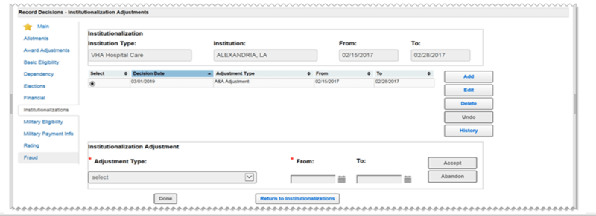 | DISPLAY slide  30. “Demonstration: Adding Institutions in VBMS Adjustments”  DISCUSS each step listed on the slide.  USE the case you selected for demonstration to show trainees how to make an adjustment in the system.
When to Deny/Develop  - If election of current-law pension plus A&A is not in the claimant’s financial interest, deny the claim  - In the notification letter, provide information concerning the time limits in 38 CFR 3.660(b) so that claimants can claim deductible expenses if current-law pension would be a better benefit if deductible expenses were a factor or, if the claimant did not submit medical evidence, send notice  - advising the claimant of the need for current medical evidence showing probable entitlement to A&A or HB  - explain the need to elect current-law pension in order to receive additional benefits  - invite the claimant to elect current-law pension  - develop for any other evidence necessary to adjudicate the claim, and  - continue any control previously established | DISPLAY slide  31. “When to Deny/Develop”  DISCUSS the content on the slide.    DEMONSTRATE, using the same claim, how a PMC VSR would develop for missing evidence or information needed to process an SMP claim.  REFER trainees to Develop for Missing Information/Evidence job aid.
Medical Expenses Deductions for NH Fees  Allow a medical expense deduction for NH fees if a responsible official of the NH certifies that the claimant or relative is a patient (as opposed to a resident) of the NH.  - Verify NH fees if/when one of the following situations exists:  - NH fees of $5,000 per month or more are first claimed at a particular facility, or  - the claimed expenses are questionable  - Examples of verification include  - VA Form 21-0779  - a documented call on VA Form 27-0820b  - an official statement provided by the nursing home, or  - financial statements showing proof of monthly payment | DISPLAY slide  32. “Medical Expenses Deductions for NH Fees”  DISCUSS the content on the slide.  STATE that questionable medical expenses are those that raise doubt of validity.  REFER trainees to Appendix A – Processing a SMP Claim job aid list of references.
Retroactive Payments  - If entitlement to Veterans Pension ends based on a decision that the Veteran is no longer permanently and totally (P&T) disabled, retroactive Veterans Pension may be awarded for any period of entitlement during which a P&T rating was in effect, if the rating decision was not in error  - if eligibility for the higher maximum annual pension rate (MAPR) for A&A or HB ends, retroactive pension or increased pension may be awarded for any period in which the A&A or HB rating was in effect and was not in error | DISPLAY slide  33. “Retroactive Payments”  SELECT one or two trainees to read each point on the slide.  STATE all pension adjustments are subject to the beneficiary’s income, net worth, and dependency status.
Reduce or Discontinue SMP (1 of 2)  - For adjustments involving discontinued or suspended pension awards, if pension was reduced or discontinued under a reduction in evaluation per 38 CFR 3.105,  - authorize an adjustment through the last day of the month in which you adjust the benefit (reduce or discontinue as of the first day of the following month), or  - If suspended, and there is no eligibility for pension beyond the date of suspense,  - limit the adjustment to the period prior to the date of suspense | DISPLAY slide  34. “Reduce or Discontinue SMP (1 of 2)”  ASK for a volunteer to read the points on the slide.  REFER trainees to the Processing a SMP Claim job aid.
Reduce or Discontinue SMP (2 of 2)  - Upon receipt of a RD proposing to discontinue P&T, A&A, or HB status, send the beneficiary a notice of proposed adverse action  - When furnishing a locally-generated notice proposing to discontinue P&T, A&A or HB status, advise the beneficiary of the proposed reduction or discontinuance as follows:  - “Your present payment will continue for 60 days to allow you to submit additional evidence. At the expiration of that 60-day period (or after a personal hearing is held, if VA receives such a hearing request from you within 30 days), all available evidence in the file will be reviewed once more and a final decision made. If this proposed decision to discontinue your [pension] and [aid and attendance] [housebound] entitlement is affirmed, your payments will be [discontinued] [reduced] when a final decision is made.” | DISPLAY slide  35. “Reduce or Discontinue SMP (2 of 2)”  REVIEW each point on the slide.  EMPHASIZE the proposed language to included in the proposed notice.  EMPHASIZE that a notice of proposed adverse action is required to remove A&A even if the beneficiary submitted the notice of discharge from the nursing home.  REFER trainees to the Processing a SMP Claim job aid – “Proposed Adverse Action.”
Effective Dates (1 of 2)  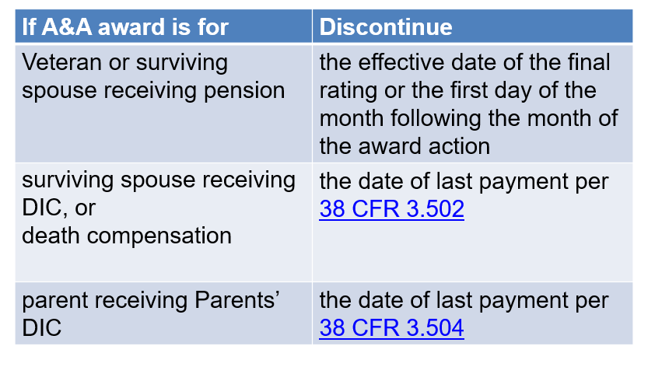 | DISPLAY slide  36. “Effective Dates (1 of 2)”  REVIEW the chart with the trainees.  INSTRUCT trainees to award housebound status for a Veteran or surviving spouse, if entitlement exists, effective the date following the date that A&A status was discontinued.
Effective Dates (2 of 2)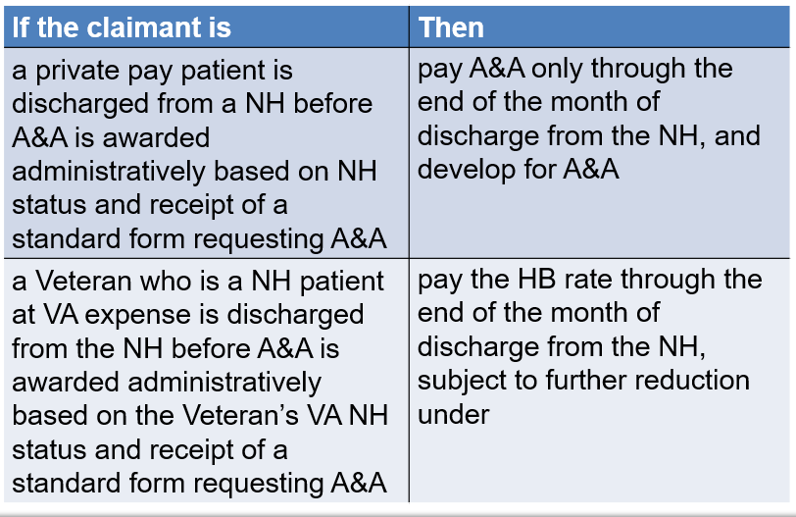 | DISPLAY slide  37. “Effective Dates (2 of 2)”  REVIEW the chart with the trainees.
Ratings for Reconsideration (1 of 2)  - Refer the case to the rating activity for reconsideration if  - additional medical evidence is received  - the rating activity had proposed to discontinue A&A status based on the evidence of record, or  - all development associated with a personal hearing is completed (if the beneficiary requests the hearing within 30 days of the notice of proposed adverse action)  - If medical evidence was submitted and forwarded for a rating decision, and the rating activity action on the A&A issue is still pending when the predetermination period elapses  - extend the suspense date for the pending EP 600, and continue payments until the rating action is completed | DISPLAY slide  38. “Ratings for Reconsideration (1 of 2)”  SELECT two or three trainees to read each point on the slide.  INFORM trainees that when the facts contained in the proposed rating were complete, they need not be repeated in the final rating decision, but need only be referenced by citing the proposed decision by date.  INSTRUCT trainees to inform the beneficiary that A&A has been established based on medical evidence, and that his/her payments will be continued when the RD establishes A&A for a beneficiary who has left a NH.  EMPHASIZE to clear the pending control.  REFER trainees to the following manual references and review, and discuss the references with trainees:  - M21-1, IX.iii.1.G.3.k. (Medical Expense Deduction for Care Facility Other than Nursing Home Fees)  - M21-1, IX.iii.1.G.3.r. (Vitamins, Food Supplements, and Herbal Remedies), and M21-1, IX.iii.1.G.5.a-c.  STATE if the amount payable was based on deductible nursing home expenses allowed prospectively, develop for current medical expenses when the beneficiary is no longer in the nursing home, they should adjust the award accordingly.  ASK trainees if there are any questions and provide feedback as needed.
Ratings for Reconsideration (2 of 2)  - Refer the case to the rating activity for a redetermination of A&A or HB status if, after the grant of A&A or HB, medical evidence is received indicating that  - the beneficiary’s condition has improved, and  - it appears the beneficiary is no longer seriously disabled  - For a claimant is already in receipt of A&A for pension with no changes in condition or competency, and a subsequent application for A&A is received, treat the application as a duplicate request for SMP, unless it can be accepted as a claim for Special Monthly Compensation (SMC) | DISPLAY slide  39. “Ratings for Reconsideration (2 of 2)”  CONTINUE discussions on Ratings for reconsideration.  ASK trainees if there are any questions and provide feedback and clarification as needed.
SMP: Veteran-Married-to-Veteran  - For a Veteran-Married-to-Veteran case, use either file number to establish a combined award, except when one spouse is A&A or HB  - Establish the award under the file number of the Veteran who is A&A or HB  - When establishing separate award payments for pension Veteran-married-to-Veteran inform the two Veterans that all pension benefits, including additional benefits for children or SMP, are equally divided  - do not count the other Veteran's pension amount as IVAP | DISPLAY slide  40. “SMP: Veteran-Married-to-Veteran”  REVIEW the content on the slide.  REMIND trainees that they learned about Veteran-Married-to_Veteran claims during Phase 5.  ASK trainees if there are any questions on any of the material covered and provide feedback and clarification as needed.
Activity: Process SMP Claim  Instructions:​  - As the instructor directs, work independently or in pairs.  - Access the Sample Rating to process the SMP rating.  - Be sure to include all notification requirements as applicable.​  - Be prepared to discuss your outcome.  Time: 15-20 minutes​ | DISPLAY slide  41. “Activity: Process SMP Claim”  DECIDE if trainees should work independently or in pairs and instruct them on how they should complete the activity.  DIRECT trainees to the Sample DIC Rating Decision 1.  READ the activity instructions on the slide to the trainees.  ASK if there are any questions before starting the practice exercise.  DEBRIEF the exercise by discussing outcome.  ASK trainees if their award and letter included all elements, and if not, share the parts missed, and explain.
Lesson Summary Review Questions  - Provide the name and number of the form used for requesting NH information in connection with a claim for A&A.  - If the VSR makes a telephone attempt to obtain missing information, what form is used to develop missing information?  - (True or False?) Only surviving spouses who are receiving or entitled to receive DIC or Survivors Pension may qualify for the HB rate under 38 CFR 3.351.  - (True or False?) VSRs should authorize a payment of A&A benefits without a rating decision if evidence establishes the claimant is a patient in a NH.  - (True or False?) There is no statutory or regulatory requirement for a Veteran pensioner to be rated 100-percent disabled to be determined to be in need of regular A&A.  - Provide the CFR under which a surviving spouse or parent in receipt of survivors pension, DIC, or death compensation can receive A&A benefits.  - List the reasons a RD is required in a Veteran Pension case.  - What EP is used for claims for SMP based on A&A?  - Provide the correct CFR that outlines the basic criteria for the higher-level A&A allowance.  - If a Veteran’s A&A status is discontinued, and HB status can be awarded, when would HB status be awarded? | DISPLAY slide  42. 43. & 44. “Lesson Summary Review Questions”  STATE that lesson summary will consist of review questions.  INSTRUCT trainees to use the worksheet located at the end of their training guide to answer the questions.  TELL trainees to be prepared to share their answers and provide a rationale.  ALLOW trainees seven to 15 to 20 minutes to complete the review questions.  INSTRUCT trainees to raise their hands as you read each question (Note to instructor: questions and answers are located at the end of your lesson plan).  RANDOMLY select trainees who have raised their hands to answer the questions, and provide feedback and clarification as needed.
Questions?   | DISPLAY slide  45. “Questions?”  ASK if they have any questions or concerns regarding the date of claim. Use this time to clear up any confusion or misconceptions about the information presented.
What’s Next?  - Complete Process SMP Claims course evaluation: TMS ID 4408389 | DISPLAY slide  46. “What’s Next?”  TELL trainees to complete Process SMP Claims course evaluation using TMS ID 4408389

Lesson Summary Review Questions – Instructor Answer Key
Directions: Based on the material discussed, provide a response to the following:

- Provide the name and number of the form used for requesting nursing home information in connection with a claim for A&A.
  - VA Form 21-0779, Request for Nursing Home Information in Connection with Claim for Aid and Attendance

- If the VSR makes a telephone attempt to obtain missing information, what form is used to develop missing information?
  - VA Form 27-0820b, Report of Nursing Home or Assisted Living Information

- (True or False?) Only surviving spouses who are receiving or entitled to receive DIC or Survivors Pension may qualify for the HB rate under 38 CFR 3.351.

- (True or False?) VSRs should authorize a payment of A&A benefits without a rating decision if evidence establishes the claimant is a patient in a NH.

- (True or False?) There is no statutory or regulatory requirement for a Veteran pensioner to be rated 100-percent disabled to be determined to be in need of regular A&A.

- Provide the CFR under which a surviving spouse or parent in receipt of survivors pension, DIC, or death compensation can receive A&A benefits.
  - 38 CFR 3.351

- List the reasons a rating decision is required in a Veteran Pension case.
  - A rating decision is required in a Veterans Pension case if the Veteran does not meet the requirement of patient status in a qualified nursing home, or to authorize A&A from the date of hospital admission when the immediately preceding period of hospitalization exceeded 90 days.

- What EP for is used for claims for SMP based on A&A?
  - 120EP

- Provide the correct CFR that outlines the basic criteria for the higher-level A&A allowance.
  - 38 CFR 3.352

- If Veteran’s A&A status is discontinued, and HB status can be awarded, when would HB status be awarded?
  - The effective date would be the date following the date that A&A status was discontinued.

