Pension and fiduciary service

PMC VSR National Training Curriculum (NTC)  
Journey-Level Training

Hospital Adjustments

Trainee Guide

October 2024

Hospital Adjustments

Lesson Overview

| Topic | Description |
| --- | --- |
| Time Estimate: | 2 hours |
| Purpose of the Lesson: | This lesson is part of the NTC journey-level curriculum, for PMC VSRs. This lesson is intended to increase your understanding of the provisions governing hospital adjustments pertaining to reductions of special monthly pension (SMP) A&A to the Housebound (HB) rate for hospitalization at VA expense, as well as the methods for processing them. This lesson will contain discussions and exercises that will allow the trainee to gain a better understanding of hospital adjustment provisions; functions of the EP 330; and processing hospital adjustments. |
| Prerequisite Training Requirements: | Prior to taking the Establish a Claim lesson, trainees must complete PMC VSR Core Pension Training (CPT) program. |
| Target Audience: | This lesson is for PMC VSRs. |
| Lesson References: | * 38 CFR 3.31, Commencement of the period of payment * 38 CFR 3.551, Reduction because of hospitalization * 38 CFR 3.556, Adjustment on discharge or release * M21-1 Part X, Subpart iii.1.A.1.a., Definition: Hospitalization * M21-1 Part I, Subpart i.1.B, General Information on Due Process * M21-4 Appendix B.2, End Products – Compensation, Pension, and Fiduciary Operations * M21-1 Part X, Subpart iii.1.D, Adjustments Under 38 CFR 3.551 and 3.556 * M21-1 Part X, Subpart iii. 1.C, Adjusting Awards Involving an Aid and Attendance (A&A) Allowance * M21-1 Part I, Subpart ii. 1.C, Pension Management Center (PMC) Procedures |
| Lesson Objectives: | By the end of this lesson, you should be able to:   * Identify hospital adjustment provisions * Interpret the dates of reduction and reinstatement of benefits * Describe procedures on processing end product (EP) 330 * Recognize hospital adjustments under 38 CFR 3.551 * Indicate the requirements to process a hospital adjustment * Demonstrate the ability to process hospital adjustments |
| Knowledge Check | Hospital Adjustments Knowledge Check |
| What You Need: | * Trainee Guide * Access to VBA Intranet * Access to the Assessment Portal * Pen and paper or access to a whiteboard * Access to the following systems:   + SHARE   + MAP-D   + VBMS |

| PowerPoint Slides | Notes |
| --- | --- |
| **Hospital Adjustments** |  |
| **References**   * 38 CFR 3.551, Reduction because of hospitalization * 38 CFR 3.556, Adjustment on discharge or release * M21-1 Part X, Subpart iii.1.A.1.a., Definition: Hospitalization * M21-1 Part I, Subpart i.1.B, General Information on Due Process * M21-4 Appendix B.2, End Products – Compensation, Pension, and Fiduciary Operations * M21-1 Part X, Subpart iii.1.D, Adjustments Under 38 CFR 3.551 and 3.556 * M21-1 Part X, Subpart iii. 1.C, Adjusting Awards Involving an Aid and Attendance (A&A) Allowance * M21-1 Part I, Subpart ii. 1.C, Pension Management Center (PMC) Procedures * CNH Report of Admissions/Discharges Macro |  |
| **Objectives**  The scope of this training centers on how benefits are affected when beneficiaries are in receipt of Special Monthly Pension (SMP) Aid and Attendance (A&A) and are hospitalized at VA expense. By the end of this lesson, you should be able to:   * Identify hospital adjustment provisions * Interpret the dates of reduction and reinstatement of benefits * Describe procedures on processing end product (EP) 330 * Recognize hospital adjustments under 38 CFR 3.551 * Indicate the requirements to process a hospital adjustment * Demonstrate the ability to process hospital adjustments |  |
| **Why This Matters!**  **This course matters as adjudicators must know that** pension is subject to reduction when a Veteran who has neither spouse, child nor dependent parent, is hospitalized, unless for Hansen's disease, and the actions required in these cases. |  |
| **Definitions (1 of 2)**  ***Hospitalization*,** generally refers to inpatient care or treatment that a Veteran receives in a:   * Department of VA hospital or medical facility * VA domiciliary * VA nursing home, or * private facility under VA contract |  |
| **Definition (2 of 2)**  **Aid and Attendance (A&A)** is:   * An additional allowance available to Veterans, spouses of Veterans, surviving spouses, and parents * Usually awarded to claimants with mental or physical disabilities requiring the regular aid and attendance of another person to perform functions of daily living |  |
| **Hospital Adjustments (A&A)**  **The following are some reasons a claimant may qualify for A&A:**   * Inability to dress/undress * Inability to keep clean and presentable * Frequent need for adjustment of any special prosthetic or orthopedic appliances * Inability to feed self through loss of coordination of upper extremities or extreme weakness * Inability to attend to the wants of nature * Incapacity which requires care on a regular basis to protect the Veteran from hazards within the daily environment |  |
| **Reductions Under 38 CFR 3.551 and 3.552**   * The award of a Veteran with no established dependents who is transferred or directly admitted to a facility for care at VA expense is subject to adjustment under   + 38 CFR 3.551, if the Veteran is receiving pension, and   + 38 CFR 3.552, if the Veteran is receiving additional benefits based on his/her need of the aid and attendance (A&A) of another person * 38 CFR 3.551 reductions are under the jurisdiction of the PMC |  |
| **Notification of Hospitalization**  Three possible methods a VA Medical Center (VAMC) use to notify a Regional Office (RO) of a Veteran hospitalization status change:   * The Compensation and Pension Record Interchange (CAPRI), and centralized automated reporting informed by Veterans Health Administration (VHA) clinical data * VA Form 10-7131, Exchange of Beneficiary Information and Request for Administrative and Adjudicative Action * VA Form 10-7132, Status Change * Although the deployment of CAPRI has substantially reduced the need for VA Form 10-7131 and VA Form 10-7132, personnel at VA medical facilities still occasionally use them because VA medical facilities cannot initiate electronic requests to ROs or ROs need to be notified of changes in the statuses of Veterans residing in contract nursing homes. |  |
| **Screening CAPRI Reports**   * Use CAPRI reports to identify pension beneficiaries who are currently active patients or discharged at VA expense * Determine if an adjustment is warranted per 38 CFR 3.551 guidance   **NOTE:** Upon receipt of notice, claims processors should first review the corporate record to determine whether an adjustment of the Veteran’s award is necessary. |  |
| **Hospital Adjustment Coordinator (HACs)**   * HACs will generate CNH/discharge reports for the preceding month no later than the third business day of each month, and * Establish EP 330 using claim label PMC-CNH Admission Report or PMC-CNH Discharge Report to ensure the reports are reviewed and/or referred for timely adjustment action, and maintain a master log that shows:   + each type of report generated   + the date generated   + reflects the period covered; and   + reports any problems noted * NOTE: Hospital reports generated by automation will also use EP 330 |  |
| **End Products (EP) Functions**   * EP 120 established upon receipt of standardized form for SMP * EP 135 applies to all reductions based on hospitalization (including nursing home or domiciliary care at VA expense) and subsequent adjustments based on discharge from hospitalization * EP 330 hospital reports |  |
| **PMC Jurisdiction**   * PMC claim labels are used when beneficiaries are in receipt of a benefit under PMC jurisdiction * PMCs are responsible for disposing EP 330 by   + Accessing CAPRI to review the hospital report to determine if a hospital adjustment is required, and   + Referring to VBMS notes for information about the location of the VAMC at which the hospitalization occurred   + Upon notice that an incompetent Veteran has been admitted to a medical institution or transferred from one medical institution to another, ROs will forward the notice to the fiduciary hub of jurisdiction |  |
| **EP 330 Claim Labels** |  |
| **Determining the Disposition of the EP 330 (1 of 2)**   * When a hospitalization adjustment is required,   + Upload all relevant records from CAPRI to the eFolder   + Clear the EP 330 when a reduction is required and establish an EP 600 for due process   + Change the EP 330 to an EP 120, if a rating is required   + Change the EP 330 to an EP 135 if restoration of benefits is required due to discharge or authorized absence of 30 days or more |  |
| **Determining the Disposition of the EP 330 (2 of 2)**   * When a hospitalization adjustment is not required,   + Annotate VBMS notes stating No Action Necessary (NAN) and include the date of admission or date of discharge, and   + Clear EP 330   + Claim processers are NOT to upload CAPRI records in these cases * Cancellation of EP 330 is ONLY appropriate when a previous EP 330 was established for the same period of hospitalization AND adjudicators MUST annotate VBMS notes |  |
| **Hospital Adjustments: 38 CFR 3.551**  **All** of the following requirements must be met to adjust benefits based on 38 CFR 3.551(b)(c)(e):   * The beneficiary is in receipt of pension and has no dependents * The beneficiary is being furnished VA Domiciliary or nursing home care at government expense and receiving Improved Pension benefits which exceed $90.00 a month (38 CFR 3.551(e)) OR * Is being furnished hospital, VA Domiciliary, or nursing home care at government expense |  |
| **Reduction Under 38 CFR 3.551**  Reduction Under 38 CFR 3.551 is required   * For a Veteran or surviving spouse who is receiving care through a Medicaid plan * Veteran or surviving spouse has neither spouse nor child * Veteran or surviving spouse is residing in a Medicaid approved facility * Veteran or surviving spouse is receiving Improved Pension benefits in excess of $90.00 * Veteran or surviving spouse is covered by a Medicaid plan for services furnished by the nursing facility * Veteran or surviving spouse was admitted to the facility due to physical or mental incapacity |  |
| **Hospital Absences of 30 Days or More**  Adjust benefits for authorized absences of 30 days or more:   * Report received, showing authorized absence of 30 days or more   + Resume payments at the full A&A rate effective the date the beneficiary left the hospital, domiciliary, or nursing home * Report received showing resumption of hospitalization   + Reduce A&A to the Housebound rate effective the date of readmission at VA expense |  |
| **Readmission Following an Irregular Discharge**  If notice is received of readmission for hospitalization:   * Within 6 months of the date of irregular discharge   + Discontinue allowance for A&A effective the date of readmission * 6 months or more after date of irregular discharge   + Discontinue allowance for A&A effective the 1st day of the 2nd calendar month following the month of readmission |  |
| **Quick Reference Adjustment Chart** |  |
| **Hospital Adjustments Effective Dates Chart**   * EXAMPLE*:* If the Veteran was admitted into a VA hospital on 3/14/2021, the reduction would be effective on 5/01/2021 |  |
| **Effective Dates Under 38 CFR 3.551**   * Improved Pension Case: Reduce Veteran's Pension benefits to $90.00 monthly effective the first day of the 4th calendar month following the month of admission * Example: If the Veteran was admitted into a VA Domiciliary on 3/14/21, the reduction would be effective on 7/01/21 |  |
| **Admission to a Contract Nursing Home (CNH)**   * Determine if reduction to $90 is required under 38 CFR 3.551, and consider authorizing A&A based qualified NH patient status * If a beneficiary receives $90 per month for pension, a reduction is not needed * If a standard form for A&A is received and the beneficiary is in receipt of $90 rate,   + Change the EP 330 to EP 120 and grant A&A administratively   + Withhold the A&A rate and continue to pay the $90 rate until discharge, and * Notify the claimant that once discharged, a determination will be made to grant A&A by rating |  |
| **Standard Form for A&A: EP330/EP600**   * If a standard form for A&A is received, the claimant was previously rated A&A and the award was not already reduced to the $90 rate or HB rate   + Clear the EP 330 and establish an EP 600   + Send the proposed adverse action notice to reduce the award to the HB rate, effective the first day of the second calendar month of admission, and   + Reduce to the $90 rate, effective the first day of the fourth calendarmonth of admission.   Note: After 65 days, make both reductions as proposed under the same award. |  |
| **Standard Form for A&A: EP330/EP400**   * If a standard form for A&A is not received, the claimant was not previously rated A&A, and the award was already reduced to the $90 rate,   + Change the EP 330 to an EP 400, and   + Send a request for *VA Form 21-2680,* *Examination for Housebound Status or Permanent Need for Regular Aid and Attendance* |  |
| **Standard Not Received, No A&A, No Reduction**   * If a standard form for A&A is not received, the claimant was not previously rated A&A, and the award was not already reduced to the $90 rate,   + Clear the EP 330   + Establish an EP 600, and   + Send proposed adverse action notice to reduce the award the first day of the fourth calendar month of admission   + Request V*A Form 21-2680,* if the beneficiary was not previously rated for A&A * If a standard form is received for A&A, grant administratively and reduce award as proposed under same award |  |
| **Due Process Currently Pending**   * If proposed adverse action is pending for an A&A reduction due to hospitalization and an EP 330 is received for admission to a domiciliary, nursing home, or contract nursing home (CNH) that requires another reduction, reissue due process to include both reductions before taking final action. |  |
| **Due Process Notification Letter**  Prepare two notices of proposed adverse action and address   * one to the Veteran’s address of record, and * another to the Veteran at the hospital or nursing home   Include the following statement:   * *I was admitted to the* [type hospital’s name] *on* [type admission date]. *Please take action without awaiting expiration of the due process period to reduce my payments to the proper rate authorized by law.*   Place it either at the bottom of the notice of proposed adverse action, or on an attached [*VA Form 21-4138, Statement in Support of Claim*](http://www.vba.va.gov/pubs/forms/vba-21-4138-are.pdf)*.* |  |
| **VBMS-A Steps for Reduction**  **VBMS-A Record Decisions screen: Click on the Institutionalizations tab**  **VBMS-A Record Decisions Screen Instruction** |  |
| **VBMS-A Steps for Reduction** |  |
| **VBMS-A Steps for Reduction** |  |
| **VBMS-A Steps for Reduction** |  |
| **VBMS-A Steps for Reduction cont.** |  |
| **VBMS-A Steps for Reduction cont.** |  |
| **VBMS-A Steps for Reduction cont.** |  |
| **VBMS-A Steps for Reduction cont.** |  |
| **VBMS-A Steps for Reduction cont.** |  |
| **VBMS-A Steps for Reduction cont.** |  |
| **VBMS-A Steps for Reductin cont.** |  |
| VBMS-A Steps for Reduction cont. |  |
| **VBMS-A Steps for Reduction cont.** |  |
| **VBMS-A Steps for Reduction cont.** |  |
| **VBMS-A Steps for Reduction cont.** |  |
| **Send Final Notice**  Complete final notice to inform the Veteran of the reduction from A&A to Housebound, and:   * Include new rates and effective dates in the letter * Check CAPRI to see if the Veteran remains hospitalized   + If not yet discharged, ask the Veteran to notify VA upon discharge, to reinstate A&A benefits * Include applicable laws and regulations in the letter:   + 38 CFRs 3.31, 3.105(e), 3.551, 3.556 |  |
| **Restoring Benefits After CNH Discharge**   * After receiving a notice of discharge from a CNH, resume pension effective the date of discharge * If A&A was administratively granted, a rating decision is required to restore * If there is medical evidence of record (e.g. VA Form 21-2680),   + Change the EP 330 to EP 120, and   + Forward the claim the rating team * Example: If a Veteran was discharged from the VA hospital on 5/02/2019, then 5/02/2019 is also the date that A&A would resume. |  |
| **Restoring Benefits After CNH Discharge cont.**   * If there is a previous rating decision granting A&A   + Change the EP 330 to EP 135, and   + Restore the award at the A&A rate * If there is no medical evidence of record demonstrating continued entitlement to A&A,   + change EP 330 to an EP 135 to restore award at A&A rate as of date of discharge, and   + establish an EP 600 to send proposed adverse action notice to discontinue A&A and request claimant submit a [*VA Form 21-2680*](https://www.vba.va.gov/pubs/forms/VBA-21-2680-ARE.pdf) for reconsideration of A&A. |  |
| **Hospitalization Review**   * The VAMC uses CAPRI, VA Form 10-7131, or VA Form 10-7132 to notify SOJs when a beneficiary is hospitalized * Requirements based on 38 CFR 3.551 must be met to adjust benefits * Check CAPRI to determine the beneficiary’s current status * Clear the EP 330 when a reduction is required and establish an EP 600 for due process * Send proposed adverse action to reduce the award to the $90 rate effective the first day of the fourth calendar month of admission |  |
| **Hospitalization Review**   * Determine if reduction to $90 is required under 38 CFR 3.551, and consider authorizing A&A based qualified NH patient status * Upon admission to a CNH, if VA Form 21-2680 is received and the beneficiary is in receipt of the $90 rate, change the EP 330 to EP 120 and grant A&A administratively * If VA Form 21-2680 is received upon discharge from a CNH, change the EP 330 to EP 120 for rating activity * If a prior rating granted A&A, change the EP 330 to EP 135 and restore the A&A rate after CNH discharge * For each report requiring no adjustment, change the EP 135 to an EP 330, clear the EP 330, and annotate the system |  |
| **Knowledge Check: Lesson Summary Review**  **Complete the course assessment.**    **Time Allowed: 10 minutes** |  |
| Questions  Question icon  **Questions should be filtered through your QRT team. They will submit your questions to the Field Inquiry Tool (FIT) on your behalf.** |  |
| What’s Next  Complete the Hospital Adjustments course evaluation: TMS ID: **4557768** |  |

Appendix

**EP 330 Claim Labels**

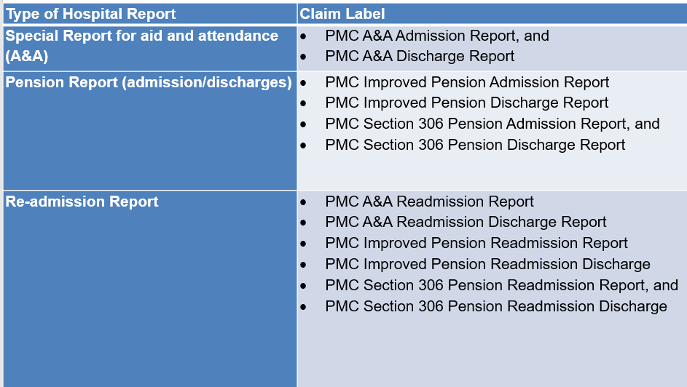

**Quick Reference Adjustment Chart**

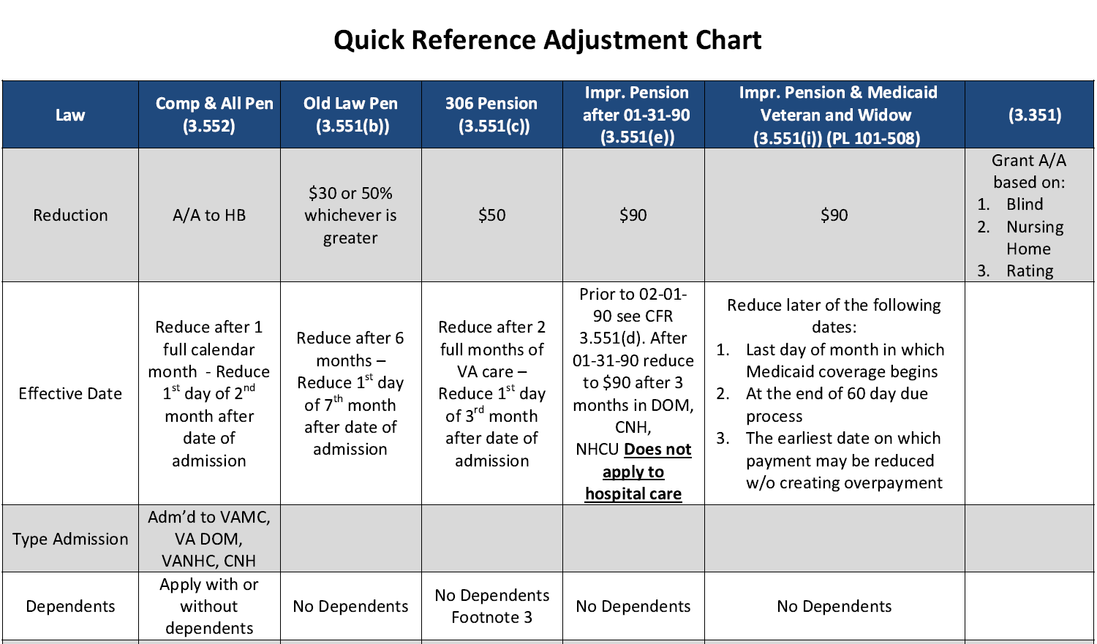

**Hospital Adjustments Effective Dates Chart**

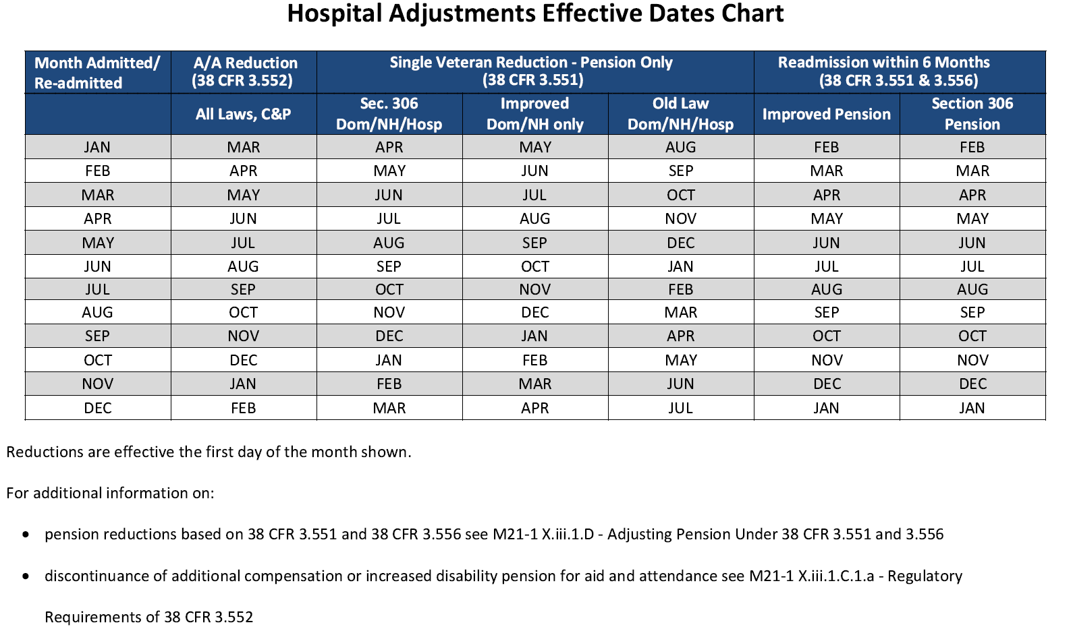

**VBMS-A Steps for Reduction**