Pension and fiduciary service
PMC VSR Intermediate Core Course
Phase 5: Proficiency Development Part 5: Award Adjustments
Phase 5.5 Knowledge Enhancer Prep
Trainee Guide

July 2024

Phase 5.5 Knowledge Enhancer Prep

Lesson Overview
Topic | Description
Time Estimate: | 3 hours
Purpose of the Lesson: | This Knowledge Enhancer Preparation (KE Prep) is part of the Core Pension Training (CPT) curriculum for PMC VSRs. The purpose of the Phase 5.5 KE Prep serves as a supplemental resource that provides additional activities and content to reinforce material covered throughout training, as well as to prepare the VSR to resubmit the Level 2 assessment(s).
Prerequisite Training Requirements: | Prior to taking the Phase 5.5 KE Prep lesson, trainees must complete PMC VSR Core Course Phases 1–5.5.
Target Audience: | This Knowledge Enhancer preparation is for entry-level PMC VSRs.
Lesson References: | - Claim Types job aid  - Old Law and Section 306 Pension Programs job aid  - Processing a Grant of Benefits job aid  - Processing a Denial of Benefits job aid  - Upfront Verification job aid  - Processing Expense Adjustment Claims Checklist  - VAMC Facility Adjustments job aid  - Pension Adjustments for Medicaid-Covered Nursing Care Facility job aid
Lesson Objectives: | By the end of this lesson, the trainee should be able to:  - Identify qualifying expense adjustments  - Determine amended income adjustments  - Compute dependency adjustments  - Assess overpayments and waiver withholdings  - Determine Post Award Audit (PAA) adjustments
What You Need: | - Trainee Guide  - Appendix A Phase 5.5 KE Prep Worksheet  - Access to VBA Intranet  - Pen and paper or access to a whiteboard  - Access to the following systems:  - SHARE  - VBMS

PowerPoint Slides | Notes
Phase 5.5: Knowledge Enhancer Prep
Lesson Objectives
- Identify qualifying expense adjustments
- Determine amended income adjustments
- Compute dependency adjustments
- Assess overpayments and waiver withholdings
- Determine Post Award Audit (PAA) adjustments
Why This Matters!
- Phase 5.5 is comprised of intermediate level courses requirements in determining qualifying expense adjustments, amended income adjustments, dependency adjustments, and compute overpayments and waiver withholdings and PAA adjustments.
  - therefore, the KE Prep is used to reinforce various concepts via practice activities and exercises for continued development.
Knowledge Enhancer Preparation Overview
- This Knowledge Enhancer preparation will consist of the following:
  - Lesson objectives review
  - Group activities/games
  - Question/answer forum
Phase 5.5 Lessons
- Determine Qualifying Expense Adjustments
- Determine Amended Income Adjustments
- Determine Dependency Adjustments
- Introduction to Overpayments and Waiver Withholdings
- Introduction to Post Award Audit (PAA) Adjustment
Determine Qualifying Expense Adjustments Objectives
- Determine qualifying expense adjustments
- Determine whether medical expense qualifies for an award adjustment
- Determine whether final expense qualifies for an award adjustment
- Determine whether educational expense qualifies for an award adjustment

Qualifying Expense Adjustments
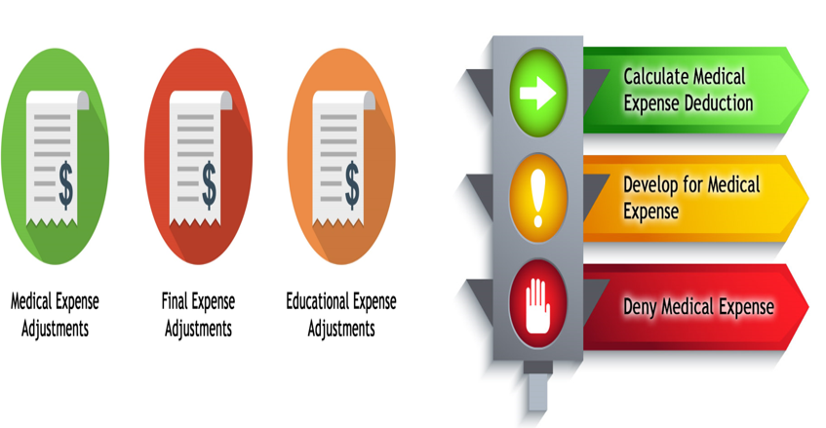
Practice Exercise -Qualifying Expenses
- Instructions:
  - Work in groups of two.
  - Review the chart in Part 1 of Appendix A: Phase 5.5 Worksheet to determine the stage of the application.
  - Complete Part 1 – Qualifying Expenses exercise
  - Be prepared to share your responses and rationale with the class.
- Time allowed: 15 minutes
Practice Exercise: Qualifying Expenses Q&A

Determine Amended Income Objectives
- Determine award adjustment based on amended income
- Determine whether income type is countable
- Determine whether to develop for amended income information
- Determine whether amended income information is received within the time limit
- Determine whether amended income qualifies for an award adjustment
Definitions: Amended Income
- The initial year is defined as the period extending from the effective date of the award, or later date of the Veteran’s death, through the end of the month that is 12 months after the month during which pension entitlement arose.
- Reported annual income refers to all countable family income before the 10-percent reduction for retirement income and the spouse’s income exclusion.
- The same calendar year is the year in which the applicable calendar year or initial period ends.
- Nonrecurring income is essentially a one-time receipt of income.
- Recurring income is income that comes to the income recipient on a regular basis, such as weekly or monthly, and is received in regular amounts.
Amended Income: Time Limit
- For an original award or a new award after a period of non-entitlement, the “income year” is the initial year.
  - a claimant can have more than one “initial year; otherwise, the income year is the applicable calendar year
- If pension was paid at a lower rate based on anticipated income, pension may be increased in accordance with the facts found if satisfactory evidence of entitlement is received within the same or next calendar year.

Amended Income Adjustments
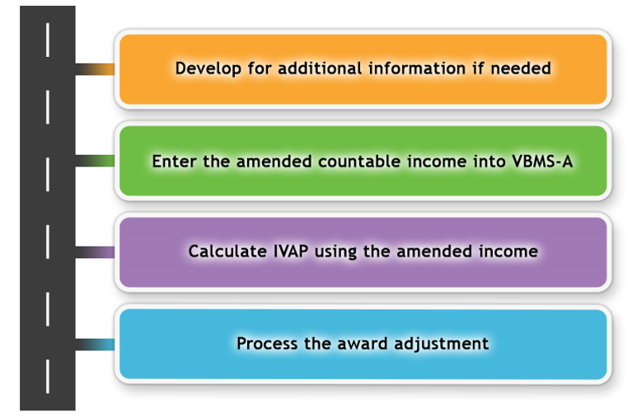
Amended Income: COLA (1 of 2)
- If the Social Security COLA does not reduce the rate of current-law pension, count the increased rate of Social Security from the effective date of the COLA (generally December 1).
- If a Social Security COLA adjustment results in a decrease in the rate of current-law pension, decrease the pension rate effective the first of the month after the effective date of the COLA/MAPR increase if deductible expenses for the calendar year associated with the COLA are projected to increase, then carry forward the previous year’s pension payment rate until February 1
- If records show no Medicare or supplementary medical insurance benefit (SMIB), multiply the monthly Social Security amount in the record by the COLA factor.
Amended Income: COLA (2 of 2)
- If records show a standard SMIB deduction,
  - multiply the pre-COLA rate by the COLA factor and round the product to the next lower dime
  - subtract from this amount the new post-COLA Social Security standard SMIB deduction and round the result to the next lower dollar, and
  - add back the SMIB deduction
- If a beneficiary receives additional income because of a COLA in a benefit program other than Social Security, the general rule for counting recurring income applies.
  - Count the additional income from the first of the month after the month during which it is received.
Amended Income: Computation (1 of 2)
- A claimant has until the end of the calendar year that follows a calendar year or the end of an initial period to furnish new income information and get a retroactive increase
  - Until the time limit has expired, the pension or parents’ DIC payment amount (“rate”) is always provisional
- The adjustment of a provisional rate does not constitute an increased rate, unless the change in income results in an increased rate compared to the month immediately preceding the date that the income change is effective
- If a change in income does cause an increased rate (compared to the month immediately preceding the date that the income change is effective), 38 CFR 3.31 applies
  - Carry forward the preceding month’s rate for the stub month
Amended Income: Computation (2 of 2)
- If a pension beneficiary receives non-recurring income, the income is counted on the award for 12 months
  - the effect on pension payments depends on whether the non-recurring income causes discontinuance or only reduction of the running award
- If an award must be reduced, resume the pre-adjustment rate exactly 12 months from the date of the reduction.
- If an award must be discontinued, benefits cannot be resumed for 13 months.
Class Activity: Amended Income
- Income that comes to the income recipient on a regular basis, such as weekly or monthly, and is received in regular amounts is known as what type of income?
- Recurring income that has not been counted on the VA award for at least 12 months is known as what type of income?
- All countable family income before the 10-percent reduction for retirement income and the spouse’s income exclusion is known as what type of income?
- (Yes, or No?). Should you count burial benefits as income?
- (True or False?). If a claimant’s benefits, such as Social Security, are subject to involuntary withholding due to legal action initiated by a third party, count the entire amount even though the claimant does not receive it all.
- (Countable or Not Countable?). Pension benefits paid as an accrued amount.
Practice Exercise: Amended Income
- Instructions:
  - Work in groups of 4.
  - Review the sentences in Part 2 of Appendix A: Phase 5.5 Worksheet to determine the stage of the application.
  - Complete Part 2 – Amended Income exercise
  - Be prepared to share your responses and rationale with the class.
Time allowed: 30 minutes
Practice Exercise: Amended Income Q&A

Determine Dependency Adjustments Objectives
- Determine award adjustment based on change in dependency
- Determine changes in dependency
- Determine actions to take based on dependency changes
- Determine the award adjustment based on change in dependency
Reasons for Removing a Dependent
- Death of spouse, child, or dependent parent
- Marriage of child
- Child adopted out of the family
- Divorce or annulment from spouse
- Separation (estrangement) from spouse with no financial contributions
- Child turns 18 and is not in school
- Child ages 18-23 terminates school attendance
- Child over 18 and in school turns 23 years old prior to school attendance termination
- Child born
Class Activity: Remove the Dependent
- (True or False?). If addition or removal of dependent results in an increase of benefits, the claim must be submitted on the prescribed form.
- (Yes, or No?). Whether the claimant submits a request for removal of a dependent on the prescribed form or not, should you develop for income/net worth?
  - Why or Why not?
- (Yes, or No?). If the separation from the spouse is due to medical reasons, can an adjustment be made?
Introduction to Overpayment and Waiver Withholdings Objectives
- Recognize whether a waiver withholding is required
- Recognize whether an overpayment was created
- Recognize a retroactive award increase
- Recognize whether a waiver has been granted
- Recognize whether a retroactive award increase occurs during the debt creation period
Debt Creation
- Debt creation period is the period between the date the claimant received an increase in income and the date the claim was processed
- To avoid processing a duplicate payment of benefits, the PMC VSR must withhold the amount previously waived before any retroactive benefit can be paid​
Reducing Debt and Granting Waivers
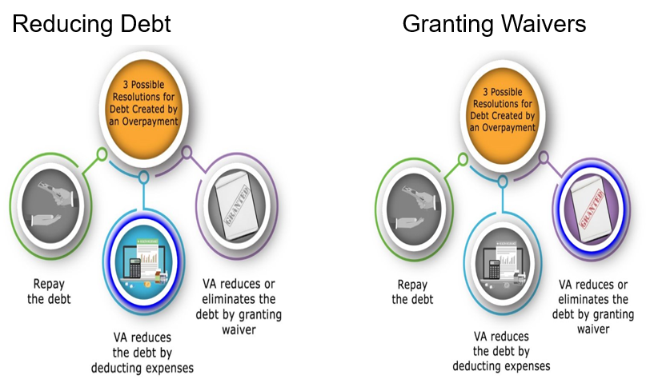
Class Activity: Overpayment and Waivers
- There is no bar to full concurrent payment of SBP and the basic DIC rate when a surviving spouse is entitled to DIC by virtue of having remarried after attaining a qualifying age, per which USC?
- Explain the term “before offset”.
- If SBP was paid to a surviving spouse entitled to DIC, the Department of Veterans Affairs (VA) offsets any overpayment of SBP from the DIC award in an amount (greater or not greater) than the basic DIC payable.
- You (should or should not) complete SBP offsets to DIC payments after the retroactive payment has already been paid.
Introduction to Post Award Audit (PAA) Adjustments Objectives
- Define a post award audit
- Understand the filtering and selection process
- Determine actions to take on the post award audit
- Determine the appropriate end product
- Understand the notification process

Introduction to PAA
- The post award audit (PAA) is an income match with the Internal Revenue Service (IRS) and the Social Security Administration (SSA) that allows the Department of Veterans Affairs (VA) to ensure a beneficiary continues to be entitled to VA benefits.
  - The match is conducted only after a grant of benefits and only if there is a current award, and unlike upfront verification, without the initiation of a claim from a Veteran or survivor
- Federal tax information (FTI) is any return or return information received from the IRS or secondary source, such as SSA.
- Need to know is defined as an individual who requires access to FTI to perform their official duties.
PAA: Filtering (1 of 2)
Prior to releasing PAAs to the PMCs, Hines ITC will exclude the matches in which the
- beneficiary is deceased
- medical expenses of record exceed the higher of either the
- total income of record in the corporate record, or
- total countable FTI
- benefit was discontinued for the full calendar year matched
- total income of record for the year matched in the corporate record is greater than the total countable FTI
PAA: Filtering (2 of 2)
- total income in the corporate record for the matched year is $0 and the total countable FTI is $0
- total countable FTI exceeds the income in the corporate record, for the same year, by $100 or less, or
- following three statements are true
  - value listed in the NET WORTH field in the corporate record is $0
  - the total income reported on IRS Form 1099-INT, Statement for Recipients of Interest Income, is less than or equal to $100, and
  - the medical expenses of record exceed the greater of income in the corporate record or total countable FTI
Exception: Hines ITC will not exclude those cases identified for a substantial net worth discrepancy in which medical expenses exceed the greater income.
Practice Exercise: PAA
- Instructions:
  - Work in groups of 4.
  - Review the sentences in Part 3 of Appendix A: Phase 5.5 Worksheet to identify the stage of each action.
  - Complete Part 3 – PAA exercise
  - Be prepared to share your responses and rationale with the class.
- Time allowed: 20 minutes
Practical Exercise: PAA Q&A

What’s Next
- Assigned Knowledge Check in the Assessment Portal as determined by the Training Manager (TM) and/or Instructor.
- Complete the Phase 5.5 Knowledge Enhancer Prep Survey

