Pension and fiduciary service
PMC VSR Intermediate Core Course
Phase 5.4: Prepare the Decision Notice
Phase 5.4 Knowledge Enhancer Prep
Trainee Guide

July 2024

Phase 5.4 Knowledge Enhancer Prep

Lesson Overview
Topic | Description
Time Estimate: | 3 hours
Purpose of the Lesson: | This Knowledge Enhancer Preparation (KE Prep) is part of the Core Pension Training (CPT) curriculum for PMC VSRs. The purpose of the Phase 5.4 KE Prep serves as a supplemental resource that provides additional activities and content to reinforce material covered throughout training, as well as to prepare the VSR to resubmit the Level 2 assessment(s).
Prerequisite Training Requirements: | Prior to taking the Phase 5.4 KE Prep lesson, trainees must complete PMC VSR Core Course Phases 1–5.4.
Target Audience: | This Knowledge Enhancer preparation is for entry-level PMC VSRs.
Lesson References: | - Claim Types job aid  - Old Law and Section 306 Pension Programs job aid  - Notification Language job aid  - Prepare the Decision Notice job aid  - Due Process job aid
Lesson Objectives: | By the end of this lesson, you should be able to:  - Demonstrate how to prepare decision notices  - Identify notification procedures for an administrative decision  - Recall elements for due process notifications
What You Need: | - Trainee Guide  - Appendix A Phase 5.4 KE Prep Worksheet  - Access to VBA Intranet  - Pen and paper or access to a whiteboard  - Access to the following systems:  - SHARE  - VBMS

PowerPoint Slides | Notes
Phase 5.4: Knowledge Enhancer Prep
Lesson Objectives
- Demonstrate how to prepare decision notices
- Identify notification procedures for an administrative decision
- Recall elements for due process notifications
Why This Matters!
- Phase 5.4 is comprised of intermediate level courses that specify the requirements for drafting decision notices, administrative decisions, and applying due process.
  - Lessons throughout Phase 5.4 provide an overview of steps required when preparing various notifications; therefore, the KC Prep is used to reinforce various concepts via practice activities and exercises for continued development.​
Knowledge Enhancer Preparation Overview
- This Knowledge Enhancer preparation will consist of the following:
  - Lesson objectives review
  - Group activities/games
  - Question/answer forum
Phase 5.4 Lessons
- Prepare the Decision Notice
- Overview of the Administrative Decision
- Apply/Issue Due Process Provisions
Prepare the Decision Notice Objectives
- Identify the need for decision notices
- Demonstrate how to prepare a decision notice
- Understand notification requirements

Prepare the Decision Notice
- When VA grants entitlement to a benefit, or makes an adjustment to a running award, the decision notice must notify the claimant of
  - the monthly rate of payment
  - the effective dates of entitlement and payment information
  - the amount of any benefits VA is withholding
  - the reason for the withholding, and
  - information about any additional benefits to which the claimant may be entitled
Prepare the Decision Notice: Naming Conventions
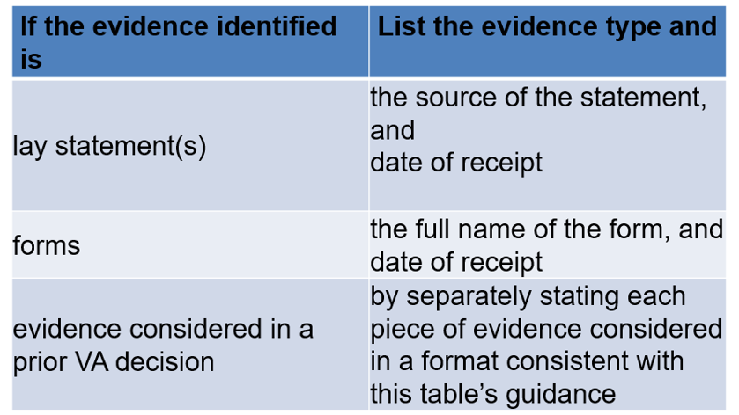
Practice Exercise -Prepare the Decision Notice
- Instructions:
  - Work in groups of two.
  - Review the Sample Form 1 to prepare a decision notice.
  - Use Sample Form 1 to Prepare the Decision Notice based on the information provided on the application.
  - Be prepared to share your responses and rationale with the class.
- Time allowed: 30 minutes
Practice Exercise: Prepare the Decision Notice Q&A

Overview of the Administrative Decision Objectives
- Demonstrate the administrative decision-making process.
- Recognize administrative decisions.
- Recognize evidentiary procedures for an administrative decision.
- Recognize notification procedures for an administrative decision.
When is an Administrative Decision Required (1 of 2)
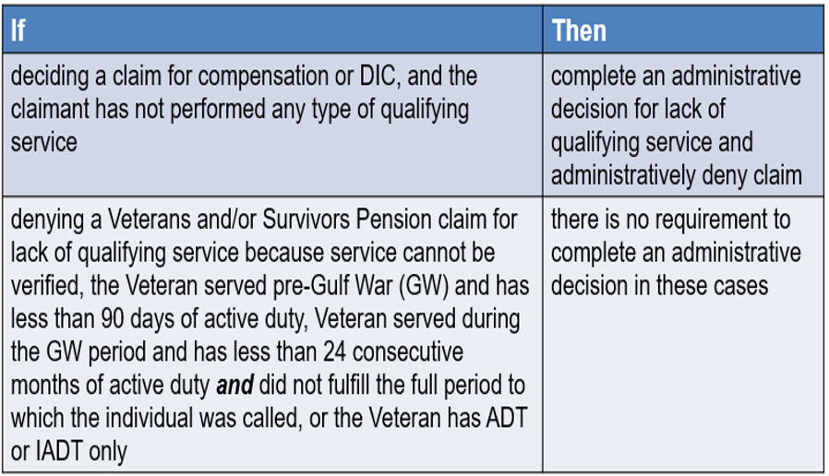
When is an Administrative Decision Required (2 of 2)
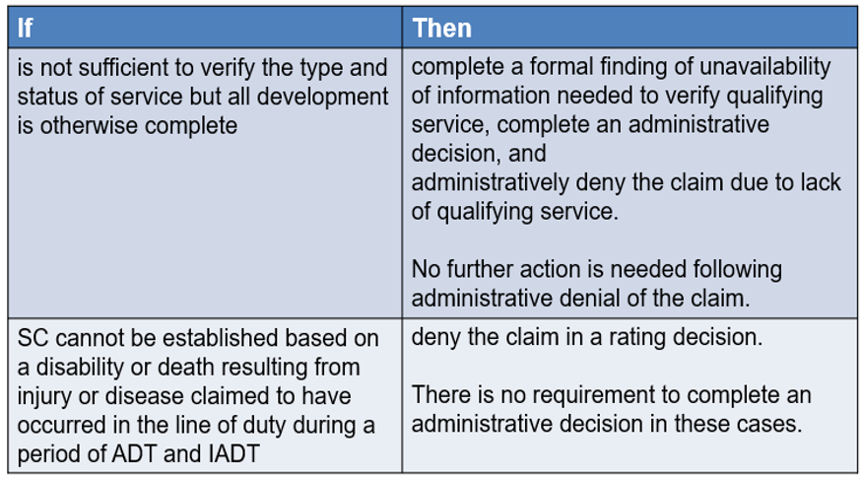
Class Activity: Administrative Decisions
- What is known as a set of guidelines on evaluation of the evidence submitted or obtained in a case?
- Explain the standard of proof.
- If a majority of the evidence is positive, should you decide in the claimant’s favor or resolve reasonable doubt in the claimant’s favor?
- Explain the relative equipoise standard in regard to evidentiary proof.
- What is meant by clear and convincing?
- What are the factors to consider in determining the probative value of evidence
- (Yes, or No?). Do presumptive provisions alleviate part of the claimant’s burden or proof?
Practice Exercise: Administrative Terms
- Instructions:
  - Work in groups of 4.
  - Review the sentences in Part 1 of Appendix A: Phase 5.4 Worksheet.
  - Complete Part 1 – Administrative Terms exercise
  - Be prepared to share your responses and rationale with the class.
Time allowed: 15 minutes
Practice Exercise: Administrative Terms Q&A

Apply/Issue Due Process Objectives
- Apply due process provisions to a claim
- Determine if due process is applicable to a claim
- Determine effective dates for the proposed change in benefits
- Determine if the change in benefits requires contemporaneous notice or due process notification letter
- Identify elements for due process letter or contemporaneous notice
Apply/Issue Due Process
- Due process - informs beneficiary of proposed reduction or termination of benefits
- Contemporaneous notice - informs beneficiary of a change in benefits that was implemented at the time the notice was sent
- Third party information is any information that is not received from the beneficiary or from the beneficiary’s fiduciary.
- The adverse action proposal period is the control period between the date the notice of proposed adverse action is mailed to the beneficiary and the date that the final decision notice is sent
  - minimum period for the proposed adverse action is 60 days
Reasons for Due Process
- Special Monthly Pension (SMP) reduction
- Excess net worth
- Hospital adjustments
- Apportionments
- Incarceration/fugitive felon
- Removal of administrative Aid and Attendance (A&A)
- Incompetency
Class Activity: Due Process
- You receive evidence that the Veteran is deceased. You determine that the evidence reasonably indicates that the beneficiary is deceased, and you must now discontinue benefits. Are you issuing a due process notice, administrative determination, or contemporaneous notice?
  - Do you include VA Form 20-0998, Your Right to Seek Review of Our Decision, and if so why or why not?
- Explain the steps required if information is received by phone that would reduce benefits.
  - What type of notice would you use in this instance.
What’s Next
- Assigned Knowledge Check in the Assessment Portal as determined by the Training Manager (TM) and/or Instructor.
- Complete the Phase 5.4 Knowledge Enhancer Prep Survey

