Pension and fiduciary service

PMC VSR Intermediate Core Course  
Phase 5.3: Promulgation

Phase 5.3 Knowledge Enhancer (KE) Prep

Trainee Guide

July 2024

Phase 5.3 Knowledge Enhancer Prep

Lesson Overview

| Topic | Description |
| --- | --- |
| Time Estimate: | 3 hours |
| Purpose of the Lesson: | This Knowledge Check Preparation (KE Prep) is part of the Core Pension Training (CPT) curriculum for PMC VSRs. The purpose of the Phase 5.3 KE Prep serves as a supplemental resource that provides additional activities and content to reinforce material covered throughout training, as well as to prepare the VSR to resubmit the Level 2 assessment(s). |
| Prerequisite Training Requirements: | Prior to taking the Phase 5.3 KE Prep lesson, trainees must complete PMC VSR Core Course Phases 1–5.3. |
| Target Audience: | This Knowledge Enhancer preparation is for entry-level PMC VSRs. |
| Lesson References: | * **Claim Types** job aid * **Old Law and Section 306 Pension Programs** * **Confirm Accuracy of a Rating Decision** job aid * **Annotate the Award** job aid * **Processing an Award Renouncement** job aid * **Processing a Grant of Benefits** job aid * **Processing a Denial of Benefits** job aid |
| Lesson Objectives: | By the end of this lesson, you should be able to:   * Recall the proper steps in determining the accuracy of a rating decision * Discuss the award process * Identify the steps needed to process a request for renouncement of benefits Old Law and Section 306 Programs * Identify 800 Series Work Items |
| What You Need: | * Trainee Guide * Appendix A Phase 5.3 KE Prep Worksheet * Access to VBA Intranet * Pen and paper or access to a whiteboard * Access to the following systems:   + SHARE   + VBMS |

| PowerPoint Slides | Notes |
| --- | --- |
| **Phase 5.3: Knowledge Enhancer Prep** |  |
| **Lesson Objectives**   * Recall the proper steps in determining the accuracy of a rating decision * Discuss the award process * Identify the steps needed to process a request for renouncement of benefits Old Law and Section 306 Programs * Identify 800 Series Work Items |  |
| **Why This Matters!**   * Phase 5.3 is comprised of intermediate level courses requirements in confirming the accuracy of the rating decision, the award process, and the correct procedures for election claims, processing a request for renouncement of benefits, and 800 Series Work Items.   + therefore, the KE Prep is used to reinforce various concepts via practice activities and exercises for continued development.​ |  |
| **Knowledge Enhancer Preparation Overview**   * This Knowledge Enhancer preparation will consist of the following:   + Lesson objectives review   + Group activities/games   + Question/answer forum |  |
| **Phase 5.3 Lessons**   1. Confirm Accuracy of a Rating Decision 2. Overview of the Award Process 3. Overview of the Election Claims 4. Introduction to Processing a Request for Renouncement of Benefits 5. Introduction to 800 Series Work Items |  |
| **Confirm Accuracy of a Rating Decision Objectives**   * Confirm accuracy of a rating decision * Confirm effective date is correct * Confirm information in rating decision is technically accurate * Confirm special benefits were addressed * Complete request for corrected rating |  |
| **Confirm the Accuracy of a Rating Decision**  When reviewing a rating decision for accuracy:   * Confirm information in rating decision is technically accurate.   + Review the rating decision for spelling/grammar errors.   + Ensure the decision is consistent with rationale provided in rating decision.   + Ensure all issues are addressed.   + If there is a POA, ensure the POA is indicated on the first page of the rating decision.   + If death was service-connected or DIC under 38 USC 1318 was granted, ensure entitlement to Chapter 35/DEA was considered.   + Verify no claim or appeal was pending at time of Veteran’s death. |  |
| **Practice Exercise – Confirm the Rating**   * **Instructions**:   + Work in groups of two.   + Review the chart in **Part 1 of Appendix A: Phase 5.3 Worksheet**.   + Complete **Part 1 – Confirm the Rating** exercise   + Be prepared to share your responses and rationale with the class. * **Time allowed: 10 minutes** |  |
| **Practice Exercise: Confirm the Rating Q&A** |  |
| **Overview of the Award Process Objectives**   * Describe how to prepare an award action * Describe the responsibilities on award action for all decisions * Describe the common steps for processing a grant of benefits * Describe the common steps for processing a denial of benefits * Describe the common steps for processing an award adjustment * Describe the common steps for processing a renouncement |  |
| **Processing an Award** |  |
| **Processing an Award: Granting and Denying Benefits** |  |
| **Class Activity: Award Process**   1. Name 7 steps for processing a grant for benefits. 2. Which step in the award process would you prepare the decision notice? 3. When granting benefits, which step requires generating an award in VBMS-A and a noteof relevant information regarding the claim after generating the award? 4. When denying benefits, which step(s) require VSRs to decide the award action needed, and to select the denial decision in VBMS-A? 5. You are preparing an award adjustment in which step would you review any additional information provided by the claimant or third party and to decide the reason for adjustment? |  |
| **Overview of Election Claim Objectives**   * Define types of elections * Determine change in eligibility based on an election * Determine whether the elected benefit is advantageous to the claimant |  |
| **Understanding Elections**   * Elections are divided into the following two categories:   + initial elections, and reelections * An election may be final and irrevocable, *or* the claimant may elect and reelect as often as desired depending on what the pertinent legislation authorizes. * An election must be in writing and must specify the benefit the person wishes to receive. |  |
| **Class Activity: Claim Elect**   1. What type of election is the subsequent change from one benefit to another and must be in writing and specify the benefit the claimant wishes to receive? 2. (True or False?). A person entitled to receive pension or compensation under more than one rule administered by the VA may elect to receive whichever benefit, regardless of whether it is the greater or lesser benefit, even though the election reduces the benefits payable to his or her dependents and may at any time elect or reelect the other benefit. 3. If a Veteran is entitled to Veterans Pension and is also entitled to receive Survivors Pension based on another person’s service, what action(s) should you take? |  |
| Introduction to Processing a Request for Renouncement of Benefits Objectives   * Identify a request for renouncement of benefits * Recognize if renouncement evidence is clear and unambiguous * Determine if there is evidence of another issue |  |
| Introduction to Processing a Request for Renouncement of Benefits   * Beneficiaries desiring to renounce their right to a benefit usually fall into one of the following categories:   + Beneficiaries who want to qualify for a low-income program such as Medicaid or government housing   + Beneficiaries who became entitled to income (SSA), failed to report it in a timely manner, and request renouncement to avoid overpayment   + DIC beneficiaries who have remarried and failed to report it in a timely manner   + DIC children who qualify for DEA, failed to report it in a timely manner, and request renouncement to avoid overpayment |  |
| Practice Exercise: Renouncement   * Instructions:   + Work in groups of 4.   + Review the sentences in Part 2 of Appendix A: Phase 5.3 Worksheet.   + Complete Part 2 – Renouncement exercise   + Be prepared to share your responses and rationale with the class.   Time allowed: 15 minutes |  |
| Practice Exercise: Renouncement Q&A   |  |
| Introduction to 800 Series Work Items Objectives   * Define the 800 series Work Items (WI) * Describe WI categories * Determine which the type of WI received * Identify the reason for the WI * Identify the appropriate steps to take upon receipt of a WI |  |
| Introduction to 800 Series Work Items   * Work Item 810 (810WI), *Notice of Benefit Payment Transaction*, prompts review of payments of benefits such as in the case of returned and undeliverable payments, verification of income or dependency, and review of the necessity for scheduled future exams that could result in a change of payments. * Work Item 820 (820WI),*Explanation of Audit Message*, is a work item that provides an explanatory message related to case audits and prompts review. * Work Item 830 (830WI),*Miscellaneous*, is a work item reserved for miscellaneous applications. * The 840WI may be used for reviews necessitated by prison and return to active-duty matches. |  |
| Class Activity: Keep it 800!   1. Once an 800 series work item has been reviewed, and it is determined that no action is required, what action(s) should you take? 2. Once an 800 series work item has been reviewed, and it is determined that additional action is required, what action(s) should you take? 3. When action is required, would you use the date of the 800 series work item as the date of claim for the controlling EP or the date of review? 4. When viewing a WI in SHARE, which function should you use? |  |
| What’s Next   * Assigned Knowledge Check in the Assessment Portal as determined by the Training Manager (TM) and/or Instructor. * Complete the Phase 5.3 Knowledge Enhancer Prep Survey |  |

Appendix

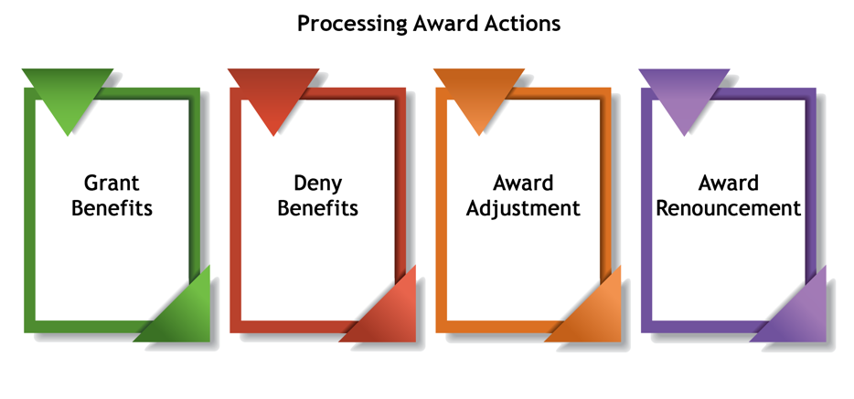

**Processing an Award: Granting and Denying Benefits**

