Pension and fiduciary service

PMC VSR Intermediate Core Course  
Phase 5.1(b): Basic Eligibility

Phase 5.1(b) Knowledge Check Prep

Trainee Guide

July 2024

Phase 5.1(b) Knowledge Check Prep

Lesson Overview

| Topic | Description |
| --- | --- |
| Time Estimate: | 2.5 hours |
| Purpose of the Lesson: | This Knowledge Check Preparation (KC Prep) is part of the Core Pension Training (CPT) curriculum for PMC VSRs. The purpose of the Phase 5.1(b) KC Prep serves as a supplemental resource that provides additional activities and content to reinforce material covered throughout training, as well as to prepare the VSR to resubmit the Level 2 assessment(s). |
| Prerequisite Training Requirements: | Prior to taking the Phase 5.1(b) KC Prep lesson, trainees must complete PMC VSR Core Pension Training course Phases 1–5.1(b). |
| Target Audience: | This Knowledge Check preparation is for entry-level PMC VSRs. |
| Lesson References: | * **Claim Types** job aid * **Dependency Eligibility Requirements** job aid * **Dependency Eligibility: Spouse** job aid * **Parents’ DIC Eligibility Requirements** job aid * **SSA Inquiry** job aid |
| Lesson Objectives: | By the end of this lesson, the trainee should be able to:   * Recall the proper steps in determining dependency eligibility for a spouse, child, or parent * Outline the steps for establishing Parental Relationship for DIC * Identify the correct presumptive criteria for Permanent and Total (P&T) Disability |
| What You Need: | * Trainee Guide * Appendix A Phase 5.1(b) KC Prep Worksheet * Access to VBA Intranet * Pen and paper * Access to the following systems:   + SHARE   + VBMS |

| PowerPoint Slides | Notes |
| --- | --- |
| **Phase 5.1(b): Knowledge Check Prep** |  |
| **Lesson Objectives**   * Recall the proper steps in determining dependency eligibility for a spouse, child, or parent * Outline the steps for establishing Parental Relationship for DIC * Identify the correct presumptive criteria for Permanent and Total (P&T) Disability |  |
| **Why This Matters!**   * Phase 5.1(b) is comprised of intermediate level courses requirements for establishing dependents and reviewing P&T disability claims.   + Lessons throughout Phase 5.1(b) provide an overview of steps required when determining dependency eligibility, as well as P&T disability; therefore, the KC Prep is used to reinforce various concepts via practice activities and exercises for continued development.​ |  |
| **Knowledge Check Preparation Overview**   * This Knowledge Check preparation will consist of the following:   + Lesson objectives review   + Group activities/games   + Question/answer forum |  |
| **Phase 5.1(b) Lessons**   * Determine Dependency Eligibility: Spouse * Determine Dependency Eligibility: Child * Establish Parental Relationship for DIC * Presumptive Criteria for Permanent and Total (P&T) Disability |  |
| **Determine Dependency Eligibility: Spouse Objectives**   * Understand what dependency is for VA purposes and why it is important * Understand the general information on establishing marital relationships * Know how to establish marital relationships in live veteran cases * Know how to establish marital relationships in death cases |  |
| **Prescribed Forms**   * VA Form 21P-527EZ, Application for Pension * VA Form 21P-534EZ, Application for DIC, Survivors Pension, and/or Accrued Benefits * VA Form 21-686c, Application Request to Add And/or Remove Dependents * VA Form 21-4170, Statement of Marital Relationship * VA Form 21P-4171, Supporting Statement Regarding Marriage |  |
| **Valid Marriage** |  |
| **Deemed Valid Marriage** |  |
| **Practice Exercise – Kinfolk**   * **Instructions**:   + Work in groups of four.   + Review the content in **Part 1 of Appendix A: Phase 5.1.b Worksheet** to provide a response.   + Complete **Part 1 – Kinfolk** exercise   + Be prepared to share your responses and rationale with the class. * **Time allowed: 10 minutes** |  |
| **Practice Exercise: Kinfolk Q&A** |  |
| **Determine Dependency Eligibility: Child Objectives**   * Determine dependency eligibility for a child of a Veteran. * Define child for VA purposes. * Determine DIC dependency eligibility requirements for a child of a Veteran. * Determine dependency eligibility requirements for a helpless child of a Veteran. * Determine pension (Veteran and Survivors) dependency eligibility requirements for a child of a Veteran. * Determine what to develop for a child of a Veteran. |  |
| **Surviving Child Rights**   * A surviving child is entitled to Survivors Pension in their own right only if   + the surviving child is not in the custody of the surviving spouse (as the term custody is defined in [38 CFR 3.57(d)](https://www.ecfr.gov/current/title-38/chapter-I/part-3/subpart-A/subject-group-ECFR2f2f66751230c72/section-3.57), or   + there is no surviving spouse who is eligible for pension, for example, the surviving spouse is deceased or remarried |  |
| **Surviving Child Rights (2 of 2)**   * To find the MAPR for a surviving child claiming Survivors Pension, first determine whether the child is in the legal custody of some person. * For purposes of pension, a child is in the legal custody of the person who   + is legally responsible for the child’s support, and   + has the right to exercise parental control over the child   + Physical custody of the child is not determinative |  |
| **Class Activity: The Benefit of a Child**   1. Name the form a child can use to apply for benefits when “in-service death only” is applicable. 2. Under what circumstances can a surviving child become entitled to Survivors Pension in their own right? 3. If a surviving child does not have a personal custodian, nor in the custody of an institution, how would you determine the child’s rate of pension? 4. Millie, the surviving child of Tom, was declared an out-of-custody child to whom VA apportioned DIC under 38 CFR 3.461(a) died on February 11th, 2023,    * is Angel, the surviving spouse entitled to an adjustment to her benefits, **and**    * does the end-of-the-month rule apply? |  |
| **Individual Exercise: Somebody’s Child**   * **Instructions:**    + Work individually to complete the task.   + Review the content in **Part 2 of Appendix A: 5.1.b Worksheet** to provide a response.   + Complete **Part 2 – Somebody’s Child** exercise   + Be prepared to share your responses and rationale with the class.   **Time allowed: 15 minutes** |  |
| Debrief: Somebody’s Child Q&A   |  |
| Establish Parental Relationship for DIC Objectives   * Establishing the parental relationship to a Veteran is critical when determining eligibility for benefits * A parent of a Veteran is, for pension purposes, eligible for DIC benefits |  |
| Forms for Parents   * [VA Form 21P-535 - Application for Dependency and Indemnity Compensation by Parent(s)](https://vbaw.vba.va.gov/bl/20/cio/20s5/forms/VBA-21P-535-ARE.pdf) * [VA Form 21P-524 – Statement of Person Claiming to Have Stood in Relation of Parent](https://vbaw.vba.va.gov/bl/20/cio/20s5/forms/VBA-21P-524-ARE.pdf) |  |
| Defining Parents   * Abandonment and entitlement benefits- a biological or adoptive parent who refused to assume the legal and moral obligations of a parent is not entitled to VA benefits. Evidence shows both a refusal and failure to provide support. * Relinquishment of control- when the parent fails to provide support for the Veteran. * Case development for alleged abandonment by a parent- fully develop the facts surrounding the allegation. |  |
| Contested Parental Status   * A contested claim exists when:   + A favorable decision on one claim requires:     - the denial of a claim from a separate claimant, or     - payment of a lesser benefit to a separate claimant.   + One claimant may contest     - the other claimant’s entitlement to that benefit, or     - payment of that benefit to the other claimant. * A contested claim automatically arises if two people:   + allege to be a deceased Veteran’s legal surviving   + Spouse, Mother, or Father file a formal claim for the same benefit |  |
| Group Exercise: Choosing Parents   * Instructions:   + Work in groups of four.   + Review the content in Part 3 of Appendix A: Phase 5.1.b Worksheet to provide a response.   + Complete Part 3 – Choosing Parents exercise   + Be prepared to share your responses and rationale with the class.   Time allowed: 15 minutes |  |
| Group Exercise: Choosing Parents   |  |
| Practice Exercise: Building Relationships   * Instructions:   + Work individually or in groups of two.   + Review the sentences in Part 4 of Appendix A: Phase 5.1.b Worksheet to determine the stage of the application.   + Complete Part 3 – Building Relationships exercise   + Be prepared to share your responses and rationale with the class. * Time allowed: 15 minutes |  |
| Practice Exercise: Building Relationships Q&A   |  |
| Presumptive Criteria for Permanent and Total (P&T) Disability Objectives   * Define Permanent and Total (P&T) Disability * Determine if the Veteran meets the presumptive criteria to satisfy the requirements for Permanent and Total (P&T) disability * Determine when evidence is required to satisfy Permanent and Total (P&T) disability |  |
| What are the Presumptive Criteria for P&T Disability? |  |
| Group Activity: P&T – Presumptive Met or Unmet   * Instructions:   + Work in groups of 4.   + Review the sentences in Part 5 of Appendix A: Phase 5.1.b Worksheet to determine the stage of the application.   + Complete Part 5 – P&T – Presumptive Met or Not exercise   + Be prepared to share your responses and rationale with the class. * Time allowed: 10 minutes |  |
| Group Activity: P&T- Presumptive Met or Unmet Q&A   |  |
| Questions? |  |
| What’s Next   * Assigned Knowledge Check in the Assessment Portal as determined by the Training Manager (TM) and/or Instructor. * Complete the Phase 5.1(b) Knowledge Check Prep Survey |  |

Appendix

**Valid Marriage**

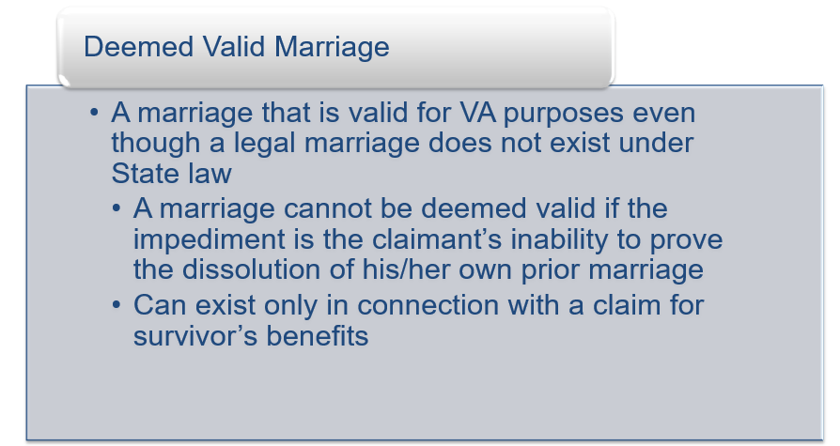

**Deemed Valid Marriage**



**Presumptive Criteria**

