Pension and fiduciary service

PMC VSR Basic Core Course  
Phase 4: Foundational Enrichment

Phase 4 Knowledge Enhancer Prep

Trainee Guide

December 2024

Phase 4 Knowledge Enhancer Prep

Lesson Overview

| Topic | Description |
| --- | --- |
| Time Estimate: | 2.5 hours |
| Purpose of the Lesson: | This Knowledge Enhancer Preparation (KE Prep) is part of the Core Pension Training (CPT) curriculum for PMC VSRs. The Phase 4 KE Prep course serves as a supplemental resource that provides additional activities and content to reinforce material covered throughout Phase 4, as well as to prepare the VSR to resubmit the Level 2 assessment(s) if/when needed. |
| Prerequisite Training Requirements: | Prior to taking the Phase 4 KE Prep lesson, trainees must complete PMC VSR Core Course Phases 1–4. |
| Target Audience: | This Knowledge Enhancer preparation is for entry-level PMC VSRs. |
| Lesson References: | * **Claim Types** job aid * **Common VA Terms** job aid * **Common VA References** job aid |
| Lesson Objectives: | * Recall the proper steps in determining the correct date of claim and end product were applied * Practice establishing Veteran status, establishing a claim, and initial screening for applications * Memorize stages of a pension claim, types of pension claims and claims recognition |
| What You Need: | * Trainee Guide * Appendix A Phase 4 KE Prep Worksheet * Access to VBA Intranet * Pen and paper * Access to the following systems:   + SHARE   + VBMS |

| PowerPoint Slides | Notes |
| --- | --- |
| **Phase 4: Knowledge Enhancer Prep** |  |
| **Lesson Objectives**   * Recall the proper steps in determining the correct date of claim and end product were applied * Practice establishing Veteran status, establishing a claim, and initial screening for applications * Memorize stages of a pension claim, types of pension claims and claims recognition |  |
| **Why This Matters!**   * Phase 4 familiarizes PMC VSRs with basic core requirements in processing claims such as determining the date of claim (DOC), establishing Veteran status, establishing a claim, and various types and stages of claims.   + Due to the intricacy, complexity, and abundance of information required to perform the PMC VSR tasks, knowledge of how to correctly stages of a claim, the proper end product (EP) codes, and claims recognition is crucial; therefore, the KE Prep is used to reinforce various concepts via practice activities and exercises for continued development. |  |
| **Knowledge Enhancer Preparation Overview**   * This Knowledge Enhancer preparation will consist of the following:   + Lesson objectives review   + Group activities/games   + Question/answer forum |  |
| **Phase 4 Lessons**   * Phase 4 Lessons   1. Initial Screening Policies for Applications   2. Stages of a Pension Claim   3. Types of Pension Claims and Claims Recognition   4. Pension Claims eFolder/Records Management   5. Date of Claim (DOC)   6. End Product (EP) Codes   7. Establish Veteran Status   8. Establish a Claim |  |
| **Initial Screening Policies for Applications Objectives**   * Identify the characteristics of a substantially complete application * Define the signature requirements for claimants * Explain concept of prescribed forms * Recognize outdated and discontinued forms and explain the process alerting claimants * Define what classifies as an incomplete claim * Explain the historic concept of informal claims * Recognize the requirements for an Intent to File * Recognize the requirements for a Request For Application (RFA) |  |
| **Initial Screening Policies for Applications**  **Initial Screening Policies for Applications** matters because initial mail screening prompts a review of all incoming applications, correspondence, and evidence to determine if a claim,   * warrants priority processing because of its nature or facts * is submitted with evidence that requires review by the rating activity * is incomplete and requires further development, or * warrants denial |  |
| **Identifying if an Application is Substantially Complete**  Upon receipt of an application for benefits, VA must determine if it is substantially complete. This includes:   * The claimant’s name * His/her relationship to the Veteran * Sufficient service information * The benefit sought * The claimant’s signature * A statement of income for applicable claims * Identification or inclusion of new evidence in supplemental clams * For Higher Level Reviews, identification of the date of decision |  |
| **Prescribed Forms**   * VA will only recognize claims if they are submitted on the required standard forms. * Example of prescribed forms:   + Veterans Pension (initial) – VA Form 21P-527EZ   + Survivors Pension (initial) – VA Form 21P-534EZ   + Burial benefits (initial) – VA Form 21P-530EZ   + Income Adjustments (increase) – EVRs or 21P-8416   + Housebound Status/Aid and Attendance – VA Form 21-2680   + Medicaid Adjustments/SMP – VA Form 21-0779 |  |
| **Intent to File** |  |
| **Practice Exercise – Checking the Box**   * **Instructions:**    + Work in groups of two.   + Review the chart in **Part 1 of Appendix A: Phase 4 Worksheet** to determine the stage of the application.   + Complete Part 1 – **Checking the Box** exercise   + Be prepared to share your responses and rationale with the class.   **Time allowed: 10 minutes** |  |
| **Stages of a Claim Objectives**   * Describe the stages of a pension claim * Describe the purpose for initial screening and determining eligibility * Describe the purpose of claims development and duty to assist * Describe the purpose of referring a claim to the rating activity * Describe the purpose of award determination and promulgation * Describe the purpose of claimant notification |  |
| **Stages of a Pension Claim** |  |
| **Group Exercise – Pick the Stage**   * **Instructions:**    + Work in groups of four.   + Review the chart in **Part 2 of Appendix A: Phase 4 Worksheet** to determine the **Stage of the Claim**.   + **Complete Part 2 – Pick the Stage** exercise   + Be prepared to share your responses and rationale with the class.   **Time allowed: 10 minutes** |  |
| Types of Pension Claims and Claims Recognition Objectives   * Recognize the most common types of PMC claims * Recognize the characteristics of each claim type * Identify the correct forms or other correspondence of each claim type |  |
| General Benefit Categories |  |
| Other Types of Claims and Claims Recognition   * Contested Claim * Burial Allowance * Elections * Month of Death (MOD) * 800 work item series |  |
| Practice Exercise: Type of Pension Claim   * Instructions:   + Work individually.   + Review the chart in Part 3 of Appendix A: Phase 4 Worksheet to determine the Identify the Type of Pension Claim.   + Complete Part 3 – Type of Pension Claim exercise   + Be prepared to share your finished activity with the class.   Time allowed: 15 minutes |  |
| Pension Claims eFolder/Records Management Objectives   * Locate information in a record * Update records when errors are identified * Address lost claims   NOTE: Records must be tracked and updated to ensure the claimant is receiving the benefits entitled and to ensure that you, the PMC VSR, have the evidence needed to justify claim decisions. |  |
| Class Activity: Working the System   1. (True or False?). The Corporate military record updates with a VBMS update function on the Military Service tab. 2. Which tool currently provides access to Veteran records and acts as a single access point to deployment history? 3. Which system is used to access Pre-conversion Compensation and Pension Master Records? 4. Which system is used to access Social Security Administration (SSA) inquiries? 5. ________ is used to request the Veteran’s service personnel records and service treatment records from the National Personnel Records Center (NPRC) |  |
| Establishing the Date of Claim   * Confirm Date Of Claim (DOC) is correct * Define a DOC * Identify the date of receipt * Recognize exceptions to DOC * Determine if DOC is correct in the systems |  |
| Determine DOC   * Each document submitted to VA *must* receive a stamp with the date of receipt or the scan vendor date. * If the receipt of the document by VA is determined to be the current date, stamp the document with an official date stamp. * If the receipt of the document by VA is determined to be prior to the current date, hand-write the date of receipt on the document. * If the receipt of the document by VA is determined to be unknown, hand-write the best estimate for the date of receipt and identify it as an estimate on the document. |  |
| Practice Exercise: Save the Date   * Instructions:   + Work individually.   + Review the chart in Part 4 of Appendix A: Phase 4 Worksheet to determine the DOC.   + Complete Part 4 – Save the Date exercise   + Be prepared to share your responses and rationale with the class. * Time allowed: 15 minutes |  |
| Establish Veteran Status   * Establish Veteran status * Determine if the Veteran meets length of qualifying service requirements for eligibility * Determine if the Veteran meets wartime service requirements for eligibility * Determine if the Veteran meets Character of Discharge (COD) requirements for eligibility * Determine outcome due to Veteran status |  |
| Veterans Discharge   * Entitlement to VA pension benefits is based on a Veteran's characters of discharge and meeting the wartime service requirement, and minimum active-duty service requirement, where applicable * Wartime service for pension is established if a Veteran served in the active military, naval, space, or air service for   + at least 90 days during a period of war   + at least 90 consecutive days and such period began or ended during a period of war   + a total of 90 or more days during one or more wartime periods, *or* any amount of time during a period of war and was discharged or released for a disability incurred in or aggravated by service, or had an SC disability at the time of discharge that would have justified a discharge for disability |  |
| Survivors Eligibility Based on Veterans Discharge   * A Veteran’s survivors may be eligible for pension if the Veteran met the wartime service requirement for Veterans Pension, or at the time of death, was in receipt of (or entitled to receive) compensation for an SC disability based on service during a period of war. * If the Veteran had less than 90 days of wartime service, basic entitlement to Survivors Pension exists if the Veteran was in receipt of or entitled to receive compensation or retirement pay by reason of wartime disability, even though such a grant of benefits is a clear and unmistakable error, and action to sever SC is pending at the time of death, in the absence of illegality or fraud. |  |
| Practice Exercise: Match the Terms   * Instructions:   + Work in groups of 2.   + Review the chart in Part 5 of Appendix A: Phase 4 Worksheet to match the terms to the correct definition.   + Complete Part 5 – Match the Terms exercise   + Be prepared to share your responses and rationale with the class. * Time allowed: 10 minutes |  |
| Establish a Claim Objectives   * Recognize situations when a PMC VSR should CEST * Select the correct system in which to CEST the claim * Demonstrate the CEST process in VBMS and SHARE |  |
| Common EPs |  |
| Payee Codes |  |
| Practice Exercise: Codes and EPs   * Instructions:   + Work in groups of four.   + Review the chart in Part 6 of Appendix A: Phase 4 Worksheet to determine the codes and EPs   + Complete Part 6 – Codes and EPs exercise   + Be prepared to share your responses and rationale with the class. * Time allowed: 15 minutes |  |
| What’s Next   * Assigned Knowledge Check in the Assessment Portal as determined by the Training Manager (TM) and/or Instructor. * Complete the Phase 4 Knowledge Enhancer Prep Survey | **DISPLAY** slide  “What’s Next?”  **INSTRUCT** trainees to complete the **Phase 4 Knowledge Enhancer Prep** Survey. |

Appendix

**Intent to File**

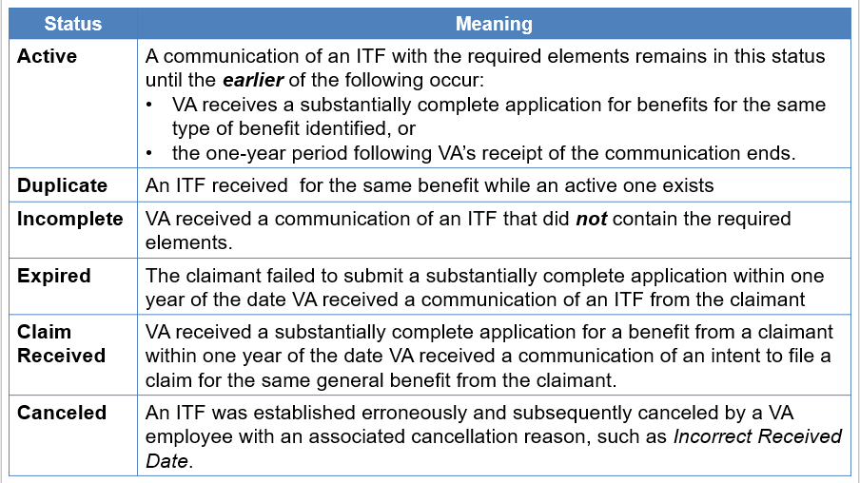

**Stages of a Pension Claim**

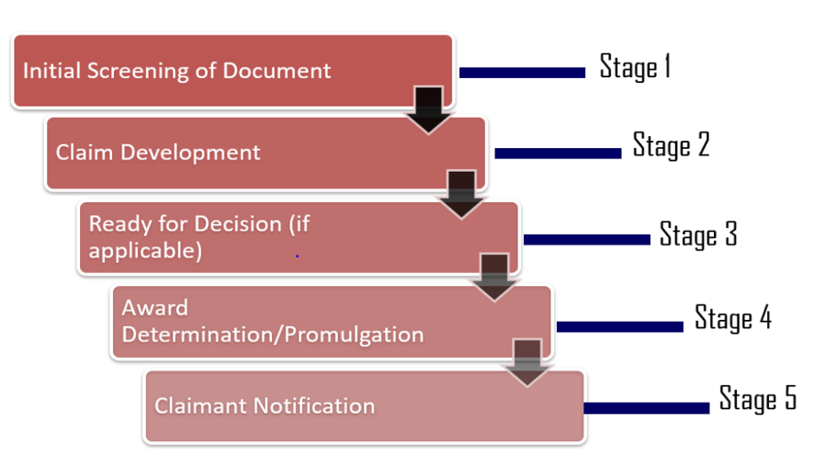

**Common EPs**

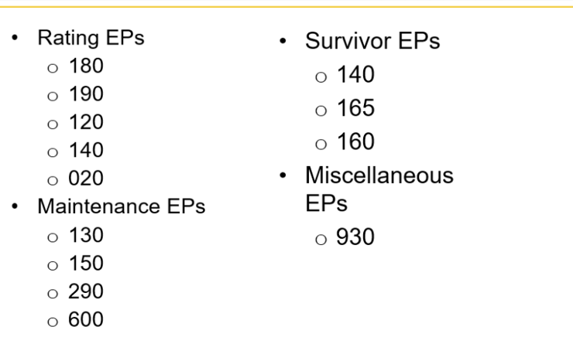

**Payee Codes**

