Pension and Fiduciary Service

PMC VSR Intermediate Core Course

Phase 5: Proficiency Development

Part 1(a): Types of Claims

Introduction to Initial vs Supplemental Claims

Trainee Guide

July 2024

Introduction to Initial vs Supplemental Claims

Lesson Overview

| Topic | Description |
| --- | --- |
| Time Estimate: | 1.5 hours |
| Purpose of the Lesson: | This lesson is part of the entry-level course for PMC VSRs. The purpose of this lesson is to Introduce PMC VSRs to Initial vs Supplemental Claims. |
| Prerequisite Training Requirements: | Prior to taking this course, trainees must complete the entry-level courses in Phases 1–4. |
| Target Audience: | This lesson is for entry-level PMC VSRs. |
| Lesson References: | * M21-1 II.iii.1.A.1.a Requirements for a Complete Claim Received on or After March 24, 2015 * M21-1 II.iii.1.C Screening Applications for Substantial Completeness and Notification Requirements * M21-1 II.iii.2.B.1.a Definition: Supplemental Claim * M21-1 II.iii.2.B.1.e Requirements for Potentially New Evidence * M21-1 X.ii.2.A.1.a Requesting Readjudication of a Previously Decided Claim * M21-1 X.ii.2.A.2.a Duty to Provide Section 5103 Notice * M21-1 X.ii.2.A.2.c Definition: New and Relevant * M21-1 X.ii.2.A.3 Effective Dates for Previously Decided Claims * M21-4 Appendix B End Product Codes and Work-Rate Standards for Quantitative Measurements |
| Technical Competencies: | * VBA Applications (PMC VSR) * Program Benefits and Eligibility (PMC VSR) |
| Knowledge Check | Phase 5.1(a) Introduction to Initial vs Supplemental Claims Knowledge Check |
| What You Need: | * Trainee Guide * Power Point Slides * Access to CPKM * Access to the Assessment Portal |
| Lesson Objectives: | By the end of this lesson, you should be able to:   * Define and identify Initial Claims for pension * Define the Appeals Modernization Act (AMA) * Define the criteria for substantially complete supplemental claims * Define potentially new evidence * Identify supplemental claims for pension |

| PowerPoint Slides | Notes |
| --- | --- |
| **Introduction to Initial vs Supplemental Claims** |  |
| Lesson Objectives  By the end of this lesson, you should be able to:   * Define and identify Initial Claims for pension * Define the Appeals Modernization Act (AMA) * Define the criteria for substantially complete supplemental claims * Define potentially new evidence * Identify supplemental claims for pension |  |
| **Why it Matters!**  The **Introduction to Initial vs Supplemental Claims** course is important because accurately determining whether a claim is considered an initial or a supplemental claim determines effective date protections for continuously pursued claims |  |
| **Definitions: Initial Pension Claim**  **Initial Pension claim:** Any complete claim, other than a supplemental claim, for a benefit on a form prescribed by the Secretary.  **Initial pension claims include**:   * **Original pension claim for benefits (first filing by a claimant).** * EP Codes: 140, 160, 165, 180, 190, or 290 * **Subsequent pension claim based on a new benefit or disability claimed**. * EP Codes: 020, 120, 130, 150, or 160 * **Subsequent pension claim based on a claim for increase due to a change in circumstance.** * EP Codes: 020, 120 or 150 |  |
| **Initial Pension Claim Forms**     |  | | --- | | **VA Form** | | * 21P-534 * 21P-534a * 21P-534ez * 21P-535 | | * 21P-527 * 21P-527ez | | * 21P-530a * 21P-530ez * 21P-8834 | |  |
| Definitions: Supplemental Pension Claim  The Claimant Disagrees with VA’s Decision  Supplemental Pension claim: Any complete claim for a Department of Veterans Affairs (VA) benefit on a prescribed application form where the claimant or his/her authorized representative disagrees with the decision VA made on an initial or supplemental claim for the same or similar benefit on the same or similar basis.  (EP 040) |  |
| **Appeals Modernization Act (AMA)**  The **Appeals Modernization Act (AMA)** was signed into law on August 23, 2017 and took effect on February 19, 2019.   * This law changed VBA’s claims and appeals processes. It also changed decision notice requirements.   *Notes:*   * A supplemental claim can be submitted at any time. * Claimants may file a supplemental claim on a decision issued before February 19, 2019, the date of implementation of the Appeals Modernization Act (AMA) * AMA Supplemental Claims have an open evidentiary record and require VA to assist in the gathering of evidence. |  |
| **Appeals Modernization Act (AMA)**  AMA features three decision review lanes when dissatisfied with VA’s decision on their claim including Supplemental claims:   * Higher Level Review (HLR) * **Supplemental Claim** * Appeal to the Board of Veterans Appeals (BVA) |  |
| Decision Review Request: Supplemental Claim  A Supplemental Claim is a **new review** of an issue(s) previously decided by the Department of Veterans Affairs (VA) based on submission of new and relevant evidence. (EP 040)   * Supplemental claims must be submitted on the prescribed supplemental claim form   (VA Form 20-0995) |  |
| **Criteria for Substantially Complete Supplemental Claims**  **Substantially Complete Supplemental Claims Must:**   * Identify the benefit type for which a new decision is requested |  |
| **Criteria for Substantially Complete Supplemental Claims (continued)**  **Substantially Complete Supplemental Claims Must:**   * Include or identify new and relevant evidence and, * Be properly signed. |  |
| **Relevant Evidence**  **Relevant evidence** is information that tends to prove or disprove a matter at issue in a claim.  Relevant evidence includes evidence that raises a theory of entitlement that was not previously addressed  ***Note****:* If a VA Law is enacted after the claimant was denied, consider the change in law as New and Relevant Evidence |  |
| **Duty to Provide Section 5103 Notice**   * The supplemental claim for the same issue has been received more than a year after the prior notification and **Item 16 on the VA Form 20-0995, Decision Review Request: Supplemental Claim has not been checked** |  |
| **Impact of Guidance Changes**  Changes to laws, regulations, or policy or procedural guidance may impact the assignment of effective dates. The outcome of an effective date determination in such situations is dependent upon the:   * nature of the change, and * the status of the claim |  |
| **Incomplete Supplemental Claims**  **Substantially Complete Supplemental Claims Must:**   * Identify the benefit type for which a new decision is requested, * Include or identify new and relevant evidence and, * Be properly signed.   **Note**: If the supplemental claim is not substantially complete, return it under an EP 400. The claimant will have either 60 days or the remainder of the year from the date of the decision (whichever is later) to substantiate the claim and consider it continuously pursued. |  |
| **Knowledge Check: Lesson Summary Review Questions**    **Time Allowed**: 10 minutes |  |
| What’s Next?  Complete the Initial vs Supplemental Claims course evaluation. |  |

Appendix

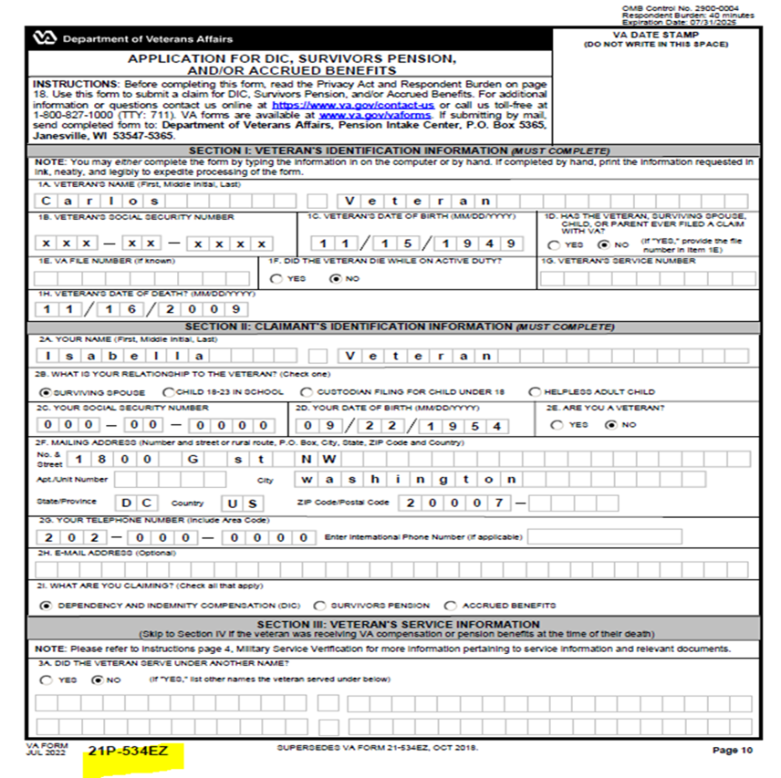

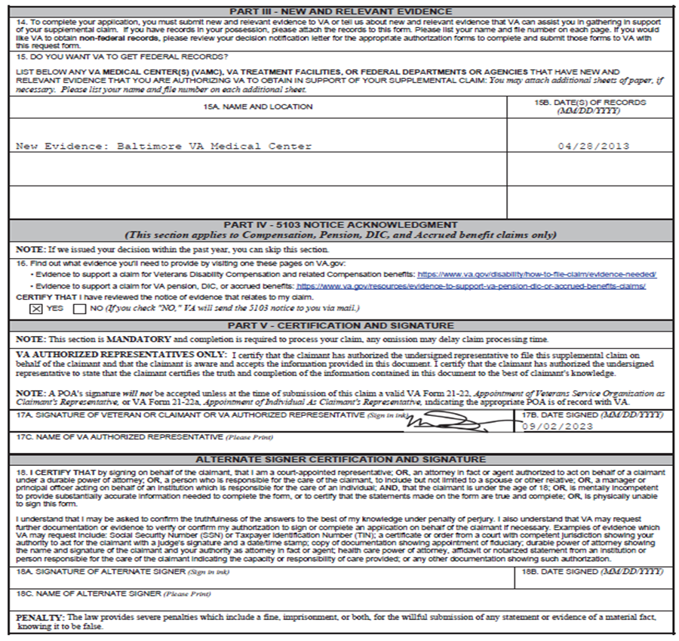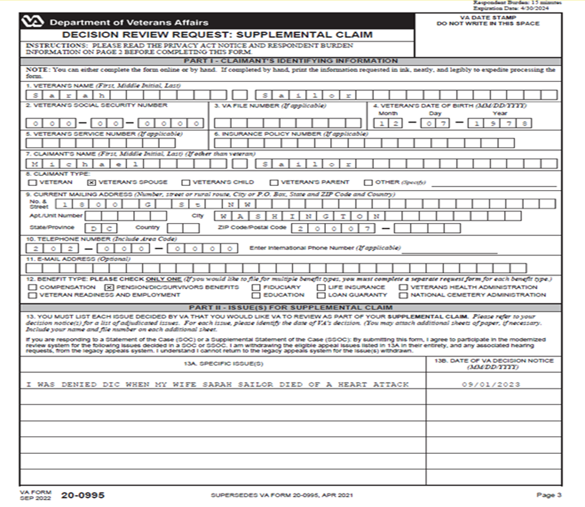

**Duty to Provide Section 5103 Notice**

The supplemental claim for the same issue has been received more than a year after the prior notification and **Item 16 on the VA Form 20-0995, Decision Review Request: Supplemental Claim has not been checked**

