Pension and Fiduciary Service

PMC VSR Intermediate Core Course   
Phase 5: Proficiency Development  
Part 6: Award Adjustments Extension

**Introduction to Special Monthly Pension (SMP), Aid & Attendance (A&A), and Housebound (HB)**

Trainee Guide

July 2024

Introduction to Special Monthly Pension

Lesson Overview

| Topic | Description |
| --- | --- |
| Time Estimate: | 2 hours |
| Purpose of the Lesson: | This lesson is part of the entry-level course for PMC VSRs. The purpose of this lesson is to train PMC VSRs on the Introduction to Special Monthly Pension. |
| Prerequisite Training Requirements: | Prior to taking the **Introduction to Special Monthly Compensation (SMP), Aid & Attendance (A&A), and Housebound (HB)** lesson, trainees must complete the entry-level courses:   * Phases 1-5.5. |
| Target Audience: | This lesson is for entry-level PMC VSRs. |
| Lesson References: | 38 USC 1122 (Rates of Wartime Death Compensation)  38 USC 1311 (Dependency and Indemnity Compensation to a Surviving Spouse)  38 USC 1315 (Dependency and Indemnity Compensation to Parents)  38 USC 1513 (Veterans 65 Years of Age and Older)  38 USC 1521 (Veterans of a Period of War)  38 USC 1541 (Surviving Spouses of Veterans of a Period of War)  38 CFR 17.73 (Medical Foster Homes—General)  38 CFR 3.351 (Special Monthly Dependency and Indemnity Compensation, Death Compensation, Pension and Spouse's Compensation Ratings)  38 CFR 3.352 (Criteria for Determining Need for Aid and Attendance and “Permanently Bedridden”)  38 CFR 3.401 (Veterans)  38 CFR 3.402 (Surviving Spouse)  M21-1 II.iii.1.A.4.e. (Handling an Unsigned Application for Benefits)  M21-1 II.iii.1.A.1.a. (Requirements for a Complete Claim Received on or After March 24, 2015)  M21-1 II.iii.1.A.3.a. (Reviewing VA Form 21-2680 to Identify Claims for SMC or SMP)  M21-1 X.iii.1.C.4.a. (Rationale for Expediting an SMP Entitlement Decision)  M21-1 X.iii.1.C.4.c. (Actions Taken by the RO)  M21-1 IX.ii.1.A.1.d. (A&A Qualification: Surviving Spouses and Parents Entitled to Survivors Pension, DIC, or Death Compensation)  M21-1 IX.ii.1.A.2.a. (Who May Qualify for Housebound Status Under 38 CFR 3.351)  M21-1 IX.ii.1.A.2.c. (Definition: Permanently Housebound)  M21-1 IX.ii.1.B.1.a. (Definition Nursing Home for Purposes of A&A Status)  M21-1 IX.ii.1.B.1.b. (Identification of Qualified Extended-Care Facilities) |
| Technical Competencies: | * VBA Applications (PMC VSR) * Program Benefits and Eligibility (PMC VSR) |
| Lesson Objectives: | By the end of this training, you should be able to   * Define Special Monthly Pension (SMP), Aid and Attendance (A&A), and Housebound Status (HB) * Determine Who May Qualify for A&A and Housebound Status Under 38 CFR 3.351 * Identify the Correct VA Forms for SMP |
| Knowledge Check: | Phase 5.6: Introduction to Special Monthly Compensation (SMP), Aid & Attendance (A&A), and Housebound (HB) Knowledge Check |
| What You Need: | * Trainee Guide * Access to VBA Intranet * Access to the Assessment Portal * Pen and paper * Access to the following systems:   + SHARE   + MAP-D   + VBMS * **Access to Appendix A** – SMP Provisions |

| PowerPoint Slides | Notes |
| --- | --- |
| Introduction to Special Monthly Pension (SMP), Aid & Attendance (A&A), and Housebound (HB) |  |
| Lesson Objectives  By the end of this training, you should be able to   * Define Special Monthly Pension (SMP), Aid and Attendance (A&A), and Housebound Status (HB) * Determine Who May Qualify for A&A and Housebound Status Under 38 CFR 3.351 * Identify the Correct VA Forms for SMP |  |
| Why It Matters!  The Introduction to Special Monthly Pension (SMP), Aid and Attendance (A&A), and Housebound (HB) course matters because A&A or HB ratings may provide a monthly payment which is an added amount to the claimant’s monthly VA Pension for a qualified Veterans and survivors. |  |
| Definition (1 of 4)   * Special Monthly Pension (SMP) is an additional pension benefit paid to the beneficiary due to mental or physical disabilities which affect their ability to perform activities of daily living or limits their ability to leave their home. * Aid and Attendance (A&A)is an allowance that is part of SMP, and it is paid due to an individual’s mental or physical disability, who requires the regular A&A of another person in conducting the basic activities of daily living. * Housebound (HB)is an allowance that is part of SMP, and it is paid due to an individual’s mental or physical disability who is very limited in his/her ability to leave home. * Permanently Houseboundis when it is determined substantially confined to their home (ward or clinical areas, if institutionalized) or immediate premises because of disability or disabilities that are reasonably certain to be permanent. |  |
| **Definitions (2 of 4)**   * **Bedridden** will be that condition which, through its essential character, actually requires that the claimant remain in bed. * The **Medical Foster Home (MFH)** Program is a non-institutional alternative to nursing home care for Veterans that are unable to safely live alone due to chronic or terminal illness. * **Higher Level of Care** is considered to be need for personal health-care services provided on a daily basis in the veteran's home by a person who is licensed to provide such services or who provides such services under the regular supervision of a licensed health-care professional. * A **Licensed Health-care Professional** includes (but is not limited to) a doctor of medicine or osteopathy, a registered nurse, a licensed practical nurse, or a physical therapist licensed to practice by a State or political subdivision. |  |
| Definitions (3 of 4)   * **Under The Regular Supervision of a Licensed Health-care Professional** means that an unlicensed person performing personal health-care services is following a regimen of personal health-care services prescribed by a health-care professional, and that the health-care professional consults with the unlicensed person providing the health-care services at least once each month to monitor the prescribed regimen. * **Personal Health-care Services** include (but are not limited to) such services as physical therapy, administration of injections, placement of indwelling catheters, and the changing of sterile dressings, or like functions which require professional health-care training or the regular supervision of a trained health-care professional to perform. * **Statutory Housebound**, in pension claims, means the single 100-percent disability and the disability that causes the Veteran to be housebound *must* be permanent as required by [**38 U.S.C. 1521(e)**](http://www.law.cornell.edu/uscode/text/38/1521). |  |
| Definitions (4 of 4)   * For purposes of meeting the A&A criteria, [**38 CFR 3.1(z)**](http://www.ecfr.gov/cgi-bin/text-idx?SID=59d25884f72731d062a78d9718ad84a1&mc=true&node=se38.1.3_11&rgn=div8) defines a ***nursing home*** as   + any extended care facility that is licensed by a State to provide skilled or intermediate-level nursing care   + a nursing home care unit in a State Veterans’ home that is approved for payment, or   + a Department of Veterans Affairs (VA) nursing home care unit * The term ***contract nursing home*** refers to a non-VA nursing home under contract with VA to provide nursing home care at VA expense for a specified period of time. |  |
| A&A Legal Provisions |  |
| ****SMP: Required Form (s)**** |  |
| **Eligibility **Under 38 CFR 3.351****   * Individuals qualify for A&A status per 38 CFR 3.351 when: * a Veteran who is receiving pension under [**38 U.S.C. 1521(d)**](http://www.law.cornell.edu/uscode/text/38/1521), or [**38 U.S.C. 1513**](http://www.law.cornell.edu/uscode/text/38/1513), if the Veteran is a patient in a nursing home * a surviving spouse or parent receiving Dependency and Indemnity Compensation (DIC) under [**38 U.S.C. 1311(c)**](http://www.law.cornell.edu/uscode/text/38/1311) or [**38 U.S.C. 1315(g)**](http://www.law.cornell.edu/uscode/text/38/1315), and * a surviving spouse receiving Survivors Pension under [**38 U.S.C. 1541(d)**](http://www.law.cornell.edu/uscode/text/38/1541), or death compensation under [**38 U.S.C. 1122(b)**](http://www.law.cornell.edu/uscode/text/38/1122) |  |
| SMP: Survivors’ Entitlement   * Surviving spouses and parents who are eligible for Survivors Pension, DIC, or death compensation may qualify for A&A under [**38 CFR 3.351**](https://www.ecfr.gov/cgi-bin/text-idx?SID=60c754436c2a5a45a21b285200463bfb&mc=true&node=se38.1.3_1351&rgn=div8). * Survivors Pension benefits include current-law pension, Section 306 Pension, Old-Law Pension, and Spanish-American War Pension * beneficiaries receiving Section 306 Pension or Old-Law Pension cannot receive a higher rate unless they elect Survivors Pension |  |
| ****HB** Eligibility**   * Individuals who may qualify for housebound status under [38 CFR 3.351](https://www.ecfr.gov/cgi-bin/text-idx?SID=4439616ccd66d811a9137071aea2c7ec&mc=true&node=se38.1.3_1351&rgn=div8) are Veterans eligible for pension, and surviving spouses eligible for pension or DIC. * Veterans eligible for pension qualify for HB status if they have a single permanent disability rated 100 percent under a schedular evaluation, and have other disabilities independently ratable at 60 percent or more, or are permanently housebound by reason of their disabilities, per [38 CFR 3.351(d)](https://www.ecfr.gov/cgi-bin/text-idx?SID=4439616ccd66d811a9137071aea2c7ec&mc=true&node=se38.1.3_1351&rgn=div8). |  |
| Eligibility Under 38 CFR 3.352  To qualify for A&A status, an individual must be:   * so helpless as to require the aid of another person to perform the personal functions required in everyday living ([38 CFR 3.352(a)](https://www.ecfr.gov/cgi-bin/text-idx?SID=e6d4f39311a07340901dfa746be047ca&mc=true&node=se38.1.3_1352&rgn=div8)), * blind or so nearly blind as to have corrected visual acuity of 5/200 or less, in both eyes, or concentric contraction of the visual field to 5 degrees or less ([38 CFR 3.351(c)(1)](https://www.ecfr.gov/cgi-bin/text-idx?SID=80e19f45429780bda9167e773d3174e2&mc=true&node=se38.1.3_1351&rgn=div8)), or * a patient in a nursing home (medical foster home) because of physical or mental incapacity ([38 CFR 3.351(c)(2)](https://www.ecfr.gov/cgi-bin/text-idx?SID=80e19f45429780bda9167e773d3174e2&mc=true&node=se38.1.3_1351&rgn=div8))   NOTE: Beneficiaries may not receive increased Old-Law Pension or Section 306 Pension because of needing A&A or being HB.  If an Old-Law Pension or Section 306 Pension beneficiary claims SMP, the case must be reviewed to determine if an election of current-law pension would be to the claimant’s benefit. |  |
| When to Award A&A   * Award A&A based on patient status in a qualified nursing home if   + a responsible official of the facility states that the person is a patient in the facility because of a mental or physical disability, and the claimant submitted an appropriate standard form requesting A&A or   + the person is a patient in a VA Nursing Home Care Unit or in a contract nursing home and the claimant submitted an appropriate standard form requesting A&A |  |
| Practice Exercise: SMP Provisions   * **Instructions**:   + Divide into groups of four.   + Access **Appendix A – SMP Provisions**.   + Use the worksheet to record answers and responses to each question.   + Be prepared to discuss answers and/or provide rationale when requested. * **Time allowed**: 15 minutes |  |
| A&A Effective Date and Status   * Awards of pension, compensation, or DIC to or for a surviving spouse for A&A and HB benefits will be the date of receipt of claim or date entitlement arose whichever is later. * When an award of DIC or pension based on an original or supplemental claim is effective for a period prior to date of receipt of the claim. * Any additional DIC or pension payable to the surviving spouse by reason of need for A&A or HB status must also be awarded for any part of the award's retroactive period for which entitlement to the additional benefit is established. |  |
| A&A Effective Date: Parents   * Awards of additional amounts of DIC based on a parent's need for A&A will be effective the date of receipt of claim or date entitlement arose. * When an award of DIC based on an original or supplemental claim is effective for a period prior to date of receipt of claim, any additional DIC payable by reason of need for A&A may also be awarded for any part of the award's retroactive period for which entitlement to A&A is established. * When the parent is provided hospital, institutional or domiciliary care at VA’s expense, the effective date will be the date of departure. |  |
| Demonstration: Reviewing VA Form 21-0779/Nursing Home Compare     * If verification of a facility’s status is needed, send the facility [*VA Form 21-0779, Request for Nursing Home Information in Connection with Claim for Aid and Attendance*](http://www.vba.va.gov/pubs/forms/VBA-21-0779-ARE.pdf)*,*for certification. This form requires a signature from a nursing home official. * NOTE: Use the Medicare.gov’s [Nursing Home Compare](http://www.medicare.gov/NHCompare/Home.asp?) website to determine whether or not an extended-care facility is licensed by a State to provide skilled or intermediate-level nursing care. |  |
| SMP: Veterans in Need of A&A (38 CFR 3.552)   * There is no statutory or regulatory requirement for a Veteran pensioner to be rated 100-percent disabled to be determined to be in need of regular A&A. * Therefore, if a Veteran pensioner meets the criteria for A&A under [38 CFR 3.352(a)](https://www.ecfr.gov/cgi-bin/text-idx?SID=cf00c9efa9108c676c7529d9a6f3a1c5&mc=true&node=se38.1.3_1352&rgn=div8), the rating activity may grant SMP at the A&A rate even though the Veteran is not rated 100-percent disabled under the rating schedule. |  |
| Reviewing VA Form 21-2680 (1 of 3)   * [*VA Form 21-2680*](http://www.vba.va.gov/pubs/forms/VBA-21-2680-ARE.pdf), can be used as a standalone form if the claimant and/or the supporting documentation identifies whether the benefit sought is SMP (only when there is a running pension award). * The identification of the benefit sought can be specific, with the Veteran identifying on the form whether the claim is for SMP, or based on sympathetic reading of the claim via reviewing the issues raised on *VA Form 21-2680* in the context of the benefits the Veteran is receiving. * When [*VA Form 21-2680*](http://www.vba.va.gov/pubs/forms/VBA-21-2680-ARE.pdf) is submitted, the Veteran is identified as the claimant, and the benefit sought is *not* identified, determine the benefit sought and next action by applying the principles in the next slides, or identified, and is a claim for SMP, apply the principles in the next slide that correspond with the SMP claim *and* the Veteran’s benefit status to determine the appropriate next action to take. |  |
| Reviewing VA Form 21-2680 (2 of 3)   * If the Veteran is receiving pension, or submitting any initial claim for pension, accept the [*VA Form 21-2680*](http://www.vba.va.gov/pubs/forms/VBA-21-2680-ARE.pdf) as a claim for SMP regardless of the conditions listed on the form. * If dual entitlement exists, accept the VA Form 21-2680 as a claim for SMP if in receipt of pension. * In addition to accepting the *VA Form 21-2680* as a claim for SMP based on the benefit currently being received, *also a*ccept the *VA Form 21-2680* as a   + - claim for the opposite benefit (the benefit the Veteran is not currently in receipt of) *only if* the opposite benefit can be granted and the grant results in a greater benefit to the Veteran, or     - request for application if the Veteran is currently receiving compensation *and* the evidence suggests that pension may be the greater benefit but no income information is of record |  |
| Reviewing VA Form 21-2680 (3 of 3)   * If a prior claim for SMP has been denied, and [*VA Form 20-0995*](http://www.vba.va.gov/pubs/forms/VBA-20-0995-ARE.pdf) (Decision Review Request: Supplemental Claim) is submitted with VA Form 21-2680, accept the [*VA Form 21-2680*](http://www.vba.va.gov/pubs/forms/VBA-21-2680-ARE.pdf) as a supplemental claim. * When a prior claim for SMP has been denied but VA Form 21-2680 is not accompanied by VA Form 20-0995, then accept the submission of VA Form 21-2680 as an initial claim for SMP only if there is a running award or pending pension claim * If the Veteran is already in receipt of A&A for pension, accept VA Form 21-2680 as a duplicate request for SMP   + If the claim is accepted as a duplicate request for SMP, provide notice that the claimed benefit has previously been awarded. |  |
| Reviewing VA Form 21-2680: Survivors’ A&A or HB (1 of 2)   * [*VA Form 21-2680*](http://www.vba.va.gov/pubs/forms/VBA-21-2680-ARE.pdf) can be used as a standalone form to claim spousal or survivors’ A&A or housebound benefits when there is an active claim and/or running DIC or Survivors Pension award and the benefit sought is adequately identified. * The identification of the benefit sought can be specific, with the claimant identifying which benefit is being claimed, or based on sympathetic reading of the claim such as   + identifying the dependent as the claimant or the individual being examined on the VA Form 21-2680, and   + considering the information on the form in the context of the VA benefits being paid based on the Veteran’s service |  |
| Reviewing VA Form 21-2680: Survivors’ A&A or HB (2 of 2)  Apply the following when a Veteran’s spouse, surviving spouse, or parent is identified as the claimant or the individual being examined on [*VA Form 21-2680*](http://www.vba.va.gov/pubs/forms/VBA-21-2680-ARE.pdf) |  |
| Demonstration: Reviewing VA Form 21-2680     * Although [*VA Form 21-2680*](http://www.vba.va.gov/pubs/forms/VBA-21-2680-ARE.pdf) may be accepted as a prescribed claim form for SMC or SMP, it is not *required* to grant entitlement to either benefit. * Do not undertake routine development for completion of this form when deciding a claim for SMC or SMP. * When accepting [*VA Form 21-2680*](http://www.vba.va.gov/pubs/forms/VBA-21-2680-ARE.pdf) as a claim for SMP, the form is a potential claim for *both*A&A and HB benefits. * If A&A is denied, the rating decision must address the issue of housebound status.   + If, however, housebound has been previously granted, the issue of entitlement to housebound need not be readdressed and/or continued in the rating decision. |  |
| Expedited Determination of Entitlement to SMP   * In some instances, an expedited determination of entitlement to SMP may be warranted such as,   + Veterans who are patients in VAMCs or maintained by VA in other hospitals who are permanently and totally disabled, and   + may be entitled to SMP by rating decision because they require A&A or are HB due to chronic invalidism or incapacity for self-care   NOTE: These individuals do not require hospital treatment and might leave the VAMCs and return to their homes or enter private nursing homes if they were assured prior to leaving that they would receive the increased pension because VA recognizes they require A&A or are HB. |  |
| A&A and Housebound Medical Expenses   * For *pension*, the following persons may be rated for A&A or HB   + Veterans, and   + surviving spouses * For *pension*, the following persons may not be rated for A&A or HB   + spouses of living Veterans   + children, or   + any other relative who is a member or constructive member of the Veteran’s or surviving spouse’s household   NOTE: For Parents’ DIC, parents may be rated for A&A but not HB |  |
| A&A or HB: IVAP   * A decision regarding the IVAP amount is separate from a decision regarding the effective date from which the A&A or housebound rate is payable. * If a medical expense deduction requires a claimant (or spouse) to be in need of A&A or housebound, then VA may deduct the expense during the initial year or calendar year in which VA determined the claimant (or spouse) to be in need of A&A or housebound. |  |
| Knowledge Check: Lesson Summary Review    Time Allowed: 10 minutes |  |
| What’s Next   * Complete the Introduction to Special Monthly Pension (SMP), Aid & Attendance (A&A), Housebound (HB) course evaluation: TMS ID: 4650014 |  |

Appendix

**A&A Legal Provisions**

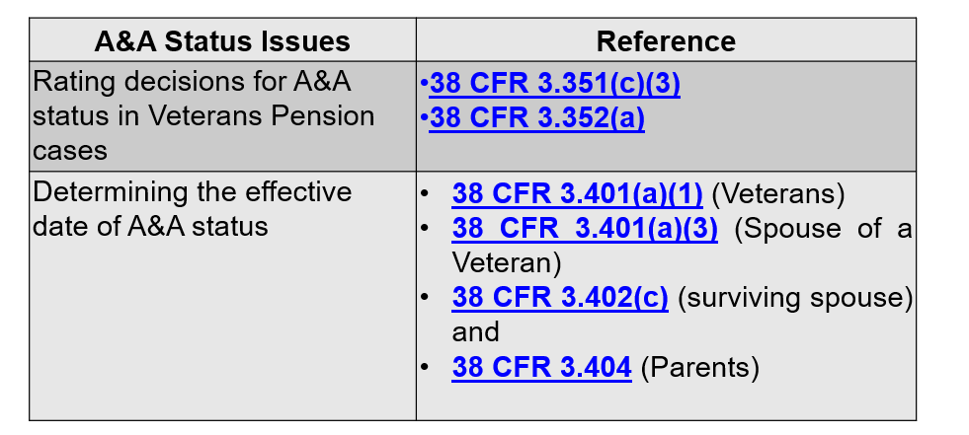

**SMP: Required Form(s)**

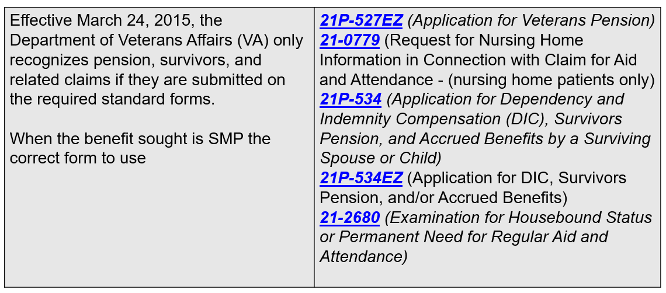

**Reviewing VA Form 21-2680: Survivors’ A&A or HB**

