Pension and Fiduciary Service
PMC VSR Advanced Core Course
Phase 6: Practical Application and Experience

Overview of 38 U.S.C. 1151 DIC Claims
Trainee Guide
July 2024

Overview of 38 U.S.C. 1151 DIC Claims

Lesson Overview
Topic | Description
Time Estimate: | 2.5 hours
Purpose of the Lesson: | This lesson is part of the entry-level course for PMC VSRs. Although positioned within the Advanced Phase, this course remains an entry-level course and its purpose is to introduce PMC VSRs to processing 38 U.S.C. 1151 DIC Claims.
Prerequisite Training Requirements: | Prior to taking the Overview of 38 U.S.C. 1151 DIC Claims lesson, trainees must complete the entry-level courses:  - Phases 1-5.6
Target Audience: | This lesson is for entry-level PMC VSRs.
Lesson References: | - 38 USC 3.361 Benefits Under 38 U.S.C. 1151(a) for Additional Disability or Death Due to Hospital Care, Medical or Surgical Treatment, Examination, Training and Rehabilitation Services, or Compensated Work Therapy Program.  - 38 U.S. Code §3.362 Offsets Under 38 U.S.C. 1151(b) of Benefits Awarded Under 38 U.S.C. 1151(a)  - M21-1 VIII.iv.6.A.1.a. General Information About Claims Filed Under 38 U.S.C. 1151  - M21-1 XII.i.1.A.1.j. DIC Under 38 U.S.C. 1151  - M21-1 XII.i.1.B.2 DIC Under 38 U.S.C 1151  - M21-1 XIII.i.1.A.1.c. (Veteran Eligibility for DEA Purposes)  - M21-1 XII.i.1.A.1.h. (When DEA is a Rating Issue)  - M21-1 XIII.i.1.B.1.c. (Notifying Surviving Spouses in DIC Cases)
Technical Competencies: | - VBA Applications (PMC VSR)  - Program Benefits and Eligibility (PMC VSR)
Lesson Objectives: | By the end of this lesson, you should be able to:  - Identify DIC claims for entitlement under 38 U.S.C 1151  - Identify proper development procedures  - Distinguish which promulgation actions are applicable for 38 U.S.C 1151 claims.  - Distinguish which benefits are applicable for 38 U.S.C 1151 claims and the Prohibition Against Duplication of Benefits  - Prepare the correct notification letter for claims involving entitlement to U.S.C 1151
What You Need: | - Overview of 38 U.S.C. 1151 DIC Trainee Guide  - Slides  - Access to VBA Intranet  - Access to the Assessment Portal  - Pen and paper or access to a whiteboard  - Access to the following job aids:  - Prepare the Decision Notification  - Notification Language

PowerPoint Slides | Notes
Overview of 38 U.S.C. 1151 DIC Claims

Lesson Objectives
By the end of this training, you should be able to
- Identify DIC claims for entitlement under 38 U.S.C 1151
- Identify proper development procedures
- Distinguish which promulgation actions are applicable for 38 U.S.C 1151 claims.
- Distinguish which benefits are applicable for 38 U.S.C 1151 claims and the Prohibition Against Duplication of Benefits
- Prepare the correct notification letter for claims involving entitlement to U.S.C 1151

Why It Matters!
The Overview of 38 U.S.C. 1151 DIC Claims course is important because it outlines entitlement to compensation specific to death in the same manner as if the death were service connected.


Definition of 38 U.S.C. 1151 DIC Claim
- not the result of the Veteran’s willful misconduct, and​
- attributable to​
- Hospital care, medical or surgical treatment, or examination furnished the Veteran under any law administered by the Secretary, either by a VA employee or in a VA facility as defined in 38 U.S.C. 1701(3)(A)​

- Participation in vocational rehabilitation training under 38 U.S.C. Chapter 31, or​

- Participation in compensated work therapy.
Definition of 38 U.S.C. 1151 DIC Claim
Award benefits for death under 38 U.S.C. 1151 in the same manner as if the death were SC.​
- Domiciliary care is not considered VA hospital care, medical or surgical treatment, or an examination for the purpose of establishing entitlement under 38 U.S.C. 1151 ​
- Hospital Care provided at a non-VA facility under VA contract is not considered VA Hospital Care​

​

Identifying 38 U.S.C. 1151 DIC Claims
- Claims for DIC under 38 U.S.C. must be submitted on a VA prescribed form for DIC Benefits​
- The claimant must specifically raise the issue that the Veteran’s death was the fault of VA.
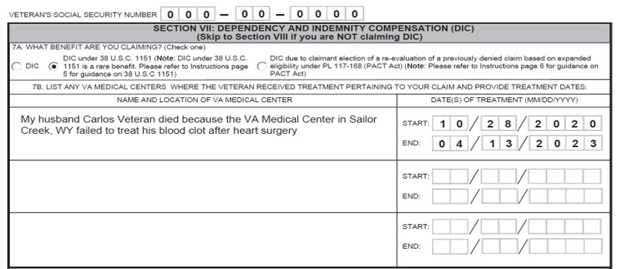
Identifying 38 U.S.C. 1151 DIC Claims
(P&F) Service determines eligibility for cases in which VA Form 10-2633, Report of Special Incident Involving a Beneficiary, indicates that death may have been due to circumstances contemplated by 38 U.S.C. 1151.
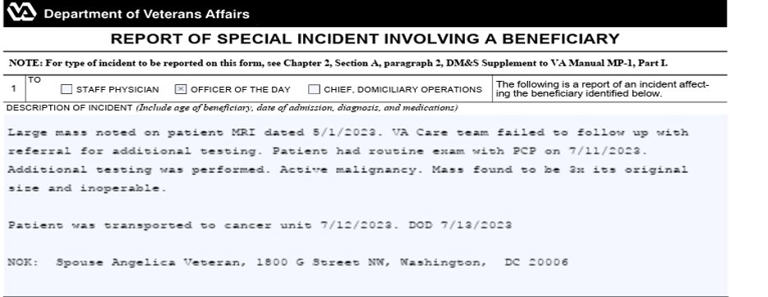
What the Evidence Must Show
To establish that fault on the part of VA in furnishing medical care, treatment or examination was the proximate cause of a Veteran’s death, the evidence must show that:
- the medical care, treatment, or examination caused the death, and​
- VA​
- failed to exercise the degree of care that would have been expected of a reasonable health-care provider, or​
- furnished the care without the Veteran’s or Veteran’s representative’s informed consent.

38 U.S.C. 1151 Claims Development
- Retrieve and upload all clinical reports, progress notes, and hospital summaries associated with the incident in question from Compensation and Pension Records Exchange (CAPRI), and/or Advanced Web Image Viewer (AWIV) Web Application.​
- For all claims under 38 U.S.C. 1151, request comprehensive evidence of the claimed incident using CAPRI’s electronic VA Form 10-7131, Exchange of Beneficiary Information and Request for Administrative and Adjudicative Action​
  - Select the 7131 Request tab in the patient’s CAPRI record and cut and paste the text located in M21-1 VIII.iv.6.A.1.c. into the comments field​

Obtaining Independent Medical Evidence and Medical Opinions
To clarify whether the care, treatment, or examination at issue resulted in death, it may be necessary to obtain
- Medical opinion from a VA medical facility ​
- Independent medical evidence​
- Independent medical opinion under 38 CFR 3.328, but only when warranted by the medical complexity or controversy involved in the case
Action to Take After P&F Service Makes a Determination

If P&F Service…
Establishes entitlement to DIC​ and a claim has been received, take appropriate rating and award action
or​
Establishes entitlement to DIC and a claim has NOT been received, send an application to any dependents who may be entitled to benefits.​
If P&F Service…
Determines that entitlement does not exist​and a claim has been received, take appropriate rating and denial action.​
Promulgation and Authorization of 38 U.S.C. 1151 DIC Awards
When a Veteran dies under circumstances that result in possible entitlement to benefits under 38 U.S.C. 1151, the beneficiary may also seek judgment against the U.S. in a civil action, called a tort claim. ​
The beneficiary may sue and recover damages after:​
- a trial, or​
- agreeing to a settlement or compromise.
Note -Tort Claims are filed in federal court whereas 1151 claims are filed with the VA***
Promulgation and Authorization of 38 U.S.C. 1151 DIC Awards
The prohibition against duplication of benefits applies whenever a claimant receives a sum of money or property to settle a legal claim arising from the injury or death of a Veteran and then files a claim for compensation with the Department of Veterans Affairs (VA) for that same injury or death.
- Defer if a tort claim for damages has been finalized, ​
- Do not defer just because a tort claim has been filed, unless there is reason to believe it has been finalized.

Tort Settlement and Offset Requirement
Prior to award promulgation, determine whether an offset is required.
***An offset is required when a tort settlement is finalized, and:
- An 1151 grant increases the total compensation payable; or, ​
- Compensation is payable solely to 1151

Unavailable Ancillary Benefits due to Qualifying Death Under 38 U.S.C. 1151
- 38 U.S.C. Chapter 35 Dependents Educational Assistance (DEA) benefits

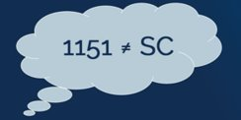
Instructions for the Preparation of DIC Awards Under 38 U.S.C. 1151 With an Offset
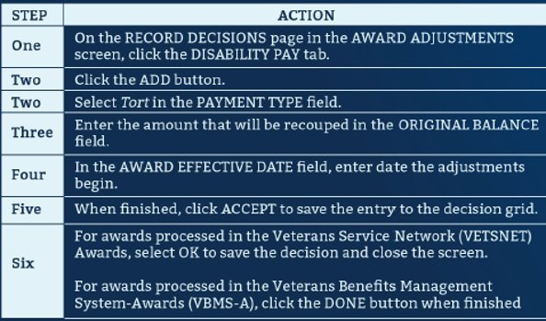
Providing Notice
Prepare a locally-generated letter, referring to the benefit as “compensation under 38 U.S.C. 1151” and not “service connection.”

When using a locally-generated letter to inform a claimant of the formal denial of a claim filed under 38 U.S.C. 1151, include all required notification elements as detailed in M21-1, Part VI, Subpart i, 1.B.1.b.​

​

Important: Do not refer to entitlement under 38 U.S.C. 1151 as “service connection.”

Providing Notice of an Offset Requirement
Use the information below to provide the notice of an offset and the related requirements.
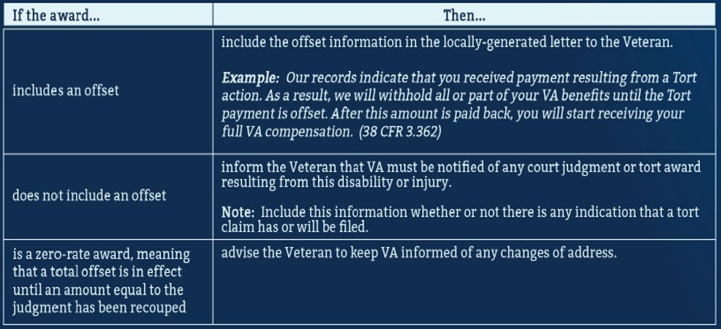

Knowledge Check: Lesson Summary Review
Time Allowed: 10 Minutes

What’s Next?
Complete Overview of 38 U.S.C. 1151 DIC Claims course evaluation: TMS ID # 4649843

