Pension and Fiduciary Service

PMC VSR Intermediate Core Course

Phase 5: Proficiency Development

Part 3: Promulgation

Introduction to 800 Series Work Items

Trainee Guide

May 2024

Introduction to 800 Series Work Items

Lesson Overview

| Topic | Description |
| --- | --- |
| Time Estimate: | 1 hour |
| Purpose of the Lesson: | This lesson is part of the entry-level course for PMC VSRs. Although positioned within the Intermediate Phase, this course remains an entry-level course and its purpose is to introduce PMC VSRs to the 800 Series Work Items. |
| Prerequisite Training Requirements: | Prior to taking the **Introduction to 800 Series Work Items** lesson, trainees must complete the entry-level courses:   * Phases 1-5.2 |
| Target Audience: | This lesson is for entry-level PMC VSRs. |
| Lesson References: | * M21-1 II.i.2.C.2.d. (Placing Claims and 800 Series Work Items Under EP Control) * M21-1 II.i.2.C.6.d. (Procedure for Obtaining a Correct Address for Undeliverable Essential Mail) * M21-1 II.i.2.C.6.k. (Processing 800 Series Work Items Commonly Related to Lack of a Correct Address) * M21-4 Appendix B. Section 3. (800 Series Work Items) * M21-4 Appendix B. Section 4 (Processing 800 Series Work Items) * M21-4 Appendix C, Section 1.b (Index of Claim Labels) |
| Technical Competencies: | Program Benefits and Eligibility (PMC VSR)  VBA Applications (PMC VSR) |
| Knowledge Check | Phase 5.3 Introduction to 800 Series Work Items Knowledge Check |
| Lesson Objectives: | By the end of this course, you the trainee will be able to:   * Define the 800 series Work Items (WI) * Describe WI categories * Determine which the type of WI received * Identify the reason for the WI * Identify the appropriate steps to take upon receipt of a WI |
| What You Need: | * Trainee Guide * Paper and Pencil * Access to VBMS * Access to SHARE * **Access to the** VSR Assistant to access job aids the following job aid   + **Processing an Award Adjustment** job aid   + **Prepare the Decision Notification job aid**   + **Language Notification job aid**   + **Due Process job aid** |

| PowerPoint Slides | Notes |
| --- | --- |
| Introduction to 800 Series Work Items |  |
| Lesson Objectives  By the end of this course, you will be able to:   * Define the 800 series Work Items (WI) * Describe WI categories * Determine which the type of WI received * Identify the reason for the WI * Identify the appropriate steps to take upon receipt of a WI |  |
| Why It Matters!  The **Introduction to the 800 Series Work Items** course is important because PMCs must consistently prioritize work items that potentially result in an underpayment, overpayment, or potential financial hardship. |  |
| Definitions   * An ***800 series work item*** is a system-generated message designed to PMCs with identifying and tracking cases that require follow-up action.   + Each 800 series work item has a descriptive claim label indicating the nature of the review required. * ***Work item*** refers to tasks that must be completed. |  |
| Types of 800 Series Work Items   * Work Item 810 (810WI), *Notice of Benefit Payment Transaction*, prompts review of payments of benefits such as in the case of returned and undeliverable payments, verification of income or dependency, and review of the necessity for scheduled future exams that could result in a change of payments. * Work Item 820 (820WI),*Explanation of Audit Message*, is a work item that provides an explanatory message related to case audits and prompts review. * Work Item 830 (830WI),*Miscellaneous*, is a work item reserved for miscellaneous applications. * The 840WI may be used for reviews necessitated by prison and return to active duty matches. |  |
| Viewing 800 Series WI  To view individual 800 series work items, take the following steps: |  |
| 800 Series (WI) – Claims Labels  Some claim labels and corresponding codes are as follows (not an exhaustive list): |  |
| 800 Series WI: Actions to Take   * Once an 800 series work item has been reviewed, and it is determined that no action is required,   + *cancel* the 800 series work item using the reason *Message Received, No Action Necessary* * Once an 800 series work item has been reviewed, and it is determined that additional action is required,   + *clear* the 800 series work item using the reason *Message Received, Worked Under Proper EP*, and   + take the required action under the proper EP |  |
| Handling 800 Series Work Items: End Production and Determining the Effective Date   * 800 series work items are to prompt review for potential action and to assist in tracking. * **Do not** complete any development, rating, or award actions under an 800 series work item.   + When necessary, certain actions can be taken in connection with review of an 800 series work item without a separate end product (EP) * When action is required, use the date of the 800 series work item as the date of claim for the controlling EP.   Do*not* use the date of review as the date of claim for the controlling EP |  |

| PowerPoint Slides | Notes |
| --- | --- |
| **Examples of When an EP is NOT Required**  In some cases, the required action does not require creation of an EP   * processing an FNOD using the FNOD command in Share * reviewing a claims folder to confirm the accuracy of the results of a records-matching program, and * sending a questionnaire or letter due to failure of automatic issuance by the Hines Information Technology Center |  |
| 800 Series WI: Dependency Verification Letter Not Sent  When the Hines ITC *cannot* issue [***VA Form 21P-0537 (Marital Status Questionnaire),***](https://vbaw.vba.va.gov/bl/20/cio/20s5/forms/VBA-21P-0537-ARE.pdf) an 800 series work item (labeled *Dependency Verification Letter Not Sent*) is generated.  When the work item appears in a regional office’s (RO’s) inventory, the RO must   * send the appropriate form to the beneficiary with a cover letter that includes the content described in [**M21-1, Part VII, Subpart i, 1.B.1.b**](https://vaww.vrm.km.va.gov/system/templates/selfservice/va_kanew/help/agent/locale/en-US/portal/554400000001034/content/554400000176614/M21-1-Part-VII-Subpart-i-Chapter-1-Section-B-Verification-of-Marital-Status-and-the-Status-of-Dependents?query=800%20series) * establish a diary under diary code 30, *Local Regional Office Special Use*, that expires the month after a 60-day period that begins the *later* of the following dates:   + the date the work item was issued to the RO, or   + the date the RO sent the request for completion of the form to the beneficiary, and * clear the pending 800 series WI |  |
| Establishing the 800 Series Work Item – Incarceration   * Each month, a VA computer system compares Social Security numbers (SSNs) in VA pension files against SSNs in SSA’s and BOP’s inmate database. * When a match arises, the system generates one of the following worksheets, depending on the database from which the match arose:   + *VA and Federal BOP Computer Match*, or *VA and SSA State Prisoner Computer Match*   + uploads a copy of the worksheet into the appropriate electronic claims folder (eFolder), and   + establishes an 800 series work item |  |
| What’s Next?  Complete **Introduction to 800 Series Work Item** course evaluation: **TMS ID #: 4649125** |  |

# Appendix

**To view individual 800 series work items, take the following steps:**

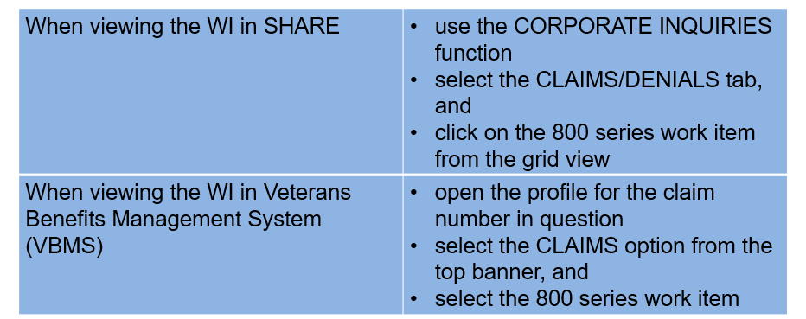

**Some claim labels and corresponding codes are as follows (not an exhaustive list):**

