Pension and fiduciary service

PMC VSR Advanced Core Course

Phase 6: Introduction to PACT Act-Related Claims

Trainee Guide

June 2024

Introduction to PACT Act-Related Claims

Lesson Overview

| Topic | Description |
| --- | --- |
| Time Estimate: | 3 hours |
| Purpose of the Lesson: | This lesson is part of the entry-level curriculum, Core Course for PMC VSRs. The purpose of this lesson is to provide PMC VSRs with an introduction to PACT Act-Related Claims. |
| Prerequisite Training Requirements: | Prior to taking the Introduction to PACT Act-Related Claims lesson, trainees must complete PMC VSR Core Course Phases 1–5.6. |
| Target Audience: | This lesson is for entry-level PMC VSRs. |
| Lesson References: | * [PL 117-168](https://www.congress.gov/117/plaws/publ168/PLAW-117publ168.pdf) (Honoring our PACT Act of 2022) * 38 USC 1117 (Compensation for Disabilities Occurring in Persian Gulf War Veterans) * 38 USC 1119 (Presumptions of Toxic Exposure) * 38 USC 1120 (Presumption of Service Connection for Certain Diseases Associated with Exposures to Burn Pits and Other Toxins) * 38 USC 5103 (Notice to Claimants of Required Information and Evidence) * 38 USC 5110 (Effective Dates of Awards) * 38 USC 1305 (Reevaluation of DIC Determinations Pursuant to Changes in Presumptions of Service Connection) * 38 CFR 3.114 (Change of Law or DVA Issue) * 38 CFR 3.309 (Disease Subject to Presumptive Service Connection) * 38 CFR 3.320 (Claims Based on Exposure to Fine Particulate Matter) * 38 CFR 3.400 (General) * M21-1, Part XII.i.3.A.2.a-b. (DIC Initial Authorization Issues) * M21-4, Appendix B (End Product (EP) Codes) * M21-4, Appendix C (Index of Claim Labels) * M21-4, Appendix E (Index of Corporate Flashes and Special Issues) * Introduction to PACT Act-Related Claims job aid * [Prepare the Decision Notification](https://epss.vba.va.gov/vsr_assistant/pmc_vsr/pdfs/ja_decnot.pdf#zoom=100) job aid * [Notification Language](https://epss.vba.va.gov/vsr_assistant/pmc_vsr/pdfs/ja_notification.pdf#zoom=100) job aid * [P&F Service PACT Act Subpage](https://vbaw.vba.va.gov/pensionandfiduciary/pact-act.asp) |
| Technical Competencies: | * Processing Claims (PMC VSR) * VBA Applications (PMC VSR) |
| Knowledge Check | Phase 6: Introduction to PACT Act Related Claims Knowledge Check |
| Lesson Objectives: | By the end of this lesson, you should be able to:   * Define key terms relevant to the PACT Act * Determine claimants’ eligibility under the PACT Act * Determine the correct EP and labels for PACT Act-Related Claims * Identify added locations per the PACT Act * Identify covered periods of service per the PACT Act |
| What You Need: | * Trainee Guide * Access to CPKM * Appendix A worksheet – Practice Exercise: Does the Veteran Qualify? * Access to the following job aids from VSR Assistant:   + **Prepare the Decision Notice** job aid   + **Notification Language** job aid   + **Introduction to PACT Act-Related Claims** job aid   + **P&F Service PACT Act Subpage** |

Trainee Guide

| PowerPoint Slides | Notes | |
| --- | --- | --- |
| Introduction to PACT Act-Related Claims |  | |
| Lesson Objectives   * By the end of this lesson, you will be able to: * Define key terms relevant to the PACT Act * Determine claimants’ eligibility under the PACT Act * Determine the correct EP and labels for PACT Act-Related Claims * Identify added locations per the PACT Act * Identify covered periods of service per the PACT Act |  | |
| Why It Matters!   * On August 10, 2022, P.L. 117-168, the Sergeant First Class Heath Robinson Honoring our Promise to Address Comprehensive Toxics Act of 2022, or the Honoring our PACT Act of 2022, was passed into law. * Under the PACT Act:   + claims processors to address any requests for reevaluations of a previously processed claim for DIC   + notification letters must solicit a properly elected reevaluation when the claims processor determines the beneficiary may be entitled to an earlier effective date   + a reevaluation must be specifically requested by a claimant |  | |
| Definitions (1 of 3)   * What does **PACT** stand for?   + Promise to Address Comprehensive Toxics   + [PACT Act](https://news.va.gov/?s=PACT%20Act) signed into law Aug. 10, 2022 * What is **toxic exposure**?   + The term “toxic exposure” refers to a subset of Military Environmental Exposures.   + Whether an exposure is “toxic” is determined by 4 factors: substance, concentration of exposure, route of exposure (inhalation, ingestion, etc.), and duration of exposure * A **covered Veteran** is any Veteran who served during the applicable timeframe in one of the locations as listed in the statute. * An **atoll** is defined as a ring-shaped coral reef, island, or series of islets. |  |
| Definitions (2 of 3)   * **Chemicals**: Herbicides (Agent Orange) used during Vietnam era, burn pits, sulfur fire in Iraq, Camp Lejeune water supplies, pesticides used during Gulf War, depleted uranium, industrial solvents * **Air Pollutants**: Burn pits, oil well fire during Gulf War, sulfur fire in Iraq, Atsugi (Japan) waste incinerator, sand, dust, and very small, fine particles or liquid droplets * **Occupational Hazards**: Asbestos, industrial solvents, lead, radiation, vibration, noise, fuels, polychlorinated biphenyl (PCBs), and special paint used on military vehicles * **Radiation**: Nuclear weapons and testing, x-rays, depleted uranium * **Warfare Agents**: Chemical weapons, Project 112/Project Shipboard Hazard and Defense (SHAD), herbicide tests and storage, and chemical experiments |  |
| Definitions (3 of 3)   * Individual Longitudinal Exposure Record (ILER): a joint Department of Defense (DoD) and VA web-based application that provides the ability to link a Veteran to military exposures and/or deployments to improve the efficiency, effectiveness, and quality of care. * Toxic Exposure Risk Activity (TERA): any activity that requires a corresponding entry in an exposure tracking record system, such as ILER, or qualifies when considering what is reasonably prudent to protect the health of Veterans. * Monoclonal Gammopathy of Undetermined Significance (MGUS): is an asymptomatic, pre-malignant disorder characterized by monoclonal plasma cell proliferation in the bone marrow and absence of end-organ damage. |  |
| Who Qualifies? (1 of 3)  Vietnam-era Veterans   * Republic of Vietnam between Jan. 9, 1962, and May 7, 1975 * Thailand at any U.S. or Royal Thai base between Jan. 9, 1962, and June 30, 1976 * Laos between Dec. 1, 1965, and Sept. 30, 1969 * Certain provinces in Cambodia between April 16, 1969, and April 30, 1969 * Guam or American Samoa (or their territorial waters) between Jan. 9, 1962, and July 31, 1980 * Johnston Atoll (or a ship that called there) between Jan. 1, 1972, and Sept. 30, 1977 |  |
| Who Qualifies? (2 of 3)   * Beginning Oct. 1, 2022, Gulf War-era Veterans who served on active duty in a theater of combat operations after the Persian Gulf War may be eligible to enroll in VA health care.   + Includes Veterans who, in connection with service during this period received:     - Armed Forces Expeditionary Medal     - Service Specific Expeditionary Medal     - Combat Era Specific Expeditionary Medal     - Campaign Specific Expeditionary Medal     - Any other combat theater award established by Federal statute or Executive Order |  |
| Who Qualifies? (3 of 3)  Post 9/11 Veterans   * Post-9/11 Veterans discharged before Oct. 1, 2013, can enroll in VA health care during a special 1-year enrollment period between Oct. 1, 2022, and Oct. 1, 2023.   + Veterans must have served on active duty in a theater of combat operations during a period of war after the Persian Gulf War, or   + They served in combat against a hostile force during a period of hostilities after Nov. 11, 1998 |  |
| Identifying SC Death PACT Act Claims (1 of 2)  Guidance applies to claims for service-connected death benefits for survivors if:   * the Veteran’s service falls into one of the newly recognized presumptive locations and there is evidence to indicate the Veteran’s death was caused by or is secondary to one of the existing or newly recognized presumptive conditions associated with the toxic exposure in that location * there is evidence indicating that the principal or contributory cause of the Veteran’s death is, or is secondary to one of the newly recognized presumptive conditions and the Veteran’s service meets the current or newly recognized presumptive locations associated with the presumptive condition(s) |  |
| Identifying SC Death PACT Act Claims (2 of 2)  Guidance applies to claims for service-connected death benefits for survivors if:   * there is a specific allegation of eligibility by the claimant under the PACT Act, or * the claim otherwise raises a question as to whether the PACT Act may affect eligibility |  |
| **Presumptive Herbicide Exposure**   * For Persian Gulf Veterans the PACT Act added additional locations associated with undiagnosed illness and medically unexplained chronic multi-symptoms illness (MUCMI).   + Afghanistan, Israel, Egypt, Turkey, Syria, and Jordan |  |
| **PACT Act Undiagnosed Illnesses and MUCMIs** |  |
| **Burn Pits and Other Toxins (BPOT): (1 of 3)**  38 CFR 3.320: presumptive SC for various toxic substances, chemicals, and airborne hazards, to include particulate matter and burn pit exposure. |  |
| **Burn Pits and Other Toxins (BPOT): (2 of 3)**  38 CFR 3.320: presumptive SC for various toxic substances, chemicals, and airborne hazards, to include particulate matter and burn pit exposure. |  |
| **Burn Pits and Other Toxins (BPOT): (3 of 3)**  38 CFR 3.320: presumptive SC for various toxic substances, chemicals, and airborne hazards, to include particulate matter and burn pit exposure. |  |
| PACT Act-EP Control (1 of 3) |  |
| PACT Act-EP Control (2 of 3) |  |
| PACT Act-EP Control (3 of 3) |  |
| PACT Act – Processing New DIC Claims   * Special issues must be applied upon claims establishment or when the claim is first determined to be a PACT Act-related claim * Initiate any necessary development for entitlement issues, to include gathering STRs. * Continue processing the claim under existing DIC processing guidance unless other requirements apply * At the authorization stage, if a deferral is necessary, defer all PACT Act-impacted contentions using the appropriate deferral reason |  |
| PACT Act-Previously Denied Claims (1 of 3) |  |
| PACT Act-Previously Denied Claims (2 of 3) |  |
| PACT Act-Previously Denied Claims (3 of 3) |  |
| Practice Exercise: Does the Veteran Qualify?”   * Instructions:   + Divide into pairs or groups of 3.   + Complete Appendix A: Does the Veteran Qualify?   + Given the scenario, determine if the Veteran would qualify and provide a rationale.   + Be prepared to share your finished activity with other groups. * Time allowed: 25 minutes |  |
| Handling PACT Act Related Burial Claims  Burial -   * Where the claimant is not currently in receipt of DIC, or a claim for DIC has not been previously filed, for SC death to be granted for burial claims based on expanded presumptive eligibility criteria under the PACT Act, the Veteran’s death must have occurred on or after August 10, 2022. |  |
| PACT Act- Accrued/Substitution (1 of 2)  Accrued and Requests for Substitution -   * When a claim is received for accrued benefits or a request for substitution based on expanded presumptive eligibility under the PACT Act, claims processors should: * confirm a PACT Act-related claim has been received and that the prescribed application submitted * establish claims as described within the content titled, Manual Claims Establishment of the SOP. Special issues should be applied upon claims establishment or when otherwise identified, and * utilize current accrued/substitution procedures found in M21-1, Part XI, Subpart ii.3, while applying policy letter benefit-specific guidance associated with the claim pending at death to address potential entitlement under the PACT Act |  |
| PACT Act- Accrued/Substitution (2 of 2)  Accrued and Requests for Substitution -   * A substitute claimant can only pursue claims and appeals that were pending, and such an individual could not pursue a new claim that was not filed by the deceased DIC claimant. * An individual seeking accrued benefits or substitution could elect to have an original claim reevaluated, even if the original claimant had not made such an election, if a relevant DIC claim was pending at the time of the original claimant’s death |  |
| Supplemental Claims Requesting DIC (1 of 3)   * Prescribed form is still required   + If the claim was previously denied, the Veteran must submit a Decision Review Request: Supplemental Claim form * When a supplemental claim is received and is associated with a PACT Act related claim for DIC,   + Establish an EP 040, and add the PACT special issue to the DIC contention in VBMS   + Initiate any necessary development for entitlement issues, to include gathering STRs   + Continue processing the claim under existing DIC processing guidance unless otherwise required |  |
| Supplemental Claims Requesting DIC (2 of 3)   * When a supplemental claim is received requesting a reevaluation of a previously denied DIC claim due to the PACT Act, apply the following steps:   + Establish an EP 040, and     - add the PACT ACT DIC Reevaluation special issue to the DIC contention in VBMS   + Claims processors should utilize the corporate record in Share, and/or VBMS, to identify the date of claim of a previously established EP 140, or the dates of claim of any subsequent EP 020, and use these dates as a basis to review documents in the claims folder |  |
| Supplemental Claims Requesting DIC (3 of 3)  When a supplemental claim is received requesting a reevaluation of a previously denied DIC claim due to the PACT Act apply the following steps: |  |
| PACT Act- Notification (1 of 2)   * VA’s current notice provided in accordance with 5103 is sufficient to provide the general information to substantiate the basic elements of DIC claims for the PACT Act, including what evidence is necessary.   + It is unnecessary to issue a 5103 notice when a claimant submits a claim on a form that provides or otherwise indicates they received the notice     - specific development for the new presumptive conditions be necessary, ensure that any free text development actions properly address the new presumptive condition(s) |  |
| PACT Act - Notification (2 of 2)   * Claims adjudicators should utilize the language in VBMS for all PACT Act related development action as it pertains to service-connected death   + if VBMS development letters are not possible, and Modern Awards Processing – Development (MAP-D) must be utilized, claims processors should not include AO–not a recognized condition paragraph or the MAP-D AO – SC Death, Nexus, Vietnam Service paragraph simply because the conditions are not currently listed under 38 CFR 3.309(e) |  |
| Knowledge Check: Lesson Summary Review    Time Allowed: 15 minutes |  |
| **What’s Next**   * Complete TMS Evaluation Introduction to PACT Act-Related Claims survey - TMS ID: (4643229)**.** |  |

Appendix

PACT Act Undiagnosed Illnesses and MUCMIs

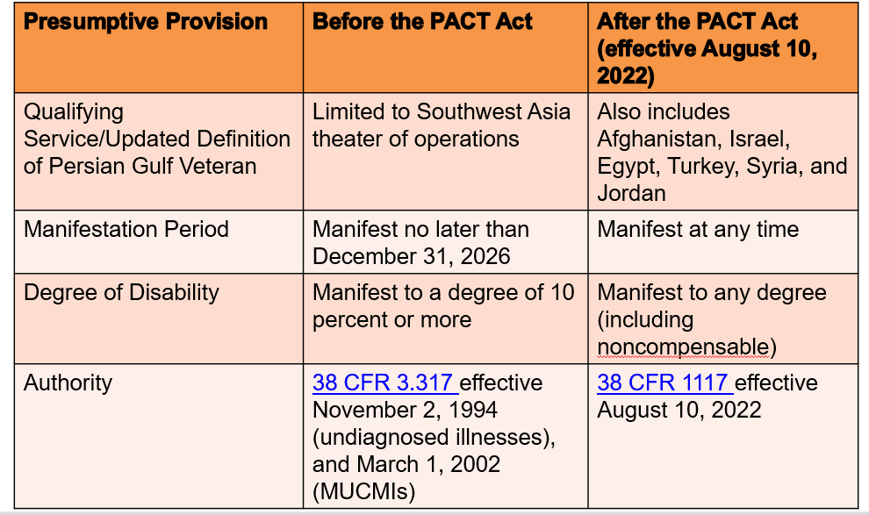

Burn Pits and Other Toxins (BPOT)

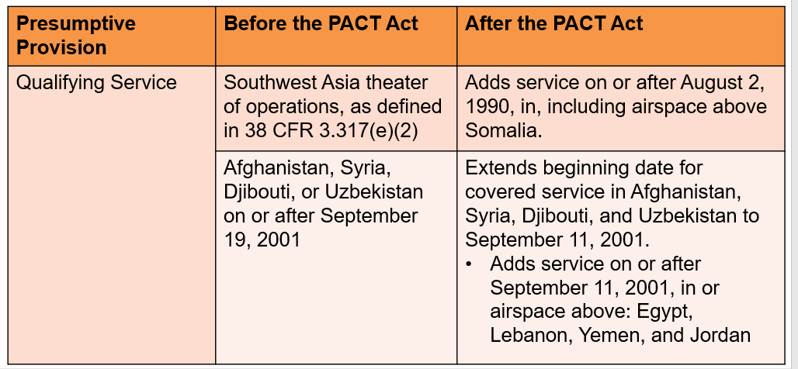

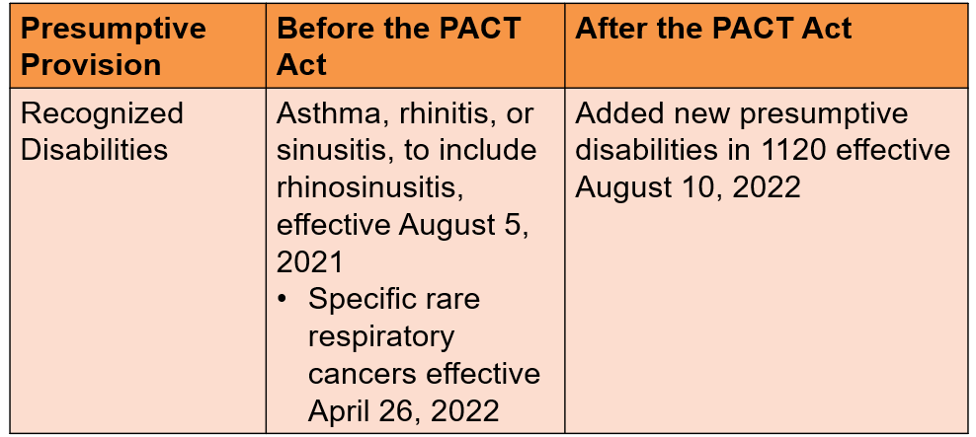

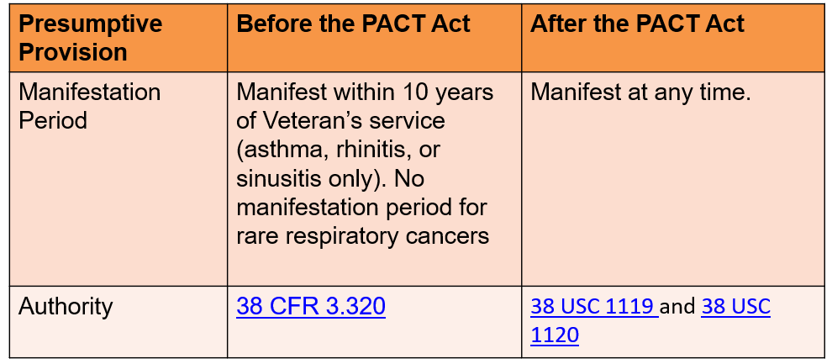

PACT Act-EP Control

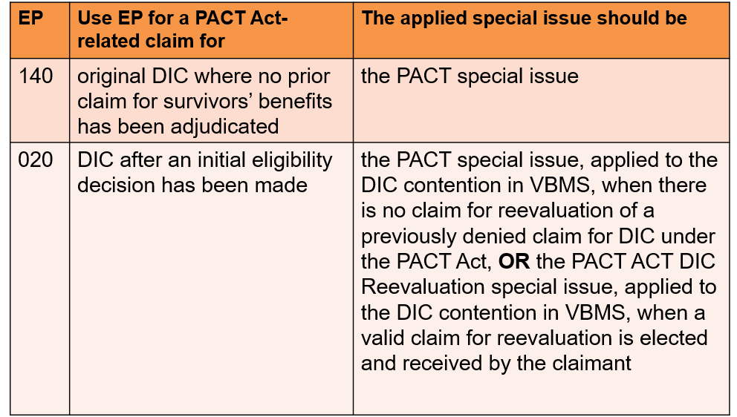

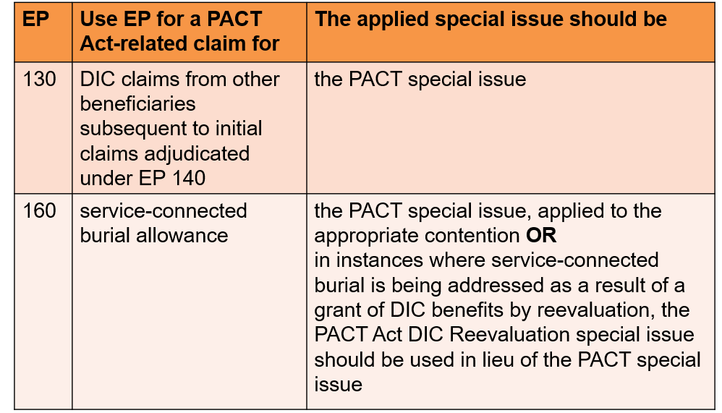

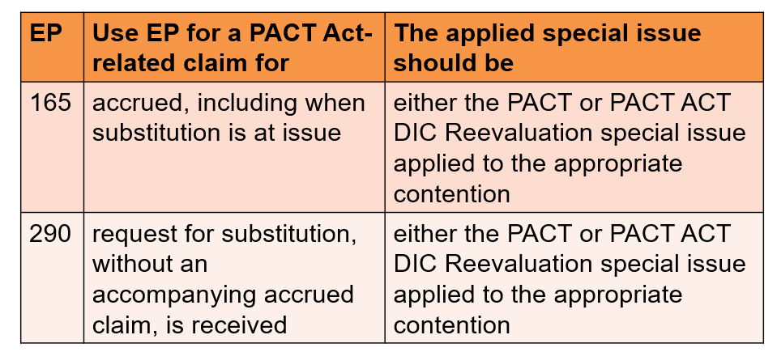

PACT Act-Previously Denied Claims

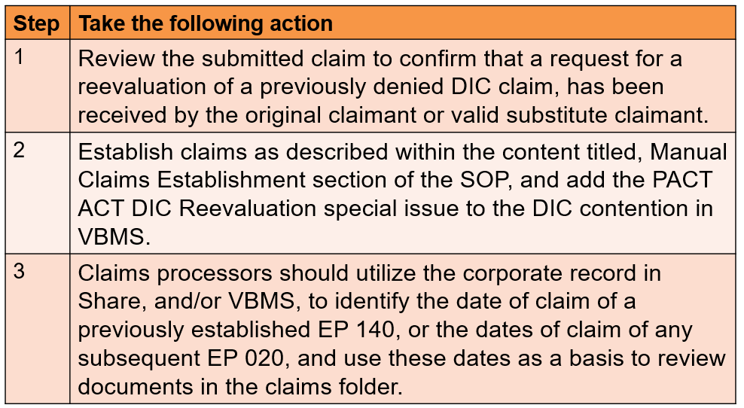

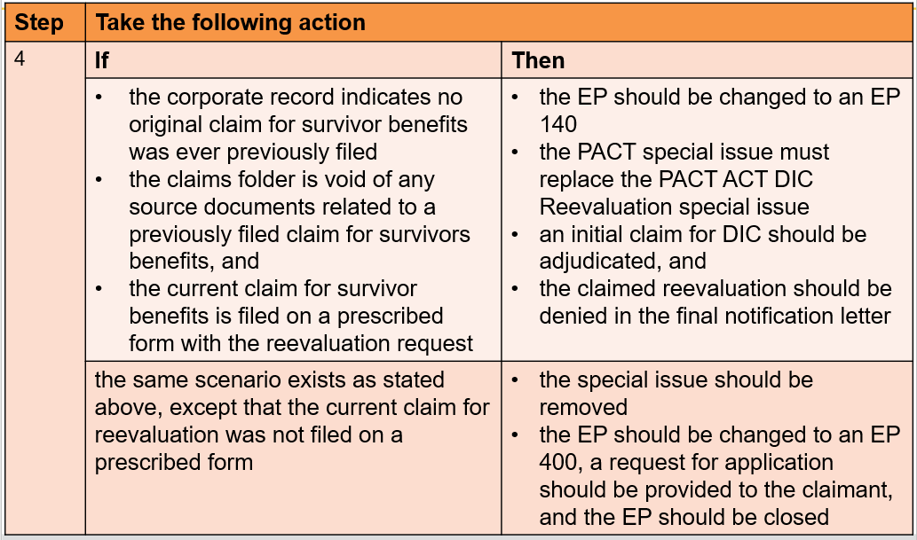

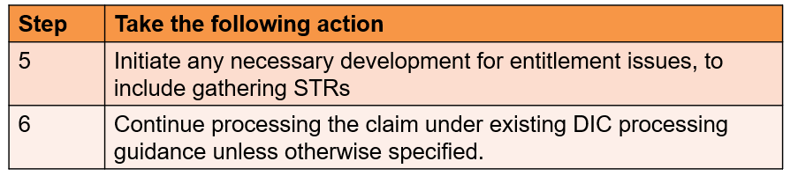

Supplemental Claim Requesting DIC

