Pension and fiduciary service

PMC VSR Intermediate Core Course

Phase 5: Types of Claims  
Part 1(a): Introduction to NOD, FNOD, and MOD Claims

Trainee Guide

April 2024

Introduction to NOD, FNOD, and MOD

Lesson Overview

| Topic | Description |
| --- | --- |
| Time Estimate: | 3 hours |
| Purpose of the Lesson: | This lesson is part of the entry-level curriculum, Core Course for PMC VSRs. The purpose of this lesson is to provide PMC VSRs with the guidance and actions required to process NODs, FNODs, and MODs. |
| Prerequisite Training Requirements: | Prior to taking the Introduction to NOD, FNOD, and MOD lesson, trainees must complete PMC VSR Core Course Phases 1–4. |
| Target Audience: | This lesson is for entry-level PMC VSRs. |
| Lesson References: | * 38 USC 1318 (Benefits for Survivors of Certain Veterans Rated Totally Disabled at Time of Death) * 38 CFR 3.20 (Surviving Spouse's Benefit for Month of Veteran's Death) * 38 CFR 3.211 (Death) * 38 CFR 3.500 (General) * 38 CFR 3.651 (Change in Status of Dependents) * M21-1 XII.i.3.B.2 (Awards to Survivors Upon the Death of a Surviving Spouse, Child, or Parent) * M21-1 IX.iii.1.D.6.d. (Marital Adjustments for the Death of the Other Parent) * M21-1 XI.iii.1.A.5 (Automated Burial and Plot or Interment Allowance Under the FNOD Process) * M21-1 XI.i.1.D (General Procedures for Non-Veteran NOD Processing) |
| Technical Competencies: | * Processing Claims (PMC VSR) * VBA Applications (PMC VSR) |
| Lesson Objectives: | By the end of this course, the trainee will be able to:   * Define the Notice of Death (NOD) and First Notice of Death (FNOD) * Explain the NOD and FNOD process * Understand step required to process the MOD |
| What You Need: | * Trainee Guide * Access to CPKM * Access to the following job aids from VSR Assistant:   + **Prepare the Decision Notice** job aid   + **Notification Language** job aid   + **Pension Systems and Applications** job aid |

Trainee Handout

| PowerPoint Slides | Notes | |
| --- | --- | --- |
| Introduction to NOD, FNOD, and MOD Claims |  | |
| Lesson Objectives  By the end of this course, the trainee will be able to:   * Define the Notice of Death (NOD) and First Notice of Death (FNOD) * Explain the NOD and FNOD process * Understand step required to process the MOD |  | |
| Why It Matters!   * This course matters because the Veteran First Notice of Death (FNOD) processing establishes or updates a Veteran’s Beneficiary Identification and Records Locator Subsystem record with the date of the Veteran’s death * If the Veteran was receiving, or was entitled to receive, disability compensation or pension, or Medal of Honor Pension, the rate payable for the MOD is the greater amount payable. |  | |
| Definitions   * **Fact of Death** – is established by the affidavits of persons who have personal knowledge of the fact of death, have viewed the body of the deceased, know it to be the body of the person whose death is being established, setting forth all the facts and circumstances concerning the death, place, date, time, and cause thereof. * **Proof of death** is evidence that establishes death via a copy of the public record of the State or community where death occurred.   + A copy of a coroner's report of death or a verdict of a coroner's jury of the State or community where death occurred, provided the report or verdict properly identified the deceased. |  |
| Proof of Death   * Proof of death of the payee meeting the requirements of [**38 CFR 3.211**](http://www.ecfr.gov/cgi-bin/text-idx?SID=f0d15f474edcb1cde7811f26011f16df&mc=true&node=se38.1.3_1211&rgn=div8) is required in all cases, unless a statement is provided by surviving spouse, parent or fiduciary, furnishing month and year of death. * Upon receipt of an acceptable statement or evidence of death of a payee, discontinue the award to the deceased payee. * If evidence is required to establish continued entitlement for one or more surviving beneficiaries, do not change his/her payments pending receipt of the required evidence within the 60-day control period established for this purpose. |  |
| Criteria for a NOD   * A notice of death (NOD) is acceptable if it furnishes sufficient information about the Veteran to allow a definite identification of the Veteran’s record, and identifies the source of the report of the death   + If the NOD is a returned check indicating that the Veteran is deceased, identification of the source of the report of death is not necessary. * Claims processors may accept the following as a NOD:   + [*VA Form 29-4125, Claim for One Sum Payment- Government Life Insurance*](http://www.vba.va.gov/pubs/forms/VBA-29-4125-ARE.pdf), or   + [*VA Form 29-4125a, Claim for Monthly Payments – National Service Life Insurance*](http://www.vba.va.gov/pubs/forms/VBA-29-4125a-ARE.pdf) * Upon receipt of the form, process the NOD, and forward the insurance claim to the Philadelphia VAROIC |  |
| Processing the FNOD   * Upon receipt of an acceptable Veteran NOD, process an FNOD *only* on a Veteran’s record under either the   + FNOD command, or   + establishment of an EP for a claim for survivor benefits, and   + when the exact date of death is known   + Process the NOD under the FNOD command in SHARE * After FNOD processing, automated benefits such as burial allowance and DIC can be awarded to eligible surviving spouses based on information contained in the corporate record |  |
| FNOD: Automated Burials   * Automated burial and plot or interment allowances under the FNOD process use EP 169   + Under *no* circumstances should an EP 169 be established.   + Burial benefits through the FNOD process may be granted without an application upon processing of a valid report of death   + FNOD automated burial under EP 169 is not the same as an EP 160 burial benefit processed under Automated Pension Claims Processing * Development is not required for the [38 U.S.C. 1318](http://www.law.cornell.edu/uscode/text/38/1318) DIC claims automated under the FNOD process |  |
| Processing the NOD (1 of 5)  Determine the actions to take for specific situations that may arise when processing a NOD by applying the following: |  |
| Processing the NOD (2 of 5)  Determine the actions to take for specific situations that may arise when processing a NOD by applying the following: |  |
| **Processing the NOD (3 of 5)**  Determine the actions to take for specific situations that may arise when processing a NOD by applying the following: |  |
| **Processing the NOD (4 of 5)**  Determine the actions to take for specific situations that may arise when processing a NOD by applying the following: |  |
| **Processing the NOD (5 of 5)**  Determine the actions to take for specific situations that may arise when processing a NOD by applying the following: |  |
| **NOD: Next of Kin**   * If the minimum required information is *not* available and the Beneficiary Identification and Records Locator Subsystem (BIRLS) database search fails to locate an existing record terminate FNOD processing, and write to the claimant or next of kin for additional identifying information * If the NOD is a claim form, advise the claimant to respond within 30 days or the Department of Veterans Affairs (VA) cannot take action   + If a response is received but the claimant or next of kin cannot provide the Veteran’s service number or Social Security Number (SSN), send [*VA Form 21-3101, Request for Information*](https://vbaw.vba.va.gov/bl/20/cio/20s5/forms/VBA-21-3101-ARE.pdf), to the appropriate service department |  |
| **NOD: Multiple Records**   * When the system finds multiple records during NOD processing, apply these steps to determine how to  review a BIRLS record, or return to the BIRLS SELECTION screen:   + To review a BIRLS record     - *double click* the BIRLS record, **or** select the BIRLS record and then use the INQUIRY command   + To return to the BIRLS SELECT screen   + Use the SELECTION command |  |
| **NOD: Non-Veteran Beneficiary**   * After receipt of a valid NOD, establish an EP 130 using the date of the source of the document as the DOC and select the claim label titled ***PMC Report of Death of Beneficiary***   + If proceeds exist, stop the beneficiary’s award effective the first day of the month of death and if proceeds remain on the account after authorization, contact the finance activity to have the proceeds applied to the debt   + If proceeds do not exist, stop the beneficiary’s award effective the first day of the month of death.   + Clear any additional EPs that were pending for the deceased payee |  |
| NOD: Notice Requirements (1 of 2)   * Although notice of proposed adverse action is not required, contemporaneous notice of the action taken is required if the NOD was obtained   + by way of telephone or personal interview   + in writing from a third party, or   + through computer matching with another Federal agency, such as SSA * Do *not* enclose [*VA Form 20-0998, Your Right to Seek Review of Our Decision*](http://www.vba.va.gov/pubs/forms/VBA-20-0998-ARE.pdf), when sending a contemporaneous notice that benefits have been discontinued based on the reported death of the beneficiary |  |
| NOD: Notice Requirements (2 of 2)   * If the claimant had a power of attorney (POA), the representation is automatically revoked upon the passing of the beneficiary   + Do not notify the former POA * Do *not* include a summary of laws and regulations * If the claimant has a VA-appointed fiduciary at the time of death, issue the contemporaneous notice to the most recent mailing address of record   NOTE: If a death certificate for the deceased non-Veteran beneficiary is of record, no notification letter is required; however, if a probability of accrued benefits exists, VA is required to provide notice. |  |
| FNOD Automation: 38 USC 1318  Automation uses the following steps to process 38 USC 1318 DIC payments: |  |
| FNOD Automation: 38 USC 1318 (2 of 3)   * The following are the automated actions taken after six days: |  |
| FNOD Automation: 38 USC 1318 (3 of 3)   * Although DIC claims may be automated, the process and end products (EPs) for automation are different * For [38 U.S.C. 1318](https://www.law.cornell.edu/uscode/text/38/1318) DIC claims automated under the FNOD process * EP 149 is solely used to process the claims * the claims are granted without an application and/or upon processing a valid report of death, and * credit for this EP is not given to the station of origination, and * For DIC claims automated under the Automated Pension Claims Processing also known as automation   + claims are processed as an EP 140 at any point during the lifecycle of the claim |  |
| Month of Death (MOD)   * Consider any communication from the surviving spouse requesting the Veteran’s benefit for the MOD as a claim for payment for the MOD * Document telephone requests on [*VA Form 27-0820,* *Report of* *General Information*](http://vbaw.vba.va.gov/bl/20/cio/20s5/forms/VBA-27-0820-ARE.pdf)   + The caller must provide oral verification satisfactory to the call agent or claims processor that the caller is the surviving spouse   + Undertake appropriate development if there is any question as to the validity of the claimant’s status as the surviving spouse |  |
| Demonstration: Month of Death (MOD)     * The MOD payment is also awarded to eligible surviving spouses after a VA employee completes the MOD screen that automatically appears *after* FNOD processing is completed. * If the surviving spouse was receiving an apportionment, do *not* pay the MOD payment until the claims folder is reviewed to ensure there is no pending action to remove the spouse. |  |
| MOD: End Products   * In order to determine if a case was paid by the batch MOD process in SHARE, take the actions below:   + Select the CLAIMS/DENIALS tab.   + Select the BENEFIT CLAIM INFORMATION tab.   + Select the 290 MOD ENTITLEMENT REVIEW.   + Under the ACTION PERSON tab, it states BATCH MOD |  |
| Automated FNOD/MOD  If a claim for death benefits is received from the surviving spouse following the automated FNOD/MOD processing, amend the CPD spouse tab using the following steps: |  |
| Entitlement to DIC and MOD  When there is entitlement to DIC and MOD and there is no running award complete the following actions:   1. In the C&P AWARDS tab, ADD SPOUSE tab (SPOUSE tab is not already created) and select RECORD DECISION 2. Select the RATING tab, and then DEATH DECISIONS 3. Under BASIC ELIGIBILITY tab select ADD, and then the appropriate DIC eligibility reason. 4. Input the date in the EVENT DATE field and then ACCEPT 5. Select ADD to record MOD, and then ELIGIBLE FOR VETERANS MOD from the BASIC ELIGIBILITY drop-down 6. Enter the date in EVENT DATE and AWARD EFFECTIVE DATE field, then select the benefit from the BENEFIT tab 7. Select the SERVICE PERIOD field, click ADD, then select OK, and generate the award |  |
| Entitlement to MOD with DIC Survivors Pension Running   * If granting MOD entitlement to a surviving spouse that already has a DIC or Survivors Pension award running, leave the DIC or Survivors Pension decision under the BASIC ELIGIBILITY tab and add the new MOD decision.   + In the C&P AWARDS tab, select ELIGIBLE FOR VETERAN’S RATE MOD from the BASIC ELIGIBILITY drop-down menu   + Input the date in the EVENT DATE and AWARD EFFECTIVE DATE field   + Input the amount in the MOD AMOUNT field.   + This is the amount the Veteran was entitled to at the time of death   + Select the SERVICE PERIOD and then ACCEPT and OK   + Generate the award |  |
| Scenario: Payment of MOD (1 of 2) |  |
| Scenario: Payment of MOD (2 of 2) |  |
| Denying MOD  If it is determined that an MOD payment was released erroneously to the incorrect spouse and the MOD payment should be denied, adjudicators must,   * CEST an EP 290 and select RECORD DECISIONS * Edit the Basic Eligibility Decision field by choosing one of the two denial reasons to replace the previous decision: * DENIED-VETERAN’S MOD RATE PREVIOUSLY PAID, or * DENIED – NOT ENTITLED TO MOD * Generate the award |  |
| Actions to Take Upon Death of a Dependent (1 of 2)   * Upon the death of a surviving spouse, terminate the surviving spouse’s award, effective the first day of the month of death * Discontinue payment of any benefits or share of benefits to a deceased child with   + no surviving spouse on the award, effective the first day of the month of death, and   + a surviving spouse on the same award, effective the first day of the month after death   + if an award is reduced or discontinued because a spouse is lost due to death, apply the end-of-month rule and reduce or discontinue the award effective the first day of the month that follows the month of the event; otherwise, reduce the award as of the date of the event |  |
| Actions to Take Upon Death of a Dependent (2 of 2)   * On the death of one of two parents, discontinue the award to the deceased parent effective the first day of the month of death. |  |
| Knowledge Check – TEST    Time allowed: 10 minutes |  |
| **What’s Next**   * Complete TMS Evaluation **Introduction to NOD, FNOD, and MOD Claims** (**TMS ID: 4641156**) |  |

Appendix

**Processing the NOD**

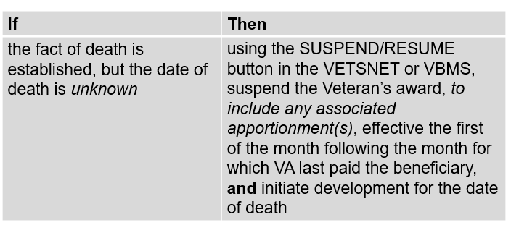

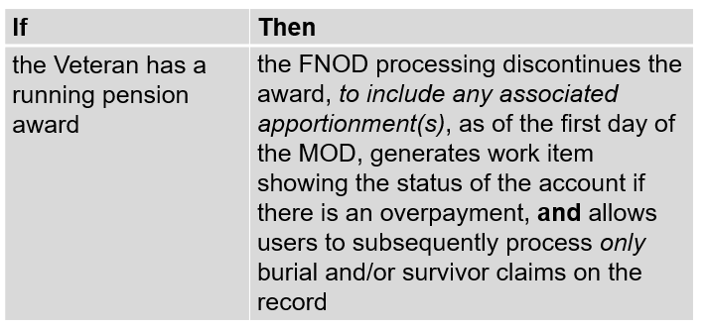

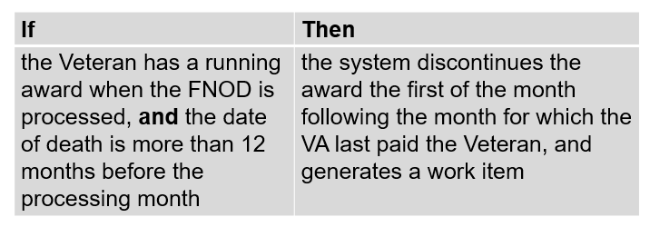

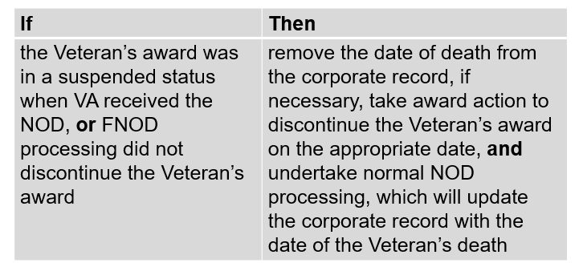

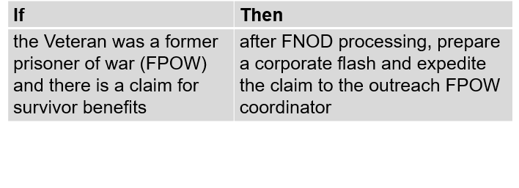

**FNOD Automation: 38 USC 1318**

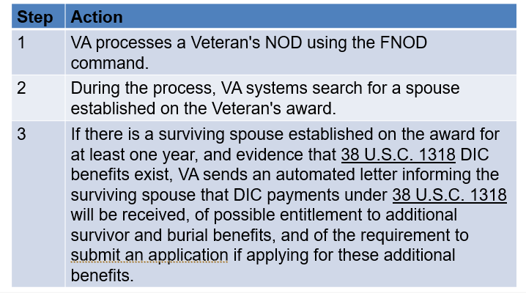

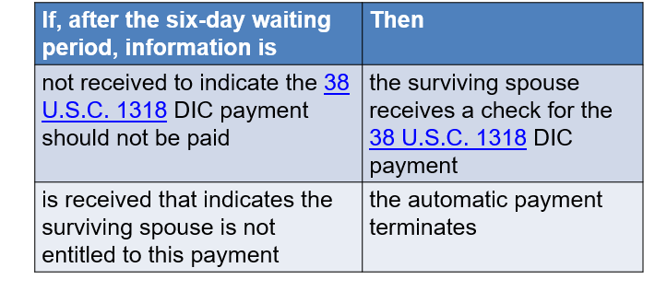

**MOD: End Products**

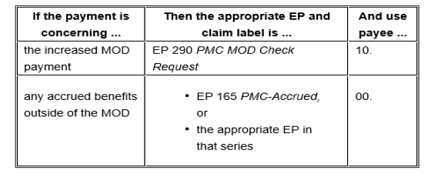

**Automated FNOD/MOD**

