Pension and fiduciary service

PMC VSR Journey-Level Course

National Training Curriculum (NTC)

Character of Discharge (COD) for the PMC

Trainee Guide

September 2024

Character of Discharge (COD) for the PMC

Lesson Overview

| Topic | Description |
| --- | --- |
| Time Estimate: | 2 hour |
| Purpose of the Lesson: | This lesson is part of the NTC for PMC VSRs. The purpose of this lesson is to explain to PMC employees what a Character of Discharge (COD) is, why they’re important, and required actions for CODs. |
| Prerequisite Training Requirements: | Prior to taking this lesson, trainees must have completed the PMC VSR Core Pension Training (CPT) program and be at journey-level. |
| Target Audience: | This lesson is for journey-level PMC VSRs. |
| Lesson References: | * 38 USC 5303 – Certain Bars to Benefits * 38 USC 5303B – Character of Service Determinations * 38 CFR 3.12 – Benefit Eligibility Based on Character of Discharge * 38 CFR 3.354 – Determinations of Insanity * 38 CFR 3.360 – Service-Connected Health-Care Eligibility of Certain Persons Administratively Discharged Under Other Than Honorable Condition * M21-1 X.iv.1.A – Character of Discharge and Bars to Benefits * M21-1 X.iv.1. B – Special Topics Involving Character of Discharge * M21-1 X.iv.1.C – Willful Misconduct and Line of Duty (LOD) * M21-1 X.iv.1.F – Reversal of Prior Determinations Related to Character of Discharge (COD), Line of Duty (LOD, or Willful Misconduct |
| Lesson Objectives: | By the end of this lesson, you should be able to:   * Identify the different types of discharges * Explain why a character of discharge decision is necessary * Explain issues involved in the reasons for discharge * Develop for evidence as it pertains to character of discharge * Write a character of discharge determination |
| Knowledge Check | Character of Discharge (COD) Knowledge Check |
| What You Need: | * Trainee Guide * Access to VBA Intranet * Access to the Assessment Portal * Pen and paper or access to a whiteboard * Access to the following systems:   + SHARE   + MAP-D   + VBMS |

| PowerPoint Slides | Notes |
| --- | --- |
| **Character of Discharge (COD) for the PMC** |  |
| **References**   * 38 USC 5303 – Certain Bars to Benefits * 38 USC 5303B – Character of Service Determinations * 38 CFR 3.12 – Benefit Eligibility Based on Character of Discharge * 38 CFR 3.354 – Determinations of Insanity * 38 CFR 3.360 – Service-Connected Health-Care Eligibility of Certain Persons Administratively Discharged Under Other Than Honorable Condition * M21-1 X.iv.1.A – Character of Discharge and Bars to Benefits * M21-1 X.iv.1. B – Special Topics Involving Character of Discharge * M21-1 X.iv.1.C – Willful Misconduct and Line of Duty (LOD) * M21-1 X.iv.1.F – Reversal of Prior Determinations Related to Character of Discharge (COD), Line of Duty (LOD, or Willful Misconduct |  |
| **Lesson Objectives**  By the end of this lesson, you should be able to:   * Identify the different types of discharges * Explain why a character of discharge decision is necessary * Explain issues involved in the reasons for discharge * Develop for evidence as it pertains to character of discharge * Write a character of discharge determination |  |
| **Why This Matters!**   * The **Character of Discharge (COD)** course matters because in order to establish Veteran status – and basic eligibility for Department of Veterans Affairs (VA) benefits that require Veteran status – a former service member must have had active military, naval, air, or space service (active service), and a discharge or release from that service under conditions other than dishonorable.   + When a discharge for a period of service is found to be dishonorable for VA purposes, there will be no basic eligibility to any VA benefits requiring Veteran status based on that service. |  |
| **Basic Eligibility**   * Basic eligibility without Veteran status can be established for health care under [38 CFR 3.360](https://www.ecfr.gov/current/title-38/chapter-I/part-3/subpart-A/subject-group-ECFR6477ad08d327384/section-3.360).   + With certain exceptions such benefits shall be furnished for any disability incurred or aggravated during a period of service terminated by a discharge under other than honorable conditions.     - Specifically, they may not be furnished for any disability incurred or aggravated during a period of service terminated by a bad conduct discharge or when one of the bars listed in [38 CFR 3.12](https://www.ecfr.gov/current/title-38/chapter-I/part-3/subpart-A/subject-group-ECFRf5fe31f49d4f511/section-3.12) applies. * Eligibility for Chapter 18 benefits is not dependent on the character of a Veteran-parent’s discharge. |  |
| **When is the COD Required**  COD determination is required when a   * claim is filed for Veterans Benefit Administration (VBA) benefits, such as compensation or pension and there is a discharge, or discharge circumstances, listed in [M21-1, Part X, Subpart iv, 1.A.1.e](https://vaww.vrm.km.va.gov/system/templates/selfservice/va_kanew/help/agent/locale/en-US/portal/554400000001034/content/554400000177986/M21-1-Part-X-Subpart-iv-Chapter-1-Section-A-Character-of-Discharge-COD-and-Bars-to-Benefits) * COD determination is requested by the former service member under [38 U.S.C. 5303B](https://www.law.cornell.edu/uscode/text/38/5303B) * claim for benefits is filed with another VA administration, and VBA receives an appropriate VA form request for a COD determination, or * former service member or survivor requests, or there are otherwise grounds for consideration of, a revision of a final COD determination based on new and relevant evidence, or CUE |  |
| **When is the COD Required**  The following service department discharge **characterizations** require a COD determination:   * other than honorable (OTH) * bad conduct discharge (BCD) * dismissal (of an officer), and * Dishonorable   The following **uncharacterized separation** will also require a COD determination:   * void enlistment or induction, or * dropped from the rolls |  |
| **When is the COD NOT Required**   * If a claim is filed based on a period of service, and a prior COD determination found the discharge for that period of service to have been under conditions other than dishonorable, another COD determination is not required. * VBA is not required to always issue a COD determination when requested by another VA administration.   + VBA will issue a COD determination only if a COD determination for the period of service is not of record. |  |
| **Development for the Facts and Circumstances**   * Development for the facts and circumstances surrounding discharge is required, even if the discharge was honorable or general-UHC, if the reason for separation code shown in the corporate record is   + T38 (possible Title 38 bar to VA benefits)   + 953 (clemency discharge)   + BEO (by executive order), or   + DRO (discharge review - prior discharge under conditions other than honorable) * If the character of service is general-UHC, and the separation reason is *drug use*, a COD determination is *not* necessary.   **NOTE:** If the characterization of service is general-UHC but the separation reason is *a conscientious objector who refused to perform military**duties, wear the uniform, or otherwise comply with lawful orders of competent military authorities*, a formal determination as to whether the separation reason poses a bar to benefits under [38 U.S.C. 5303(a)](https://www.law.cornell.edu/uscode/text/38/5303) *is* necessary. |  |
| **Final COD Determination (1 of 2)** |  |
| **Final COD Determination (2 of 2)**   * If late flowing evidence is received, or the claimant submits new and relevant evidence, list the evidence, and state that it was considered but did not change the prior COD determination (make sure to specify the date of the prior determination).   + The explanation must explain why evidence was not new and relevant and/or why new and relevant evidence did not change the prior decision. * If a CUE was asserted but not found, briefly explain the determination that no CUE was found. * In cases where no change in a prior final COD determination is warranted but the prior COD determination did not address former service member basic eligibility for treatment under [38 U.S.C. Chapter 17](https://www.law.cornell.edu/uscode/text/38/part-II/chapter-17) pursuant to [38 CFR 3.360](https://www.ecfr.gov/current/title-38/chapter-I/part-3/subpart-A/subject-group-ECFR6477ad08d327384/section-3.360), prepare a newCOD determinationaddressing only that issue. |  |
| **Basic Eligibility: Health Care Benefits (1 of 4)**   * Health care benefits can be paid to former service members when there is an OTH discharge except when the period of service was terminated with a bad conduct discharge (BCD), **or** one of the bars listed in [**38 CFR 3.12(c)**](http://www.ecfr.gov/cgi-bin/text-idx?SID=514aa275325137ed149956ccc8beb291&node=se38.1.3_112&rgn=div8) applies. * When making a COD determination in response to a claim, ***and*** the primary decision reached is that the discharge for the period of service is found to be dishonorable for VA purposes (such that there is no Veteran status and no eligibility to VA benefits requiring Veteran status), a secondary decision must be made on whether the former service member meets basic eligibility for health care under [**38 CFR 3.360**](https://www.ecfr.gov/current/title-38/chapter-I/part-3/subpart-A/subject-group-ECFR6477ad08d327384/section-3.360). |  |
| **Basic Eligibility: Health Care Benefits (2 of 4)**   * [**38 CFR 3.360**](https://www.ecfr.gov/current/title-38/chapter-I/part-3/subpart-A/subject-group-ECFR6477ad08d327384/section-3.360) was promulgated to provide an avenue for basic eligibility for health care for former service members with OTH discharges whose conduct fell under a [**38 CFR 3.12(d)**](https://www.ecfr.gov/current/title-38/chapter-I/part-3/subpart-A/subject-group-ECFRf5fe31f49d4f511/section-3.12) bar such that*COD would otherwise be a bar to all VA benefits*.   + It must be read together with [**38 CFR 3.12**](http://www.ecfr.gov/cgi-bin/text-idx?SID=514aa275325137ed149956ccc8beb291&node=se38.1.3_112&rgn=div8) (as well as [**38 CFR 3.13**](https://www.ecfr.gov/current/title-38/chapter-I/part-3/subpart-A/subject-group-ECFRf5fe31f49d4f511/section-3.13) and [**38 CFR 3.354**](https://www.ecfr.gov/current/title-38/chapter-I/part-3/subpart-A/subject-group-ECFR6477ad08d327384/section-3.354), if applicable).   + It *must not* be used to deny health care under where basic eligibility to benefits based on Veteran status has been established   **NOTE**: The COD decision must be that the discharge was other than dishonorable notwithstanding that the former service member’s conduct meets the criteria for a statutory bar listed in [**38 CFR 3.12(c)**](http://www.ecfr.gov/cgi-bin/text-idx?SID=514aa275325137ed149956ccc8beb291&node=se38.1.3_112&rgn=div8), or the service was terminated with a BCD if insanity is at issue, and a rating determination is made that the person was insane at the time of the conduct resulting in the discharge. |  |
| **Basic Eligibility: Health Care Benefits (3 of 4)**  Apply the following only when making a primary COD decision that there is a statutory or regulatory bar to benefits under [38 CFR 3.12](https://www.ecfr.gov/current/title-38/chapter-I/part-3/subpart-A/subject-group-ECFRf5fe31f49d4f511/section-3.12), which puts the issue of basic eligibility to health care under [38 CFR 3.360](https://www.ecfr.gov/current/title-38/chapter-I/part-3/subpart-A/subject-group-ECFR6477ad08d327384/section-3.360) at issue: |  |
| **Basic Eligibility: Health Care (4 of 4)**  Apply the following only when making a primary COD decision that there is a statutory or regulatory bar to benefits under [**38 CFR 3.12**](https://www.ecfr.gov/current/title-38/chapter-I/part-3/subpart-A/subject-group-ECFRf5fe31f49d4f511/section-3.12), which puts the issue of basic eligibility to health care under [**38 CFR 3.360**](https://www.ecfr.gov/current/title-38/chapter-I/part-3/subpart-A/subject-group-ECFR6477ad08d327384/section-3.360) at issue: |  |
| **Statutory Bars to Benefits**  Benefits are not payable where a former service member was discharged or released under one of the following conditions:   * As a conscientious objector who refused to perform military duty, wear the uniform, or comply with lawful orders of competent military authorities * By reason of the sentence of a general court-martial * Resignation by an officer for the good of the service * As a deserter * As an alien during a period of hostilities, where it is affirmatively shown that the former service member requested his or her release * By reason of a discharge under other than honorable conditions issued because of an absence without official leave (AWOL) for a continuous period of at least 180 days |  |
| **Regulatory Bar to Benefits**  Benefits are not payable where a former service member was discharged or released under one of the conditions listed:   * Compelling circumstances exception **is not applicable** for:   + Discharge in lieu of trial.     - Acceptance of a discharge under other than honorable conditions or its equivalent in lieu of trial by general court-martial.   + Mutiny or espionage. * Compelling circumstances exception **is applicable** for:   + An offense involving moral turpitude   + Willful and persistent misconduct |  |
| **COD: Who’s Responsible (1 of 2)**   * The development activity is generally responsible for making COD determinations.   + When a rating decision is received, whether or not insanity is established, the development activity must prepare an administrative decision concerning COD, LOD, or willful misconduct for approval, as required. * In cases where insanity is claimed or raised by the record, the rating activity is responsible for making that determination for use in the COD determination. |  |
| **COD: Who’s Responsible (2 of 2)** |  |
| **Line of Duty (LOD) and Willful Misconduct**   * Survivors Pension benefits may be payable if death   + was *not* in the LOD, or   + was due to willful misconduct, and   + occurs in service * Prepare a formal favorable or unfavorable VA determination, as to whether the injury occurred in the LOD if the service department   + did not make such finding *and* the death was incurred under circumstances which raise a legitimate issue of willful misconduct   + holds the death to be not in the LOD, or   + holds the death to be in the LOD, but its finding may be properly questioned |  |
| **Knowledge Check: Lesson Summary Review**    **Time Allowed: 10 minutes** |  |
| What’s Next   * Complete **Character of Discharge (COD) for the PMC** course evaluations: TMS ID #: **4638210** |  |

Appendix

**Final COD Determination**

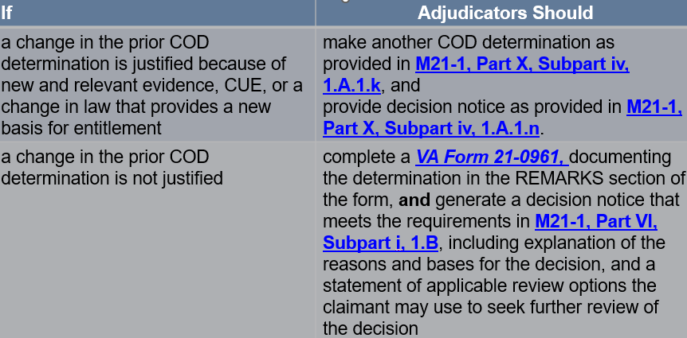

**Basic Eligibility: Health Care Benefits**

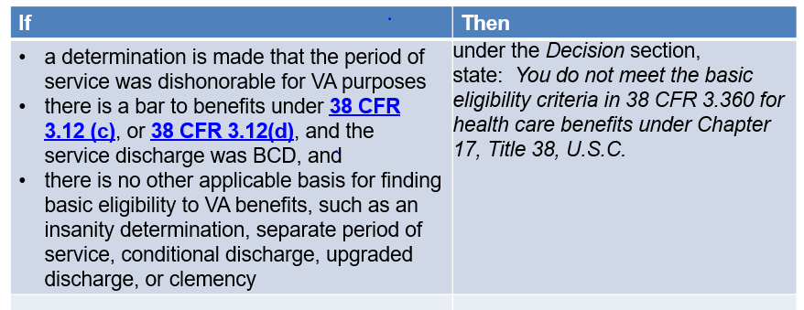

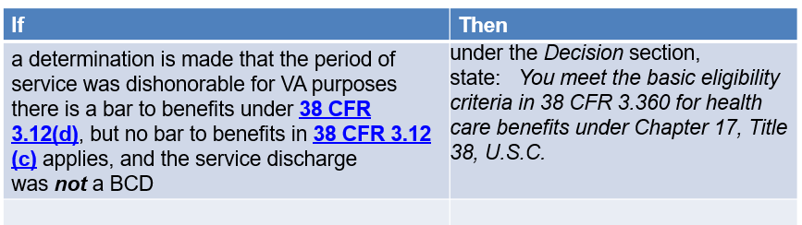

**COD: Who’s Responsible**

