Pension and fiduciary service
PMC VSR Advanced Core Course
Phase 5: Stages of a Claim
Part 1: Determine Eligibility
Determine Substitution Eligibility
Trainee Guide
June 2023

Determine Substitution Eligibility

Lesson Overview
Topic | Description
Time Estimate: | 2 hours
Purpose of the Lesson: | This lesson is part of the entry-level curriculum Core Course for PMC VSRs. The purpose of this lesson is to prepare PMC VSRs on processing a claimant’s request for substitution.
Prerequisite Training Requirements: | Prior to taking the Determine Substitution Eligibility lesson, trainees must complete PMC VSR Core Course Phases 1–4 and Phase 5, Part 1.a-c.
Target Audience: | This lesson is for entry-level PMC VSRs.
Lesson References: | - VA Form 21P-601, Application for Accrued Amounts Due A Deceased Beneficiary  - VA Form 21P-534EZ, Application for DIC, Survivors Pension, and/or Accrued Benefits  - VA Form 21P-0847, Request for Substitution of Claimant Upon Death of Claimant  - VA Form 21-4142, Authorization to Disclose Information to the Department of Veterans Affairs  - 38 USC 5121A, Substitution in Case of Death of Claimant  - 38 CFR 3.1000 (Entitlement under 38 U.S.C. 5121 to benefits due and unpaid upon death of a beneficiary)  - M21-1 XI ii.3 (Definition: Accrued Benefits)  - M21-1 XI.ii.3.A.2.a. (Definition: Claim Pending at the Date of Death)  - M21-1 XI.ii.3.B.1.a. (Definition: Substitution in Case of Death of Claimant)  - M21-1 XI.ii.3.B.1.b. (Definition: Original Claimant)  - M21-1 XI.ii.3.B.1.c. (Definition: Substitute Claimant)  - M21-1 XI.ii.3.B.2.b. (Definition: Categories of Eligible Persons)  - M21-1 XI.ii.3.C.3.b. (Definition: Evidence Needed to Complete the Request to Substitute)  - M21-1 XI.ii.3.A.4.b. Definition: (Evidence in the File at the Date of Death)  - M21-1 XI.ii.3.A.4.c. (Definition: Evidence in VA’s Possession)  - M21-1 XI.ii.3.A.5.f. (Evidence Requirements)  - M21-1 XI.ii.3.C.1.b. (Applications for a Request to Substitute)  - M21-1 XI.ii.3.C.4.a. (When Development, Including the 5103 Notice, Is Required)  - M21-1 XI.ii.3.C.4.b. (When Development, Including the Section 5103 Notice, Is Not Required)  - M21-1 XI.ii.3.E.17.c (EP Control for Substitution and Accrued Claims)
Technical Competencies: | - Program Benefits and Eligibility (PMC VSR)  - Processing Claims (PMC VSR)
Lesson Objectives: | By the end of this lesson, you will be able to:  - Define key terms relating to a request to substitute  - Establish control of a request to substitute  - Determine eligibility to request substitution  - Explain the rights of the substitute claimant
What You Need: | - Trainee Guide  - Pen and paper or access to an electronic whiteboard  - Access to VBA intranet  - Access to the following systems:  - SHARE  - VBMS  - Access to the Determine Substitution Eligibility job aid from VSR Assistant  - Access to the Accrued Benefits job aid from VSR Assistant  - Time and Date Online Calculator

PowerPoint Slides | Notes
Determine Substitution Eligibility
Lesson Objectives
By the end of this lesson, you will be able to:
- Define key terms relating to a request to substitute
- Establish control of a request to substitute
- Determine eligibility to request substitution
- Explain the rights of the substitute claimant
Why This Matters!
- Determining Substitution Eligibility is important because it offers an eligible living claimant the ability to submit evidence in support of a claim that was pending at the time death of an original claimant.
Definitions (1 of 2)
- Substitution is the right of a living person to submit additional evidence in support of the deceased claimant’s pending claim, request for decision review, or appeal of decision.
- An original claimant is the deceased claimant whose claim, decision review request, or appeal of an adverse decision on the claim was pending when he or she died.
- A substitute claimant is an individual whom the VA has recognized to replace the original claimant in a pending claim, decision review request, or pending appeal
Definitions (2 of 2)
- Joint class is a group of two or more individuals in which each individual is an eligible substitute of the same preference such as two or more surviving children or persons who bore the expense of last sickness or burial, or two surviving parents
Applications for a Request to Substitute
- A standard application is not required to request to substitute.
- A request to substitute, from eligible persons, is deemed to be included when VA receives a
  - claim for accrued benefits, Survivors Pension, or Dependency and Indemnity Compensation (DIC)
  - a written request containing intent, name of substitute and the name, claim number, social security number or appeal number of the deceased claimant
Request for Substitution Forms
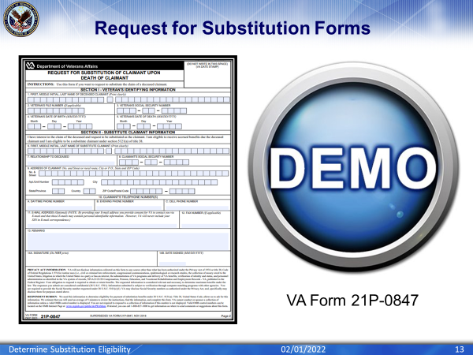
Scenario—Request for Substitution
April Spouse, surviving spouse of Willie Veteran, submits a claim for survivor benefits in VA Form 21P-534EZ, Application for DIC, Survivors Pension, and/or Accrued Benefits. The Veteran had a claim pending at time of death.

Based on the information received, what would be your next step and why?
Evidence Requirements
- Evidence is required to eliminate persons who have a higher status of preference only if the record indicates that a person survived the deceased beneficiary, or
  - Statements of record received by VA prior to the death of the Veteran or primary beneficiary are adequate
- Evidence needed to complete the request to substitute means information necessary to establish the claimant is in the categories of eligible persons, and first in priority order, and proof of payment, if the claim is based on reimbursement
Time Limits for Evidence of Eligibility
- When a claim is a request for substitution, VA must receive the evidence of eligibility the later date of the following:
  - 60 days after the date of the original VA notification, or
  - within one year of the claimant’s death
Considering FTI Income in Substitution (1 of 2)
- Federal tax information (FTI) should be considered in substitution that have a valid substitute claimant when a claim for pension was pending at the time of the original claimant’s death and the
  - FTI is available
  - Sum of the total income reported by the IRS/SSA is higher than the sum of the total income reported on the original application, and
- FTI income is considered countable for VA purposes
Considering FTI Income in Substitution (2 of 2)
- For claimants providing evidence that verifies the actual income to be the same, more or less than reported by IRS/SSA use the amounts verified by the valid substitute claimant
- For claimants who do not provide evidence clarifying the actual income amounts in question, or provide evidence appears to be incomplete, or does not respond, deny the claim for failure to prosecute
Jurisdiction of Accrued and Substitution Claims
- If the Veteran’s claim or request for decision review pending at the time of death is intertwined with the cause of the Veteran’s death, the claim, request for decision review, or appeal for substitution is worked by the PMC of jurisdiction
- If the Veteran’s claim or request for decision review pending at the time of death is not intertwined with the cause of the Veteran’s death the claim, request for decision review, or appeal for substitution is worked by the VSC of original jurisdiction
- If the Veteran’s claim or request for decision review pending at the time of death is pending appeal at the time of death the claim, request for decision review, or appeal for substitution is worked by the DROC of jurisdiction
Control for Substitution Claim
- Most often the request to substitute is received as part of a claim for accrued benefits
- Establish end product (EP) 165 to record work credit for a valid request for accrued benefits. Use the appropriate accrued claim label when establishing an EP 165
- An EP (either 140 or 190, as appropriate) is authorized when a survivor’s claim for death benefits is received in addition to the request for substitution and accrued
Prohibition of Substitution
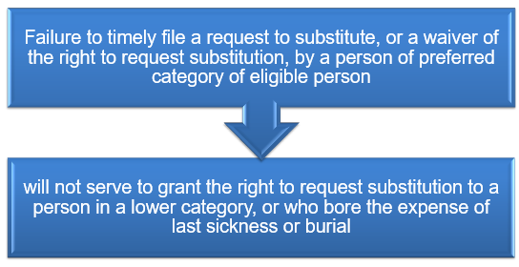

Death of a Substitute Claimant
- If a substitute claimant dies while a claim, decision review request, or appeal is pending, a request to continue the original claimant’s claim may be granted to:
  - another member of the same joint class, or
  - a member of the next preferred class
Substitution Notification Requirement
- If a person's request to substitute does not include evidence of eligibility when it is originally submitted and the person may be an eligible person, notify the person
  - of the evidence of eligibility required to complete the request to substitute
  - that VA will take no further action on the request to substitute unless the evidence of eligibility is received, and
  - that VA must receive the evidence of eligibility no later than 60 days after the date of notification or 1 year after the claimant's death, whichever is later, or VA will deny the request to substitute
Denial Without Development
- It is not required to issue development when
  - accrued benefits do not exist
  - there is a lack of legal eligibility
  - the claim lacks merit, or
  - the claimant is not entitled to the benefit as a matter of law
Denying a Request to Substitute
- Only three findings potentially relevant to a denial of a request to substitute. The three potentially relevant findings are whether
  - there was a claim, request for decision review, or appeal pending at the time of the deceased claimant’s death
  - evidence of eligibility has been received, or
  - the request was submitted timely
- Therefore, any findings listed on a decision to deny the request to substitute should be limited to these three findings
Steps to Deny Substitution Decisions
- An EP 290 with an appropriate substitution of claimant claim label should be established and cleared when the claimant requesting substitution is notified of an unfavorable decision pertaining to the request for substitution
  - Notify the claimant of the decision and provide appeal rights
  - If award action is needed for the accrued, process or establish an EP 165 if there is no EP pending, to provide a formal accrued decision to the claimant
Steps to Granting Substitution Decisions
- An EP 290 with an appropriate substitution of claimant claim label should be established and cleared when the claimant requesting substitution is notified of a favorable decision pertaining to the request for substitution
  - Notify the claimant of the decision and provide appeal rights
  - If award action is needed for the accrued, process or establish an EP 165 if there is no EP pending, to provide a formal accrued decision to the claimant
Scenario— When to Clear EP 290
Scenario:
An adult child submits a VA Form 21P-0847 with proof they paid last expenses. The Veteran had a claim pending at time of death.
Based on the information received, what would be your next step and why?
Rights Afforded to the Substitute Claimant
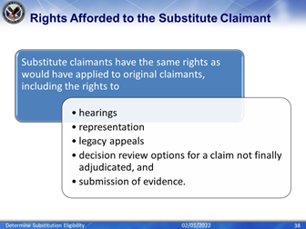
Rights Not Afforded to Substitute Claimants
- Rights that may have applied to the claimant prior to death but which cannot practically apply to a substitute are not available to the substitute.
- The substitute claimant may not add an issue to the claim or expand the claim.
- Entitlement to additional compensation for dependents does not always constitute adding an issue to the claim nor expanding the claim
Calculating Remaining Time to Act (1 of 3)
- Once a substitution request is granted, the substitute claimant must complete any action required within the time period remaining for the original claimant
- Determine the number of days that elapsed between the day after a decision notice is sent to the original claimant and date of their death by using the COUNT DAYS tab in the Time and Date online calculator
- Check the box that says include the end date in calculation
Calculating Remaining Time to Act (2 of 3)
- Calculate the total number of days in the original claimant’s decision review period
  - (365 or 366 if the decision review period included February 29) minus the elapsed days calculated from Step 1 to determine the remaining days for the substitute claimant to file a disagreement
- Since the substitute claimant has the remainder of one year from when the decision notification letter was sent to the original claimant to complete the required actions, add the difference to the date VA sent the notice of approval for substitution by using the ADD DAYS tab in the Time and Date online calculator
Calculating Remaining Time to Act (3 of 3)
- The calculated new date will reflect the date VA must receive the final actions to be considered timely
- If the new date for final action is a Saturday, Sunday, or holiday extend the time limit to the next succeeding workday
- PMCs must use and upload a copy of the Time and Date online calculator to the claims folder when determining a substitute claimant’s timeline to complete any actions
PACT Act – Request for Substitution
- There is no language in the PACT Act that supersedes 38 CFR 3.1010(g), so a substitute claimant can only pursue claims and appeals that were pending, and such an individual could not pursue a new claim that was not filed by the deceased DIC claimant.
- For a PACT Act-related claim use EP 165 for accrued, including when substitution is at issue
  - Apply either the PACT or PACT ACT DIC Reevaluation special issue
- For a PACT Act-related claim use EP 290 for request for substitution, without an accompanying accrued claim
Appy either the PACT or PACT ACT DIC Reevaluation special issue
Course Review Activity
- Instructions:
  - Divide into groups of three.
  - Access CPKM to use the eCFR and M21-1 to complete the exercise.
  - Locate each reference and provide the name for each
    - 38 CFR 3.1000
    - 38 CFR 4.25
    - M21-1 XI.ii.3.A.2.a.
    - M21-1XI.ii.3.B.1.a.
    - M21-1 XI.ii.3.C.1.b.
    - M21-1 XI.ii.3.C.4.a.
    - M21-1 XI.ii.3.A.4.b.
    - M21-1 XI.ii.3.E.17.c
- Time allowed: 15 min.

PowerPoint Slides | Instructor Activities
What’s Next
- TMS Evaluation Determine Substitution Eligibility: TMS ID# 4624038

Example Claim Activity Worksheet: Determine Substitution Eligibility
For each following references provide a response to the references below. Show your work.
- 38 CFR 3.1000

- 38 CFR 4.25

- M21-1 XI.ii.3.A.2.a.

- M21-1XI.ii.3.B.1.a.

- M21-1 XI.ii.3.C.1.b.

- M21-1 XI.ii.3.C.4.a.

- M21-1 XI.ii.3.A.4.b.

- M21-1 XI.ii.3.E.17.c

