pension and fiduciary service
PMC VSR Basic Core Course
Phase 4: Foundational Enrichment
Stages of a Pension Claim
Trainee Guide
May 2024

Stages of a Pension Claim Lesson

Lesson Overview
Topic | Description
Time Estimate: | 1 hour
Purpose of the Lesson: | The purpose of this lesson is to introduce PMC VSRs to the stages of a pension claim and the activities in each stage.
Target Audience: | This lesson is for entry level PMC VSRs.
Lesson References: | - 38 CFR 3.159 (Department of Veterans Affairs assistance in developing claims)  - M21-1 II.i.2.A. (Process Overview for Screening Mail)  - M21-1 I.i.1.A (Description and General Information on Duty to Notify and Duty to Assist)  - M21-1 V.i.1.B (Referrals to the Rating Activity)  - M21-1 VI.i.1.A (Decision Authorization)  - M21-1 VI.i.1.B (Decision Notices)
Knowledge Check: | Phase 4: Introduction to Pension Management Knowledge Check
Lesson Objectives: | By the end of this lesson, you will be able to:  - Describe the stages of a pension claim  - Describe the purpose for initial screening and determining eligibility  - Describe the purpose of claims development and duty to assist/duty to notify  - Describe the purpose of referring a claim to the rating activity  - Describe the purpose of award determination and promulgation  - Describe the purpose of claimant notification
What you need: | - Trainee Guide  - Access to VBA Intranet

PowerPoint Slides | Notes
Stages of a Pension Claim
Objectives
By the end of this lesson, you will be able to:
- Describe the stages of a pension claim.
- Describe the purpose for initial screening and determining eligibility.
- Describe the purpose of claims development and duty to assist.
- Describe the purpose of referring a claim to the rating activity.
- Describe the purpose of award determination and promulgation.
- Describe the purpose of claimant notification.
Why This Matters!
The Stages of a Pension Claim course matters because it explains the stages of a pension claim and introduces the activities required in each stage.
Definition
Substantially complete application means an application containing
- the claimant's name
- his/her relationship to the Veteran, if applicable
- sufficient service information for VA to verify the claimed service, if applicable
- the benefit sought and any medical condition(s) on which it is based
- the claimant's signature
- a statement of income in claims for Veterans Pension or Survivors Pension and Parents' DIC
- identification or inclusion of potentially new evidence in supplemental claims, and
- for HLRs, identification of the date of the decision for which review is sought
Stages of a Pension Claim
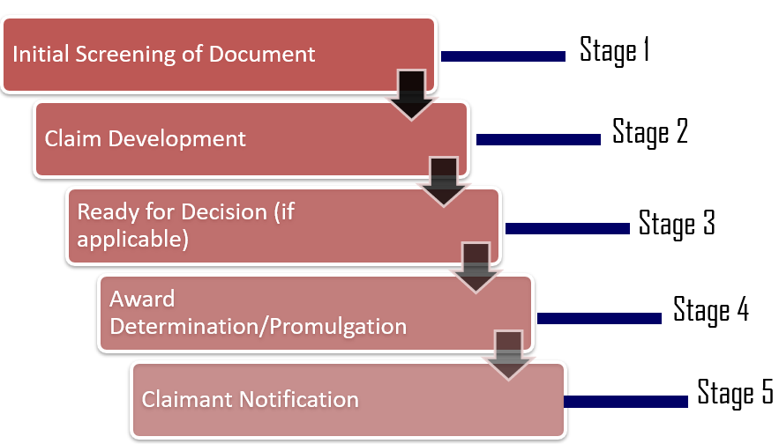
Initial Screening (1 of 3)
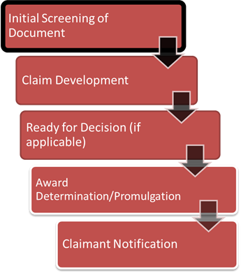
Broken up into two distinct steps:
- Determine if a claim is substantially complete and was established correctly
The VSR should review all incoming evidence to ensure the claim:
- Is substantially complete;
- Is properly signed;
- Is submitted on an acceptable version of the VA standard form.
Initial Screening (2 of 3)
Once a claim is determined to be substantially complete, the VSR should review the claim for accuracy of claims establishment:
- Ensure date of claim is correct
- Ensure payee code and end product (EP) are correct
  - Ensure the evidence received should not have been associated with an already pending claim
- Ensure claimant’s name and address are correct
- Ensure any applicable POAs have been acknowledged and added to the pending EP
- Ensure contentions are entered correctly
Initial Screening (3 of 3)
- Screen for priority processing, immediate denial reasons, or items that need development.
Once the VSR has determined the claim is substantially complete and was established correctly, the VSR should review the facts of the claim to determine:
- If claim warrants priority processing
- If claim warrants immediate denial
- If claim requires further development

PowerPoint Slides | Notes
Claim Development (1 of 2)
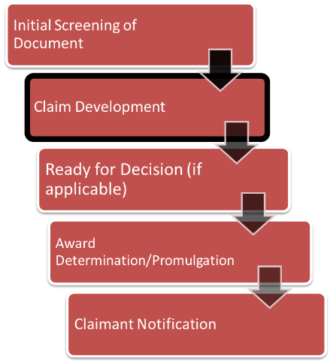
Purpose: To assist the claimant in obtaining evidence and/or to request evidence from the claimant to substantiate the claim before VA makes a decision on it.
Claim Development (2 of 2)
As long as the claimant provides the proper authorization to release the records to VA, the role of the PMC VSR is to:
- Make every effort to request all the evidence needed to decide a claim, and
- Make reasonable efforts to obtain records held by a Federal records custodian, and/or privately held records the claimant identified, as long as the claimant provides proper authorization to release records to VA
PowerPoint Slides | Notes
Ready for decision

Purpose: If the pension claim requires a rating decision and the claim is otherwise eligible for benefits refer the claim to the rating activity after all development actions are complete.

PowerPoint Slides | Notes
Award Determination/Promulgation (1 of 2)
Purpose: To address all issues pertaining to a sigle eclaim by:
- Awarding benefits when entitlement exists
- Denying benefits when entitlement does not exist

PowerPoint Slides | Notes
Award Determination/Promulgation (2 of 2)
The PMC VSR must:
- Conduct a thorough review of the evidence of record.
- Ensure that development and rating review have been completed (if applicable).
- Accurately enter the data into the claims-processing system.
- Generate the award.

PowerPoint Slides | Notes
Claimant Notification (1 of 2)
Purpose: To provide the claimant with full knowledge of the decision made and their rights pertaining to that decision.

Power Point Slides | Notes
Claimant Notification (2 of 2)
The PMC VSR must notify the claimant of the decision the VA made:
- If the VA grants entitlement to a benefit, then the PMC VSR must notify the claimant of information such as the monthly rate of payment, the effective dates of entitlement and payment, and his or her appeal rights.
- If the VA denies entitlement to a benefit, then the PMC VSR must provide the claimant with information such as the reason(s) for the decision, a summary of the evidence considered, and his or her appeal rights.
PowerPoint Slides | Notes
Knowledge Check: Lesson Summary
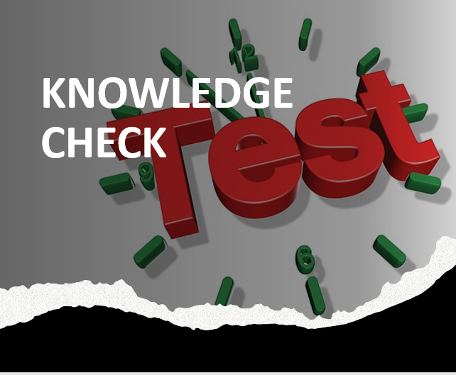
Time Allowed: 10 minutes
Questions?

What’s Next
- Complete Stages of a Pension Claim course evaluation: TMS ID: 4551444

