Pension and fiduciary service
PMC VSR Intermediate Core Course Phase 5: Proficiency Development
Part 5: Award Adjustments
Introduction to Overpayments and Waiver Withholdings
Trainee Guide
July 2024

Introduction to Overpayments and Waiver Withholdings

Lesson Overview
Topic | Description
Time Estimate: | 2 hours
Purpose of the Lesson: | This lesson is part of the entry-level course for PMC VSRs. The purpose of this lesson is to introduce PMC VSRs to the rules for overpayments and waiver withholdings.
Prerequisite Training Requirements: | Prior to taking the Introduction to Overpayments and Waiver Withholdings lesson, you must complete the entry-level course Phases 1–4, Phase 5, Parts 1-4; and Phase 5.4.
Target Audience: | This lesson is for entry-level PMC VSRs.
Lesson References: | - VA Form 1837 (Decision of Waiver of Indebtedness)  - VA Form 5655 (Financial Status Report)  - 38 USC 5302 (Waiver of Recovery of Claims by the US)  - 38 CFR 1.912 (Collection by Offset)  - M21-1 VI.iii.2.C (Debt Disputes and Collection)  - M21-1 VI.iii.2.C.3.a (Description of the COWC)  - M21-1 VI.iii.2.B.2 (Reviewing an Award for Indebtedness)  - M21-1 III.vi.2.B.2.b. (Debt Management)  - Processing an Award Adjustment job aid  - Time Limits job aid  - Notification Language job aid  - Prepare the Decision Notice job aid
Technical Competencies: | - Income Counting and Net Worth  - VBA Applications (PMC VSR)
Knowledge Check: | Phase 5: Introduction to Overpayments and Waiver Withholdings
Lesson Objectives: | By the end of this lesson, you will be able to:  - Recognize whether a waiver withholding is required.  - Recognize whether an overpayment was created.  - Recognize a retroactive award increase.  - Recognize whether a waiver has been granted.  - Recognize whether a retroactive award increase occurs during the debt creation period.
What You Need: | - Trainee Guide  - Appendix A—PMC Centers Jurisdictions and Stations Chart job aid  - Appendix B—Introduction to Overpayments and Waiver Withholdings Scenarios – Worksheet  - Introduction to Overpayments and Waiver Withholdings Training Notes job aid  - Prepare the Decision Notice job aid  - Notification Language job aid  - Access to CPKM  - Access to VBMS  - Access to the Assessment Portal  - Access to the following job aids from VSR Assistant:  - Processing an Award Adjustment job aid  - Time Limits job aid

PowerPoint Slides | Notes
Introduction to Overpayments and Waiver Withholdings

Lesson Objectives
By the end of this lesson, you will be able to:
- Recognize whether a waiver withholding is required.
- Recognize whether an overpayment was created.
- Recognize a retroactive award increase.
- Recognize whether a waiver has been granted.
- Recognize whether a retroactive award increase occurs during the debt creation period.
Why It Matters!
- The Introduction to Overpayments and Waiver Withholdings course is important because 38 USC 5302, provides the authority for any Veteran payee or beneficiary, indebted to VA as the result of participation in a VA benefits program, to request a waiver of repayment of that debt. 5 USC 5584 provides the authority for employees to request waivers for erroneous payments of pay and allowances, as well as travel, transportation and relocation expense debts for employees.
Definition (1 of 2)
The following are key terms used when reviewing awards for indebtedness:
- Committee on Waivers and Compromises (COWC) – are divisions that are responsible for reviewing and have authority to resolve requests for full or partial waiver of a debt
- The term before offset means that if the award adjustment creating an overpayment and the award adjustment creating an increase are processed simultaneously before the amount of the resulting debt is put into the payment system for collection, VA recovers the overpayment created for the one issue with the increase or retroactive benefit created by the other.
- In this case, the increase would offset the debt.
Definitions (2 of 2)
- Debt Management Center (DMC), located in St. Paul, MN, is responsible for VA’s debt collection, and processing requests for waiver of an overpayment.
- An accounts receivable (A/R) is created when an award adjustment that creates an overpayment in a beneficiary’s account is authorized.
- Fiscal adjustment (FISA) refers to action finance activity must undertake prior to the authorization of an award that will create an A/R.
- Indebtedness is the condition of owing money, or the amount of money owed.

Establishment of Debt
- Benefit debts arise out of participation in a VA benefits program (e.g., compensation, education, pension, home loan, etc.)
- VA is responsible for collecting both types of debts and has established the standards for due process afforded all debtors, file documentation, financial status reports, credit reports, and subsequent actions when requested by a debtor
- Overpayments established under the fugitive felon program are subject to waiver or compromise
  - VA will withhold benefits from those Veterans, including family members, who are categorized as fugitive felons or have felony warrants against them
Debt Creation Period
- Debt creation period is the period between the date the claimant received an increase in income and the date the claim was processed
- To avoid processing a duplicate payment of benefits, the PMC VSR must withhold the amount previously waived before any retroactive benefit can be paid​
Decision on Waiver of Indebtedness Form
VA Form 1837 –
Decision on Waiver of
Indebtedness

Types of Receivable Classes and Deduction Codes
Some receivable classes and deduction codes that appear in SHARE and FAS include, but are not limited to:
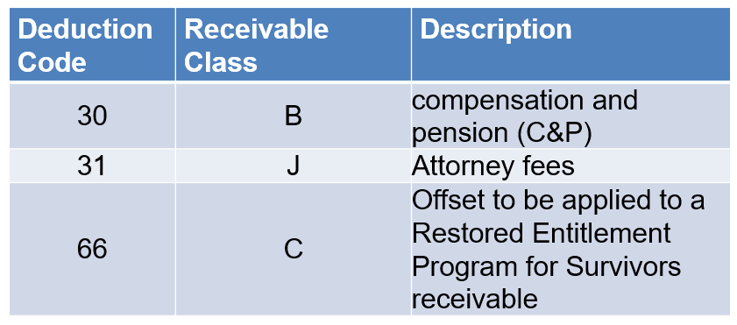
Financial Status Report

VA Form 5655 – Financial Status Report

Reduce the Debt by Deducting Expenses (1 of 2)
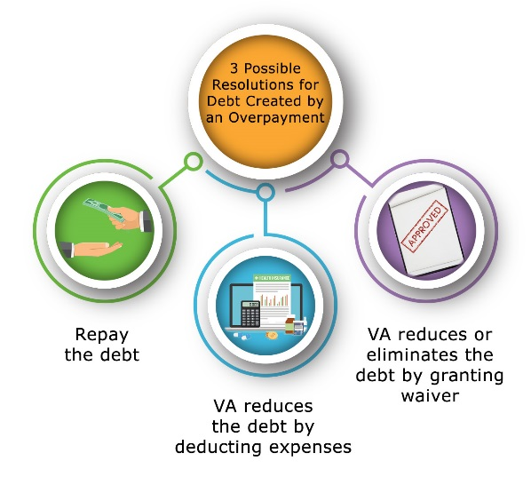
Reduce the Debt by Deducting Expenses (2 of 2)
Scenario: Lark Veteran has had a running award since 2015. Mr. Veteran has no reported income. On May 25, 2020, Mr. Veteran reports he won the lottery. The award is processed November 28, 2020. This generates a debt creation period from June 1, 2020 to November 30, 2020. Mr. Veteran submits medical expenses on January 1, 2021 for the calendar year of 2020. The total amount of medical expenses is significant enough to reduce the IVAP for 2020. The overpayment has been eliminated.

PowerPoint Slides | Notes
Granted Waiver
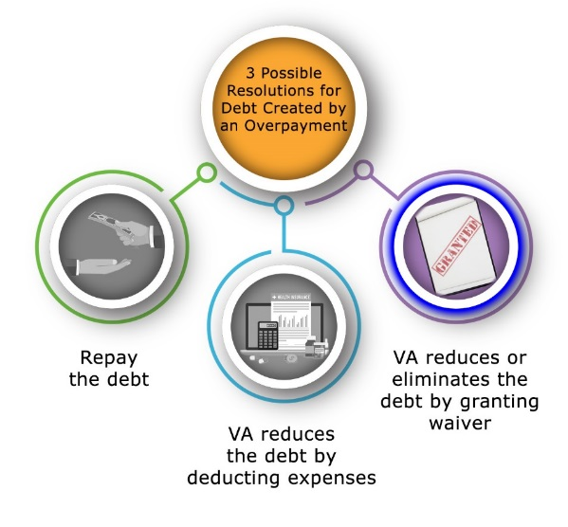
Request for Waiver of Debt Granted
- If VA retroactively awards benefits over a range of dates that includes a time period over which VA created and waived all or part of a debt, the claimant may not be entitled to the full amount of the retroactive payment
- If the COWC has waived all or part of a debt, documentation of the waiver will exist in the eFolder
  - Use the Enterprise Management of Payments Workload and Reporting for VA (eMPWR-VA) to determine the amount of the debt COWC waived for any time period that overlaps the time period the pending award will affect.
  - the OTHER ADJUSTMENTS tab in the awards-processing system,
  - Select Debt Waiver in the ADJUSTMENT REASON field
  - Enter the amount that must be withheld each month in the ADJUSTMENT AMOUNT field, and
  - Enter the time period for the withholding in the FROM DATE and TO DATE fields.
  - Make any other necessary adjustments to the beneficiary’s award.
  - Follow the instructions in M21-1, Part VI, Subpart i, 1.B, for notifying the beneficiary of the actions taken.

PowerPoint Slides | Notes
Notice of Indebtedness (NOI) – (1 of 2)
- VBA pursues the collection of all debts as well as ensures the debtor is advised of the Veteran’s due process rights regarding the nature and amount of the debt through the issuance of the proper NOI, also known as a demand letter
- For fugitive felon debts, the RO Finance Office of Jurisdiction files a claim for overpayment of any benefits paid, when law enforcement agencies notify VA that a Veteran has been identified as being either in prison or is a fugitive felon
  - If there is a warrant against the Veteran, the Veteran should notify VA immediately to prevent benefit overpayments.

Notice of Indebtedness (NOI) – (2 of 2)
- The RO Finance Officer provides the imprisoned Veteran or identified felon with a 60-day due process notification prior to reducing or terminating VA benefits
  - Because of this due process requirement, overpayments of benefits usually cannot be avoided
- VBA will inform debtors, including fugitive felons/incarcerated Veterans, of their legal rights to dispute the existence or amount of the debt within 30 days from the date of VA’s first demand for repayment or to request a waiver of the debt except for vendor debts

PowerPoint Slides | Notes
Elements of the Demand Letter
The written demand letter must inform the debtor of:
- The basis for the indebtedness and any rights the debtor may have to seek review, including a right to request waiver;
- The applicable standards for imposing any interest or other late payment charges;
- The date by which payment should be made to avoid interest and other late payment charges and enforced collection, which should not be more than 30 days from the date that the demand letter is mailed;
- The name, address, and phone number of a contact person or office within the agency;
- The opportunity to inspect and copy VA records related to the debt; and
- The opportunity to make a written agreement to repay the debt
Dispute or Waiver Request
- When a debtor disputes a debt and requests waiver at the same time, a verification of the existence and amount of debts is conducted
- The waiver request is delivered to the COWC pending resolution of the disagreement/dispute and the COWC records the pending resolution of disagreement/dispute case in Salesforce COWC Case Management Application to generate a not workable status
  - the waiver request is not considered until VA responds to the dispute

PowerPoint Slides | Notes
Beneficiary Disagrees w/ Debt
When a beneficiary expresses disagreement with the creation and/or validity of the debt, and requests a waiver:
- Determine if the award adjustment that resulted in the creation of the debt is appropriate, and if so, notify the beneficiary that:
  - VA reviewed the award adjustment that created the debt and determined it was proper in all respects, or
  - VA made a correction to the award adjustment that created the debt, but the correction did not eliminate the debt in its entirety
Scenario 1: Determining the Beneficiary’s Expression of Disagreement – Question
Scenario:
- On April 9th, 2020, Jackie Veteran stressed to VA that she believes the debt created was incorrectly calculated. On April 15th, 2020, she further indicated that she was unsure of the amount, but the calculations seemed off.
- Based on this information, should this be treated as a request for a waiver? Why or why not?
Eliminating an Overpayment
To eliminate the overpayment:
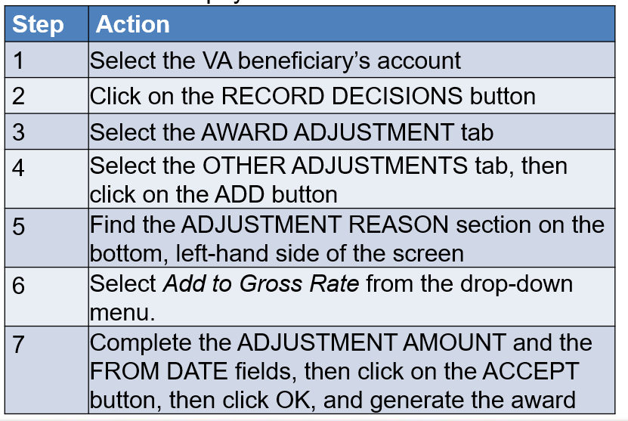
Survivors Benefits Plan (SBP) Overpayments (1 of 3)
- Prior to January 1, 2021, a surviving spouse was not entitled to receive the full amount of SBP and Dependency and Indemnity Compensation (DIC) benefits concurrently
- Beginning January 1, 2021, when a claimant is entitled to both SBP and DIC, they are entitled to
  - a phased amount of SBP payable to a surviving spouse, but
  - the full amount of SBP if a child or parent, since there is no bar against full payment of both benefits for those dependents
- Under 38 U.S.C. 1311, there is no bar to full concurrent payment of SBP and the basic DIC rate when a surviving spouse is entitled to DIC by virtue of having remarried after attaining a qualifying age
Survivors Benefits Plan (SBP) Overpayments (2 of 3)
- Deductions for an SBP overpayment can only be made from the effective date of the DIC award, instead of the effective date of SBP payments if a DIC claim is not filed within one year from the date of death of a Veteran, and the claimant is receiving SBP
- Complete an SBP offset by:
  - Generating the DIC award and sending to the authorizer
  - Authorization will review for accuracy and forward the RPC payment information to the finance activity to request that they create a debt to recoup the SBP overpayment
Survivors Benefits Plan (SBP) Overpayments (3 of 3)
- In all DIC awards involving a SBP deduction, prepare a locally-generated award letter per 38 CFR 3.103(e) that fully advises the claimant
  - of the award, and
  - that the award is subject to offset for concurrent payments of the SBP annuity
- In initial or supplemental DIC awards involving SBP benefits, enclose VA Form 21P-8765, Service-Connected Death Award Attachment, with the locally generated award letter
Retroactive Award Increase
When processing an award adjustment, consider the following:
- Does the award have a history of an overpayment?
- Has the claimant submitted a waiver of debt?
- Does the claimant have a granted waiver and VA Form 1837 on file?
- Does the change in income or expense occur during the debt creation period?
- Will the change in income or expense cause a retroactive increase?
Activity 1 – Withholding Benefits from a Retroactive Award
- Instructions:​
  - Divide into groups of three.
  - Use Appendix B: Question and Answer Worksheet.​
  - Discuss the appropriate actions and use the worksheet to share your answers.
  - Be prepared to share and compare your findings with the class.​
Time allowed: 5-7 minutes
Activity 2 – Partial Withholding of Retroactive Benefits
- Instructions:​
  - Remain in your groups.
  - Use Appendix B: Question and Answer Worksheet.​
  - Discuss the appropriate actions and use the worksheet to share your answers.
  - Be prepared to share and compare your findings with the class.​
- Time allowed: 5-7 minutes

Activity 2 – Partial Withholding of Retroactive Benefits-Answer
An award adjustment that discontinued pension effective January 1, 2020, was processed in June 2020, and created a $2,500 overpayment. An award is subsequently processed in September 2020 that reinstates benefits effective January 1, 2020, but at a lower rate. The new award entitles the payee to a $900 retroactive payment. A review of the claims folder indicates that only $300 of the retroactive payment represents benefits due the beneficiary during the period the overpayment was created (January 1, 2020, to June 2020). A waiver request is pending.
Explain the actions needed.
Knowledge Check: Lesson Summary Review Questions

Time Allowed: 15 minutes

PowerPoint Slides | Notes
What’s Next
- Complete Introduction to Overpayments and Waiver Withholdings TMS evaluation: TMS ID # 4408497

