Pension and fiduciary service
PMC VSR Intermediate Core Course
Phase 5: Proficiency Development
Part 5: Award Adjustments
Determine Dependency Adjustments
Trainee Guide
August 2024

Determine Dependency Adjustments

Lesson Overview
Topic | Description
Time Estimate: | 1 hour
Purpose of the Lesson: | This lesson is part of the entry-level curriculum course for PMC VSRs. The purpose of this lesson is to prepare you for determining changes in dependency and for the impact those changes have on a running award.
Prerequisite Training Requirements: | Prior to taking the Determine Dependency Adjustments lesson, you must complete the entry level course Phases 1–4 – Phase 5.4.
Target Audience: | This lesson is for entry-level PMC VSRs.
Lesson References: | - 38 CFR 3.57(a)(1) (Child: General)  - 38 CFR 3.204 (Evidence of dependents and age)  - 38 CFR 3.205 (Marriage)  - 38 CFR 3.206 (Divorce)  - 38 CFR 3.207 (Void or annulled marriage)  - 38 CFR 3.208 (Claims based on attained age)  - 38 CFR 3.209 (Birth)  - 38 CFR 3.210 (Child's relationship)  - 38 CFR 3.211 (Death)  - M21-1 II.iii.1.A.1.a. (Requirements for a Complete Claim Received on or After March 24, 2015)  - M21-1 VII.i.1.A. (Relationship and Dependency)  - M21-1 VII.i.1.A.4.a. (Forms Claimants Must Use to Initiate the Process of Adding a Dependent to Their Award)  - M21-1 VII.i.2.B.2. (How to Develop for Common Law Marriage)  - M21-1 VII.i.2.B.3.a. (Recognition of Common Law Marriages by State)  - M21-1 VII.i.2.C.1. (Tribal, Proxy, and Transgender Marriages)  - M21-1 VII.i.3.B. (Establishing a Biological Child, Adopted Child, or Stepchild as a Veteran's Child for Department of Veterans Affairs (VA) Purposes)  - M21-1 VII.i.3.B.6 (Award Adjustments Involving Stepchildren)  - M21-1 VII.ii. (School Attendance)  - M21-1 XII.i.1.A.1.a. (Definition: DIC)  - M21-1 IX.i.3.A.2.a. (Income Development for Initial and Supplemental Claims)  - M21-1 IX.iii.1.F. (Dependents for Current- Law Pension Purposes)  - M21-1 IX.iii.1.F.2.a. (General Information on Counting the Income of Dependents)  - M21-1 IX.iii.1.F.2.k. (Failure to Resolve the Income of Dependents)  - Annotate the Award Checklist job aid  - Dependency Eligibility Requirements job aid  - Dependency Eligibility: Spouse job aid  - Develop for Missing Information/Evidence job aid  - Income and Net Worth Status job aid  - Initial Year job aid  - Time Limits job aid
Lesson Objectives: | - Determine award adjustment based on change in dependency  Determine changes in dependency  Determine actions to take based on dependency changes  Determine the award adjustment based on change in dependency
What You Need: | - Trainee Guide  - Access to VBA intranet  - Pen and paper or access to a whiteboard  - Access to the following VBA systems:  - VBMS  - SHARE  - PCGL  - Access to the following job aids from VSR Assistant:  - Annotate the Award Checklist job aid  - Dependency Eligibility Requirements job aid  - Dependency Eligibility: Spouse job aid  - Develop for Missing Information/Evidence job aid  - Initial Year job aid  - Income and Net Worth Status job aid  - Time Limits job aid

PowerPoint Slides |  | Notes
Determine Dependency Adjustments
Lesson Objectives
- Determine award adjustment based on change in dependency.
- Determine changes in dependency.
- Determine actions to take based on dependency changes.
- Determine the award adjustment based on change in dependency.
Why It Matters!
The Determine Dependency Adjustments course is important because it focuses on guidance that indicates what evidence can be used to determine who can be considered a dependent.
Job Aids for Determining Changes in Dependency
- Annotate the Award Checklist job aid
- Initial Year job aid
- Income and Net Worth Status job aid
- Time Limits job aid
- Dependency Eligibility Requirements job aid
- Dependency Eligibility: Spouse job aid
- Develop for Missing Information/Evidence job aid
Lesson Overview
- Demonstration—Instructor completes an award adjustment based on dependency changes with opportunities for questions.
- Guided Practice—Trainees complete an addition/removal of a dependent and award adjustment with questions and feedback/remediation.
Changes in Dependency
- Review dependency documents in VBMS when claim is received
- May be submitted by claimant, fiduciary, or third party
  - If submitted by a third party, you will need to complete due process before taking any action on the claim.
Verify Addition/Removal of Dependent
- Verify if dependent being added/removed is:
  - Spouse
  - Child
- Verify the reason for addition/removal
- Develop or conduct due process for more information if needed
- If claim contains all information needed, continue with addition/removal of dependent
Acceptable Reasons for Removing a Dependent
- Death of spouse, child, or dependent parent
- Marriage of child
- Child adopted out of the family
- Divorce or annulment from spouse
- Separation (estrangement) from spouse with no financial contributions
- Child turns 18 and is not in school
- Child ages 18-23 terminates school attendance
- Child over 18 and in school turns 23 years old prior to school attendance termination
- Child born
Will Addition/Removal of Dependent Result in Increase of Benefits?
- If addition or removal of dependent results in an increase of benefits, the claim must be submitted on the prescribed form.
  - M21-1 VII.i.1.A.4.a. (Forms Claimants Must Use to Initiate the Process of Adding a Dependent to Their Award)
- If not submitted on prescribed form, develop for income/net worth as income could result in award reduction.
Scenario–Can You Add the Dependent?
Veteran James Van Winkle has a running pension award since August 1, 2011. He submitted VA Form 21-686c, Declaration of Status of Dependents, on June 13, 2016. On the form, he reports that he got married on March 15, 2016, to Sandra Johnson. He filled out the form with his complete marital history and Sandra's complete marital history, indicated that Sandra is not a Veteran, and provided her SSN and date of birth. Along with this form, he submitted VA Form 21-4138, Statement in Support of Claim, stating "My new wife has no income or net worth to report."
Based on the information provided, are you able to add the dependent?
Scenario–Can You Add the Dependent? Answer
Veteran James Van Winkle has a running pension award since August 1, 2011. He submitted VA Form 21-686c, Declaration of Status of Dependents, on June 13, 2016. On the form, he reports that he got married on March 15, 2016, to Sandra Johnson. He filled out the form with his complete marital history and Sandra's complete marital history, indicated that Sandra is not a Veteran, and provided her SSN and date of birth. Along with this form, he submitted VA Form 21-4138, Statement in Support of Claim, stating "My new wife has no income or net worth to report."
Based on the information provided, are you able to add the dependent?
Guided Practice–Add/Remove Dependent Based on Information Provided
- Instructions:
  - Access the Claim 1 provided in VBMS
  - Access the following job aids:
    - Dependency Eligibility: Spouse
    - Dependency Eligibility Requirements
  - Along with the instructor:
    - Determine if all the information to add/remove the dependent is present
    - Add/Remove the dependent
- Time allowed: 10 min.
Demonstration—Determine Award Adjustment Based on Change in Dependency
- Ensure:
  - All evidence has been received
  - Income and net worth has been received
- Enter information into VBMS-A
- Generate the award
Guided Practice—Determine Award Adjustment and Generate Award
- Instructions:
  - Access the following job aids:
    - Dependency Eligibility Requirements
    - Dependency Eligibility: Spouse
    - Annotate the Award Checklist
    - Initial Year
    - Income and Net Worth Status
    - Time Limits
    - Develop for Missing Information/Evidence
  - Review Claim 2 in VBMS.
  - Determine the award adjustment in VBMS-A.
  - Generate the award.
  - Be prepared to answer questions about whether to add/remove a dependent and how you determined the award adjustment.
- Time allowed: 10 min
Guided Practice—Determine Award Adjustment and Generate Award Debrief
- Follow along as the instructor confirms:
  - The type of dependent
  - If the correct information was provided
  - Whether to add or remove the dependent
  - The correct way to add or remove the dependent
  - The information used to complete the SHARE and VBMS-A screens
  - The correct award adjustment
  - The new updated award
- Ask for clarification on how the award adjustment was determined, if needed.
Knowledge Check – Test
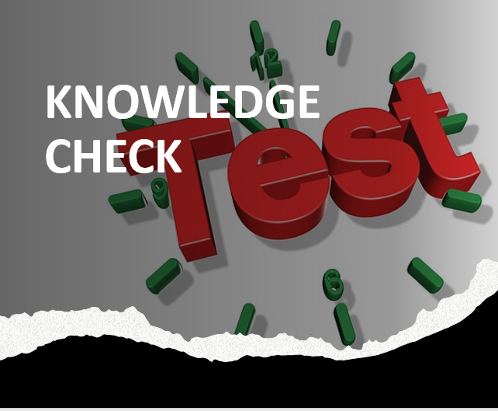
Time Allowed: 10 minutes
What’s Next?
- Complete Determine Adjustments course evaluation: TMS ID #: 4408490

