Pension and fiduciary service

PMC VSR Intermediate Core Course

Phase 5: Proficiency Development  
Part 5: Award Adjustments

Determine Qualifying Expense Adjustments

Trainee Guide

June | 2024

Determine Qualifying Expense Adjustments

Lesson Overview

| Topic | Description |
| --- | --- |
| Time Estimate: | 4 hours |
| Purpose of the Lesson: | This lesson is part of the entry-level curriculum, Core Course for PMC VSRs. The purpose of this lesson is to prepare you to recognize and accurately calculate award adjustments for unreimbursed medical, final, and educational expenses. |
| Prerequisite Training Requirements: | Prior to taking the Determine Qualifying Expense Adjustments lesson, you must complete PMC VSR Core Course Phases 1–4, Phase 5.1.a – 5.4. |
| Target Audience: | This lesson is for entry-level PMC VSRs. |
| Lesson References: | * Compensation and Pension Knowledge Management (CPKM) * VA Form 21P-8416 (Medical Expense Report) * VA Form 21P-8049 (Request for Detail of Expenses) * 38 CFR 3.262 (Final expenses) * 38 CFR 3.272 (Exclusions from Income) * M21-1 IX.i.3.D.2 (Developing for UMEs) * M21-1 IX.i.3.D.3. (Developing for Unreimbursed Funeral and Other Final Expenses) * M21-1 IX.i.3.D.4 (Developing for Unreimbursed Educational Expenses) * M21-1 IX.iii.1.A.3.g. (Definition of Initial Year for Pension and Time Limit for Establishing Entitlement for the Initial Year) * **M21-1 IX.iii.1.A.5.b. (Provisions of 38 CFR 3.31)** * **M21-1 IX.iii.1.A.5.c.(History of 38 CFR 3.31)** * **M21-1** IX.iii.1.A.5.d. (Determining Whether to Apply 38 CFR 3.31) * **M21-1 IX.iii.1.A.5.i. (Example 2: Re-computing Awards Based on New Income Information)** * M21-1 IX.iii.1.E.7.b.(Deductible Medical Expenses Paid During the Initial Year) * M21-1 IX.iii.1.G.2( (UME) Deductions)   + **M21-1 IX.iii.1.G.2.a. (Rules for Deductibility of UMEs)**   + **M21-1IX.iii.1.G.2.c. (List of Common Allowable Medical Expenses)** * M21-1 IX.iii.1.G.3 (Sources of Medical Expenses)   + M21-1 IX.iii.1.G.3.j. (Medical Expense Deduction for Nursing Home Fees)   + M21-1 IX.iii.1.G.3.k. (Medical Expense Deduction for Care Facility Other Than Nursing Home Fees)   + M21-1 IX.iii.1.G.3.m. (In-Home Attendants for a Disabled Person)   + M21-1 IX.iii.1.G.3.o. (Documentation of In-Home Attendant Fees)   + M21-1 IX.iii.1.G.3.q. (Medicare Premiums)   + M21-1 IX.iii.1.G.3.r. (Vitamins, Food Supplements, and Herbal Remedies) * M21-1 IX.iii.1.G.4 (Processing UME Deductions) * **M21-1 IX.iii.1.G.4.a. (General Rule on Allowing Medical Expenses)** * **M21-1 IX.iii.1.G.4.b. (Requirements for a Medical Expense Deduction Claim)** * M21-1 IX.iii.1.K.1 (Final Expense Deductions – Overview and Definitions) * **M21-1 IX.iii.1.K.2.c. (Example 2: General Rule for Deducting Final Expenses)** * **M21-1 IX.iii.1.K.2.d. (Example 3: Final Expenses Paid During the Calendar Year Following the Year of Death)** * **M21-1 IX.iii.1.K.2.e. (Example 4: Final Expenses Paid by the Surviving Spouse Before the Veteran’s Death)** * **M21-1 IX.iii.1.K.2.f. (Example 5: Final Expenses Paid by the Surviving Spouse After the Veteran’s Death but Before the Date of Pension Entitlement)** * **M21-1 IX.iii.1.K.2.g. (Example 6: Final Expenses Paid by the Surviving Spouse Before the Veteran’s Death and During the Calendar Year Following the Year of Death)** * M21-1 IX.iii.1.K.3 (Educational Expense Deductions) * **M21-1 IX.iii.1.K.3.c. (Period of Deduction)** * **Annotate the Award Checklist** job aid * **Care Expense Guide** job aid * **Develop for Missing Information/Evidence** job aid * **Income and Net Worth Status** job aid * **Initial Year** job aid * **Integration of Medical Expenses in VBMS-A** job aid * **Processing an Award Adjustment** job aid * **Time Limits** job aid |
| Technical Competencies: | * Processing Claims (PMC VSR) * Income Counting and Net Worth * Special Monthly Pension (SMP) Processing * VBA Applications (PMC VSR) |
| Knowledge Check: | Phase 5: Determine Qualifying Expense Adjustments Knowledge Check |
| Lesson Objectives: | By the end of this lesson, you should be able to:   * Determine qualifying expense adjustments. * Determine whether medical expense qualifies for an award adjustment. * Determine whether final expense qualifies for an award adjustment. * Determine whether educational expense qualifies for an award adjustment. |
| What You Need: | * Trainee Guide * Access to CPKM * Access to VBMS-A * Access to VSR Assistant for job aids:   + **Annotate the Award Checklist job aid**   + **Care Expense Guide job aid**   + **Develop for Missing Information/Evidence job aid**   + **Income and Net Worth Status job aid**   + **Initial Year job aid**   + **Integration of Medical Expenses in VBMS-A job aid**   + **Processing an Award Adjustment job aid**   + **Time Limits job aid** |

| PowerPoint Slides | Notes |
| --- | --- |
| Determine Qualifying Expense Adjustments |  |
| Lesson Objectives  By the end of this lesson, you should be able to:   * Determine qualifying expense adjustments. * Determine whether medical expense qualifies for an award adjustment. * Determine whether final expense qualifies for an award adjustment. * Determine whether educational expense qualifies for an award adjustment. |  |
| Why this Matters!  The Determine Qualifying Expense Adjustments course is important because VA may be able to pay beneficiaries a higher benefit rate if they identify expenses that can be deducted from their income. |  |
| Definitions   * Educational expense refers amounts equal to expenses paid by a veteran or surviving spouse pursuing a course of education or vocational rehabilitation or training, to include amounts paid for tuition, fees, books, and materials   + in the case of a veteran or surviving spouse in need of regular aid and attendance, unreimbursed amounts paid for unusual transportation expenses in connection with the pursuit of such course * *Burial expenses* includes all funeral and burial expenses incident to disposition of the remains of deceased persons. * Medical expenses refers to any unreimbursed amounts which have been paid within the 12-month annualization period for medical expenses regardless of when the indebtedness was incurred. |  |
| Example: Qualifying Expense Adjustments  **Scenario:**  Andrew Roberts is a Veteran that has been in receipt of NSC pension since July 2012. His only source of continuing medical expenses are his Medicare Part B Premiums, which is reported on a 2016 SHARE print as $104.90 monthly. On January 18, 2017 he submits a completed VA Form 21-8416, Medical Expense Report, for his 2016 annual unreimbursed medical expenses. He reports his monthly Medicare Part B premium of $104.90, co-pays to his doctor of $125.00 annually, prescriptions of $650.00 annually, and over-the-counter medications of $225.00 annually. You perform a SSA inquiry in 2017 verifying his updated Medicare Part B Premium for 2017 has increased to $106.00 per month. |  |
| Example: Qualifying Expense Adjustments   * What are Mr. Robert’s 2016 Unreimbursed Medical Expenses (UMEs)? * What are Mr. Robert’s 2016 Continuing Medical Expenses (CMEs)? * What are Mr. Robert’s 2017 Continuing Medical Expenses (CMEs)? |  |
| Qualifying Expense Adjustments  Qualifying Expense Adjustments with the three adjustments: medical expense adjustments, final expense adjustments, and educational expense adjustments. |  |
| Medical Expense Adjustments  Medical Expense Adjustments with the three adjustments: medical expense adjustments, final expense adjustments, and educational expense adjustments. Medical expense adjustments is highlighted. |  |
| Review Medical Expenses (1 of 2)  Qualifying medical expenses:   * M21-1 IX.iii.1.G.2.a (Rules for Deductibility of UMEs) * M21-1 IX.iii.1.G.2.c (List of Common Allowable Medical Expenses) * M21-1 IX.iii.1.G.3 (Sources of Medical Expenses) |  |
| Review Medical Expenses (2 of 2)   * Allowing medical expense deduction:   + **M21-1 IX.iii.1.G.4.a. (General Rule on Allowing Medical Expenses)** * **Information required for medical expenses**   + **M21-1 IX.iii.1.G.4.b. (Requirements for a Medical Expense Deduction Claim)** |  |
| Review Medical Expenses Answers   * *A claim for a medical expense deduction must be supported by a:*   + *Fully-completed VA Form 21P-8416 (Medical Expense Report)*   + *Document furnishing the information requested on VA Form 21P-8416* * *The following information is required for a medical expense deduction claim:*   + *Purpose*   + *Amount Paid*   + *Date Paid*   + *Name of Provider*   + For Whom Paid |  |
| Determine Qualifying Medical Expense Adjustment  Determine Qualifying Medical Expense Adjustment with the following traffic light labels: Green light—Calculate medical expense deduction Yellow light—Develop for medical expense Red light—Deny medical expense |  |
| Calculate the Medical Expense  Determine Qualifying Medical Expense Adjustment with the following traffic light labels: Green light—Calculate medical expense deduction Yellow light—Develop for medical expense Red light—Deny medical expense  Green light is highlighted. |  |
| Determine if Medical Expense is Within Initial Year or Calendar Year  Example of initial year, calendar year and overlap period with the following dates: 5/13/2016 Entitlement date/effective date; beginning of initial year 6/1/2016 Date of payment  5/13/2016 to 12/31/2016  A period 12/31/2016 End of A period 1/1/2017 beginning of first full calendar year 1/1/2017 to 5/31/2017 Overlap period or B period 5/31/2017 End of initial year 6/1/2017 to 12/31/2017 C period 12/31/2017 End of first full calendar year |  |

**Image on slide 13**

Example of initial year, calendar year and overlap period with the following dates:
5/13/2016 Entitlement date/effective date; beginning of initial year
6/1/2016 Date of payment 
5/13/2016 to 12/31/2016  A period
12/31/2016 End of A period
1/1/2017 beginning of first full calendar year
1/1/2017 to 5/31/2017 Overlap period or B period
5/31/2017 End of initial year
6/1/2017 to 12/31/2017 C period
12/31/2017 End of first full calendar year

| PowerPoint Slides | Notes |
| --- | --- |
| **Class Activity—Review Initial Year**   * Instructions:   + Access Claim 1   + Use Appendix A: Part A—Review Initial Year worksheet.   + Refer to **Initial Year** job aid.   + Work as a class to find the correct dates based on the Claim 1. * Time allowed: 25 minutes |  |
| Class Activity—Review Initial Year Answers  Answers provided by instructor based on example claim selected.  Effective (Entitlement) Date:  Payment (Financial Decision Effective) Date:  Beginning of “A” period:  End of “A” period:  Beginning of first full calendar year:  Beginning of overlap period or “B” period:  End of overlap period or “B” period:  End of initial year:  Beginning of “C” period:  End of first full calendar year: |  |
| Initial Year in VBMS-A Demo  Title: Question Icon - Description: This icon prompts you to demonstrate a process or activity. |  |
| Compare Medical Expenses  *VBMS-A medical expense tab with the CME column highlighted* |  |

**Image on slide 17**

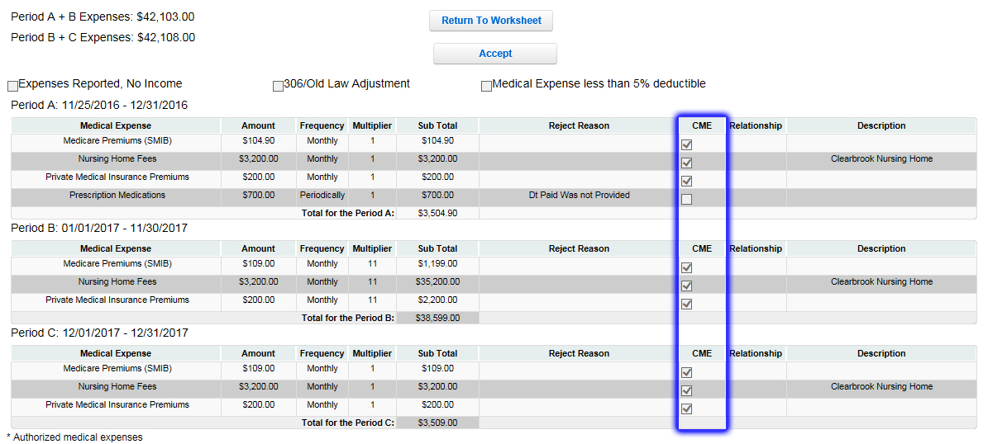

| PowerPoint Slides | Notes |
| --- | --- |
| Medicare Premiums  VBMS-A showing Medicare Part B in Medical Expense tab |  |

**Image on slide 18**

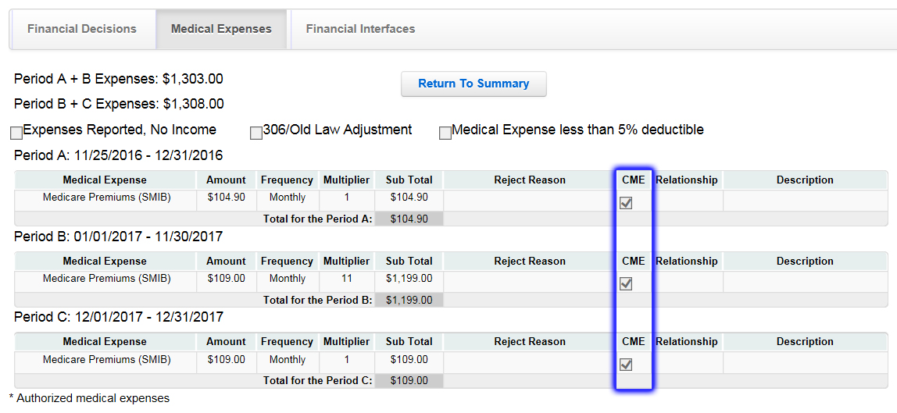

| PowerPoint Slides | Notes |
| --- | --- |
| Enter Medical Expenses in VBMS-A Demo  Title: Question Icon - Description: This icon prompts you to demonstrate a process or activity. |  |
| Return to Financial Decision Tab in VBMS-A Demo  Title: Question Icon - Description: This icon prompts you to demonstrate a process or activity. |  |
| **Practice Exercise—Compare Medical Expenses**   * Instructions:   + Divide into groups of three.   + Use Claim 1.   + Complete Appendix A: Part B—Compare Medical Expenses worksheet.   + Be prepared to share your finished activity with other groups. * Time allowed: 10 minutes |  |
| Practice Exercise—Compare Medical Expenses Answers   * *Answers provided by instructor based on example claim selected.* |  |

Effective (Entitlement) Date:

Payment (Financial Decision Effective) Date:

Medical Expenses:

| Description | Amount Paid | Date Paid | Provider | Paid For | UME or CME? |
| --- | --- | --- | --- | --- | --- |
|  |  |  |  |  |  |
|  |  |  |  |  |  |
|  |  |  |  |  |  |
|  |  |  |  |  |  |
|  |  |  |  |  |  |
|  |  |  |  |  |  |
|  |  |  |  |  |  |

| PowerPoint Slides | Notes |
| --- | --- |
| **Enter Nursing Home/Assisted Living/In-home Care Related Expenses**   * Nursing home related expenses:   + M21-1 IX.iii.1.G.3.j. (Medical Expense Deduction for Nursing Home Fees) * Assisted living facility expenses:   + M21-1 IX.iii.1.G.3.k. (Medical Expense Deduction for Care Facility Other Than Nursing Home Fees) * In-home care related expenses:   + M21-1 IX.iii.1.G.3.m. (In-Home Attendants for a Disabled Person)   + M21-1 IX.iii.1.G.3.o. (Documentation of In-Home Attendant Fees) |  |
| Apply Omnibus if Increased Award  Omnibus applies to the following types of claims:   * Original awards * Reopened awards * **Increased award** |  |
| Practice Exercise—Enter Medical Expenses   * Instructions:   + Divide into groups of three.   + Use Claim 2.   + Use Appendix A: Part C—Enter Medical Expenses worksheet .   + Be prepared to share the total medical expense amount with other groups. * Time allowed: 15-20 minutes |  |
| Practice Exercise—Enter Medical Expenses Answers   * *Answers provided by instructor based on example claim selected.* |  |
| Award Adjustment for Medical Expense  Common Steps for Award Adjustment with the following seven steps: step 1 Decide the award action; step 2 Perform calculation (if required); step 3 Enter updated information in VBMS-A; step 4 Generate award in VBMS-A; step 5 Annotate the award; step 6 Prepare the decision notice ; and step 7 Submit to Authorizer. |  |

| PowerPoint Slides | Notes |
| --- | --- |
| Develop for Medical Expense (1 of 2)  Determine Qualifying Medical Expense Adjustment with the following traffic light labels: Green light—Calculate medical expense deduction Yellow light—Develop for medical expense Red light—Deny medical expense  Yellow light is highlighted |  |
| Develop for Medical Expense (2 of 2)  *VA Form 21P-8416 with missing information.* |  |

**Image on slide 29**

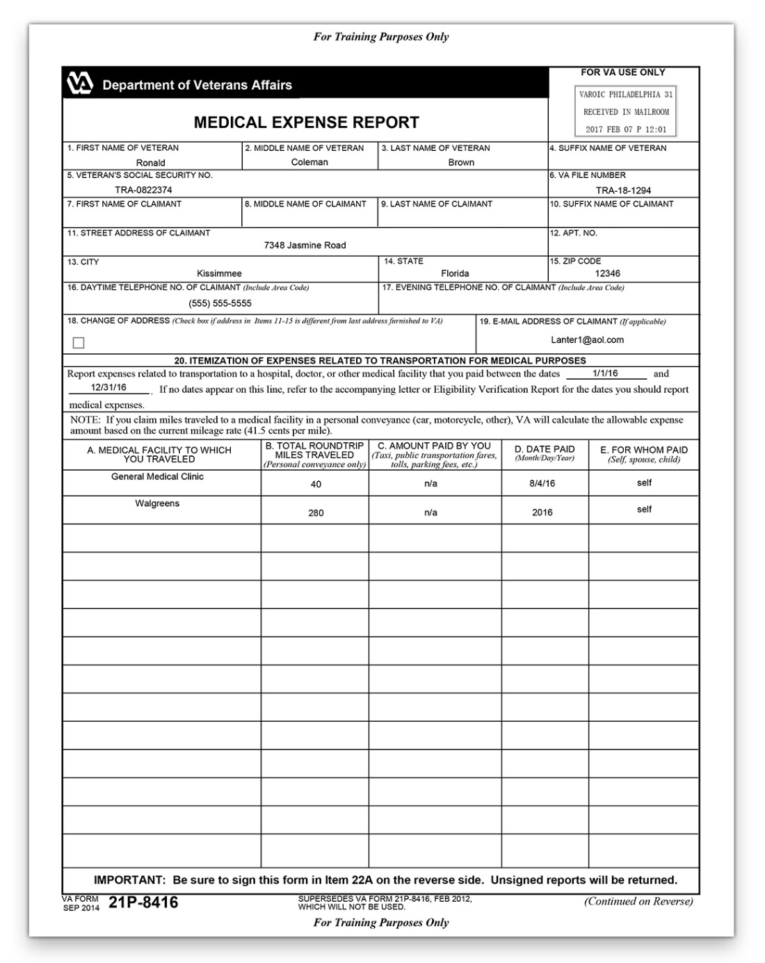

| PowerPoint Slides | Notes |
| --- | --- |
| Class Activity—Develop for Medical Expenses   * Instructions   + Access Appendix B: VA Form 21P-8416.   + Work as a class to identify any missing information and/or information that needs development. * Time allowed: 10-15 minutes |  |
| Class Activity—Develop for Medical Expenses Answers  • *The vitamins are over the $1500 limit so development would be needed for a doctor note. Refer to M21-1 IX.iii.1.G.3.r. (Vitamins, Food Supplements, and Herbal Remedies).* |  |
| Practice Exercise—Develop for Medical Expenses   * Instructions:   + Divide into groups of three.   + Use Claim 3.   + Complete Appendix A: Part D—Develop for Medical Expenses worksheet.   + Be prepared to share your finished activity with other groups. * Time allowed: 15 minutes |  |
| Practice Exercise—Develop for Medical Expenses Answers   * Answers provided by instructor based on example claim selected. |  |

Does each medical expense include the following required information?

| ✓ | Required Information | Details of Missing Information |
| --- | --- | --- |
|  | Purpose |  |
|  | Amount Paid by claimant |  |
|  | Date Paid |  |
|  | Name of Provider |  |
|  | For Whom Paid |  |
|  | Nursing home or other facility care statement (if applicable) |  |
|  | Doctors statement in order to allow an specific expenses (if applicable) |  |

| PowerPoint Slides |  |
| --- | --- |
| Deny the Medical Expense  Determine Qualifying Medical Expense Adjustment with the following traffic light labels: Green light—Calculate medical expense deduction Yellow light—Develop for medical expense Red light—Deny medical expense Red light is highlighted. |  |
| Deny the Medical Expense Demo  Title: Question Icon - Description: This icon prompts you to demonstrate a process or activity. |  |
| Practice Exercise—Medical Expense Adjustment   * Instructions:   + Work on your own.   + Use Claim 4.   + Use Appendix A: Part E—Medical Expense Adjustment worksheet to show your work.   + Be prepared to share the total medical expense adjustment amount with other trainees.   Time allowed: 15-20 minutes |  |

Effective (Entitlement) Date:

Payment (Financial Decision Effective) Date:

Medical Expenses:

| Description | Amount Paid | Date Paid | Provider | Paid For | UME or CME? |
| --- | --- | --- | --- | --- | --- |
|  |  |  |  |  |  |
|  |  |  |  |  |  |
|  |  |  |  |  |  |
|  |  |  |  |  |  |
|  |  |  |  |  |  |

| PowerPoint Slides | Notes |
| --- | --- |
| Practice Exercise—Medical Expense Adjustment Group Review  Instructions:   * + Divide into groups of three.   + Review your medical expense adjustment with the other members of the group.   + Discuss with your group the rationale for your answers. * Time allowed: 7-10 minutes |  |
| Practice Exercise—Medical Expense Adjustment Answers   * Answers provided by instructor based on example claim selected. |  |
| Final Expense Adjustments  Final Expense Adjustments with the three adjustments: medical expense adjustments, final expense adjustments, and educational expense adjustments. Final expense adjustments is highlighted. |  |
| Determine Qualifying Final Expense Adjustments  Determine Qualifying Final Expense Adjustments Determine Qualifying Final Expense  Adjustments with the following traffic light labels: Green light—Enter final expense Yellow light—Develop for final expense Red light—Deny final expense |  |
| Enter the Final Expense Adjustment  Determine Qualifying Final Expense  Adjustments with the following traffic light labels: Green light—Enter final expense Yellow light—Develop for final expense Red light—Deny final expense Green light is highlighted |  |
| Enter the Final Expense Demo  Title: Question Icon - Description: This icon prompts you to demonstrate a process or activity. |  |
| Develop for Final Expense  Determine Qualifying Final Expense  Adjustments with the following traffic light labels: Green light—Enter final expense Yellow light—Develop for final expense Red light—Deny final expense Yellow light is highlighted |  |
| Develop for Final Expense Answers  Information required for final (last illness or burial) expenses:   * + To whom Paid   + Nature of expense or debt   + Total amount of expense or debt   + Amount paid by claimant   + Date paid |  |
| Deny the Final Expense  Determine Qualifying Final Expense  Adjustments with the following traffic light labels: Green light—Enter final expense Yellow light—Develop for final expense Red light—Deny final expense Red light is highlighted. |  |
| Practice Exercise—Final Expense Adjustment   * Instructions:   + Divide into groups of three.   + Use Claim 5.   + Use Appendix A: Part F—Final Expense Adjustment worksheet to show your work.   + Be prepared to share your finished activity with other trainees. * Time allowed: 15 minutes |  |
| Practice Exercise— Final Expense Adjustment Answers   * Answers provided by instructor based on example claim selected. |  |

Effective (Entitlement) Date:

Payment (Financial Decision Effective) Date:

Final Expenses:

| To Whom Paid | Nature of Debt | Debt Amount | Amount Paid | Date Paid |
| --- | --- | --- | --- | --- |
|  |  |  |  |  |
|  |  |  |  |  |
|  |  |  |  |  |
|  |  |  |  |  |
|  |  |  |  |  |

| PowerPoint Slides | Notes |
| --- | --- |
| Educational Expense Adjustments  Educational Expense Adjustments with the three adjustments: medical expense adjustments, final expense adjustments, and educational expense adjustments. Educational expense adjustments is highlighted. |  |
| Determine Qualifying Educational Expense Adjustments  Determine Qualifying Expense Adjustments with the following traffic light labels: Green light—Enter educational expense Yellow light—Develop for educational expense Red light—Deny educational expense |  |
| Enter the Educational Expense  Determine Qualifying Educational Expense Adjustments with the following traffic light labels: Green light—Enter educational expense Yellow light—Develop for educational expense Red light—Deny educational expense Green light highlighted |  |
| Enter the Educational Expenses Demo  Title: Question Icon - Description: This icon prompts you to demonstrate a process or activity. |  |
| Develop for Educational Expense  Determine Qualifying Expense Adjustments with the following traffic light labels: Green light—Enter educational expense Yellow light—Develop for educational expense Red light—Deny educational expense Yellow light highlighted. |  |
| Deny the Educational Expense  Determine Qualifying Expense Adjustments with the following traffic light labels: Green light—Enter educational expense Yellow light—Develop for educational expense Red light—Deny educational expense Red light highlighted. |  |
| Practice Exercise—Educational Expense Adjustment   * Instructions:   + Divide into groups of three.   + Use Claim 6.   + Complete Appendix A: Part G—Educational Expense Adjustment worksheet to show your work.   + Be prepared to share your finished activity with other trainees. * Time allowed: 15 minutes |  |

Effective (Entitlement) Date:

Payment (Financial Decision Effective) Date:

Educational Expenses:

| Description | Amount Paid | Date Paid | Provider | Paid For |
| --- | --- | --- | --- | --- |
|  |  |  |  |  |
|  |  |  |  |  |
|  |  |  |  |  |
|  |  |  |  |  |
|  |  |  |  |  |
|  |  |  |  |  |

| PowerPoint Slides | Notes |
| --- | --- |
| Practice Exercise— Educational Expense Adjustment Answers  Answers provided by instructor based on example claim selected. |  |
| **Knowledge Check: Lesson Summary Review**    **Time Allowed: 15 minutes** |  |
| **Questions?**  This icon prompts you to ask trainees a discussion question or to ask trainees if they have any questions before proceeding with instruction. |  |
| **What’s Next**   * Complete Determine Qualifying Expense Adjustments Evaluation: TMS ID **4408485** |  |