Pension and fiduciary service
PMC VSR Intermediate Core Course
Phase 5: Proficiency Development
Part 3: Promulgation
Confirm Accuracy of a Rating Decision
Trainee Guide
June 2024

Confirm Accuracy of a Rating Decision

Lesson Overview
Topic | Description
Time Estimate: | 1 hour
Purpose of the Lesson: | This lesson is part of the entry-level curriculum Core Course for PMC VSRs. The purpose of this lesson is to prepare PMC VSRs to review a rating decision for completion and accuracy.
Prerequisite Training Requirements: | Prior to taking the Confirm Accuracy of a Rating Decision lesson, trainees must complete PMC VSR Core Course Phases 1–4, and Phase 5, Part 3.
Target Audience: | This lesson is for entry-level PMC VSRs.
Lesson References: | - 38 CFR 3.31 (Commencement of the period of payment)  - 38 CFR 3.351 (Special Monthly Dependency and Indemnity Compensation, Death Compensation, Pension, and Spouse’s Compensation Ratings)  - 38 CFR 3.400 for effective dates (General)  - 38 CFR 3.500 for effective date of rating reduction/discontinuance (General)  - 38 CFR 3.351 (Special Monthly Dependency and Indemnity Compensation, Death Compensation, Pension and Spouse’s Compensation Ratings)  - 38 CFR 21.3021 (Definitions)  - M21-1 VI.i.1.A.2.c (Award Processing Responsibilities)  - M21-1 V.iv.1.E.1.a (Review of Rating Decisions)  - M21-1 VI.i.1.A (Decision Authorization)  - Confirm Accuracy of a Rating Decision job aid  - Ready to Rate job aid  - Pension Systems and Applications job aid
Knowledge Check: | Phase 5.3: Confirm Accuracy of a Rating Decision Knowledge Check
Technical Competencies: | - Program Benefits and Eligibility (PMC VSR)  - Processing Claims (PMC VSR)
Lesson Objectives: | By the end of this lesson, you should be able to:  - Confirm accuracy of a rating decision  - Confirm effective date is correct  - Confirm information in rating decision is technically accurate  - Confirm all issues were addressed  - Complete request for corrected rating
What You Need: | - Access to VBA intranet  - Pen and paper or access to an electronic whiteboard  - Access to the following VBA systems:  - VBMS  - SHARE  - Access to the following job aids from VSR Assistant:  - Confirm Accuracy of a Rating Decision job aid  - Effective Dates EPSS job aid  - Ready to Rate job aid  - Pension Systems and Applications job aid

PowerPoint Slides |  | Notes
Confirm Accuracy of a Rating Decision
Lesson Objectives
By the end of this lesson, you should be able to:
- Confirm accuracy of a rating decision
- Confirm effective date is correct
- Confirm information in rating decision is technically accurate
- Confirm all issues were addressed
- Complete request for corrected rating
Why It Matters!
To Confirm Accuracy of a Rating Decision is important because it is the last step before processing the award and information must be correct and accurate to properly process the award.
Review: Authorization Activity
The authorization activity has the authority to make basic eligibility determinations and the authority to decide
- the effect an individual's income and/or net worth has on his/her entitlement to income-based benefits
- whether entitlement to additional benefits for a dependent or dependents exists, and
- whether entitlement to A&A under 38 CFR 3.351(c)(2) exists, based on the status of the following individuals as a patient in a nursing home:
  - Veteran in receipt of Veterans Pension
  - surviving spouse or parent in receipt of DIC
  - surviving spouse in receipt of Survivors Pension, or
  - spouse of a Veteran when the Veteran is in receipt of disability compensation
Review: Definitions (1 of 3)
- A rating decision is a record purposes document detailing the formal determination made by the rating activity regarding one or more issues of benefit entitlement, stating the decisions made and explanation supporting each decision.
- A decision means a formal determination on all questions of fact and law affecting the provision of VA benefits to a claimant.
- A favorable finding means a conclusion either on a question of fact or on an application of law to facts made by an adjudicator concerning the issue(s) under review.
- The initial rating decision, establishes the basic eligibility factors such as SC for the cause of death or an SC P&T disability.
Review: Definitions (2 of 3)
- 38 U.S.C. Chapter 35 program called, Survivors' and Dependents' Educational Assistance (DEA), provides education and training opportunities for eligible dependents of certain Veterans and service members.
- P&T means permanent and total “disability,” permanently and totally “disabled,” or permanent and total “rating”
  - Permanent disability means disabling manifestations reasonably certain to continue throughout the lifetime of the individual
  - Total disability means schedular or extra-schedular evaluations of 100 percent, a combined evaluation of 100 percent, or a total evaluation on the basis of IU
Review: Definitions (3 of 3)
- Effective date of the P&T rating means the date from which VA considers that the veteran's P&T disability commenced for purposes of VA benefits, as determined by the initial rating decision.
- The term first finds means the effective date of the P&T rating or the date VA first notifies the veteran of that rating, whichever is more advantageous to the child
- The date entitlement arose is the date on which the facts in the case demonstrate that the entitling criteria are first met
Confirm Accuracy of a Rating Decision
- After rating decisions are completed, they are routed directly to the authorization activity, which is responsible for processing rating decisions
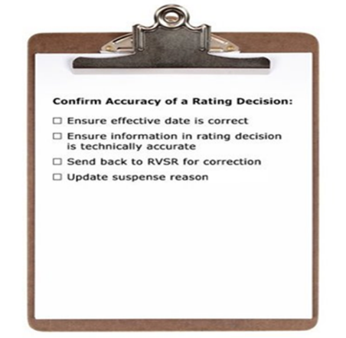
Ensure Effective Date is Correct
- Compare the effective date on the rating decision with the effective date in the claim documents and the date entered in VBMS-A
- The effective date on the rating decision may not always match the effective date in basic eligibility
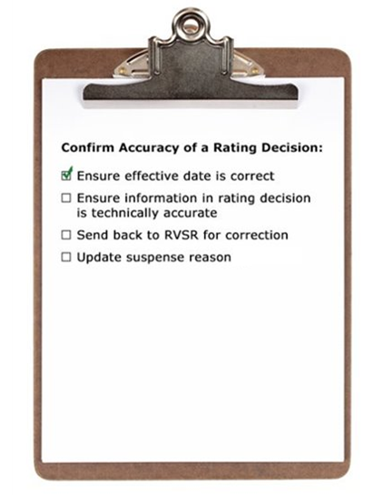
Ensure Information in Rating Decision is Technically Accurate
- Review the rating decision for spelling/grammar errors
- Ensure the decision is consistent with rationale provided in rating decision
- Ensure all issues are addressed:
  - All eligible benefits were considered
  - Date of death is accurate
- If there is a POA, ensure the POA is indicated on the first page of the rating decision
- If death was service-connected or DIC under 38 USC 1318 was granted, ensure entitlement to Chapter 35/DEA was considered
- Verify no claim or appeal was pending at time of Veteran’s death
  - Refer to rating if review of accrued benefits is necessary
Eligibility to DEA
- Basic eligibility to DEA is a rating issue if:
  - there is a claim for DEA or Chapter 35 benefits
  - a beneficiary requests a determination on P&T disability
  - SC for the cause of death is awarded, or
  - in connection with a claim for death benefits, the Veteran was rated 100-percent disabled due to SC disabilities or entitled to IU on the date of death
Correcting Rating Decisions
The rating activity must correct all Narrative section deficiencies when those are noted prior to promulgation and/or authorization
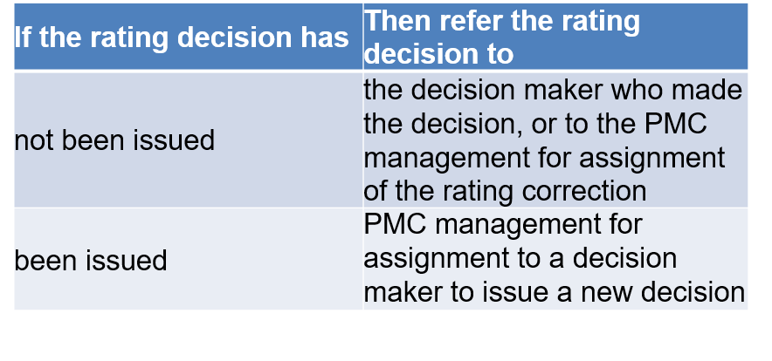
Send Back to the RVSR for Correction
- Notify the RVSR via email, phone, or in person.
- Request that rating be corrected.
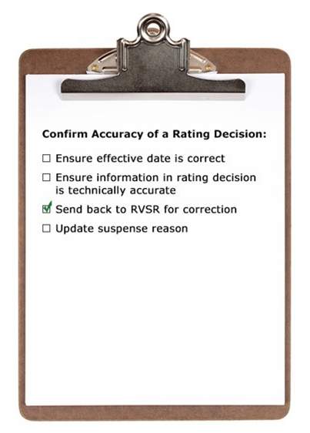
Update Suspense
- Update suspense reason.
- Wait 1-2 days for the corrected rating decision to be returned.
- If no corrections are needed, continue processing the award.
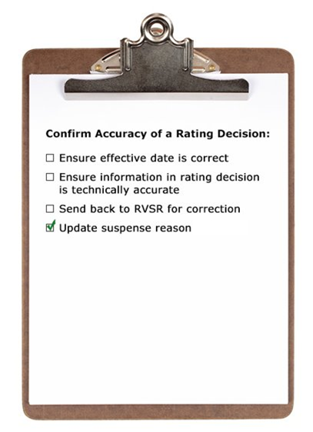
Example Scenario 1—Ensure All Issues are Addressed
You processed a claim for Dependency & Indemnity Compensation (DIC). During your review of the rating decision, you see the RVSR granted service connection for the cause of death and established eligibility to Chapter 35 benefits. You review the claim documents in VBMS and discover a VA Form 21-2680 (Examination for Housebound Status or Permanent Need for Regular Aid and Attendance) was submitted with the original claim documents. The rating does not address Aid and Attendance or Housebound benefits.
Based on the information received, what would be your next step and why?​
Example Scenario 1—Ensure All Issues are Addressed Answer
Based on the information received, what would be your next step and why?​

Example Scenario 2—Ensure Date of Death is Correct
You processed a claim for survivor's pension with the aid and attendance allowance and are reviewing the rating decision completed by an RVSR. You determine the aid and attendance allowance decision is accurate; however, the date of death of the Veteran listed in the narrative is incorrect. You review SHARE and BIRLS and determine the date of death was input incorrectly into the VA system programs.
Based on the information received, what would be your next step and why?​
Example Scenario 2—Ensure Date of Death is Correct Answer
Based on the information received, what would be your next step and why?​
Demonstration—Review the Rating Decision
- Instructions:
  - Access Claim 1
  - Access the Confirm Accuracy of a Rating Decision job aid.
  - Follow along as the instructor reviews the rating decision for accuracy.
- Time allowed: 10 minutes
Claim 2 Activity—Confirm Accuracy of a Rating Decision
- Instructions:
  - Divide into groups of three.
  - Access the Confirm Accuracy of a Rating Decision job aid to complete the exercise.
  - Review the Claim 2.
  - Be prepared to explain your group’s findings.
- Time allowed: 10 minutes
Claim 2 Activity—Confirm Accuracy of a Rating Decision Debrief
- Follow along as the instructor reviews the correct findings for each rating decision.
- Ask for clarification on steps or actions, if needed.
Confirm Accuracy of a Rating Decision Review
When reviewing a rating decision for accuracy:
- Confirm information in rating decision is technically accurate
  - Review the rating decision for spelling/grammar errors
  - Ensure the decision is consistent with rationale provided in rating decision
  - Ensure all issues are addressed
  - If there is a POA, ensure the POA is indicated on the first page of the rating decision
  - If death was service-connected or DIC under 38 USC 1318 was granted, ensure entitlement to Chapter 35/DEA was considered
  - Verify no claim or appeal was pending at time of Veteran’s death
- Ensure effective date is correct
  - Compare with effective date entered in VBMS-A
- Complete request for corrected rating
  - Notify the RVSR via email, phone, or in person
  - Update suspense reason
Knowledge Check Lesson Summary Review
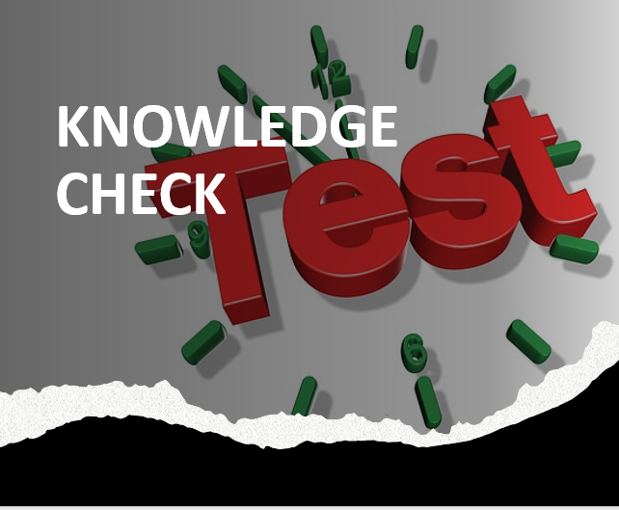
Time Allowed: 10 minutes
What’s Next?
- Complete TMS Evaluation Confirm Accuracy of Rating Decision using (TMS# 4408481)

