Pension and fiduciary service
PMC VSR Intermediate Core Course
Phase 5: Proficiency Development
Part 3: Promulgation
Overview of the Award Process

Trainee Guide

June 2024

Overview of the Award Process

Lesson Overview
Topic | Description
Time Estimate: | 2 hours
Purpose of the Lesson: | This lesson is part of the entry-level curriculum, Core Course for PMC VSRs. The purpose of this lesson is to prepare PMC VSRs to process an award action.
Prerequisite Training Requirements: | Prior to taking the Overview of the Award Process lesson, trainees must complete PMC VSR Core Course Phases 1–5.2.
Target Audience: | This lesson is for entry-level PMC VSRs.
Lesson References: | - Compensation and Pension Knowledge Management (CPKM)  - 38 CFR 3.106 (Renouncement)  - M21-1 VI.i.1.A. (Decision Authorization)  - M21-1 VI.i.1.A.1.a. (Final Stage in Adjudicating a Claim)  - M21-1 VI.i.1.A.1.b. (Responsibility for Awarding or Denying Benefits)  - M21-1 VI.i.1.A.2. (General Information on Processing Decisions)  - M21-1 VI.i.1.A.2.c. (Award Processing Responsibilities)  - M21-1 VI.i.1.A.3. (General Information on Denials)  - M21-1 VI.i.1.A.3.a. (Definition: Denial)  - M21-1 VI.i.1.A.2.d. (Circumstances Under Which a VSR May Authorize His/Her Own Award Action)  - M21-1 VI.i.1.A.4. (Denials Based on a Claimant’s Failure to Furnish Requested Evidence)  - M21-1 VI.i.1.B. (Decision Notices)  - M21-1 VI.i.1.B.1.b. (Decision Notice Requirements)  - M21-1 X.iv.4. (Renouncements)  - M21-1 X.iv.4.1. (General Information About Renouncement)  - M21-1 X.iv.4.1.b. (Acceptable Means of Renouncing the Right to a Benefit)  - M21-1 X.iv.4.3.c. (System Entries for Discontinuing an Award)  - M21-1 X.iv.4.3.d. (Notification of Renouncement of the Right to Pension or Parents DIC)  - M21-1 X.iv.4.3.e. (Notification of Renouncement of the Right to Benefits Other Than Pension or Parents DIC)  - Annotate the Award job aid  - Processing an Award Adjustment job aid  - Processing an Award Renouncement job aid  - Processing a Denial of Benefits job aid  - Processing a Grant of Benefits job aid
Technical Competencies: | - Processing Claims (PMC VSR)  - Special Monthly Pension (SMP) Processing  - VBA Applications (PMC VSR)
Knowledge Check: | Phase 5.3 Overview of the Award Process Knowledge Check
Lesson Objectives: | By the end of this lesson, you should be able to:  - Describe how to prepare an award action  - Describe the responsibilities on award action for all decisions  - Describe the common steps for processing a grant of benefits  - Describe the common steps for processing a denial of benefits  - Describe the common steps for processing an award adjustment  - Describe the common steps for processing a renouncement
What You Need: | - Trainee Guide  - Access to CPKM  - Access to the following job aids from VSR Assistant:  - Processing a Grant of Benefits job aid  - Processing a Denial of Benefits job aid  - Processing an Award Adjustment job aid  - Processing an Award Renouncement job aid  - Annotate the Award job aid  - Appendix A – Overview of the Award Process

PowerPoint Slides | Notes
Overview of the Award Process

Lesson Objectives
By the end of this lesson, you should be able to:
- Describe how to prepare an award action
- Describe the responsibilities on award action for all decisions
- Describe the common steps for processing a grant of benefits
- Describe the common steps for processing a denial of benefits
- Describe the common steps for processing an award adjustment
- Describe the common steps for processing a renouncement
Why It Matters!
Overview of the Award Process is important because the authorization activity is responsible for ensuring VA makes a decision to award or deny entitlement to benefits for each issue a claimant raises. The authorization activity must address all issues based on eligibility criteria and the rating decision and inform the claimant of the decision on each issue.
Award Actions
Processing an award action includes granting, denying, or adjusting benefits for the following claims:
- Veterans pension
- Survivors pension
- Survivors DIC
- Parents DIC
- Accrued
- Burial
Processing an Award
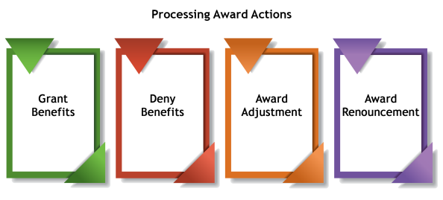

Common Steps for Granting Benefits
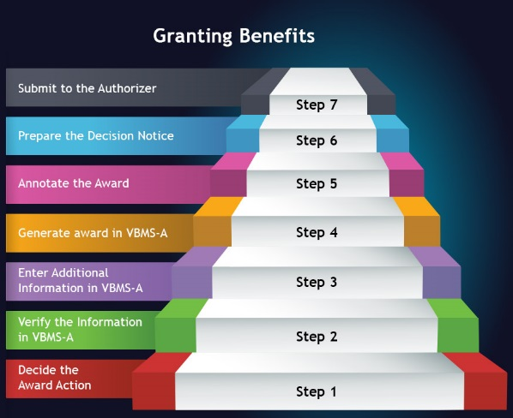
Granting Benefits—Generate Award in VBMS-A
- Conduct a cursory review of the rating decision, to include the code sheet, in an attempt to identify any obvious errors, such as failure to consider entitlement to Chapter 35 benefits when a total disability rating is granted and no future examination is required
- Access the RATING screen in the Veterans Benefits Management System – Awards (VBMS-A) to validate data contained in the rating decision and notify the rating activity if any inconsistencies exist
- Enter additional data pertaining to the decision into the claims-processing system, as applicable
- Generate an award
Granting Benefits—Annotate the Award
- Ensure, as applicable, that the award document fully reflects all new and/or increased entitlements implemented by the associated rating decision and/or authorization determination(s)
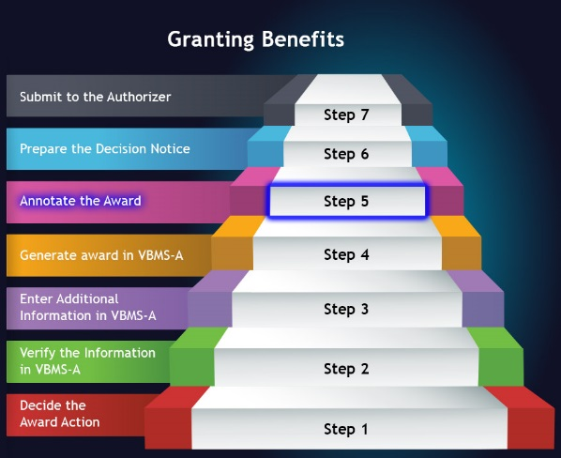
Granting Benefits—Prepare the Decision Notice
- Prepare a decision notice for the claimant
- For pension and Parents' DIC cases only, VSRs must ensure documentation of calculations made to determine the rate of benefits (such as calculations of medical expenses, net worth, and waived overpayments) are included in the electronic claims folder
- Route the award to a Senior VSR (SVSR)
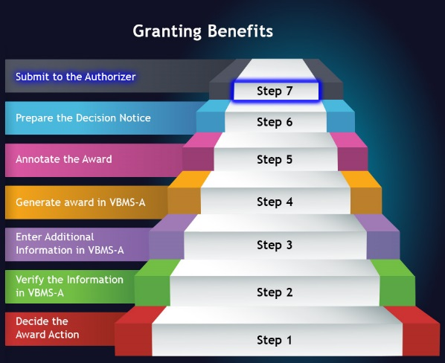
Practice Exercise—Granting Benefits
- Instructions:
  - Divide into groups of three.
  - Complete Appendix A: Part A—Granting Benefits worksheet.
  - Use the Processing a Grant of Benefits job aid.
  - Be prepared to share your finished activity with other groups.
- Time allowed: 7-10 minutes
Practice Exercise—Granting Benefits Answers
- What decision would you use for granting this award?
- What award type would this decision be processed under in VBMS-A?
- You have successfully entered all the information into VBMS-A. What is your next step in granting benefits?

Denying Benefits
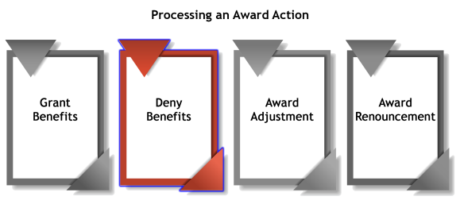
Common Steps for Denying Benefits
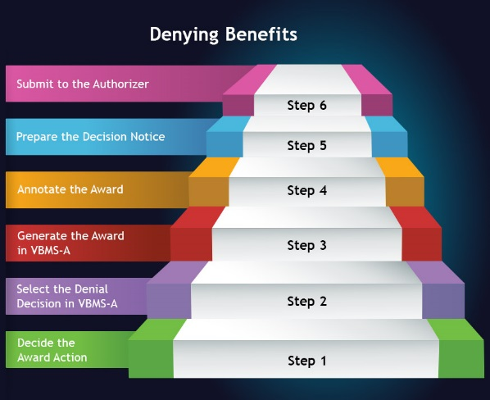
Practice Exercise—Denying Benefits
- Instructions:
  - Divide into groups of three.
  - Complete Appendix A: Part B—Denying Benefits worksheet.
  - Use the Processing a Denial of Benefits job aid.
  - Be prepared to share your finished activity with other groups.
- Time allowed: 10 minutes
Practice Exercise—Denying Benefits Answers
- What decision would you use for denying this award?
- What denial decision would be selected in the VBMS-A?
- What is the final step of the denial process?
Award Adjustment
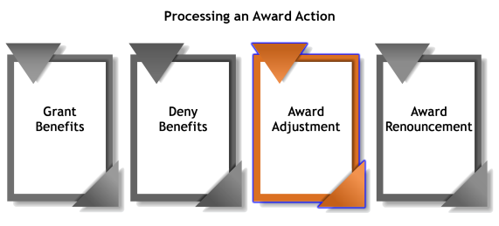
Common Steps for Award Adjustment
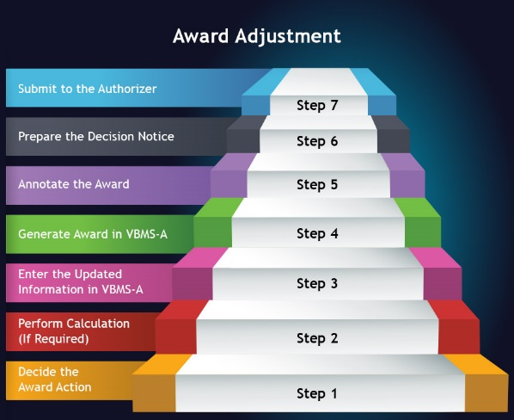
Practice Exercise—Award Adjustment
- Instructions:
  - Divide into groups of three.
  - Complete Appendix A: Part C—Award Adjustment worksheet.
  - Use the Processing an Award Adjustment job aid.
  - Be prepared to share your finished activity with other groups.
- Time allowed: 10-15 minutes
Practice Exercise—Award Adjustment Answers
- What decision would you use for processing this award adjustment?
- What information would be updated in the VBMS-A?
- After you have updated in the VBMS-A, what is the next step in the award adjustment process?
Award Renouncement
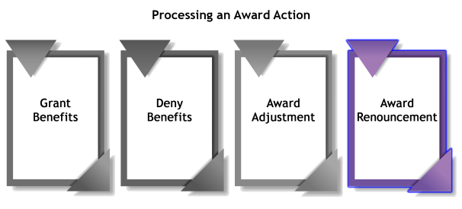
Common Steps for Award Renouncement
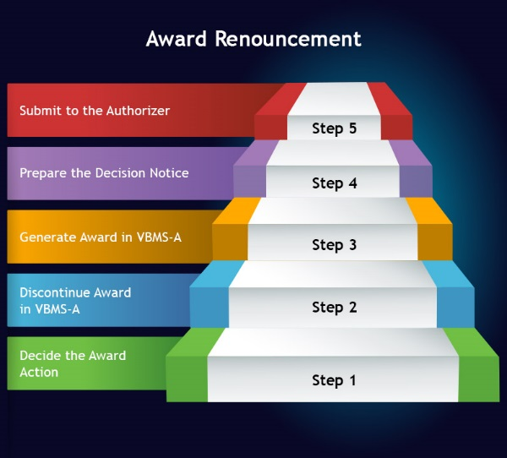
Practice Exercise—Award Renouncement
- Instructions:
  - Divide into groups of three.
  - Complete Appendix A: Part D—Award Renouncement worksheet.
  - Use M21-1 X.iv.4. (Renouncements).
  - Be prepared to share your finished activity with other groups.
- Time allowed: 5-7 minutes
Practice Exercise—Award Renouncement Answers
Scenario 1:

Scenario 2:
Practice Exercise—Award Process
- Instructions:
  - Divide into groups of three.
  - Complete Appendix A: Part E—Award Process Worksheet.
  - Use the job aid listed in Part E.
  - Be prepared to share your finished activity with other groups.
- Time allowed: 15-20 minutes
Practice Exercise—Award Process Questions (1 of 2)
- Based on this scenario, are there multiple issues for this claim? If so, what are the issues?
- If Mr. Curtis was granted benefits, what would be the first step in the award process?
Practice Exercise—Award Process Questions (2 of 2)
- You have started the award process and you need to enter a decision for the dependent. Based on the scenario, what information should be entered in VBMS-A?
- After you have prepared a decision notice for Mr. Curtis, what is the final step you need to take in the award process?
Knowledge Check: Lesson Summary Review
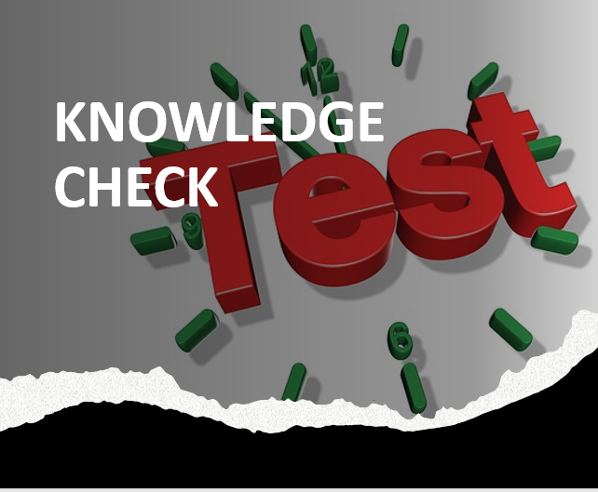
Time Allowed: 15 minutes
What’s Next
- Complete TMS Evaluation Confirm Accuracy of Rating Decision using (TMS# 4408480)

