PENSION AND FIDUCIARY Service

**PMC VSR Intermediate Core Course**

**Phase 5: Proficiency Development**  
**Part 1(d): Beyond Basic Eligibility**

Determine Burial Benefits Eligibility

Trainee Guide

May 2024

Determine Burial Benefits Eligibility

Lesson Overview

| Topic | Description |
| --- | --- |
| Time Estimate: | 3 hours |
| Purpose of the Lesson: | This lesson is part of the entry-level course for PMC VSRs. The purpose of this lesson is to train PMC VSRs how to determine burial benefits eligibility through demonstration and practice. This lesson also includes instruction on how to use the systems for determining burial benefits eligibility. |
| Prerequisite Training Requirements: | Prior to taking the Determine Burial Benefits Eligibility lesson, trainees must complete entry-level:   * Phases 1–4 and Phase 5 Lessons 1.a-c. |
| Target Audience: | This lesson is for entry-level PMC VSRs |
| Lesson References: | * VA Form 21P-530EZ, Application for Burial Benefits (Under 38 U.S.C. Chapter 23) * VA Form 27-0820, Report of General Information * VA Form 27-0820a, Report of First Notice of Death * 38 U.S.C. Chapter 23 – Burial Benefits * 38 CFR 3.1700 – Types of VA Burial Benefits * 38 CFR 3.1702 – Persons who may Receive Burial Benefits – Priority of Payments * 38 CFR 3.1703 – Claim for Burial Benefits * 38 CFR 3.1704 – Burial Allowance Based on Service-connected Death * 38 CFR 3.1705 – Burial Allowance Based on Non-Service-Connected Death * 38 CFR 3.1712 – Effect of Forfeiture on Payment of Burial Benefits * M21-1 XI.iii.1.A. (General Information on Burial Benefits Allowances) * M21-1 IX.iii.1.B (Burial Benefits) * **Burial Benefits Eligibility** job aid * **Prepare the Decision Notice** job aid * **Notification Language** job aid * ***Appendices A and B*** |
| Technical Competencies: | * Program Benefits and Eligibility (PMC VSR) * VBA Applications (PMC VSR) |
| Knowledge Check: | Phase 5.1(d) Determine Burial Benefits Eligibility Knowledge Check |
| Lesson Objectives: | At the end of this lesson, given the training and references, the learner will be able to do the following:   * Define types of burial benefits * Determine whether general eligibility requirements for burial benefits are met * Identify claimant eligible for payment * Determine whether eligibility requirements for service-connected (SC) burial benefits are met * Determine whether eligibility requirements for non-service-connected (NSC) burial benefits are met * Determine **whether eligibility for** whether eligibility requirements for death while under VA care burial benefits are met * Determine whether development is required for burial-related information * Determine whether a burial claim requires rating activity |
| What You Need: | * Trainee guide * Pen and paper * Access to the **Burial Benefits Eligibility** job aid * Access to the **Prepare the Decision job aid** * Access to the **Notification Language job aid** * *Appendix A* for other job aids * *Appendix B* exercise worksheet |

| PowerPoint Slides | | Notes |
| --- | --- | --- |
| **Determine Burial Benefits Eligibility** | |  |
| **Lesson Objectives (1 of 2)**  At the end of this lesson, given the training and references, the learner will be able to do the following:    * Define types of burial benefits * Determine whether general eligibility requirements for burial benefits are met * Identify claimant eligible for payment * Determine whether eligibility requirements for service-connected (SC) burial benefits are met | |  |
| **Lesson Objectives (2 of 2)**   * Determine whether eligibility requirements for non-service connected (NSC) burial benefits are met * Determine whether eligibility for whether eligibility requirements for death while under VA care burial benefits are met * Determine whether development is required for burial-related information * Determine whether a burial claim requires rating activity | |  |
| Why It Matters!   * Burial benefits assist the deceased Veteran’s family with unexpected expenses they will incur or have already incurred at a difficult time * In addition, there are several different types of burial benefits, each with different eligibility requirements * Thus, it is important to be able recognize the benefit being requested and apply the correct rules | |  |
| Types of Burial Benefits   * VBA provides the following four burial benefits:   + service-connected (SC) burial allowance   + non-service-connected (NSC) burial allowance (to include death while under VA care)   + plot or interment allowance, and   + transportation benefits   Note: National Cemetery Administration (NCA) processes claims for headstones, markers, and burial flags. | |  |
| Definitions (1 of 4)  **Burial** includes all the various recognized methods of disposing of the remains of deceased persons. Examples include   * **Cremation** is a burial, regardless of what is done with the ashes * **Burial** at sea occurs when the deceased Veteran’s body is committed to the sea (not eligible for plot or interment allowance) * **Medical school donation** is considered a recognized method of disposing of remains if the deceased Veteran’s body is turned over to a medical school for scientific purposes * **Alkaline Hydrolysis** (Green Cremation) is a water-based dissolution process for human remains that uses alkaline chemicals to accelerate natural decomposition | |  |
| **Definitions (2 of 4)**   * **Plot** is the final disposal site of the remains.   + the grave where the casket is buried, not the casket itself, or   + the columbarium niche containing the cremation urn, not the urn itself * **Interment** is the act of placing the remains of a deceased person into a final resting place (e.g., grave, or cremains into a columbarium niche). * The ***place of death*** is the place shown by the death certificate or other acceptable evidence of death under 38 CFR 3.211. | |  |
| **Definitions (3 of 4)**   * ***Covered Veterans’ cemetery*** is a Veterans cemetery in which a deceased Veteran is eligible to be buried that is owned by a State or is on a trust land owned by, or held in trust for, a tribal organization, and for which the Secretary has made a grant under 38 U.S.C. 2408 (e.g., State Veterans’ Cemetery and Tribal Veterans’ Cemetery).   + [VA Grant-Funded Cemeteries Listing](https://www.cem.va.gov/find-cemetery/all-grant-funded.asp) * The ***nearest national cemetery*** is a cemetery under the jurisdiction of VA National Cemetery Administration (NCA) or Arlington National Cemetery that is the closest, geographically, to the Veteran’s last place of residence,   + or a national cemetery or covered Veterans’ cemetery where burial space was reserved for the Veteran, when there has been interment in that space of a dependent who died before the Veteran died |  | |
| **Definitions (4 of 4)**   * **Transportation** is described as the cost of transporting the remains.​ * **Proof of death** is evidence that establishes death via a copy of the public record of the State or community where death occurred.   + A copy of a coroner's report of death or a verdict of a coroner's jury of the State or community where death occurred, provided the report or verdict properly identified the deceased.   **Note:** Where it is indicated that the veteran died under circumstances which precluded recovery or identification of the body, the fact of death should be established by the best evidence, which from the nature of the case must be supposed to exist. | |  |
| **Definition: Last Place of Residence**   * The ***last place of residence*** is the place where the Veteran lived at the time of death.   + It is normally the legal domicile but includes a temporary residence if it is more advantageous to the claimant   + Unless the claimant affirmatively shows it to be elsewhere, accept the place of last residence as the home address to which checks were being mailed, if the Veteran was in receipt of VA benefits at the time of death (a home address is *not* a bank address, post office box, or the address of a fiduciary), **or** address shown as the residence of the deceased on the death certificate | |  |
| **Definition: Unclaimed Veteran Remains**   * ***Unclaimed Veteran remains*** are the remains of an identified Veteran   + who has not been claimed by relatives or friends   + who does not have sufficient resources available in the Veteran’s estate to cover the burial and funeral expenses, and   + whose burial is not the responsibility of any other Federal, State, or local agency   **Note:** VHA is responsible for burial payments and arrangements for the unclaimed remains of Veterans who die while hospitalized under VA medical care. | |  |
| **Burial Forms (1 of 5)**   * For burial benefits not automatically processed, a [*VA Form 21P-530EZ, Application for Burial Benefits, (Under 38 U.S.C. Chapter 23)*](https://www.vba.va.gov/pubs/forms/VBA-21P-530EZ-ARE.pdf) is required and must contain the signature of the claimant. * For tribal organization and State consolidated claims for plot or interment allowance, a [*VA Form 21P-530a, State or Tribal Organization Application for Interment Allowance (Under 38 U.S.C. Chapter 23)*](https://www.vba.va.gov/pubs/forms/VBA-21P-530a-ARE.pdf), is required. * For reimbursement of headstone or marker expense claims, a [*VA Form 21P-8834, Application for Reimbursement of Headstone or Marker Expense*](http://vbaw.vba.va.gov/bl/20/cio/20s5/forms/VBA-21P-8834-ARE.pdf)*,* is required and must contain the signature of the claimant. | |  |
| **Burial Forms (2 of 5)**   * VA accepts electronically filed versions of [*VA Form 21P-530EZ*](https://www.vba.va.gov/pubs/forms/VBA-21P-530EZ-ARE.pdf), to include those submitted through [www.VA.gov](http://www.va.gov/). * Take the following actions when reviewing 21P-530EZ​ | |  |
| ****Burial Forms (3 of 5)****  For signed claims on a [*VA Form 21P-530EZ*](https://www.vba.va.gov/pubs/forms/VBA-21P-530EZ-ARE.pdf), and **incurred expenses** for the Veteran's **burial** | |  |
| **Burial Forms (4 of 5)**  For signed claims on a [*VA Form 21P-530EZ*](https://www.vba.va.gov/pubs/forms/VBA-21P-530EZ-ARE.pdf), and incurred expenses for the Veteran's **plot or interment**​, | |  |
| **Burial Forms (5 of 5)**  For signed claims on a [*VA Form 21P-530EZ*](https://www.vba.va.gov/pubs/forms/VBA-21P-530EZ-ARE.pdf), to determine transportation benefits, | |  |
| **Group Activity – Match the Terms/Actions**  Instructions:   * Divide into groups of three. * Access **Appendix B – Match the Terms/Actions Worksheet**. * Use **Burial Benefits Eligibility** job aid * Use the worksheet to record the group’s response.   Time allowed: 10 minutes | |  |
| **Burial Benefits: Verification of Service (1 of 3)**   * A Veteran for the purpose of burial benefits is an individual who served in the active military, naval, air, or space service, and was discharged or released under conditions other than dishonorable. * A Veteran must have had one qualifying period of other than dishonorable service for burial benefits to be payable. * To verify qualifying service for entitlement to burial benefits, use the evidence on which VA relied to pay benefits during the Veteran’s lifetime, *unless* there is evidence that creates doubt as to its validity. | |  |
| **Burial Benefits: Verification of Service (2 of 3)**   * If the Veteran was never in receipt of VA benefits and acceptable documentation verifying service is not of record * request verification from the Veteran’s service department via the Personnel Information Exchange System (PIES), and/or ask the claimant to submit a copy or certified copy of *DD Form 214, Certificate of Uniformed Service,* or Certificate of Discharge * review service information within Veteran Information Solution (VIS), or * submit a Defense Personnel Records Information Retrieval System (DPRIS) request | |  |
| **Burial Benefits: Verification of Service (3 of 3)**  Concede service as verified for   * burial purposes *only* if there is evidence that the Veteran is buried in a national cemetery when there is no service verified and annotate the award that service is conceded because the Veteran is buried in a national cemetery, or * claims based on unclaimed remains, if there is no service verified, and a*DD Form 214* or equivalent report of separation showing character of service as noted in [M21-1, Part III, Subpart i, 1.B.2](https://vaww.vrm.km.va.gov/system/templates/selfservice/va_kanew/help/agent/locale/en-US/portal/554400000001034/content/554400000181425/M21-1,-Part-III,-Subpart-i,-Chapter-1,-Section-B---Service-Requirements-and-Verification-of-Eligibility) is of record, and in the opinion of the claims processor, the discharge document is genuine and unaltered, and the information contained in it is accurate | |  |
| ****Eligibility Requirements for SC Burial Benefits****  SC burial allowance is payable for Veterans   * who died as a result of SC disability or disabilities (including [**38 U.S.C. 1151**](https://www.law.cornell.edu/uscode/text/38/1151)) * who were rated totally disabled (100 percent) for an SC disability or disabilities at time of death (excluding IU), or * when Dependency and Indemnity Compensation (DIC) is granted (including DIC granted under [**38 U.S.C. 1318**](https://www.law.cornell.edu/uscode/text/38/1318) or [**38 U.S.C. 1151**](https://www.law.cornell.edu/uscode/text/38/1151)) | |  |
| ****Service Unverified****   * If other qualifying criteria are met, and service is not shown as verified in VA systems, service requirements can be conceded for payment of the following benefit for a Veteran who, on the date of death, was receiving VA pension or disability compensation:   + NSC burial allowance (to include death while under VA care)   + plot or interment allowance, or   + transportation benefit * If there is conflicting evidence with respect to the period(s) of service, and VA pension or disability compensation was granted, the evidence must be verified before payment can be authorized | |  |
| ****Claimants Eligible for Payment (1 of 3)****   * VBA automatically pays a burial and plot or interment allowance to an eligible surviving spouse without a claim, when VA is able to determine burial benefit eligibility based on evidence of record or when the surviving spouse is added at the time of the First Notice of Death (FNOD) is processed.   + A surviving spouse may file a [*VA Form 21P-530EZ*](https://www.vba.va.gov/pubs/forms/VBA-21P-530EZ-ARE.pdf) for additional burial benefits, including the plot or interment allowance, if not paid during the automated process, the SC burial allowance under [38 CFR 3.1704](http://www.ecfr.gov/cgi-bin/text-idx?SID=7237d0a3574053bda9ef7dbe28c3b45b&mc=true&node=se38.1.3_11704&rgn=div8), and transportation benefits. | |  |
| Claimants Eligible for Payment (2 of 3)   * For all burial benefits not paid automatically to the eligible surviving spouse at the notice of death (NOD), VBA may pay the applicable burial benefit to the first person to file a claim for burial benefits from the following list of eligible claimants: * Veteran’s surviving spouse * survivor of a legal union between the deceased Veteran and the claimant that   + existed on the date of the Veteran’s death   + was recognized under the law of the State in which the couple formalized the relationship, and   + was evidenced by the State’s issuance of documentation memorializing the relationship | |  |
| Claimants Eligible for Payment (3 of 3)   * Veteran’s child, regardless of age * Veteran’s parent * Other relative or friend of the Veteran * Executor or administrator of the Veteran’s estate or a person acting for the executor or administrator of the estate of the deceased Veteran * Funeral directors can only be paid for burial claims for a Veteran whose remains are unclaimed. * Note: Development for a claimant's eligibility is generally not required if the relationship of the claimant to the deceased Veteran is left blank on VA Form 21P-530EZ, but the claimant identifies that they incurred the expenses for the Veteran’s burial, plot or transportation. | |  |
| FNOD and NOD   * An NOD is acceptable if it furnishes sufficient information about the Veteran to allow a definite identification of the Veteran’s record and identifies the source of the report of the death. * Upon receipt of an acceptable Veteran NOD, process an FNOD *only* on a Veteran’s record under either the   + FNOD command, or * establishment of an EP for a claim for survivor benefits, and when the exact date of death is known. | |  |
| ****Proof of Death (1 of 2)****   * If proof of death does not accompany the claim, access the Federal On-line Query (FOLQ) through Veterans Benefits Management System or Share using the Social Security Administration (SSA) INQUIRY command for proof of death. * When FOLQ attempts are unsuccessful, proof *may* be obtained verbally   + All verbal information reported to VBA must be documented on a [*VA Form 27-0820, Report of General Information*](http://vbaw.vba.va.gov/bl/20/cio/20s5/forms/VBA-27-0820-ARE.pdf), or [*VA Form 27-0820a, Report of First Notice of Death*](http://vbaw.vba.va.gov/bl/20/cio/20s5/forms/VBA-27-0820a-ARE.pdf) | |  |
| ****Proof of Death (2 of 2)****   * For claims of SC death where a rating decision is needed, a death certificate or other acceptable proof of death as outlined in [38 CFR 3.211](https://www.ecfr.gov/cgi-bin/text-idx?SID=618b4be8fc2e0bdea399eae739f01c2a&mc=true&node=se38.1.3_1211&rgn=div8) that specifies a cause of death is required. * If acceptable proof of death as outlined in [38 CFR 3.211](https://www.ecfr.gov/current/title-38/chapter-I/part-3/subpart-A/subject-group-ECFRdc46cfd3b31f77a/section-3.211) that specifies a cause of death is not received after development, but eligibility and acceptable proof of death for NSC burial allowance exists,   + grant the NSC burial allowance and   explain in the decision notice that evidence of the proof of death specifying a cause of death is required to grant the SC burial allowance. | |  |
| **Burial: Time Limits**   * Claims for the NSC burial allowance must be filed within two years of the date of permanent burial or cremation of the Veteran.   + Payment may not exceed the statutory rate in effect at the time of the burial * There is no time limit for applying for the   + SC burial allowance   + NSC burial allowance based upon death while under VA care   + plot or interment allowance, or transportation benefit | |  |
| ****Burial and Plot Allowance**** | |  |
| ****Priority Payment****   * + The provisions of priority of claimants do not apply to a State, an agency or political subdivision of a State, or a tribal organization when claiming plot or interment allowance for burial in a State Veterans cemetery or other cemetery as listed in [38 CFR 3.1707](https://www.ecfr.gov/current/title-38/chapter-I/part-3/subpart-B/subject-group-ECFR5b4f6562c054728/section-3.1707) or for the burial of a Veteran whose remains are unclaimed. | |  |
| **NSC Burial Allowance Eligibility**   * Eligibility for the NSC burial allowance exists if the Veteran   + was receiving pension or compensation at the time of death   + was receiving military retired pay in lieu of compensation at the time of death   + had a claim pending at the time of death and has been found entitled to compensation or pension from a date prior to the date of death   + has no family or friends who claim the Veteran’s body and there are insufficient resources to cover burial and funeral expenses, or   + died while under VA care | |  |
| ****NSC Burial Allowance (1 of 2)****   * The NSC burial allowance based upon death while under VA care may also be payable for a Veteran who died while under VA care but who was not at a qualifying facility at the time of death. * This provision applies if the Veteran was   + on authorized absence that did not exceed 96 hours at the time of death   + on unauthorized absence for a period not in excess of 24 hours at the time of death, or   + absent from the facility for a period not in excess of 24 hours of combined authorized and unauthorized absence at the time of death | |  |
| ****NSC Burial Allowance (2 of 2)****   * If a Veteran is entitled to both NSC burial allowance based upon death while under VA care and SC burial allowance, pay the SC burial allowance as the greater benefit. * Death while hospitalized in the Philippines does not qualify for payment of the NSC burial allowance based upon death while under VA care * If the Veteran is entitled to both the SC burial allowance and the NSC burial allowance based upon death while under VA care, pay the SC burial allowance as the greater benefit | |  |
| **Unclaimed Remains (1 of 4)**  NSC burial allowance is payable for a Veteran if   * the remains of the deceased Veteran are unclaimed * burial expenses were not paid for or reimbursed by another agency such as Veterans Health Administration (VHA) and * there are insufficient resources available in the Veteran’s estate to cover the burial and funeral expenses.   **Notes:**   * Per PL 112-260 (with effective date of July 7, 2014, per 79 FR 32653), the following are not required for unclaimed remains: | |  |
| **Unclaimed Remains (2 of 4)**   * wartime service or discharge due to disability requirements * receipt of compensation or pension at the time of death, or * authorization of the deceased Veteran’s funeral service by the State or political subdivision of the State. * The claim must be denied if the application for burial benefits indicates that there are sufficient resources available in the Veteran’s estate to cover the burial and funeral expenses, and the funeral home is claiming benefits for unclaimed remains. | |  |
| **Unclaimed Remains (3 of 4)**   * Next-of-kin listed on a death certificate does not necessarily mean that a Veteran’s remains are claimed. If a VA Form 21P-530EZ is received from a funeral home or other third party, the signature on the application indicates they have legally sworn that they incurred expenses. However, if the Unclaimed Remains of the Veteran box is not checked and there is no indication of evidence of an unclaimed remains claim (such as an indication elsewhere on the application that certifies the remains of the deceased Veteran have not been claimed and sufficient resources aren’t available), deny the claim and notify the funeral home of the evidence needed in the decision letter.   + Following termination of the prior plot award, the PMC should pay the State Veterans cemetery or tribal cemetery the plot or interment allowance. | |  |
| **Unclaimed Remains (4 of 4)**   * Before paying the burial allowance for unclaimed remains, claims processors must review the Veteran’s eFolder for a potential Veteran Unclaimed Remains Memo to ensure burial expenses were not already paid by VHA. * In cases where VBA pays a burial allowance associated with unclaimed remains, VBA claim processors are required to complete a Veteran Unclaimed Remains Memo and upload it to the Veteran’s eFolder. * If the funeral home is the proper claimant on the application, VA can accept a stamped signature on the application. There is no requirement for a wet signature. | |  |
| ****Plot and Interment (1 of 4)****   * VBA will pay the plot or interment allowance to a State, or government agency or political subdivision of a State, or tribal organization that provided a burial plot or interment if the State or government agency or political subdivision of the State, or tribal organization * is claiming the plot or interment allowance for burial of the Veteran in a cemetery, or section of a cemetery, owned by the State or government agency or subdivision of the State, or on trust land owned by, or held in trust for, a tribal organization * did not charge for the expense of the plot or interment, and   uses the cemetery or section of the cemetery solely | |  |
| ****Plot and Interment (2 of 4)****   * VBA will pay the plot or interment allowance to a State, or government agency or political subdivision of a State, or tribal organization that provided a burial plot or interment for the Veteran if the State or government agency or political subdivision of the State, or tribal organization * o is claiming the plot or interment allowance for burial of the unclaimed Veteran remains in a cemetery, or section of a cemetery, owned by the State or government agency or subdivision of the State or on trust land owned by, or held in trust for, a tribal organization | |  |
| **Plot and Interment (3 of 4)**   * VBA may pay the plot or interment allowance to an eligible claimant who incurred plot or interment expenses relating to the purchase of a burial plot for a deceased Veteran when the Veteran is buried in a cemetery ***other*** than a State or national Veterans cemetery or other cemetery, if the   + NSC burial allowance is payable   + NSC burial allowance based upon death while under VA care is payable   + Veteran was discharged from active service for a disability incurred or aggravated in line of duty, or   Veteran, at the time of discharge from active service, had a disability, shown by official service records, which in medical judgment would have justified a discharge for disability | |  |
| ****Plot and Interment (4 of 4)****   * If a State or tribal cemetery submits a claim for plot or interment allowance that has already been paid to the surviving spouse or other beneficiary, the PMC should send a due process notification to the beneficiary requesting evidence showing they paid for plot or interment   + If no evidence is received during the due process period, the PMC must terminate the prior plot or interment allowance payment   Following termination of the prior plot award, the PMC should pay the State Veterans cemetery or tribal cemetery the plot or interment allowance. | |  |
| ****Eligibility for Transportation Reimbursement**** Benefit for deaths that occurred prior to January 5, 2023   * Before January 5, 2023, eligibility for the transportation benefit is authorized if at the time of the Veteran's death, the Veteran met one of the following conditions: * SC entitlement is determined **and** was buried in a **national or covered Veteran’s cemetery.** * Remains are unclaimed **and** was buried in a **national or covered Veteran’s cemetery.** * Was receiving military retired pay **or** VA pension at the time of death in lieu of disability compensation and was buried in **national or covered Veteran’s cemetery.** * Died while hospitalized by VA, or other facility as listed in [38 CFR 3.1706](https://www.ecfr.gov/cgi-bin/text-idx?SID=466e54fe50c5115cfdc1758593f56665&mc=true&node=se38.1.3_11706&rgn=div8). * **Reference**: For more information on Transportation Benefit, see [M21-1 XI.iii.1.B.6](https://vaww.vrm.km.va.gov/system/templates/selfservice/va_kanew/help/agent/locale/en-US/portal/554400000001034/content/554400000174201/M21-1,-Part-XI,-Subpart-iii,-Chapter-1,-Section-B----Burial-Benefits)[.](https://vaww.vrm.km.va.gov/system/templates/selfservice/va_kanew/help/agent/locale/en-US/portal/554400000001034/content/554400000014974/M21-1-Part-VII-Chapter-1-Section-B-Burial-Benefits) | |  |
| ****Transportation Benefit: Death Under VA Care****   * VBA may pay the costs incurred to transport a Veteran's remains if the Veteran died while hospitalized by VA, or other facility as listed in [38 CFR 3.1706](https://www.ecfr.gov/cgi-bin/text-idx?SID=466e54fe50c5115cfdc1758593f56665&mc=true&node=se38.1.3_11706&rgn=div8). * VBA will pay the costs incurred to transport a Veteran’s remains from the place of death to the place of burial if the death occurs within a State, and the place of burial is in any State, Canada, or Mexico   + reimbursement for transportation for burial is authorized only from the place of death within a State to the port of embarkation within a State, or the border limits of the US   + If a Veteran is eligible for the NSC burial allowance based upon death while under VA care, the Veteran is entitled to transportation benefits as subject to the limitations per [38 CFR 3.1709](https://www.ecfr.gov/current/title-38/chapter-I/part-3#3.1701). | |  |
| **Eligibility for Transportation Benefit for Deaths that Occurred on or After January 5, 2023 (1 of 3)**  For deaths that occur on or after January 5, 2023, the statutory changes within [38 USC 2303(a)](https://gcc02.safelinks.protection.outlook.com/?url=https%3A%2F%2Fuscode.house.gov%2Fview.xhtml%3Freq%3Dgranuleid%3AUSC-prelim-title38-section2303%26num%3D0%26edition%3Dprelim&data=05%7C01%7C%7C2335f0f3577348443d2208db2c903d77%7Ce95f1b23abaf45ee821db7ab251ab3bf%7C0%7C0%7C638152770234227779%7CUnknown%7CTWFpbGZsb3d8eyJWIjoiMC4wLjAwMDAiLCJQIjoiV2luMzIiLCJBTiI6Ik1haWwiLCJXVCI6Mn0%3D%7C3000%7C%7C%7C&sdata=5CzBrlJzX6%2F0fSAX7JpuLHAqQIlyKlpQ3AjhGdiX09Y%3D&reserved=0) allow payment of the burial transportation benefit, ***even if the Veteran was not buried in a national or covered Veterans’ cemetery***, when transportation expenses were incurred by the claimant and:   * death occurs within a State * place of burial is in any State, and * Veteran meets any of the following:   + the Veteran died while hospitalized by VA or other facility listed in [38 CFR 3.1706](http://www.ecfr.gov/cgi-bin/text-idx?SID=ad275643432556b9dda942343fb89296&mc=true&node=pt38.1.3&rgn=div58), | |  |
| **Eligibility for Transportation Benefit for Deaths that Occurred on or After January 5, 2023 (2 of 3)**   * the Veteran was in receipt of compensation (or in receipt of militaryretirement in lieu of compensation) at the time of death, * the Veteran was in receipt of pension at the time of death, or * or the Veteran’s remains are unclaimed * **Exception:** Veterans that died while hospitalized by VA or other facility listed in [38 CFR 3.1706](https://www.ecfr.gov/current/title-38/chapter-I/part-3), the place of burial may be a State, Mexico, or Canada. | |  |
| **Eligibility for Transportation Benefit for Deaths that Occurred on or After January 5, 2023 (3 of 3)**  **Important:**  In instances where eligibility for transportation benefit exists under both [2303(a)](https://www.law.cornell.edu/uscode/text/38/2303) and [2308](https://www.law.cornell.edu/uscode/text/38/2308), the benefit payable under [2303(a)](https://www.law.cornell.edu/uscode/text/38/2303) will always be at least as great or more than under [2308](https://www.law.cornell.edu/uscode/text/38/2308).   * + Reference: For more information see [M21-1Part XI.iii.B.6.a](https://vaww.vrm.km.va.gov/system/templates/selfservice/va_kanew/help/agent/locale/en-US/portal/554400000001034/content/554400000174201/M21-1-Part-XI-Subpart-iii-Chapter-1-Section-B-Burial-Benefits) | |  |
| ****Transportation Benefit: Itemized Statement****   * The itemized receipt or statement must show the   + name of the deceased Veteran for whom the services and transportation were furnished   + nature and cost of the services and transportation   + name of the claimant that files for the transportation benefit, and   + dates of the services rendered * VA will approve claims for transportation expenses that are ***incurred*** as claimed on the application and verified through the statement of account.   **Statements or receipts do not have to show paid in full, only that expenses were *incurred.*** | |  |
| ****Transportation: Allowable Expenses****   * Transportation expenses include, ***but are not limited*** ***to*** charges for   + the pickup of remains (round-trip or flat-charge basis)   + escort accompanying remains if the Veteran dies while properly receiving VA care, and   + air transportation when deemed necessary or advantageous on the basis of urgency and funeral arrangement details and on a cost basis (if air shipment is authorized, limit the amount paid to the usual air freight charges)   + shipment via common carrier, and   + general costs of transporting the remains to the place of burial | |  |
| ****Burial End Products****   * Burial payments are processed under the EP 160 series   + EP 160 should be established using the appropriate claim label.   + EP 160 can be processed by PA at any given point during the claim’s lifecycle after the EP is established   + EP 162 is to be solely used for radiation claims; worked at the Jackson Regional Office only   + Establish an EP 500 with the claim label *Burial Arrangements for Unclaimed Remains*      - Add a VBMS note: “*A request for verification of Veteran status and/or burial arrangements was received requiring action by the IVURC.”* | |  |
| ****Burial: PACT Act-related Claims End Products****   * EP 160 should be established using the appropriate claim label.   + the PACT special issue **or**   + in instances where service-connected burial is being addressed as a result of a grant of DIC benefits by reevaluation, the PACT Act DIC Reevaluation special issue should be used in lieu of the PACT special issue * Where the claimant is not currently in receipt of DIC, or a claim for DIC was not previously filed, for SC death to be granted for burial claims based on expanded presumptive eligibility criteria under the PACT Act, the Veteran’s death must have occurred on or after August 10, 2022 | |  |
| **Automated Burial: End Products**   * Automated burial and plot or interment allowances under the FNOD process use EP 169   + Burial benefits through the FNOD process may be granted without an application upon processing of a valid report of death * Although both use an automated process, an FNOD automated burial under EP 169 is not the same as an EP 160 burial benefit processed under Automated Pension Claims Processing, also known as Pension Automation (PA) | |  |
| Burial Benefits: Suicide   * Death by suicide does *not* preclude the payment of burial benefits   + SC burial allowance may be granted *only* if the suicide can be linked to a disability that is subject to service connection   + If a death certificate is received with suicide listed as the cause of death, and the Veteran’s SC disabilities are rated 100-percent disabling (excluding IU), a rating decision is not required | |  |

| PowerPoint Slides | Notes |
| --- | --- |
| ****Burial Benefits: Performance of Duty or Travel****   * If the deceased Veteran was a Federal employee whose death resulted from an injury or disability sustained in the performance of duty, determine whether burial allowance has been paid, or will be paid, under the Federal Employees' Compensation Act, by contacting the Office of Workers' Compensation Program (OWCP) as described on the [OWCP webpage](https://www.dol.gov/agencies/owcp/FECA/contacts/fecacont). * In some situations, a Veteran might die while in an authorized travel status as a civilian employee of the Federal Government |  |
| ****Burial Benefits: Not Payable****   * VBA does *not* pay burial benefits to other Federal agencies if the deceased Veteran or servicemember   + died during active military service   + was admitted to a hospital prior to separation from service, but died before being separated   + was a member of Congress who died while holding office, or   + was a Federal prisoner |  |
| ****Debts Against a State or Tribal Cemetery****   * VSRs are responsible for processing a State plot award in VBMS-A to terminate payment against the incorrect State Veterans cemetery or tribal cemetery, and therefore,   + creates and sends a decision notification letter to the cemetery   + notifies the local finance activity of termination, and   + requests the local finance activity to create and mail debt notice to the cemetery, who will notify the VSR of when the debt is moved into Centralized Administrative Accounting Transaction System (CAATS), and   + the VSR Processes a State plot award decision in VBMS-A to pay the correct State Veterans cemetery or tribal cemetery, and creates and sends a decision notification letter to the cemetery |  |
| ****Burial Payment to Improper Recipient****   * In the case where a burial benefit was paid to an improper recipient, follow due process procedures and create an overpayment on the erroneous payment   + After due process expires, create a debt and clear the EP 600   + In the notification letter to the improper recipient, indicate that the previous favorable finding that the recipient was the proper claimant has been overturned * If a priority claimant listed in [38 CFR 3.1702](https://www.ecfr.gov/current/title-38/chapter-I/part-3/subpart-B/subject-group-ECFR8035f0ab73c02c9/section-3.1702) applies for a SC burial allowance after VA has paid a NSC burial allowance for unclaimed remains, this would be considered a contested claim |  |
| Knowledge Check – TEST    Time allowed: 20 minutes |  |
| ****What’s Next?****  Complete TMS Evaluation Determine Burial Benefits Eligibility using (TMS# 4408455) |  |

Appendix

**Burial Forms:**

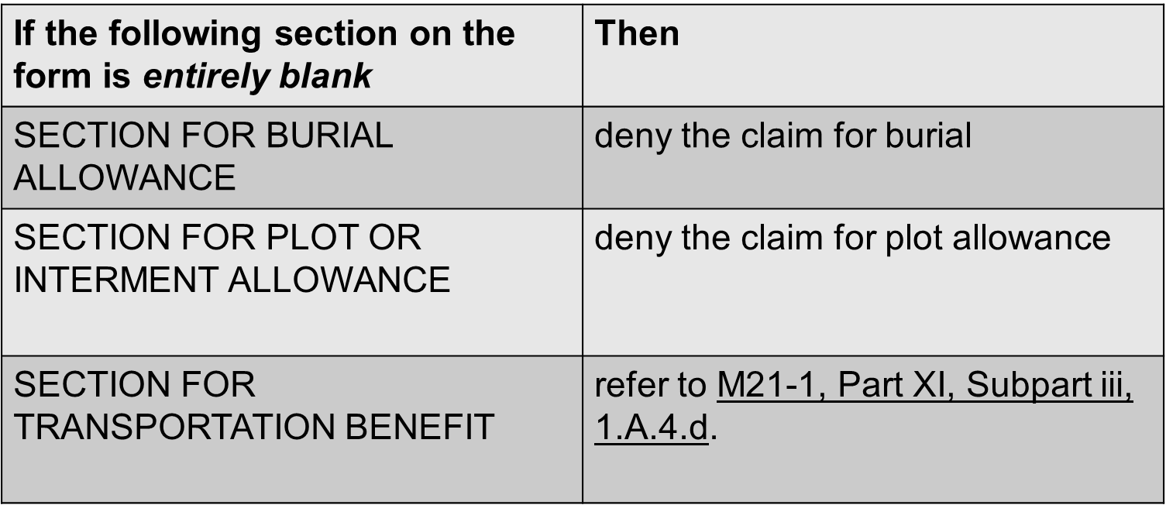

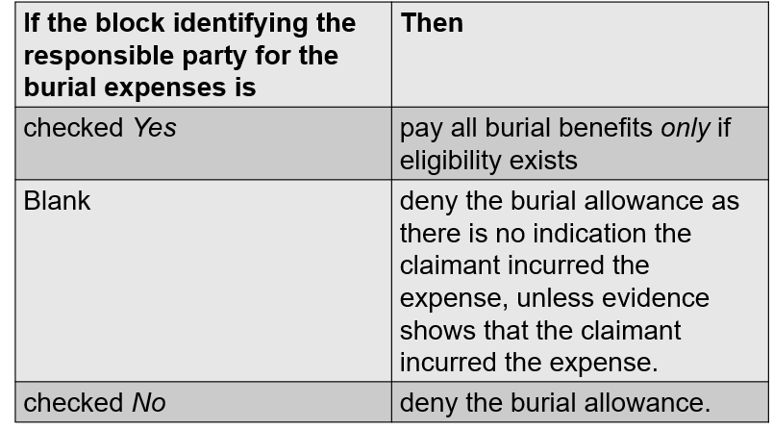

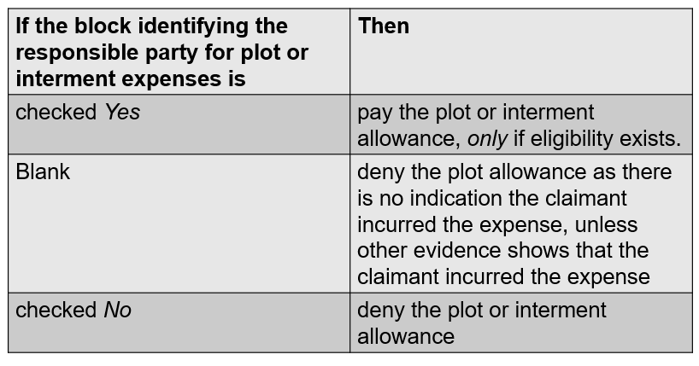

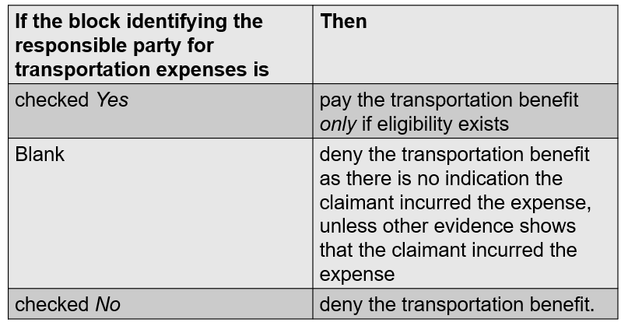

**Burial Rates:**

[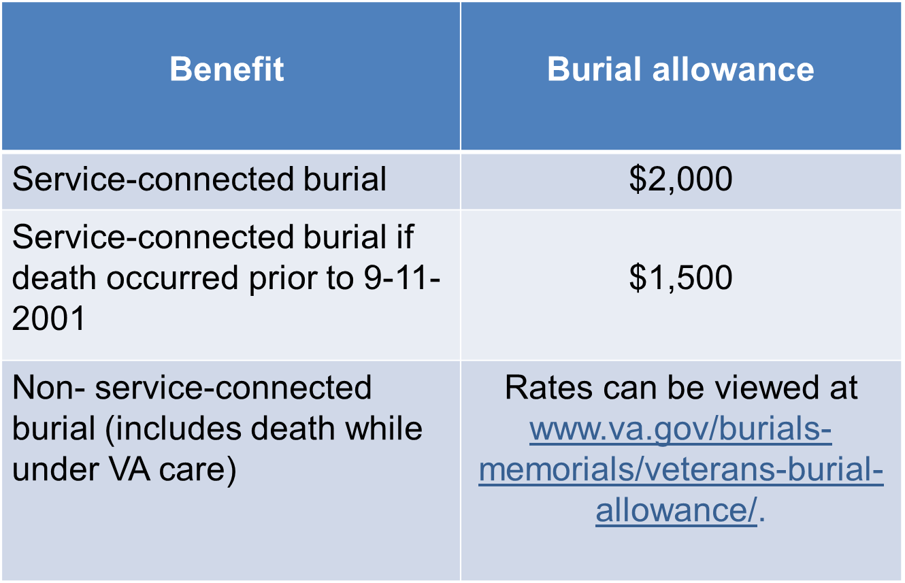](https://www.va.gov/burials-memorials/veterans-burial-allowance/)