Pension and fiduciary service

VSR Intermediate Core Course  
Phase 5: Proficiency Development  
Part 1(d): Beyond Basic Eligibility

Determine Eligibility for Month of Death Benefit

Trainee Guide

June 2024

Determine Eligibility for Month of Death Benefit

Lesson Overview

| Topic | Description |
| --- | --- |
| Time Estimate: | 1 hour |
| Purpose of the Lesson: | This lesson is part of the entry-level curriculum Core Course for PMC VSRs. The purpose of this lesson is to prepare you to determine a surviving spouse’s eligibility for MOD benefit. |
| Prerequisite Training Requirements: | Prior to taking the Determine Eligibility for Month of Death Benefit lesson, you must complete PMC VSR Core Course Phases 1–4. |
| Target Audience: | This lesson is for entry-level PMC VSRs. |
| Lesson References: | * 38 USC 5101 (Claims and Forms) * 38 CFR 3.20 (Surviving spouse's benefit for month of veteran's death) * M21-1 VII.i.2.D.1 (Establishing a Valid Marriage in Survivors Cases) * M21-1 XI.i.1.B.2 (Existing BIRLS Records and Veteran NOD Processing) * M21-1 XI.ii.2 (Month of Death (MOD) Benefit) * **Month of Death** job aid |
| Technical Competencies: | * Program Benefits and Eligibility (PMC VSR) * Processing Claims (PMC VSR) |
| Knowledge Check | * Phase 5.1(d) Determine Eligibility for Month of Death Benefit Knowledge Check |
| Lesson Objectives: | Determine whether the surviving spouse is eligible for MOD benefits.   * Determine whether Veteran was receiving pension or compensation benefits at time of death. * Determine whether MOD payment was made. * Check whether Veteran was married to claimant at time of death. |
| What You Need: | * Trainee guide * Pen and paper * Access to VBA intranet * Access to the following systems:   + SHARE   + VBMS   + MAP-D * Access tothe **Month of Death (MOD)** job aid from VSR Assistant |

| PowerPoint Slides | | Notes | |
| --- | --- | --- | --- |
| **Determine Eligibility for Month of Death Benefit** | |  | |
| **Lesson Objectives**  At the end of this lesson, you will be able to:   * Determine whether the surviving spouse is eligible for MOD benefits * Determine whether Veteran was receiving pension or compensation benefits at time of death * Determine whether MOD payment was made * Check whether Veteran was married to claimant at time of death | |  | |
| **Why This Matters!**  The **Month of Death Benefit** course is important because a surviving spouse, who may not be entitled to death compensation, DIC, or death pension would be entitled to payment for the Veterans MOD   * A claim for MOD is not required and payment can be made as long as evidence establishes the claimant’s relationship to the Veteran | |  | |
| **What Is MOD Benefit?**   * When a Veteran passes away, his or her benefits are terminated the first of the month of death. That month of death benefit is called the Month of Death (MOD) * ​The MOD payment amount represents the disability payment amount that the Veteran was entitled to receive for the month that he or she died (gross benefit) * The Veteran's rate for the month of death is an entitlement available only to the surviving spouse of the Veteran | |  | |
| **Requirements for MOD Benefit** |  | |
| **Eligibility for MOD Payment**  If eligible, surviving spouse is entitled to benefit ​   * A claim for MOD is not required and payment can be made as long as evidence establishes the claimant’s relationship to the Veteran * In order to establish dependency for MOD entitlement, VA needs the surviving spouse’s name, date of birth, SSN, and address |  | |
| **Verification of Receipt of Benefits at Time of Death**   * Review Corporate Record in SHARE * Ensure that Veteran was receiving pension or compensation benefits at time of death * Can also be verified through payment history, if needed |  | |
| **Veteran Married to Claimant at Time of Death**   * Review the Veteran’s Award history in SHARE * Development may be required to establish relationship |  | |
| **Apportioned Share for MOD**  If the surviving spouse is entitled to the Veteran’s disability rate for the MOD, and the award is to be apportioned, the following applies:   * the child’s apportioned share for the MOD is the same apportioned rate payable to the child for the month after the MOD, based on the recurring survivors benefit rate, and * the surviving spouse’s apportioned share for the MOD is the difference between the Veteran’s disability rate and the child’s apportioned share |  | |
| **End Products for MOD Payments**   * If VA receives a claim for pension, MOD should be paid as part of an EP 190 * If VA receives a claim for DIC, MOD should be paid as part of an EP 140, as MOD   + MOD may be paid under EP 140 before a decision on DIC * EP 299 is to be used solely for the MOD automation process   + Do not establish manually for MOD claims |  | |
| **Example: Award Screen of MOD Payment Made** |  | |
| **MOD Adjusted Based on Accrued Benefits** |  | |
| **Scenario—Is the Surviving Spouse Eligible for MOD Benefit?** |  | |

| PowerPoint Slides | Notes |
| --- | --- |
| **Determine Eligibility for MOD Benefit Review**   * If a Veteran died on or after December 1, 1962, but before October 1, 1982, payment is made to the surviving spouse for the MOD * If the Veteran died on or after October 1, 1982, the surviving spouse is entitled to payment for the MOD only if the Veteran’s rate for the MOD is greater than the monthly rate of Survivors Pension or DIC to which the surviving spouse is entitled * Veterans who died on or after October 1, 1982, but before January 1, 1997, if, after receiving payment under [**38 CFR 3.20(c)**](https://www.ecfr.gov/cgi-bin/text-idx?SID=ff07c75cd57bc7c5816feafc92fa44e0&node=se38.1.3_120&rgn=div8), the surviving spouse becomes entitled to death benefits from the date of the Veteran’s death at a rate higher than the amount paid under [**38 CFR 3.20(c)**](https://www.ecfr.gov/cgi-bin/text-idx?SID=ff07c75cd57bc7c5816feafc92fa44e0&node=se38.1.3_120&rgn=div8) |  |
| **Knowledge Check: Lesson Summary Review**    **Time Allowed: 15 minutes** |  |
| **What’s Next**  Complete TMS Evaluation Determine Month of Death (MOD) Eligibility using **(TMS# 4408454)** |  |

Appendix

**Requirements for MOD Benefits**

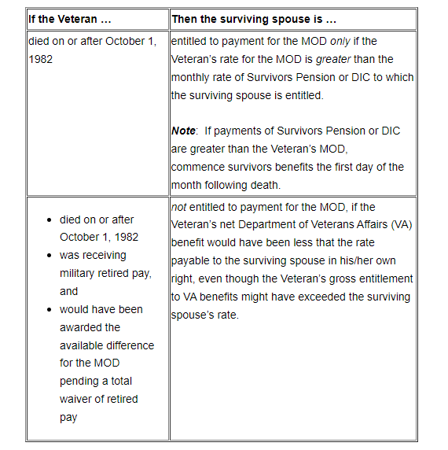

**Veteran Married to Claimant at Time of Death**

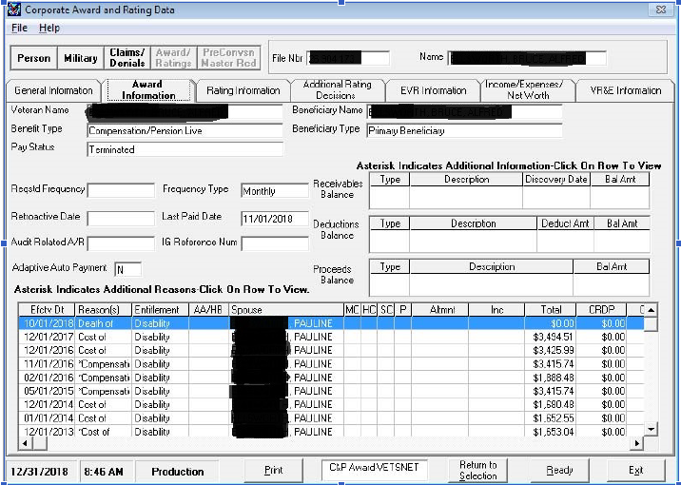

**Example: Award Screen of MOD Payment Made**

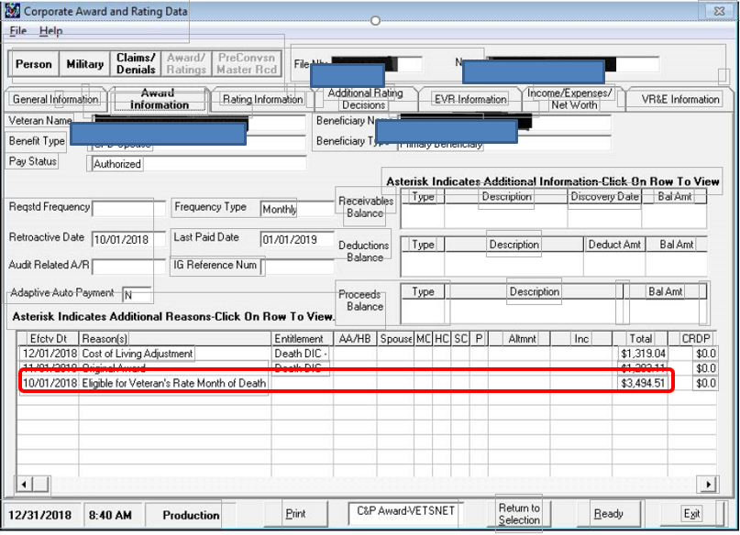

**MOD Adjusted Based on Accrued Benefits**

