Pension and fiduciary service
PMC VSR Intermediate Core Course
Phase 5: Proficiency Development
Part 1(d): Beyond Basic Eligibility
Determine Accrued Benefits Eligibility
Trainee Guide
January 2025

Determine Accrued Benefits Eligibility

Lesson Overview
Topic | Description
Time Estimate: | 2 hours
Purpose of the Lesson: | This lesson is part of the entry-level curriculum Core Course for PMC VSRs. The purpose of this lesson is to prepare PMC VSRs to determine a claimant’s eligibility for accrued benefits.
Prerequisite Training Requirements: | Prior to taking the Determine Accrued Benefits Eligibility lesson, trainees must complete PMC VSR Core Course Phases 1–4 and Phase 5, Part 1.a-c.
Target Audience: | This lesson is for entry-level PMC VSRs.
Lesson References: | - VA Form 21P-601, Application for Accrued Amounts Due a Deceased Beneficiary  - VA Form 21P-534EZ, Application for DIC, Survivors Pension, and/or Accrued Benefits  - VA Form 21P-535, Application for Dependency and Indemnity Compensation by Parent(s) (Including Accrued Benefits and Death Compensation When Applicable)  - VA Form 21P-0847, Request for Substitution of Claimant Upon Death of Claimant  - VA Form 21-4142, Authorization to Disclose Information to the Department of Veterans Affairs  - 38 USC 5121 (Payment of Certain Accrued Benefits Upon Death of a Beneficiary)  - 38 CFR 3.1000 (Entitlement under 38 U.S.C. 5121 to Benefits Due and Unpaid Upon Death of a Beneficiary)  - 38 CFR 3.1001 (Hospitalized Competent Veterans)  - 38 CFR 3.1003 (Returned and Canceled Checks)  - 38 CFR 3.1010 (Substitution Under 38 U.S.C. 5121A Following Death of a Claimant)  - 38 CFR 3.816 (Awards Under the Nehmer Court for Disability or Death Caused by a Condition Presumptively Associated with Herbicide Exposure)  - M21-1 XI ii.3. (Accrued and Substitution)  - M21-1 II.i.2.B.1.d. (Date of Receipt for Mail Processed in the CM Portal)  - M21-1 VII.i.1.A.1.c. (Importance of Establishing the Relationship of an Individual to a Veteran)  - M21-1 IX.iii.1.K.1. (Final Expense Deductions—Overview and Definitions)  - Accrued Benefits job aid  - Accrued Paid/Date Calculator
Technical Competencies: | - Program Benefits and Eligibility (PMC VSR)  - Processing Claims (PMC VSR)
Lesson Objectives: | By the end of this lesson, the trainees should be able to:  - Define key terms related to accrued benefits  - Determine basic entitlement to accrued benefits  - Determine control and jurisdiction of accrued claims  - Determine if accrued benefits are payable  - Determine the proper claimant for accrued benefits  - Identify the types of accrued benefits claims
What You Need: | - Trainee Guide  - Pen and paper or access to an electronic whiteboard  - Access to VBA intranet  - Access to the following systems:  - SHARE  - VBMS  - Access to the Accrued Benefits job aid from VSR Assistant

PowerPoint Slides |  | Notes
Determine Accrued Benefits Eligibility
Lesson Objectives
By the end of this lesson, you should be able to:
- Define key terms related to accrued benefits
- Determine basic entitlement to accrued benefits
- Determine control and jurisdiction of accrued claims
- Determine if accrued benefits are payable
- Determine the proper claimant for accrued benefits
- Identify the types of accrued benefits claims
Why This Matters!
The Determine Accrued Benefits Eligibility course is important because there may exist benefits due to the beneficiary that were not paid prior to death
How Does an Accrued Claim Result?
An accrued claim can result from the following claims or appeals pending at death:
- initial claims
- claims based on clear and unmistakable error (CUE)
- supplemental claims
- higher-level reviews (HLRs)
- claims that have not been finally adjudicated (one-year appeal period has not expired)
- legacy appeals, and
- Appeals Modernization Act (AMA) Board of Veterans’ Appeals (BVA) appeals
Basic Eligibility for Accrued Benefits
- If death occurred on or after December 1, 1962, monetary benefits, may be authorized
- Payment may be made for benefits
  - to which a payee was entitled at their death under existing ratings or decisions, or
  - which are based on evidence in the file at the date of death and due and unpaid
Applications for Accrued Benefits (1 of 2)
Claims for accrued benefits can be filed on:
- VA Form 21P-601, Application for Accrued Amounts Due a Deceased Beneficiary
- VA Form 21P-534EZ, Application for DIC, Survivors Pension, and/or Accrued Benefits
- VA Form 21P-535, Application for Dependency and Indemnity Compensation by Parent(s) (Including Accrued Benefits and Death Compensation When Applicable)
Applications for Accrued Benefits (2 of 2)
Claims for accrued benefits can be filed on:
- VA Form 21P-0847, Request for Substitution of Claimant Upon Death of Claimant, only if submitted by a surviving spouse and the substitution determination results in the claimant being recognized as a valid substitute.
  - VA Form 21P-0847, is not considered a prescribed form for accrued benefits for claimants other than a surviving spouse that meets the criteria
Definitions (1 of 4)
- Accrued benefits are benefits due to the beneficiary but not paid prior to death
- A claim pending at the date of death means a claim that had not been finally adjudicated on or before the date of death, including a deceased claimant’s
  - initial claim
  - informal claim received prior to March 24, 2015
  - supplemental claim
  - a request for an HLR
  - claim to raise a clear and unmistakable error in a prior rating or decision
  - claim in which the period to file a review option has not yet expired, or
  - claim in which funds were withheld pending appointment of a fiduciary.
Definitions (2 of 4)
- Evidence in the file at date of death means evidence in VA’s possession on or before the date of the beneficiary’s death, even if the evidence was not physically located in the VA claims folder on or before the date of death
- Evidence in VA’s possession means evidence physically located at any VA facility, including, but not limited to:
  - VA Regional Office
  - VA insurance centers
  - VAMC
  - Vet Centers, and
  - the Records Management Center
Definitions (3 of 4)
- A legacy appeal pending at the date of death means a deceased claimant’s
  - pending notice of disagreement on a decision rendered before February 19, 2019
  - statement of the case in which the applicable appeal period has not expired, and the appellant has not opted into the new modernized system, and
  - any substantive appeals or administrative appeals pending at the time of death, including issues on appeal to the
    - Board of Veterans Appeals (BVA), or
    - Court of Appeals for Veterans Claims (CAVC)
Definitions (4 of 4)
- Evidence needed to complete an application for accrued benefits means information necessary to establish that
  - the claimant is within the category of eligible persons, and
  - circumstances exist which make the claimant the specific person entitled to the accrued benefit
- Non-negotiated benefits – payments made to the beneficiary but not negotiated prior to his/her death
Definition: Substitution
- Substitution is the right of a living person to submit additional evidence in support of the deceased claimant’s pending claim, request for decision review, or appeal of decision
- A substitute claimant is an individual whom VA has recognized to replace the original claimant in a pending claim, decision review request, or pending appeal (i.e., a preferred eligible survivor)
- Substitution applies to the same benefits for which accrued benefits are payable, i.e., periodic monetary benefits (other than insurance and service member’s indemnity) such as compensation, pension, DIC and Chapter 18 benefits
Line of Succession (1 of 2)
Upon the death of a Veteran, accrued benefits are payable to the living person in the following order:
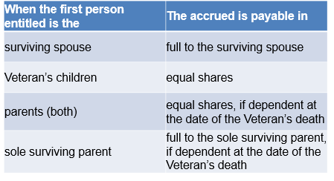
Line of Succession (2 of 2)
Upon the death of a surviving spouse or child, accrued benefits are payable in the following order:
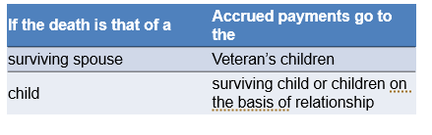
Time Limits for Accrued Benefits Claims
The time limits for applying for accrued benefits are:
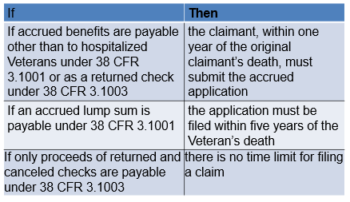
Time Limits for Retroactive Period
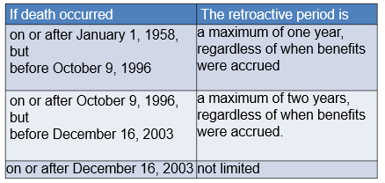
For accrued benefits payable to the survivors or estate of a Nehmer class member, there is no limitation in the retroactive period, regardless of the date of death.
Developing for Accrued Benefits (1 of 2)
- Development is not required when:
  - accrued benefits do not exist
  - there is a lack of legal eligibility
  - the claim lacks merit, or
  - the claimant is not entitled to the benefit as a matter of law
- Additional development is required if a Section 5103 for the original claimant’s claim was not sent or inadequate
Developing for Accrued Benefits (2 of 2)
- Additional development is required if
  - action is required on a pending VA Form 21-4142, Authorization to Disclose Information to the Department of Veterans Affairs (VA), that the
    - original claimant requested assistance with obtaining, or
    - substitute claimant requested assistance with obtaining
  - a duty to assist error is discovered upon an HLR and the maximum benefit cannot be granted
Scenario—Determine If Claim Was Received within Required Time Frame
On June 5, 2021, you receive a VA Form 21P-601, Application of Accrued Amounts Due a Deceased Beneficiary. The beneficiary indicated she is the surviving spouse of Benjamin Veteran. The beneficiary also provided the death certificate for Benjamin and a copy of their marriage license. Mr. Veteran had a claim pending for VA benefits on December 13, 2019, which closed on April 15, 2020. You review the claim and discover that the Veteran passed away on March 19, 2020.
Based on the information received, what would be your next step and why?

Control for Accrued Claims
- End product (EP) 165 is used to record work credit for a valid request for accrued benefits
- An EP (140 or 190, as appropriate) is authorized when a survivor’s claim for death benefits is received in addition to the request for accrued
  - An accrued claim should only be established when a standard form is received
Rating Action for Accrued Purposes

- Do not request rating action for accrued purposes unless evidence was in the file at the date of death to establish entitlement
- The rating activity is responsible for determining if the medical evidence necessary for a rating determination was in the file at the date of death
- Authorization determines if all other evidence necessary to support an award was on file at the date of death
NOTE: Evidence showing that the claimant is an eligible person to receive accrued benefits does not need to be in the file at the date of death.
Federal Tax Information: Substitution and Accrued Claims
- Federal tax information (FTI) should be considered in substitution and accrued claims that have a valid substitute claimant when a claim for pension was pending at the time of the original claimant’s death and the
  - FTI is available
  - sum of the total income reported by the Internal Revenue Service (IRS)/Social Security Administration (SSA) is higher than the sum of the total income reported on the original application, and
  - FTI income is considered countable for VA purposes
Jurisdiction of Accrued Claims with an Associated Claim for DIC
- If the Veteran’s claim or request for decision review pending at the time of death is intertwined with the cause of the Veteran’s death, the claim request for decision review, or appeal for substitution is worked by the PMC of jurisdiction ​
  - VSC of original jurisdiction if not intertwined with the cause of the Veteran’s death​
- If an award of benefits from an accrued/substitution claim affects the rate paid for the MOD, the station processing the accrued/substitution claim must also correct the MOD payment by issuing the increase payment under a separate EP​
- For pending appeal at the time of death, the claim is worked by the decision review operations center (DROC) of jurisdiction
Claims for Reimbursement (1 of 3)
- Accrued benefits may be used to reimburse a person or person(s) who paid the expenses of the last illness and burial of a beneficiary, but only if there is no one in a permitted class entitled to the accrued benefit on the basis of relationship
- Provide VA Form 21P-601, Application for Accrued Amounts Due a Deceased Beneficiary, to the person who paid the expenses of the last illness and burial of the deceased beneficiary, or is held responsible by the unpaid creditors for the payment of the deceased beneficiary’s bills
Claims for Reimbursement (2 of 3)
- Payment of accrued benefits, as reimbursement, is not limited to specific items or amounts
- Consider for reimbursement all reasonable expenses incident to the last illness and burial of a beneficiary, Veteran, and/or surviving spouse
  - Disallow only those charges that are unrelated to the beneficiary’s last illness or burial
  - Approvable charges for medical treatment are limited to the actual period of the last illness
Claims for Reimbursement (3 of 3)
- If the expenses of transporting the body of a deceased Veteran were partially paid by VA in connection with a burial claim, only those expenses in excess of the amount paid by VA will be reimbursed
- A creditor may be paid accrued benefits as reimbursement, but must support the claim by a waiver of claims from all other creditors and any person who is shown to have an interest in the accrued benefits because of services rendered and holds the creditor responsible for the payment of his/her claim
Time Limits: Reimbursement
- If the accrued is payable as reimbursement, establish a control for the expiration of the period within which additional claims may be filed.
- If the necessary evidence establishing the claimant’s entitlement to their full share is not received within the time limit allowed and a claim is not filed by any other claimant,
  - award the claimant of record a proportionate share of the accrued amount payable based on the expenses supported by receipted bills or waivers
- Exception: If there are proceeds of non-negotiated payments available for payment as reimbursement, do not apply the partial allowance procedures.
Reimbursement Upon the Death of Surviving Spouse or Child
- Accrued Dependent’s Educational Assistance (DEA) of a spouse is payable only as reimbursement under 38 CFR 3.1000(f)
- If the deceased child was entitled to an apportioned share of the surviving spouse’s award, the accrued benefit is payable only as reimbursement
- When a person having preferred entitlement dies, forfeits entitlement or otherwise becomes disqualified before receiving and negotiating the check for his/her share of the accrued benefit, if a claim is timely filed, pay the next person entitled based on relationship or reimbursement
Multiple Claimants for Reimbursement
Apply these actions when multiple claimants are eligible:
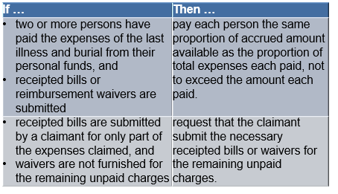
Accrued Lump Sum Benefits
- The accrued lump sum benefit under 38 CFR 3.1001, the amount withheld from hospitalized competent Veterans, is payable to the same persons in the same order of relationship as is the accrued benefit under 38 CFR 3.1000, except that the entitlement of children is not subject to age or marital status requirements
- Time limitations for accrued lump sum benefits apply to:
  - A claim for accrued lump sum must be filed within five years from the date of the Veteran’s death
  - There is no time limit for the submission of evidence of an accrued claim
  - There is no restriction on the retroactive period that may be covered by an award of lump sum accrued benefits

Scenario—Claim Based on Reimbursement
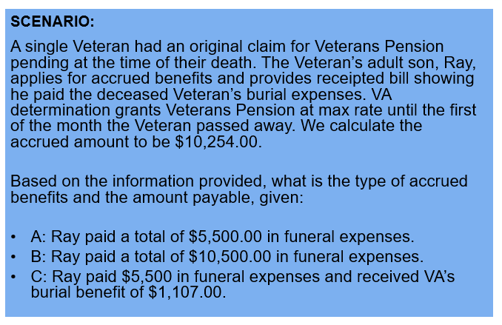
The Administrator of the Estate Is the Claimant
- If a co- executor/administrator of an estate files a claim, any award to the estate must be payable to all the co executors/administrators as appointed by the court
- VA Form 21P-601 must be filed, supported by certified copy of the letters of administration bearing the signature and seal of the appointing court
- If VA is notified that the estate is closed before an award, obtain a certified copy of the discharge of fiduciary, including the court order of distribution, and authorize payment to the distributees shown
NOTE: Consider the claimant the sole executor unless there is evidence that there are other executors.
No Administrator or Executor Is Appointed
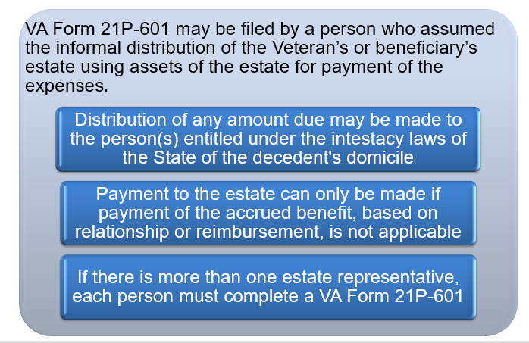

Personal Funds
- Money borrowed to pay the expenses of the last illness, burial, funeral, and transportation of the deceased beneficiary is considered the personal funds of the person who received the loan and not the funds of the lender​
- If the expenses of the last illness, burial, funeral, and transportation of the deceased beneficiary are paid from an account held jointly by the claimant and the decedent with the right of survivorship, consider that account to be the personal funds of the claimant​
Demonstration 1—Accrued Benefits Eligibility
- Instructions:
  - Access the Accrued Benefits job aid and M21-1 to complete the exercise.
- Follow along as the instructor:
  - Determines if the claim is within the time limit
  - Determines if accrued funds are payable
  - Determines the proper claimant
  - Concludes that the claimant is eligible for accrued benefits
Time allowed: 15 min.
Example Claim Activity—Determine If Claimant Is Eligible for Accrued Benefits
- Instructions:
  - Divide into groups of three.
  - Access CPKM to use the eCFR and M21-1 to complete the exercise
- Access the Accrued Benefits job aid and M21-1 to complete the exercise.
  - Review the provided example claims in VBMS.
- For each claim:
  - Determine if the claim was received within the time limit.
  - Determine if accrued funds are payable.
  - Determine the proper claimant.
  - Conclude whether the claimant is eligible for accrued benefits.
Time allowed: 15 min.

Example Claim—Determine if Claimant is Eligible for Accrued Benefits Q&A
Compare your findings with another group
- Was the claim received within the time limit?
- Are accrued funds payable?
- Who is the proper claimant?
- Is the claimant eligible for accrued benefits?

Time Allowed: 15 minutes
What’s Next
- Complete TMS Evaluation Determine Accrued Benefits Eligibility (TMS# 4408449)

Example Claim Activity Worksheet: Determine Eligibility for Accrued Benefits
For each claim provided by the instructor, answer the questions below. Show your work.
- Was the claim received within the time limit?

- Are accrued funds payable?

- Who is the proper claimant?

- Is the claimant eligible for accrued benefits?

