Pension and fiduciary service
PMC VSR Intermediate Core Course
Phase 5.1(d): Beyond Basic Development
Process Veteran-Married-to-Veteran Cases
Trainee Guide
January 2025

Process Veteran-Married-to-Veteran Cases

Lesson Overview
Topic | Description
Time Estimate: | 1 hour
Purpose of the Lesson: | This lesson is part of the entry-level curriculum Core Course for PMC VSRs. The purpose of this lesson is to prepare you to calculate the pension rate when a Veteran is married to a Veteran.
Prerequisite Training Requirements: | Prior to taking the Process Veteran-Married-to-Veteran Cases lesson, you must complete PMC VSR Core Course Phases 1–4 and Phase 5, Part 1.a-c.
Target Audience: | This lesson is for entry-level PMC VSRs.
Lesson References: | - VA Form 21P-527EZ, Application for Pension  - M21-1 IX.iii.1.E.1.c. (Determining the Monthly Rate of Pension Payment)  - M21-1 IX.iii.1.E.3.a. (Combined Rate Payable to Veterans Married to Each Other)  - M21-1 IX.iii.1.E.3.b. (Award Procedures in Veteran-Married-to-Veteran Cases)  - M21-1 IX.iii.1.E.3.c. (Determining the File Number to Use in Combined Awards)  - M21-1 IX.iii.1.E.3.d. (Estranged Married Veterans)  - M21-1 IX.iii.1.E.3.e. (Mandatory Election from Protected Pension in Veteran-Married-to-Veteran Cases)  - M21-1 IX.iii.2.B.2. (Making Payments in Veteran-Married-to-Veteran Pension Cases)  - 38 CFR 3.23 a(4) (Improved pension rates—Veterans and surviving spouses)  - 38 CFR 3.31 – Commencement of the Period of Payment  - Common VA Terms job aid  - Veteran-Married-to-Veteran job aid
Technical Competencies: | - Program Benefits and Eligibility (PMC VSR)  - Processing Claims (PMC VSR)
Knowledge Check | Phase 5.1(d): Veteran-Married-to-Veteran Knowledge Check
Lesson Objectives: | At the end of this lesson, given the training and references, the learner will be able to do the following  - Identify Veteran-married-to-Veteran cases  - Calculate the award payment for a Veteran-married-to-Veteran claim
What You Need: | - Trainee guide  - Access to VBA intranet  - Pen and paper or access to a whiteboard  - Appendix A – Vet-Married-to-Vet Worksheet  - Access to the following systems:  - SHARE  - VBMS  - Access to completed electronic versions of the following VA forms:  - VA Form 21P-527EZ  - Access to the following job aids from VSR Assistant:  - Common VA Terms job aid  - Veteran-Married-to-Veteran job aid

PowerPoint Slides | Notes
Process Veteran-Married-to-Veteran Cases
Lesson Objectives
At the end of this lesson, given the training and references, the learner will be able to do the following:
- Identify Veteran-married-to-Veteran cases
- Calculate the award payment for a Veteran-married-to-Veteran claim

Why This Matters!

- When a Veteran marries a Veteran, and both receive VA benefits, VSRs must be aware of the regulations that are used when awarding VA benefits​
- If one spouse in a Veteran-married-to-Veteran case dies, the surviving Veteran may be entitled to Survivors Pension ​
- A Veteran may receive only one benefit, either Veterans Pension or Survivors Pension​
Definition of Veteran-Married-to-Veteran Claims?
- Veteran-married-to-Veteran claims are two awards combined, unless otherwise requested
- A special combined maximum annual pension rate (MAPR) applies to Veterans who are married to each other
- The combined rate is the same as it is for a Veteran with a dependent, unless both Veterans are eligible for SMP
Example: Vet to Vet on VA Form 21P-527EZ
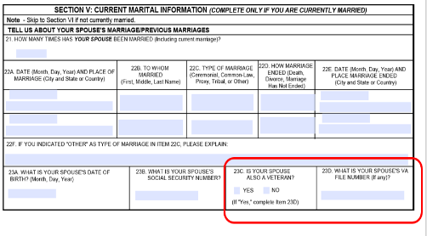
Award Calculation

For a Veteran-married-to-Veteran case, use either file number to establish a combined award, except when one spouse is A&A or housebound. In those cases
- establish the award under the file number of the Veteran who is A&A or housebound
- enter the names of both Veterans on the first address line if awarding benefits in a combined award, and
- cross-reference the two Veterans married to each other’s claims folders

Example: SHARE Screen Vet-to-Vet
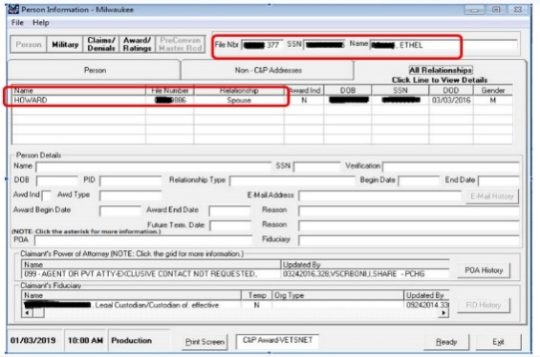
Veteran-to-Veteran: Authorizing Payments

- ​Authorize payments in a Veteran-married-to-Veteran case on a single award unless:​
  - one spouse requests separate payment
  - both Veterans have either aid and attendance (A&A) or housebound (HB) status, or
- a Medal of Honor award is involved

PowerPoint Slides | Notes
Veteran-to-Veteran Claims: Separate Awards
- When establishing separate award payments for Veteran-married-to-Veteran cases:
  - Cross-reference the two Veterans married to each other’s claims folders, and
  - Inform the two Veterans married to each other that all pension benefits, including additional benefits for children or SMP, are equally divided
- When preparing separate pension awards for each Veteran, do not count the other Veteran’s pension amount as income for VA purposes
Estranged Married Veterans

- In cases where two Veterans are married to each other but estranged:
- Apply the combined pension rate if one is making reasonable contribution to support the other
- Do not apply the combined pension rate where there is no contributing support

PowerPoint Slides |  | Notes
Scenario—Calculate the Award

Scenario:
- Vet (A) SSA/mo. $950.00 = $11,400
- Vet (B) SSA/mo. $767.00 = $9,204
- Annual medical expenses (for both) = $30,000.00
- Both Veterans are rated A/A, DOC 10-12-21

What is the correct Monthly Pension Rate (MPR)?
Scenario—Calculate the Award Answer
Based on the information provided, what is the correct MPR?

PowerPoint Slides | Notes
Demonstration—Process a Veteran-Married-to-Veteran Claim

Instructions:
- Access Claim
- Access the Veteran-Married-to-Veteran job aid and M21-1 to complete the exercise.
Follow along as the instructor:
- Calculates the award
- Adds the Veteran spouse as a dependent
- Confirms the general award
- Adds the flash indicating the award
Activity—Process Veteran-Married-to-Veteran Claims
- Instructions:
  - Divide into groups of three.
  - Access Appendix A – Veteran Married to Veteran worksheet
  - Access the Veteran-Married-to-Veteran job aid and Pension Rate Table to complete the exercise.
    - Use calculator when needed.
  - Answer the question listed in the worksheet
Time allowed: 15 minutes

PowerPoint Slides | Notes
Activity—Process Veteran-Married-to-Veteran Claims Rate

- In July 2021, a claim is received for two Veterans who are married to each other, and one qualifies for A&A benefits, what is the MAPR?
- On November 30, 2020, a claim is received for Veterans married to each other, and neither qualifies for A&A or HB. Veteran A receives a monthly check for $700 from SSA, and Veteran B receives a monthly check for $650 from SSA. Medical expenses were not reported. They have requested separate checks. Explain the IVAP, MAPR, and the award.
In September 2019, a claim is received for two Veterans who are married to each other, and one qualifies for A&A benefits, and they have one dependent child, what is the MAPR?

PowerPoint Slides | Notes
Knowledge Check: Lesson Summary Review Questions

Time Allowed: 10 minutes
What’s Next
- Complete TMS Evaluation Process Veteran-Married-to-Veteran Cases using (TMS# 4408446)

