Pension and fiduciary service

PMC VSR Intermediate Core Course  
Phase 5: Proficiency Development  
Part 1(d): Beyond Basic Eligibility

Apply Liberalizing Law to Pension Eligibility

Trainee Guide

March 2024

Apply Liberalizing Law to Pension Eligibility

Lesson Overview

| Topic | Description |
| --- | --- |
| Time Estimate: | 1 hour |
| Purpose of the Lesson: | This lesson is part of the entry-level curriculum Core Course for PMC VSRs. The purpose of this lesson is to prepare PMC VSRs to apply liberalizing legislation for pension claims. |
| Prerequisite Training Requirements: | Prior to taking the Apply Liberalizing Law to Pension Eligibility lesson, trainees must complete PMC VSR Core Course Phases 1–4, Phase 5, Part 1.a-c. |
| Target Audience: | This lesson is for entry-level PMC VSRs. |
| Lesson References: | * 38 CFR 3.114 (Change of law or Department of Veterans Affairs issue) * M21-1 IX.iii.1.A.2.h. (Considering FTI on Grants of Pension based Liberalizing Law) * M21-1 V.ii.4.A.6.c. (Awarding Retroactive Benefits Based on a Law Change) * M21-1 V.ii.4.A.6.i. (Awarding or Increasing Benefits Under 38 CFR. 3.114) * M21-1 IX.iii.1.A.4.d. (Retroactive Effective Dates to Pension Due to Liberalizing Law) |
| Technical Competencies: | * Program Benefits and Eligibility (PMC VSR) * Processing Claims (PMC VSR) |
| Knowledge Check: | * Phase 5.1(d): Apply Liberalizing Law to Pension Eligibility Knowledge Check |
| Lesson Objectives: | By the end of this lesson, you will be able to:   * Determine whether Veteran meets criteria for liberalizing law. * Determine whether to apply liberalizing legislation eligibility. |
| What You Need: | * Trainee Guide * Master Course Map learning aid * Access to VBA intranet * Pen and paper or access to a virtual whiteboard * Access to the following systems:   + SHARE   + VBMS |

| PowerPoint Slides | Notes | |
| --- | --- | --- |
| **Apply Liberalizing Law to Pension Eligibility** |  | |
| **Lesson Objectives**   * Determine whether Veteran meets criteria for liberalizing law * Determine whether to apply liberalizing legislation eligibility |  | |
| **Why This Matters!**   * VA may award retroactive benefits if   + claimant had potential entitlement     - at the time liberalizing law became effective * Applies to:   + Cases involving pending or previously denied claims   + Original claims filed after the change in law |  | |
| **What Is Liberalizing Law?** |  | |
| **Origins of a Liberalizing Issue or VA Issue (1 of 2)**   * A liberalizing issue originates from regulation by VA,   + or statutes (38 U.S.C.) by Congress * A VA issue originates from an existing regulation or a new regulation issued by VA * Changes of law may alter   + the standard of entitlement,   + the burden of proof,   + the extent of the duty to assist,   + substantive due process requirements,   + the existing understanding of medical or legal concepts, or   + agency procedures |  | |
| **Origins of a Liberalizing Issue or VA Issue (2 of 2)**   * Some changes of law may require a reviewof potentially-impacted past claimants and current beneficiaries who do not have claims pending.   + General reviews *are not routinely mandated* and should *never be initiated by field decision makers* in the absence of a *specific agency directive* permitting authorized review jurisdiction. * This may consist of outreach or even re-adjudication of claims. |  | |
| **Eligibility Requirements**   * Veteran’s pension may be retroactively awarded up to one year prior to date of initial claim if one of the criteria was continuously met from 09/17/2001   + Age 65   + found disabled by SSA   + a patient in a nursing home for long-term care because of disability |  | |
| **Liberalizing Law: Retroactive Benefits**   * Under [38 CFR 3.114(a)](http://www.ecfr.gov/cgi-bin/text-idx?SID=ea5c5026977fe12ebf59b42c334f0440&mc=true&node=se38.1.3_1114&rgn=div8), VA may award retroactive benefits if the claimant had potential entitlement at the time the liberalizing law, VA issue, such as certain precedent opinions of VA General Counsel, or regulation became effective. * This regulation applies to   + cases involving pending or previously denied claims, and * original claims filed after the change in law or administrative issue |  | |
| **Statutory Eligibility Requirements: Retroactive Benefits**   * Under [38 U.S.C. 5110(g)](https://www.law.cornell.edu/uscode/text/38/5110) governing the effective date for a claim granted based on a favorable change in law and its implementing regulation requires two specific findings:   + a liberalizing law or administrative issue was implemented, and   + the ultimate grant of benefits was *pursuant to* such a favorable change in law. |  | |
| **Regulatory Eligibility Requirements: Retroactive Benefits**   * The provisions of [38 CFR 3.114(a)](http://www.ecfr.gov/cgi-bin/text-idx?SID=ea5c5026977fe12ebf59b42c334f0440&mc=true&node=se38.1.3_1114&rgn=div8) for retroactive benefits apply to claimants who become eligible for initial or increased benefits solely because of liberalizing changes in law or administrative issues. * Claimants must meet the eligibility requirements of the liberalizing law or regulations on the effective date of the   + liberalizing law or regulation,   + award, and   + during the entire retroactive period |  | |
| **Partial Grants of Liberalizing Law**   * Partial retroactive payments during the liberalized period can be paid if   + net worth changes during the liberalized period that allows a partial payment or   + if the maximum annual pension rate (MAPR) changes during the liberalized period, resulting in the income for VA purposes (IVAP) being less than the MAPR * The MAPR can change if a dependent is added to the award or SMP is granted.   + it does not include a change in medical expenses without a change in MAPR |  | |
| **Liberalizing Law and Federal Tax Information**   * Use the appropriate year’s IRS and SSA information that corresponds to the year at issue   **NOTE:** Ensure that any medical expenses the claimant provides are associated with the appropriate year for which income may be reduced. |  | |
| **Liberalizing Law Effective Dates** |  |
| **Example: Effective Date**   * In [*Gregory v. Brown*](https://vaww.vrm.km.va.gov/system/templates/selfservice/va_kanew/help/agent/locale/en-US/portal/554400000001034/content/554400000066787/Gregory-v.-Brown,-May-13,-1993,-5-Vet.App.-108-(1993)), 5 Vet.App. 108 (1993), CAVC invalidated portions of [38 CFR 3.53(a)](http://www.ecfr.gov/cgi-bin/text-idx?SID=c8e3364e2db208e64affe225b927214e&mc=true&node=se38.1.3_153&rgn=div8).  VA subsequently published an amendment to that regulation that implemented CAVC’s holding with an effective date of the regulation retroactive to May 13, 1993, the date of CAVC’s decision.  On June 1, 1994, the surviving spouse, who had a final decision denying benefits in 1985 due to reliance on the now invalidated regulation, filed a claim. * ***Results***:  Because VA issued liberalizing regulations to implement the decision, the provisions of [38 CFR 3.114(a)](http://www.ecfr.gov/cgi-bin/text-idx?SID=c8e3364e2db208e64affe225b927214e&mc=true&node=se38.1.3_1114&rgn=div8) must be applied, and the appropriate effective date is June 1, 1993, one year prior to date of claim. |  |
| **Statutory vs Regulatory**   * When a statute or regulation changes during the pendency of a claim to which the law is applicable, a determination must be made as to whether the new law or prior law is more favorable to the disposition of the pending claim. * The new law is more favorable if   + it would support an allowance that the prior standard would not, or   + both standards would support an allowance but the new standard would support an allowance of a greater degree   **Note**: The prior standard is more favorable when it would support a greater allowance than the new law, or the same allowance, making it more favorable in that the allowance could typically be assigned from an earlier effective date. |  |
| ****Regulatory Amendment****   * When VA issues a regulatory amendment to the rating schedule while an initial or increased rating claim is pending, and that amendment is more favorable to the claimant than the prior regulation, VA should apply the   + more favorable regulation to rate the disability for periods from and after the effective date of the change, and   + prior regulation to rate the disability for earlier periods |  |
| Reducing and Discontinuing Awards Under 38 CFR 3.114   * Under [38 CFR 3.114(b)](http://www.ecfr.gov/cgi-bin/text-idx?SID=ea5c5026977fe12ebf59b42c334f0440&mc=true&node=se38.1.3_1114&rgn=div8), VA must provide due process if a new law, regulation, change in the interpretation of a law, or issue requires VA to reduce or discontinue benefits that were properly authorized under instructions in effect at the time the award was processed. * VA must send the claimant a written notice of proposed adverse action, and allow 60 days for the claimant to submit evidence showing why the change should *not* be made. * Make the proposed change effective the first of the month following the date on which the 60-day due process period ends, *unless* VA receives evidence within 65 days of the date of the notice of proposed adverse action that shows VA should *not* take the proposed action. |  |
| ****Group Activity—****Does the Claim Meet Eligibility Requirements for Liberalizing Law?   * **Instructions:**   + **Divide into groups of three.**   + **Access CPKM to use the eCFR and M21-1 to complete the exercise.**   + **Review Claim 1 and 2.**   + **Determine if liberalizing law can be applied.**   **Time allowed: 15 minutes** |  |
| Claim 1—Does the Claim Meet Eligibility Requirements for Liberalizing Law?   * Does the claim meet the criteria for liberalizing law? * Answer provided by instructor based on the information provided in the example claim. * Can liberalizing law be applied to the claim? * If yes, when should you establish liberalized standards of entitlement and award or increase benefits retroactively? |  |
| Claim 2—Does the Claim Meet Eligibility Requirements for Liberalizing Law?   * Does the claim meet the criteria for liberalizing law? * Answer provided by instructor based on the information provided in the example claim. * Can liberalizing law be applied to the claim? * If yes, when should you establish liberalized standards of entitlement and award or increase benefits retroactively? |  |
| Liberalizing Law: PACT Act   * All the presumptions in the PACT Act will be effective on the date of enactment, August 10, 2022, the date the President signed the PACT Act into law * The effective date for the new presumptive conditions is August 10, 2022, which is the same day that the law went into effect   + Liberalizing law is applicable   IMPORTANT: Claims regarding service-connected death benefits may have an effective date earlier than August 10, 2022.​ |  |
| **Liberalizing Law Review**   * If a liberalizing law or approval of a liberalizing VA issue establishes liberalized standards of entitlement   + Award benefits from the effective date of the law or VA issue if a claim is received within one year of the effective date of the law or VA issue * Claimants submitting requests more than one year after the effective date of the law or VA issue, award benefits for a period of one year prior to the date of receipt of claim |  |
| **Knowledge Check: Lesson Summary Review**    **Time Allowed**: **10 minutes** |  |
| **What’s Next**  Complete TMS Evaluation Liberalizing Law using **(TMS# 4408444)** |  |

**Appendix**

**Liberalizing Law Effective Dates**

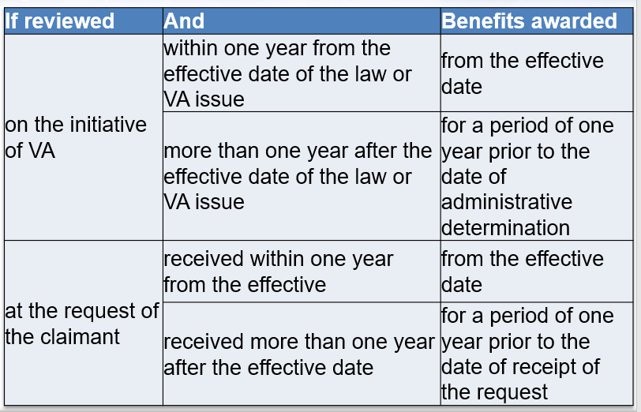

Claim 1 - Does the Claim Meet Eligibility Requirements for Liberalizing Law?

1. Does the claim meet the criteria for liberalizing law?
2. Answer provided by instructor based on the information provided in the example claim.
3. Can liberalizing law be applied to the claim?
   1. If yes, when should you establish liberalized standards of entitlement and award or increase benefits retroactively?

**­­­­­­­­­­­­­­­­­­­Claim 2 – Does the Claim Meet Eligibility Requirements for Liberalizing Law?**

1. Does the claim meet the criteria for liberalizing law?
2. Answer provided by instructor based on the information provided in the example claim.
3. Can liberalizing law be applied to the claim?
4. If yes, when should you establish liberalized standards of entitlement and award or increase benefits retroactively?