Pension and fiduciary service
PMC VSR Intermediate Core Course
Phase 5: Proficiency Development
Part 1: Beyond Basic Eligibility
Verify Proof of Death of Veteran for Survivors’ Benefits
Trainee Guide
June 2024

Verify Proof of Death of Veteran for Survivors’ Benefits

Lesson Overview
Topic | Description
Time Estimate: | 1 hour
Purpose of the Lesson: | This lesson is part of the entry-level curriculum Core Course for PMC VSRs. The purpose of this lesson is to prepare PMC VSRs to verify proof of the cause of death of the Veteran for survivors’ pension claims.
Prerequisite Training Requirements: | Prior to taking the Determine Dependency Eligibility: Parent lesson, you must complete PMC VSR Core Course Phases 1–4, Phase 5, Part 1.a-c.
Target Audience: | This lesson is for entry level PMC VSRs.
Lesson References: | - 38 CFR 3.211 (Death)  - 38 CFR 3.212 (Unexplained Absence for 7 Years)  - 38 CFR 3.312 (Cause of Death)  - M21-1 X.iv.2.B (Considering Eligibility When Homicide is Involved)  - M21-1 XI.i.2.B (Finding of Fact and Date of Death)  - M21-1 XI.iii.1.A.4.f. (Proof of Death)  - M21-1 XII.i.3.B.1.a. (Acceptable Proof of Death)  - M21-1 XII.i.1.B.1.g. (Obtaining Evidence Relating to Cause of Death)  - M21-1 XII.i.1.B.1.n. (Developing for Proof of Death)
Technical Competencies: | - Program Benefits and Eligibility (PMC VSR)
Knowledge Check | Phase 5: Verify Proof of Death of Veteran for Survivors’ Benefits Knowledge Check
Lesson Objectives: | At the end of this lesson, you will be able to demonstrate how to:  - Determine if proof of death is of record  - Determine if development is required for proof of death  - Establish death of the Veteran
What You Need: | - Trainee guide  - Access to VBA Intranet  - Pen and paper  - Access to the following systems:  - SHARE  - VBMS  - VSR Assistant  - Access to CPKM to display the references  - Access to an electronic example of VA Form 21P-534EZ, Application for DIC, Death Pension, and/or Accrued Benefits

PowerPoint Slides | Notes
Verify Proof of Death of Veteran for Survivors' Benefits
Lesson Objectives
At the end of this lesson, you will be able to demonstrate how to:
- Determine if proof of death is of record
- Determine if development is required for proof of death
- Establish death of the Veteran
Why This Matters!
- Verifying proof of death of a Veteran is important because a surviving child, spouse, or parent of a Veteran can receive benefits only if proof of death is received showing the Veteran’s date and cause of death.
Definitions
- Proof of death is the legal and verifiable documentation required to establish the Veteran is deceased for the purpose of determining eligibility and entitlement to VA benefits, such as survivors benefits and pension.
- The place of death is the place shown by the death certificate or other acceptable evidence of death.
- A wrongful and intentional killing is one in which the claimant or beneficiary caused the death of the Veteran or another beneficiary without justification or excuse.

Proof of Death: Verbal Reports
- If proof of death does not accompany the claim, it may be obtained verbally
- All verbal information reported to VBA must be documented on a
  - VA Form 27-0820, Report of General Information, or
  - VA Form 27-0820a, Report of First Notice of Death

Evidence of Proof of Death (1 of 2)
- Death certificate signed by a medical officer
- A copy of the public record of the State where death occurred.
- A copy of a coroner’s report of death
- A clinical summary showing fact and date of death signed by a medical officer
- An official report of death from the service department (in-service death)
Evidence of Proof of Death (2 of 2)
If death occurs abroad:
- A United States consular report of death
- A copy of the public record of death authenticated by the United States Consul
- An official report of death from the head of the department concerned, where the deceased person was, at the time of death, a civilian employee of such department
When to Develop Cause of Death
- Undertake development to establish the fact of death when the death of a person cannot be established by any of the types of evidence outlined in 38 CFR 3.211(a) through (e), and
- Develop when evidence of record indicates death occurred under circumstances that preclude recovery or identification of the body
When to Develop SC Cause of Death
- Send the claimant a Section 5103 notice requesting medical evidence showing the Veteran’s death was caused by service when
  - there is not already sufficient evidence of record to grant DIC, and
  - SC for the cause of death is specifically claimed, or
  - the claimant is filing for Parents’ DIC
NOTE: Do not develop for SC for the cause of death if the claimant does not meet relationship requirements or submits VA Form 21P-534EZ.
Proof of Death Due to Homicide
- If the available evidence indicates that the death of the Veteran or a beneficiary is the result of a homicide, determine if the claimant was implicated in the death
- When evidence connects the claimant with the homicide, then develop by field examination to obtain all the facts
- A death may be considered accidental if the chain of circumstances resulting in the fatality was not set in motion for the purpose of causing death
  - If it is established that such act was committed while insane, the killing will not bar the claimant from receiving survivors benefits
Proof of Death Due to Disaster
- When a missing person is alleged to have died in a disaster and the body is not recovered or identified, request evidence that shows, as definitely as possible,
  - the missing person was at the scene of the disaster
  - the missing person was in imminent peril at the time the disaster occurred, and
  - the missing person’s disappearance was attributable to the disaster
NOTE: Request certified statements as outlined in M21-1, XI.i.2.B.2.b. for what to request when undertaking development for evidence to establish death occurred during a disaster.

Proof of Death for a 7-year Unexplained Absence
If satisfactory evidence is produced establishing the fact of the continued and unexplained absence of any individual from his or her home and family for a period of 7 years or more and that a diligent search disclosed no evidence of his or her existence after the date of disappearance, and cannot be furnished, the death of such individual as of the expiration of such period may be considered as sufficiently proved.
Is the Proof of Death of Record?
- Instructions:
- Review Claim 1.
- Based on information provided, determine:
  - If the claim contains proof of death
  - If the proof of death provided is satisfactory
  - If development is needed
- Explain your answer.
- Time allowed: 10 min.

Verifying Proof of Death
- BIRLS VID screen via SHARE
- Compare date of death to proof provided
- BIRLS and SSA Inquiry must show same date of death
Group Activity—Verify Proof of Death

- Instructions:
  - Divide into groups of three
  - Access CPKM to use the eCFR to complete the exercise
  - Review Claim 2 and Claim 3
  - Verify proof of death
  - Determine if development is needed
Time allowed: 10 min
Proof of Death Review (1 of 2)
- Proof of death of record
- In order for a surviving spouse, child, or parent to receive survivor benefits, proof of death and cause of death need to be of record.
Types of proof
- Death certificate
- Coroner report
- Hospital or government institution
Proof of Death Review (2 of 2)
Development required when
- Death certificate is not of record
- Cause of death not provided on death certificate
- Homicide
Verifying proof of death
- BIRLS
- SSA Inquiry
Knowledge Check: Lesson Summary Review
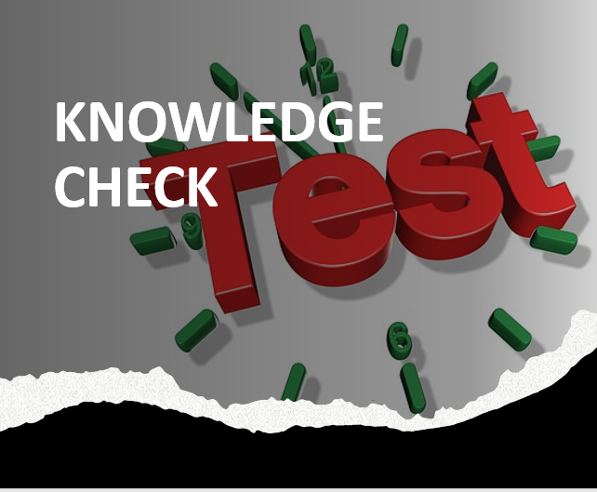
Time Allowed: 10 minutes
What’s Next
- Complete TMS Evaluation Verify Proof of Death of Veteran for Survivors’ Benefits (TMS# 4408438)

Practical Exercise: Verify Proof of Death
Answer the questions below. Include references with your explanations to support your rationale.

Claim 1—Is The Proof of Death of Record

- Does the claim contain proof of death?

- Is the proof of death satisfactory?

- Is further development needed?

Claim 2 – Verify Proof of Death
- Could the proof of death be verified with what was provided?

- Is further development needed to verify the proof of death?

Claim 3 – Verify Proof of Death
- Could the proof of death be verified with what was provided?

- Is further development needed to verify the proof of death?

