Pension and fiduciary service

PMC VSR Intermediate Core Course

Phase 5: Proficiency Development  
Part 1(c): Income Eligibility

Determine Net Worth Status

Trainee Guide

July 2024

Net Worth, Asset Transfers and Penalty Periods Lesson Overview

| Topic | Description |
| --- | --- |
| Time Estimate: | 3 hours |
| Purpose of the Lesson: | This lesson is part of the entry-level curriculum, Core Course for PMC VSRs. The purpose of this lesson is to prepare PMC VSRs to calculate a claimant’s net worth and to determine if net worth is a bar to benefits for the claimant. |
| Prerequisite Training Requirements: | Prior to taking the **Determine Net Worth Status** lesson, trainees must complete PMC VSR Core Course Phases 1–4, and Phases 5, Part 1.a-b. |
| Target Audience: | This lesson is for entry-level PMC VSRs. |
| Lesson References: | * Compensation and Pension Knowledge Management (CPKM) * VA Form 21P-0969 (Income and Asset Statement in Support of Claim for Pension or Parent's Dependency and Indemnity Compensation (DIC)) * VA Form 21P-8416 (Medical Expenses Report) * VA Form 21P-534EZ, Application for DIC, Survivors Pension and/or Accrued Benefits * VA Form 21P-527EZ, Application for Veterans Pension * 38 CFR 3.274 (Net worth and VA pension.) * 38 CFR 3.275 (How VA determines the asset amount for pension net worth determinations.) * 38 CFR 3.276 (Asset transfers and penalty periods) * 38 CFR 3.277 (Eligibility Reporting Requirements) * 38 CFR 3.278 (Deductible Medical Expenses) * 38 CFR 3.279 (Statutory exclusions from income or assets (net worth or corpus of the estate)) * M21-1 IX.iii.1.J.1.a. (Impact of the Claimant’s Net Worth on VA Benefits) * M21-1 IX.i.3.A.4. Developing for Net Worth * M21-1 IX.i.3.A.1 The Effect of Income/Net Worth on Benefit Entitlement * M21-1 IX.i.3.A.1.c (Definition: Net Worth) * M21-1 IX.iii.1.J.1.b. (When to Consider the Net Worth of the Spouse) * M21-1 IX.iii.1.J.1.f. (Net Worth Criteria for Claims Received on or After October 18, 2018) * M21-1 IX.iii.1.J.1.g (Definition: Assets) * M21-1 IX.iii.1.J.1.h (Definition: Fair Market Value) * **M21-1 IX.iii.1.J.1.q. Evaluating Net Worth on Benefit Eligibility for Claims Received on or After October 18, 2018** * M21-1 IX.iii.1.J.4 (Net Worth Determinations for Claims Received on or After October 18, 2018) * M21-1 IX.iii.1.J.5 (Asset Transfers and Penalty Periods for Claims Received on or After October 18, 2018) * M21-1 IX.iii.1.J.6 (Determining the Value of Property and its Effect on Net Worth) * M21-1 IX.iii.1.J.7.a. (Life Expectancy Table) * **Claim Types job aid**   **Income and Net Worth Status** job aid |
| Technical Competencies: | * Program Benefits and Eligibility (PMC VSR) * Income Counting and Net Worth * VBA Applications (PMC VSR) |
| Lesson Objectives: | * Determine Net Worth Status. * Explain net worth significance to Pension entitlement * Define key terms related to net worth * Describe how net worth affects Pension entitlement * Explain how to calculate net worth * Identify and evaluate asset transfers * Recall how to accurately calculate penalty periods * Identify property eligible to be considered net worth * List the proper forms for net worth reporting |
| What You Need: | Trainee Guide  Calculator  Access to VBA Intranet for VA Form search   * + VA Form 21P-0969 Income and Asset Statement in Support of Claim for Pension or Parent’s Dependency and Indemnity Compensation (DIC)   + VA Form 21P-8416 (Medical Expenses Report)   Access to CPKM  Access to the following job aids from VSR Assistant:   * + **Claim Types job aid**   + **Income and Net Worth Status** job aid   Examples of VA forms applications used to determine net worth status |

| PowerPoint Slides | Notes |
| --- | --- |
| Determine Net Worth Status |  |
| Lesson Objectives   * Determine Net Worth Status. * Explain net worth significance to Pension entitlement * Define key terms related to net worth * Describe how net worth affects Pension entitlement * Explain how to calculate net worth * Identify and evaluate asset transfers * Recall how to accurately calculate penalty periods * Identify property eligible to be considered net worth   List the proper forms for net worth reporting |  |
| Why It Matters!  The **Determine Net Worth Adjustments** course is important because VA pension is a needs-based benefit and is not intended to preserve the estates of individuals who have the means to support themselves. |  |
| **Definitions (1 of 4)**   * ***Net worth***, for claims received on or after October 18, 2018, is the sum of a claimant’s assets, and IVAP. * ***Assets*** are the fair market value of all property that an individual owns, including all real and personal property * ***Fair market value*** is the price at which an asset would change hands between a willing buyer and seller. * The ***covered asset amount*** is the monetary value by which a claimant’s net worth would have exceeded the limit due to covered asset(s) alone if the uncompensated value of the covered asset(s) had been included in net worth. |  | |
| **Definitions (2 of 4)**   * A***Look-back*** *period* means the 36-month period immediately preceding the date on which VA receives either an original pension claim, or a new pension claim after a period of non-entitlement   + A look-back period will not include any date prior to October 18, 2018   + The look-back period starts from the date a formal claim is submitted after a period of non-entitlement.   + A look-back period does not start from the date of an intent to file. |  | |
| **Definitions (3 of 4)**   * A***penalty period*:**   + is a period of non-entitlement due to the transfer of a covered asset(s) during the look-back period   + cannot exceed 5 years   + begins on the first day of the month following the date of the last transfer, and   + is calculated by dividing the total covered asset amount by the monthly penalty rate and rounding down.   + The resulting whole number is the number of months VA will not pay pension. |  | |
| **Definitions (4 of 4)**   * For claims received on or after October 18, 2018, the **bright-line** net worth limit for pension entitlement is $123,600 for alleffective dates of payment prior to December 1, 2018.   + The current net worth limit for pension entitlement is listed on the [Veterans Pension Rate Table](https://www.va.gov/pension/veterans-pension-rates/).   + This limit is increased by the same percentage as the COLA in Social Security benefits.     - Net worth is assets plus IVAP (assets + IVAP). * Deny or discontinue pension if a claimant’s net worth exceeds the limit.   + The net worth calculator must be saved if pension is denied or discontinued due to excessive net worth. |  | |
| **Review of Net Worth** |  | |
| Excessive Net Worth   * Deny pension if net worth exceeds the limit.   Discontinue pension if   * Net worth becomes excessive * determine effective date of excess * terminate first of the next calendar year * earlier termination may apply |  | |
| When to Calculate Net Worth  Calculate net worth when VA receives:   * Original pension claim * Supplemental claim after a period of non-entitlement * Request to establish a new dependent * Information of net worth increase or decrease |  | |

| PowerPoint Slides | Notes | |
| --- | --- | --- |
| **Net Worth and Dependents**   * Net worth of Veteran’s spouse is a factor in:   + Veterans pension claims   + Survivors pension claims * Net worth of a child can also be a factor * Net worth is not a factor in DIC claims |  | |
| **Can Net Worth Decrease?**   * Net worth can decrease:   + assets can decrease in value   + annual income can decrease   Downward trend |  | |
| **Net Worth & Federal Tax Information (FTI)**   * Claimant’s net worth may come from:   + Self-report   + VA matching programs:     - Internal Revenue Service (IRS) or     - Social Security Administration (SSA) |  | |
| Net Worth & FTI   * Review FTI for net worth purposes   + match sources and compare to VA Form 21P-0969   + income/assets not normally considered must be reviewed |  |
| Net Worth & Asset Exclusions |  |
| Net Worth & Financial Instruments   * Annuity or similar financial instrument   + count the total value as an asset for net worth purposes     - if the claimant can liquidate the entire balance     - exclude the monthly income yield   + count the monthly income yield for net worth purposes     - if the claimant cannot liquidate the entire balance     - exclude the financial instrument’s total value |  |
| **Asset Transfers and Penalty Periods**   * Entitlement cannot be created by transferring covered assets. * VA will review terms and conditions of asset transfers made during the look-back period to determine whether the transfer constituted transfer of a covered asset |  |
| Transfer for Less Than FMV |  |
| **Less Than FMV Transfer Example**   * Example: A Veteran reported they voluntarily purchased an irrevocable annuity on August 19, 2019. The purchase price of the annuity was $200,000. The annuity pays $1,000 per month to the Veteran for the life of the contract. On March 25, 2020, the Veteran applies for pension.   **Result**: The Veteran cannot receive a return of his $200,000 annuity purchase because the annuity is irrevocable; therefore, the purchase of the annuity is a transfer for less than fair market value and will be used to calculate a penalty period. |  |
| **Contracts as FMV Transfers**   * Evidence should note:   + fair market value for services is being rendered   + person is in geographic proximity to the claimant   + contract can be liquidated or transferred   + services rendered are outlined in sufficient detail   + signature of both parties |  |
| **Covered Assets** |  |
| **Covered Asset Amount** |  |
| **Covered Asset Amount Example** |  |
| **Evaluating Asset Transfer** |  |
| **Penalty Period Calculation** |  |
| **Penalty Period Ending**   * Penalty period ends:   + last day of the last month of the penalty period * Payment date is:   + first day of following month * Claimant must apply:   + last month of the period   **Monthly calendar** |  |
| **Penalty Rates/Periods** |  |
| **Penalty Period Recalculation**  VA will recalculate a penalty period only:   * if the original calculation is shown to be erroneous, or * if evidence is received no later than 90 days after the date of notice of the penalty period showing that some or all covered assets were returned to the claimant within 60 days VA notified the claimant of the penalty period |  |
| **No Penalty Period Exists**   * If denial for excess net worth without covered assets   + claimant may reapply when net worth is below bright line     - benefits paid from the date net worth isn’t a bar     - supplemental claim must be received before denial is final |  |
| **Property & Net Worth Development**   * It may be necessary to determine the value of property because claimants:   + unaware of current real estate process, and   + greatly underestimating the value of their holdings * Evidence of current market value may be necessary if it appears the claimant is underestimating the value or real estate |  |
| **Acceptable Value Sources** |  |
| **Primary Home Considerations**   * Rental income is countable income. * Property sale is a conversion of assets. * Unit occupied is excluded in a multifamily dwelling.   Example: The claimant owns a duplex worth $200,000  resides in one of the units, and both units are roughly comparable.  **Result**: Consider assets of $100,000. |  |
| **Dual Use of Property**   * Home and place of business may be the same.   + Value of the home must be excluded   + Value of the business area is an asset   + State Homestead and Exemptions do not apply |  |
| **Residential Lot Determination (1 of 2)** |  |
| Residential Lot Determination (2 of 2) |  |
| Net Worth Development |  |
| Expired Development |  |
| **Net Worth Information on VA Forms**  DEMO Icon |  |
| Outdated Application Form |  |
| Current Application Form   * If claimant submits current application declaring assets over $25,000.00.   + VA Form 21P-0969 is required in addition to the application. |  |
| Use Default Net Worth Amount  When:   * Current application is submitted * Assets are unknown * Claimant reports assets at or under $25,000, and * VA Form 21P-0969 is not required   Note: This applies to the older version of VA Form 21P-534EZ with a default net worth threshold of $10,000. |  |
| **Relevant Information**   * If claimant is both excess income and net worth:   + deny the claim for excess net worth, and   + complete A073 calculator and upload to VBMS |  |
| Lesson Summary Review Questions    Time Allowed: 15 minutes |  |
| What’s Next   * Complete the Determine Net Worth Adjustments Course Evaluation: TMS ID: 4408435 |  |

Appendix

**Net Worth & Asset Exclusions**

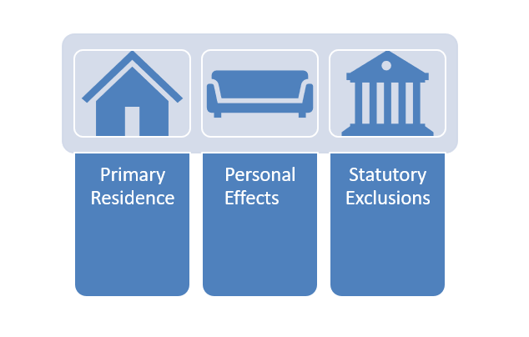

**Transfer for Less than FMV**

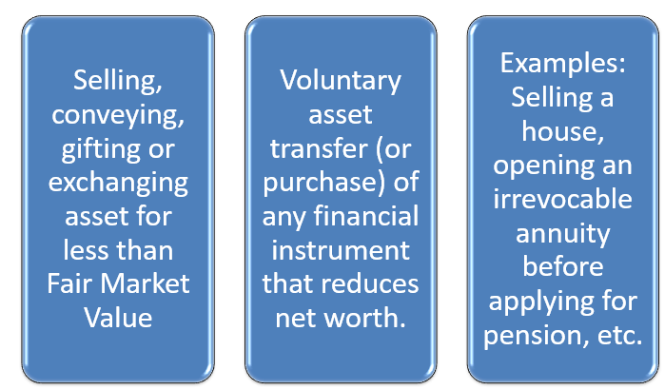

**Covered Assets**

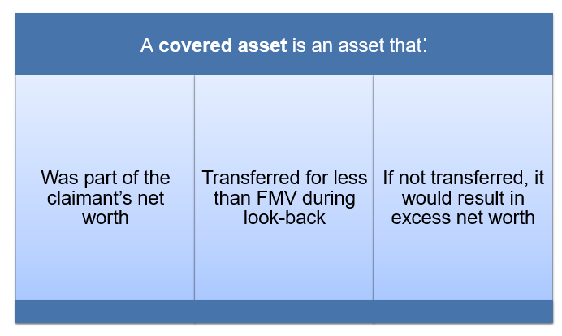

**Acceptable Value Sources**

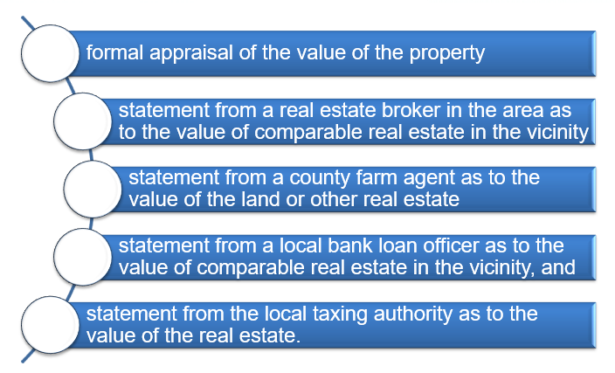

**Residential Lot Determination**

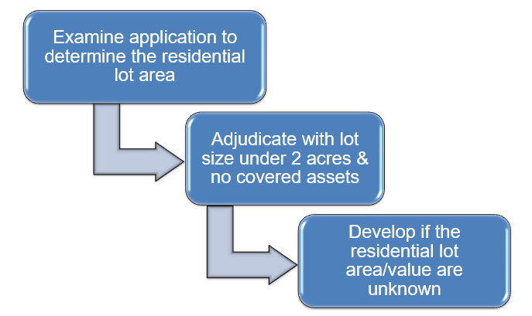

**Net Worth Development**

