Pension and Fiduciary Service
PMC VSR Intermediate Core Course
Phase 5: Proficiency Development
Part 1(c): Income Eligibility
Select Qualifying Expenses
Trainee Guide
June 2024

Select Qualifying Expenses

Lesson Overview
Topic | Description
Time Estimate: | 2 hours
Purpose of the Lesson: | The purpose of this lesson is to prepare you to select qualifying expenses to deduct when calculating income for VA purposes.
Prerequisite Training Requirements: | Prior to taking the Select Qualifying Expenses lesson, trainees must complete PMC VSR Core Course Phases 1–4 and Phase 5.1 (a) and (b)
Target Audience: | This lesson is for entry-level PMC VSRs.
Lesson References: | - 38 CFR 3.262.o (Final Expenses of Veteran or Parent’s Spouse; Dependency and Indemnity Compensation)  - 38 CFR 3.272 (Exclusions from income)  - M21-1 X.iii.1.A (Reports of Hospitalization and Other Information Exchanges Between Department of Veterans Affairs (VA) Regional Offices (ROs) and Medical Facilities)  - M21-1 IX.i.3.D.1 (Determining When Unreimbursed Medical Expenses Are Deductible)  - M21-1 IX.iii.1.A.3.g (Definition of Initial Year for Pension and Time Limit for Establishing Entitlement for the Initial Year)  - M21-1 IX.iii.1.E.7 (Counting Income During the Initial Year)  - M21-1 IX.iii.1.G. (Pension – Deductible Medical Expenses)  - M21-1 IX.iii.1.K. (Pension – Other Deductible Expenses)  - Care Expense Guide job aid  - Claim Types job aid  - Income and Net Worth Status job aid  - Initial Year job aid
Technical Competencies: | - Income Counting and Net Worth  - Program Benefits and Eligibility (PMC VSR)
Lesson Objectives: | - Select qualifying expenses for calculating income.  - Describe the rules for allowing medical expenses as a deduction when calculating income.  - Describe the rules for allowing final expenses as a deduction when calculating income.  - Describe the rules for allowing education expenses as a deduction when calculating income.  - Determine if claimed expenses are acceptable when calculating income.  - Determine whether to develop for claimed expenses when calculating income.
What You Need: | - Income and Net Worth Determination EPSS  - Whiteboard or flip chart  - Access to the following job aids from VSR Assistant:  - Care Expense Guide job aid  - Claim Types job aid  - Income and Net Worth Status job aid  - Initial Year job aid

PowerPoint Slides | Notes
Select Qualifying Expenses

Objectives
- Select qualifying expenses for calculating income.
- Describe the rules for allowing medical expenses as a deduction when calculating income.
- Describe the rules for allowing final expenses as a deduction when calculating income.
- Describe the rules for allowing education expenses as a deduction when calculating income.
- Determine if claimed expenses are acceptable when calculating income.
- Determine whether to develop for claimed expenses when calculating income.
Why It Matters!
- Correct calculation of claimant income affects amount of benefit for claimant.
- Qualifying expenses reduce claimant income; therefore, qualifying expenses may result in an increase in benefits.
- The PMC VSR selects expenses that qualify for deduction from income.
Applicable Benefits
- Current Law Pension
  - Veterans Pension
  - Survivors Pension
- Parents’ DIC
- Section 306 Pension
When Expenses are Considered
- Original
- Maintenance (Award Adjustments)
- New/Supplemental
Definition: What are Deductible Expenses?
- Medical expenses greater than 5% of MAPR
- Final expenses
- Education expenses
Rules for Deducting Medical Expenses
- Expenses paid may be used to reduce the claimant’s countable income. All the conditions below must exist:
- Expenses actually paid by claimant or claimant’s dependent(s) for VA purposes
- Expenses are unreimbursed
- Expenses for claimant or relative who is a member of household
- Paid on or after date of pension entitlement or date of Veteran’s death (if after date of pension entitlement)
- Expenses exceed five percent deductible (MAPR x .05)
Prescribed Form
- A claim for a medical expense deduction that will result in increased benefit payments must be supported by a:
- Fully completed VA Form 21P-8416, Medical Expense Report, or
- Another standard form that requests information consistent with what is requested on the VA Form 21P-8416 such as:
  - VA Form 21P-527EZ
  - VA Form 21P-534EZ
  - Proper standard form accompanying evidence of paid medical expenses that is appropriate to the benefit sought
Information Required for a Medical Expense Deduction Claim
M21-1 IX.iii.1.G.4.b. (Requirements for a Medical Expense Deduction Claim)
M21-1 IX.iii.1.G.4.e (Information Required on VA Form 21P-8416 for Medical Expenses)
- Purpose
- Amount paid
- Date paid
- Provider
- For whom paid
Information Required for a Medical Expense Deduction Claim—Exceptions (1 of 2 and 2 of 2)
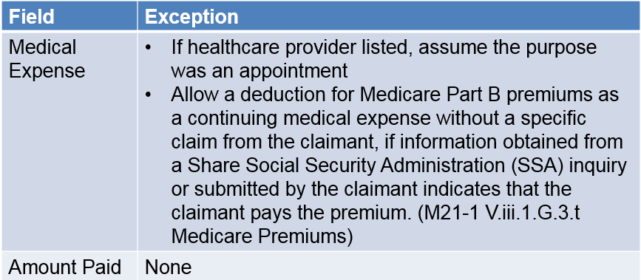
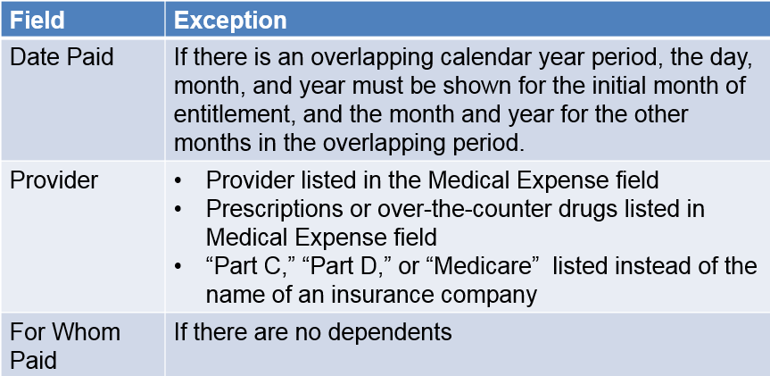

PowerPoint Slides | Notes
Medical Expense Deduction Claim
- Develop for missing information
- Do not develop just to deny if there is already a clear reason to deny
- Normally medical expenses are allowed as a deduction after the fact based on the claim’s report of expenses actually paid.
- May be allowed prospectively if the beneficiary is paying recurring nursing home fees or in other situations where medical expenses are reasonably predictable.
Unreimbursed Medical Expenses
Most often seen:
- Medical Insurance
  - Medicare premiums
- Prescriptive or Nonprescription drugs
- Adaptive Equipment
- Facility fees
- In home care fees
- Transportation expenses for medical purposes
Qualifying Types of Medical Expenses
- M21-1 IX.iii.1.G.2.c (Common Allowable Medical Expenses)
- M21-1 IX.iii.1.G.3 (Sources of Medical Expenses)
Overlapping Period
- Overlapping periods occur when the initial year overlaps the first calendar year.
- If an overlapping period is involved:
  - Calculate medical expenses for each reporting period separately, and
  - Allow the greater amount of medical expenses during the overlap, subject to 38 CFR 3.31
Overlapping Period Example
Example: A surviving spouse’s initial year is July 15, 2020, through July 31, 2021.​
Result: Compare the medical expenses for the following two periods:​
- July 15, 2020 through July 31, 2021, and​
- calendar year 2021.​
- For the overlapping period (January 1, 2021 through July 31, 2021) pay based on the higher period of medical expenses.
Dates for Medical Expenses for an Original Claim
- M21-1 IX.iii.1.A.3.g. (Definition of Initial Year for Pension and Time Limit for Establishing Entitlement for the Initial Year)
- M21-1 IX.iii.1.E.7.a. (Definition: Initial Period)
- M21-1 IX.iii.1.E.7.b. (Deductible Medical Expenses Paid During the Initial Year)
Allowing Prospective Continuing Medical Expenses (CMEs) (1 of 2)
- M21-1 IX.iii.G.4.f (Allowing Medical Expenses Prospectively)
- 38 CFR 3.272.g (Exclusions from income; Medical expenses)
Allowing Prospective Continuing Medical Expenses (CMEs) (2 of 2)
- A prediction of future expenses
- Amount and frequency of payment is easily predictable
- Examples of common continuing medical expenses:
  - Nursing home, assisted living, in-home care
  - Private medical insurance
  - Medicare Part B and D
- Subject to adjustment
- Prescription drugs (claims processed on a case-by-case basis)
Final Expenses
38 CFR 3.272.h (Expenses of last illnesses, burials, and just debts)
- Three categories of final expenses
- When final expenses are deducted
- Veteran’s final expense
- Spouse or child’s final expense
Final Expense Deductions—Overview and Definitions
M21-1 IX.iii.1.K.1 (Final Expense Deductions—Overview and Definitions):
- Last illness
- Burial
- Just debts of the Veteran
Final Expenses (1 of 2)
Under 38 CFR 3.272(h)(1) and 38 CFR 3.272(h)(2)(i), deductible final expenses include amounts paid by a​
- surviving spouse or child for the unreimbursed expenses of a Veteran’s last illness and burial as well as the Veteran’s just debts​
- Veteran for the unreimbursed expenses of a spouse’s or child’s last illness and burial, but not amounts paid for the spouse’s or child’s just debts, and​
- Veteran’s spouse or surviving spouse for the unreimbursed expenses of the Veteran’s child’s last illness and burial, but not amounts paid for the child’s just debts.
Final Expenses (2 of 2)
Expenses of last illness and burial expenses, for example, prepaid burial, paid before the date of pension entitlement, can be considered final expenses if paid by a surviving spouse. There is currently no time limit for allowing such expenses.​
Expenses of a Veteran’s last illness that were allowed as a previous medical expense deduction cannot later be deducted as a final expense on the surviving spouse’s pension award.
Last Illness
Last illness​
- Is the period from the onset of the acute attack causing death to the date of death. Generally, expenses incurred more than one year prior to date of death should not be considered expenses of last illness. ​
- If death resulted from a lingering or prolonged illness instead of an acute attack, the period of last illness is considered to have begun at the time the person became so ill as to require the regular and daily attendance of another person.
Burial Expenses
Burial Expenses​
- Include all funeral and burial expenses incident to disposition of the remains of deceased persons.

Example: A surviving spouse claims $3,000 in burial expenses. VA paid $600 toward the burial and plot and $400 in transportation costs, for a total of $1,000. Therefore, only $2,000 of the claimed burial expenses is deductible for pension purposes.
Just Debts (1 of 2)
Just debts of the Veteran​
- Under 38 CFR 3.272(h)(1)(ii), deduct just debts only when the debts are those of a Veteran and they are paid by a surviving spouse or child claimant.​
- Payments of unsecured debts incurred solely by the Veteran and debts incurred jointly by the Veteran and surviving spouse, for other than the purchase of real or personal property, are deductible as just debts.
Just Debts (2 of 2)
Just debts of the Veteran​
- Payments of secured debts incurred jointly by the Veteran and surviving spouse for the purchase of real or personal property are not deductible as just debts. This includes payments on home and car loans. ​
Notes: ​
- Just debts of the Veteran paid during the Veteran’s lifetime cannot be deducted as a final expense. ​
- If a deceased Veteran’s medical expenses are not deductible as final expenses, consider the possibility of deducting the expenses as just debts of the Veteran.
Processing Final Expense Deductions
- Final expenses are deducted dollar-for-dollar during the calendar year (or initial year) during which they are paid
- Exceptions M21-1 IX.iii.1.K.2.a
- Examples M21-1 IX.iii.1.K.2.b-g
Final Expenses and Joint Accounts
- If the evidence establishes that payment was made from the claimant’s separate funds or from a joint account with the claimant and another person, consider the expenses to have been paid by the claimant.
- If a final expense deduction is allowed, and the beneficiary subsequently receives reimbursement for some or all expenses, recalculate IVAP for the period over which the deduction was allowed to remove those expenses for which reimbursement was received.
Education Expenses (1 of 4)
- 38 CFR 3.272.i (Educational Expenses)
- M21-1 IX.iii.1.K.3 (Educational Expense Deductions)
  - Paid by Veteran or surviving spouse
  - Paid for education expense of the Veteran or surviving spouse
- M21-1 IX.iii.1.K.4.d (Deducting a Child's Postsecondary Education Expenses)
Education Expenses (2 of 4)
Allow a deduction for the unreimbursed expenses for a Veteran or surviving spouse pursuing a course of education or vocational rehabilitation, per 38 CFR 3.272(i). ​
Deductible expenses include amounts paid for​
- tuition​
- fees​
- books
- necessary materials, and
- Unusual transportation (if requirements are met).
Note: There is no requirement that the course of education or vocational rehabilitation be approved for VA educational benefits.
Education Expenses (3 of 4)
Child’s Postsecondary Education Expenses ​
A child’s postsecondary education expense deduction applies only when a child has earned income in excess of the amount deducted under 38 CFR 3.272(j)(1). The educational expense deduction may not exceed the net amount of the child’s earnings after the child’s earned income deduction.
Education Expenses (4 of 4)
Child’s Postsecondary Education Expenses ​
The postsecondary educational expense deduction applies: ​
- only to postsecondary (beyond the high school level) educational or vocational training programs, and​
- regardless of whether the child is the person entitled or a dependent on a Veteran’s or surviving spouse’s award. ​
Note: Do not deduct amounts paid from scholarships and grants since scholarships and grants are not countable income for pension purposes unless they exceed education expenses.
KC - Lesson Summary Review Questions

Time Allowed: 15 minutes
What’s Next
Complete the Selecting Qualifying Expenses course evaluation: TMS ID # 4408432

