Pension and fiduciary service
PMC VSR Intermediate Core Course
Phase 5: Proficiency Development
Part 1(c): Income Eligibility
Determine Types of Income
Trainee Guide
July 2024

Determine Types of Income

Lesson Overview
Topic | Description
Time Estimate: | 2.5 hours
Purpose of the Lesson: | This lesson is part of the entry-level curriculum, Core Course for PMC VSRs. The purpose of this lesson is to prepare PMC VSRs to determine sources of income for a pension claimant.
Prerequisite Training Requirements: | Prior to taking the Determine Types of Income lesson, trainees must complete PMC VSR Core Course Phases 1-5.1.b.
Target Audience: | This lesson is for entry-level PMC VSRs.
Lesson References: | - Compensation and Pension Knowledge Management (CPKM)  - 38 CFR 3.261 (Character of income; exclusions and estates)  - 38 CFR 3.271 (Computation of income)  - 38 CFR 3.272 (Exclusions from income)  - M21-1 IX.iii.1.A.2.d (Action to Take When SS Rate Reported by the Beneficiary is Different Than SS Rate in VBMS )  - M21-1 IX.iii.1.B.1.b (SS Benefits)  - M21-1 IX.iii.1.B.3 (Computing Monthly SSA and Medicare Benefits)  - M21-1 IX.iii.1.E.5. (Income Classifications)  - M21-1 IX.iii.1.E.6 (Counting Income for Department of Veterans Affairs Purposes)  - M21-1 IX.iii.1.F.1.e. (Considering Support Contributions to a Child  - M21-1 IX.iii.1.F.2 (Counting the Income of Dependents)  - M21-1 IX.iii.1.K.5 (Hardship Deductions from a Child’s Income)  - M21-1 IX.iii.1.I.3 (Income Exclusions)  - Income and Net Worth Status job aid  - Initial Year job aid  - SSA Inquiry job aid
Technical Competencies: | - Program Benefits and Eligibility (PMC VSR)  - Income Counting and Net Worth  - VBA Applications (PMC VSR)
Lesson Objectives: | - Determine the types of income for pension purposes.  - Define income for VA purposes.  - Determine income inclusions.  - Determine income exclusions.  - Enter income into VBMS-A.
What You Need: | - Trainee Guide  - Access to VBA intranet  - Access to VBMS-A User Guide  - Access to CPKM  - Access to the following job aids from VSR Assistant:  - Income and Net Worth Status job aid  - Initial Year job aid  - SSA Inquiry job aid

PowerPoint Slides | Notes
Determine Types of Income

Lesson Objectives
- Determine the types of income for pension purposes.
- Define Income for VA Purposes (IVAP).
- Determine income inclusions.
- Determine income exclusions.
- Enter income into VBMS-A.
Why This Matters!
This course matters because it provides an overview of what is IVAP, whose income is counted for pension claims, where is the income information indicated on the application, what sources of income are inclusions or exclusions, as well as discusses the breakdown of countable income categorized into classifications.
Definition: Income for VA Purposes
What is Income for VA Purposes (IVAP)?
- IVAP is all countable income combined with regard to deductible expenses
Countable income for VA purposes​
- Deductible Expenses for VA purposes​
(+ 5% medical deduction)_
IVAP

Income and Dependents
Whose income is counted for pension claims?
- Income for all persons on an award is countable:
  - Veteran
  - Spouse / surviving spouse
  - Child dependents
Sources of Income Overview
- Various sources of income can be divided into two categories:
  - Income inclusions
  - Income exclusions
Income Inclusions
All income is countable for pension purposes unless it is specifically excluded.
Examples:
- Social Security
- Earnings
- Retirement or survivors’ programs
- Interest
- Dividends
- Unemployment compensation
Social Security Income
- Social Security is the type of income most often received by beneficiaries of VA income-based benefit programs.
- Use the Social Security Administration (SSA) Inquiry to verify the gross amount of SS income.
Income Exclusions
Some income types are not countable for pension purposes for the following reasons:
- Not considered to be income under 38 CFR 3.271 (Computation of income)
- Deemed to fall under one of the specific exclusions in 38 CFR 3.272 (Exclusions from income)
- Excluded by federal statute
Exclusions from Countable Income
- Business and/or farm income
- Withholdings from SSA income for SSA overpayment
- Tribal (Indian) income
- Installment sale income from sale of property
- Child’s earned income exclusion
- Child’s income not available to beneficiary
- Hardship exclusion of child’s income
- Gambling winnings minus gambling losses
Income Classifications
- All income must generally be counted for at least 12 months.
- The classifications explain how to count the income based on frequency.
- There are four income classifications:
- Non-recurring
- Recurring
- Short-term recurring
- Irregular
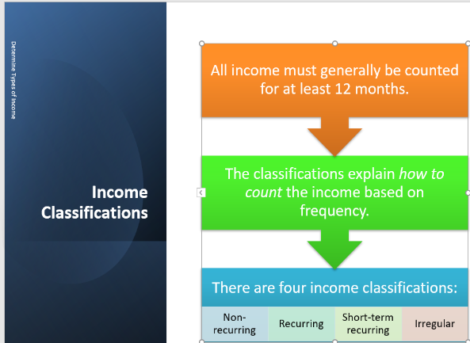
Non-recurring Income
- Non-recurring income is usually a one-time receipt of income.
- There may be more than one receipt, but each receipt is a different occurrence.
- Examples:
  - Lump sum Social Security retroactive payment
  - Inheritance
  - Gambling Winnings

PowerPoint Slides | Notes
Recurring Income
Recurring income is received on a regular basis in fixed amounts for 12 or more months.
- For current-law pension purposes, recurring type income, must be counted on the VA award for at least 12 months to be considered recurring income. Treat retroactive payments of recurring type benefits as nonrecurring income. ​
- Examples include: ​
  - Social Security benefits​
  - Civil Service benefits​
  - Wages​
  - Military Retired Pay benefits
Short-term Recurring Income
Short-term recurring income is recurring income that has not been counted on the VA award for at least 12 months.

An example of short-term recurring income is regular wages that are counted on the award for six months when the beneficiary is laid off and the income stops.
Irregular Income
- Irregular income is received several times during a reporting period, but it arrives at irregular intervals or in irregular amounts.
- Irregular income is received several times during a reporting period, but it arrives at irregular intervals or in irregular amounts.
- Examples:
  - earned income from odd jobs, and​
  - interest income where the rate of return fluctuates
Counting Procedures
- Income is annualized for the purpose of determining entitlement to pension benefits. ​
- Generally, income must be counted for at least 12 months. ​
  - First, classify the income. ​
  - Second, determine how to count it based on the classification.
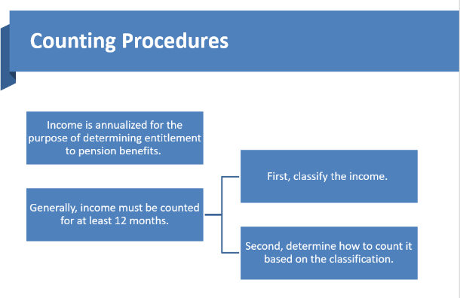
When Income Stops
- If the VA has been counting recurring income the beneficiary has been in receipt of for more than 12 months and that income is stopped, we remove the income the first of the month after the income stopped. ​
​
- Example 1: The Veteran has been working for two years and earns $7,000 annually. He reports on 8/15/21 that he quit his job. ​
- Remove the recurring income of $7,000 effective 9/1/21
Reclassify Income (1 of 2)
- In some instances, income that is initially characterized as recurring income is reclassified as irregular income after the fact.
- Example:
  - A surviving spouse’s original award is payable from May 1, 2020. The surviving spouse reports anticipated earnings of $200 per month.
  - The award is made based on reported IVAP of $2,400(recurring income)

PowerPoint Slides | Notes
Reclassify Income (2 of 2)
- During May 2021, VA receives a statement from the surviving spouse indicating that she​
  - was laid off in August 2020​
  - got another job in September 2020 making $300 per month​
  - quit in October 2020​
  - earned $250 in March 2021 from odd jobs, and​
  - is presently unemployed
Reclassify Income Result
- Result: Total earnings during the period May 1, 2020, through April 30, 2020, came to $1,650.​
- Recharacterize the recurring income as irregular income and change the IVAP to $1,650 effective May 1, 2020.
Date of Receipt Unknown
- For original and new awards, if the date of receipt of income is not known, count the income from the effective date of the award. Explain your decision in the notification letter. ​
- For running awards, we need to know at least the month during which the income started, stopped or changed. If this information is not of record, initiate development (may need due process if adverse action is required)
Knowledge Check – Test

Time Allowed: 10 minutes
What’s Next
Complete the Establishing Periods for Calculating Income course evaluation: TMS ID # 4408431

