Pension and Fiduciary Service
PMC VSR Intermediate Core Course
Phase 5: Proficiency Development
Part 1(c): Income Eligibility
Establish Periods for Calculating Income
Trainee Guide
July 2024

Establish Periods for Calculating Income

Lesson Overview
Topic | Description
Time Estimate: | 2 hours
Purpose of the Lesson: | The purpose of this lesson is to prepare PMC VSR on selecting the correct dates and periods of time for calculating income when determining eligibility.
Prerequisite Training Requirements: | Prior to taking the Establish Periods for Calculating Income lesson, trainees must complete PMC VSR Core Course Phases 1–5.1.b.
Target Audience: | This lesson is for entry-level PMC VSRs.
Lesson References: | - 38 CFR 3.31 (Commencement of the period of payment)  - 38 CFR 3.400—3.404 (Effective Dates)  - M21-1 IX.i.3.A.3 (Income and Net Worth Reporting Periods)  - M21-1 IX.iii.1.A (General Information on the Effect Income and Net Worth Have on Pension and Parents’ Dependency and Indemnity Compensation (DIC))  - M21-1 IX.iii.1.E.7 (Counting Income During the Initial Year)  - M21-1 IX.iii.1.G.4.q (Overlapping Initial Year and Calendar Year Periods)  - M21-1 IX.iii.1.H.1 (Adjustments Based on Changes in Income)  - Income and Net Worth Status job aid  - Initial Year job aid
Technical Competencies: | - Income Counting and Net Worth  - Program Benefits and Eligibility (PMC VSR)
Lesson Objectives: | - Establish periods for calculating income.  - Select the effective date.  - Derive the payment date.  - Select the dates of initial year period.  - Select the dates of the overlap period between the initial year and calendar year.  - Select the dates beginning and ending the second 12-month period.
What You Need: | - Access to the following job aids from VSR Assistant:  - Income and Net Worth Status job aid  - Initial Year job aid  - Appendix A: Establishing Dates for Calculating Income worksheet  - Example claim materials:  - Claim 1: Original claim for Veterans Pension  - Claim 2: Original claim for Survivors Pension

PowerPoint Slides | Notes
Establish Periods for Calculating Income
Objectives
- Establish periods for calculating income
- Select the effective date
- Obtain the payment date
- Select the dates of initial year period
- Select the dates of the overlap period between the initial year and calendar year
- Select the dates beginning and ending the second 12-month period
Why It Matters
- This course is important because it focuses on selecting the correct dates for establishing the time periods used to calculate Income for VA Purposes (IVAP).
  - Using incorrect dates may result in errors in denying or awarding benefits.
Definitions
- The payment date is the date an award is effective.
- The effective date or entitlement date is the date a claimant is entitled to benefits under the existing law.
- The initial year for a pension award extends from the effective date of the award (or the date of the Veteran’s death, if later than the effective date) to 12 months after the payment date.
  - the initial year ranges in length from 12 months plus the stub month (up to 13 months) and does not coincide with a calendar year
  - “initial year” and “initial period” refer to the same period of time and are used interchangeably
Overview of Dates and Periods When Calculating Income
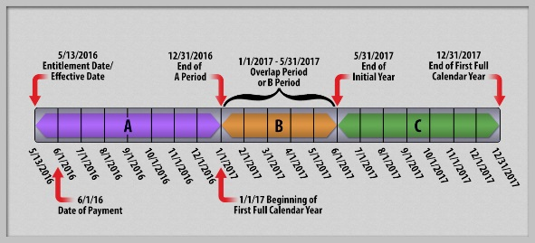

PowerPoint Slides | Notes
Relevance of Dates for Eligibility
- Calculation of income
- Deduction of expenses
- Time limits for establishing entitlement
Determine Period for Establishing Entitlement
- Effective date
- Entitlement date
- Financial decision effective date
- Payment date
- Initial year
- Initial period
- Same calendar year
- Period A
- Period B

PowerPoint Slides | Notes
Effective Date for Survivor Benefits
- 38 CFR 3.400(c)(3): Nonservice-connected death after separation from service
  - First day of the month in which the Veteran’s death occurred if claim is received within 1 year after the date of death; otherwise, date of receipt of claim or intent to file
  - The effective date for countable income and expenses is the date of the Veteran’s death if the claim is received within 1 year after the date of death, or the date of receipt of claim or intent to file
Exercise: Effective Date and Payment Date
- Instructions:
  - Work with a partner.
  - Complete Part A of the Establishing Dates for Calculating Income worksheet.
  - Be prepared to share your answers with the class.
Time allowed: 15 minutes.
Exercise: Effective Date and Payment Date Answers
- Claim 1: Veterans Pension
  - Effective date?
  - Payment date?
- Claim 2: Survivors Pension
  - Effective date?
  - Payment date?
Initial Year Examples
- Live (Veterans) Pension: If the claim is received on April 19, 2021, then the initial period is April 19, 2021, through April 30, 2022
- Survivors Pension: If the Veteran died on February 2, 2020, and the claim is received on:
  - May 5, 2020 (within one year after the date of death), then the initial period is February 2, 2020, through February 29, 2021
  - May 5, 2021 (more than one year after the date of death), then the initial period is May 5, 2021, through May 31, 2022
Exercise: Dates of Initial Year
- Instructions:
  - Work with a partner.
  - Complete Part B of the Establishing Dates for Calculating Income worksheet.
  - Be prepared to share your answers with the class.
- Time allowed: 10 minutes
Exercise: Dates of Initial Year Answers (1 of 2)
- Claim 1: Veterans Pension
  - What is the beginning date of the initial year?
  - What is the ending date of the initial year?
Exercise: Dates of Initial Year Answers (2 of 2)
- Claim 2: Survivors Pension
  - What is the beginning date of the initial year?
  - What is the ending date of the initial year?
Calendar Year and Overlap of Initial Year
Calendar Year and Overlap of Initial Year Answers
- What are the dates of the initial year?

- What are the dates of the first calendar year?

- What are the dates of the overlap period?

- What are the dates of the “A” period?

- What are the dates of the “B” period”?

Exercise: Dates of Overlap
- Instructions:
  - Work with a partner.
  - Complete Part C of the Establishing Dates for Calculating Income worksheet.
  - Be prepared to share your answers with the class.
- Time allowed: 10 minutes
Exercise: Dates of Overlap Answers (1 of 2)
- Claim 1: Veterans Pension
  - What are the dates of the initial year?
  - What are the dates of the first calendar year?
  - What are the dates of the overlap period?
  - What are the dates of the “A” period?
  - What are the dates of the “B” period”?
Exercise: Dates of Overlap Answers (2 of 2)
- Claim 2: Survivors Pension
  - What are the dates of the initial year?
  - What are the dates of the first calendar year?
  - What are the dates of the overlap period?
  - What are the dates of the “A” period?
  - What are the dates of the “B” period”?
Counting the Initial 12 Months of Income for Disallowed Claims
- Income that bars payment of Pension must be considered for 12 months from the first day of the month after the effective date
- Example:
  - June 10, 2020, surviving spouse files for pension and is denied because of monthly wages of $1,400.
  - May 1, 2021, spouse re-applies and states she lost her job and made $9,800 between June 10, 2020 and November 2020.
  - $9,800 is counted for a full 12 months from July 1, 2020 to June 30, 2021 before it is removed
Counting the Second 12 Months of Income for Disallowed Claims (1 of 2)
- A claimant has two 12-month periods to submit evidence establishing entitlement to benefits for the second 12-month period after denial of a claim because income exceeds the limit during the first 12-month period
- If a claim has been denied because income for the first 12-month period exceeded the MAPR, evaluate income for the second 12-month period to determine if entitlement exists

PowerPoint Slides | Notes
Counting the Second 12 Months of Income for Disallowed Claims (2 of 2)
- Example: A Veteran files an original claim on March 14, 2019 and is denied because of wages of $2,000 per month.
  - On September 29, 2020, the Veteran reports the last paycheck was received on September 3, 2020 and received a one-time payment of $500 on June 16, 2020.
  - The Veteran’s entitlement for the second 12-month period must be based on income received April 1, 2020 thought March 31, 2021
  - Wages of $12,000 and $500 one-time payment
Exercise: Dates of Second 12-Month Period
- Instructions:
  - Work with a partner.
  - Complete Part D of the Establishing Dates for Calculating Income worksheet.
  - Be prepared to share your answers with the class.
- Time allowed: 10 minutes
Exercise: Dates of Second 12-Month Period Answers (1 of 2)
- Claim 1: Veterans Pension
  - What is the beginning date of the second 12-month period?
  - What is the ending date of the second 12-month period?
Exercise: Dates of Second 12-Month Period Answers (2 of 2)
- Claim 2: Survivors Pension
  - What is the beginning date of the second 12-month period?
  - What is the ending date of the second 12-month period?
KC - Lesson Summary Review Questions

Time Allowed: 15 minutes

PowerPoint Slides | Notes
What’s Next?
Complete Establishing Periods for Calculating Income course evaluation: TMS ID # 4408425

Appendix

Overview of Dates and Periods When Calculating Income
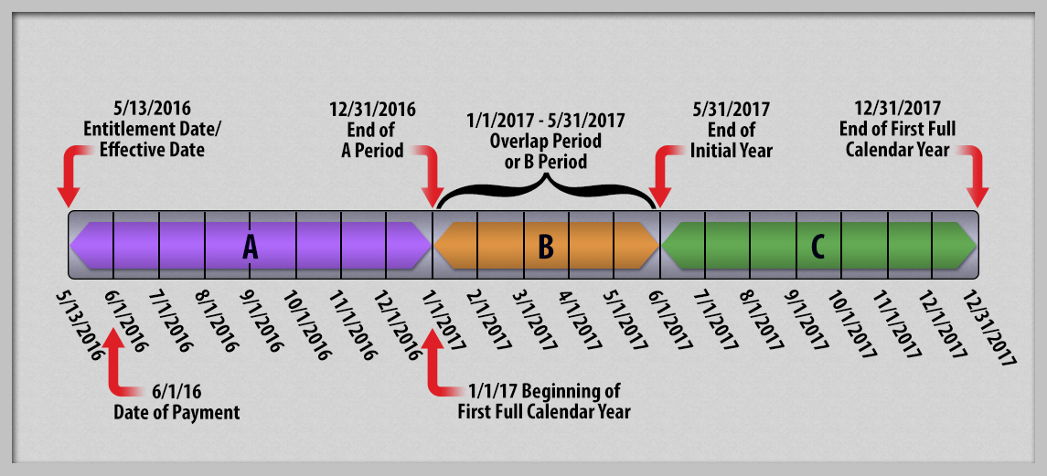

Calendar Year and Overlap of Initial Year

