Pension and fiduciary service
PMC VSR Intermediate Core Course
Phase 5: Proficiency Development
Part 1(b): Basic Eligibility
Establish Parental Relationship for DIC
Trainee Guide
June 2024

Establish Parental Relationship for DIC

Lesson Overview
Topic | Description
Time Estimate: | 2 hours
Purpose of the Lesson: | This lesson is part of the entry-level curriculum, Core Course for PMC VSRs. The purpose of this lesson is to prepare you to establish a parental relationship to the Veteran to determine eligibility for DIC benefits.
Target Audience: | This lesson is for entry level PMC VSRs.
Lesson References: | - 38 CFR 3.59 (Parent)  - 38 CFR 3.209 (Birth)  - 38 CFR 3.210 (Child’s relationship)  - M21-1 VII.i.3.A.4.c (Examples of Acceptable Secondary Evidence)  - M21-1 VII.i.4.A (Establishing Parental Relationship)  - M21-1 VI.iii.3.A (General Information on Contested Claims)  - M21-1 V.iii.1.D.1.b (Determination of Parents' DIC Income Limit)  - M21-1 IX.iii.1.D.6.a. (General Information on Changes in Marital and Dependency Status)  - M21-1 IX.i.1.4 (Entitlement Requirements and Development for Parents’ DIC)
Lesson Objectives: | By the end of this lesson, you will be able to:  - Establish parental relationship to a Veteran for the purpose of receiving DIC benefits  - Identify parental relationship requirements  - Determine whether evidence shows abandonment, foster parent, or contested claim
What You Need: | - Trainee guide  - Access to VBA Intranet  - Pen and paper or access to a whiteboard  - Access to the following systems:  - SHARE  - VBMS

PowerPoint Slides | Notes
Establish Parental Relationship for DIC
Lesson Objectives
By the end of this lesson, you will be able to
- Establish parental relationship to a Veteran for the purpose of receiving DIC benefits
- Identify parental relationship requirements
- Determine whether evidence shows abandonment, foster parent, or contested claim
Why This Matters!
- The Establish Parental Relationship for DIC course matters because VA benefits may be payable to a surviving parent(s) of a deceased veteran.
Who Is an Eligible Parent?
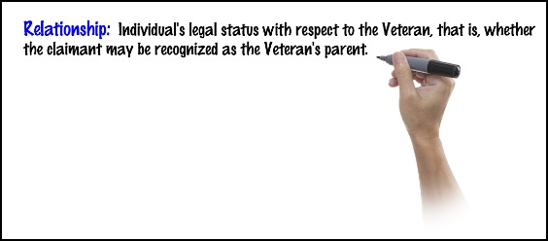
Reference: M21-1 VII.i.4.A.1.c

PowerPoint Slides | Notes
Application for DIC—Parent
- VA Form 21P-535, Application for Dependency and Indemnity Compensation by Parent(s)
- VA Form 21P-524 – Statement of Person Claiming to Have Stood in Relation of Parent
Parental Relationship
- Biological - M21-1 VII.i.4.A.4
  - Veteran’s birth certificate
  - Primary evidence
  - Secondary evidence
- Adoptive - M21-1 VII.4.A.5
  - Final decree of adoption
  - Impounded adoption records
  - Foreign adoption
- Foster parent - M21-1 VII.i.4.A.6.a-c
  - Length of time foster parent must stand in place of biological parent
  - Relinquishment of control
- Abandonment – M21-1 VII.i.4.A.8
- Examples of Control vs. Abandonment
- Entitlement Requirements and Development for Parents’ DIC
  - Acceptable Proof of Relationship of a Parent to a Veteran (M21-1, IX.i.1.4.d)
Definitions: Abandonment by Parent
- Abandonment and entitlement benefits-
a biological or adoptive parent who refused to assume the legal and moral obligations of a parent is not entitled to VA benefits. Evidence shows both a refusal and failure to provide support.
- Relinquishment of control
when a the parent fails to provide support for the Veteran.
- Case development for alleged abandonment by a parent-
fully develop the facts surrounding the allegation.
Contested Claims
- A contested claim exists when:
  - A favorable decision on one claim requires:
  - the denial of a claim from a separate claimant, or
  - payment of a lesser benefit to a separate claimant.
  - One claimant may contest
  - the other claimant’s entitlement to that benefit, or
  - payment of that benefit to the other claimant.
- A contested claim automatically arises if two people:
  - allege to be a deceased Veteran’s legal surviving
  - Spouse, Mother, or Father file a formal claim for the same benefit
Scenario—Who Is Eligible for DIC Benefits?
Nancy, has filed a DIC claim as a foster parent. Ms. Audrey, the biological mother of the Veteran, has also filed a DIC claim as the biological parent. The evidence received from Nancy, shows that Ms. Audrey, the Veteran’s biological mother, left the Veteran with his aunt, Nancy, at the age of nine and never returned or made contact with the Veteran until he entered the service at age 19. The evidence shows that Ms. Audrey, made attempts to contact the Veteran via email, but the Veteran never answered any of the emails.
- Based on the evidence given, who is eligible to receive DIC benefits?

Lesson Summary Review Questions
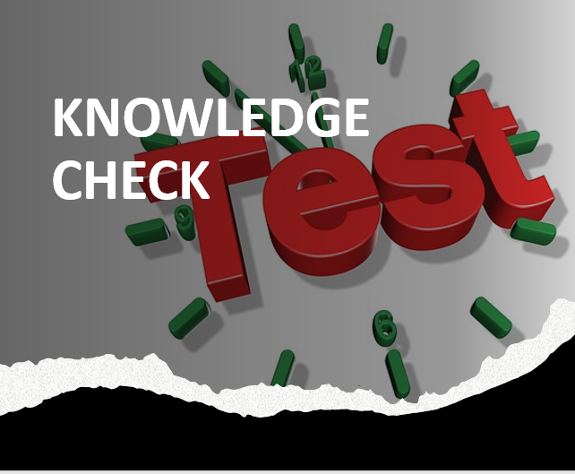
Time Allowed: 10 minutes
What’s Next?
- Complete Establish Parental Relationship for DIC evaluation course: TMS ID #4408422

