Pension and Fiduciary Service
PMC VSR Advanced Core Course
Phase 6: Practical Application and Experience
Process VAMC Facility Adjustments
Trainee Guide
June 2024

Process VAMC Facility Adjustment

Lesson Overview
Topic | Description
Time Estimate: | 7 hours
Purpose of the Lesson: | This lesson is part of the entry-level course for PMC VSRs. The purpose of this lesson is to train PMC VSRs to process a VAMC facility adjustment through demonstration, practice, and feedback.
Prerequisite Training Requirements: | Prior to taking the Process VAMC Facility Adjustment lesson, trainees must complete the entry-level course Phases 1–5.6.
Target Audience: | This lesson is for entry-level PMC VSRs.
Lesson References: | - 38 CFR 3.351 (Special Monthly DIC, Death Compensation, Pension and Spouse Compensation Ratings)  - 38 CFR 3.551 (Reduction Because of Hospitalization)  - M21-1 IX.ii.1.A.1.a. (Who May Qualify for A&A Status Under 38 CFR 3.351)  - M21-1 X.iii.1 (Hospital Adjustments)  - M21-1 IX.iii.1.D.1 (General Information on Reducing Pension Under 38 CFR 3.551 and 3.556)
Technical Competencies: | - Processing Claims (PMC VSR)  - Income Counting and Net Worth  - Special Monthly Pension (SMP) Processing  - VBA Applications (PMC VSR)  - Program Benefits and Eligibility (PMC VSR)
Lesson Objectives | By the end of this lesson, you should be able to:  - Define hospitalization for VA purposes.  - Recognize indicators of VAMC facility adjustment.  - Determine whether there is an entitlement change due to VAMC facility admission/readmission.  - Determine whether to apply due process provisions.  - Decide the award action for an admission/readmission VAMC facility adjustment.  - Determine contents of decision notice letter for an admission/readmission VAMC facility adjustment.  - Submit the adjustment to the Authorizer.
What You Need: | - Trainee Guide  - Pen, Pencil, and Notebook  - Access to Appendix A  - Access to the following job aids from VSR Assistant:  - VAMC Facility Adjustments job aid

PowerPoint Slides | Notes
Process VAMC Facility Adjustment

Lesson Objectives
By the end of this lesson, you should be able to:
- Define hospitalization for VA purposes.
- Recognize indicators of VAMC facility adjustment.
- Determine whether there is an entitlement change due to VAMC facility admission/readmission.
- Determine whether to apply due process provisions.
- Decide the award action for an admission/readmission VAMC facility adjustment.
- Determine contents of decision notice letter for an admission/readmission VAMC facility adjustment.
- Submit the adjustment to the Authorizer.
Lesson Overview
- Introduction to VAMC facility adjustments
- Demonstration— Instructor goes over a claim scenario and review questions with trainees. Instructor discusses the claims review process from start to finish with opportunities to discuss trainee questions.
- Guided Practice— Trainees are assigned VAMC claims to process.
- There will be a demonstration and guided practice processing each of the following VAMC facility adjustments:
  - Initial admission
  - Discharge
  - Readmission
Demonstration Reminder
The Processing VAMC Facility Adjustments Checklist job aid will provide the steps of the process.
The VAMC Facility Adjustments job aid will provide the detail information for each steps of the process.
Use the notes column of the Processing VAMC Facility Adjustments Checklist job aid to write down any questions or notes from the demonstration.

Definitions
- Hospitalization, as it is used in this section and throughout this chapter, generally refers to inpatient care or treatment that a Veteran receives in a VA hospital or medical facility, VA domiciliary, VA nursing home, or private facility under VA contract.
- A nursing home is any extended care facility that is licensed by a State to provide skilled or intermediate-level nursing care, a nursing home care unit in a State Veterans’ home that is approved for payment, or a VA nursing home care unit.

Definitions cont.
- For pension purposes, a medical foster home means a private home in which a medical foster home caregiver provides care to a veteran resident and
  - The medical foster home caregiver lives in the medical foster home
  - The medical foster home caregiver owns or rents the medical foster home; and
  - There are not more than three residents receiving care (including veteran and non-veteran residents)
- A medical foster home caregiver is the primary person who provides care to a Veteran resident in a medical foster home.
Exchanging Information
- VA medical facilities and regional offices (ROs) use the following methods to exchange information:
- VA Forms
  - 10-7131, Exchange of Beneficiary Information and Request for Administrative and Adjudicative Action, and 10-7132, Status Change
  - the Compensation and Pension Record Interchange (CAPRI), and
  - centralized, automated reporting informed by Veterans Health Administration (VHA) clinical data
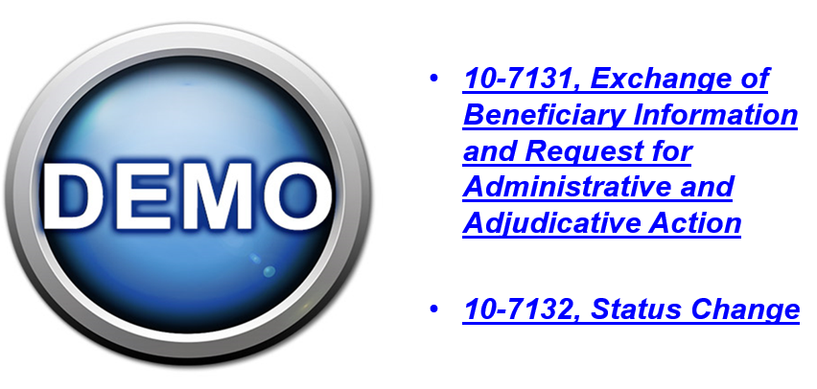
Admission and Discharges
- PMCs must use CAPRI to manually generate, on or around the first day of each month, the Contract Nursing Home (CNH) Report of Admissions/Discharges to ensure pension benefits do not require adjustment.
- To access these reports, log into CAPRI, but do not attempt to locate a specific Veteran. Instead, select
  - File from the tool bar in the top, left-hand corner of the screen, and
  - Reports from the drop-down box

PowerPoint Slides | Instructor Activities
VAMC Facility Adjustments Under 38 CFR 3.551
- The provisions of 38 CFR 3.551 require a reduction of pension payments for a Veteran who has not established dependents for Department of Veterans Affairs (VA) purposes, and is being furnished hospital, domiciliary or nursing home care by VA or at VA expense.
- Upon receipt of notice showing that an authorized absence of 30 days or more has been granted to a competent Veteran, act without awaiting expiration of the 30 days, per 38 CFR 3.556(a).
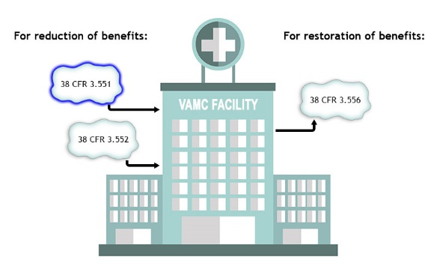
Process VAMC Adjustments
Demonstration: Claim 1
On September 2, 2023, VA runs a CAPRI report to review for Veterans who are hospitalized and in receipt of pension. The report indicates that John Doe, was admitted to a domiciliary on August 29, 2023.CAPRI confirms that the Veteran is still admitted to the domiciliary. Reviewing the record shows that the Veteran is receiving pension with aid and attendance, has no dependents and is a no income case.
Claim 1 Processing Questions
Does the claim require due process?
- Answers provided by instructor
What adjustments should be proposed in the due process letter?
- Answers provided by instructor
What are the proper end products?
- Answers provided by instructor
Process VAMC Adjustments
Demonstration: Claim 1 Continued
Due process was sent to Veteran John Doe on September 28, 2023. It was proposed that his pension be reduced to the housebound rate on October 1, 2021, and to $90 on December 1, 2021. A review of CAPRI on December 20, 2021, shows that the Veteran is still admitted to the domiciliary. The only evidence in the file since due process was the Veteran’s response that his pension should not be reduced because he needed the money.
Claim 1 Processing Questions
Is there sufficient information to proceed with the claim?
- Answers provided by instructor
What adjustments should be implemented?
- Answers provided by instructor

Process VAMC Adjustments
Demonstration: Claim 1 Continued
On February 18, 2022, John Doe was given a weekend pass from the domiciliary. He was allowed to leave on the 18th and returned on the 20th. He sent in a statement asking that his pension be restored to the full rate for the days he was on pass. While reviewing CAPRI, it is noted that the Veteran also was transferred from the domiciliary to the local VAMC on February 25, 2022. He was transferred back to the domiciliary on April 18, 2022. You are reviewing the evidence on April 20, 2022.
Claim 1 Processing Questions
Can you restore full benefits for the period of the weekend pass?
- Answers provided by instructor
Should the $90 rate be adjusted for the period the Veteran was in the VAMC?
- Answers provided by instructor

Process VAMC Adjustments
Demonstration: Claim 2
On March 15, 2021, VA receives VA Form 21P-527EZ from Elijah Veteran. The address on the application is the same as a VAMC. His verified service shows he honorably served in the Marine Corps from 8/22/64 through 8/15/66. He has no dependents, is claiming special monthly pension, and has no income or net worth.
The claim is supported by VA Form 21-2680, which supports a grant of aide and attendance and says the Veteran is competent. The FTI and SSA data matches confirm the Veterans income statement. A review of CAPRI shows the Veteran was admitted to the hospital on March 10, 2021 and was transferred to a NHCU on March 30, 2021.
Claim 2 Processing Questions
Is there sufficient evidence to decide the claim?
- Answers provided by instructor
Does the claim require a rating decision?
- Answers provided by instructor
What are the effective dates for the pension award?
- Answers provided by instructor
Process VAMC Adjustments
Demonstration: Claim 2
On October 12, 2021, VA received a statement from Elijah Veteran stating that he was discharged that day from the NHCU. He requested that his benefits be restored to full rate as soon as possible. CAPRI confirms that the Veteran was fully discharged the morning of October 8, 2021.

Claim 2 Processing Questions
Does the claim require a rating decision?
- Answers provided by instructor
What is the effective date for the restoration of benefits?
- Answers provided by instructor
Process VAMC Adjustments
Demonstration: Claim 2
On May 2, 2022, VA runs a CAPRI report to review for Veterans who are hospitalized and in receipt of pension. The report indicates that Elijah Veteran was admitted to the emergency department at the VAMC on March 29, 2022, and then transferred to the NHCU on April 21, 2022. He is currently at the NHCU.
Claim 2 Processing Questions
Does this claim require due process?
- Answers provided by instructor.
What is the effective date for the reduction of benefits?
- Answers provided by instructor.
If the Veteran had been admitted to the NHCU unit on April 2, 2022, what would be the effective date of the $90 reduction?
- Answers provided by instructor
Process VAMC Adjustments
Demonstration: Claim 2
In response to the due process letter proposing to reduce him again, Elijah Veteran stated he adopted his granddaughter on January 20, 2022. He stated that she has no income or net worth and supplied the VA with the adoption decree.
Claim 2 Processing Questions
Does the Veterans dependent affect the hospitalization adjustments?
- Answers provided by instructor.
Should the VA add the dependent to the pension award?
- Answers provided by instructor
Guided Practice Overview
Instructions:
  - Instructors assign hospitalization adjustment claims to trainees.
  - Trainees review pending claims and take necessary action
  - Use the job aids, references, and systems available.
  - Consult with instructors for assistance.
Knowledge Check: Lesson Summary


Time Allowed: 10 minutes
What’s Next?
- Complete the Process VAMC Facility Adjustments course evaluation: TMS ID#4408418

