Pension and Fiduciary Service
PMC VSR Advanced Core Course Phase 6: Practical Application and Experience
Process a Post Award Audit (PAA) Award Adjustment
Trainee Guide
June 2024

Process a Post Award Audit (PAA) Award Adjustment

Lesson Overview
Topic | Description
Time Estimate: | 2 hours
Purpose of the Lesson: | This lesson is part of the entry-level course for PMC VSRs. The purpose of this lesson is to train PMC VSRs to process a PAA award adjustment through demonstration, practice, and feedback.
Prerequisite Training Requirements: | Prior to taking the Process a Post Award Audit (PAA) Award Adjustment lesson, you must complete the entry-level course Phases 1–5.6.
Target Audience: | This lesson is for entry-level PMC VSRs.
Lesson References: | - 38 CFR 3.271 (Computation of income)  - 38 CFR 3.272 (Exclusions from income)  - M21-1 IX.iii.1.E.7.i (Counting the Initial 12 Months of Income for Disallowed Claims)  - M21-1 IX.iii.1.E.7.j (Counting the Second 12 Months of Income for Disallowed Claims)  - M21-1 XIV.4.B.2.j (FTI Tracking Log [VSC and PMC])  - M21-1 XIV.4.C.1.a (Definition: PAA)  - M21-1 XIV.4.C.1.b (Overview of the Match)  - M21-1 XIV.4.C.1.c (OPA&I Filtering of Matches)  - M21-1 XIV.4.C.1.d (Hines ITC Filtering of Matches)  - M21-1 XIV.4.C.1.f (PAA EP)  - M21-1 XIV.4.C.1.h (Periodic Release Dates for PAA)  - M21-1 XIV.4.C.3.b (Additional Development)  - M21-1 XIV.4.C.3.c (Finalizing the PAA Claim)  - M21-1 XIV.4.C.3.d (Example 1 of Final Award Action)  - M21-1 XIV.4.C.4.c (Determining Income Classification)  - Process a PAA Award Adjustment Checklist job aid
Technical Competencies: | - Processing Claims (PMC VSR)  - Income Counting and Net Worth  - Special Monthly Pension (SMP) Processing  - VBA Applications (PMC VSR)  - Program Benefits and Eligibility (PMC VSR)
Knowledge Check: | Phase 6: Process a Post Award Audit (PAA) Award Adjustment Knowledge Check
Lesson Objectives: | By the end of the lesson, you should be able to:  - Process a PAA award adjustment  - Identify if EP 154 was established.  - Maintain the tracking log.  - Determine evidence was received.  - Determine if additional development is required.  - Apply due process, if necessary.  - Determine the income classification.  - Determine if an interim decision can be made.  - Process the award adjustment
What You Need: | - Trainee Guide  - Upfront Verification job aid  - Care Expense Guide job aid  - Income and Net Worth Status job aid  - Initial Year job aid  - Develop for Missing Information/Evidence job aid  - Annotate the Award job aid  - SSA Inquiry job aid  - Due Process job aid

PowerPoint Slides | Notes
Process a Post Award Audit (PAA) Award Adjustment
Lesson Objectives
By the end of this lesson, you should be able to:
- Process a PAA award adjustment
- Identify if EP 154 was established
- Maintain the tracking log
- Determine evidence was received
- Determine if additional development is required
- Apply due process, if necessary
- Determine the income classification
- Determine if an interim decision can be made
- Process the award adjustment
Why It Matters!
- The Post Award Audit (PAA) Award Adjustment training is important because it affects the award payments of the claimant or beneficiary based on information obtained from other government sources.

Definition: What is a Post Award Audit (PAA)?
- A post award audit (PAA) is an automated process that randomly select cases periodically (first, third, and fourth quarter of the calendar year)
- Compares the social security and IRS income reported to the amount that is actually received (i.e., Federal Tax Information [FTI] match)
- Hines Information Technology Center (ITC) filters out cases in accordance with M21-1 XIV.4.C.1.d (Hines ITC Filtering of Matches)
- PMC VSRs receive cases not filtered out by Hines
Review–Establishing Periods for Calculating Income
- Initial Year job aid
- Income and Net Worth Status job aid
- Dates of eligibility
  - Calculation of income
  - Deduction of expenses
  - Time limits for establishing entitlement
- Period for establishing entitlement
- Effective date vs. payment date
- Initial year/initial period
- Second 12 months
Review—Types of Income for Pension Purposes
- Income and Net Worth Status job aid
- SSA Inquiry job aid
- Initial Year job aid
- Income for VA Purposes (IVAP)
- Income inclusions/exclusions

Review—Qualifying Expenses for Calculating Income
- Care Expense Guide job aid
- Claim Types job aid
- Income and Net Worth Status job aid
- Initial Year job aid
- MAPR rates
- Qualifying medical expenses
- Final expenses
- Education expenses
Review—Income and Net Worth
- Income and Net Worth Status job aid
- Claim Types job aid
- Net worth for VA purposes
- Sources of net worth
- Calculation of net worth
- Net worth is a bar to benefits
Review—Developing for Missing Information/Evidence
- Develop for Missing Information/Evidence job aid
- Can determine whether to complete an adjustment or interim adjustment based on what is received from the claimant

PowerPoint Slides | Notes
Review—Qualifying Expense Adjustments
- Care Expense Guide job aid
- Income and Net Worth Status job aid
- Initial Year job aid
Review–Processing Award Adjustments
- Care Expense Guide job aid
- Income and Net Worth job aid
- Initial Year job aid
  - Review the Income/Expenses/Net Worth Adjustments section
Review–Due Process
- Due Process job aid
- Due process vs. contemporaneous notice
Lesson Overview
- Demonstration—Instructor processes a PAA claim from start to finish with opportunities for questions.

PowerPoint Slides | Notes
Demonstration Claim 1— Process a PAA Award Adjustment

- Demonstration Claim 1—

  - Review VBMS, VBMS-A and SHARE
  - Compare the income we are currently counting vs. what was listed in the Worksheet and Compressed Letter

Claim 1—Identify if EP 154 Was Established
- Suspense date is automatically set for 65 days
- Only one EP 154 is allowed per beneficiary record
Claim 1— Determine if Additional Development is Required
- Allow 30 days development if a response or evidence is received from the beneficiary that requires clarification or additional information
- Conduct due process if information is received from a third party and will adversely affect the award
Claim 1— Determine Income Classification and Countable Income
- Upfront Verification job aid
- Income and Net Worth Status job aid
- Compare the income reported in the PAA worksheet to the income in the beneficiary’s eFolder.
Determine if an Interim Decision Can be Made
- Review the evidence received from the beneficiary
- Process an interim adjustment if the evidence received could be used to adjust the benefit given further development
- Document the decision in the PAA tracking log
Claim 1—Perform the Award Adjustment
- Upfront Verification job aid
- Generate the award in VBMS
- Route claim to authorizer through National Work Queue
PowerPoint Slides | Notes
Claim 1—Prepare the Decision Notice
- Clear EP 154
- Create decision notice in PCGL
- Letter must state decision, even if no adjustment was made
- Document in the PAA tracking log
Claim 1—Submit to the Authorizer
- Submit completed claim and decision notice to the Authorizer
- Annotate the Award Checklist job aid
Knowledge Check – TEST
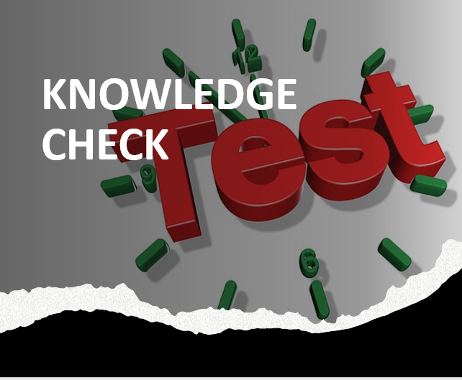
Time allowed: 10 minutes
What’s Next?
Complete the Process a Post Award Audit (PAA) Award evaluation: TMS ID #4408416

